# Agent Level Enhancements

**The following section contains changes that are active system wide** **and available to users based on their assigned security levels.**

Ability to Save Property Search after Customizing Fields

The search customization modal has been modified to include three options for saving a search: for existing (apply/save), for new (apply/save as), apply to current search only (apply). This is the first of coming changes to this function tying the ability to save a search after customizing fields.

New Email Opt Out Process

We are introducing a new opt out process for emails to eliminate accidental email opt outs. Users will now have to enter an email address and select what type of messages they want to opt out from.

Show Listing Status in Power Search

The listing status will be displayed next to the listing’s address when displaying power search results.

Additional Power Search Voice Functionality

After introducing voice search, we are introducing two new keyword functions to help users perform price and phone numbers searches. Also, the inactivity time to terminate the recording and run the search has been increased to two seconds.

* Price: low price **TO** high price
* Phone: **PHONE** xxx-xxx-xxx

BKMLS Banner Update

The banner on the email subscription page has been updated to conform to Current Black Knight branding standards.

CMA – Updated Text for Calculated Adjustments

The instructions for calculated adjustments have been updated to help clarify the steps to apply calculated adjustments.

Summary of Adjustments Page for Calculated Adjustments

The summary of adjustments page will now appear no matter what workflow was used to make the adjustment.

CMA Summary Report – Text Wrap Issue Fixed

The CMA Summary Report was updated to fix an issue whereby when the report was emailed, many of the columns would experience excessive and awkward text wrapping. Note: Adding a large amount of fields to the report may still cause text wrapping to occur.

Geocode Request Process

We’ve updated the process for geocoding a listing when the provided address cannot be accurately mapped. Previously, the system would return a latitude and longitude of 0,0 plotting the property in the Atlantic ocean. This result will now trigger a second request based on the Zip/Postal code, which will plot the property in the center of the Zip/Postal code.

# MLS Customizations and Administration

All options in this section are configurable via MLS Administration controls or by your System Support Manager as noted.

Limit Agent Lookup Fields to Board Members

A new option has been added to the Paragon administrative menu (LIM Agent Filter) that allows customers using Association Autonomy to filter agents available to be selected as co-listing or selling agents based on board membership.

Password Reset Modification

We’re implementing a new methodology for handling password resets. Instead of sending a temporary password and invalidating the old password, users will now be directed to a password reset page where they can enter a new password, which will also be dynamically validated.

Limit Listing Export Eligibility by User Code (Type)

We have added a new User Code (Type) attribute to restrict users from exporting listing data from Paragon via the Spreadsheet view. The attribute is *Allow Listing Data Export* and will be enabled by default for existing user groups. Newly created groups will have this set to disabled by default. This will help address concerns that certain user groups, such as affiliates, could build email and phone lists by exporting results.

Preferences—Hide CMA Wizard

For user codes with the *CMA System Wide Access* option disabled, they will no longer see the CMA Wizard in their preferences or during the Collab Center Wizard.

Admin—MLS Messaging Board Name Field for Security Level 8 Users

This change restores the board name field in the messaging module for Security Level 8 users. This field for level 8 users was inadvertently affected by a 5.69 enhancement that restricted security level 7 users to specific boards.

Lookup Relationships for Multi Class Searches and Market Monitor

The lookup relationships from listing class 1 (typically residential) have been applied to multi class searches and the market monitor. This expands access to lookup relationships to function properly and allows multiple lookup fields to be linked to one another. For example, if you selected Missouri for a state, the city field search options would only return Kansas City, Missouri instead of both Kansas City, Missouri and Kansas City, Kansas.

New CRS Data Integration Point

Agents now have the ability to jump to the CRS Data Property Report from the Map Panel for a MLS Listing. Previously, agents would have to toggle back to a Detail or the Spreadsheet views in order to access the link.

# Corrected Issues

|  |  |  |  |  |
| --- | --- | --- | --- | --- |
| **Work Order** | **Seq** | **Module** | **Reporting Customer(s)** | **Issue Corrected** |
| 87953 | 2 | Print/Print+ | NEREN | iPad User Can't Scroll Multiple Modals |
| 100936 | 1 | Custom Layout Editor | East Central Iowa, NEREN | Layout Editor - Using a quotation mark (") in a text control causes the layout to fail to save |
| 113706 | 1 | Print/Print+ | Birmingham, Quad City, REB3, RANW | Existing - Print+ Download/Save option saves file with "The page you are attempting to access is unavailable or cannot be displayed” |
| 116821 | 1 | Input Maintenance | Tallahassee, IRMLS, SWMLS | MLS# 201451465, converted from subject property, did not add CDOM from expired listing |
| 120315 | 1 | Search - Hotsheet | Memphis, Birmingham | Cannot sort by Area short value in the hotsheet search |
| 132118 | 1 | Admin - Reports | North Central WV, Traverse, Charlottesville, RANW, Western Kentucky | System Price per Acre for Land is not displaying in CMA Summary |
| 132346 | 1 | Admin - System Setup Options | Columbia SC, NEREN, REB3 | Power Search Using City data Number instead of Name |
| 133684 | 1 | Admin - Agent | San Diego MLS, Huntsville, REB3 | Cannot use Transfer utility in Admin>Agents to update listings to same agent's new office |
| 134663 | 1 | Admin - Listings | MAXMLS / EBRD | Incorrect photo watermark is appearing on listings |
| 135832 | 1 | Input Maintenance | South Central Wisconsin MLS | Recovered listing functionality triggering after copying a listing as a subject property |
| 136589 | 1 | Statistical Reporting | San Diego MLS, Huntsville | Agents unable to generate Market Activity by Zip and Month report |
| 138839 | 1 | Admin - Office | Tuolumne County, Gainesville, Birmingham, Great Plains, NKMLS, San Diego MLS | 'Re-Assign' button missing from Office Merge Process |
| 144083 | 1 | Third Party Integration | MAXMLS / EBRD | Publink calling RatePlug for EVERY report when RATE_PLUG_USED = Y |
| 144270 | 1 | RETS | Georgia MLS (ATL) | GAMLS reporting issue where agent preference is not passed with ADD |
| 144998 | 1 | General UI | New England Real Estate Network (NEREN) | Power Search cursor placed at end when attempting to edit criteria |
| 145111 | 1 | Quick Search | Colorado Real Estate Network (CREN) | Load Saved Search on Quick search does not display saved searches to load |
| 145408 | 1 | Email | Paragon 5 - All Accounts | Change the BKMLS Logo in the banner of the email subscription page |
| 144297 | 1 | CMA | Greater Greenville, REB3, Highland Lakes, Quad City, Spokane, St. Augustine, Willamette | MLS reporting the CMA Summary report is converting the "Acres" column to a dollar amount |
| 144714 | 2 | Admin - Messaging | MAXMLS / EBRD 4 | Cannot Select Boards in Board Messaging |
| 114288 | 1 | CMA | MAXMLS / EBRD 4 | CMA Summary wraps text within the column along with the data making it difficult for the receiver to view |
| 116874 | 4 | Admin - Listings | MiRealSource Michigan MLS | Request to Allow Board/Association Autonomy to Limit Agent Lookup Fields to Members of that Board |
| 137629 | 18 | CMA | Paragon 5 - All Accounts | Adding Calculated Adjustments does not trigger the Summary of Adjustments page |
| 145617 | 1 | General UI | Outer Banks Association of Realtors | Tab labels barely visible when using Beach Theme |

# Agent Level Changes

**The following section contains changes that are active system wide** **and available to users based on their assigned security levels.**

Ability to Save Property Search after Customizing Fields

**Action Item:** N/A

Currently, to permanently save changes to search criteria, the user has to first change the fields and then know/remember to save the search criteria to a saved search or template. In this first round of changes, the search customization modal has been modified so that the user can apply their changes and save a search with one click. They can now choose to modify an existing search (apply/save), create a new search (apply/save as), or apply to the current form without saving (apply).

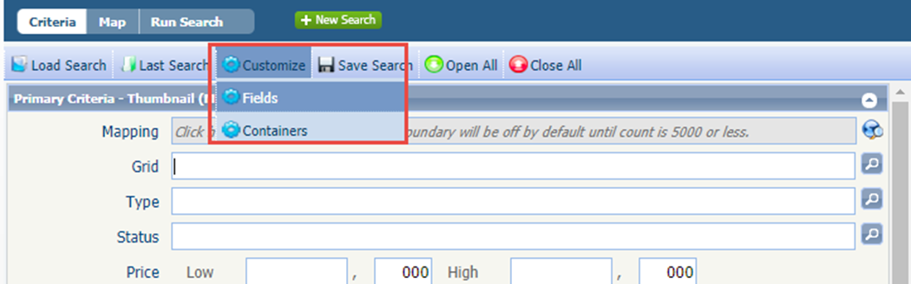

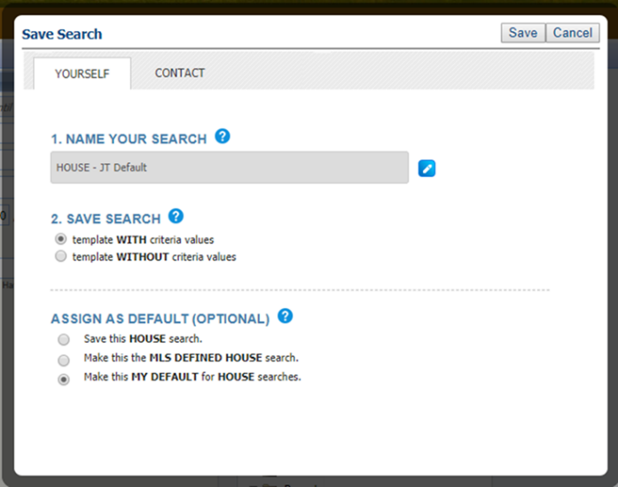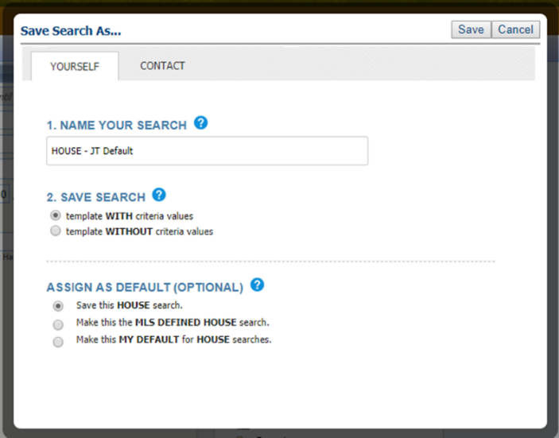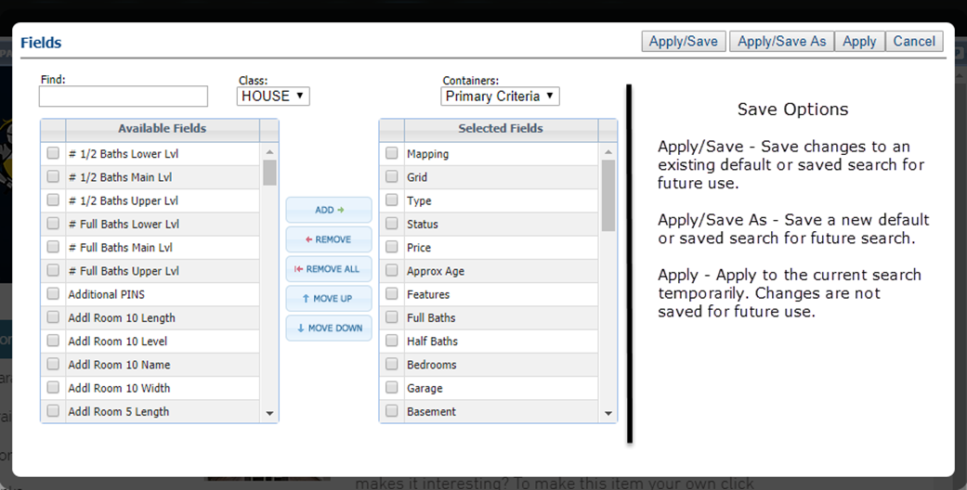New Email Opt Out Process

**Action Item:** N/A

The current method passes original recipient email information when the opt-out link is clicked, this becomes a problem when the email is forwarded to another person. If the secondary person uses the opt-out link, the initial user will be opted out (this results in a significant amount of support calls for our customers and our customer care team). We are introducing a new opt out process for emails to eliminate accidental email opt outs. Users will now have to enter an email address and select what type of messages they want to opt out from.

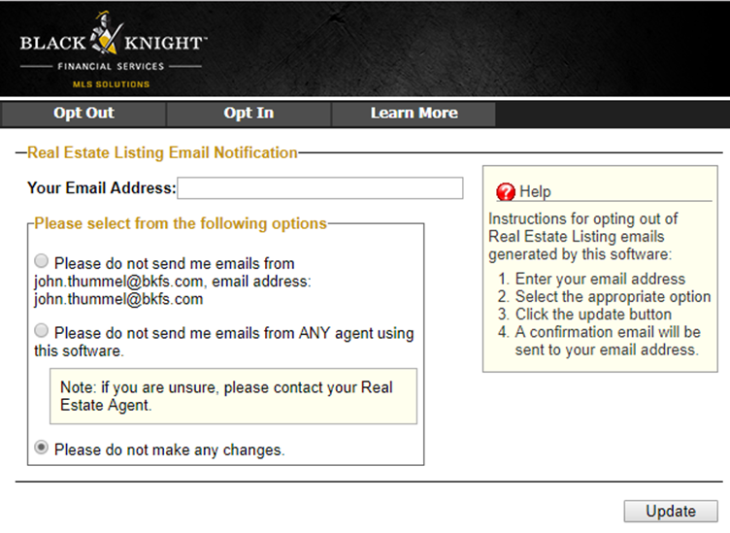

Show Listing Status in Power Search

**Action Item:** N/A

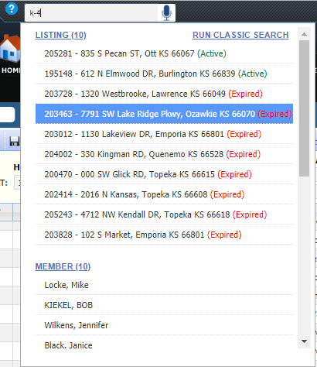The listing status will be displayed next to the listing’s address when displaying power search results. The color code is determined by the color code of the status category. 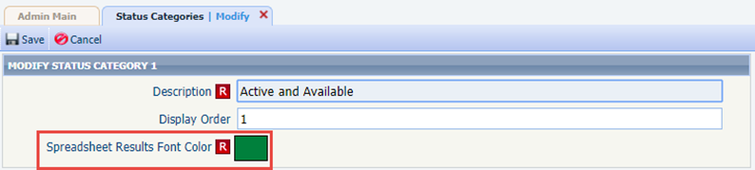

Additional Power Search Voice Functionality

**Action Item:** N/A

We’ve gotten some good feedback from users who have begun to use the voice search functionality introduced in 5.70. In 5.71 two new keyword functions are implemented to help users perform price range and phone number searches. These keywords reintroduce hyphens that are automatically stripped out by the voice recognition so that users can easily perform MLS Listing ID searches. The inactivity timeout before running the search has been increased to two seconds.

To perform these functions users must say the all-caps, bolded word as part of their query:

* Price: low price **TO** high price
* Phone: **PHONE** xxx-xxx-xxx

Black Knight MLS Banner Update

**Action Item:** N/A

The banner on the email subscription page has been updated to conform to Current Black Knight branding standards. 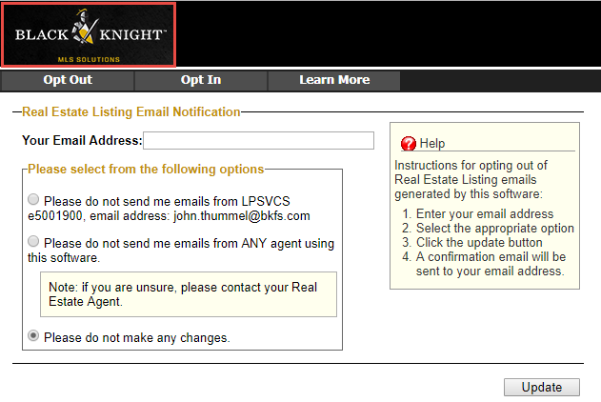

CMA – Updated Text for Calculated Adjustments

**Action Item:** N/A.

This enhancement helps clarify the steps required to apply Calculated Adjustments. The instructions on the Calculated Adjustments page in Preferences and in CMA > Adjustments have been reworded, and the hover tool tip on the Calc Adjust button has been updated. There is no change to the Calculated Adjustments functionality with this enhancement.

Updated Calc Adjust hover tool tip

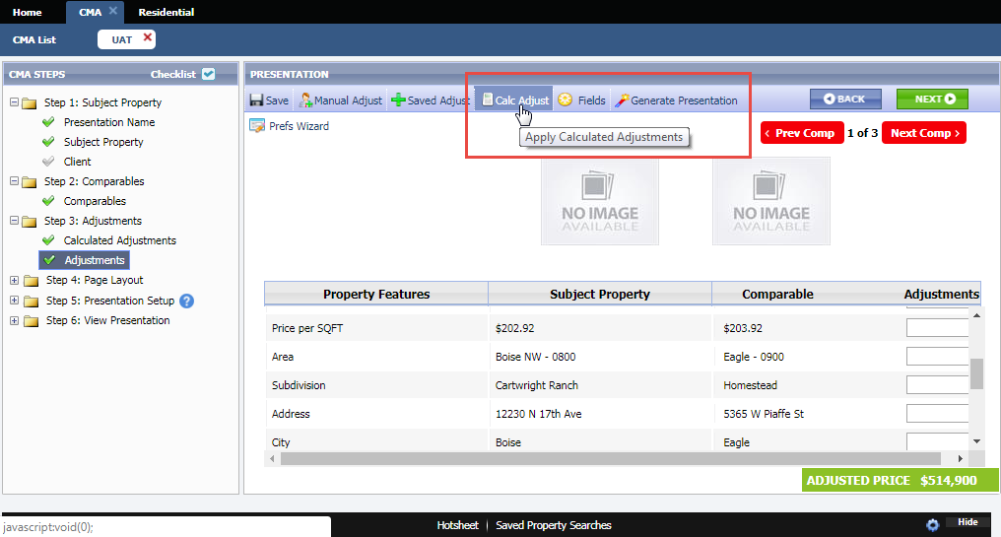

CMA > Calculated Adjustments revised text

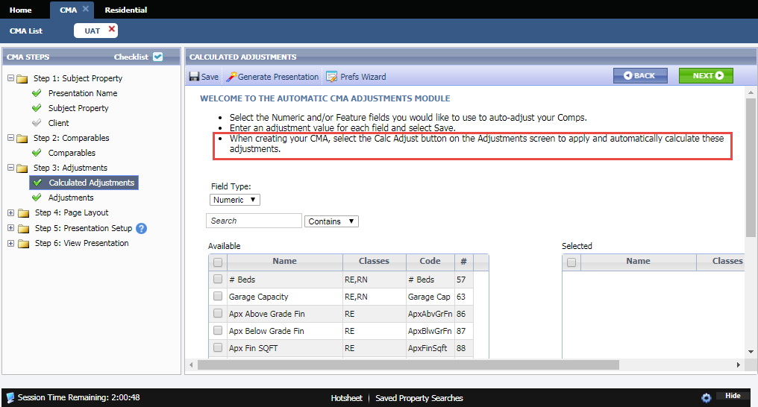

Summary of Adjustments Page for Calculated Adjustments

**Action Item:** N/A.

This enhancements corrects an issue whereby the summary of adjustments page didn’t generate if the only adjustments were made using the Calc Adjust button. Currently, the Summary of Adjustments page is only generated when adjustments are made to comparable listings.

Summary of Adjustments and Calc Adjust

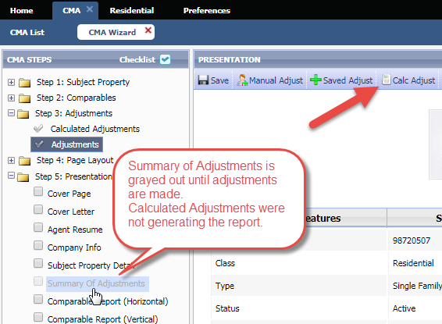

CMA Summary Report – Fixed Text Wrap Issue

**Action Item:** N/A.

The CMA Summary Report was updated to fix an issue whereby, when the report was emailed, many of the columns would experience excessive and awkward text wrapping. Note: Adding a large amount of fields to the report may still cause text wrapping to occur.

CMA Summary Report, old version vs new version

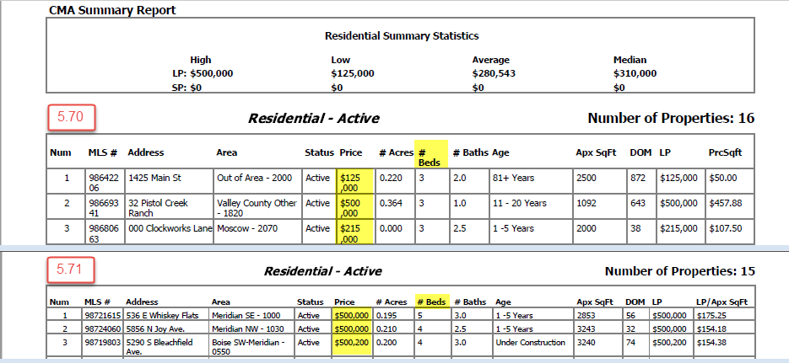

Geocode Request Process

**Action Item:** N/A.

We’ve updated the process for geocoding a listing when the provided address cannot be accurately mapped. Previously, this would then return a geocode quality of 0.1, with a latitude and longitude of 0, 0, in the Atlantic Ocean, just off the west African coast. This result will now trigger a second request based on just the Zip/Postal code, which will produce more accurate results with a geocode quality of 0.85.

# MLS Customizations and Administration

**All options in this section are either configurable via MLS Administration controls or by your System Support Manager as noted.**

Limit Agent Lookup Fields to Board Members

**Action Item:** Select agent filter settings.

A new option has been added to the Paragon administrative menu (LIM Agent Filter) that allows customers using Association Autonomy to filter agents available to be selected as co-listing or selling agents based on board membership.

To implement, select *Lim Agent Filter* in the listings sections of the menu. This control will allow the customer to apply two agent filters. **NOTE: The LIM Agent Filter DOES NOT apply to the primary listing agent field.**

* The MLS may choose to apply the listing search permissions as a filter for eligible agents in LIM.
* The MLS may choose to apply the membership permissions as a filter for eligible agents in LIM.
* 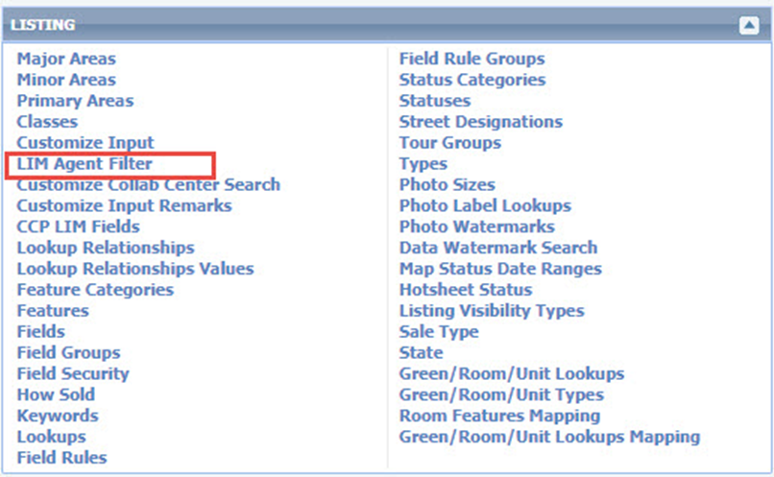**The default value for the LIM Agent Filter IS DISABLED**.

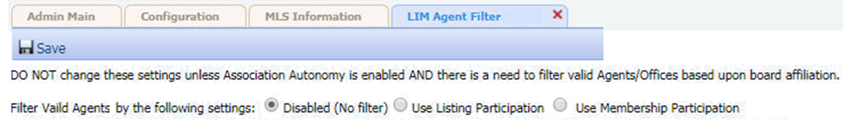

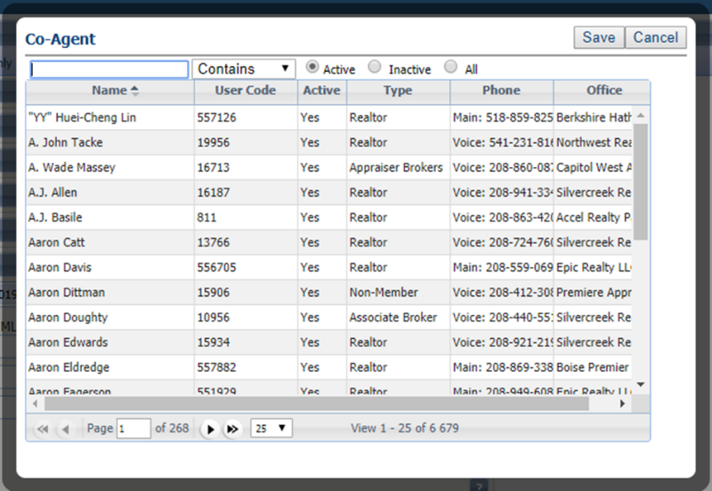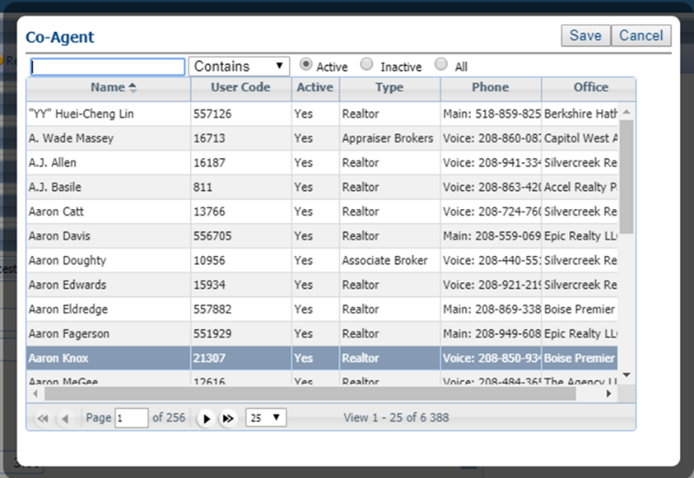

Filtered List

Unfiltered List

Password Reset Modifications

**Action Item:** N/A

We’re implementing a new methodology for handling password resets. Instead of sending a temporary password and invalidating the old password, users will now be directed to a password reset page where they can enter a new password, which will also dynamically validated

* The majority of settings that control passwords will remain unchanged. For example, if users can’t currently manage passwords in Paragon, they will still not be able to do so post change. Administrators can still force password resets on next login for individuals or groups of users. They will also still be able to set passwords when creating new agent records.
* Password reset emails and text messages will utilize a hyperlink to a dedicated password reset page. By default, the link will remain valid for 30 minutes.
* Administrators will still be able to manually change a user’s password. This function is limited to specific user groups via a user code/type setting. **NOTE: The Enable Change Password and Enable Change Password via Email options CANNOT be enabled for a user group at the same time**.
* If the group to which a user is assigned allows manual password reset changes the change password option will appear in the agent record. A password reset modal will displayed. The reset modal uses the same UI as the password reset page.

Admin Options

Password Reset Email

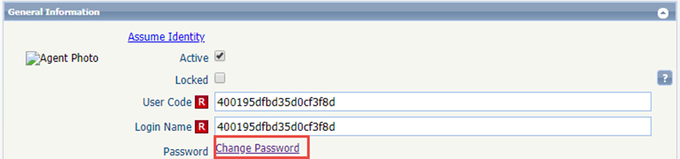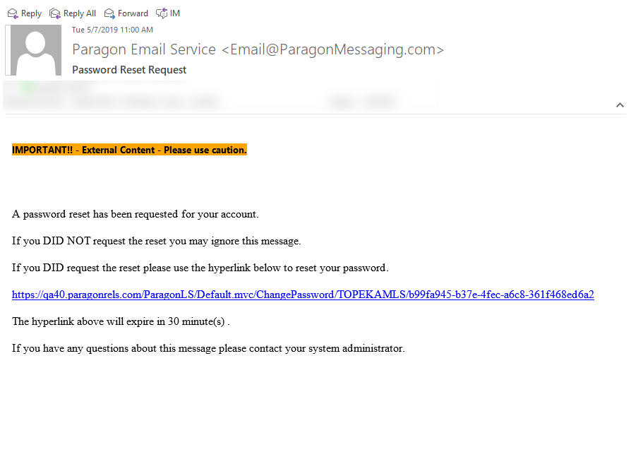

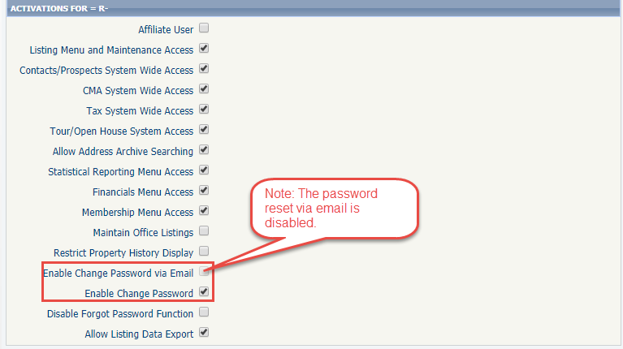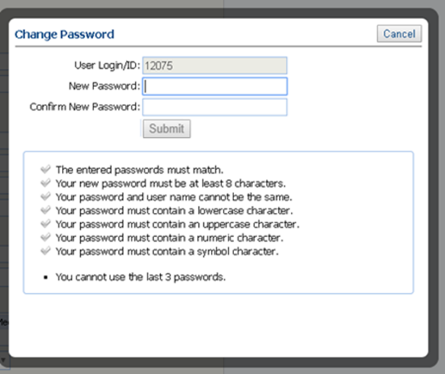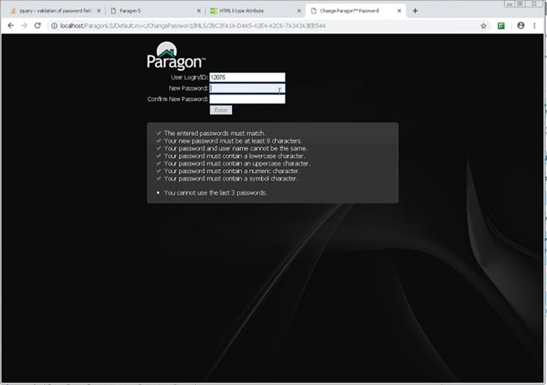

Reset Page

Limit Listing Export Eligibility by User Code (Type)

**Action Item:** Disable for any existing user codes that should not have this ability, enable for new codes that should have ability.

We have added a new user/group type attribute used to restrict users from exporting data from Paragon. The attribute is *Allow Listing Data Export* and will be **enabled by default** for **existing** user codes. **Newly** created codes will have this set to **disabled by default**. This will help address concerns that certain users, such as affiliates, could build email and phone lists by exporting results. 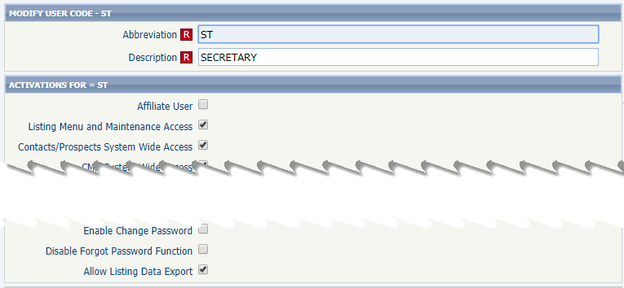

Preferences—Hide CMA Wizard

**Action Item:** N/A

For user codes with the *CMA System Wide Access* option disabled, they will no longer see the CMA Wizard in their preferences or during the Collab Center Wizard.

Agent Type/User Code Module

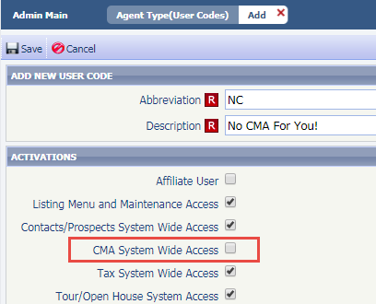

CMA Preferences Wizard

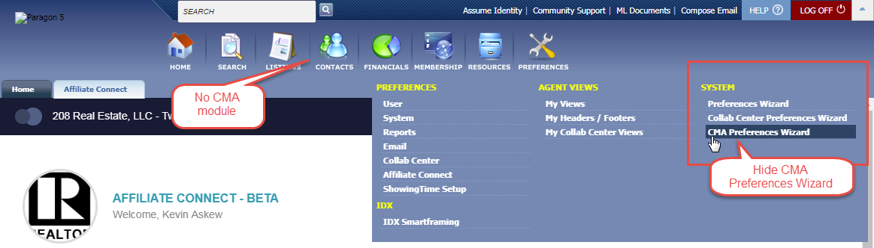

Admin—MLS Messaging Board Name Field for Security Level 8 Users

**Action Item:** N/A

Restores the board name field in the messaging module for Security Level 8 users. This field for level 8 users was inadvertently affected by a 5.69 enhancement that restricted security level 7 users to specific boards.

Affects customers using multiple Boards and/or Association Autonomy only. Level 8 users with no Office Boards or User Boards selected in the Office or Agent record, and where the configuration setting RESTRICT_SL8_TO_OFFICE_BOARDS = N, should now have access to the full list of Boards.

MLS Messaging module

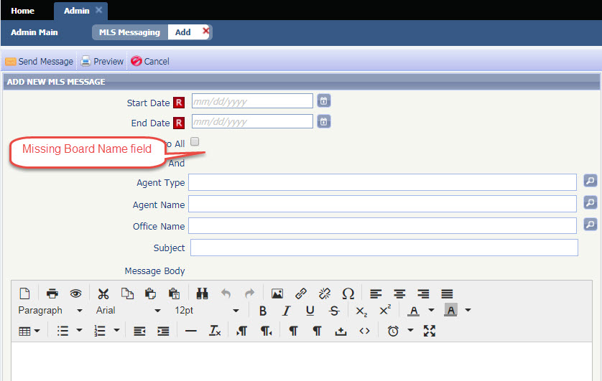

Lookup Relationships for Multi Class Searches and Market Monitor

**Action Item:** N/A

Previously users could not limit multiple lookup selections based upon a value they had assigned to a previous search field. This was especially true when the user performed a statistical report search or configured the market monitor filters. In 5.71 we have changed both of these searches to use the MLS defined lookup field relationships listing class 1 (typically the residential class). This will ensure that multiple lookup fields can be linked to one another and when performing a search the choice made in one lookup field will filter the eligible lookup values in a second field.

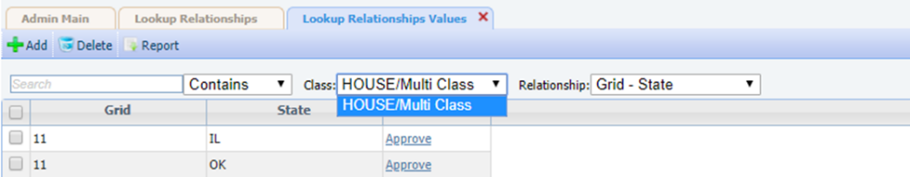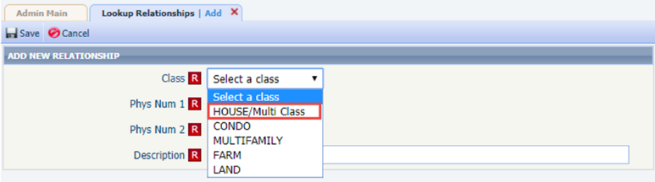

New CRS Data Integration Point

**Action Item:** N/A

Agents now have the ability to jump to the CRS Data Property Report from the Map Panel for a MLS Listing. Previously, agents would have to toggle back to a Detail or the Spreadsheet views in order to access the link. 