# Agent Level Enhancements

**The following section contains changes that are active system wide** **and available to users based on their assigned security levels.**

Quick Action Buttons Added to Quick Search Field Customization

In the last release we added some additional saving options to search to help users perform various saving functions quicker and more efficiently. In this release we’ve brought that functionality to Quick Search.

HTML 5 Notifications for Session Expiration

Paragon only displayed a warning that your session is about to expire with a minute remaining. If the user is on another browser tab, has their browser minimized, or is otherwise distracted this is easy to miss and unsaved work will be lost. To help prevent this, we are adding push notifications to Paragon.

Listing Activity Report

The listing activity report has been updated to track listing activity data for the life of the listing from 5.72 forward.

Adjustment Values for CMA Comparable Reports

The addition of the adjustment value on the Summary of Adjustments and CMA Comp Report Horizontal allows the user to see how the adjustment value was derived. This is especially useful if using calculated adjustments.

Updated Map Option Descriptions

The preference map option descriptions for custom map address and zoom level, boundary by default, and zoom to fit have been improved to offer users a better explanation of these options.

Interactive Map Layers

Interactive Map layers are here! Users can create their own shapes and save them as a layer which can then be used as part of search criteria. Interactive Map Layers are available at the Agent, Office, Board, and MLS level. **See our map layers handout for more on how to get started with this enhancement.**

# MLS Customizations and Administration

All options in this section are configurable via MLS Administration controls or by your System Support Manager as noted.

E-Mail Column added to Admin Agent and Office Maintenance Spreadsheets

A new column has been added to the Agent and Office Maintenance Spreadsheets. The email column allows admins to sort and search by email address.

Second Field Search for Lookup Relationships

When performing a Lookup Relationship search, the search will now display results found in both of the related fields.

RUG Fields Added to Paragon Database for Native DD RESO Compliance

More Room, Unit and Green fields have been added to the Paragon Database to support native Data Dictionary compliance and to have room for future growth.

Ability to Hide Feature Categories from Search and Views

This enhancement offers the ability to restrict feature categories by user type for search, listing spreadsheets and views. Each feature category will have two new sets of controls to enable searchable/viewable and consequently the ability to add restricted user codes.

Interactive Map Layers Admin

New interactive Map layers are here! Layers are available at the Agent, Office, Board, and MLS level. MLS-level layers can have shapes tied to Major Area Codes, Minor Area Codes, or Lookup values, such as Subdivision, School District, etc. Users can only create layers for their own level or below. **See our Map Layers Admin Addendum for more details.**

Start an Offer

We’ve made a number of improvements to the Start an Offer process since the 5.70 release. This feature allows clients to notify their agent that they are interested in starting the process for making an offer on a particular listing. In the 5.72 release, **Start an Offer will be enabled for all Collaboration Center users unless an MLS has an important reason not to do so initially.**

ShowingTime Agent Widget

A new agent-facing widget will be available for customers with ShowingTime site licenses. The widget will appear under the Contact Activity widget but can be repositioned on the homepage by the agent.

ShowingTime Sell-Side Activity Widget

A new client-facing ShowingTime widget will be available for consumers on the sell side of the Collaboration Center to view the Showing activity on their property.

Automated Valuations

To integrate more data analytics into Paragon, Paragon Connect, and Collaboration Center, we are introducing Automated Valuations from Black Knight, RPR, and Zillow. Automated Valuations are estimated market values based on mathematical modeling of a property’s value at a specific point in time based on comparable properties and other available data.

Paragon Connect – Lookup Relationships

The Paragon Connect search now properly filters lookup relationships. This prevents users from selecting data that will conflict and return zero results.

Paragon Connect – Associate Contact to Search

When saving a search, agents can now select any contact from Paragon or Paragon Connect to assign to the search. The same rules as saving a contact apply: Must be below X number of listings, and must follow all rules established by the MLS to save a search to a contact. The ability to associate a search with an agent already exists.

Paragon Connect – Setup CC2 Notification

Users can now enable Collaboration Center notifications via Paragon Connect. Paragon Connect uses the user’s default Paragon settings to create and send users to Collaboration Center sites. Make sure to double check your notification triggers, scheduling, and email options in Paragon to ensure they are up-to-date. Legacy email notifications will not be offered via Paragon Connect.

Paragon Connect Add/Modify Contact

We have added the ability to add/modify a contact within Paragon Connect. The add screen contains all the fields needed to create a contact. Required fields are indicated with a red block and requirements follow the same rules built into Paragon.

Paragon Connect – Home Icon

We have released a newly updated mobile home screen icon for Paragon Connect. This has fixed an error with the old icon which would result in users being logged out of the system.

# Corrected Issues

|  |  |  |  |  |
| --- | --- | --- | --- | --- |
| **Work Order** | **Seq** | **Module** | **Reporting Customer(s)** | **Issue Corrected** |
| 133423 | 1 | CMA | REB3 | Subject property photo is not resizing for the Basic presentation theme. |
| 134548 | 1 | Search - Property | REB3, NEREN | Customizing blank class search criteria, throws in Last Search criteria. |
| 139968 | 1 | Views/Reports | Sioux Empire, REB3 | Google Map report does not print after rearranging listings. |
| 145325 | 1 | Collab Center - Buy Side | Superior Area (Duluth), RANM, Willamette, MAXEBRD | Public Associated Documents do not display on Collab Center for some Customers. |
| 146324 | 1 | Search - Saved Searches | REB3 | Deleting multiple saved searches at once shows No Records selected on confirmation modal. |
| 146393 | 1 | Contact Management | IRMLS | Contact Export/Import process not working as expected. |
| 118350 | 1 | Tour/Open House | Texarkana Board of Realtors, PACMLS | Printing from Tour thumbnail view doesn’t work. Need to add verbiage like Multi-Up Printing on Listing Reports. |
| 145348 | 1 | Admin - MLS Views and Reports | Knox County | When modifying report through field preferences modal just displays "here" |
| 146334 | 1 | Input Maintenance | Lancaster, Traverse, Jackson MI, REB3, Roswell, Upper Pen | Special Characters in Photo Name Prevents Image Upload. |
| 126726 | 1 | Views/Reports | Outer Banks, RANW, Bayou | When OFFICE_LICENSE_PHYS_NUM is set, values from wrong field appear as Office License for some users. |
| 143974 | 1 | Admin - Field Setup | Spokane, SCWMLS | Price per Acre doesn't calculate correctly. |
| 146379 | 1 | Admin - Reports | Spokane Assoc. of REALTORS | Spelling Typo in LIM Agent Filter page. |
| 118801 | 1 | Email | South Central Wisconsin MLS, REB3 | MLS requests change to confusing messaging on opt-in page. |
| 145282 | 1 | General UI | REB3 | Collab Link Share Error message shows System ID rather than Display ID for MLS number. |
| 146488 | 1 | Views/Reports | Paragon 5 - All Accounts | Modify Listing Activity statistics in Seller Side CC and PC. |
| 145682 | 1 | RETS Search | REB3 | Modify RETS resource to include last 3 Sale Transactions. |

# Agent Level Changes

**The following section contains changes that are active system wide** **and available to users based on their assigned security levels.**

Quick Action Buttons Added to Quick Search Field Customization

**Action Item:** N/A

The Quick Search customization modal has been modified so that the user can apply their changes and save a search with one click. They can now choose to modify an existing search (apply/save), create a new search (apply/save as), or apply to the current form without saving (apply).

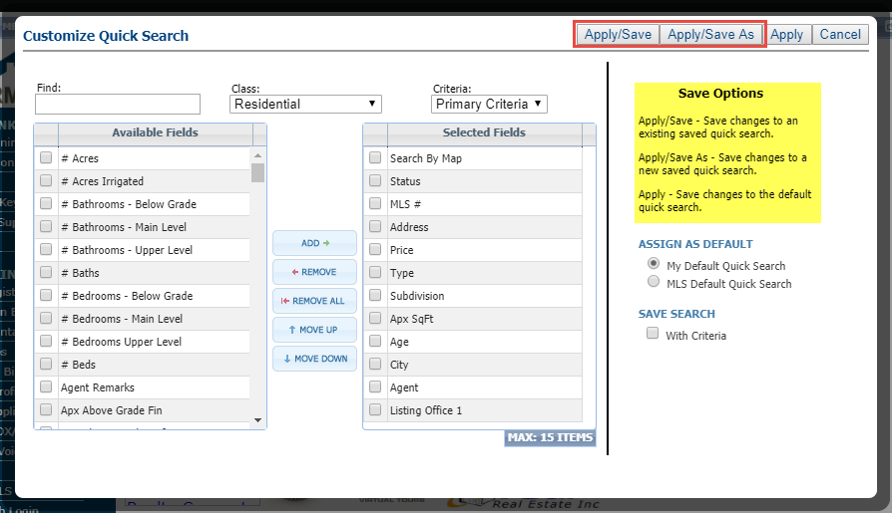

The new saving methods are now available in quick search

HTML 5 Notifications for Session Expiration

**Action Item:** Ensure membership knows they must actively allow this feature via their browser

To enable the push notifications the user must agree to allow Paragon to show notifications. These settings can be changed later in the browser settings if necessary.

* The push notifications work in the following operating systems:
  + Windows
  + MacOS
  + Android
* The push notifications work in the following browsers:
  + Edge (Classic and Chromium versions)
  + Chrome
  + Firefox

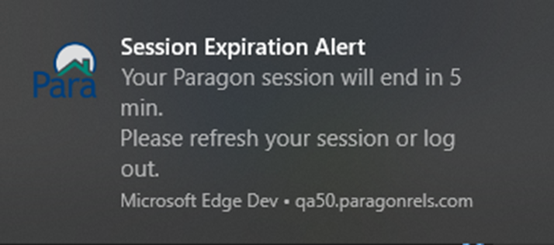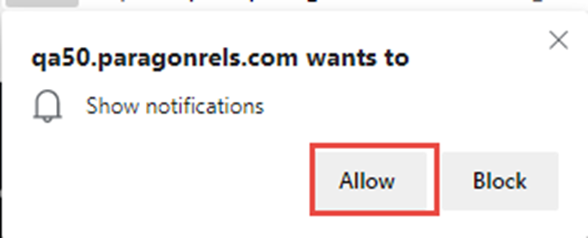

Left: Users must click to allow notifications to be sent. Right: Example of the notification appearing in the OS notification tray

Below: Additional OS notification examples

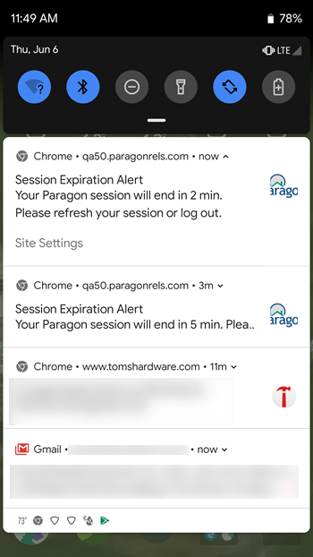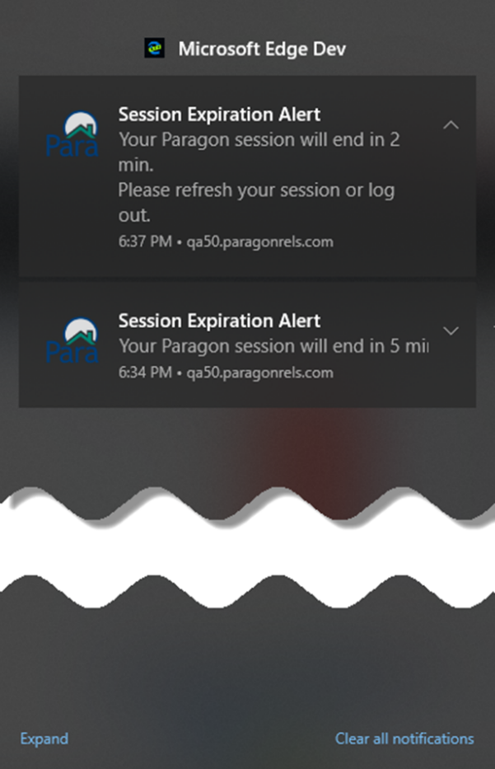

Listing Activity Report

**Action Item:** N/A

The listing activity report has been updated to track listing activity data for the life of the listing (up from the previous 120 day limit) from 5.72 forward. Previously pruned data cannot be recovered.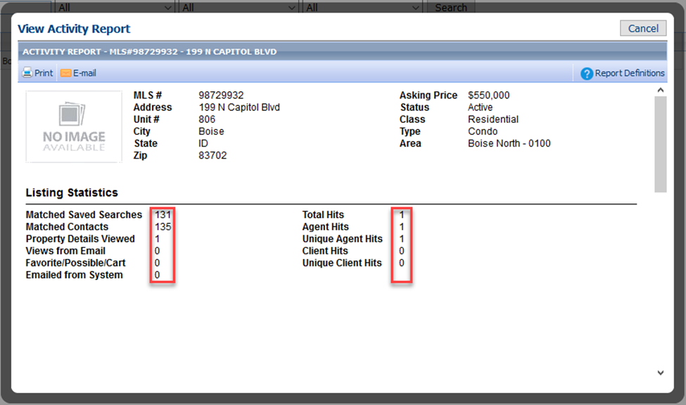

City and State Added to Address on Statistical Reporting: Sales Detail Report

**Action Item:** N/A

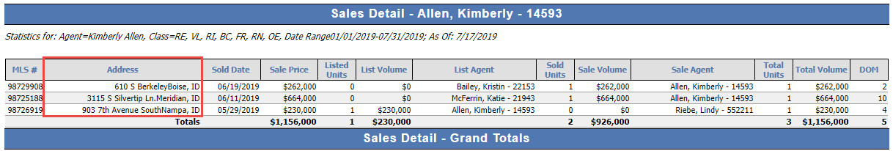City and State/Province now appears as part of the address field on the Sales Detail report.

Adjustment Values for CMA Comparable Reports

**Action Item:** N/A

The addition of the adjustment value on the Summary of Adjustments and CMA Comp Report Horizontal allows the end user to see how the adjustment value was derived. This is especially useful if using calculated adjustments.

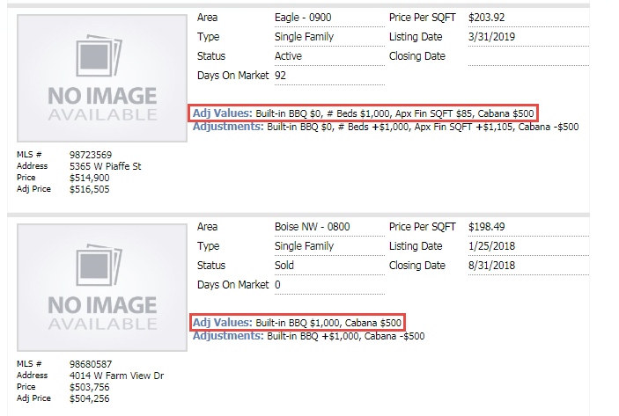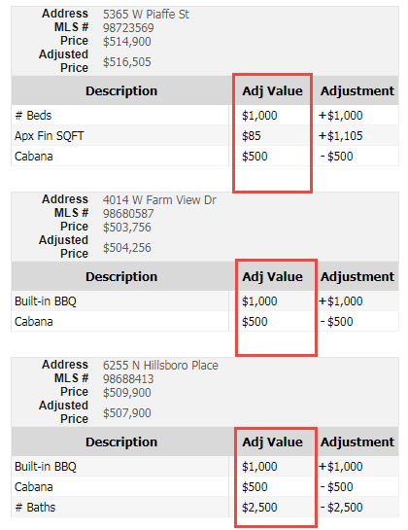Left: CMA Summary of Adjustments Report. Above: CMA Comp Report, Horizontal

Updated Map Option Descriptions

**Action Item:** N/A

Descriptive text was updated in Preferences System > Search Options for the following options:

* Custom Map Address and Zoom Level;
* 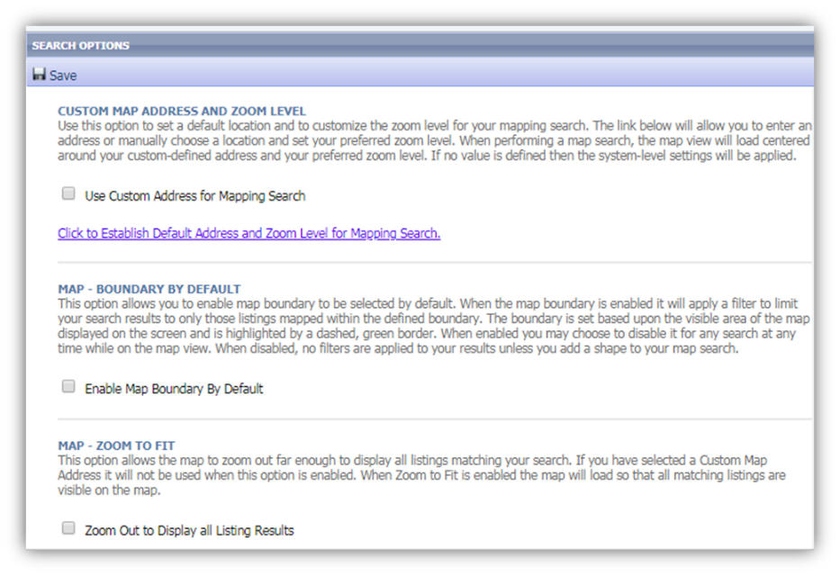Map – Boundary by Default;
* Map – Zoom to Fit.

# MLS Customizations and Administration

**All options in this section are either configurable via MLS Administration controls or by your System Support Manager as noted.**

E-Mail Column added to Admin Agent and Office Maintenance Spreadsheets

**Action Item:** N/A

By adding this column, administrators will be able to easily identify accounts if only the email address is known, identify accounts that require email verification, and find accounts that do not have assigned email addresses. This column will appear on the summary grid for both agent and office maintenance modules and can be sorted via the column header.

The email column can contain the following three values:

* Hyperlinked email address:
  + Email address has been verified (agents only)
  + The administrator can click the hyperlinked address and a compose email modal will be displayed
  + The TO field will be prepopulated with the email address that was clicked
* Verify:
  + The agent email address has not been verified
  + If the hyperlink is selected Paragon will offer to send a verification email to the agent
  + This value is not valid for the office summary grid
* Blank (NULL):
  + There is no email address included in the agent or office record

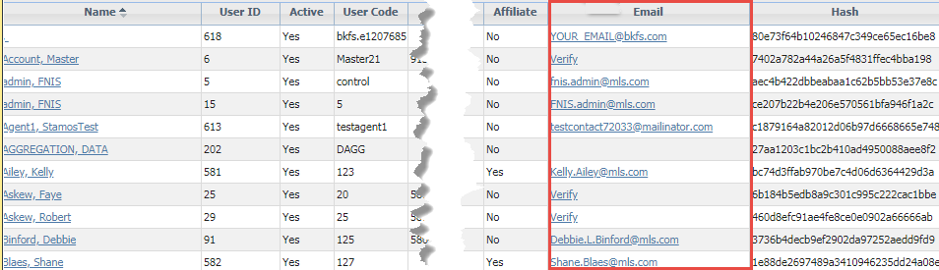

Email Column

Second Field Search for Lookup Relationships

**Action Item:** N/A

When performing a lookup relationship search, results will now include matches in both the initial field and the related field. Prior to this change, only results from the initial field would be shown.

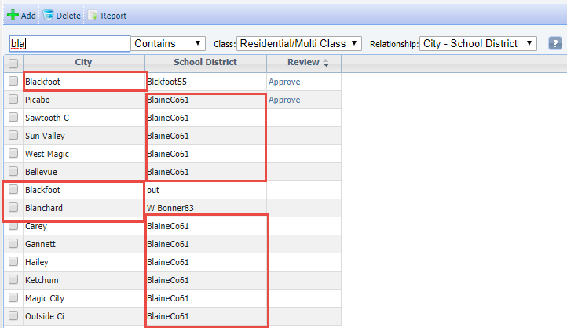

Results from both fields

RUG Fields Added to Paragon Database for Native DD RESO Compliance

**Action Item:** N/A

In order to ensure that Paragon is natively RESO Data Dictionary compliant and has room for future growth we have added multiple fields to each of the listing Room, Unit and Green Information tables. These fields may be used in Listing Input/Maintenance, searches, reports and RETS. The details of the numbers and types of fields are below.

* Green Information Fields:

|  |  |
| --- | --- |
| **Field Type** | **# of Fields** |
| Feature | 1 |
| Single ID Lookup | 5 |
| VARCHAR 50 | 5 |
| DateTime or DateTime 2 | 3 |
| INTEGER 4 (BIGINT) | 5 |
| DECIMAL | 5 |
| VARCHAR 255 | 1 |
| Totals | 25 |

* Room Table Fields

|  |  |
| --- | --- |
| **Field Type** | **# of Fields** |
| Single ID Lookup | 5 |
| VARCHAR 50 | 5 |
| DateTime or DateTime 2 | 3 |
| INTEGER 4 (BIGINT) | 5 |
| DECIMAL | 5 |
| VARCHAR 255 | 1 |
| Totals | 24 |

* Unit Table Fields

|  |  |
| --- | --- |
| **Field Type** | **# of Fields** |
| Feature | 1 |
| Single ID Lookup | 5 |
| VARCHAR 50 | 5 |
| DateTime or DateTime 2 | 3 |
| INTEGER 4 (BIGINT) | 5 |
| DECIMAL | 5 |
| VARCHAR 255 | 1 |
| Totals | 25 |

Ability to Hide Feature Categories from Search and Views

**Action Item:** Determine Feature Categories to restrict, add restricted user types to list, uncheck any categories that should not be searchable/viewable.

To restrict user types for feature categories, you first enable the searchable/viewable checkbox for the category. By default, any categories that previously existed will be enabled for searchable/viewable. This will allow the field to be searchable/viewable in search, listing spreadsheets, and views. This change will not impact visibility via RETS.

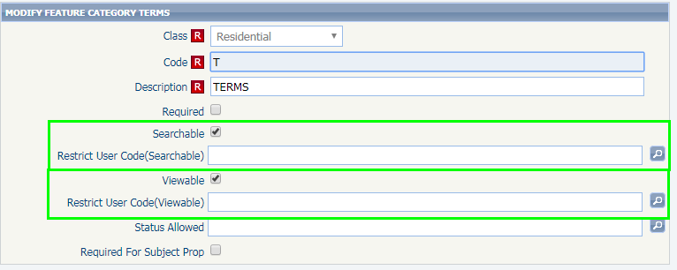

Check the box and then enter user codes to restrict access

Start an Offer

**Action Item:** N/A

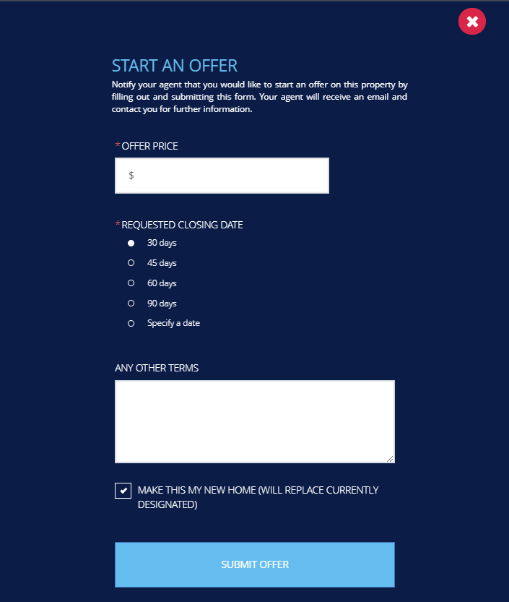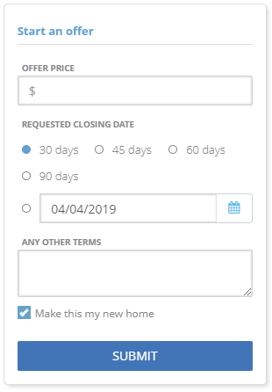We’ve made a number of improvements to the Start an Offer process since the 5.70 release. This feature allows clients to notify their agent that they are interested in a particular listing. In the 5.72 release, Start an Offer will be enabled for all users.

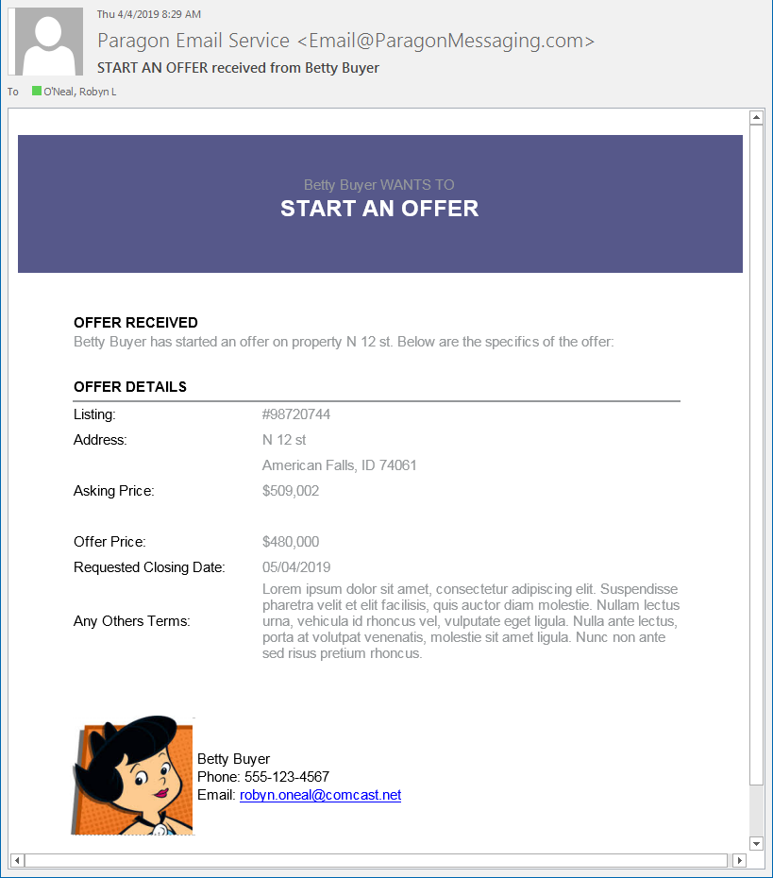

ShowingTime Agent Widget

**Action Item:** N/A (enabled automatically) for ShowingTime, site-licensed customers; non-ShowingTime customers, contact your Black Knight sales rep for additional information.

A new agent-facing widget will be available for customers with ShowingTime site licenses. The widget will appear under the Contact Activity widget but can be repositioned on the homepage by the agent. Clicking on any of the icons will launch a new browser and seamlessly log the agent into ShowingTime and land them on the specific data.

When there are new data available, a red circle will appear on the icon with a number representing the number of available changes/new data.

**NOTE:** Currently, the widget will appear to all users in the MLS. In 5.73, we will be adding User Type and Board filters to support a few customers who require those filters on the feature.

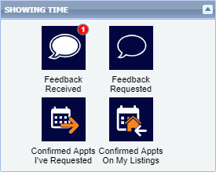

ShowingTime Widget

ShowingTime Sell-Side Activity Widget

**Action Item:** N/A (enabled automatically) for ShowingTime, site-licensed customers; non-ShowingTime customers, contact your Black Knight sales rep for additional information.

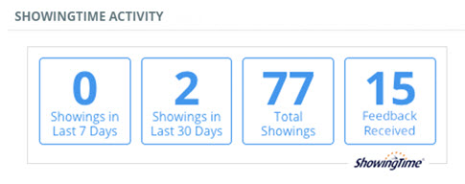This widget will appear on the activity page of the seller activity tab for consumers with the sell side of Collaboration Center enabled to view the Showing activity on their property. The data in the widget is view only for the consumer. An agent-facing option is currently being developed for a future release that will allow agents to view more information on the activity.

ShowingTime Widget for Seller

Automated Valuations

**Action Item:** Verify AVM setup

To integrate more data analytics into Paragon, Paragon Connect, and Collaboration Center, we are introducing Automated Valuations from Black Knight, RPR, and Zillow. Automated Valuations are estimated market values based on mathematical modeling of a property’s value at a specific point in time based on comparable properties and other available data. The AVMs will be available in the following three areas:

1. The Property Detail Report in Paragon Connect and Collaboration Center
2. The Map Panel for Listings and Parcels in Paragon
3. The CMA Comparable Price Analysis Report in Paragon

The AVMs can be enabled/disabled at the MLS and Board levels by Black Knight. Once they are enabled, Agents will see a new User Preference for the Collab Center called Automated Valuations. This will give agents the ability to disable the AVMs so that they do not appear in the Collaboration Center.

**NOTE:** The new data and analytics that we are adding to Paragon including AVMs are provided as a courtesy to customers that license BK Public Record Data, either through Paragon Tax and CRS. If your MLS does not use Paragon Tax or CRS then please contact your Sales Representative to discuss options for enabling these new features in your Paragon system.

**AVMs in Detail View of Collaboration Center and Paragon Connect**

When enabled, a new “Valuations” tab will appear in the Detail View. Clicking on the tab will jump the user to the section of the report.

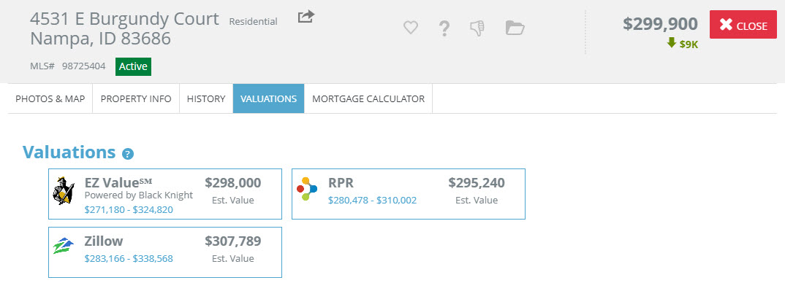

**AVM User Preference setting**

Agents can enable/disable the AVMs for the Collab Center from this new User Preference. If the MLS or Board does not have the AVMs enabled, this user preference will not appear. If the MLS or Board only enable one or two of the AVMs, only those AMS will appear in the user preference.

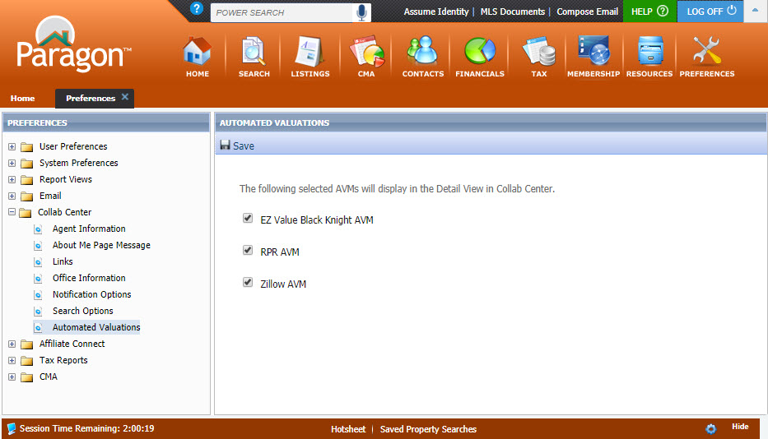

**Map Panel for Listings and Parcels**

If the MLS/Board has the AVMs enabled, they will appear in the map panels for listings and parcels in Paragon only. There is no user preference to disable these AVMs.

**Listing Map Panel Parcel Map Panel**

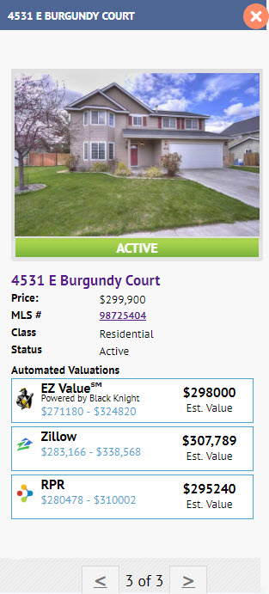 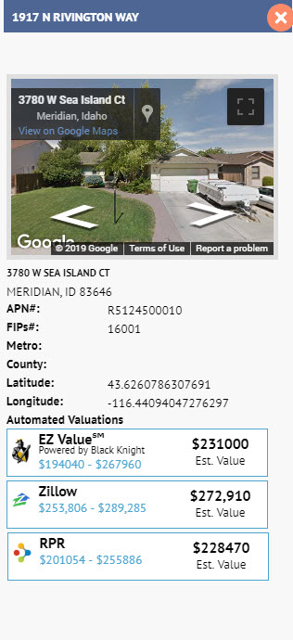

**AVMs in the CMA Comparable Price Analysis Report**

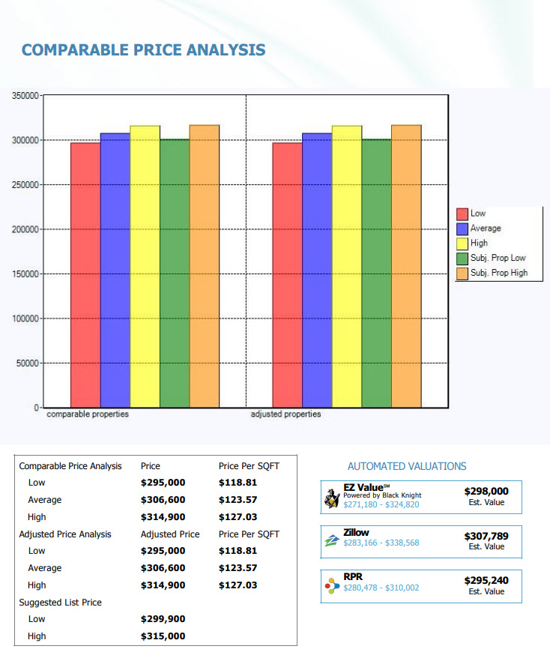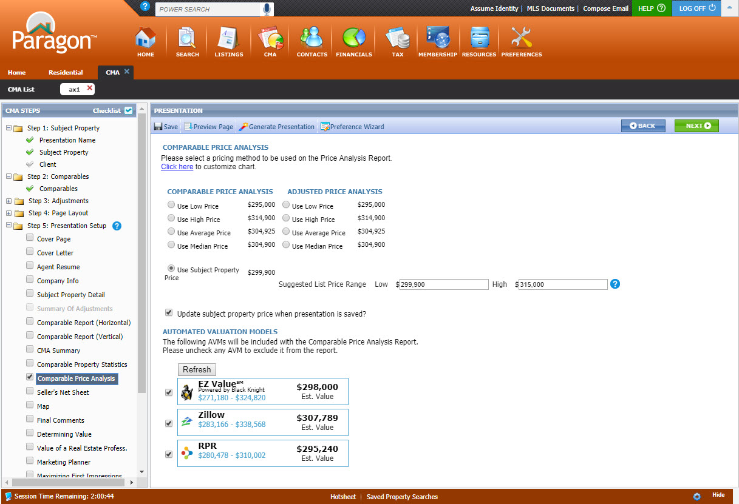Like the map panel AVMs, there is no user preference to disable/enable because the agent can do this at the report level. If the agent deselects all three AVMs, the section will not appear on the report.

Paragon Connect – Lookup Relationships/ERMS

**Action Item:** N/A

The Paragon Connect search now properly filters lookup relationships. This prevents Users from selecting data that will conflict and return zero results.

Paragon Connect – Associate Contact to Search

**Action Item:** N/A

When saving a search, agents can now select any contact from Paragon or Paragon Connect to assign to the search. The same rules as saving a contact apply: Must be below X number of listings, and must follow all rules established by the MLS to save a search to a contact. The ability to associate a search with an agent already exists.

Paragon Connect – Setup CC2 Notification

**Action Item:** N/A

You can now enable Collaboration Center notifications via Paragon Connect. Paragon Connect uses the User’s default Paragon settings to build and send Collaboration Center sites. Make sure to double check your notification triggers, scheduling, and email options on the Paragon desktop application to ensure they are up-to-date. **Legacy email notification will not be offered via Paragon Connect.**

Paragon Connect Add/Modify Contact

**Action Item:** N/A

We have added the ability to add/modify a contact within Paragon Connect. The add screen contains all the fields needed to create a contact. Required fields are indicated with a red block and requirements follow the same rules built into Paragon.

Paragon Connect – Home Icon

**Action Item:** N/A

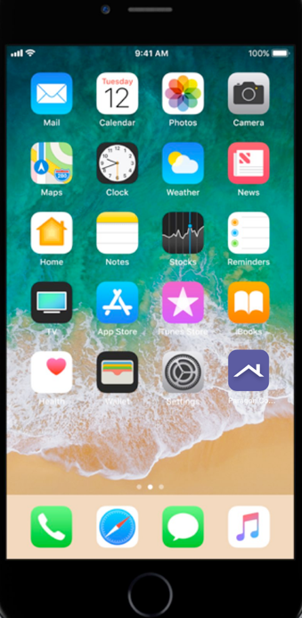We have released a newly updated, home screen icon for Paragon Connect. This has fixed an error with the old icon which would result in users being logged out of the system.

