# Agent Level Enhancements

**The following section contains changes that are active system wide** **and available to users based on their assigned security levels.**

* Option to Email Initial Search Results
* Display Favorite/Possible Listing Preview in Agent Notification Email
* Replace Google+ with Instagram for Agent Info
* Mobile Account Settings and Password Reset Messages
* Batch Download Associated Documents
* Search Results Saved to Contact - Limit Raised to 500
* New User Menu
* Enhanced Parcel-click Map Panel

# MLS Customizations and Administration

All options in this section are configurable via MLS Administration controls or by your System Support Manager as noted.

* Affiliate Connect: Added MLS Configurations
* Affiliate Connect: Branding Block Preview Added to Dashboard
* Affiliate Connect: Additional Parameters Added to Block Action for Premium Affiliates
* Add “Publish” Option to Interactive Map Layers
* Various Paragon Connect Enhancements
* Automated Valuation Models (AVMs)

Corrected Issues:

|  |  |  |  |  |
| --- | --- | --- | --- | --- |
| **Work Order** | **Seq** | **Module** | **Reporting Customer(s)** | **Issue Corrected** |
| 87953 | 3 | Email | Cape May , MiRealSource, NEREN, NORMLS | Not Able to Scroll Down in E-mail Window When Sending Listings |
| 101857 | 1 | Admin - Field Setup | Nova Scotia, Rockford | When choosing search control for a lookup/keyword field, CheckBoxList causes error in search |
| 118721 | 2 | Email | Duluth, Lewis-Clark, Memphis, NEREN, NRV, RANW, REB3, Tahoe Sierra, Triangle | Error for sending Multi-Up Reports should be updated |
| 120351 | 1 | Statistical Reporting | South Jersey Shore, San Diego, NNRMLS, Great Plains, Gainesville | Market Statistics stat report can't generate report when using map |
| 122040 | 2 | Email | MAXMLS / EBRD, Charlottesville, Birmingham, MiRealSource, NEREN, NKMLS, RE3, San Diego, Triangle | Emailing T/OH records shows blank for T/OH data fields when "All Listings" option selected |
| 123691 | 1 | CMA | Coastal Carolinas, REB3 | The CMA cover page is not accepting photo changes |
| 134548 | 1 | Search - Property | REB3, NEREN | Customizing blank class search criteria, throws in Last Search criteria |
| 141071 | 1 | Statistical Reporting | Lawrence, Intermountain, NEREN | Problem with volume ranking stats report - Include w/ Zero Volume |
| 144383 | 1 | Admin - Listings | MAXMLS / EBRD, MLS Listings | MLSL - Photos are displaying over large on emailed reports |
| 145347 | 3 | Search - Saved Searches | Superior Area, Duluth | Email saved search alert should be search specific rather than first browser click specific 27.5_ps |
| 145389 | 1 | Admin - Reports | Wichita, Bayou, Great Plains, NEREN | Support Dashboard - Call Stats not populating properly |
| 147310 | 1 | Collab Link | NNRMLS, REB3 | 404 Error on Publink |
| 142640 | 1 | Admin - Listings | Wisconsin Real Estate Exchange/SCWMLS/WIREX | Docs on Imported listing with same name not loaded |
| 139054 | 2 | Mapping | NEREN | Force Manual Geocode not occurring when converting Subject Property to full listing |
| 139165 | 1 | Admin - Listings | NEREN | State Lookup Doesn't Give Option for Null Value When Starting a New Subject Property |
| 145131 | 1 | Search - Address | NEREN | NULL Street Designation Displays in Power Search and Validate Mapping |
| 146216 | 1 | Admin - Listings | NEREN | Lookup Relationship Values (ERMS) do not behave correctly for dropdown LIM fields |
| 146744 | 1 | Input Maintenance | REB3 | LIM Modify error button functionality between browsers |
| 89502 | 5 | Member Import | NEREN | Remove Agent from Team if They Transfer to a Different Office |
| 146506 | 2 | Statistical Reporting | NEREN | Add Ability to Remove Customize Search for Stat Reports and Limit Fields in Search Criteria |
| 139701 | 1 | Views/Reports | Wichita, Butte, Columbia SC, Quad City | Advanced Mapping Not Displaying Listing Thumbnail Images |

# Agent Level Changes

**The following section contains changes that are active system wide** **and available to users based on their assigned security levels.**

Option to Email Initial Search Results

**Action Item:** N/A

When setting up Saved Search notifications, a message is displayed informing the User that to send the initial results they need to click an action link. Upon doing so, the User is sent to the search results to manually email the initial set of listings. The verbiage has been updated to inform the user that they will be sent to this location and tells them what to do, to complete the task.

Display Favorite/Possible Listing Preview in Agent Notification Email

**Action Item:** Enable Configuration

When enabled, this adds previews for listings marked as favorite or possible by their client to the agent notification email. NOTE: In some cases, this can result in a listing appearing twice in the email, for example, if it is both new and marked as favorite.

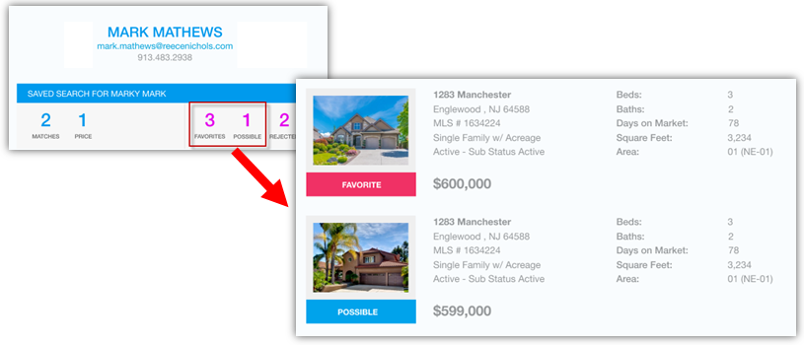

Replace Google+ with Instagram for Agent Info

**Action Item:** Enable Social Media Links if needed

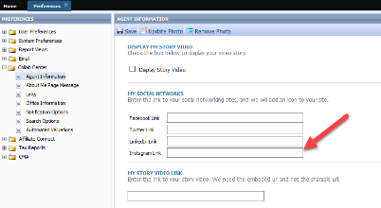Google has finally decided to put Google+ out to pasture. As such, Google+ is being replaced with Instagram as an option for Agent social media links.

Mobile Account Settings and Password Reset Messages

**Action Item:** User selects or enters their number in the Preference Setup.

While we continue to build out texting capabilities in Paragon, one of our steps is to add functionality to the Mobile Account Settings along with simplifying the setup process. From User Preferences, the user simply has to select or add their phone number to enable receiving of text messages from their System Administrator or Contacts. 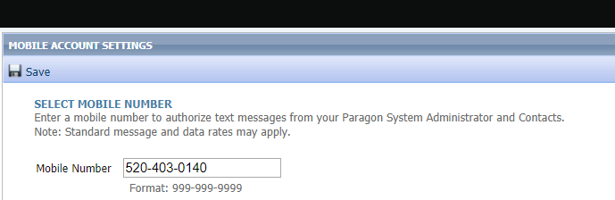

Collaboration Center: Add Text Message to Start an Offer

**Action Item:** Enable start an offer configuration setting

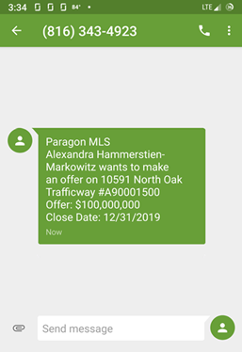If mobile text messaging is enabled, agents will receive a text message along with an email when a client completes a Start an Offer form. The text message will include the following information: Contact Name, Listing Address, MLS ID, Offer Price, and Proposed Closing Date.

Batch Download Associated Documents

**Action Item:** None

We’ve added a download option in the export menu for Associated Documents. On the screen the user can select multiple public (e-mailable) documents, then select Export > Download. The selected Associated Docs will then be downloaded as a ZIP file; where the user can complete a number of actions including print, open, or save the files from the zip.

NOTE: Only files marked Public (e-mailable) can be zipped and downloaded.

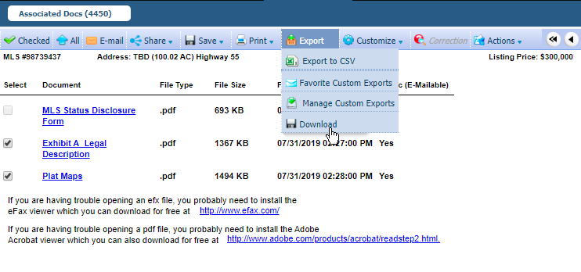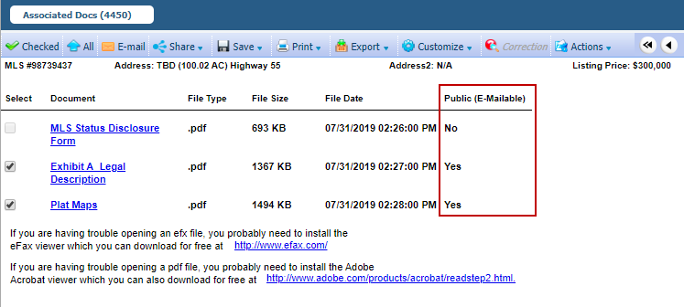

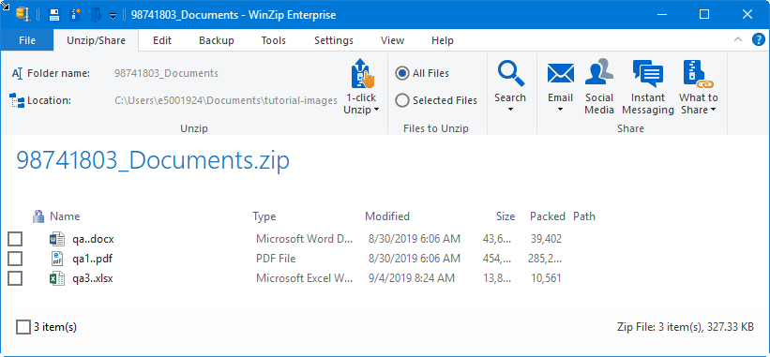

Search Results Saved to Contact - Limit Raised to 500

**Action Item:** N/A

With this enhancement, you can now have up to 500 matches for a search saved to a contact, doubling the amount of listings permitted for prospecting. This also makes the maximum number of listings available for prospecting consistent between Paragon and Paragon Connect.

New User Menu

**Action Item:** N/A

We’re rolling out a new user menu! This new menu persistently reflects the logged in or assumed user across Paragon, contains the switchers and assume identity features as well as the user code, and adds a bit more graphical flair.

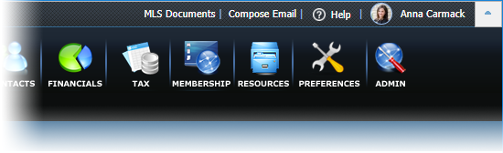

The menu displays User identifying information, User specific actions and the Log Out button.

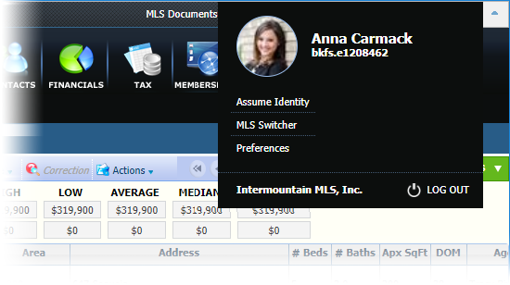

Assumed identities are denoted with an icon on the menu button and within the menu itself.



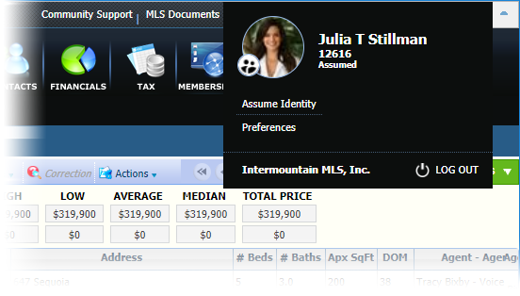

Enhanced Parcel-click Map Panel

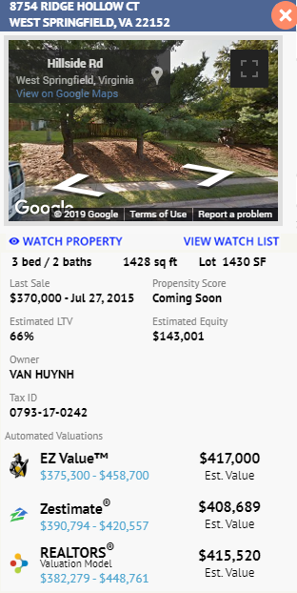**Action Item:** N/A

The Map Panel that displays upon a parcel-click has been enhanced to contain enhanced Black Knight Data information. CRS Data and Paragon Tax customers (using Black Knight Managed Data) will automatically receive this enhancement.

The following enhanced data is being added:

* Last Sale Amount & Date
* Propensity (to sell) Score (actual data coming in 5.74)
* Also coming in 5.74 will be **REO** and **Owner Occupied**
* Estimated Loan to Value (LTV)
* Estimated Equity

The following additional public record fields are also being included:

* Beds/Baths
* SqFt
* Lot Size
* Owner Name

For non CRS-Data and Paragon Tax customers who are interested in receiving the enhanced data panel, please contact your BK Sales representative for more information.

# MLS Customizations and Administration

**All options in this section are either configurable via MLS Administration controls or by your System Support Manager as noted.**

Affiliate Connect: Added MLS Configurations

**Action Item:** Select Configs on Customer Config Form

A number of new configurations have been added for the MLS to govern functionality of Affiliate Connect.

Configurations added:

* Disable agent ability to opt out of receiving subscription requests
* Disable buyer activity tab on premium dashboard
* Disable buyer activity tab on dashboard (Agent option to hide buyer information)
* Ability to set a maximum number of invitations that can be sent by a Premium Affiliate
* Ability to restrict access to Premium Affiliate Connect to specified brokers
  + Allows only agents of allowed broker office(s) to see Affiliate Connect preference and settings and Affiliates will only be able to search and connect with those agents.

Affiliate Connect: Branding Block Preview Added to Dashboard

**Action Item:** N/A

New functionality added to the Premium Affiliate Dashboard that allows the affiliate to have additional control over the content of their branding block, how their call to action functions, and additionally displays a preview while they make changes.

Affiliate Connect: Additional Parameters Added to Block Action for Premium Affiliates

**Action Item:** N/A

Premium Affiliates can now pass the Listing Price and Affiliate User Name via their branding block action. Other available options are: Agent Name, Agent Email, Contact Name, Listing ID, and Listing Address.

Add “Publish” Option to Interactive Map Layers

Action Item: N/A

This feature grants MLS, Board, and Office admins the ability to save a search layer privately while finalizing shapes, lookups, and labels. On the administrative map layers admin section, a new checkbox for Publish appears. By default all newly created layers will be unpublished by default. To publish and make visible, check the box and click save; however, once published, the layer can no longer be unpublished—this minimizes issues and disruption that could be caused to searches using a layer. NOTE: All already created layers will be set to published.

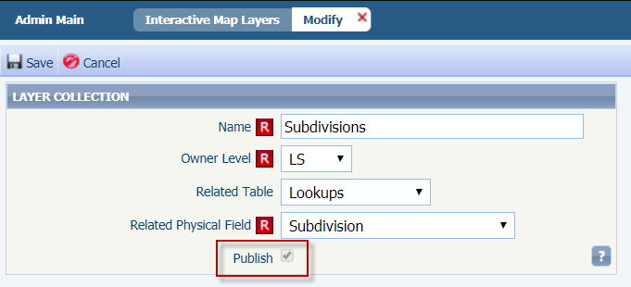

Various Paragon Connect Enhancements

**Action Item:** N/A

We’ve made a number of changes to Paragon Connect. There’s a new search workflow to help with properly locating the map when running a search, updated the UI to make it easier to understand, updated the amount of listings that appear, tweaked headers and counts, and improved loading screens.

**New Search Workflow**

A lot of new features were added to Paragon Connect in the 5.73 release. However, the most critical enhancement is the new search workflow for Paragon Connect.

**Where are the listings?**

The Paragon Connect property search was modeled after the Collaboration Center search. We took your starting location from Paragon and populated the map with listings based on this location. However, as we expanded the search to include additional fields, we now have to take into effect several fields that are location based (Areas, Cities, School Districts, etc.). These location-based fields may not be located near your starting location resulting in listings being found but not displayed on your map.

To correct this workflow, Paragon Connect will modify the current search workflow and create a new location type search.

|  |  |
| --- | --- |
|  |  |
| **Criteria Based Search**  Rather than focusing on the map and locations the user will be focused on search criteria. How many beds, baths, etc? What school district, what area, etc? The search starts on a form rather than map. This is similar to how Paragon Desktop works today. Map results will now zoom out and center on all the results to do a best fit each time a search is performed. | **Location Based Search**  This is a map centric type of search where a user will search for listings near their current location or a specified address or place on the map. The map will then act as a filter and will re-run a search each time the map is panned or zoomed. |

**Multiple Workflows**

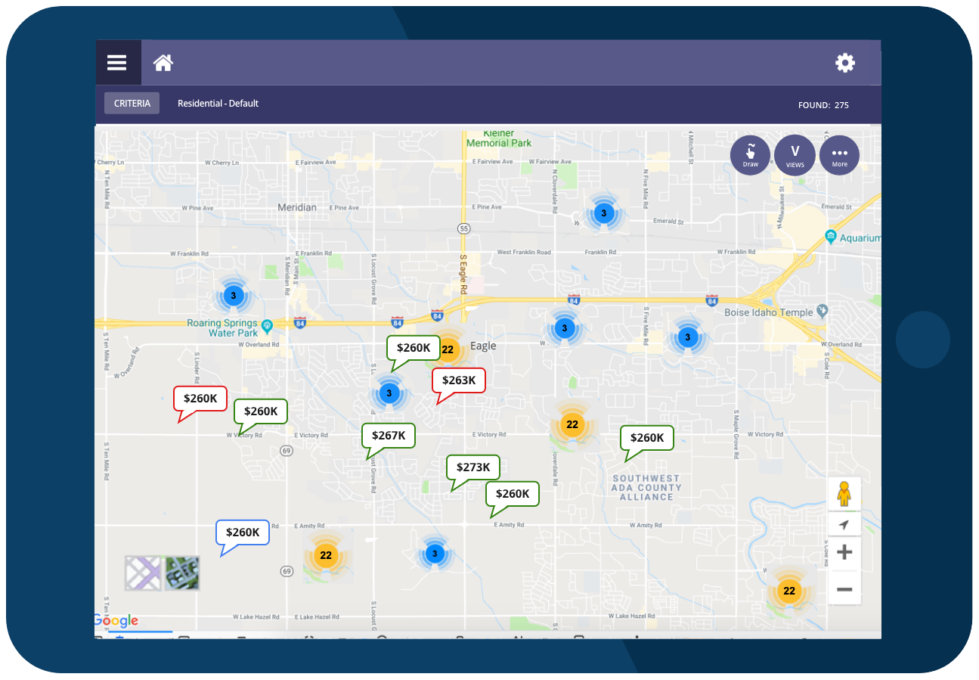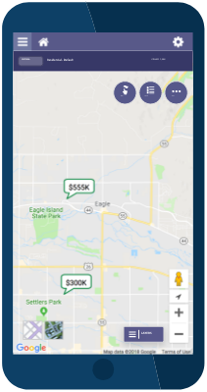

Another change you will find in Paragon Connect is the UI and workflow for property search is now the same no matter which device or resolution you are on. We have moved away from the search criteria listed at the top of the map.

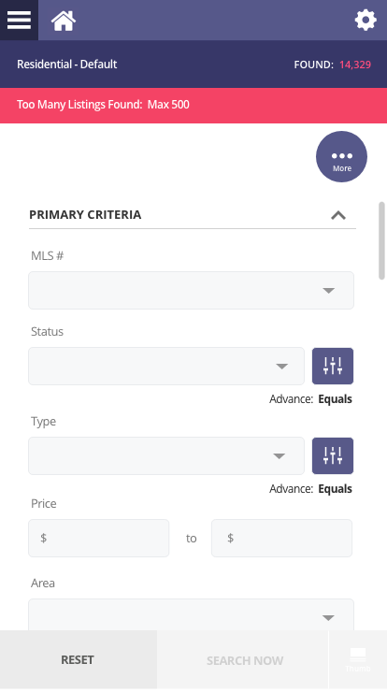

**Max of 500 Listings**

Unlike Paragon Desktop, Paragon Connect has to work well on weak Wi-Fi, data plans, and other slower connections. Therefore, when running a search in Paragon and end user must reduce the number of listings found below 500 before performing a search. The max number of pins on the map is also 500.

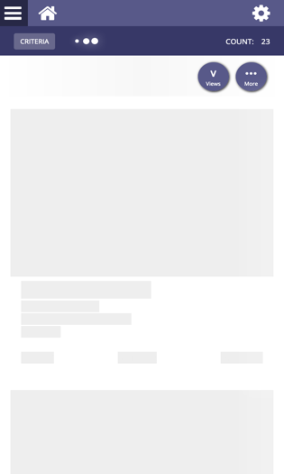

**Loading Screens**

Some other smaller enhancements made are the elimination of some of the loading splash screens. Rather than showing you a loading message on a purple modal window, we want to start painting the page. This reduces the amount of loading time.

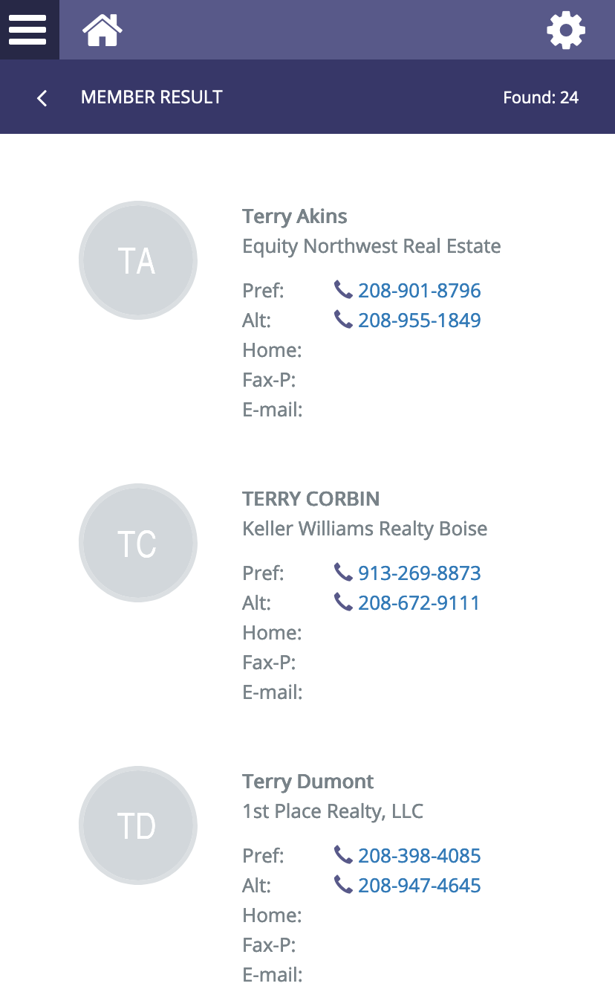

**Updated Headers and Counts**

The Hotsheet, Tour and Open House, and Membership search modules have all been updated to include a new header bar. This new header bar will contain a count now that allows you to see the results found from the search. This is helpful to get a better understanding of the results.

Automated Valuation Models (AVMs)

**Action Item: N/A**

As communicated in the separate Customer Announcement on September 25th, Black Knight is launching the AVMs to all customers and will begin appearing in the following four locations: Collab Center, User Preferences, Map Panels and CMA Comparable Price Analysis Report.

**AVMs: Valuations Tab in Collab Center Detail View**

A new Valuations tab will appear in the Detail View in CC. Clicking on the tab will jump the user to the section for viewing the AVMs. This section can be disabled at the agent level under the User Preferences for the Collab Center in Paragon. This feature will be added to the Detail View in Paragon Connect in 5.74.

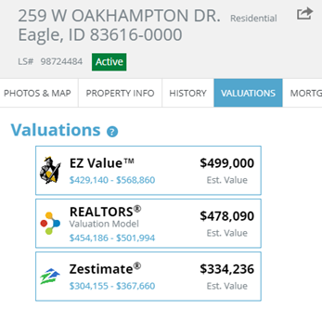

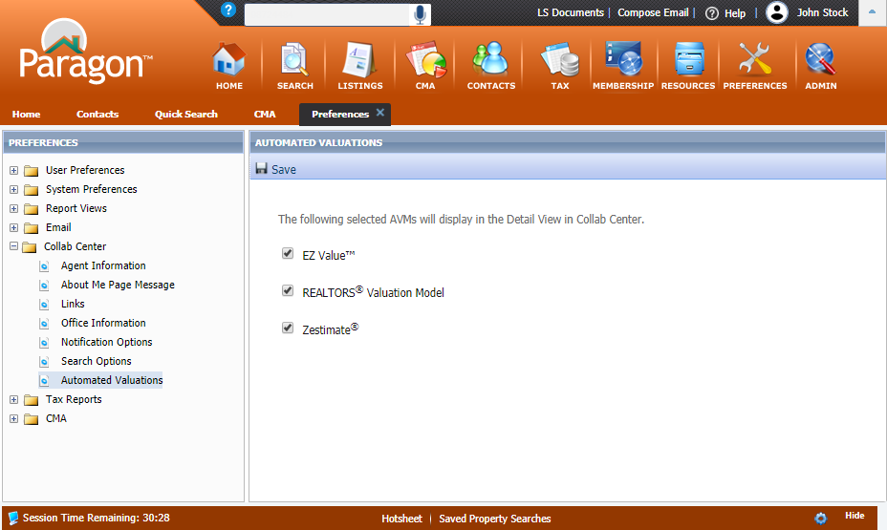

**AVMs: User Preferences**

The AVMs can be disabled by agents under the new Automated Valuations option under the Collab Center User Preference. This selection will only hide the AVMs from clients. The AVMs will continue to appear in the other agent-facing locations inside Paragon and Paragon Connect.

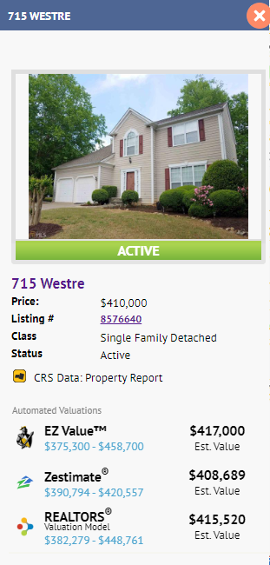

**AVMs: Map Property Panel**

When selecting a Public Record Parcel or a MLS Record on the map view in Paragon, the AVMs will display in the Property Panel. This will provide quick access to estimated valuations for properties in the neighborhood around your subject property.

**AVMs: Comparable Price Analysis Report in Paragon CMA**

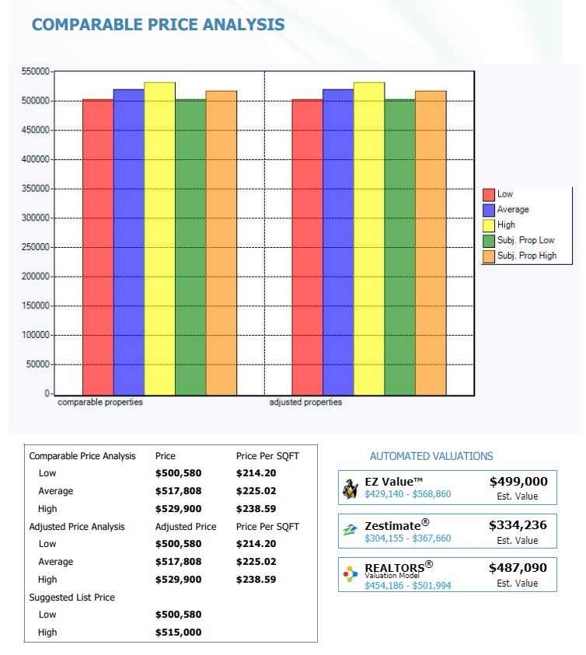The AVMs will also appear on the Comparable Price Analysis Report in the Paragon CMA. The AVMs will be selected by default, but agents can deselect the AVMs to omit them from the report. If nothing else, the AVMs will help agents determine a suggested list price or price range for the Subject Property.

