# Paragon 5.74 Release Enhancements (DEC 2019)

**Corrected Issues** 3

**Agent Level Changes** 5

Map Parcel Lines Default to On 5

Enhanced Scrollbar on Property Panel 5

Share Listings Via Text 5

Logging Text Messages 5

Opt In to Text Messaging 6

**MLS Customizations and Administration** 7

Access Compliance Report 7

Property Watch 7

Paragon Affiliate Connect: Disable Agent Request Affiliate Ability 8

PAC: SSO Integration for Clareity to Premium Dashboard 8

PAC: Ability for Agents to Share Contact(s) with Affiliate(s) 8

Collab Center Sell Side Auto Disable Based on Status 8

**Paragon Connect** 9

Membership Search Improvements 9

Clear Options 9

Fixed Header 9

Agent License ID & Broker Name and License ID 9

Add Contact While Saving 10

Combine Advanced Search Control 10

Photo Enhancements 10

Property Search Sessions 11

Performance Upgrades 11

AVMs Added 11

Area Control Updated 11

Text Listings 12

Updated Map Types 12

Multi Photo Select 13

Mini Loading Animation 13

Audit Logins for Paragon Connect 13

**Action Item Contents** 13

# Corrected Issues

|  |  |  |  |  |
| --- | --- | --- | --- | --- |
| **Work Order** | **Seq** | **Module** | **Reporting Customer(s)** | **Issue Corrected** |
| 116874 | 6 | Admin - Listings | MiRealSource | LIM Agent Filter Should Apply to All Agent Fields |
| 137317 | 4 | Login/Login Page | IRMLS | MLS staff being presented with a You are not authorized message again |
| 139686 | 1 | CMA | Greenville, Columbia SC, Heart of Kentucky, IRMLS, MiRealsource, NEREN, Northeast Iowa, Paul Bunyan, SCWMLS, REB3 | Edge version 38.14393.00 is not saving adjustments in CMA |
| 140269 | 5 | Statistical Reporting | NEREN | Sales Detail Report - Street Designation is Not Displaying with Address |
| 145454 | 1 | Seller Side Activity | REB3, NEREN | COLLAB SELL SIDE: Need to be able to auto disable the CC2 Sell side email if status goes off market. |
| 145671 | 1 | Print/Print+ | REB3 | Printing google map report in Chrome causes formatting issue when switching landscape/portrait |
| 146469 | 1 | Power Search | Triangle, REB3, NEREN. | Power Search Not Returning Correct Results |
| 147308 | 1 | Search - Hotsheet | Superior Area, NEREN, Memphis, REB3, MiRealsource | Hotsheet Count Search Wrong When User has a Default Hotsheet Search |
| 147313 | 1 | Admin - Field Setup | Buffalo, Taos, Western Kentucky | Price Per Acre now display a calculated value despite the SQFT Config set to Off |
| 147318 | 1 | Views/Reports | Central Wisconsin, Capital Region, Tallahassee, REB3, Willamette, Kingston, Traverse, Northern Ontario, Spokane, Iowa City | When scrolling through listings, reports for some listings don't load |
| 147422 | 1 | Email | South Central Wisconsin | Email Generates 404 error after clicking back to edit email |
| 147446 | 1 | Email | Sanibel & Captiva Islands | Default E-mail Signature Missing HTTPS for REALTOR Logo |
| 147521 | 1 | Admin - Listings | NEREN | All Status Date Fields Exposed When Property Type Added in LIM |
| 147689 | 1 | Print/Print+ | Western Kentucky | Print Times Out Doesn't Work When Printing All Fields Detail/Customizable from Hotsheet Results |
| 148196 | 1 | Property Search | NEREN | Detail Security on Status Doesn't Affect Status Searching in Paragon Connect |
| 147464 | 1 | Collab Center | Central Mississippi | Start an Offer emails don't appear to be sending to agent |
| 94753 | 2 | Admin - Listings | Greater Tyler, Birmingham | Sorting the E-mail Colum in Admin: Agents Doesn't Work |
| 103710 | 1 | Property History | Greater Pocatello, NEREN | Property history showing listings with statuses set with higher detail security |
| 146248 | 1 | Admin - Agent | Indiana Regional, CRIB | User Insert using MLS local time instead of UTC for InputDate, UpdateDate |
| 147236 | 1 | Input Maintenance | Spokane Assoc. of REALTORS | Features Modal doesn't show required 'R' for feature categories |
| 147830 | 1 | Third Party Integration | All Customers | Reorder AVMs in CMA Comparable Price Analysis Report |
| 107575 | 2 | Admin - Maintain | Outer Banks, Birmingham, Huntsville, Mid-Eastern Indiana, Pensacola, Triangle | Admin/Staff can’t edit and delete street lookup values. |
| 127967 | 1 | Configuration | Omaha | Customer can’t sort watermarks |

# Agent Level Changes

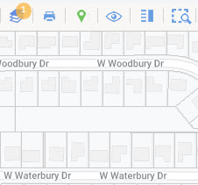**The following section contains changes that are active system wide and available to users based on their assigned security levels.**

## Map Parcel Lines Default to On

### Action Item: N/A

We’ve updated the mechanics behind map parcels. As such, we’ve set the map layer for parcel lines to appear by default. No more having to click multiple times to get them to appear. Once you reach the appropriate zoom level on the map, parcel lines will display automatically and you will be able to interact with the parcels. Note: Parcel labels will not be enabled by default.

## Enhanced Scrollbar on Property Panel

### Action Item: N/A

As more data is being added to the Parcel and Listing property panels, we have changed the scroll bar to allow for the entire panel to scroll. This will make it easier to access the data, especially at lower screen resolutions or on smaller devices.

## Share Listings Via Text

### Action Item: Enabled by default (Search Results, Listing Input and Maintenance Quick Actions, LIM Form Menu), please contact your SSM if you require this functionality to be disabled

This enhancement enables Agents to share listings via Text Message. The outgoing text message includes the Agent’s name and mobile number along with a CollabLink hyperlink to view the listings. Note: Users must complete the Mobile Account Settings in Preferences in order to send text messages from Paragon.

## Logging Text Messages

### Action Item: N/A

The existing Sent Email and Email History logs have been updated to include sent text messages. The type column displays whether the message was manual or auto. Hovering over the contact name will reveal the associated phone number. Note: Text messages follow the same retention policy as emails.

## Opt In to Text Messaging

### Action Item: N/A

This enhancement allows agents to send an opt in email to a contact who may have accidentally opted out of receiving text messages. In order to opt in a contact, the agent will need to visit the contact record where an Opt In link will be displayed next to the contact phone numbers that have opted out. The contact will receive an email with a link to the Text Message Opt In screen, where they will need to enter the phone number to opt in. Upon doing so, they will receive a confirmation text. Note: a phone number can only be opted in once every 30 days. A message will display if the phone number cannot be opted in.

# MLS Customizations and Administration

**All options in this section are either configurable via MLS Administration controls or by your System Support Manager as noted.**

## Access Compliance Report

### Action Item: N/A

We’ve added a new report to help our customers enforce access compliance policies. This report is similar to the Audit Login report. The report will also automatically flag potential violations; however, this is only meant to help highlight suspicious activity. Note: The report is applicable to customers who manage passwords and access in Paragon. Customers who use 3rd party password and access applications will need to use those applications to determine compliance to access policies. See the Access Compliance Guide for additional instructions.

## Property Watch (Not on at release: Delayed for Testing)

### Property Watch PanelAction Item: Property Watch is available to current CRS Data and Paragon Tax customers and can be made available to other customers for minimal costs. Please contact your Black Knight sales representative for more information.

Property Watch is a new feature that allows agents to select a parcel on the map in Paragon and sign up to receive email notifications if the property goes to foreclosure, has a value change, delinquent taxes, or even gets listed on the MLS by another agent.

By clicking the “Watch Property” control in the parcel property panel, agents will automatically be registered to receive email alerts when any of the following public record changes occur:

* Foreclosure Alert
* 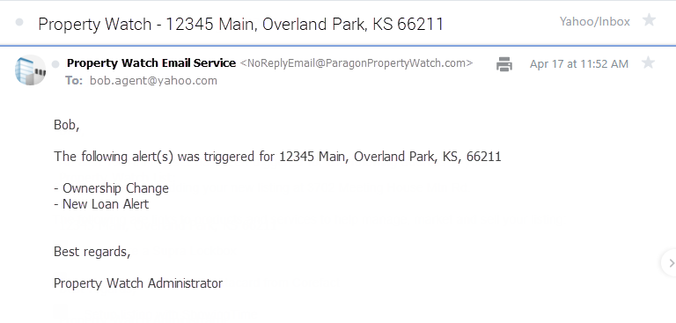ARM Reset
* Ownership Change
* Tax Delinquency Alert
* Valuation Change
* New Loan Alert
* Listed on MLS

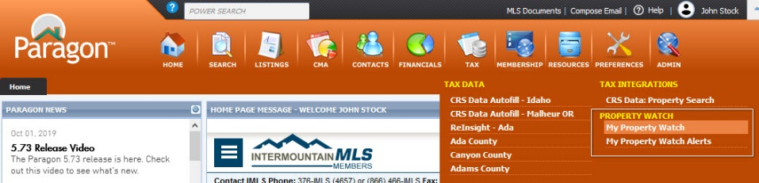Property Watch options have been added under the TAX menu so that users can quickly access and manage their Watches and Alerts. Clicking on either option will launch a new Paragon tab to display the data.

## Paragon Affiliate Connect: Disable Agent Request Affiliate Ability

### Action Item: Set Configuration to off

For MLSs who wish to disable the ability of agents to request affiliates we have added a configuration that will disable this functionality.

## PAC: SSO Integration for Clareity to Premium Dashboard

### Action Item: N/A

For MLSs who use Clareity, Premium Affiliate users will be able to use the SSO ability to go directly to the PAC Premium Dashboard

## PAC: Ability for Agents to Share Contact(s) with Affiliate(s)

### Action Item: N/A

Using the contacts module, an agent can now select one or more contacts and use the share option to select any connected affiliates they wish to share with. This will generate an email to the affiliate(s) that includes the contact(s) information. 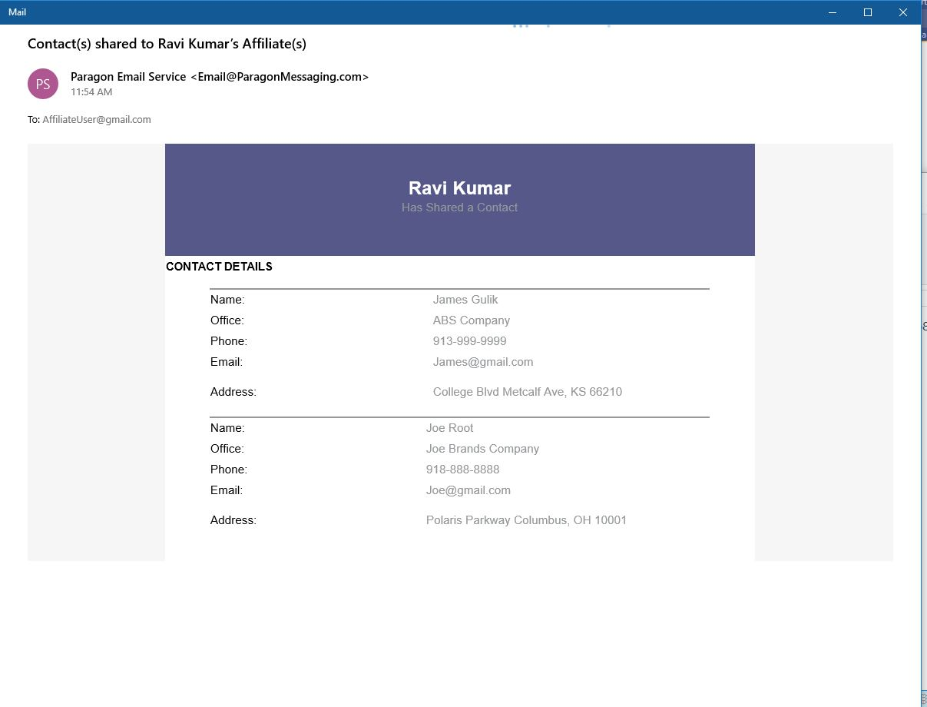

## Collab Center Sell Side Auto Disable Based on Status

### Action Item: Enable and provide selected trigger statuses

This MLS level option allows for the CC’s Seller Side Site and Email notices to be disabled when a contact’s Seller Listing status changes to any of the configured off-market statuses.

# Paragon Connect

**Due to the number of enhancements for Paragon Connect in this release, we’ve split them off into a separate section for ease of navigation and organization.**

## Membership Search Improvements

### Action Item: N/A

The membership module has been updated and tweaked to improve speed and performance. Search now defaults to “contains” for additional searching capabilities. When running agent search, the button label now reads “Agent Type” to mirror Paragon. And, you can now search for license ID or Broker License.

## Clear Options

### Action Item: N/A

You can now clear all or remove individual agent types from your member search screen.

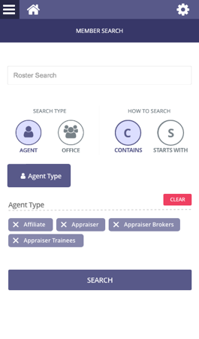

Your selections can be removed from the main screen one at a time



You can now quickly clear all of your agent type selections

## Fixed Header

### Action Item: N/A

The agent type modal now has a fixed header that contains a search bar. The search allows you to quickly find the agent type you want for your membership search.

## Agent License ID & Broker Name and License ID

### Action Item: N/A

The agent license ID is now displayed with the membership results. Also, if your system is configured to show broker information as part of office results, the Broker name and Broker ID will be appended to the bottom of the office results.

## Add Contact While Saving

### Action Item: N/A

The save a search to contact workflow has been enhanced to include the ability to add a new contact. There are now two buttons, one to select a contact and another to add contact.

## Combine Advanced Search Control

### Action Item: N/A

Currently, the workflow for refining your search results is split into two separate access points and can be confusing to users. Both lookup controls and advanced search features will now be accessed by pressing the same icon and then displayed via separate tabs.

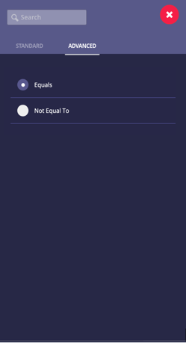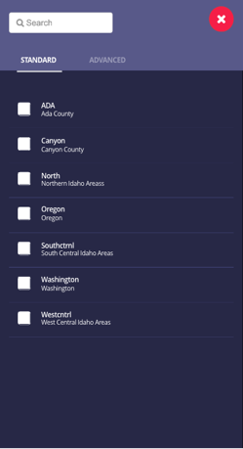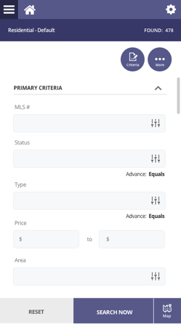

## Photo Enhancements

### Action Item: N/A

Already you can snap and upload photos from your mobile device and crop, flip, rotate, and add labels. In 5.74 we’re adding the ability to change brightness, tweak sharpness, add shapes or icons, add text, and highlight specific areas of a photo.

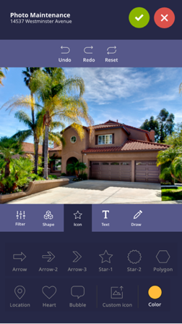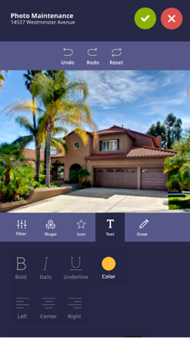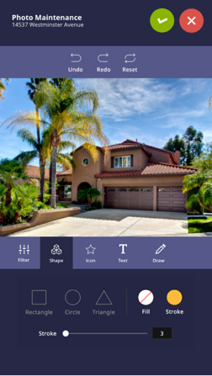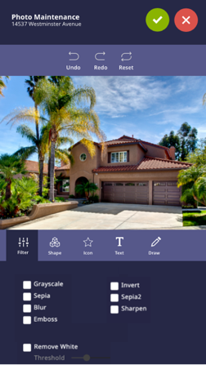

## Property Search Sessions

### Action Item: N/A

Have you run a search, gone to something else, then come back to your class-based search just to rerun your original search? We’ve enhanced the system to remember your last-run search. Now, when you run a search, go elsewhere, then return, you won’t need to re-input your search criteria. Note: this will only remember your last run criteria and revert back to default upon logout.

## Performance Upgrades

### Action Item: N/A

More work has been done to increase performance. Logins and search form loading have been improved.

## AVMs Added

### Action Item: Enable AVMs if disabled

AVMs can now be displayed for listing when using Paragon Connect. This feature uses the same settings as Paragon.

## Area Control Updated

### Action Item: N/A

In order to accommodate and expand the ability to use area search, we’ve introduced the ability to use primary and major areas via dropdown to narrow down which minor areas are displayed.

## Text Listings

### Action Item: N/A

On mobile devices, you can now text one or more listings to any contact or prospect via your mobile device’s text messaging solution. To use, select the listing(s) then click the text messaging icon. This will open your mobile device’s texting app and allow you to send the link to whomever you want. The link will take the individual to their Collaboration Center Link site.

Note: only available for mobile devices

## Updated Map Types

### Action Item: N/A

We’ve added three new map views to Paragon Connect. Alongside the already available road and aerial views, you can now use the retro, silver, and night view.

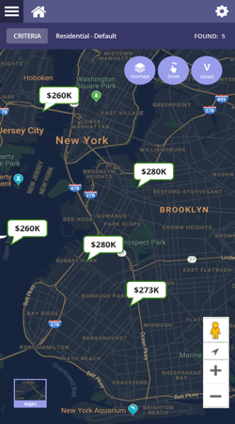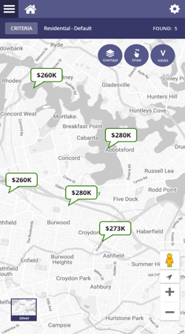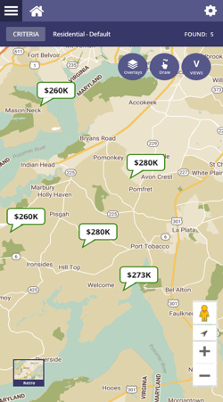

## Multi Photo Select

### Action Item: N/A

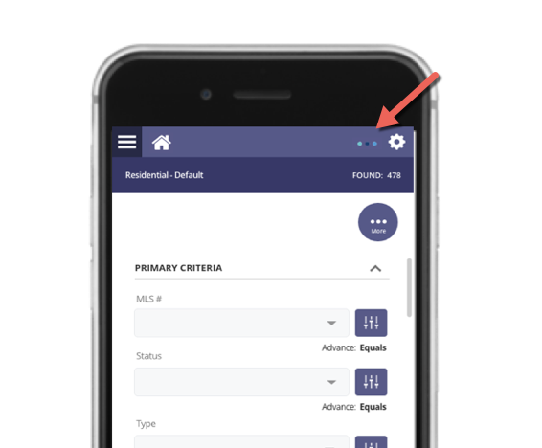The ability to select multiple photos at once has been added. Unlike Paragon, in Connect, photos will automatically reorder when photos are deleted.

## Mini Loading Animation

### Action Item: N/A

There’s a new mini loading animation in the header to show any background applications loading. This does not disrupt the page you are currently working on.

## Audit Logins for Paragon Connect

### Action Item: N/A

Some information on who is logging into Paragon Connect can now be tracked. This is a first step into tracking data in Paragon Connect

# Action Item Contents

**Agent Level Changes** 5

Share Listings Via Text 5

Action Item: Enabled by default (Search Results, Listing Input and Maintenance Quick Actions, LIM Form Menu), please contact your SSM if you require this functionality to be disabled 5

**MLS Customizations and Administration** 7

Property Watch 7

Action Item: Property Watch is available to current CRS Data and Paragon Tax customers and can be made available to other customers for minimal costs. Please contact your Black Knight sales representative for more information. 7

Paragon Affiliate Connect: Disable Agent Request Affiliate Ability 8

Action Item: Set Configuration to off 8

Collab Center Sell Side Auto Disable Based on Status 8

Action Item: Enable and provide selected trigger statuses 8

**Paragon Connect** 9

AVMs Added 11

Action Item: Enable AVMs if disabled 11