# Paragon 5.75 Release Enhancements (FEB 2020)

**Corrected Issues** 2

**Agent Level Changes** 4

Select All Associated Documents 4

Recurring Open Houses and Tours 4

Input Maintenance Errors Table Enhancements 4

Email CollabLink 5

New Date Picker Control 5

Simplified Save Search and Listing Cart 6

Tree Enhancements 6

Tooltip for Public Associated Documents 6

Listing Office Check when Converting a Subject Property 6

Link to BK Privacy Policy 6

Default Phone Type for Share Via Text and Adding Contact 7

**MLS Customizations and Administration** 8

Better Wording for Password Reset Email 8

Autofill from MLS Map Layer Lookups 8

Property Watch 9

My Property Watch & Alerts 11

New CRS Data Integration Point 11

Enhanced Data to Parcel Panel for Premium Tax Users 12

Homebot UI Update 12

Affiliate Connect: Notifications for Sold Listings 12

Affiliate Connect: Additional Contact Information Available in Branding Block 13

Allow Agent to Add Comments When Sharing Contacts & Affiliates 13

Collaboration Center: School and Neighborhood Reports 13

**Paragon Connect** 14

Paragon Connect Workflow Improvements 14

**Action Item Contents** 18

# Corrected Issues

|  |  |  |  |  |
| --- | --- | --- | --- | --- |
| **Work Order** | **Seq** | **Module** | **Reporting Customer(s)** | **Issue Corrected** |
| 61785 | 2 | Tour/Open House | Willamette, Central Penn, Birmingham, Huntsville, NEREN, Nova Scotia, Rockford, San Diego | Open houses hangs while saving cc enhancement 3-19, community, neren |
| 118328 | 5 | General UI | New England Real Estate Network (NEREN) | Street Type Selection Modal Has Inconsistent Labeling in Input |
| 143971 | 1 | Contact Activity | Intermountain, IRMLS, Hudson, REB, Tallahassee | Importing Contacts not importing Email Address-Error about invalid address |
| 144317 | 1 | CMA | Intermountain, NEREN, Willamette | CMA - Comparable Report (Horizontal) Error |
| 148678 | 1 | Admin - System Setup Options | Spokane Assoc. of REALTORS | problems with field setting in admin |
| 149223 | 1 | Affiliate Connect - Paragon | New England Real Estate Network (NEREN) | Share Contacts Functionality is Displaying in View Manage Contacts when PAC Config is Off |
| 120075 | 1 | HomePage Message | Indiana Regional Multiple Listing Service (IRMLS) | Enhancement request for more specific warning dialogue when deleting home page message |
| 122224 | 1 | Views/Reports | REB | Clicking 'Selected' checkbox from a listing quick view does not select the listing |
| 146119 | 1 | Collab Center | Baton Rouge | Modal window doesn't appear when clicking Agent Recommended link under COLLAB CENTER header |
| 147800 | 1 | Collab Center - Buy Side | New England Real Estate Network (NEREN) | New Comment Icon Link Remains if Listing is No Longer a Match in Collab Center |
| 148636 | 1 | Admin - MLS Views and Reports | All | Collab Center Views functionality is fully deprecated and should be removed from Admin UI |
| 149324 | 1 | Paragon Connect - Reports |  | LARGER CHECKBOXES: Need larger checkboxes on listing thumb and and grid views... |

# Agent Level Changes

**The following section contains changes that are active system wide and available to users based on their assigned security levels.**

## Select All Associated Documents

### Action Item: N/A

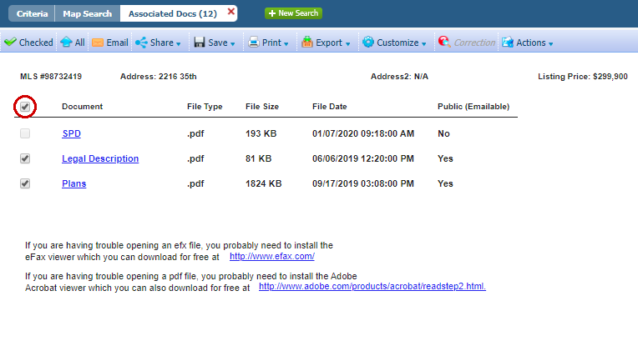The first in a number of quality of life upgrades in this release. We’ve added a checkbox for associated documents allowing you to select all that are Public.

## Recurring Open Houses and Tours

### Action Item: N/A

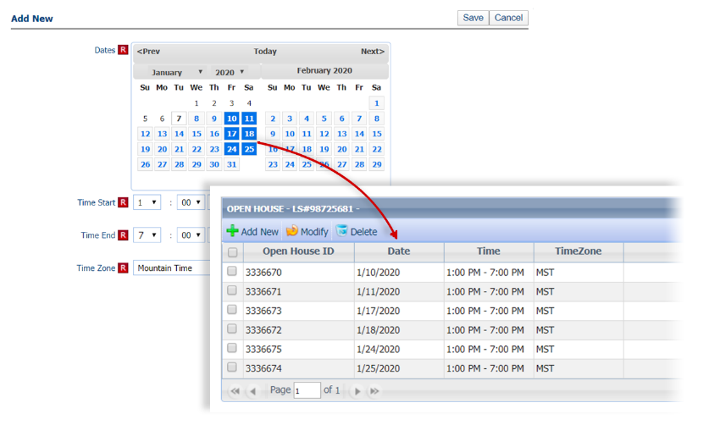With various enhancements along with new calendar controls for Open Houses and Tours, users can now select multiple dates to efficiently create recurring instances.

## Input Maintenance Errors Table Enhancements

### Action Item: N/A

We’ve made a number of usability and workflow improvements to help you move through and correct errors in the Input Maintenance Table.

* Resizable pane above the form
* New icons indicate condition type
* Persistent highlighting on the form
* Errors and warnings totals
* Added navigation buttons for moving through the errors (F8 still works too)
* Simplified column data by combining condition type and acceptance columns

## Email CollabLink

### Action Item: N/A

The new CollabLink email type allows users to send the CollabLink report. This report is designed to be responsive and accessible across all device sizes.

## New Date Picker Control

### Action Item: N/A

The Paragon date picker has been upgraded, which will make navigating calendars and selecting dates easier.

## Simplified Save Search and Listing Cart

### Action Item: N/A

The designs for Save Search and Listing Carts dialog boxes have been upgraded with better controls, straightforward wording, and consistent design. This will help usability by making workflows and instructions similar across Paragon.

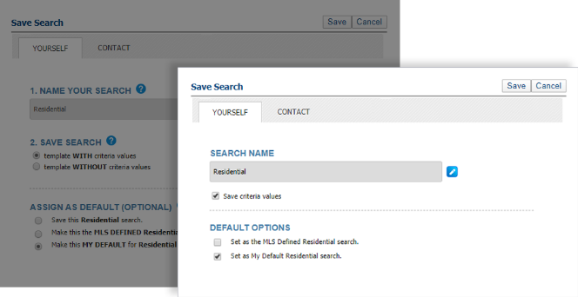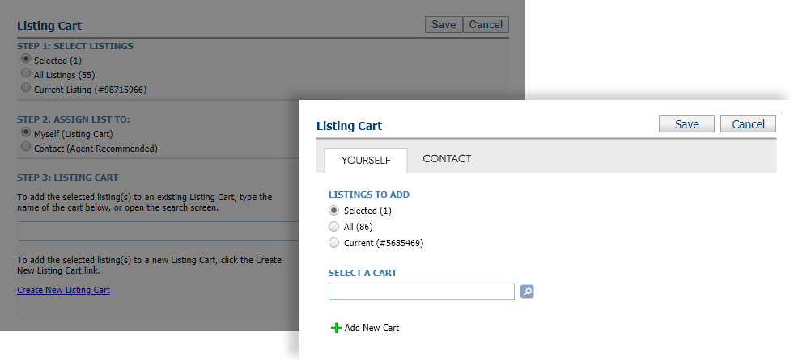

## Tree Enhancements

### Action Item: N/A

We’ve made a number of usability enhancements to the menu (tree view) while also maintaining legacy functionality.

* Made it easier to click
* Removed unnecessary UI elements
* Promoted single items to be top level and no longer requiring a dropdown
* More intuitive method for managing favorites in Views/Reviews

## Tooltip for Public Associated Documents

### Action Item: N/A

A new tooltip has been added to the Add New Documents screen that explains “Public” must be checked in order for the document to be emailed from Paragon.

## Listing Office Check when Converting a Subject Property

### Action Item: N/A

When converting a Subject Property to a listing using CMA> Maintain Subject Property, the system will check that the Listing Agents is in the Listing Office for the selected property. If not, an error is returned and the user must select the correct office to clear the error and save. This ensures that if an agent changes offices after creating a Subject Property, the newly saved listing will be assigned to the correct office.

## Link to BK Privacy Policy

### Action Item: N/A

A link for the BK Privacy policy has been added to the Quick Action bar at the bottom of Paragon. This link cannot be removed when customizing the bar.

## Default Phone Type for Share Via Text and Adding Contact

### Action Item: N/A

When adding a new contact from the Share via Text modal, the phone type will now default to Personal Cellular.

# MLS Customizations and Administration

**All options in this section are either configurable via MLS Administration controls or by your System Support Manager as noted.**

## Better Wording for Password Reset Email

### Action Item: N/A

For those who allow password resets through Paragon, the subject line of the email sent to the user has been modified to specifically state the request comes from Paragon. This will make it easier for the user to identify and less likely to be filtered out by automated junk email filters.

## Autofill from MLS Map Layer Lookups

### Action Item: MLS-level map layers using Minor Area Codes or Lookups must be created for this functionality.

This enhancement uses the MLS-Level Interactive Map Layers and uses the geocode when using Listing Input and Change Geocode to autofill lookup location fields. When a listing is saved, Paragon determines the geocode, compares it to the interactive map layers with lookups, and autofills data where needed.

* If map layer data matches already provided listing data: no changes are made
* If blank or data doesn’t match: field is autofilled with the map layer lookup value and a warning notification is generated.

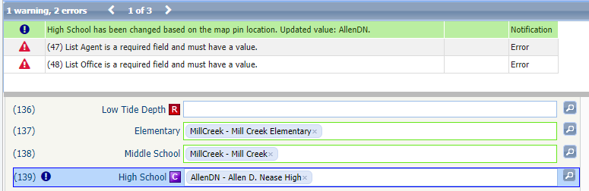

Note: Map Layers are created in Admin > System Setup > Interactive Map Layers

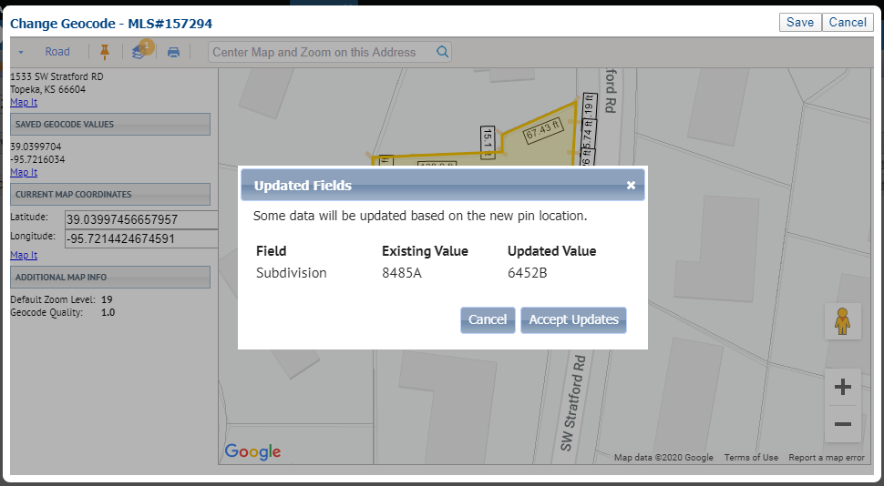

## Property Watch

### Action Item: Available for Customers who have Paragon Tax or CRS Data. Also available to others for a monthly fee. Contact Black Knight sales rep for more information

We are excited to announce the release of Property Watch, a new Premium Tax offering.

Property Watch gives agents the ability to select a parcel from the map and add it to a watchlist and to be notified when any of the following occurs on the public record: Foreclosures, ARM Reset, Ownership Change, Tax Delinquency, Valuation Change, New Loan or even when it’s Listed on MLS by another agent.

After a Property Watch has been added, the agent is automatically set up to receive simple, textual email alerts when something has changed on the public record. After receiving the email alert, the agent can log into Paragon to view the Alerts from a new option under the Tax Menu

Property Watch can also be used like a “favorites” for public records, giving agents a way to quickly access a public record within Paragon.

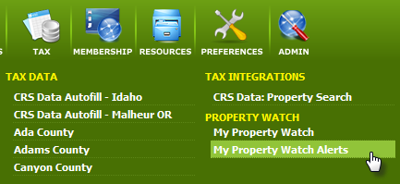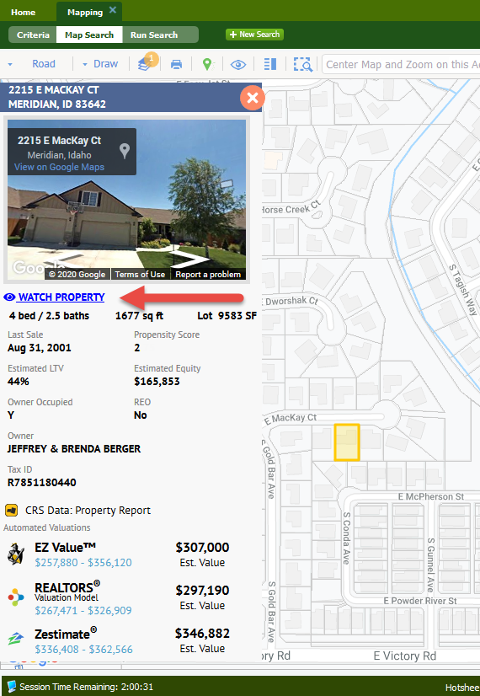Property watches can be added from the Parcel Property Panel in the Map Search or Google Map View.

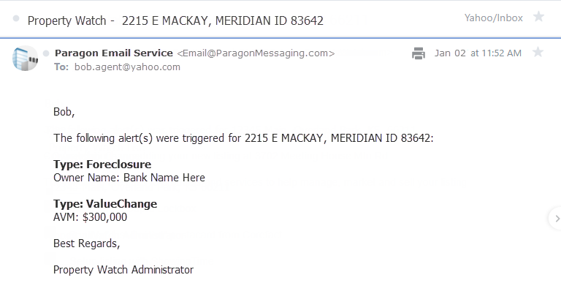

## My Property Watch & Alerts

### Action Item: N/A

We’ve added a new grid view that displays information about a property that also includes the property panel from the Map View. Highlighting any of the rows updates the property panel for quick access to the enhanced data.

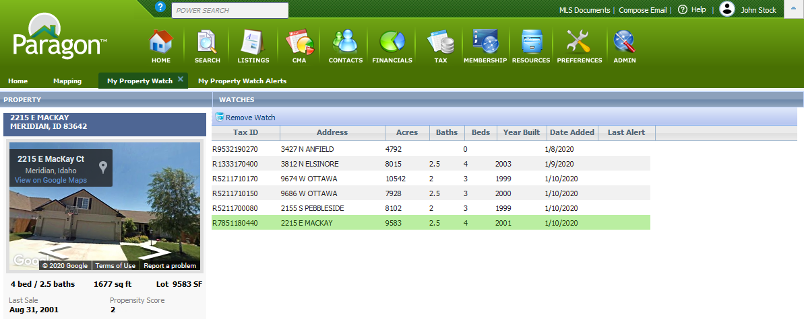

Alerts use a similar display to the property watch grid view.

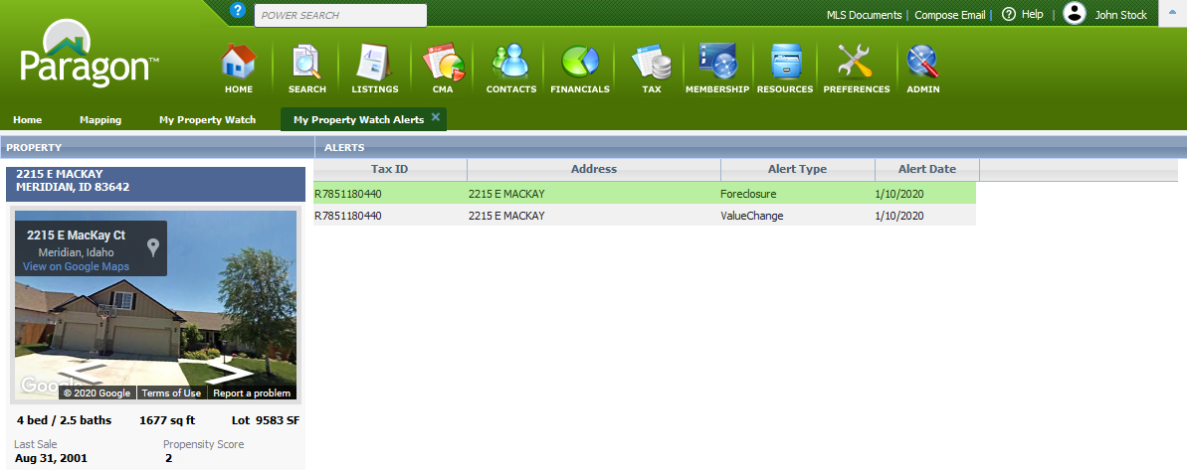

## New CRS Data Integration Point

### Action Item: N/A

In 5.72 we added a link to the CRS Data Property Report from the property panel that displays for listings. We’ve now added the integration point to the parcel property panel.

## Enhanced Data to Parcel Panel for Premium Tax Users

### cid:image001.png@01D5E71C.CB591090Action Item: Requires Premium Tax Data Agreement. Contact Black Knight Sales Rep for additional information

We’ve added three new data sets to the parcel panel: Propensity to List Score, Owner Occupied, and REO Data.

**Propensity to List:** Propensity to List has been added to the parcel property panel for Premium Tax users. The feature uses a proprietary algorithm that considers a variety of data to include Sales History, Loan to Value Ratio, Estimated Equity, Owner Occupied, Foreclosure Activity and Neighborhood Trends and assigns one of the following scores that reflects the probability that a property will be listed for sale: Low, Medium, High, Very High and Listed.

**Owner Occupied and REO Data:** These two fields provide additional information for agents.

## Homebot UI Update

### Action Item: Requires Homebot to be enabled

A new, more appealing graphic, has replaced the graphic previously shown to agents who are not Homebot subscribers.

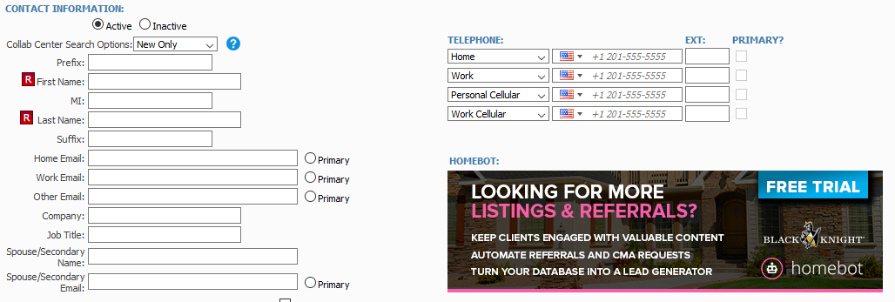

## Affiliate Connect: Notifications for Sold Listings

### Action Item: N/A

Added the ability for Agents to opt to send notifications to affiliates when the status of their listing(s) change to Sold. They can turn this option on in the preference settings.

## Affiliate Connect: Additional Contact Information Available in Branding Block

### Action Item: N/A

Affiliates can now add additional contact information to the Call to Action part of their Branding Block. This includes phone number, email, and street address.

## Allow Agent to Add Comments When Sharing Contacts & Affiliates

### Action Item: N/A

Added ability for Agents to add comments when sharing contact/affiliate information with contacts/affiliates.

## Collaboration Center: School and Neighborhood Reports

### Action Item: Currently Only Available for US Customers

Collaboration Center is getting even better with the introduction of School and Neighborhood charts and reports powered by Onboard. These new charts and reports provide users with detailed information that allows them to understand the area around their potential new home.

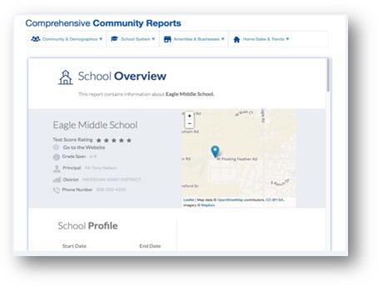

# Paragon Connect

**All options in this section are either configurable via MLS Administration controls or by your System Support Manager as noted.**

## Paragon Connect Workflow Improvements

### Action Item: N/A

In the 5.75 release, Paragon Connect has had a number of workflow improvements and UI updates to improve the overall user experience when using Connect.

#### Drawer Menu

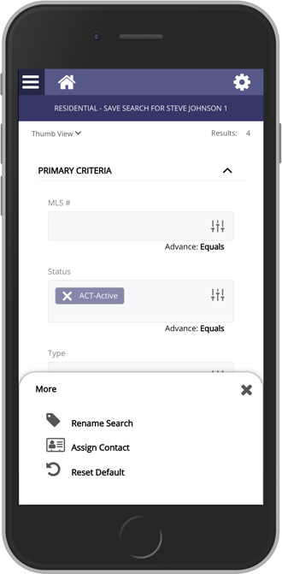This menu takes a more mobile centric approach to displaying menu options. It allows for the full link and quicker access to action items. This will replace several full screen modals and their circle icons.

**NEW**

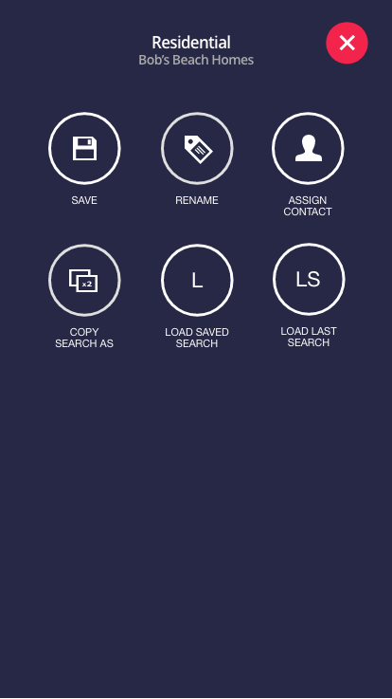

**OLD**

#### Search Layout

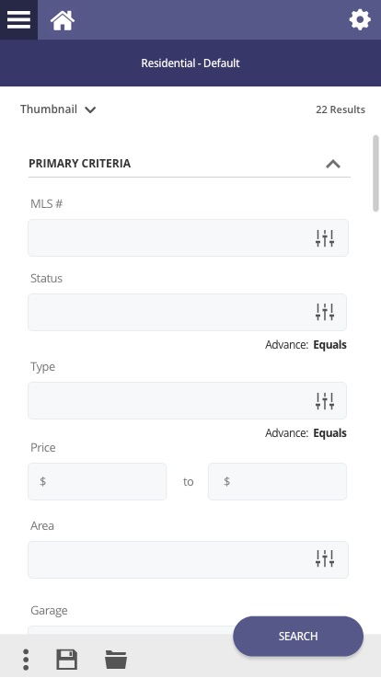

**COUNT:**

The count section moved below purple header and is fixed.

**VIEWS:**

The view switcher is now located here at the top. Remains sticky.



**SEARCH BUTTON:**

The search button now floats and it is a single action.

**ACTION BAR:**

The search footer contains all your search related actions

#### Results Layout

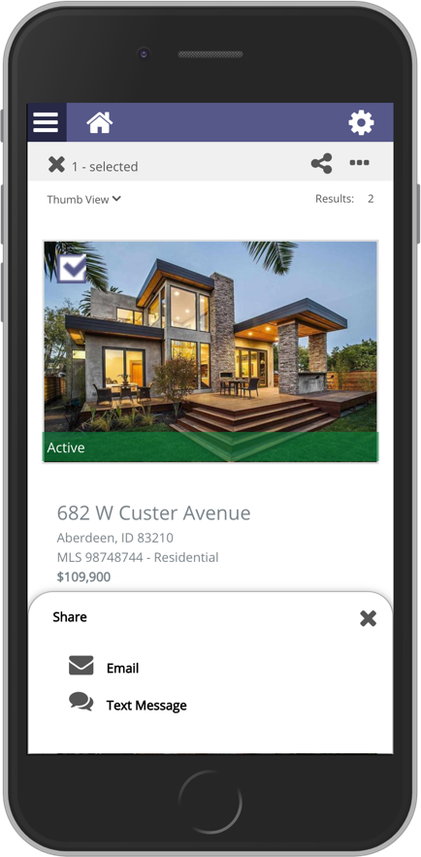Along with removing circle icons, the workflow has been updated so that when selecting a listing(s), the available actions will be updated.

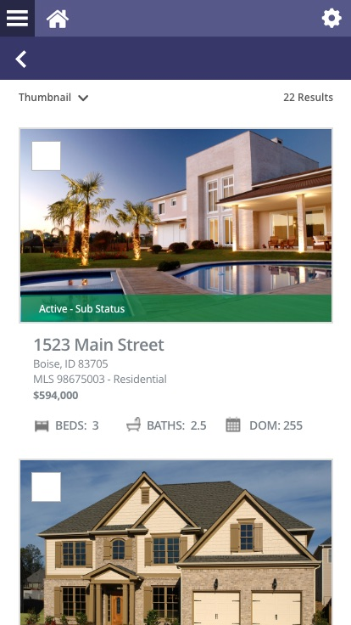

**COUNT:**

The count section moved below purple header and is fixed.

**BACK BUTTON:**

Removed criteria button and replaced with a back arrow



**VIEWS:**

The view switcher is now located here at the top. Remains sticky.



**CLEANER FIXED HEADER**

A more defined fixed header. Old approached used a floating header that appeared after you scrolled down.

**LARGER CHECKBOXES**

Increased the size of the checkboxes and click area around the checkbox.



**SHARE**

New share icon added. Main objective is to get listing out of PC. Email, text, etc.

**SELECTED COUNT**

Shows number of listings selected and ability to clear checked listings.

**VIEWS & COUNT:**

Just like the search the view selection and count remain in same location.

**MORE**

This icon contains your third-party integrations and any other Paragon like actions.



**DRAWER MENU**

Same drawer menu with your share actions available.

#### Map Update



**ACTIONS:**

The map actions move from circle icons on the map to more mobile like icons. Note: some of these actions are for future.

**BACK ARROW:**

Same back arrow to navigate to the criteria page.



**COUNT & VIEWS**

Map retains the same actions as the other views. Allows you to switch views and see the count.

#### Detail Report



**ACTIONS:**

Find your common actions and third-party integrations here.

**BACK BUTTON:**

We removed the close button as the user doesn’t know that this is a modal. The x button looked like a delete option.

**SHARE LISTING**

The new share floating button allows you to quickly share this listing. Note: some options for future.

# Action Item Contents

MLS Customizations and Administration 8

Autofill from MLS Map Layer Lookups 8

Action Item: MLS-level map layers using Minor Area Codes or Lookups must be created for this functionality. 8

Property Watch 9

Action Item: Available for Customers who have Paragon Tax or CRS Data. Also available to others for a monthly fee. Contact Black Knight sales rep for more information 9

Enhanced Data to Parcel Panel for Premium Tax Users 12

Action Item: Requires Premium Tax Data Agreement. Contact Black Knight Sales Rep for additional information 12

Homebot UI Update 12

Action Item: Requires Homebot to be enabled 12