# Paragon 5.76 Special Release (04-2020)

# Live Stream Tour and Open House

## New Tour/Open House option for Live Streams

### Action Item: A RETS metadata refresh must be scheduled to enable the new resources and fields in RETS.

This new feature gives the MLS options to help agents, consumers, and home-owners practice social distancing while still providing services.

A new configuration setting provides three options for creating Tour and Open House events:

* **Allow In-Person and Live Stream.** This new default configuration allows users to optionally enter a live stream event URL into the current Tour and Open House management module, as well as schedule in-person events.
* **Allow Live Stream only.** This option requires users to enter a live stream URL when scheduling T/OH events.
* **Allow In-Person only.** This option makes no changes to the existing T/OH module.

When Live Stream is enabled, two new fields will be added to the T/OH module:

* Live Stream
* Live Stream URL

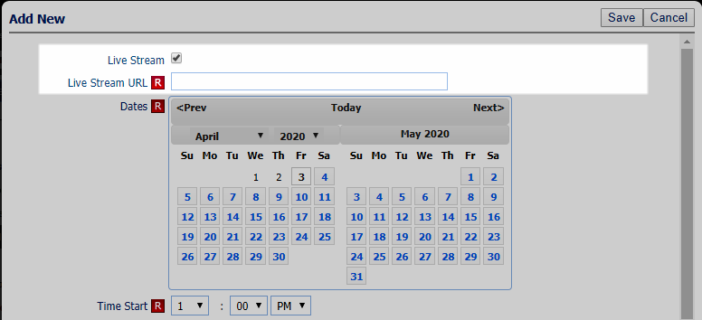

**Searching Live Stream Events**: A new yes/no field, Tour/Open House – Live Stream, will be added to the Tour and Open House search screen.

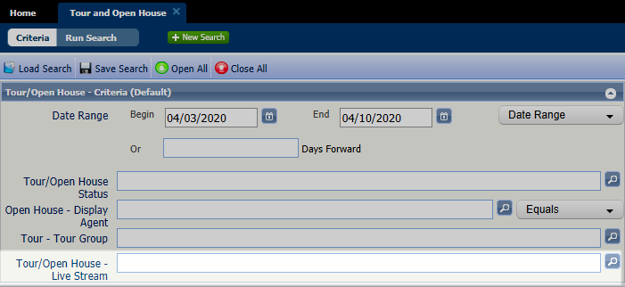

The new fields (Tour/Open House – Live Stream and Tour/Open House – Live Stream URL) will be added to the Tour/Open House Spreadsheet view by default, and available to be added to T/OH custom reports. *Note:* The new fields cannot be added to the Tour/Open House Thumbnail view at this time.

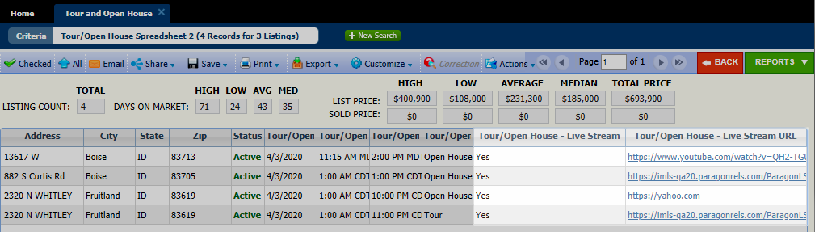

**Collaboration Center and CollabLink Detail Views**

The Open House Information section of the Collab Center and CollabLink detail view will automatically change to Live Stream Open House Information, when viewing a Live Stream event. The usual Start Date, Start Time, End Time, and Comments fields display, along with the Live Stream URL as entered in the T/OH module.

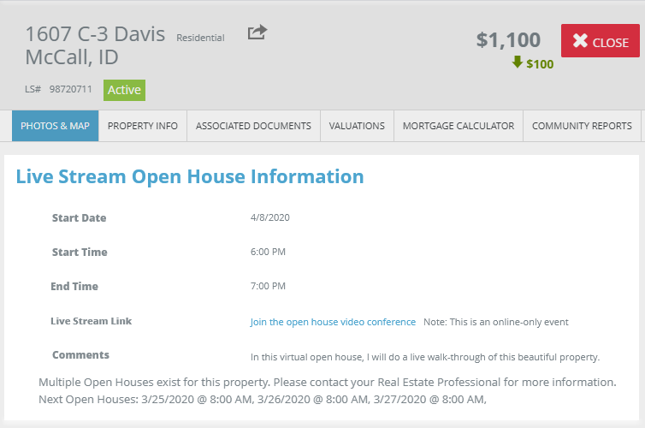

**RETS**

To accommodate the new Live Stream T/OH, two new resources have been added to RETS, Live Stream Open House and Live Stream Tour, with two new RETS fields, Live Stream (Y/N) and Live Stream URL.

The existing Open House and Tour resources will only include traditional in-person events. The new Live Stream resources will only include the live stream events. Users can enable in-person only, live stream only, or both. By default, both are enabled.

If the config setting TOUR_OH_MODE = O, then no Tour or Open House data will export from any resource.

**Configuration Settings:** A new configuration setting, **TOUR_OH_MODE**, determines what type of T/OH is available to users.

**Options:** V=Live stream only; P=in-person only; B=Both; O=no T/OH records are sent via RETS.

**Default:** B=Both live stream and in-person.