# Paragon 5.76 Release Enhancements

Paragon 5.76 Release Enhancements 1

Corrected Issues 2

Agent Level Changes 3

Email Reports: UI cleanup 3

Contacts: Saved Searches simplification 4

Contacts: Tree Updates 6

Contacts: Search the ‘To’ field in Sent Messages 6

New CRS Data Integration Point 7

Display Average Value of all AVMs 8

Property Watch Enhancements 8

Clarified Subject line on password reset emails 9

Collab Center: Display Sold and List Price on Agent email notifications 10

Collab Center: Display Previous and Current list price on Agent email notifications 10

MLS Customizations and Administration 11

Office Admin: Display Office Logo on Office Admin screen 11

Agent Admin: Add link to Agent Audit report 12

Autofill LIM from Map Layers via Tax Autofill 12

Streamlined the RETS setup for multiple profiles 13

Affiliate Connect 15

5.76 Updates 15

Paragon Connect 15

5.76 Updates 15

Action Item Contents 15

# Corrected Issues

|  |  |  |  |  |  |  |
| --- | --- | --- | --- | --- | --- | --- |
| **WO#** | **Seq** | **Type** | **Product** | **Module** | **Organization** | **Summary** |
| 89852 | 1 | Bug | Paragon 5 | Input Maintenance | Northern Great Lakes Realtors MLS (Traverse) 2 | Confidential field changing value when listing maintained by user below update security level |
| 125452 | 1 | Bug | Paragon 5 | Configuration | Outer Banks Association of Realtors 3 | error occurs when Corporate License ID field has NULL value in GAMLS ST10 |
| 147448 | 1 | Bug | Paragon 5 | Input Maintenance | Georgia MLS (ATL) 2 | P100-VALLEYMLS: Users get "No photo changes were saved" when cropping images |
| 148846 | 1 | Bug | Paragon Connect | Property Search | Stillwater Board of Realtors | Stillwater Paragon Connect is displaying a Run Time area when attempting a search |
| 149504 | 1 | Bug | Paragon 5 | Quick Search | Regional Multiple Listing Service Alliance (RMLSA) | Default Quick Search Criteria Is Not Retained, and Doesn't Set Search as Default for Board Levels |
| 150045 | 1 | Bug | Paragon 5 | Admin - Listings | Regional Multiple Listing Service Alliance (RMLSA) | Expiration Emails sent to brokers show system id rather than display_id |
| 143011 | 1 | Config Issue | Paragon 5 | RETS | New England Real Estate Network (NEREN) | Additional Functionality to Allow for Enabling Fields in RETS |
| 149183 | 1 | Data Issue | Paragon 5 | Export | Great Plains Realtors MLS Inc (Omaha) | Realty Toolkit export MLS#s do not match label on the photos |
| 121749 | 1 | Design Issue | Paragon 5 | Admin - Agent | Nova Scotia Association of Realtors 2 | Unable to add info tip to Region field in Users Table |
| 144714 | 3 | Design Issue | Paragon 5 | Admin - Messaging | MiRealSource Michigan MLS | MLS Messaging Not Respecting Board Selection to Filter Agent, Office, or Firm Name Field |
| 146961 | 1 | Design Issue | Paragon 5 | Admin - Field Setup | Willamette | WVMLS- the office address is not displaying in the Team Information box when clicking the team |
| 149670 | 1 | Design Issue | Paragon 5 | Admin - Reports | San Diego MLS | P00 SPN: RETS Volume Report does not count more than one user |
| 150037 | 1 | Design Issue | Paragon 5 | Preferences | P100 - All Accounts | P100 Email Preferences menu text showing as black instead of white when selected. |

# Agent Level Changes

**The following section contains changes that are active system wide and available to users based on their assigned security levels.**

## Email Reports: UI cleanup

### Action Item: N/A

We used more concise labels, removed some irrelevant information, and clarified some terminology to simplify the manual email reports dialog box.

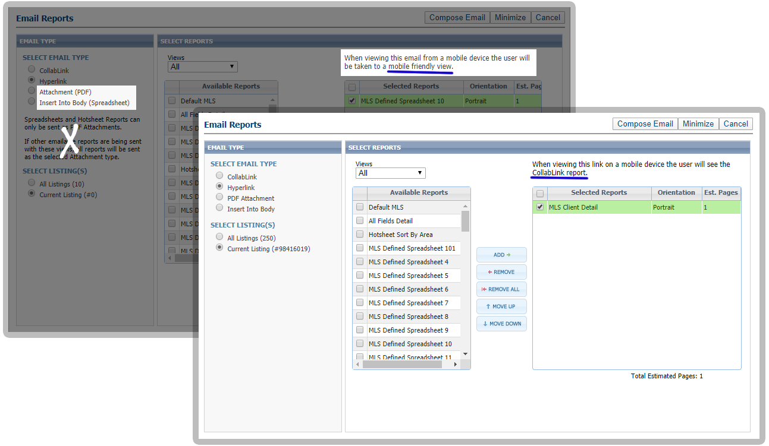

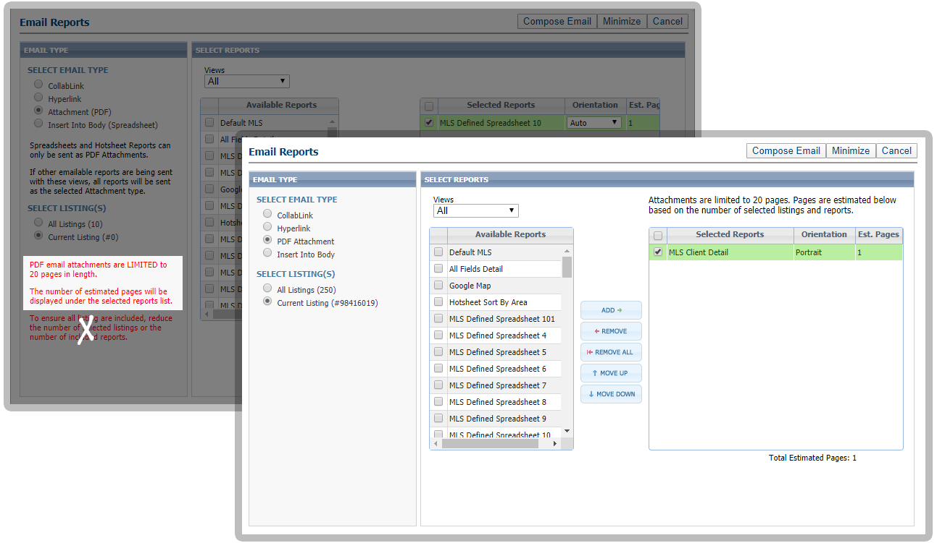

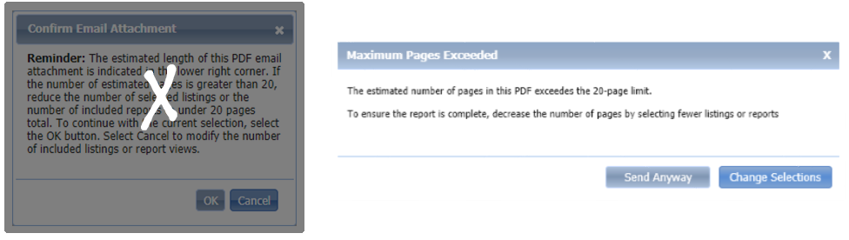

## Contacts: Saved Searches simplification

### Action Item: N/A

Current functionality was retained while a much more intuitive experience was achieved through careful analyzation and thoughtful design.

* Settings are grouped together

• Tools are in the toolbar

• Statistics are displayed together

• Comments are in context

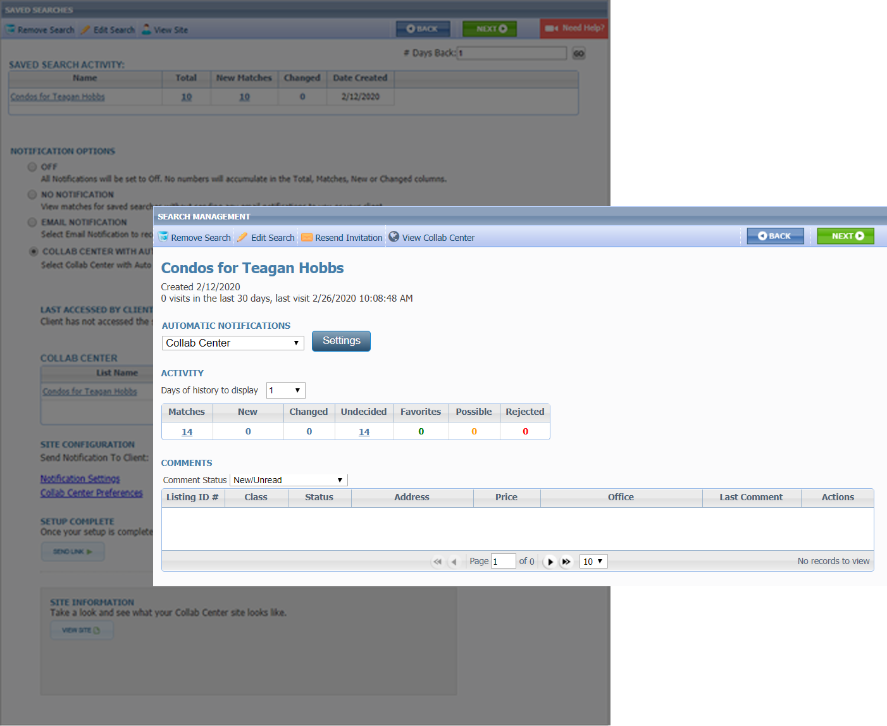

## Contacts: Tree Updates

### Action Item: N/A

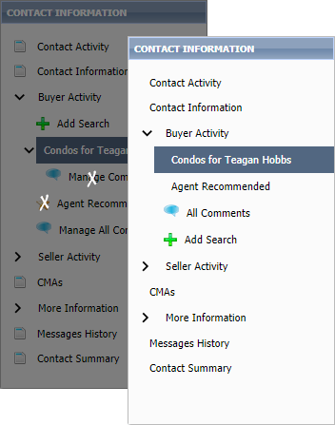We simplified the tree by removing unnecessary icons and we removed search-specific comments because they are now on the page with the search settings.

## Contacts: Search the ‘To’ field in Sent Messages

### Action Item: N/A

In Contacts > Sent Messages and Message History, the Search field will now search on both the Subject Line and the “To” field, enabling users to search for messages to a specific contact.

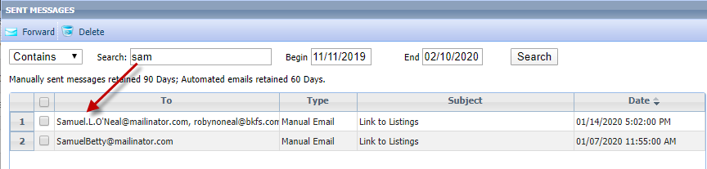

## New CRS Data Integration Point

### Action Item: N/A

You asked, we delivered. Now CRS agents can get more information about a public record property from CRS Tax Autofill search results via the new Tax Specialty View under the REPORTS menu. The link will use the following logic when accessed:

1. From the grid view, if no records are selected, the link will use the first record in the results
2. From the grid view, if one or more records are selected, the link will use the first selected record
3. From the Detail View, the link will use the current record in view

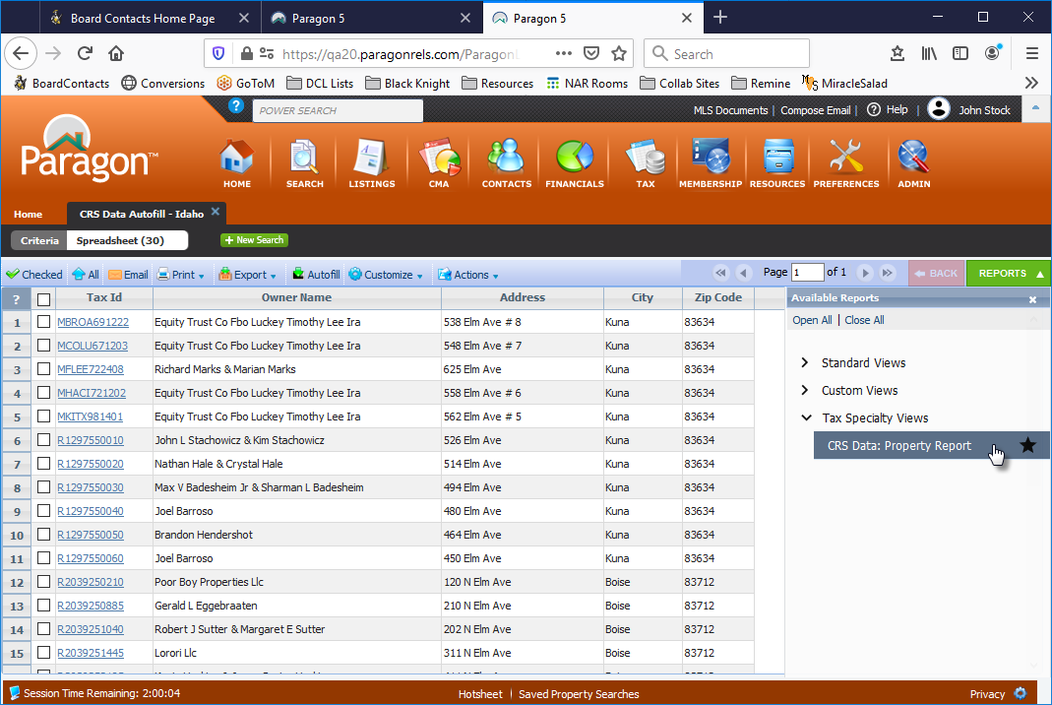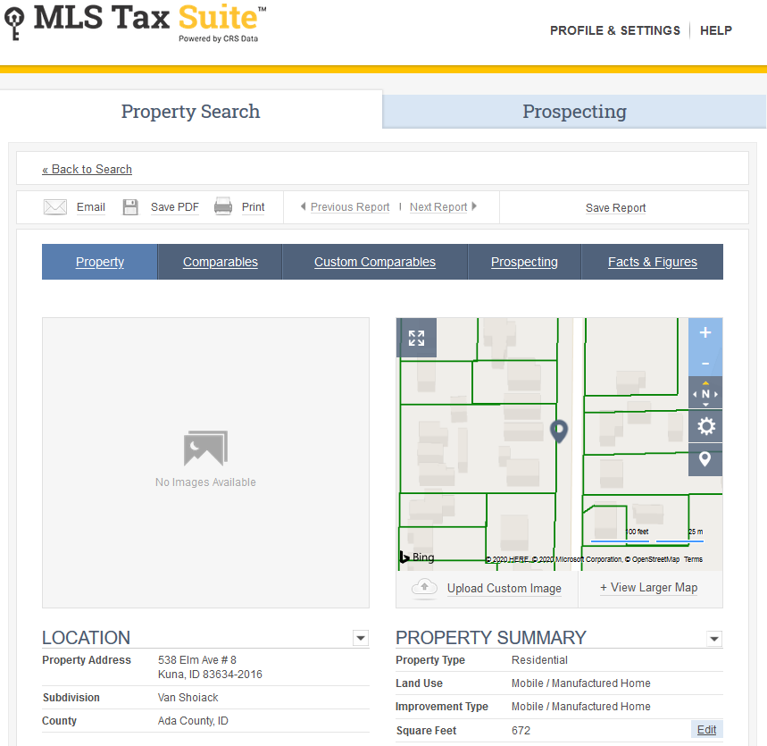

## Display Average Value of all AVMs

### Action Item: N/A

While it’s nice to know the individual values, what’s the average of the AVMs? Good question. With 5.76, you will have the answer. We’ve added the average value to everywhere the AVMs display; the CMA Comparable Price Analysis report, the parcel-click map panel in Paragon, the Detail View in Collab Center and Paragon Connect. The feature includes logic that if there are fewer than two AVM values returned, the Average will be hidden.

In addition, we’ve also gone to monochromatic logos for a cleaner, consistent look.

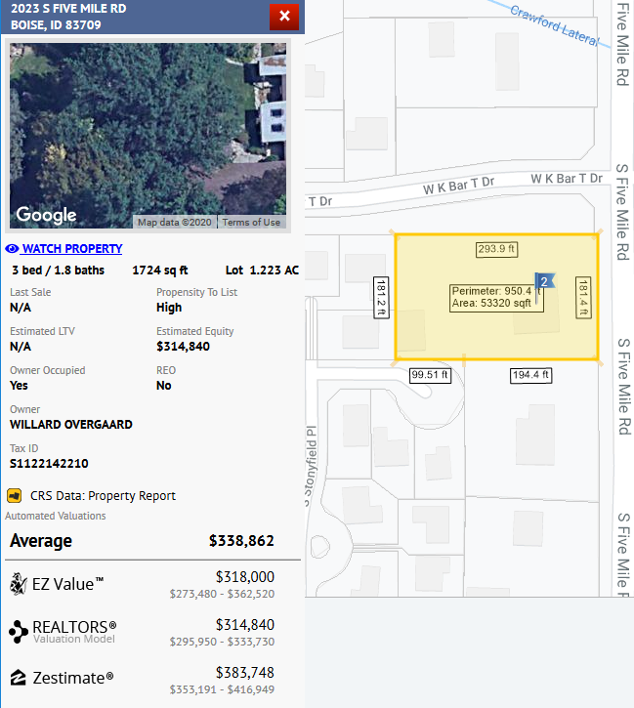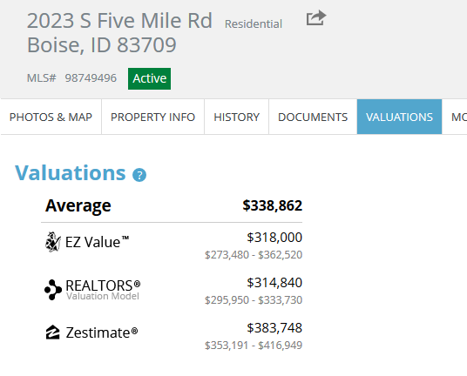

## Property Watch Enhancements

### Action Item: N/A

While we’re still in the process of enabling Property Watch for Premium Tax customers, we have made a few enhancements to improve the awesome feature.

* First, we changed the sort so the most recent addition appears at the top of the list.
* Next, we added all of the enhanced data from the property panel to the grid to include Propensity to List, Estimated Loan to Value (LTV) and Estimated Equity to name a few.
* Finally, since the grid is static, we added a “Refresh Record” button to the menu – if the Refresh Date is last month, just highlight the row and click the Refresh Record button to ensure you have the latest data.

Property Watch is a premium feature made available to customers using CRS Data or BK Paragon Tax. It is also available to other customers as an upgrade. If you’d like more information, contact your Black Knight Sales Representative.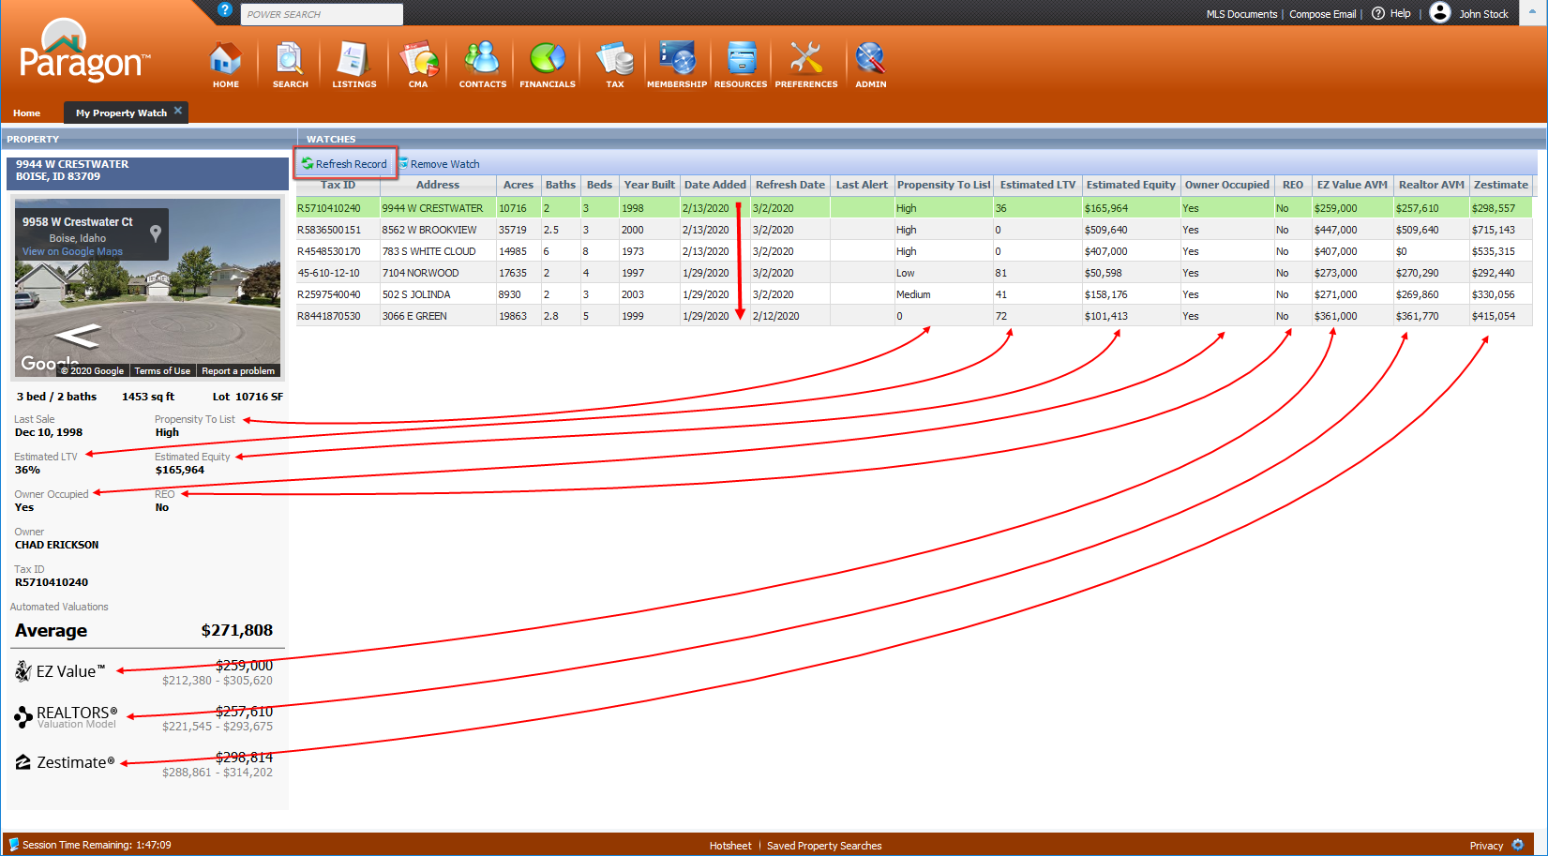

## Clarified Subject line on password reset emails

### Action Item: N/A

On password reset emails initiated from Paragon, the subject line will now include the word “Paragon” to enable users to more easily identify the emails, and reduce the chance of being blocked by spam filters.

## Collab Center: Display Sold and List Price on Agent email notifications

### Action Item: N/A

If your MLS allows notifications on Sold or Leased listings, both the List Price and Sold Price will display on the Agent Collab Center email notifications, for status categories 2 and 6. All other statuses will continue to display the List Price.

## Collab Center: Display Previous and Current list price on Agent email notifications

### Action Item: N/A

On Agent Collab Center email notifications for price changes, both the previous price and current price will display.

# MLS Customizations and Administration

**All options in this section are either configurable via MLS Administration controls or by your System Support Manager as noted.**

## Office Admin: Display Office Logo on Office Admin screen

### Action Item: N/A

If the office broker has uploaded an office logo in Preferences, the logo will display on the Office record in Admin, and on the Office Information modal.

If no office broker is assigned to the office, no image displays.

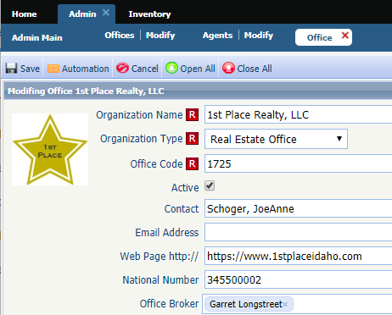

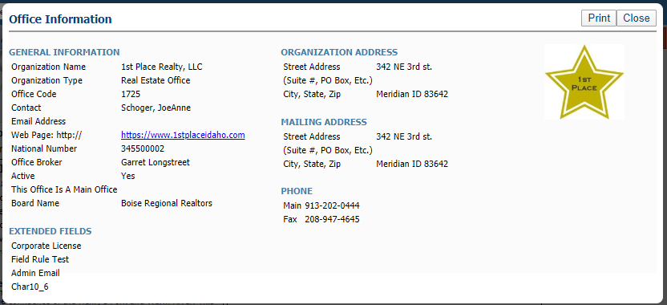

## Agent Admin: Add link to Agent Audit report

### Action Item: N/A

An Audit link in the toolbar of the Agent record in Admin will open the Agent Audit Report in a new tab, displaying information for the selected agent. 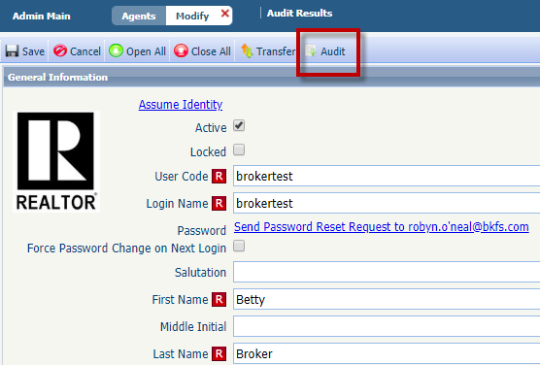

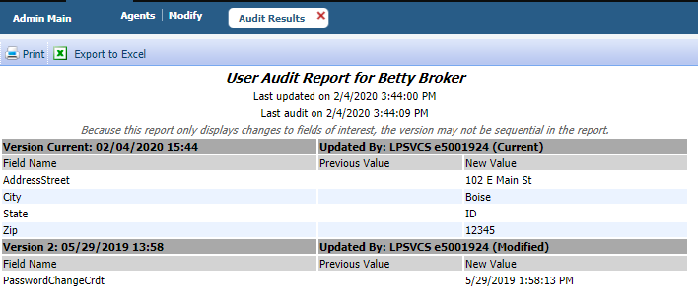

## Autofill LIM from Map Layers via Tax Autofill

### Action Item: The MLS must have created interactive map layers with lookup values.

When autofilling a listing via Tax Autofill, if the MLS has interactive map layers with lookups available, Paragon will return lookup values from those map layers, and autofill the values into the LIM form. If both the Tax record and the map layer have data for the same field, the map layer takes precedence.

The MLS must have created interactive map layers with lookups to use this feature.

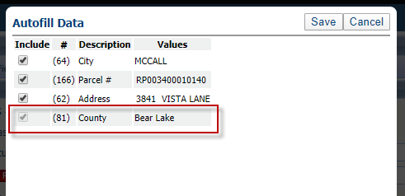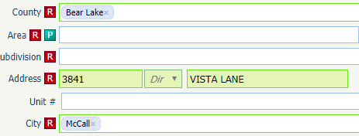

## Streamlined the RETS setup for multiple profiles

### Action Item: N/A

The new RETS Multi-Profile Field module helps simplify enabling or disabling fields to multiple RETS profiles at once.

For new fields added in Admin > Fields, select Used in RETS, and request a RETS Refresh. When the refresh is completed, the new field will be added to the RETS table, but as disabled for all profiles.

Enable the new field for multiple profiles via the RETS Multi-Profile Field module, or continue to use the existing RETS Profile module to work with single profiles.

*Note: The following options have been removed from the Field Admin: Enable Field in All RETS Profiles, Enable Field in RetsProfile, Enable Field in Resources.*

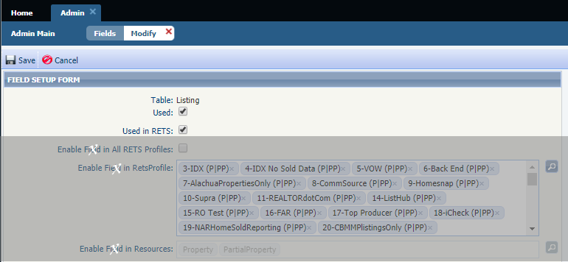

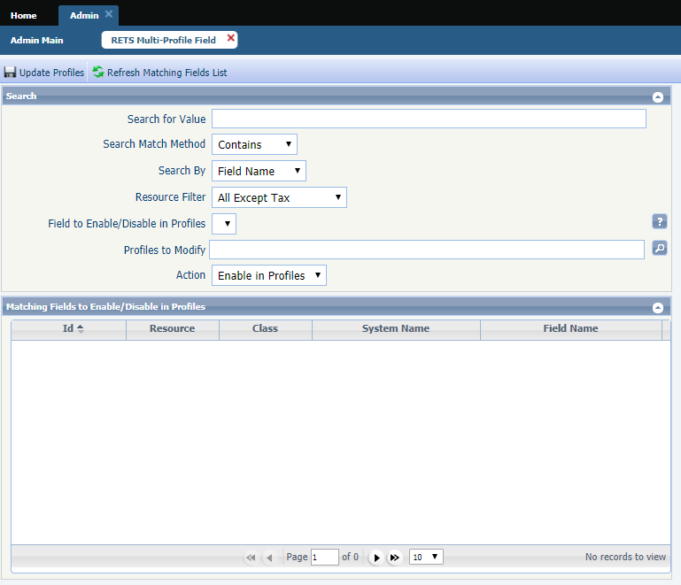

# Affiliate Connect

**All options in this section are either configurable via MLS Administration controls or by your System Support Manager as noted.**

## 5.76 Updates

### Action Item: N/A

Some minor bug fixes were completed for 5.76, and Affiliate Connect is releasing a new-look dashboard in 5.77.

# Paragon Connect

**All options in this section are either configurable via MLS Administration controls or by your System Support Manager as noted.**

## 5.76 Updates

### Action Item: N/A

Our focus for Paragon Connect this release has been to clean up existing bugs to ensure better performance and reliability for users. Look for new features in the 5.77 release!

# Action Item Contents

Autofill LIM from Map Layers via Tax Autofill 12

Action Item: The MLS must have created interactive map layers with lookup values. 12