# Paragon 5.77 Release Enhancements (June 2020)

Paragon 5.77 Release Enhancements (June 2020) 1

Corrected Issues 2

Agent Level Changes 3

New System Features and Enhancements Tours 3

Contacts – Agent email not configured 4

Contacts – Improved handling of email address 4

Contacts – Contacts grid columns reordered 4

Search – Share via Text email requirement removed 5

Search – Save and Notify for Listing Carts 5

Search – Power Search Refinements 6

Search – Display Public Records with Listings on Map 7

Search – CRS Data Property Report from Property Watch and Alerts 9

LIM – Retain 1.0 Geocode when converting Partial Listings 10

MLS Customizations and Administration 11

LIM – Audit Listing Report from LIM Quick Actions 11

Search – Improved handling of Notifiable Statuses and Status Security Level 11

New Premium Tax Features 13

Paragon Connect 14

Driving Directions 14

Criteria Summary 14

About Page 15

Paragon Affiliate Connect 16

Affiliate Dashboard available to all Affiliate Connect users 16

Updated PAC Agent Dashboard 16

Listing Search link added to Affiliate Dashboard 17

Add Agent comments when sharing Contacts with Affiliates 18

Action Item Contents 19

# Corrected Issues

|  |  |  |  |  |
| --- | --- | --- | --- | --- |
| WO# | Seq | Module | Organizations | Summary |
| 112727 | 1 | Configuration | West Central (MN), IRMLS, San Diego MLS, SCWMLS, | Firm Market Monitor not loading for specific Agents |
| 143720 | 1 | Input Maintenance | Gainesville-Alachua County Association of REALTORS | Unable to upload image to partial - GIF resolution dimensions |
| 144489 | 1 | Quick Search | San Diego MLS, NEREN | Power search not picking up on address search |
| 149207 | 1 | Paragon Connect - Property Search | Mid-Kansas Multiple Listing Service | Paragon Connect Property Search page won't load database |
| 151022 | 1 | RETS | Baton Rouge | Download error caused by LR_remarks* field in History: RE_1 resource |
| 150016 | 1 | Search - Stat Report Views | NorthstarMLS (NSMLS) - Regional MLS of Minnesota | MLS reporting an issue with MLS Statistics for a specific office |
| 117200 | 1 | Input Maintenance | Spokane, NEREN, Northern Great Lakes, REB3 | Partial Listings, Subject Properties: retain 1.0 quality geocode when converting listing |
| 129893 | 2 | Contact Management | New England Real Estate Network (NEREN) | Collab Center Search Options Tool Tip Has Two Different Verbiage Based on Settings |
| 150176 | 1 | Admin - Office | Regional Multiple Listing Service Alliance (RMLSA) | The Word 'Modifying' is Misspelled When Editing Offices in Admin |
| 105507 | 2 | Email | NEREN, REB3, IRMLS, Triangle | Request for User Error Message if Special Characters Present in Email Addresses |
| 117247 | 1 | Input Maintenance | Lawrence Board of Realtors | Board is requesting ability to customize "All Active" functionality |
| 147085 | 1 | Login/Login Page | Maui, NEREN, RMLSA | Request for New Change Password or Password by E-mail to Work when SSO Enabled |

# Agent Level Changes

**The following section contains changes that are active system wide and available to users based on their assigned security levels.**

## New System Features and Enhancements Tours

### Action Item: N/A

Take a mini-walkthru of new Paragon features and enhancements. The tour pops up in Paragon automatically at selected features. Page through the tour, or select Remind Me Later to view on your next visit to the page. Look for the inaugural tour on the Map Search tab in this release!

In Preferences, users can choose to stop showing tours, or show them all again. [Preferences > System Preferences > User Interface > UI Tours.]

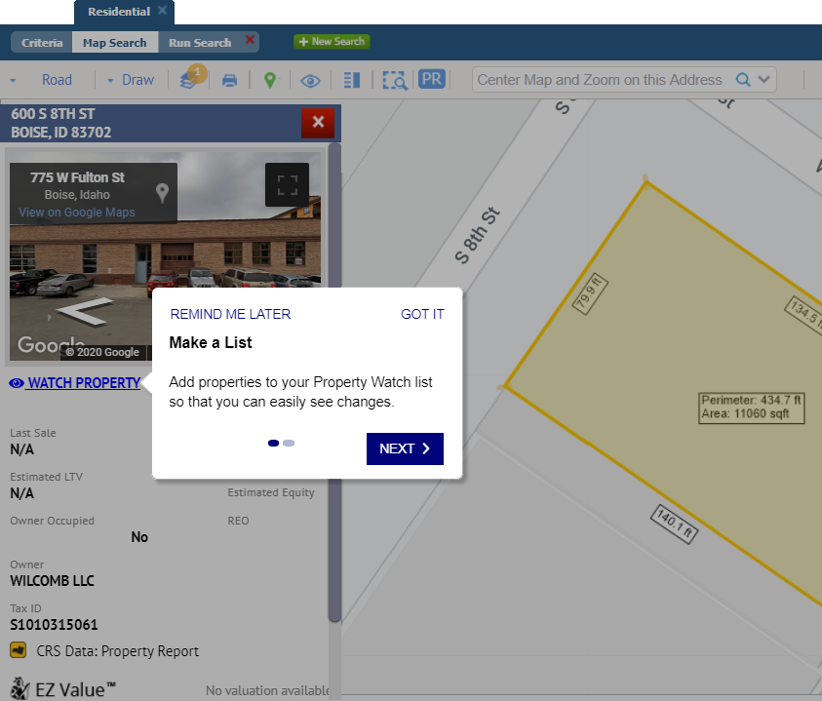

## Contacts – Agent email not configured

### Action Item: N/A

We’ve clarified the message that displays if the user doesn’t have an email address configured when attempting to set up notifications for a contact.

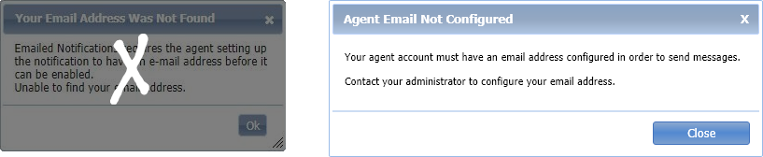

## Contacts – Improved handling of email address

### Action Item: N/A

Paragon has improved the handling of invalid characters in email addresses, based on industry standards, to help improve data quality and avoid bounced messages.

* When an email address is entered with invalid characters, an updated error message displays the incorrect address and provides a list of invalid characters.
* If an email address has a plus sign in the “local part” of the email address, Paragon will retain the plus sign, rather than replacing it with a space, as it did previously. The receiving email system will handle those addresses according to their protocols.

## Contacts – Contacts grid columns reordered

### Action Item: N/A

We’ve rearranged the columns in the View/Manage Contacts grid to match the nested Search grid.

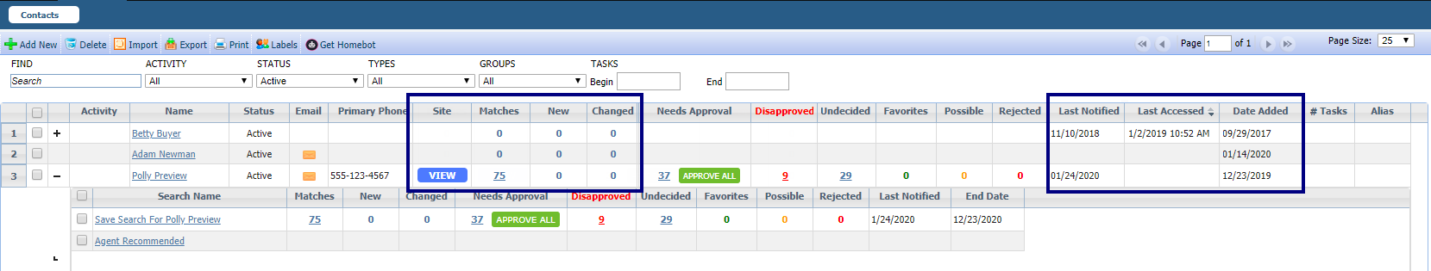

## Search – Share via Text email requirement removed

### Action Item: N/A

We’ve removed the email address requirement when adding a new contact from Share via Text. The email address is needed to opt a contact back into receiving text messages from Paragon. The Opt-In process in Contacts has an existing check for an email address, making it unnecessary to require it when a new contact is being added.

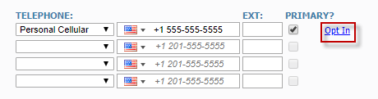

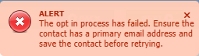

## Search – Save and Notify for Listing Carts

### Action Item: N/A

The Save & Notify button has been added to the Listing Cart, to improve the client communication workflow. Clicking Save & Notify routes you to the selected Contact’s Agent Recommended page, just as it does for Saved Searches.

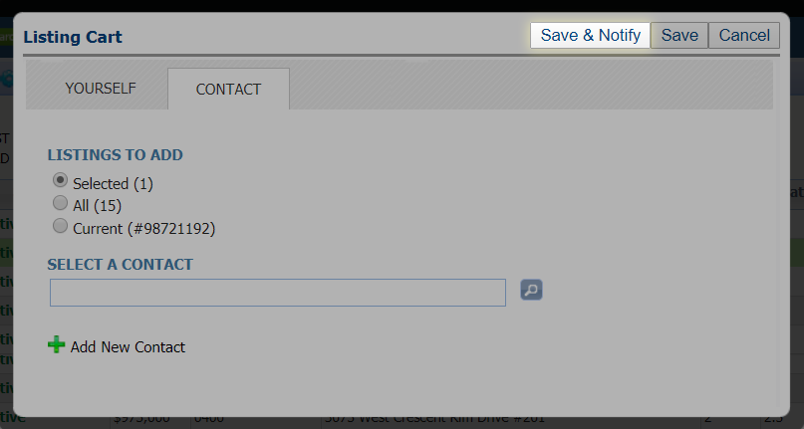

## Search – Power Search Refinements

### Action Item: N/A

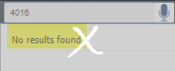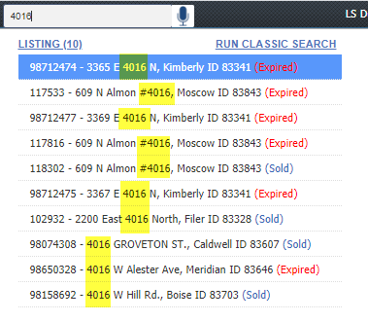We’ve tweaked Power Search to return better results when searching a numeric string. Power Search will return general search results based on matches to address fields, in addition to matching listing IDs.

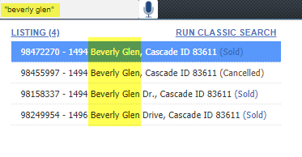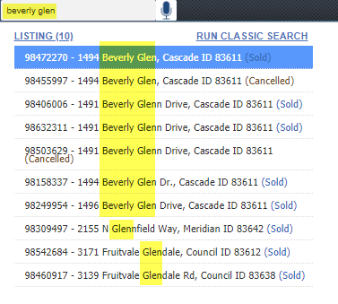Did you know that using quotes around your “search criteria” can return better results? We’ve updated the Power Search tooltip to include this helpful tip.

Look for more Power Search enhancements in future releases!

## Search – Display Public Records with Listings on Map

### Action Item: N/A

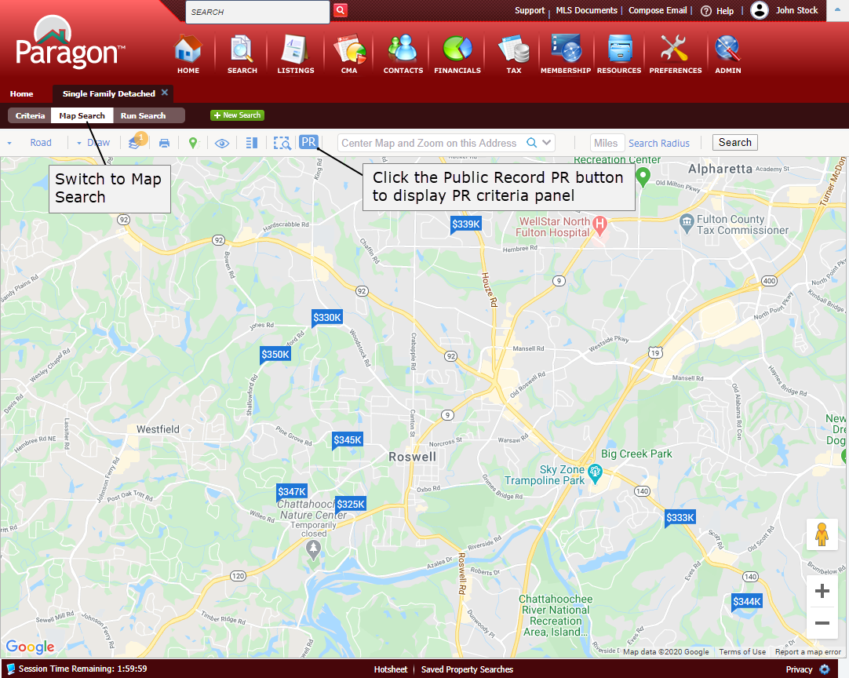Black Knight MLS is very excited to announce the release of a new Premium Tax feature called Integrated Search that gives agents the ability to display both Listings and Public Records that meet the same criteria on a single Map View. Not only that, agents can also include Owner Occupied as criteria. This feature will automatically be enabled for CRS Data and Paragon Tax users.

Here’s how it works.

After getting search results, switch to Map Search to access the new feature and click on the PR button.

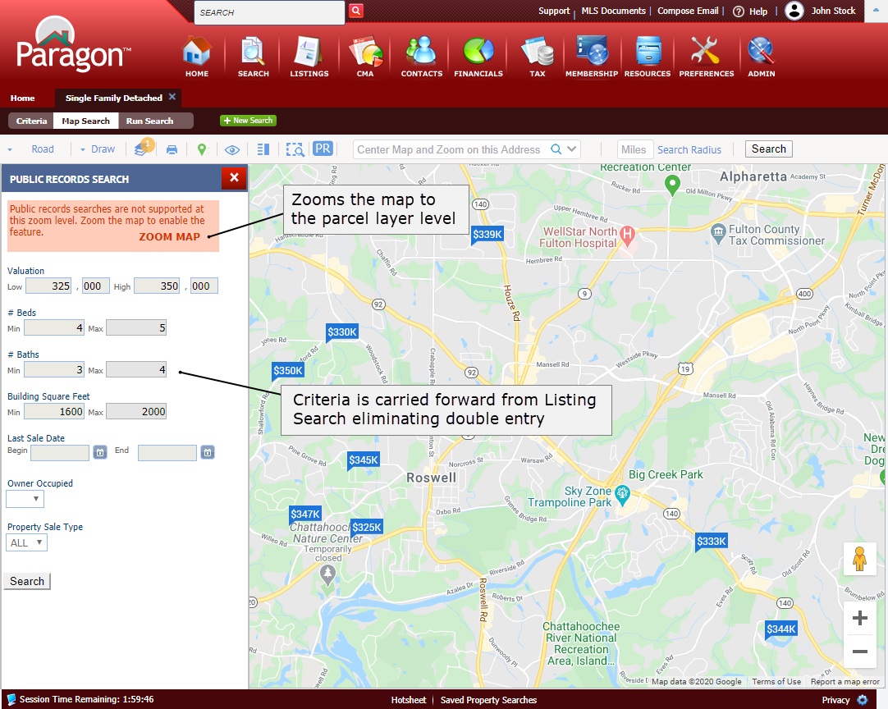

The new search is enabled at the parcel layer level. If the map is not at the parcel level, a ZOOM MAP option will jump the view to the parcel level when clicked and enable the criteria panel so the search can be run. Any Price, Beds, Baths, and Square Foot criteria entered for the Listing Search will automatically carry forward, eliminating the need to enter criteria twice. Users can also search by Last Sale Date, Owner Occupied and Property Sale Type = REO.

Click the Search button to display any criteria-related public records (in the aqua colored pins) within the current map boundaries. If necessary, the public record pins can be removed by clicking the “Clear Public Record Pins” link.

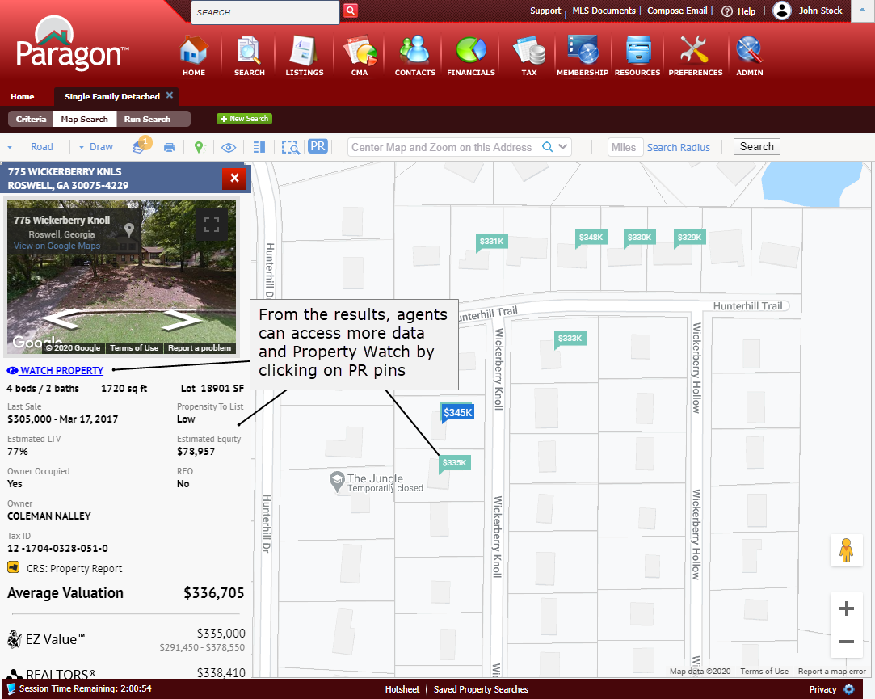

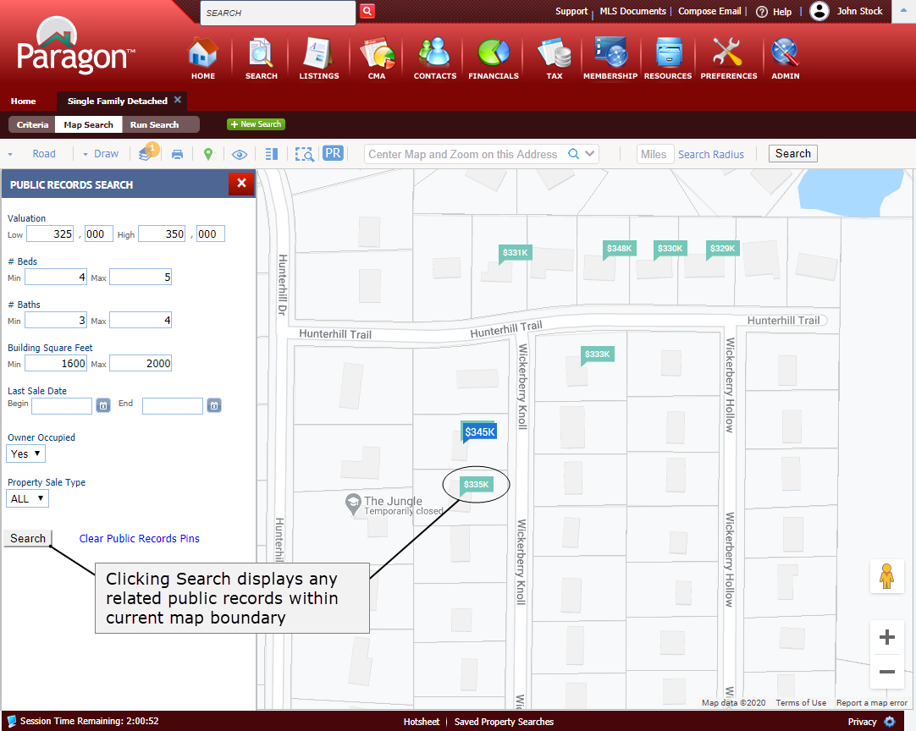

Phase one will use the map boundaries for the search but future phases will include the ability to use map drawings.

From the results, agents can view more data about the related public records by clicking on the pins.

From the panel, agents can also add a property watch by clicking the WATCH PROPERTY option.

## Search – CRS Data Property Report from Property Watch and Alerts

### Action Item: N/A

When Property Watch was introduced, it was missing the ability to link to the CRS Data Property Report from the property panel that displays next to the Property Watch and Alerts grids. This feature was added in 5.77 and will automatically appear to customers with CRS Data.

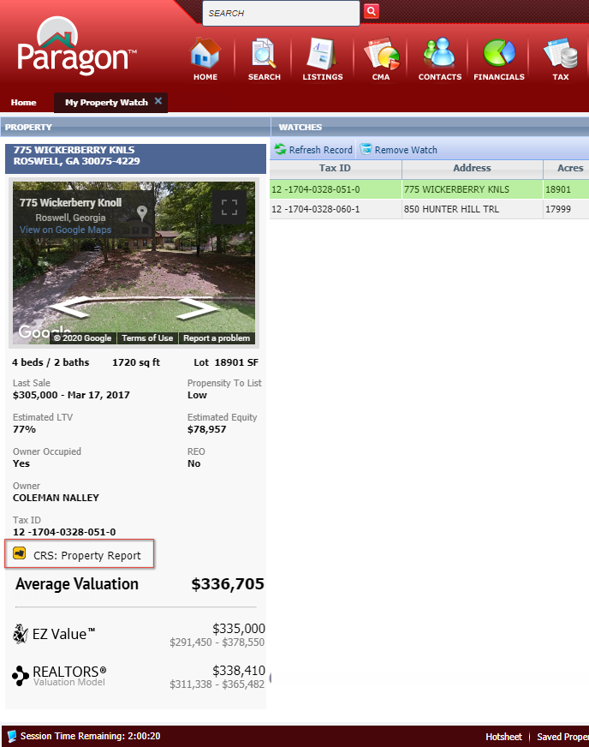

## LIM – Retain 1.0 Geocode when converting Partial Listings

### Action Item: N/A

### If you have manually placed the map pin on a partial listing, resulting in a 1.0 geocode quality, Paragon will retain that pin placement when you convert the listing to a live listing, eliminating the extra step of placing the pin a second time.

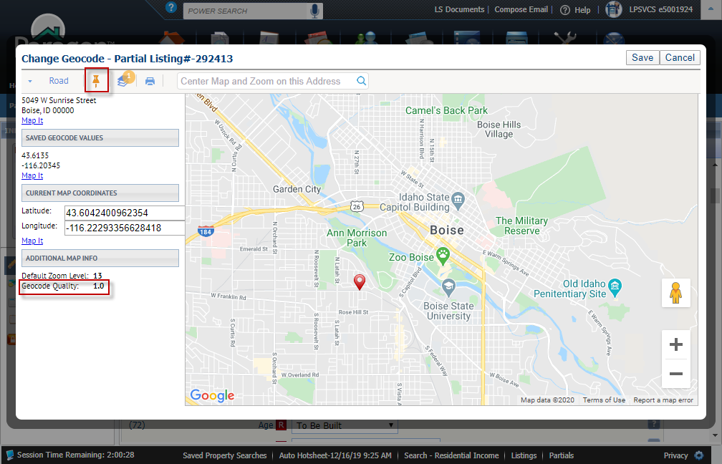

# MLS Customizations and Administration

**All options in this section are either configurable via MLS Administration controls or by your System Support Manager as noted.**

## LIM – Audit Listing Report from LIM Quick Actions

### Action Item: N/A

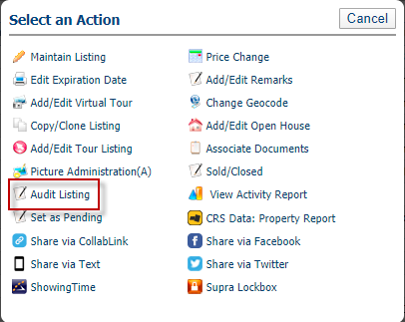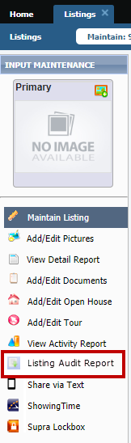

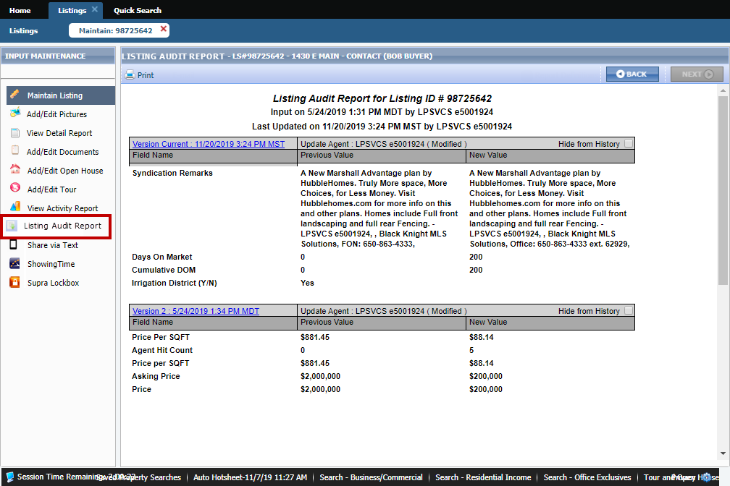By popular request, a link to the Audit Listing Report is now available in the LIM > Quick Actions menu and the LIM left navigation pane. The link opens the Listing Audit Report for the selected listing. Existing security restrictions on the report are enforced.

## Search – Improved handling of Notifiable Statuses and Status Security Level

### Action Item: N/A

This enhancement resolves an issue where statuses restricted to a user by security level were still triggering the Prospecting Criteria Conflict error when trying to save a search to a contact.

In this scenario, if a status has a Detail View security level greater than the agent’s security level, that status is hidden to the agent in search criteria and search results.

In a search, if the user selected an “All” status (All Active, for example) that included a “hidden” status that was not notifiable to contacts, the error would be triggered. But, since the status triggering the error was hidden to the user, they could not see it in the search criteria to unselect it.

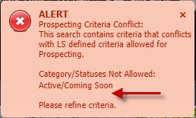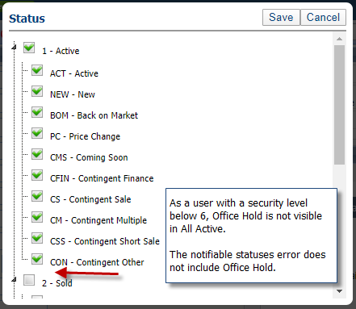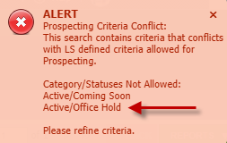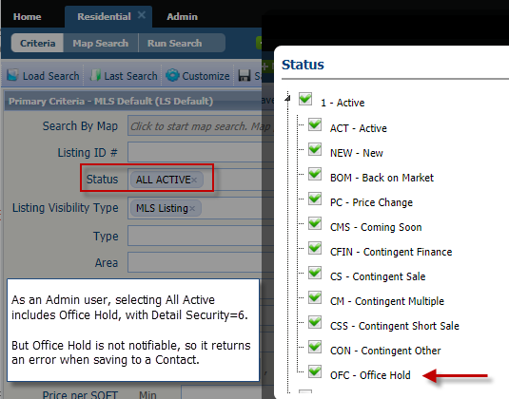This enhancement fixes that conundrum; if the status is hidden to the user and is not notifiable to contacts, then it will not trigger the error.

## New Premium Tax Features

### Action Item: Integrated Search must be enabled in Configuration Settings.

**Display Public Records with Listings on Map**

Black Knight MLS is very excited to announce the release of a new Premium Tax feature that gives agents the ability to display both Listings and Public Records that meet the same criteria on a single Map View. Not only that, but agents can also include Owner Occupied and REO as criteria.

This feature will automatically be enabled for CRS Data and Paragon Tax users. All other customers are encouraged to contact their Black Knight Sales representatives for more information.

**CRS Data Property Report from Property Watch and Alerts**

When Property Watch was introduced, it was missing the ability to link to the CRS Data Property Report from the property panel that displays next to the Property Watch and Alerts grids. This feature was added in 5.77 and will automatically appear to customers with CRS Data.

# Paragon Connect

**All options in this section are either configurable via MLS Administration controls or by your System Support Manager as noted.**

## Driving Directions

### Action Item: N/A

Our Paragon Connect 5.77 release begins by looking at the new driving directions feature for mobile devices. Click or tap Driving Directions to open your default native map option on your mobile device and get directions for a single point-to-point route. Future updates will include tours, multi-point routes, stops, etc.

There are two access points for driving directions on Paragon Connect:

* Select a single listing from the thumbnail view or grid view;
* Or, open the detail view of any listing.

From your selected listing, click the More menu (three dot icon) to open the drawer menu, then click Driving Directions.

## Criteria Summary

### Action Item: N/A

Easily view and refine your search criteria with the new Criteria Summary in the property search module. A new icon in the bottom footer of the property search toggles the criteria summary right in the search screen. Click or tap the icon to display only the ﬁelds that have search criteria. Make any changes to those ﬁelds, then click the icon again to toggle the criteria summary off and display all search ﬁelds again.

## About Page

### Action Item: N/A

The new About page, accessed from the main menu, displays both user and legal information for your Paragon Connect session.

User information includes:

* Username
* User Code
* System ID
* Oﬃce
* Time Zone
* Session Time Remaining

# Paragon Affiliate Connect

**All options in this section are either configurable via MLS Administration controls or by your System Support Manager as noted.**

## Affiliate Dashboard available to all Affiliate Connect users

### Action Item: N/A

To help simplify Affiliate Connect setup for our users, we’ve eliminated the Basic and Premium tiers in favor of one level of service. Now all Affiliate Users have access to their own Affiliate Dashboard, and will not have access to your Paragon MLS site.

When Affiliates receive their setup email, the included URL directs them to the Dashboard.

## Updated PAC Agent Dashboard

### Action Item: N/A

The PAC Agent Dashboard has been updated to support a streamlined workflow. Agent and Office Affiliates have been combined onto one tab. Agents can share their Affiliates with their contacts, view Affiliate Disclosures, and add comments to Affiliates all from the same screen.

For Office and Firm managers, new enhancements accommodate adding Affiliates to one or more offices within a firm, or adding Disclosures to any Office Affiliate.

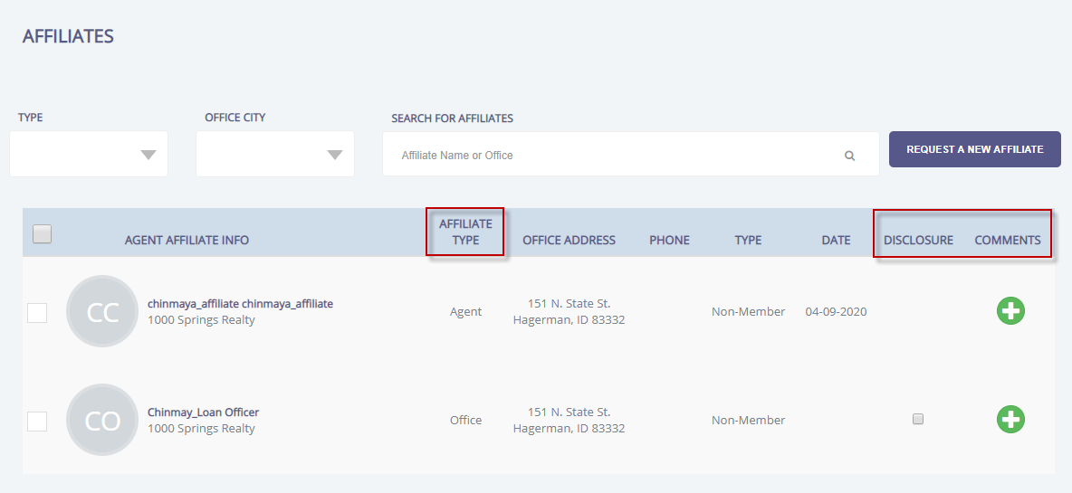

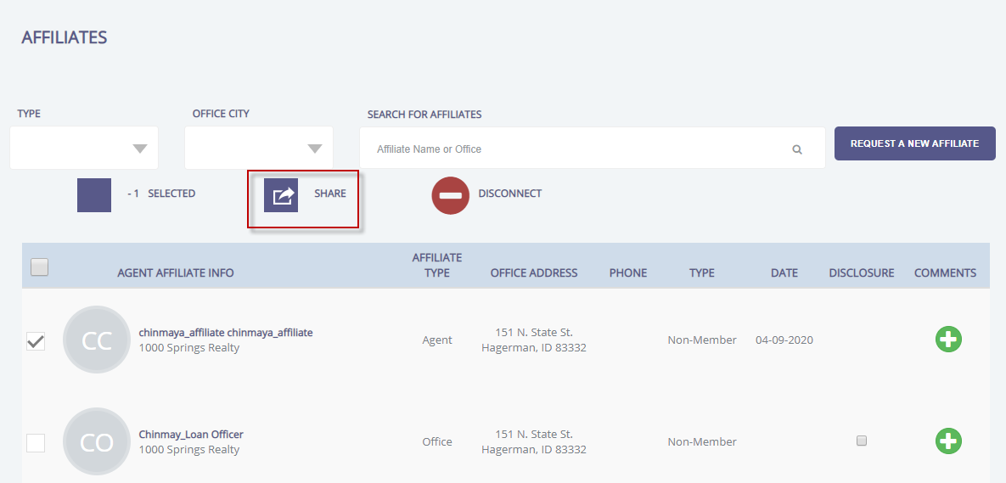

## Listing Search link added to Affiliate Dashboard

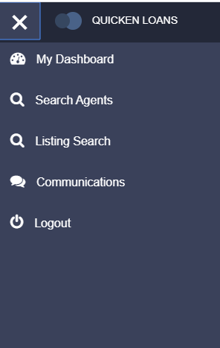

### Action Item: Add search site URL to the config setting AFFILIATE_CONNECT_PROPERTY_SEARCH_URL

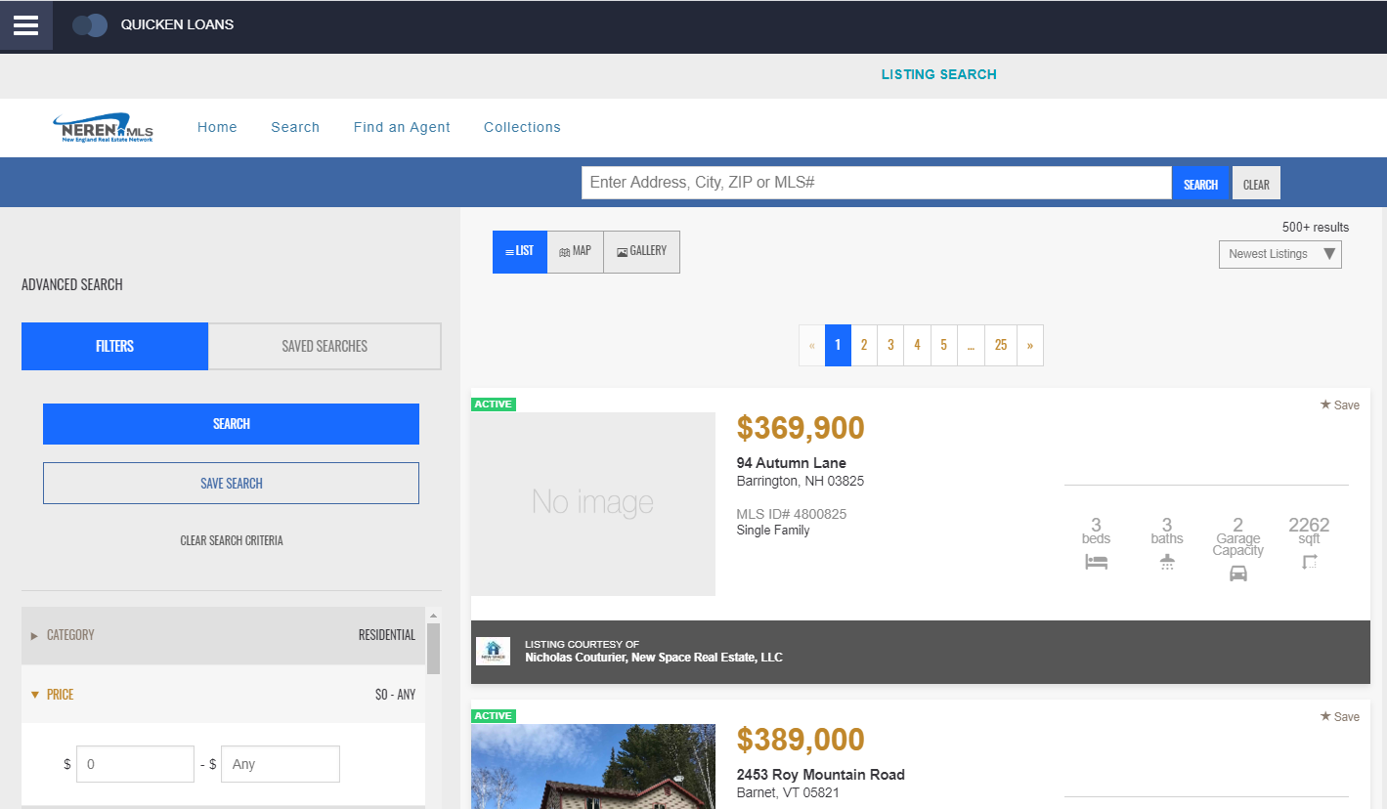A Listing Search link can be added to the Affiliate Dashboard menu. The MLS can select the search site, either the MLS’s consumer facing site, or Black Knight’s IDX solution if a consumer site is not available. The search site is framed in the Affiliate Dashboard.

## Add Agent comments when sharing Contacts with Affiliates

### Action Item: N/A

Agents have the option of including comments or notes when sharing affiliate information with clients, or when sharing clients with affiliates.

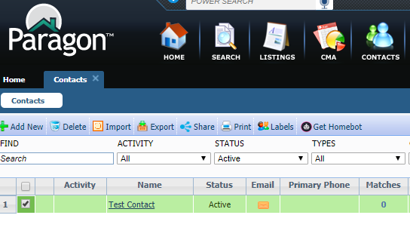

# Action Item Contents

New Premium Tax Features: Action Item: Integrated Search must be enabled in Configuration Settings.

Listing Search Link added to Affiliate Dashboard: Action Item: Add search site URL to the config setting AFFILIATE_CONNECT_PROPERTY_SEARCH_URL