Paragon Customer Toolkit - Release 5.78

## **Communications Plan Overview**

Welcome to the Paragon release communication Toolkit. The intention of this kit is to help you with communicating the release information to your membership.

In this kit you will find the following:

* Link to Release Notes for Paragon 5.78: the notes include any configurations and administration items that you will need to know about.
* Administration Configuration Options: What changes you may have to make a decision on
* Agent level Communication Plan: a link to an editable Customer Communication, and homepage notifications.
* Social Media: a post that you can use for Facebook, Instagram or other sites with a video of the release features
* Example Home Page Announcements: You can cut and paste into your Homepage.

The goal is to make everyone aware of all the great Paragon enhancements to boost the way Members do Business!

## **Release Notes for Paragon 5.78**

Listed below is a link to the full release notes for the MLS. These release notes are for the Association/MLS. The Agent Level changes in this document are included in the e-mail template that you will want to send out to your members.

**Link:** [Release Notes](http://paragonconnect.paragonrels.com/images/documents/release_notes/578/Paragon%205.78%20Release%20Notes.docx)

## **Administration Configuration Options**

**Partial Listing Retention Settings**

**Action Item:** Review retention settings and contact SSM if you would like to make any changes

To address multiple customer requests for partial listings to be retained on the Paragon site for a sufficient amount of time, a script will be run during the 5.78 deployment to update purge settings for only customers who currently keep Partial Listings for one day.

* Admin > Status Category=10 Partial Listings > **ALL** Months to Keep value will be changed to 12 months for all sites where it is currently 0.
* **Sites with Months to Keep greater than zero will not be changed.**

## **Agent Level Changes Communication Plan**

The following link is to the e-mail template that you can copy and paste from to send out to your members keeping them informed on the release. [Paragon Release 5.78 Member Email](http://paragonconnect.paragonrels.com/images/Client_toolkit/Email%20to%20agents%205.78%20-%20doc.docx)

This is a word document that you can edit so if you **do not** have certain functionality, for example Premium Tax or Affiliate Connect, you can remove those sections first before sending. Also, in the first sentence you will want to add **your MLS name** (it is in red), so that it is being sent from **your** organization to **your** members.

To ensure that your members are always informed about the latest and greatest enhancement to their MLS System, please announce the enhancements to your membership, post to Social Media sites, include them in your newsletters and post notices to your homepage and login messages.

## **Social Media Post**

Copy and past the following into your social media and the picture below will display with the video.

Please encourage your membership to like our Facebook page @ParagonMLS.

Check out the exciting new features of the Paragon 5.78 release which includes an all new ConnectView for listings, a new, fast, Google import for contacts and key enhancements to partial listings, power search and the parcel mapping! <https://vimeo.com/436882417/ff87d336a9>

[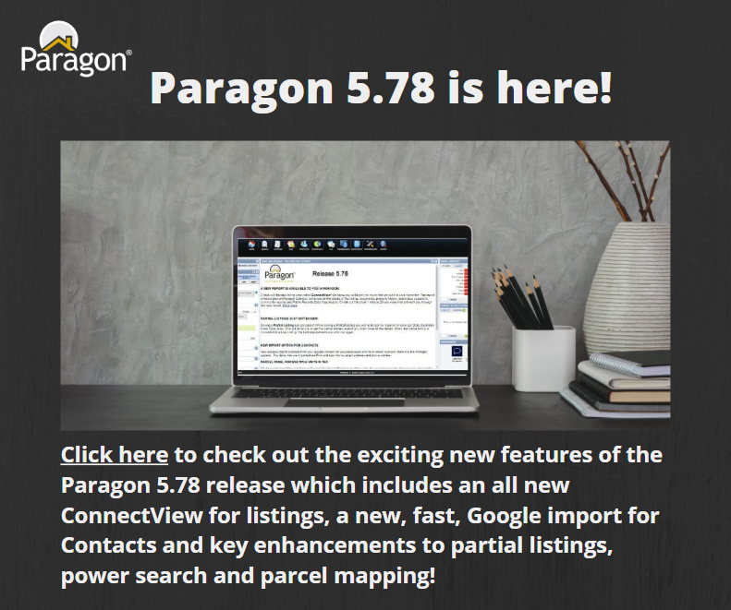](https://vimeo.com/436829753/0a12c38571)

## **Example Home Page Announcements**

The release has a lot of nice enhancements, you may want to highlight a different one every few days on your homepage and via Social Media. You can just cut and paste these into your homepage editor. If you want to add pictures you can do that too but make sure to upload them to your server.

**A NEW REPORT IS AVAILABLE TO YOU IN PARAGON!**

Check out the new listing view called **ConnectView**! We know you will love it so much that we put it in your Favorites! The report, which is also on Paragon Connect, combines all the details of the listing, documents, property history, automated valuations, community reports and Public Records Data if applicable. Check out this short 1 minute 25 sec video that will walk you through this new report. [Click here](https://vimeo.com/427754219/23850c104b).

**PARTIAL LISTINGS JUST GOT EASIER!**

Saving a **Partial Listing** just got easier! When saving a Partial Listing you will no longer be required to save List Date; Expiration Date; Type; Area. This will allow you to get the partial started, even if you don’t have all the details. When the Partial listing is converted to a Live Listing, the field requirements are enforced again.

**NEW IMPORT OPTION FOR CONTACTS**

You can now import contacts from your google contact list you can browse and mutli-select to import them into the Paragon system.  The fields that are imported are First and Last Name, email address and phone number.

**PARCEL PANEL FOR MULTIPLE UNITS IN TAX**

We have enhanced the parcel property panel for places that have multiple units, for example a condo. You can now click on the property panel and it will display in a panel the multiple Unit numbers that have the individual parcels.

I would put these two on your homepage the same day

**DIRECT LINK TO LISTING FROM ZESTIMATE LABEL**

When you see Zestimate label if you click on it you will be linked out to the specific property in Zillow. Previously it just brought you to Zillow home page.

**DIRECT LINK TO REFINED VALUATION MODEL IN RPR**

Like the Zestimate link, a link has been added to the Realtors Valuation Model to SSO the user directly into the Refined Valuation Model in RPR, where the user can use the interactive RVM to create a report. This is being added as a value-add, not as a terms-of-use requirement. This link will only appear to agents.

