

**PARAGON - INNOVATING THE WAY AGENTS DO BUSINESS**

**Paragon Release 5.78**

We (enter your MLS Name here) wanted you to be the first to know about the latest enhancements to your Paragon MLS System. All enhancements are designed to help you navigate through the system and enhance your experience with Paragon.  Below is a list of the enhancements and links to view videos or PDFs of the new features. We encourage you to continue reading and let us know what you think on the [Paragon MLS Facebook site](https://www.facebook.com/ParagonMLS/). Also make sure you click like on the Facebook site to view what’s new with Paragon more frequently.

**WHAT’S NEW**

**PARAGON**

* Everyone loved the **Paragon Connect Detail View** – So now we have embedded that view in the Paragon Classic system as a new report that you can use. This Powerful Report can be found in your Favorites folder and is called **ConnectView.** This report combines all the details of the listing, with any Documents, Property History, Automated Valuations, Community Reports and if you are a premium tax member you will see Public Record Data as well. Check out this short 1 minute 25 sec video that will walk you through it [Click here](https://vimeo.com/427754219/23850c104b).
* 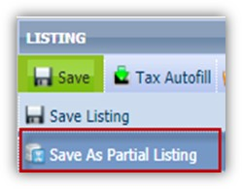Saving a **Partial Listing** just got easier! When saving a Partial Listing you will no longer be required to save List Date; Expiration Date; Type; Area. This will allow you to get the partial started, even if you don’t have all the details. When the Partial listing is converted to a Live Listing, the field requirements are enforced again.

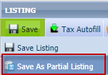

* We continue to refine **Power Search** to bring you better results! In this release, we’ve enhanced how Power Search views a short numeric string. Assuming a short numeric string is looking for an address, Power Search will return exact matches first, before returning ‘starts with’ matches. For example, “123” will return listings with street number 123 before listings with street number 1234 or 1235.

* You asked and we delivered! You now have a new import option for your **Contacts,** this will allow you to browse and multi-select **Google** contacts to import into Paragon!

The fields that are imported are First and Last Name, the email address and the phone number.

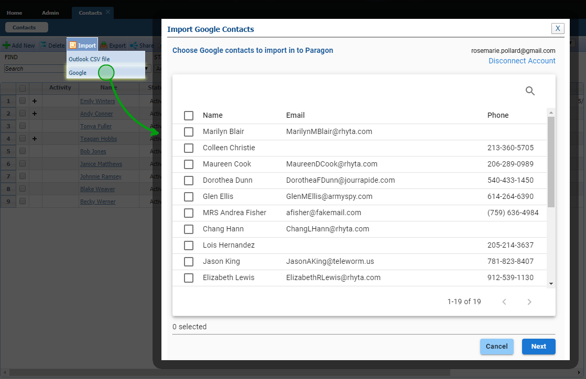

* In our last release we implemented the ability to display associated **public record pins** with listing pins on the same map for select customers, however the public record portion was limited to the map boundaries and ignored any drawings used in the search for listings. Now when there are drawings on the map, the public record search will include the drawing coordinates in the search and limit the results to the drawings, just like the listings.

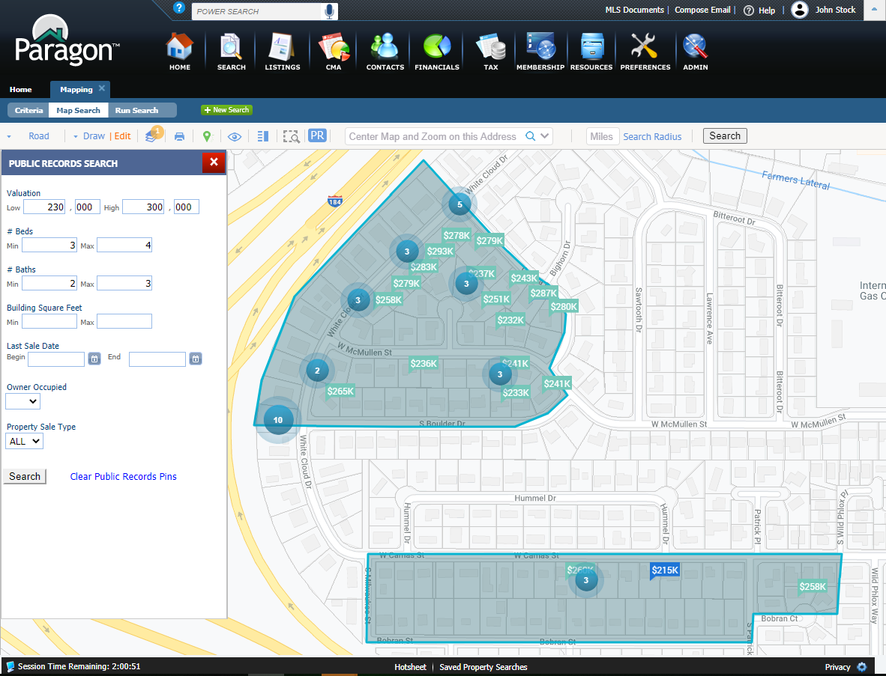

* Now when you see **Zestimate** label if you click on it you will be linked out to the specific property in Zillow. Previously it just brought you to Zillow.

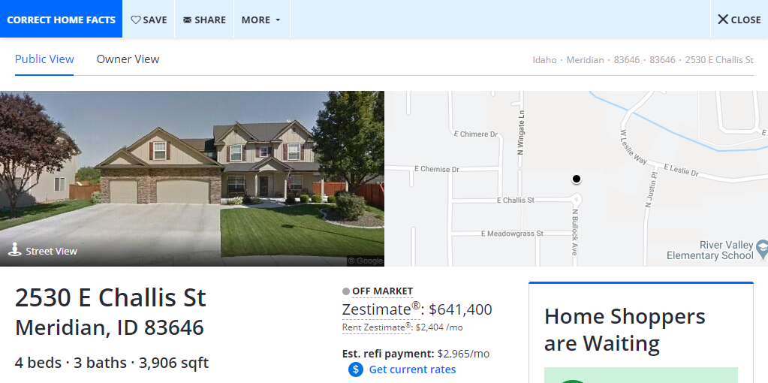

* Similar to the Zestimate link, a link has been added to the **Realtors Valuation Model** to SSO the user directly into the Refined Valuation Model in RPR, where the user can use the interactive RVM to create a report. This is being added as a value-add, not as a terms-of-use requirement. This link will only appear to agents.



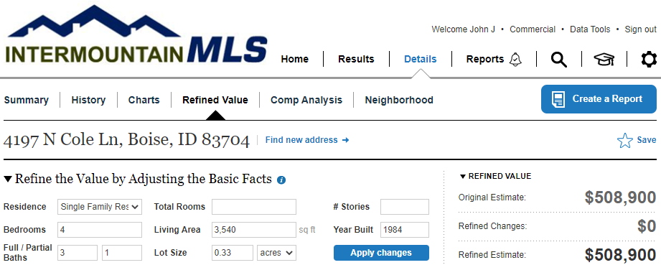

* We have enhanced the parcel property panel for places that have multiple units, for example a condo. You can now click on the property panel and it will display in a panel the multiple Unit numbers that have the individual parcels.

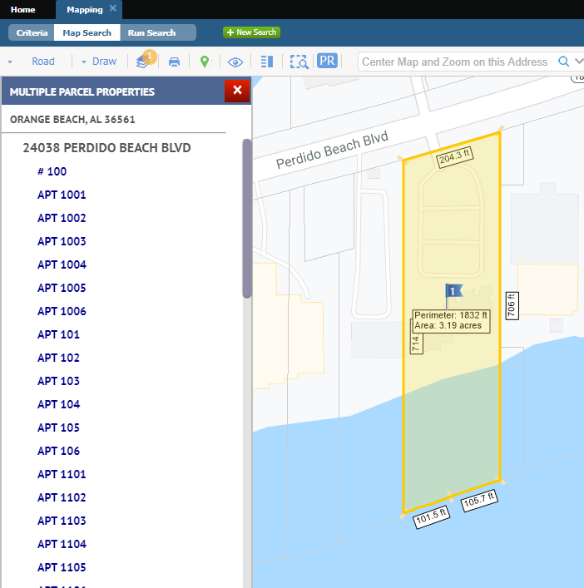

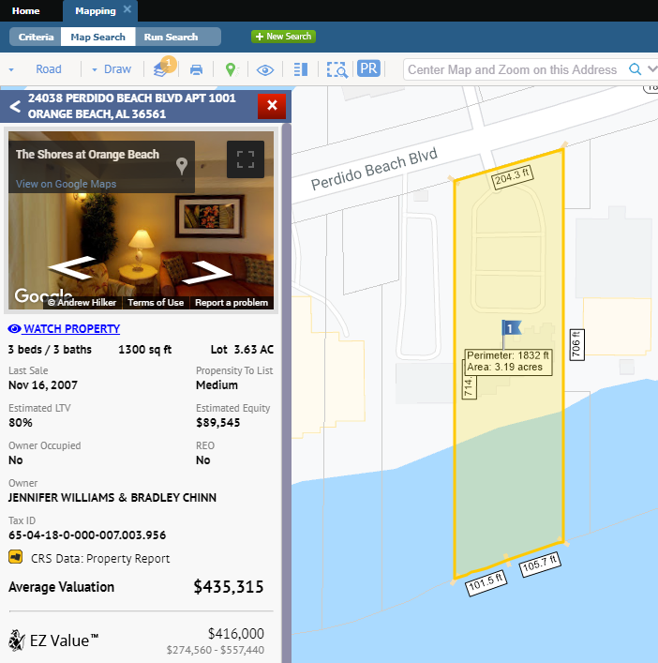

**PARAGON CONNECT**

With the 5.78 release we give you more reasons to start using Paragon Connect as your mobile and tablet search and collaboration tool. In the video that outlines the new enhancements to Paragon Connect, it will also give you a sneak peek at what is coming later in the 5.79 release. [Click here](https://vimeo.com/425605798) and please watch all the way through to get your sneak peek.

* Review the ConnectView
* Public Record Data – View public Record and MLS data all in the same report and zoom in and click on the parcel to view
  + Owner Information
  + Mortgage History
  + Location Information
  + Building Characteristics
  + Tax Assessment
* Interactive Parcels (for our premium tax members) – You can view in close to any property visible on the screen and click the parcel record to view the public record info on that property.

**CRS TAX**

* When viewing your property watches in the grid, you now have the ability to select watched properties, we have added the check box to the give you the ability to select one, more or all your properties from your watch list and export the data. With the export, the agent will be able to sort, print or email the list. We have also added the Owner Name to the grid so that you can use that information in a mailing

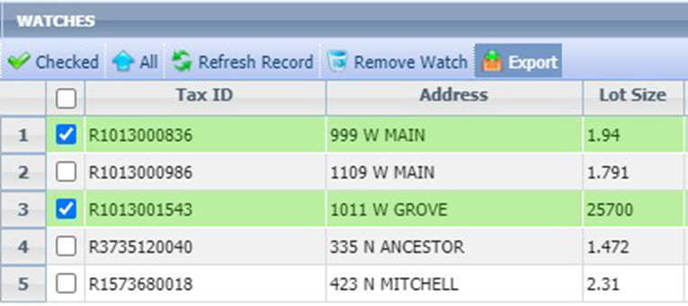

* We added “Details” as a column to My Property Watch Alert Grid, this way you will not have to return to your original email to see the details of the alert.

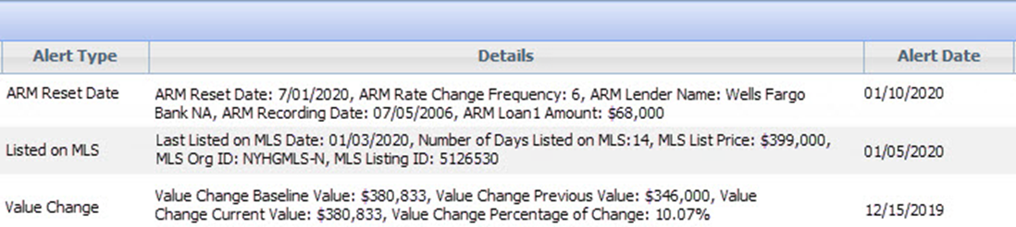

**PARAGON AFFILIATE CONNECT**

The Paragon Affiliate Connect agent dashboard has been further improved to support agent, office and firm level users.

The agent can connect with affiliates on an agent level, and benefit from being connected to affiliates on an office level by their office manager. Agents can interact with both agent and office level affiliates through comments. Any comment added will be available to the affiliate in their dashboard, and they can also send an email to the affiliate. The agent can view any disclosure added by an office or firm level manager.

An office or firm manager will be able to add affiliates to a specific office they oversee, or multiple offices within their firm. They are also able to add or edit disclosures as appropriate for the specific affiliate. When an affiliate is connected at an office or firm level, all the agents within the office(s) are visible in their dashboard.

