# Paragon 5.78 Release Enhancements (July 2020)

Paragon 5.78 Release Enhancements (July 2020) 1

Corrected Issues 2

Agent Level Changes 3

New View – ConnectView 3

LIM – Saving a Partial Listing Certain Field Requirements Removed 4

Contacts - Importing Google Contacts 5

Search - Power Search – Numeric String Changes 6

Search – Display Public Records with Listings on Map 7

Zestimate Direct Link 8

Deep Link from REALTORS® Valuation Model to RPR 8

Checkboxes and Export Option Added 9

Added Details Column to Alerts Grid 9

Parcel Property Panel Now Supports Multi-Unit Parcels 10

MLS Customizations and Administration 11

Partial Listings Retention Settings 11

Admin - Add Audit Button to Maintain Office 11

Admin - Simplified Transfer of Agents and Assets 12

Paragon Connect 14

Public Record Data 14

Interactive Parcels 15

Activity Tracking 15

Affiliate Connect 16

Agent Dashboard Updates 16

New! Affiliate Market Page and Sign up Form 17

# Corrected Issues

|  |  |  |  |  |
| --- | --- | --- | --- | --- |
| **WO#** | **Seq** | **Module** | **Organization** | **Summary** |
| 131637 | 1 | RETS | New England Real Estate Network (NEREN) | Vendor updates to listings via FTP, L_UpdateDate does not reflect change PETL |
| 136259 | 1 | CMA | Willamette, NEREN | CMA Summary Report Cutting Off |
| 146363 | 1 | Views/Reports | Intermountain, CARMLS, Global MLS, MAXEBRD, Memphis | Sub Area not sorting properly on spreadsheets for some users |
| 147022 | 3 | Update | Northern Nevada Regional MLS, Georgia MLS, St. Augustine | RETS: Interactive Map Layer Errors Can't Be Bypassed with RETS Update |
| 149750 | 1 | Admin - Listings | New England Real Estate Network (NEREN) | Incorrect Updating Agent on Associated Documents Audit Report from Assumed Agent |
| 150562 | 1 | CMA | New England Real Estate Network (NEREN) | Subject Property Photo Not Being Used on Cover Setup Page |
| 150903 | 1 | Views/Reports | New England Real Estate Network (NEREN) | Clicking the Favorite Icon on a Tax Report Results in an Error |
| 151186 | 1 | Admin - Listings | NorthstarMLS (NSMLS) - Regional MLS of Minnesota, RMLS Portland | Under certain situations, photo slideshow is cutting off bottom of photos |
| 151287 | 1 | Admin - MLS Views and Reports | New England Real Estate Network (NEREN) | Delete Field Preference Section Confirms Delete Home Page Message - Wrong Wording |
| 128572 | 1 | Views/Reports | South Central Kansas MLS – Wichita, Charlottesville, Rutherford | Emailed hyperlink of more than four listings in QuickCMA View causes overlapping |
| 150281 | 1 | Mapping | Baldwin County AOR (BCAR) | Need to enhance parcel-click property panel to display multiple properties from parcel of condos |
| 147881 | 1 | Collab Center Preferences | New England Real Estate Network (NEREN) | Agent Photo Aspect Ratio is Not Maintained in Collab Center, it distorts the photo, making it necessary to attach a custom photo. |

# Agent Level Changes

**The following section contains changes that are active system wide and available to users based on their assigned security levels.**

## New View – ConnectView

### Action Item: N/A

Everyone loves the Paragon Connect Detail View – So now we have embedded that view in Paragon Classic. This powerful report is located at the top of your Favorites folder (because we are sure you are going to want it as a favorite) and is called the **ConnectView.** If you decide to remove ConnectView from your favorites, it will appear under Specialty Views.

User Preferences are available for setting the ConnectView as the default search result report, default double-click report, etc.

The power of this view is that it combines all the details of the Listing, with any Documents, Property History, Automated Valuations, and Community Reports, and where applicable, Public Record Data as well. Simply click the tabs at the top to be taken to each section or scroll the View. Check out this short 1 minute 25 sec video that will walk you through it [Click here](https://vimeo.com/427754219/23850c104b).

Note: Due to its interactive nature, when shared via email the ConnectView will be sent as a CollabLink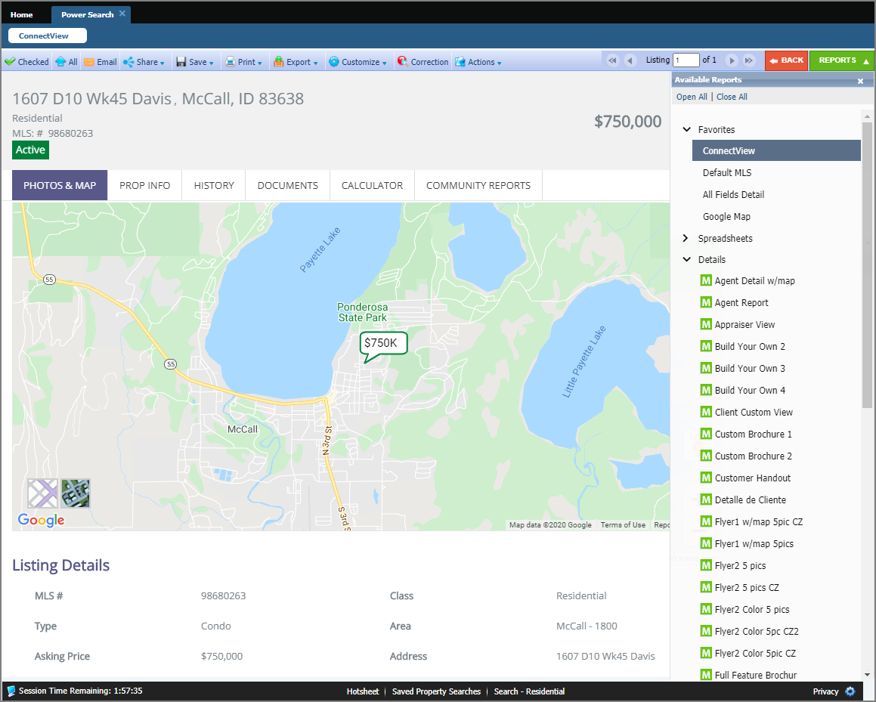

## LIM – Saving a Partial Listing Certain Field Requirements Removed

### Action Item: N/A

Saving a Partial Listing just got easier!

When saving a Partial Listing you will no longer be required to save List Date, Expiration Date, Type, or Area. This will allow you to get the partial started, even if you don’t have all the details.

When the Partial listing is converted to a listing, the field requirements are enforced again.

## Contacts - Importing Google Contacts

### Action Item: N/A

You asked and we delivered! You now have a new import option for Contacts, this will allow you to browse and multi-select Google contacts to import into Paragon!

The fields that are imported are; First Name, Last Name, Email, and Phone Number.

**Note:** Browsers must allow pop-ups from Paragon for this function.

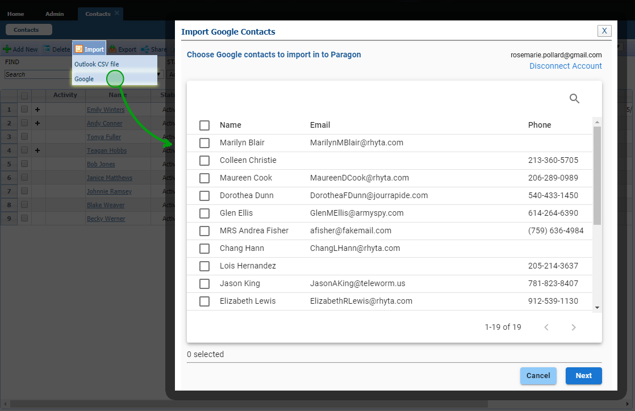

## Search - Power Search – Numeric String Changes

### A screenshot of a cell phone Description automatically generatedAction Item: N/A

We continue to refine Power Search to bring you better results!

In this release, we’ve enhanced how Power Search views a short numeric string. Assuming a short numeric string is looking for an address, Power Search will return exact matches first, before returning ‘starts with’ matches insuring better accuracy.

For example, “123” will return listings with street number 123 before listings with street number 1234 or 1235.

## Search – Display Public Records with Listings on Map

### Action Item: N/A

In 5.77, we released the ability to display associated public record pins with listing pins on the same map for select customers. But the public record portion was limited to the map boundaries and ignored any drawings used in the search for the listings. Now if/when there are drawings on the map, the public record search will include the drawing coordinates in the search and limit the results to the drawings, just like the listings.

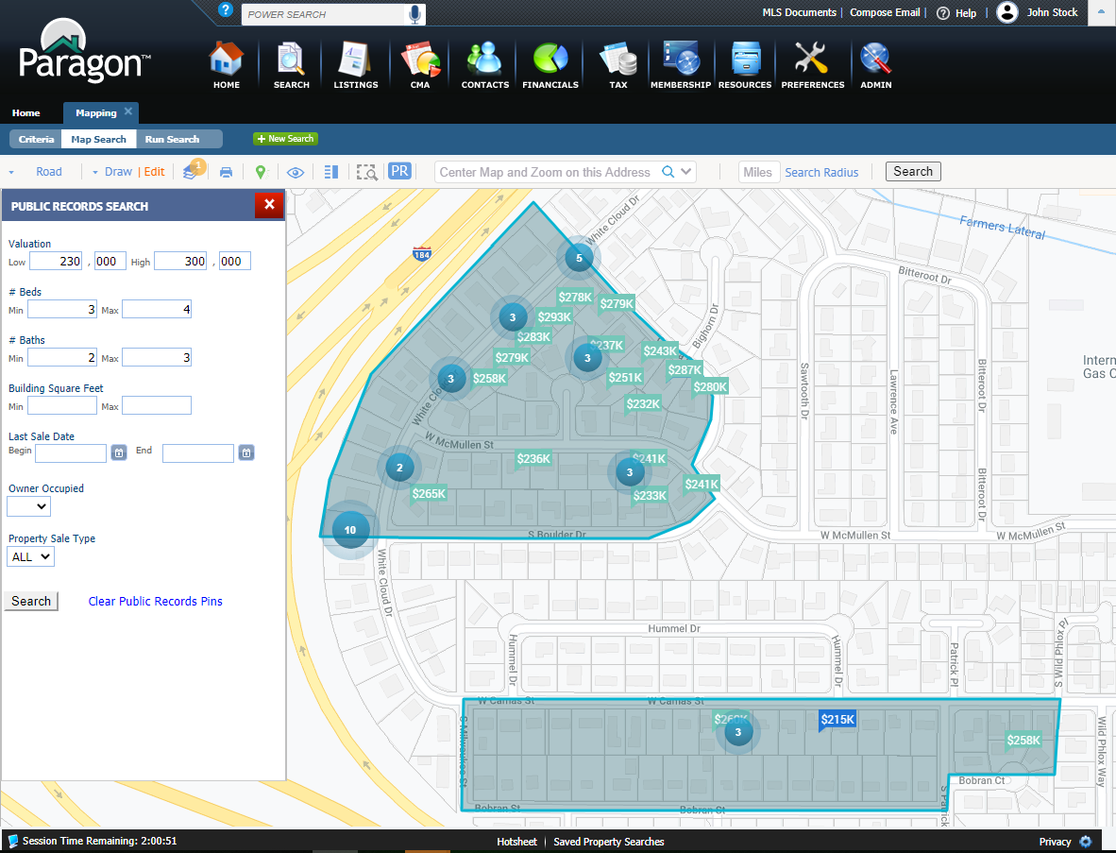

## Zestimate Direct Link

### Action Item: N/A

A link has been added from the Zestimate to the specific property in focus. Previously, the feature just linked to Zillow.com. Now it lands on the specific property in Zillow.

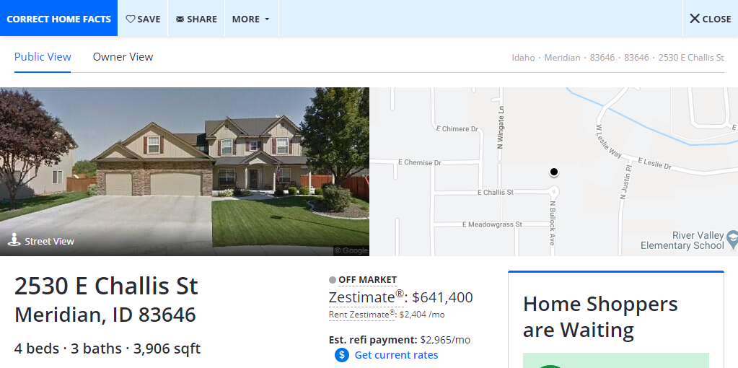



## Deep Link from REALTORS® Valuation Model to RPR

### Action Item: N/A

Similar to the Zestimate link, a link has been added to the Realtors Valuation Model (RVM) that takes the user directly into the Refined Valuation Model in RPR, where the user can use the interactive RVM to create a report. **Note:** This link will only appear to agents.

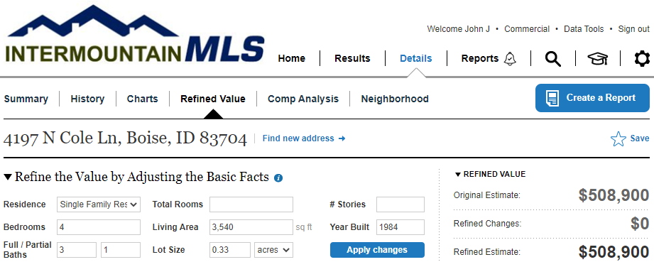

## Checkboxes and Export Option Added

### Action Item: N/A

When viewing your property watches in the grid, you now can select watched properties. We have added the check box to the give you the ability to select one, more or all your properties from your watch list and export the data. With the export, the agent will be able to sort, print or email the list. We have also added the Owner Name to the grid so that you can use that information in a mailing list. 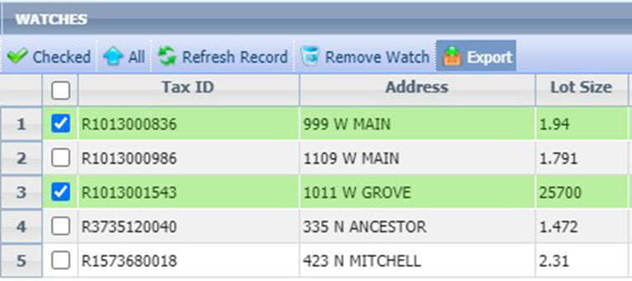

## Added Details Column to Alerts Grid

### Action Item: N/A

So that the user will not have to return to the original email to see the details of the alert, we have added the details to the grid when looking at your watches. 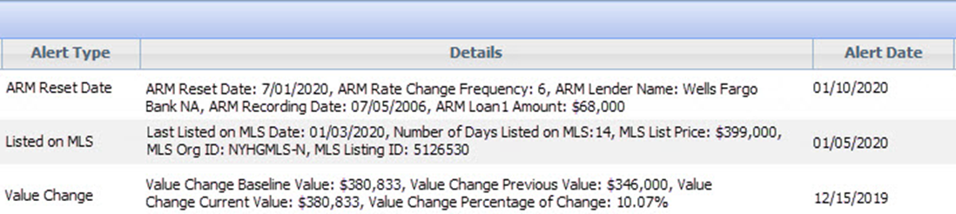

## Parcel Property Panel Now Supports Multi-Unit Parcels

### Action Item: N/A

You asked and we delivered! If you have a single parcel with multiple units, such as a condo, the property panel will display the parcel address followed by multiple Unit numbers for that parcel. Click the unit number to view the individual property record for that unit.

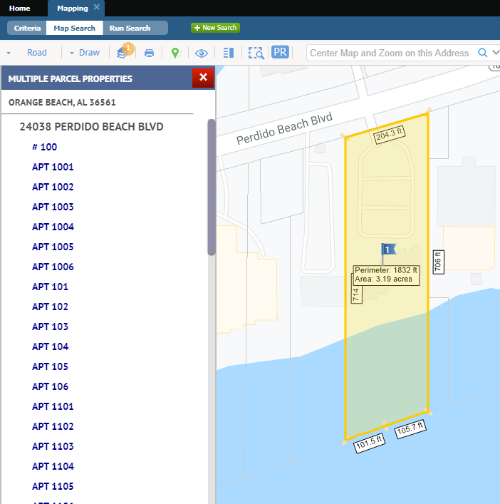

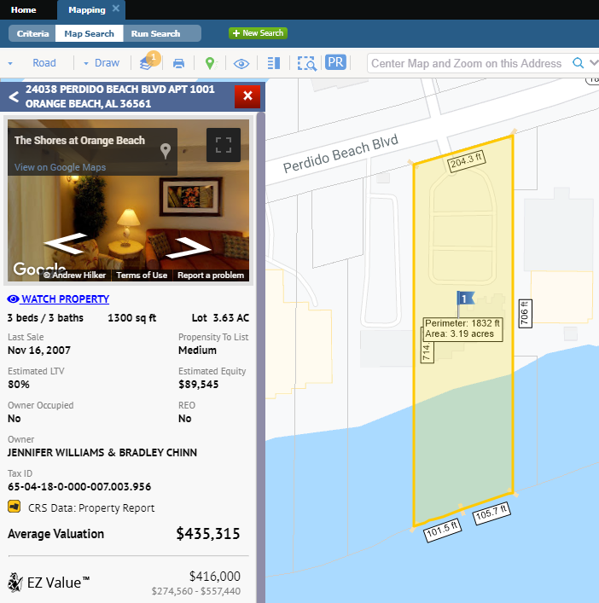



# MLS Customizations and Administration

**All options in this section are either configurable via MLS Administration controls or by your System Support Manager as noted.**

## Partial Listings Retention Settings

### Action Item: Review retention settings and contact SSM is you would like to make any changes

To address multiple customer requests for partial listings to be retained on the Paragon site for a sufficient amount of time, a script will be run during the 5.78 deployment to update purge settings for only customers who currently keep Partial Listings for one day.

* Admin > Status Category=10 Partial Listings > ALL Months to Keep value will be changed to 12 months for all sites where it is currently 0.
* **Sites with Months to Keep greater than zero will not be changed.**

## Admin - Add Audit Button to Maintain Office

### Action Item: N/A

After high acclaim for the recently added Audit button on the Admin > Maintain Agent page, we’ve added an Audit button to the Maintain Office page, too! Clicking the Audit button in the toolbar while on an office record displays the Organization Audit Report for that office.

## Admin - Simplified Transfer of Agents and Assets

### Action Item: N/A

We have simplified the interface and workflow for moving an agent between offices and transferring an agent’s assets (CMAs, Listings, Contacts, etc.). There is now a separate tool for each of these two functions!

Both tools are available in the agents grid and the agent viewer.

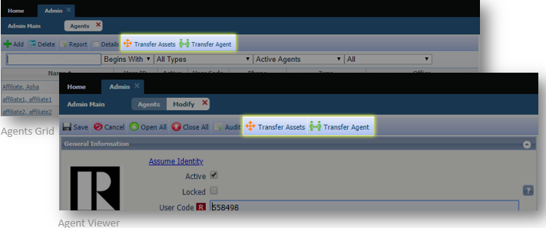

When transferring **Assets** the updated UI is easier to read and understand due to a more refined layout.

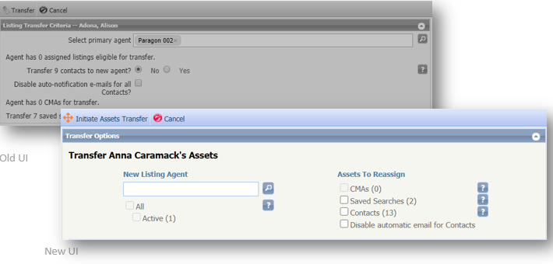

When transfering an Agent the new updated UI makes the options easier to understand. **A long awaited feature has been added for changing the agent’s team. If the Admin User DOES NOT specify a team during a transfer, the agent’s team will be removed.** Also the Listing Agent column has been added to the grid so that you can individually manage listing assignments.

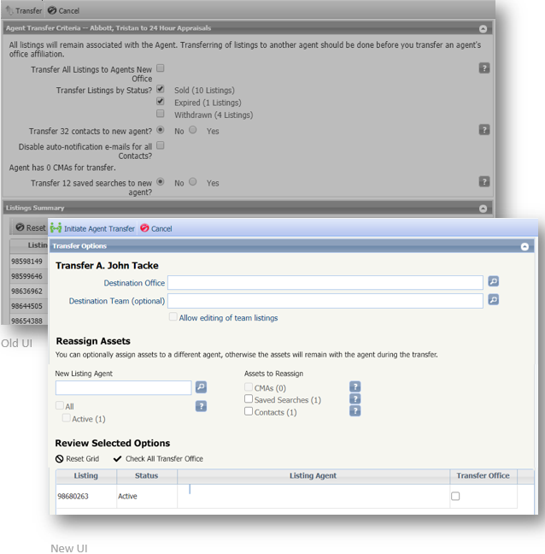

# Paragon Connect

**All options in this section are either configurable via MLS Administration controls or by your System Support Manager as noted.**

## Public Record Data

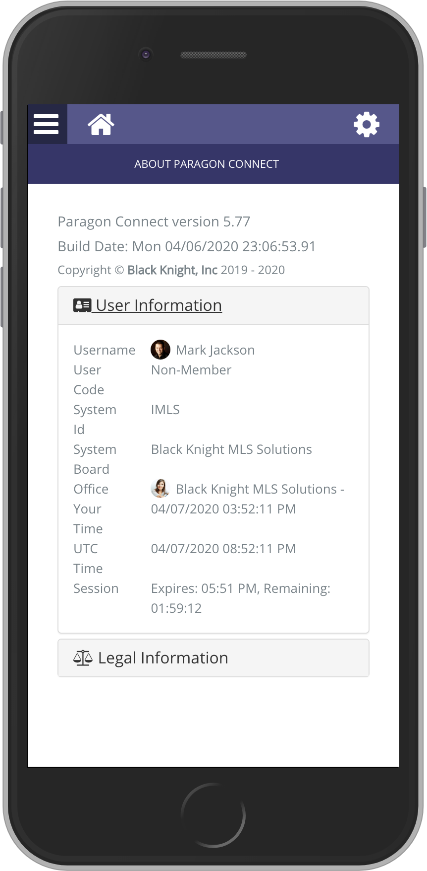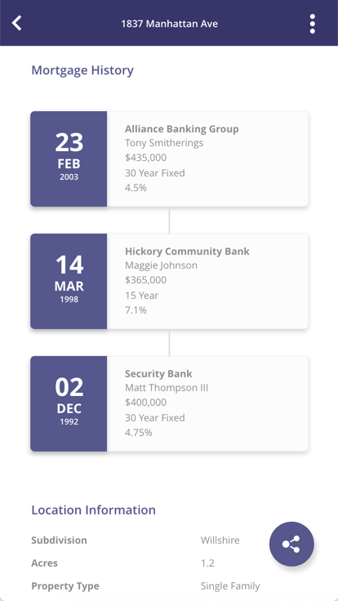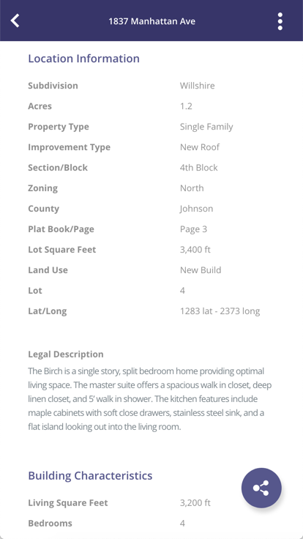

### Action Item: N/A

In our last 5.77 release, we accessed standardized Public Record Data from Black Knight and CRS via API.

Now in 5.78, if you subscribe to any of these two Premium Tax services, you can view public record data along with MLS data all in the same report. You can also zoom in on the map and click on any parcel to view any public record data on that property. View the following:

1. Owner Information
2. Mortgage History
3. Location Information
4. Building Characteristics
5. Tax Assessment

## Interactive Parcels

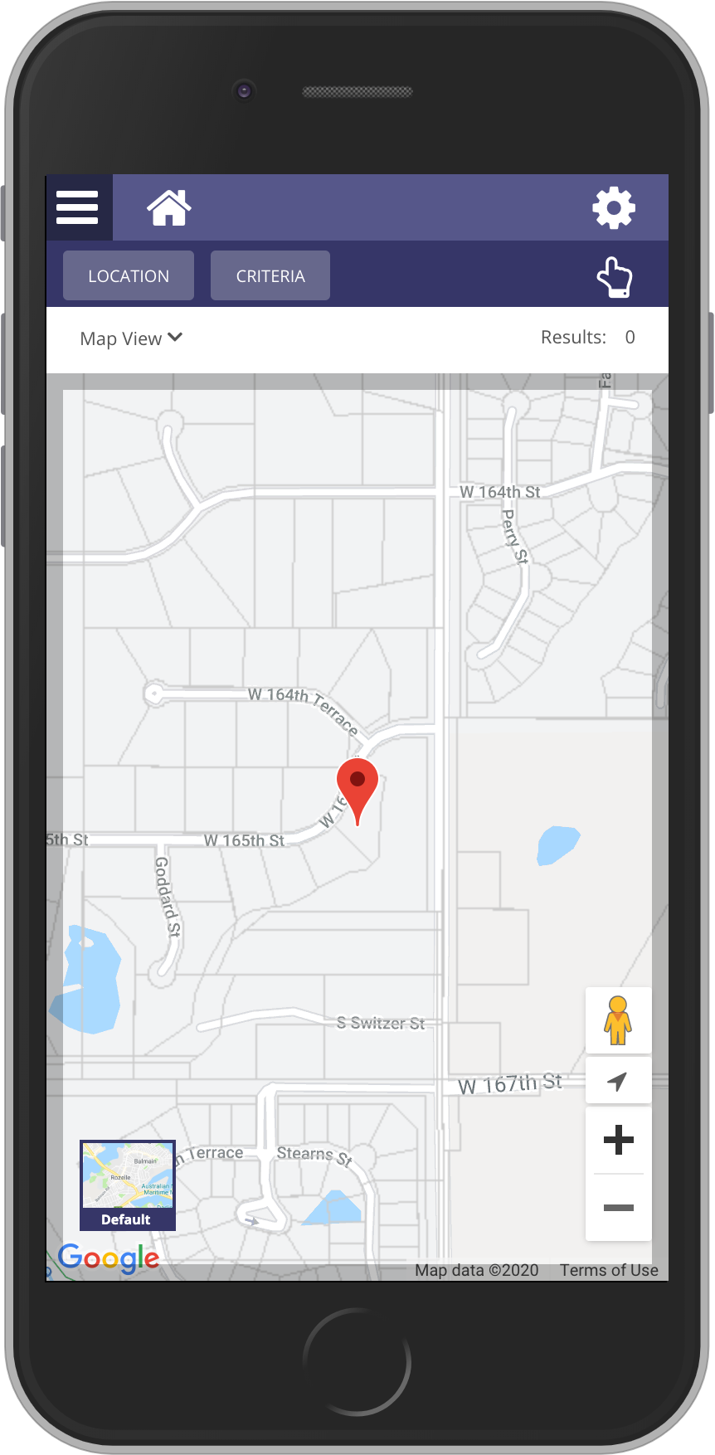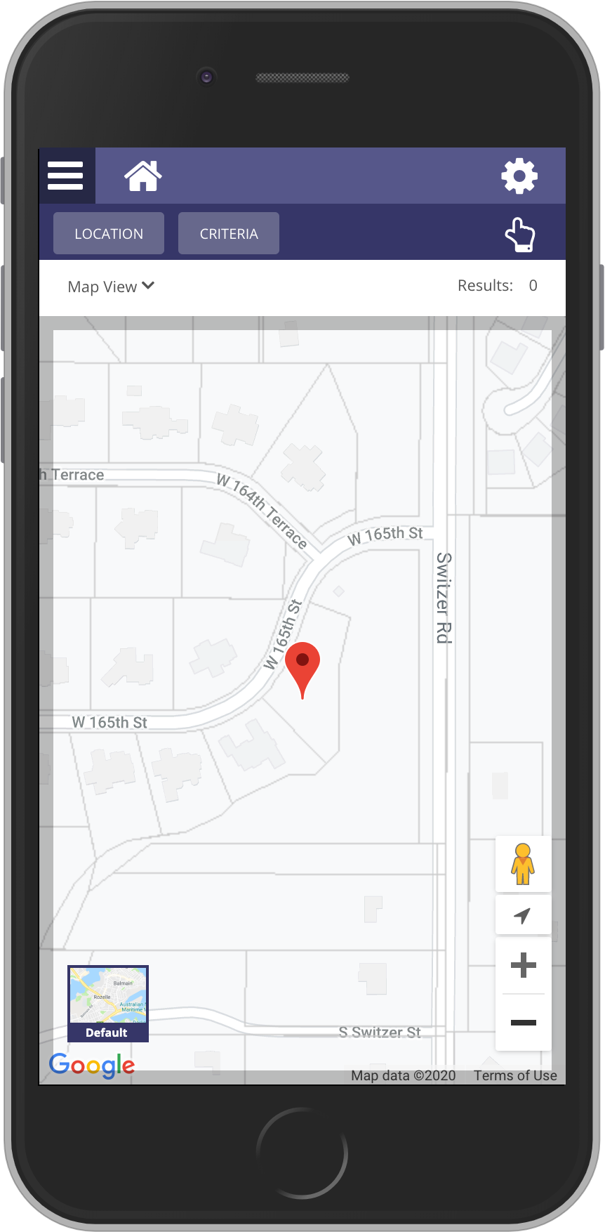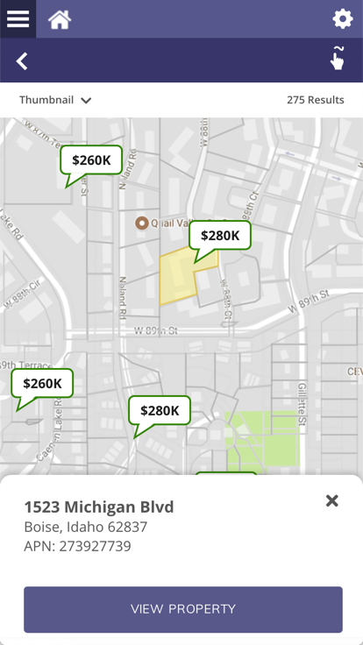

### Action Item: N/A

Prior to the 5.78 release, the only interaction available within the map view was to either draw a free hand shape or click on a MLS pin. Now, you can view in close to any property visible on the screen and click the parcel record to view the public record information on that property.

**Note:** Only available to premium tax members.

## Activity Tracking

### Action Item: N/A

While not yet visible, additional tracking elements have been added to Paragon Connect. These tracking items help identify usage of the application. Below are a few new items being tracked:

1. Logins
2. Viewing Detail Report
3. Emailing a listing
4. Perform a Power Search
5. Add/Modify a Photo
6. Setup buyer or a sell side site

# Affiliate Connect

**All options in this section are either configurable via MLS Administration controls or by your System Support Manager as noted.**

## Agent Dashboard Updates

### Action Item: N/A

The PAC agent dashboard has been further improved to support agent, office and firm level users.

The agent can connect with affiliates on an agent level, and benefit from being connected to affiliates on an office level by their office manager. Agents can interact with both agent and office level affiliates through comments. Any comment added will be available to the affiliate in their dashboard, and they can also send an email to the affiliate. The agent can view any disclosure added by an office or firm level manager.

An office or firm manager will be able to add affiliates to a specific office they oversee, or multiple offices within their firm. They are also able to add or edit disclosures as appropriate for the specific affiliate. When an affiliate is connected at an office or firm level, all the agents within the office(s) are visible in their dashboard.

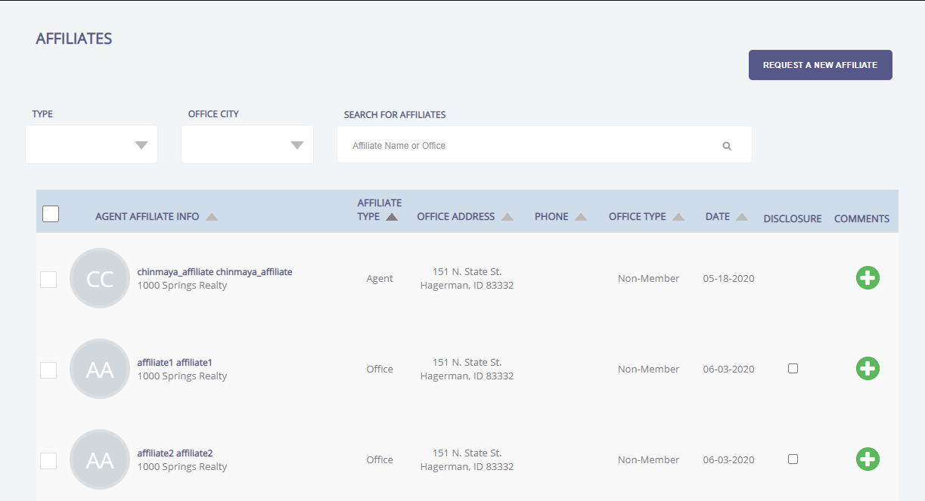

## New! Affiliate Market Page and Sign up Form

### Action Item: N/A

Paragon Affiliate Connect is now an easy, turn-key solution for the MLS to implement. We now have a full marketing page, sign up form and paywall for affiliates.

Black Knight will hold webinars for affiliates to learn about PAC, handle the onboarding of affiliates for your particular MLS and we will train and support the affiliates.

The pricing for PAC is $25 per month, per affiliate. There is no long-term contract and affiliates can cancel with a 30 day notice.