Paragon Customer Toolkit - Release 5.79

## **Communications Plan Overview**

Welcome to the Paragon release communication Toolkit. The intention of this kit is to help you with communicating the release information to your membership.

In this kit you will find the following:

* Link to Release Notes for Paragon 5.79: The notes include any configurations and administration items that you will need to know about.
* Administration Configuration Options: What changes you may have to make a decision on.
* Agent level Communication Plan: A link to an editable customer communication, and homepage notifications content.
* Social Media: A post that you can use for Facebook, Instagram or other sites with a video of the release features.
* Example Home Page Announcements: You can cut and paste into your Homepage.

The goal is to make everyone aware of all the great Paragon enhancements to boost the way members do Business!

## **Release Notes for Paragon 5.79**

Listed below is a link to the full release notes for the MLS. These release notes are for the Association/MLS. The Agent Level changes in this document are included in the e-mail template that you will want to send out to your members.

**Link:** [Release Notes](http://paragonconnect.paragonrels.com/images/documents/release_notes/579/Paragon%205.79%20Release%20Notes.docx)

## **Administration Configuration Options**

**CDOM Calculation to include check for Previous List Office Match**

**Action Item:** **To enable this setting you must contact your SSM**

To eliminate calculation of Cumulative Days on Market for a listing if the previous listing was with a different office, we have added a new configuration. This setting is defaulted to No, if you want to include previous office listings you will need to have your SSM set it to Yes for you.

## **Agent Level Changes Communication Plan**

The following link is to the e-mail template that you can copy and paste from to send out to your members keeping them informed on the release. [Paragon Release 5.79 Member Email](http://paragonconnect.paragonrels.com/images/documents/release_notes/579/Email%20to%20agents%205.79%20.docx)

This is a word document that you can edit so if you **do not** have certain functionality, for example Premium Tax or Affiliate Connect, you can remove those sections first before sending. Also, in the first sentence you will want to add **your MLS name** (it is in red), so that it is being sent from **your** organization to **your** members.

To ensure that your members are always informed about the latest and greatest enhancement to their MLS System, please announce the enhancements to your membership, post to Social Media sites, include them in your newsletters and post notices to your homepage and login messages.

## **Social Media Post**

Copy and paste the following into your social media, it will link out to our video on the latest release.

Check out the exciting new features of the Paragon 5.79 release which includes both Paragon changes and Paragon Connect! <https://vimeo.com/456360809/4ed8700819>

Here is what you will see in your post when you put this in your Facebook post

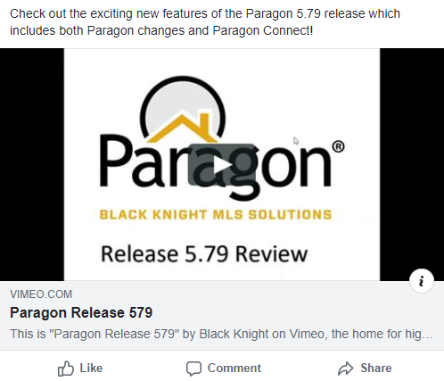

Please encourage your membership to like our Facebook page @ParagonMLS, and we are on Instagram at Paragon_MLS.

## **Example Home Page Announcements**

The release has a lot of nice enhancements, you may want to highlight a different one every few days on your homepage and via Social Media. You can just cut and paste these content pieces into your homepage editor. If you want to add pictures you can do that too but make sure to upload them to your server.

**COLLABORATION CENTER NOTIFICATIONS ADDED TO SEARCH ACTIVITY**

The Contact Summary in the Paragon Contact Manager has been enhanced to now show Collaboration Center Notifications! Previously it only showed email searches, however now when you go to your Contact you will be able to see all information for notifications you sent out of Paragon to that client and how they were sent.

Go to Contacts> View Manage Contacts> Click on the Contact Name you wish to view. Next click on Contact Summary > Search Activity section. The grid has been enhanced to show all notification settings: Off, Email, or Collab Center.

**NEW CONTACT VIEW SHOWS LISTING DETAIL AND COMMENTS**

To help save you time, we have created a new view in contacts where you can see your listing default report with any comments made for a particular property your client is collaborating on with you. This view will allow you to be able to read the comment and know exactly what property they are commenting on, so you can comment right back to them. Accessing this view can be through the contact widget on the front page or through the contact tab by clicking on the bubble.

**POWER SEARCH REFINEMENTS**

**Viewing Inactive Members and Include in Roster Flag:** In this release, we’ve refined how the Power Search results for members are displayed in the agent roster.

Previously the agent roster was only returning active members, even when the user had permission to view inactive members. Now the roster will return inactive members where applicable.

In addition to this the system will now respect the Include in Roster Flag in the agent record when returning Power Search results, based on user security.

**User Interface Enhancements to Power Search Bar:** To help improve the readability of the Power Search input and results, some minor UI changes were made. The size of the input box was increased; the Help icon and Voice Search icons were aligned with the box.

**Refinement to update status color:** To improve the readability of the listing results, in Power Search, the status text changes to white when the row is highlighted and returns to the specified status color when the row is not highlighted.

**PARAGON CONNECT – PROPERTY WATCH**

In our previous release, we introduced interactive parcels. With interactive parcels, you can zoom and tap on any parcel. You can then view the public record data of that property. In this release, we are now adding the ability for you to watch these properties and get alerted when any data changes on these records. We also apply a color overlay to any watched properties. This allows you to see which parcels you are already watching.

1. Click on any Parcel
2. View Public Record Data
3. Watch that record
4. Map highlights any watch properties
5. Alerts sent on any changes to the property

**PARAGON CONNECT – MULTIPLE TOURS AND OPEN HOUSES**

The tour and open house search results in Paragon Connect have been enhanced to show you multiple events per listing. In the past if you searched for an open house within the next 7 days it would show you only the next open house that is occurring. But if there were more tours that week you wouldn’t be able to see that information. Now if there are multiple events within that time frame it will show each event.

In addition to the multiple results, you can now click on these results to view the details of that tour or open house event. You can even click on the “Add to Calendar” to add to your default calendar on your phone or computer.

**PARAGON CONNECT – LIVE STREAM OPEN HOUSES**

Paragon Connect will now include the live stream Open House options that were added to Paragon Classic. You can now configure your tour and open house search to search by only in person events, live only events, or allow both.

When live stream options are available you will see the same live link you see in Paragon Classic.