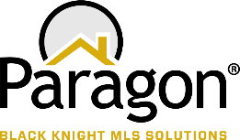

**PARAGON - INNOVATING THE WAY AGENTS DO BUSINESS**

**Paragon Release 5.79**

We (enter your MLS Name here) wanted you to be the first to know about the latest enhancements to your Paragon MLS System. All enhancements are designed to help you navigate through the system and enhance your experience with Paragon.  Below is a list of the enhancements and links to view videos or PDFs of the new features. We encourage you to continue reading and let us know what you think on the [Paragon MLS Facebook site](https://www.facebook.com/ParagonMLS/). Also make sure you click “Like” on the Facebook site to view what’s new with Paragon more frequently.

**WHAT’S NEW**

**PARAGON**

* **Add Collaboration Center Notifications to Search**

The Contact Summary in the Paragon Contact Manager has been enhanced to now show Collaboration Center Notifications! Previously it only showed email searches, however now when you go to your Contact you will be able to see all information for notifications you sent out of Paragon to that client and how they were sent.

Go to Contacts> View Manage Contacts> Click on the Contact Name you wish to view. Next click on Contact Summary > Search Activity section. The grid has been enhanced to show all notification settings: Off, Email, or Collab Center.

* **New Contact View Shows Listing Detail and Comments**

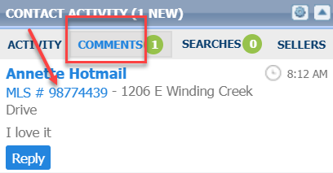To help save you time, we have created a new view in contacts where you can see your listing default report with any comments made for a particular property your client is collaborating on with you. This view will allow you to be able to read the comment and know exactly what property they are commenting on, so you can comment right back to them. Accessing this view can be through the contact widget on the front page or through the contact tab by clicking on the bubble.

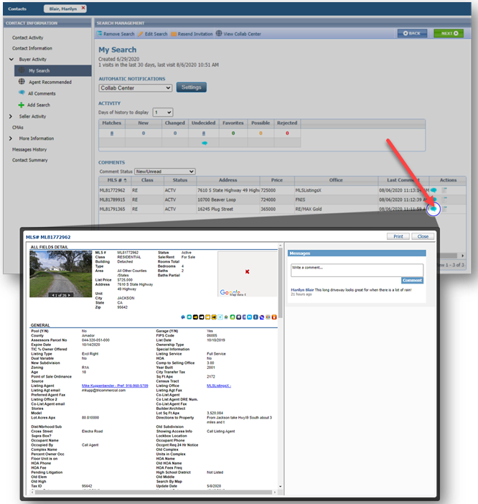

We continue to refine **Power Search** to bring you better results! In this release we have three additional refinements for you.

**Viewing Inactive Members and Include in Roster Flag:** In this release, we’ve refined how the Power Search results for members are displayed in the agent roster.

Previously the agent roster was only returning active members, even when the user had permission to view inactive members. Now the roster will return inactive members where applicable. In addition to this the system will now respect the Include in Roster Flag in the agent record when returning Power Search results, based on user security.

**User Interface Enhancements to Power Search Bar:** To help improve the readability of the Power Search input and results, some minor UI changes were made. The size of the input box was increased; the Help icon and Voice Search icons were aligned with the box.

**Refinement to update status color:** To improve the readability of the listing results, in Power Search, the status text changes to white when the row is highlighted and returns to the specified status color when the row is not highlighted.

* **Add Tour/Open House to Partial Listings**

Now you can add Tour and Open House events to your Partial Listings! The Add/Edit Tour and Add/Edit Open House options for Partial Listings have been added to the left navigation pane in Listing Input/Maintenance, and in the Quick Action Modal.

**Note:** Tour and Open House events on Partial Listings will not go out in RETS or IDX feeds, and will not display in Tour and Open House searches, until the listing is saved as a full complete listing.

**PARAGON CONNECT – More than Mobile**

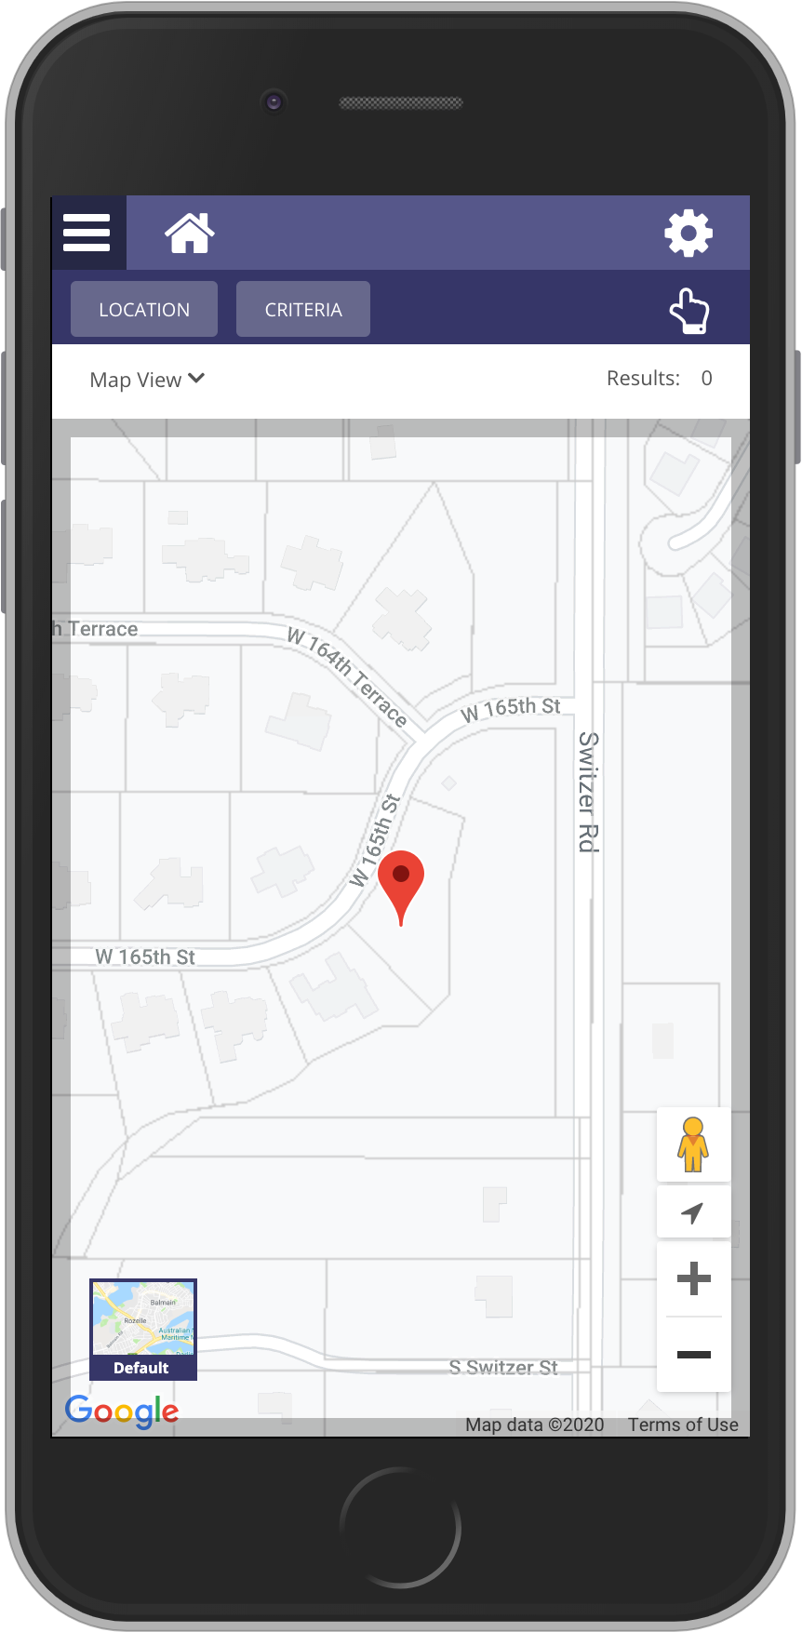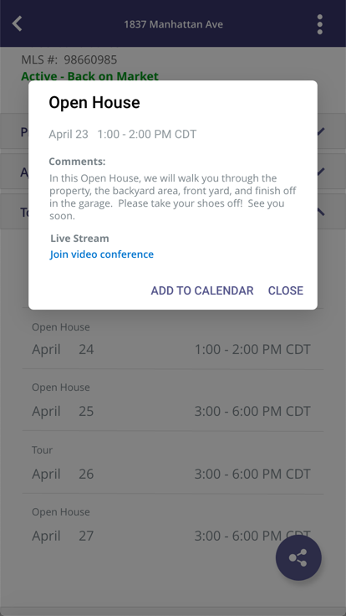

* **Live Stream Open Houses – Now in Paragon Connect!**

Paragon Connect will now include the live stream Open House options that were added to Paragon Classic. You can now configure your tour and open house search to search by only in person events, live only events, or allow both.

When live stream options are available you will see the same live link you see in Paragon Classic.

* **Property Watch**

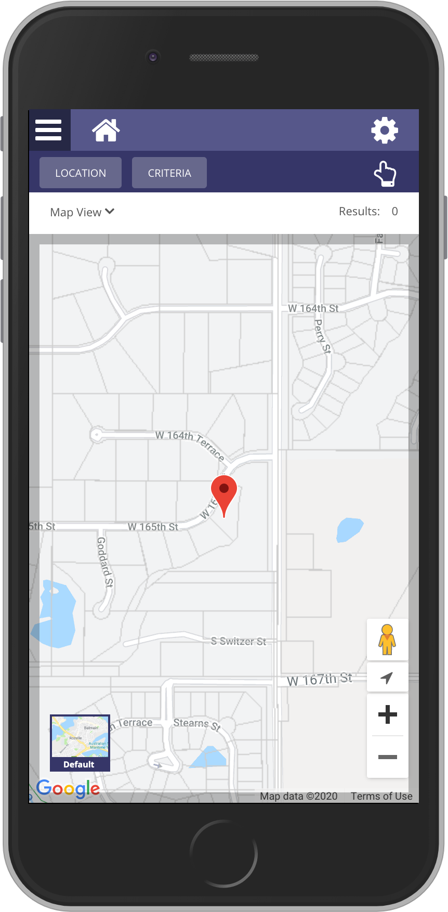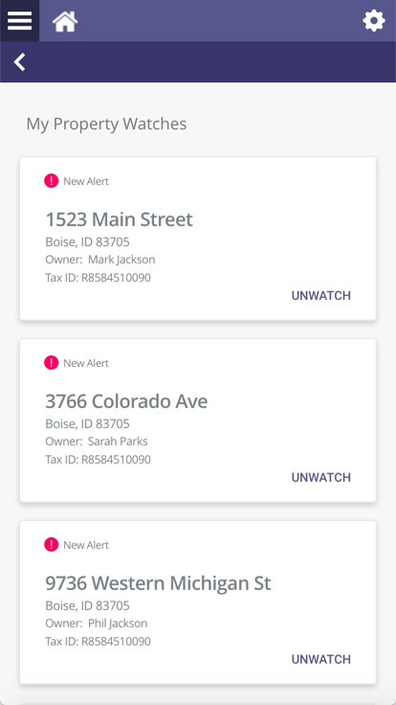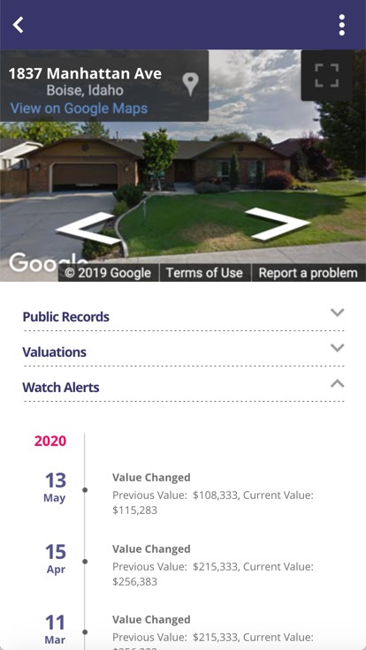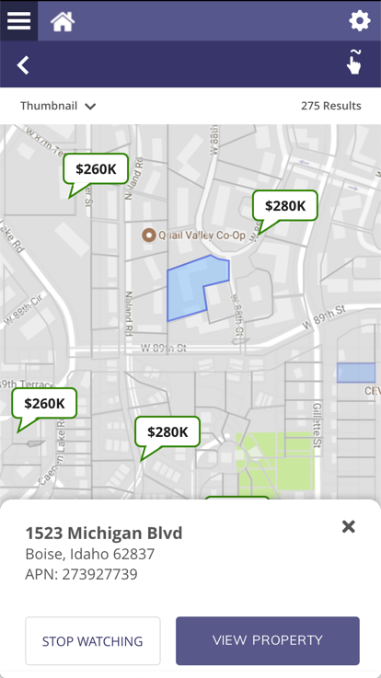

In our previous release, we introduced interactive parcels. With interactive parcels, you can zoom and tap on any parcel. You can then view the public record data of that property. In this release, we are now adding the ability for you to watch these properties and get alerted when any data changes on these records. We also apply a color overlay to any watched properties. This allows you to see which parcels you are already watching.

* Click on any Parcel
* View Public Record Data
* Watch that record
* Map highlights any watch properties
* Alerts sent on any changes to the property
* **Multiple Tours and Open Houses**

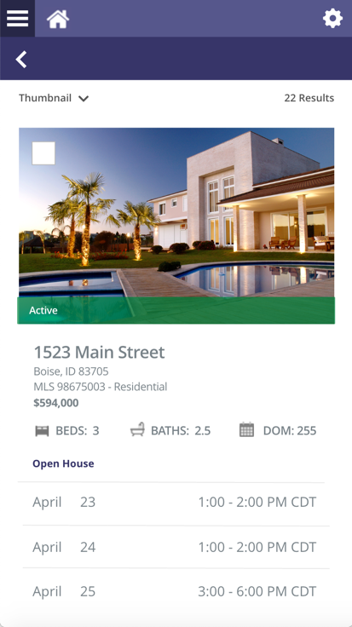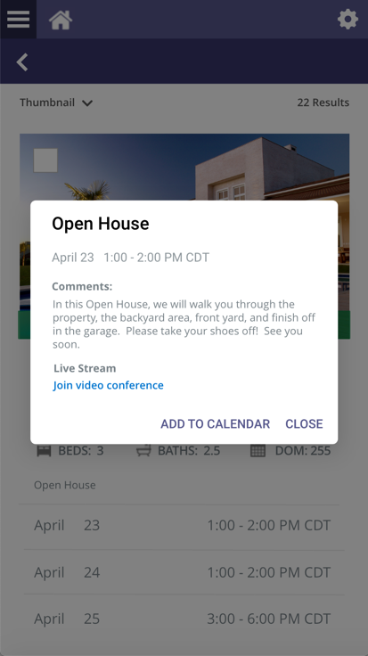

The tour and open house search results in Paragon Connect have been enhanced to show you multiple events per listing. In the past if you searched for an open house within the next 7 days it would show you only the next open house that is occurring. But if there were more tours that week you wouldn’t be able to see that information. Now if there are multiple events within that time frame it will show each event.

In addition to the multiple results, you can now click on these results to view the details of that tour or open house event. You can even click on the “Add to Calendar” to add to your default calendar on your phone or computer.