# Paragon 5.79 Release Enhancements (September 2020)

Paragon 5.79 Release Enhancements (September 2020) 1

Corrected Issues 2

Agent Level Changes 3

Contact Summary – Add Collaboration Center Notifications to Search Activity Section 3

Contacts- New Contact View Shows Listing Detail and Comments 4

Contacts – Importing Yahoo Contacts 5

Search - Power Search – Three Additional Refinements 6

LIM – Add Tour/Open House to Partial Listings 8

MLS Customizations and Administration 9

Admin – Email Address added to New Agent Report 9

Admin – Partial Listings Retention Settings 9

Admin – CDOM Calculation to include check for Previous List Office Match 9

Admin – New RETS Business Rules Option - Broker Only Feed Required 10

Admin – Affiliate Connect New Login Agreement Type 11

Paragon Connect 12

Property Watch 12

Multiple Tours and Open Houses 13

Live Stream Open Houses – Now in Paragon Connect 13

Paragon Affiliate Connect 14

Login Agreement Type – Terms of Use 14

Accepting Terms of Use 15

Terms of Use added to Quick Action Bar in Paragon 15

Paragon Affiliate Connect NEW Paywall Sign up Form 16

Added MLS logo to the Affiliate Dashboard 17

Added Disclaimer to Collaboration Center Detail Report 18

Added license number to Agent Details in Affiliate Dashboard 19

Allow Agent to suppress Affiliate from Displaying in Collaboration Center 20

# Corrected Issues

|  |  |  |  |  |
| --- | --- | --- | --- | --- |
| **WO#** | **Seq** | **Module** | **Organization** | **Summary** |
| 130801 | 2 | Search – Property | New England Real Estate Network (NEREN) | Power Search: Receiving unexpected result due to Agent and Office Active/Inactive fields |
| 143460 | 1 | Collab Link | San Diego MLS, CRIB, Sanibel | Customer reporting issue when using Share > CollabLink Share when viewing Tours and Open Houses |
| 145080 | 1 | Admin - Agent | Lake County, Highland Lakes | Contact Count is Not Displaying After Agent Transfer on Transfer Summary |
| 152405 | 1 | Admin - Agent | Greater Alabama MLS, Inc - Birmingham | ELMAH Error When Transferring Listings to Same Agent With New Transfer Agent Functionality |
| 145131 | 1 | Search - Address | New England Real Estate Network (NEREN) | NULL Street Designation Displays in Power Search and Validate Mapping |
| 149990 | 1 | Input Maintenance | Georgia MLS, NEREN, REB3, RMLSA | Update Agent in Listing Audit not always accurate |
| 150299 | 1 | Admin - Listings | Triangle MLS, NEREN, RANW | Saving Listings with a Low Amount of Errors/Warnings Result in Hidden or Collapsed Field Rule Box |
| 151901 | 1 | Contact Activity | MiRealSource Michigan MLS | Find Contact Search Tooltip has Unicode Values Displaying in it |

# Agent Level Changes

**The following section contains changes that are active system wide and available to users based on their assigned security levels.**

## Contact Summary – Add Collaboration Center Notifications to Search Activity Section

### Action Item: N/A

The Contact Summary in the Paragon Contact Manager has been enhanced to now show Collaboration Center Notifications! Previously it only showed email searches, however now when you go to your Contact you will be able to see all information for notifications you sent out of Paragon to that client and how they were sent.

Go to Contacts> View Manage Contacts> Click on the Contact Name you wish to view. Next click on Contact Summary > Search Activity section. The grid has been enhanced to show all notification settings: Off, Email, or Collab Center. A screenshot of a social media post

## Contacts- New Contact View Shows Listing Detail and Comments

### Action Item: N/A

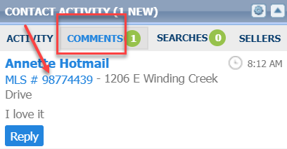To help save you time, we have created a new view in contacts where you can see your listing default report with any comments made for a particular property your client is collaborating on with you. This view will allow you to be able to read the comment and know exactly what property they are commenting on, so you can comment right back to them. Accessing this view can be through the contact widget on the front page or through the contact tab by clicking on the bubble.

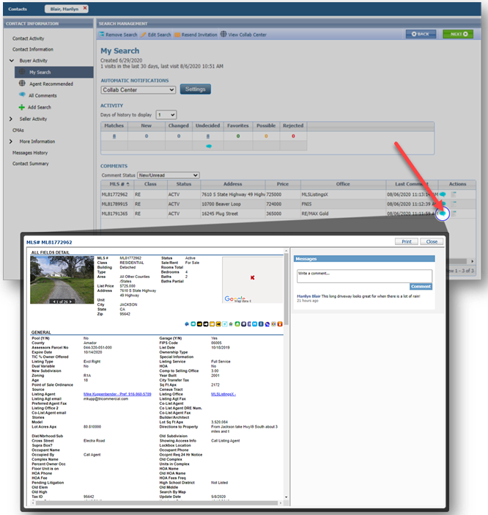

## Contacts – Importing Yahoo Contacts

### Action Item: N/A

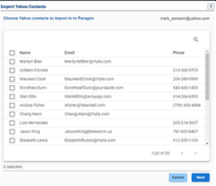Importing contacts just got easier. You can now import Contacts from your Yahoo account. This new option will allow you to browse, search, and multi-select Yahoo contacts to import into Paragon. The fields that will be imported are First and Last Name, Email Address and Phone number. Please note that Yahoo requires approval before you can access your Yahoo contacts, so you will need to get a code to view and import the contacts.A screenshot of a social media post

Once you select Get Code the Yahoo autohorization screen will open and give you the code to be able to grant access to log into your Yahoo account. You can now select your contacts to import.

**Note:** Importing Google Contacts has been temporarily disabled. Black Knight is pending approval from Google on importing contacts.

## Search - Power Search – Three Additional Refinements

### Action Item: N/A

We continue to refine Power Search to bring you better results!

**Viewing Inactive Members and Include in Roster Flag:** In this release, we’ve refined how the Power Search results for members are displayed in the agent roster.

Previously the agent roster was only returning active members, even when the user had permission to view inactive members. Now the roster will return inactive members where applicable.

In addition to this the system will now respect the Include in Roster Flag in the agent record when returning Power Search results, based on user security.

**User Interface Enhancements to Power Search Bar:** To help improve the readability of the Power Search input and results, some minor UI changes were made. The size of the input box was increased; the Help icon and Voice Search icons were aligned with the box.



**Refinement to update status color:** To improve the readability of the listing results, in Power Search, the status text changes to white when the row is highlighted and returns to the specified status color when the row is not highlighted.

## LIM – Add Tour/Open House to Partial Listings

### Action Item: N/A

Now you can add Tour and Open House events to your Partial listings! The Add/Edit Tour and Add/Edit Open House options for Partial listings have been added to the left navigation pane in Listing Input/Maintenance, and in the Quick Actions modal.

**Note**: Tour and Open House events on Partial Listings will not go out in RETS or IDX feeds, and will not display in Tour and Open House searches, until the listing is saved as a full listing.

# MLS Customizations and Administration

**All options in this section are either configurable via MLS Administration controls or by your System Support Manager as noted.**

## Admin – Email Address added to New Agent Report

### Action Item:

The Nightly Reports > New Agent report now has a column for Email Address. The addresses are clickable in Paragon, and opens the Paragon Compose Email modal. When exporting the report, the export file also includes the Email Address column. This will provide an easy way to reach new users via email.

## Admin – Partial Listings Retention Settings

### Action Item: N/A

To standardize retention settings for Partial Listings (status category 10), all Paragon customers whose Months to Keep Partial Listings and assets (photos and documents) setting were zero (0) have been increased to 12 months. Customers who already had settings greater than zero (0) were not affected.

## Admin – CDOM Calculation to include check for Previous List Office Match

### Action Item: Contact your SSM to turn on this configuration setting

To eliminate calculation of Cumulative Days on Market for a listing if the previous listing was with a different office, we have added a new configuration. This setting is defaulted to No, if you want to include previous office listings you will need to have your SSM set it to Yes for you.

## Admin – New RETS Business Rules Option - Broker Only Feed Required

### Action Item: N/A

To meet requirements by NAR, a new business rule option will be added in Admin under RETS Profiles. This Option will allow a single profile to provide access to all data belonging to a single Office/Firm. The single profile can also be assigned to multiple RETS users; the user’s office value defines the scope of the available data.

When ***Broker Rules*** is selected, the following will happen:

1. All Fields from all Resources of the profile will be enabled by default (with exception of Tax, if the MLS includes a Tax Resource)
2. When the ***Broker Rules*** profile is assigned to an agent account and the agent performs a RETS request, the profile will automatically
   1. Identify the Main Office
   2. Identify any Branch Offices
   3. Return listings where List Office = List Office 1, 2 or 3

**FAQs**

**Q:** Do I need to create a Broker Rules profile for each of my Brokers?

**A:** No. You can create a single Broker Rules profile and assign it to many brokers.

**Q:** Can I change an existing profile to be a Broker Rules profile?

**A:** Yes, but it will replace any filters or selected Resources with the Broker Rules selections. However, Paragon will warn you in a prompt that this will happen before you click Save so you can cancel if you’re not sure.

**Q:** After creating the Broker Rules profile, can I edit any of the Resources of the profile?

**A:** Yes, but if you have multiple brokers assigned to a Broker Rules profile, it will affect all users. You might want to consider creating a separate Broker Rules profile for any exceptions.

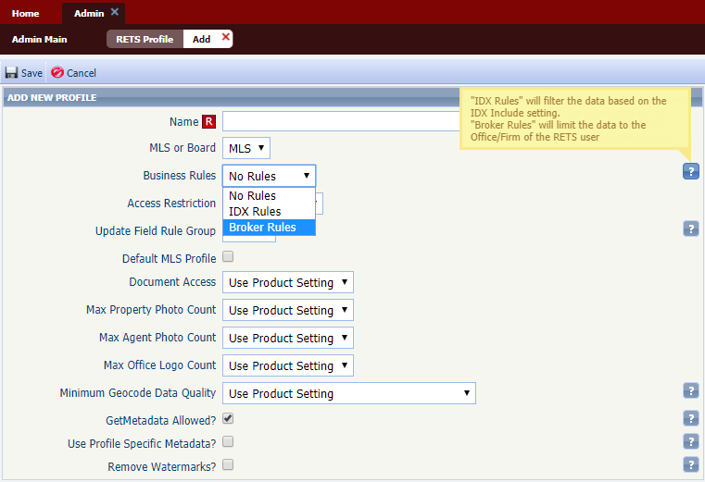

## Admin – Affiliate Connect New Login Agreement Type

### Action Item: N/A

Paragon Affiliate Connect will require a Terms of Use agreement to be accepted by the agent. To accommodate this, we have added to the Admin>Messaging>Login agreement the Type field. When a new login agreement is added the admin will have the choice of MLS/Board or BK Terms. Currently there is not a type drop down so it assumes MLS/Board.

# Paragon Connect

**All options in this section are either configurable via MLS Administration controls or by your System Support Manager as noted.**

## Property Watch

### Action Item: N/A

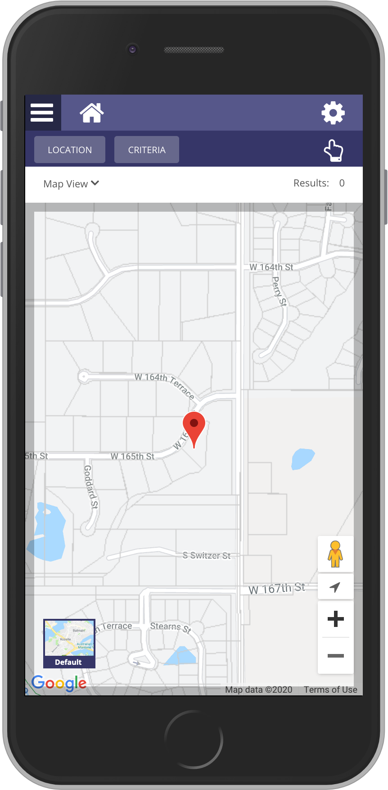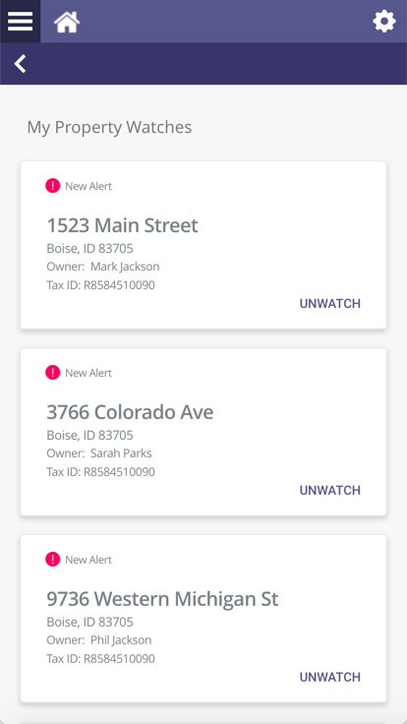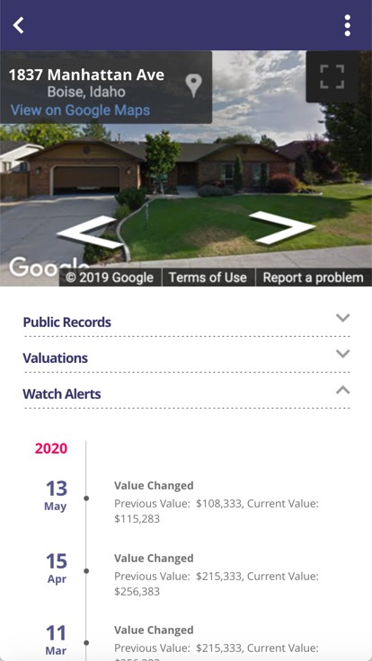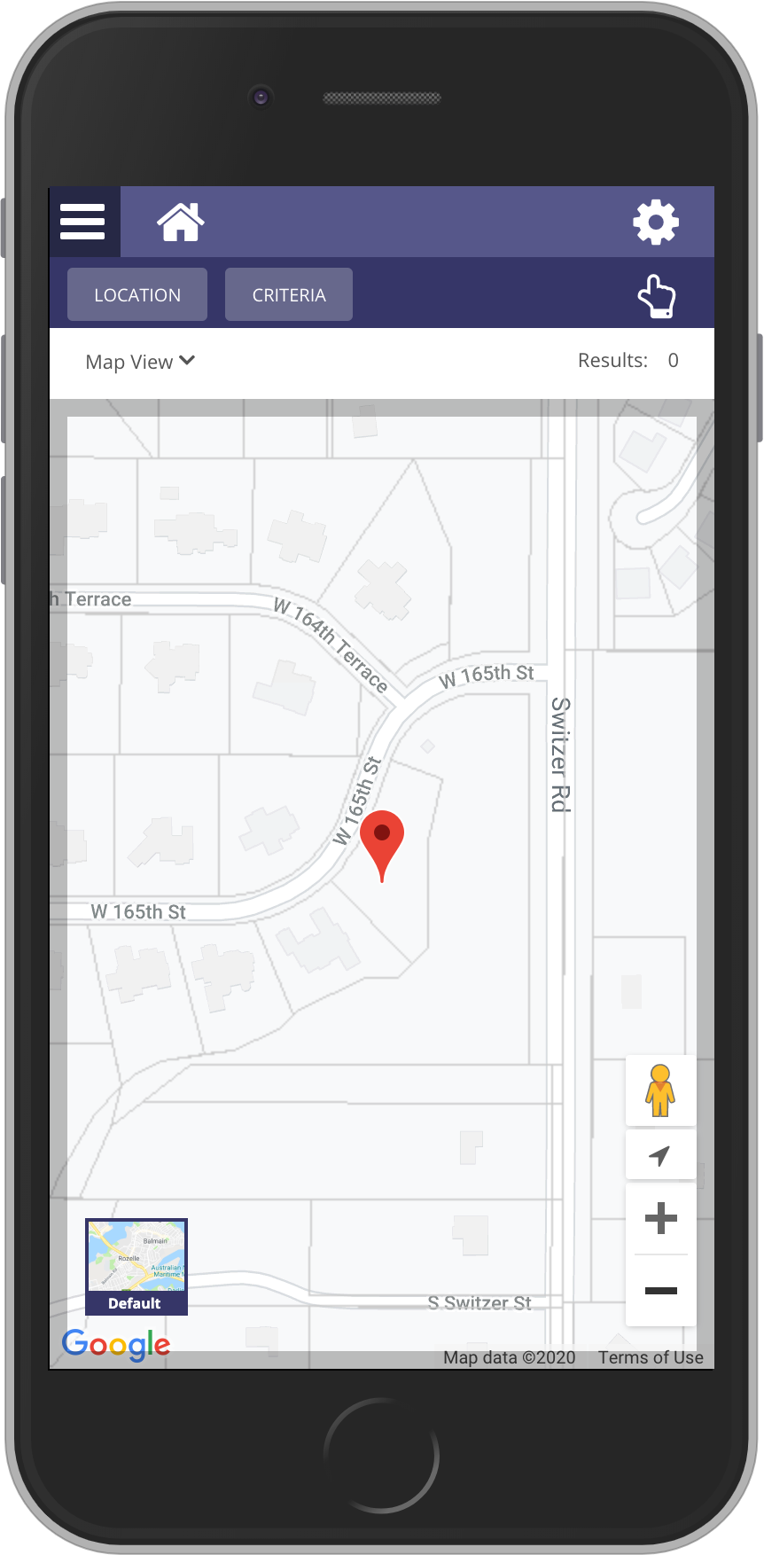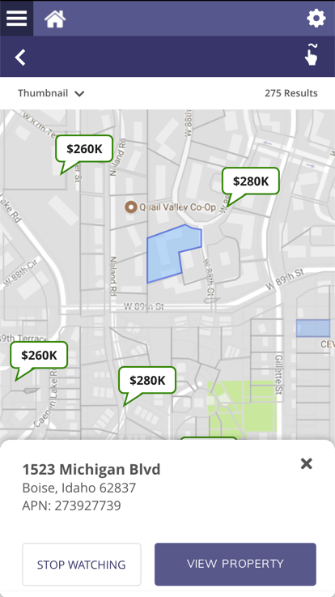

In our previous release, we introduced interactive parcels. With interactive parcels, you can zoom and tap on any parcel. You can then view the public record data of that property. In this release, we are now adding the ability for you to watch these properties and get alerted when any data changes on these records. We also apply a color overlay to any watched properties. This allows you to see which parcels you are already watching.

1. Click on any Parcel
2. View Public Record Data
3. Watch that record
4. Map highlights any watch properties
5. Alerts sent on any changes to the property

## Multiple Tours and Open Houses

### Action Item: N/A

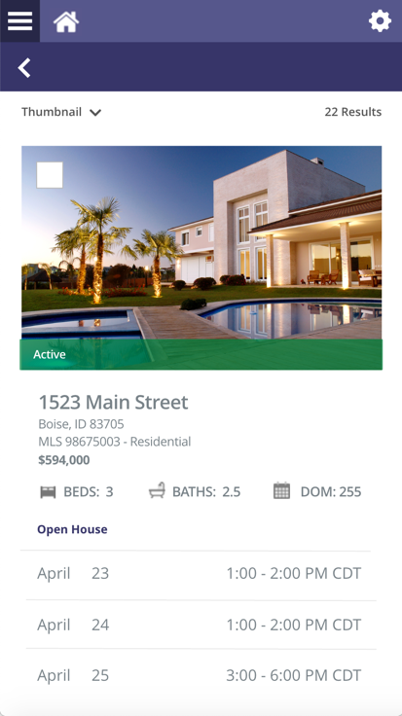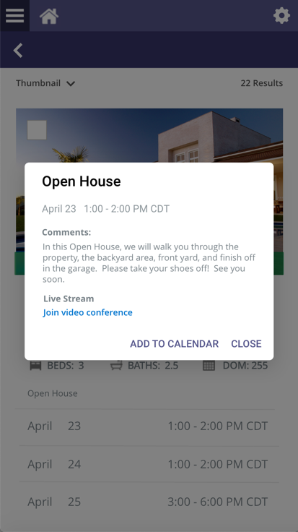

The tour and open house search results in Paragon Connect have been enhanced to show you multiple events per listing. In the past if you searched for an open house within the next 7 days it would show you only the next open house that is occurring. But if there were more tours that week you wouldn’t be able to see that information. Now if there are multiple events within that time frame it will show each event.

In addition to the multiple results, you can now click on these results to view the details of that tour or open house event. You can even click on the “Add to Calendar” to add to your default calendar on your phone or computer.

## Live Stream Open Houses – Now in Paragon Connect

### Action Item: N/A

Paragon Connect will now include the live stream Open House options that were added to Paragon Classic. You can now configure your tour and open house search to search by only in person events, live only events, or allow both.

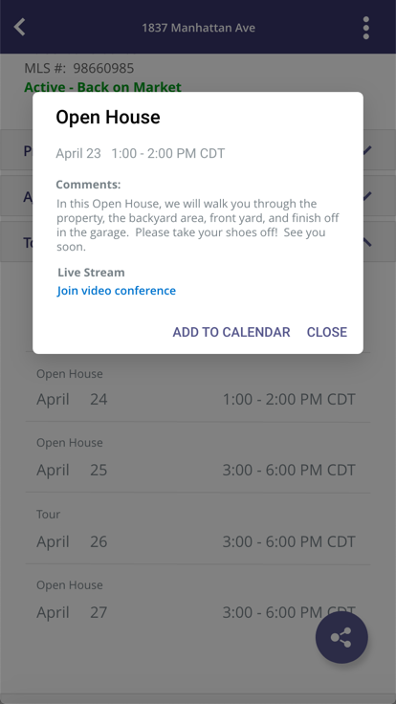

When live stream options are available you will see the same live stream link you see in Paragon Classic.

# Paragon Affiliate Connect

**All options in this section are either configurable via MLS Administration controls or by your System Support Manager as noted.**

## Login Agreement Type – Terms of Use

### Action Item: N/A

Agents will be required to accept a Terms of Use Agreement in order to expose their buyers contacts to any Affiliate. Once Paragon Affiliate Connect is enabled, the MLS will enable the login agreement module. The next time the agents log in they will be prompted to accept the terms of use for Paragon Affiliate Connect.

The Admin in Paragon will go to Paragon, select Admin>Messaging>Login Agreement and then click on the + to add a new Login Agreement.

Once the agreement is saved you will see the following when you click on Login Agreement in Admin>Messaging>Login Agreement

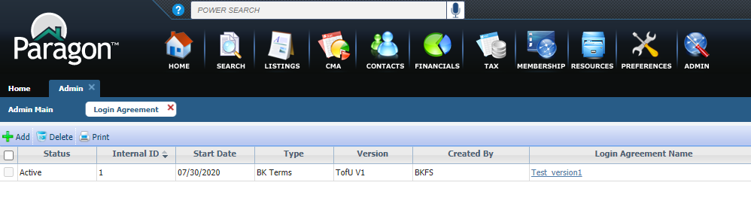

## Accepting Terms of Use

### Action Item: N/A

Agents will be required to accept a Terms of Use Agreement in order to expose their buyers contacts to any Affiliate. Once Paragon Affiliate Connect is enabled, the MLS will enable the login agreement module. The next time the agents log in they will be prompted to accept the terms of use for Paragon Affiliate Connect. Click here to read the full [BK Terms of Use.](http://paragonconnect.paragonrels.com/images/documents/release_notes/579/BK%20Paragon%20Terms%20of%20Use%2020180913%20Paragon%20Affiliate%20Connect.docx)

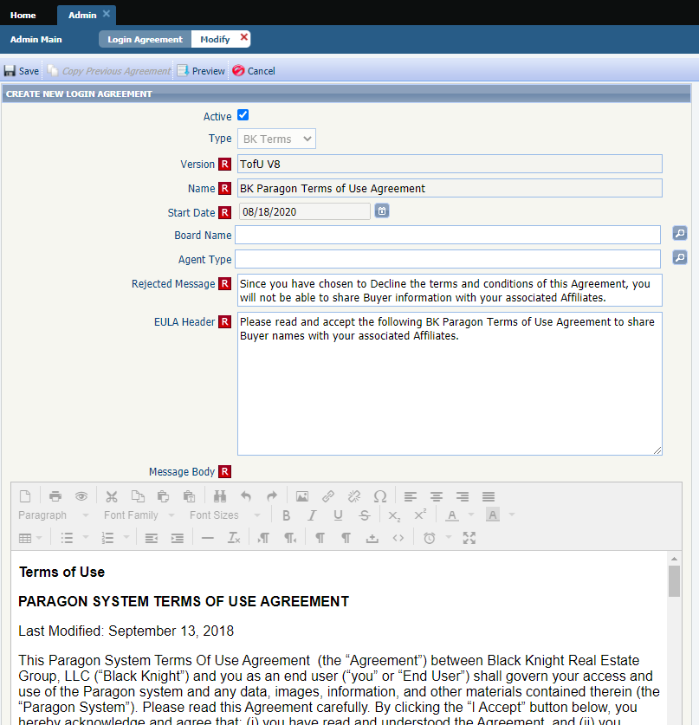

## Terms of Use added to Quick Action Bar in Paragon

### Action Item: N/A

To accommodate the addition of the Terms of Use for Paragon Affiliate Connect, we have added a link in the Quick Action Bar so that Agents can view the terms at any time.

Click here to read the full [BK Terms of Use.](http://paragonconnect.paragonrels.com/images/documents/release_notes/579/BK%20Paragon%20Terms%20of%20Use%2020180913%20Paragon%20Affiliate%20Connect.docx)

## Paragon Affiliate Connect NEW Paywall Sign up Form

### Action Item: N/A

Paragon Affiliate Connect now allows Affiliates to directly sign up from the Paragon Affiliate Connect marketing portal.

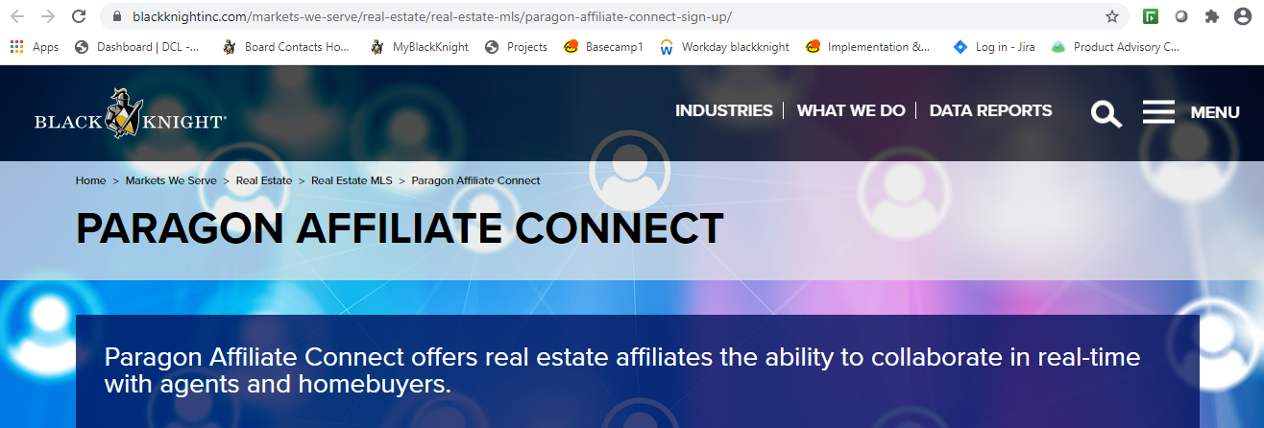

At the bottom of the screen the Affiliate will have the opportunity to click on the Sign up Today button which will allow them to pay via their credit card and sign up for monthly billing.

Once they click on the Sign Up Today button it will take them to a form to fill out and then they will click on Start me up!

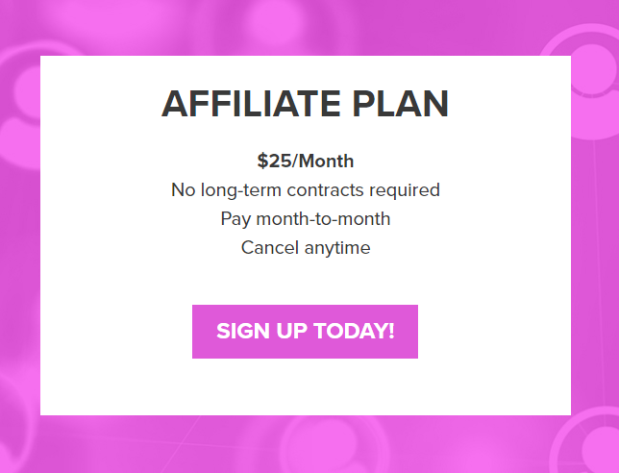

Once they click on Start Me up! they will be redirected to the Paywall where they will enter in their credit card information to pay for the service.

## Added MLS logo to the Affiliate Dashboard

### Action Item: MLS Admin must load logo in Paragon Admin/System Setup Options/MLS Information/MLS Login Page Logo Path (600 x 250)

If the MLS logo is uploaded in Paragon by the MLS administration, the logo will now appear on the Affiliate Dashboard login page. This helps identify what MLS they are affiliated with. If the MLS did NOT load a logo into Paragon, no logo will be displayed.

## Added Disclaimer to Collaboration Center Detail Report

### Action Item:

MLSs can add a specific disclaimer to appear in Collaboration Center. It is found in Admin/MLS Information/Disclaimers. It allows for up to 2,000 characters. It is NOT dependent upon PAC being enabled.

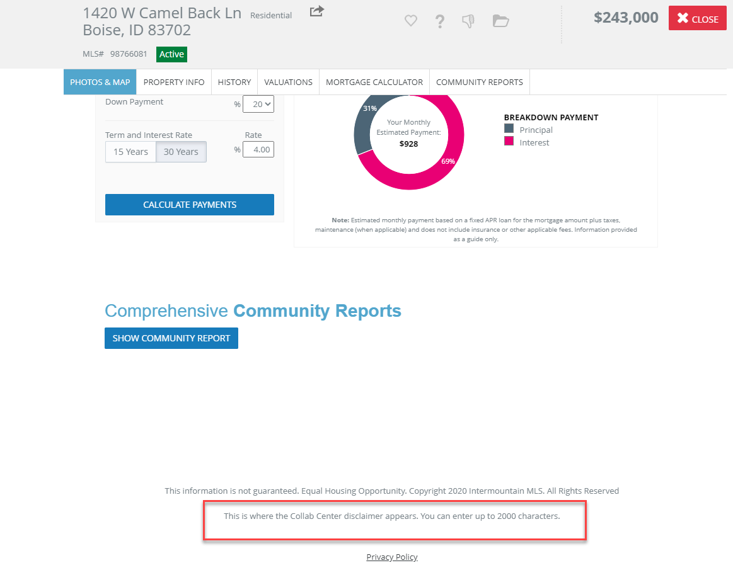 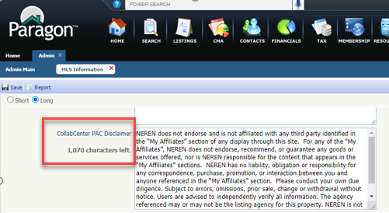

## Added license number to Agent Details in Affiliate Dashboard

### Action Item:

Previously, the License number was not on the agent details on the Affiliate Dashboard. This has now been added.

## Allow Agent to suppress Affiliate from Displaying in Collaboration Center

### Action Item:

From their list of affiliates, agent can select an affiliate and hide that affiliate from displaying in their collaboration center.

