Paragon Customer Toolkit - Release 5.80

## **Communications Plan Overview**

Welcome to the Paragon release communication Toolkit. The intention of this kit is to help you with communicating the release information to your membership.

In this kit you will find the following:

* Link to Release Notes for Paragon 5.80: the notes include any configurations and administration items that you will need to know about.
* Administration Configuration Options: What changes you may need to decide on
* Agent level Communication Plan: a link to an editable Customer Communication, and homepage notifications.
* Social Media: a post that you can use for Facebook, Instagram or other sites with a video of the release features.
* Example Home Page Announcements: You can cut and paste into your Homepage.

The goal is to make everyone aware of all the great Paragon enhancements to boost the way Members do Business!

## **Release Notes for Paragon 5.80**

Listed below is a link to the full release notes for the MLS. These release notes are for the Association/MLS. The Agent Level changes in this document are included in the e-mail template that you will want to send out to your members.

**Link:** [Release Notes](http://paragonconnect.paragonrels.com/images/documents/release_notes/580/Paragon%205.80%20Release%20Notes%20.docx)

## **Administration Configuration Options**

**Change New Login Picture and Logo**

**Action Item:** **If you choose to change the Logo or Background image contact your SSM**

As part of our continued effort to enhance the usability of Paragon, we have refreshed the Paragon login page. The MLS Logo and Background image can be customized by contacting your SSM.

Note: If these fields are blank, the default Paragon logo and default background photo (shown below) be displayed.

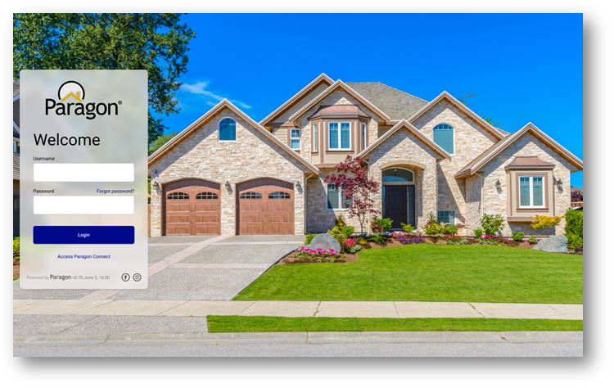

Your MLS may choose to replace the background image and Paragon logo with their own image and logo. This is a great opportunity to select a background photo that represents your local region, like a popular landmark.

**Note:** The updates to the Paragon Login Page only affects MLSs that use the Paragon Login screen and not those who use a Third-Party login solution like Clareity.

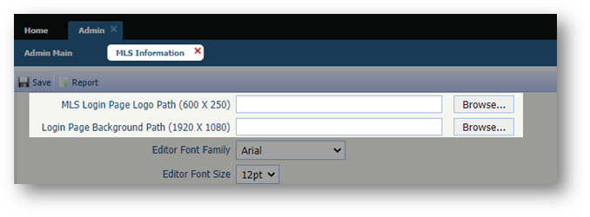To customize the MLS Logo and New Background image, you will contact your SSM with the new Logo and/or Photo. Please follow the recommendations below.

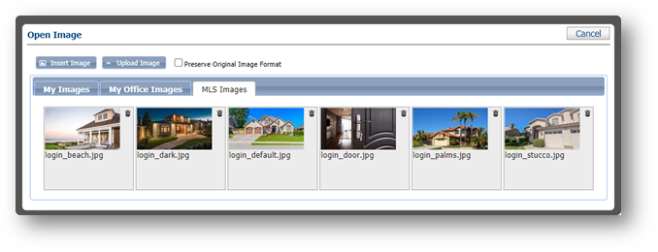When uploading the MLS Logo, **it is highly recommended that the logo includes a transparent background (.png file) for optimal display and a minimum resolution of 600X250.**

For the New Background Image, Black Knight provides six regional images, or **you can send your SSM your own background Image photos with a minimum resolution of 1920X1080.**

We are excited to present to you the newly redesigned Paragon Login Page!

## **Add Allowed Paragon Clients and RETS Profiles to Agent Audit**

### **Action Item:** N/A

To help track the administration of Paragon Clients and RETS Profiles on the agent record, changes to those settings have been added to the Agent Audit Report. RETS profiles will not include any default profiles but will show when a specific RETS profile is added or removed from an agent’s member record.

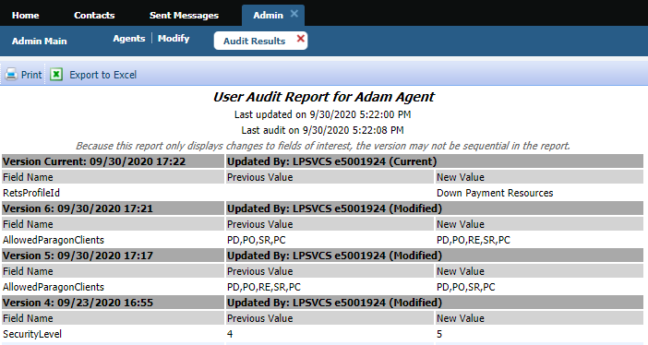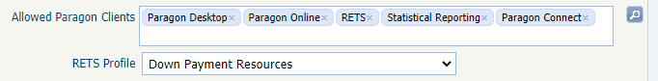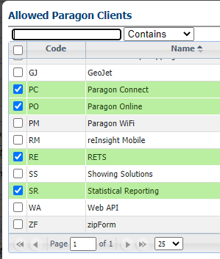

## **Agent Level Changes Communication Plan**

The following link is to the e-mail template that you can copy and paste from to send out to your members keeping them informed on the release. [Paragon Release 5.80 Member Email](http://paragonconnect.paragonrels.com/images/documents/release_notes/580/Email%20to%20agents%205.80.docx)

This is a word document that you can edit so if you **do not** have certain functionality, for example Premium Tax or Affiliate Connect, you can remove those sections first before sending. Also, in the first sentence you will want to add **your MLS name** (it is in red), so that it is being sent from **your** organization to **your** members.

To ensure that your members are always informed about the latest and greatest enhancement to their MLS System, please announce the enhancements to your membership, post to Social Media sites, include them in your newsletters and post notices to your homepage and login messages.

## **Social Media Post**

Copy and paste the following into your social media and the picture below will display with the video.

Please encourage your membership to like our Facebook page @ParagonMLS.

Check out the exciting new features of the Paragon 5.80 release!

[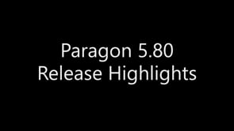](https://player.vimeo.com/video/480372989?app_id=122963)

## **Example Home Page Announcements**

The release has a lot of nice enhancements, you may want to highlight a different one every few days on your homepage and via Social Media. You can just cut and paste these into your homepage editor. If you want to add pictures you can do that too but make sure to upload them to your server.

**PARAGON – NEW LOGIN PAGE**

When logging in today you may have noticed a new login page! This new login page includes elegant regional background photo options, version information, links to Black Knight’s social media pages, linked access to Paragon Connect, and all previous functionality.

We are excited to present to you the newly redesigned Paragon Login Page!

**CMA – UNIQUE COVER LETTERS PER PRESENTATION**

With this enhancement, adding a cover letter to a presentation creates and saves a unique copy of the cover letter to that presentation. Users can edit and modify the cover letter, and it will only affect that presentation, rather than all instances of the cover letter throughout the CMA module.

To get the unique cover letter on an existing CMA, open the Cover Page in Presentation Setup for that CMA, then Save the new cover page.

**CONTACTS – AGENT PREVIEW**

The interface for approving and disapproving listings for Agent Preview searches has been modernized and clarified. Multiple listings can still be approved or disapproved as a group from the grid view. On the detail view, each listing can be approved or disapproved individually. We also fixed the detail view advancing to the next listing in the set, rather than returning to the first listing.

**LISTING SLIDE SHOW**

The Paragon Listing Slideshow can now be emailed directly to anyone while creating the listing slideshow! Previously, the only option was to email the link to yourself, or you could copy and paste the URL from the preview and then email it. We have also updated the user interface so that it is easier to use. After selecting the listings that you want to use in a slide show, click on the Action menu and select Listing Slideshow. Below is the old interface vs the new.

**PARAGON CONNECT – MOBILE REDIRECT**

As part of our plan to sunset Paragon Mobile (PM), agents who attempt to access PM via a bookmark or app shortcut link after the 5.80 release will automatically be redirected to an introduction page for Paragon Connect (PC). This page will include information about the upgrade from PM, features and benefits of PC, a button to “Learn More” and an “OK, let’s go!” button to the PC login page.

**PARAGON CONNECT – TOUR & OPEN HOUSE AND DETAIL REPORT**

The detail report found in Paragon Connect and the ConnectView in Paragon Classic will now have a new container dedicated to tour and open house information. This is not restricted to tour and open house searches. Any listing found in the system that has upcoming tour or open house events, will now display inside the detail report.

You can click on each event to view the details or view a live stream link and you can even add it to your default native calendar for reminders.

We also recently updated each event with an icon. This will allow you to identify it as a live stream or in-person event.