

**PARAGON - INNOVATING THE WAY AGENTS DO BUSINESS**

**Paragon Release 5.80**

We (enter your MLS Name here) wanted you to be the first to know about the latest enhancements to your Paragon MLS System. All enhancements are designed to help you navigate through the system and enhance your experience with Paragon.  Below is a list of the enhancements and links to view videos or PDFs of the new features. We encourage you to continue reading and let us know what you think on the [Paragon MLS Facebook site](https://www.facebook.com/ParagonMLS/). Also make sure you click “Like” on the Facebook site to view what’s new with Paragon more frequently.

**WHAT’S NEW!**

**PARAGON**

* **New Paragon Login Page**

We are excited to present to you the newly redesigned Paragon Login Page! The new page boasts a regional background photo, version information, links to Black Knight social media pages, access to Paragon Connect and all previous functionality. Your MLS may choose to replace the background image and Paragon logo with their own image and logo.

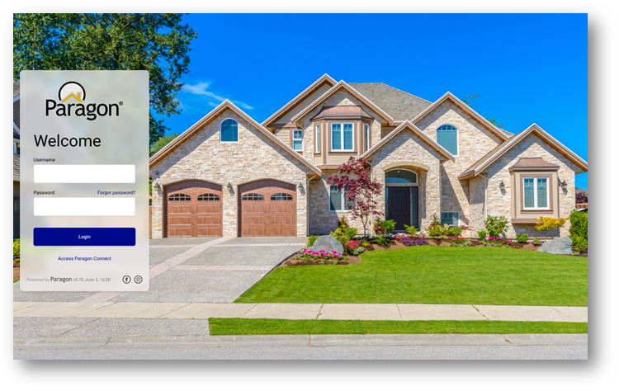

* **Unique Cover Letters Per Presentation in CMA**

Adding a cover letter to a presentation creates and saves a unique copy of the cover letter to that presentation. Users can edit and modify the cover letter, and it will only affect that presentation, rather than all instances of the cover letter throughout the CMA module. To get the unique cover letter on an existing CMA, open the Cover Page in Presentation Setup for that CMA, then Save the new cover page.

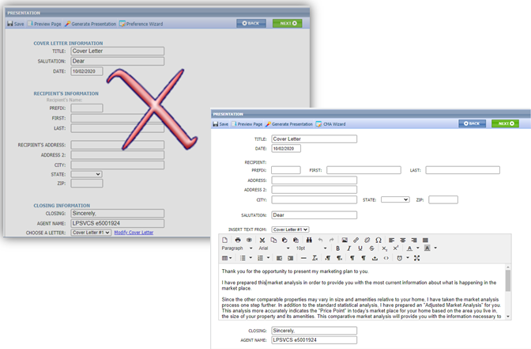

* **Agent Preview in Contacts**

The interface for approving and disapproving listings for Agent Preview searches has been modernized and clarified. Multiple listings can still be approved or disapproved as a group from the grid view. On the detail view, each listing can be approved or disapproved individually. We also fixed the detail view advancing to the next listing in the set, rather than returning to the first listing.

* **Advanced Date Range Operators Search and Prospecting**

To improve performance, we’ve added Advanced Date Range Operators (7 days back, 6 months back, etc.) to the list of invalid search criteria for prospecting. Including advanced date operators in a search saved to a contact causes degraded performance issues over time. The advanced date operators are now included in the check for invalid criteria, and a warning message will alert the user as to which fields are invalid

Advanced date range operators can still be used in a saved search if it is not saved to a contact for prospecting.

* **Listing Slide Show**

The Paragon Listing Slideshow can now be emailed directly to your contacts! Previously, the only option was to email the link to yourself, or you could copy and paste the URL from the preview and then email it. We have also updated the user interface so that it is easier to use. After selecting the listings that you want to use in a slide show, click on the Action menu and select Listing Slideshow. Below is the old interface vs the new.

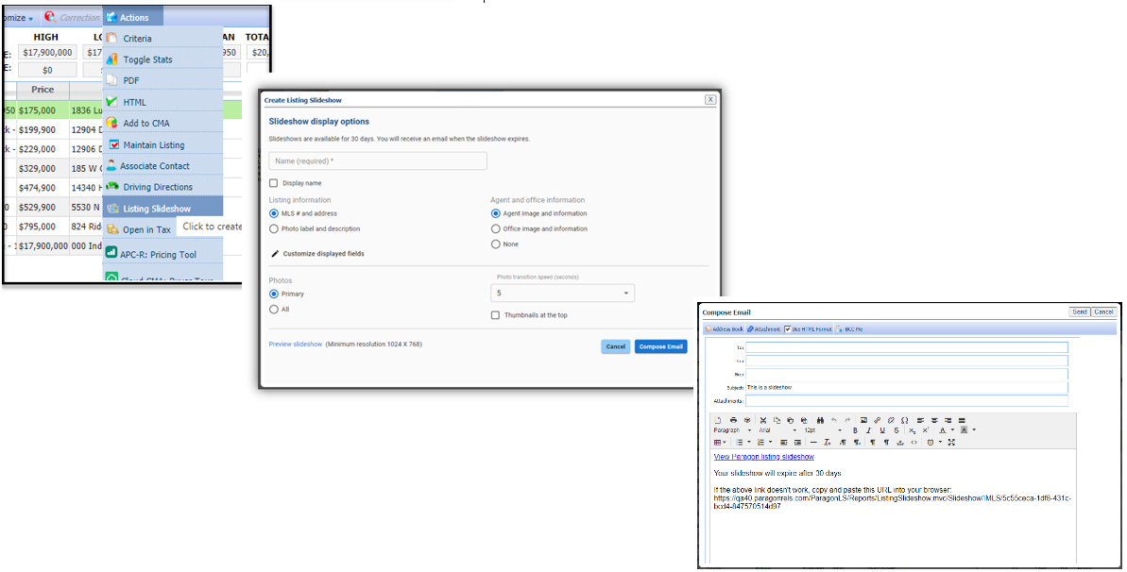

* **Listing Expiration Notices in Sent Message Log**

Listing expiration notices have been added to the Sent Messages log to help users track them. We’ve also updated the subject line by adding the listing address where available. Listing expiration notices use the current customer automated email retention settings.

* **Office Broker and Main Office Added to Membership Roster**

On the Membership Roster, a link to the Office Broker’s information card and the Main Office information card has been added below the existing office information. When the links are clicked the detail, cards are displayed. 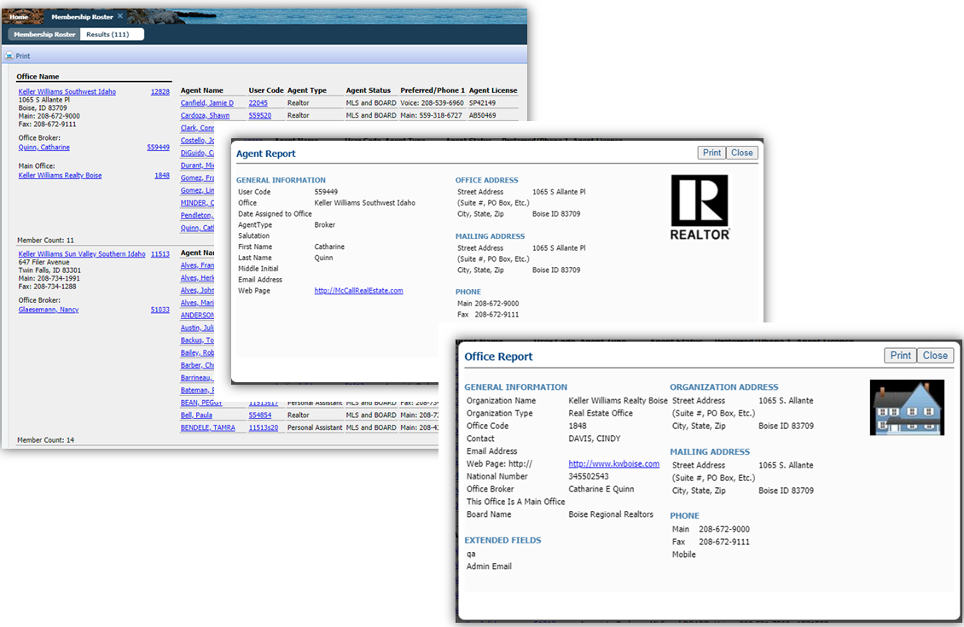

* **Added Notification Indicators in the Contacts Tree for Saved Searches**

### If a saved search has been linked to a Contact, it appears under the Contact details. Each linked saved search may be enabled or disabled for prospecting. New icons now appear next to search to indicate the type of notification setting. These three icons indicate:

* Off 
* Collaboration Center with Notification 
* Email Only Notification 

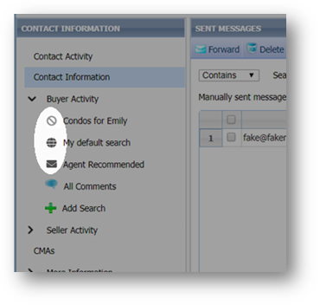

**PARAGON CONNECT – More than Mobile**

* **Tour & Open House and Detail Report**

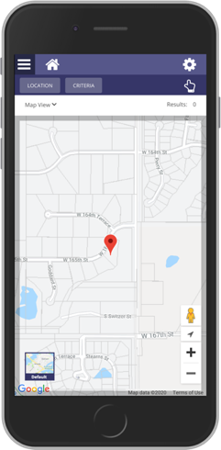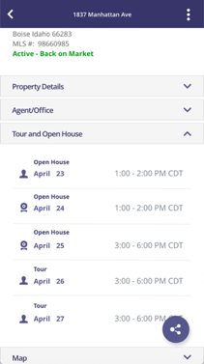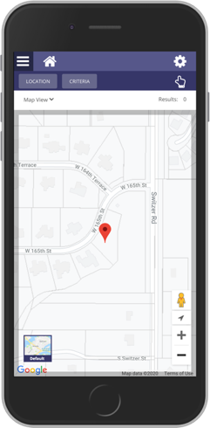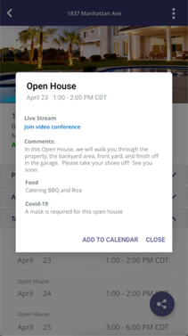

The detail report found in Paragon Connect and the ConnectView in Paragon Classic will now have a new container dedicated to tour and open house information. This is not restricted to tour and open house searches. Any listing found in the system that has upcoming tour or open house events, will now display inside the detail report.

You can click on each event to view the details or view a live stream link and you can even add it to your default native calendar for reminders.

We also recently updated each event with an icon. This will allow you to identify it as a live stream or in-person event.

* **Photo Check**

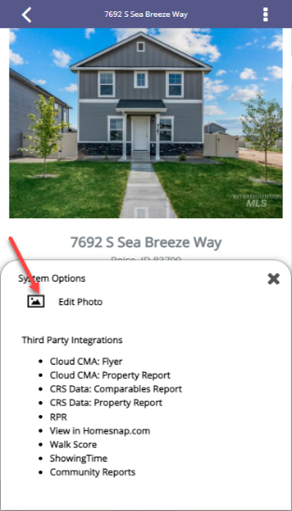As we continue our work on rolling out full listing edit, you will be pleased to know that we have just added a listing photo check to our detail report. This means that if you have edit permissions on a listing you will be able to go directly to the listing form from any property search to quickly add or modify any listing photo! This is available throughout the application, whether you are running a power search, property search, hotsheet search, etc.

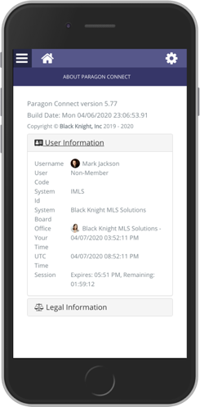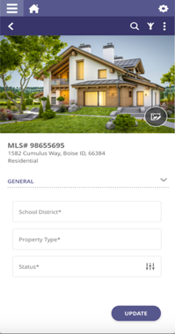

* **Detail Report Cleanup**

The Paragon Connect detail report and the ConnectView in Paragon Classic has been updated to match the UI/UX of the mobile detail report. Now the report will look and function the same regardless of the device that you are on. Users will now be able to access third party integrations, and other system related options.



