Paragon 5.80 Release Enhancements (December 2020)

Corrected Paragon Issues 2

Agent Level Changes 3

Paragon – New Login Page 3

CMA – Unique Cover Letters Per Presentation 4

Contacts – Agent Preview 5

Search – Advanced Date Range Operators and Prospecting 6

Search – Listing Slide Show 7

LIM – Listing Expiration Notices in Sent Messages Log 8

Membership Roster – Office Broker and Main Office Added 9

Contact Saved Searches – Notification Indicator in Contacts Tree 10

MLS Customizations and Administration 11

Admin – Add Allowed Paragon Clients and RETS Profiles to Agent Audit 11

Admin – Change New Login Page Picture and Logo 12

Paragon Connect 14

Tour & Open House and Detail Report 14

Mobile Redirect 14

Detail Cleanup 15

Photo Check 16

Collaboration Center Cleanup 16

Paragon Affiliate Connect 21

Corrected Paragon Affiliate Connect Issues 21

Paragon Affiliate Connect – Disclaimer for Collaboration Center 22

Paragon for Brokers (P4B) Dashboard change 23

Preferences - Ability to Suppress a Connected Affiliate’s Branding Block 23

Preferences – Notification Options 24

Search Screen – Office City/State 25

# Corrected Paragon Issues

|  |  |  |  |  |
| --- | --- | --- | --- | --- |
| **WO#** | **Seq** | **Module** | **Organization** | **Summary** |
| 118831 | 1 | Input Maintenance | GAMLS, Birmingham, Charlottesville, MiRealsource, Pensacola, Peoria, Quad Cities, REB3, RMLSA, Triangle, | Features are showing required when they should not be |
| 134901 | 2 | Email | Willamette, SCWMLS, MAXMLS/EBRD | Email CollabLink - price change amounts display forever, regardless of when change occurred |
| 146363 | 1 | Views/Reports | Intermountain MLS, Global MLS, CARMLS, MAXMLS, Memphis | Sub Area not sorting properly on spreadsheets |
| 146601 | 1 | Collab Center | Maui, NEREN, San Diego | The Collab Center "Last Accessed by Client" not counting correctly |
| 148114 | 1 | Admin - Listings | Tallahassee, RANW, REB3, Global MLS | Features Modal pop-up intermittently will not finish loading |
| 149460 | 1 | Input Maintenance | Hays Multiple Listing Service, Inc. | Staff member unable to maintain Virtual Tours |
| 150562 | 1 | CMA | New England Real Estate Network (NEREN) | Subject Property Photo Not Being Used on Cover Setup Page |
| 150743 | 2 | Tax | MAXMLS / EBRD | Property Watch Menu and WATCH PROPERTY link from parcel-click panel return errors |
| 152352 | 1 | Search - Property | Cheyenne Board of Realtors | Members able to search for hidden feature category |
| 152659 | 1 | Web API Client | REB3 | WebAPI: Add History Resource |
| 147447 | 1 | Statistical Reporting | MAXMLS / EBRD, NEREN | Customer reporting the Market Absorption Rate graph is generating oddly |
| 137726 | 1 | Collab Center - Buy Side Saved Searches | REALTORS Association of Edmonton | Workflow is inconsistent when using Agent Preview |
| 147881 | 2 | Preferences | New England Real Estate Network (NEREN) | Request the Removal of the Agent Image Section Under Preferences > Collab Center > Agent Information |

# Agent Level Changes

**The following section contains changes that are active system wide and available to users based on their assigned security levels.**

## Paragon – New Login Page

### Action Item: N/A

As part of our continued effort to enhance the usability of Paragon, we have refreshed the Paragon login page. New features on the refreshed login page include:

* Multiple Elegant regional background photo options
* Version information
* Links to Black Knight’s social media pages
* All previous functionality
* Access to Paragon Connect Link

Your MLS may choose to replace the background image and Paragon logo with their own image and logo.

We are excited to present to you the newly redesigned Paragon Login Page!

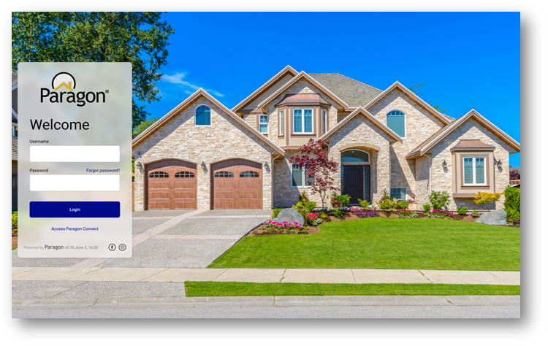

## CMA – Unique Cover Letters Per Presentation

### Action Item: N/A

With this enhancement, adding a cover letter to a presentation creates and saves a unique copy of the cover letter to that presentation. Users can edit and modify the cover letter, and it will only affect that presentation, rather than all instances of the cover letter throughout the CMA module.

To get the unique cover letter on an existing CMA, open the Cover Page in Presentation Setup for that CMA, then Save the new cover page.

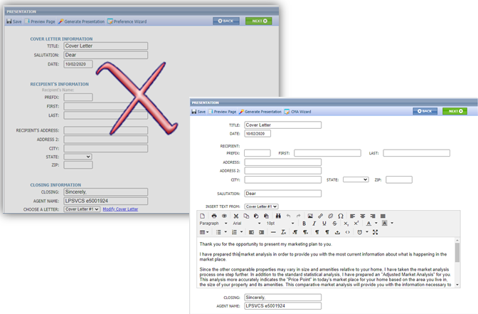

## Contacts – Agent Preview

### Action Item: N/A

The interface for approving and disapproving listings for Agent Preview searches has been modernized and clarified. Multiple listings can still be approved or disapproved as a group from the grid view. On the detail view, each listing can be approved or disapproved individually. We also fixed the detail view advancing to the next listing in the set, rather than returning to the first listing.

## Search – Advanced Date Range Operators and Prospecting

### Action Item: N/A

To improve performance, we’ve added Advanced Date Range Operators (7 days back, 6 months back, etc.) to the list of invalid search criteria for prospecting. Including advanced date operators in a search saved to a contact causes degraded performance issues over time. The advanced date operators are now included in the check for invalid criteria, and a warning message will alert the user as to which fields are invalid

Advanced date range operators can still be used in a saved search if it is not saved to a contact for prospecting.

## Search – Listing Slide Show

### Action Item: N/A

The Paragon Listing Slideshow can now be emailed directly to your contacts! Previously, the only option was to email the link to yourself, or you could copy and paste the URL from the preview and then email it. We have also updated the user interface so that it is easier to use. After selecting the listings that you want to use in a slide show, click on the Action menu and select Listing Slideshow. Below is the old interface vs the new.

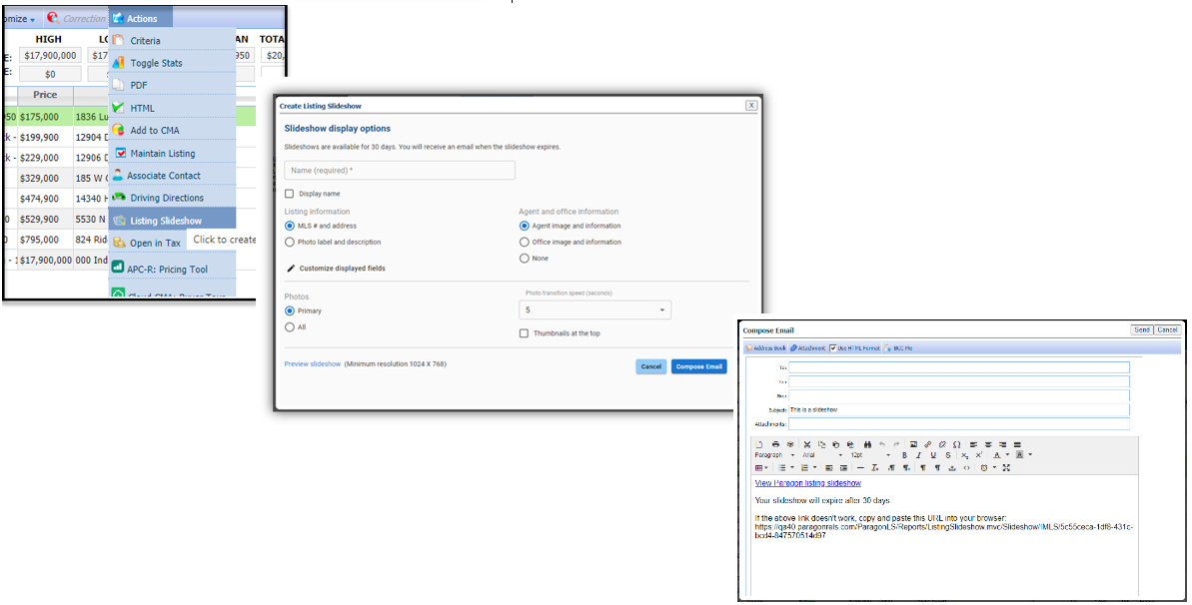

## LIM – Listing Expiration Notices in Sent Messages Log

### Action Item: N/A

Listing expiration notices have been added to the Sent Messages log to help users track them. We’ve also updated the subject line by adding the listing address where available. Listing expiration notices use the current customer automated email retention settings.

## Membership Roster – Office Broker and Main Office Added

### Action Item: N/A

On the Membership Roster, a link to the Office Broker’s information card and the Main Office information card has been added below the existing office information. When the links are clicked the detail cards are displayed.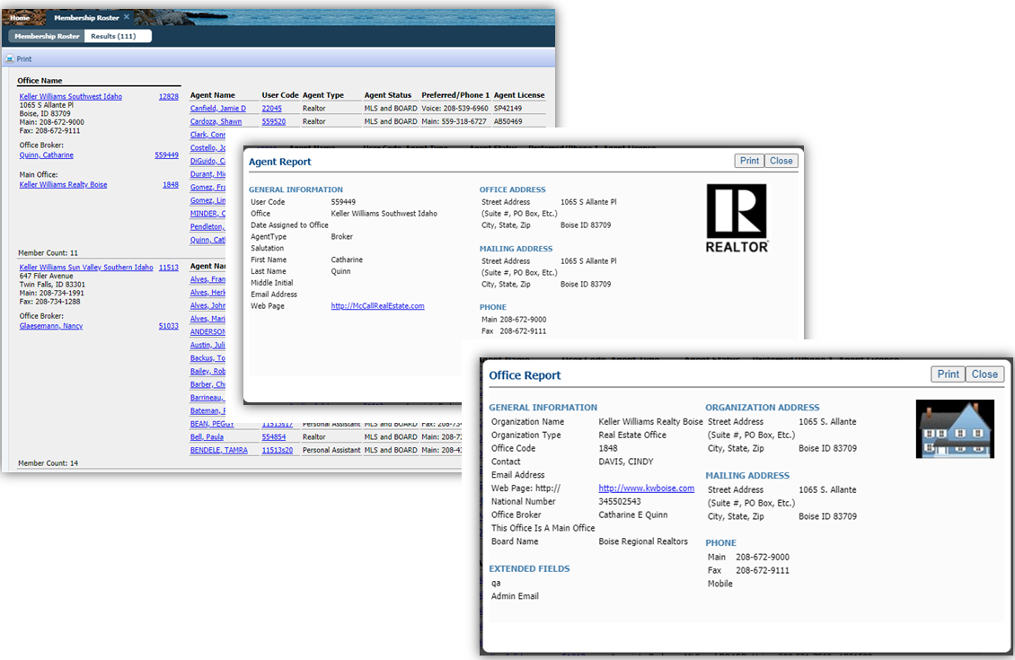

## Contact Saved Searches – Notification Indicator in Contacts Tree

### Action Item: N/A

### If a saved search has been linked to a Contact, it appears under the Contact details. Each linked saved search may be enabled or disabled for prospecting. New icons now appear next to search to indicate the type of notification setting. These three icons indicate:

* Off 
* Collaboration Center with Notification 
* Email Only Notification 

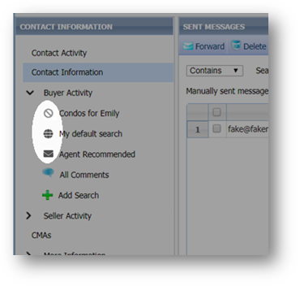

# MLS Customizations and Administration

**All options in this section are either configurable via MLS Administration controls or by your System Support Manager as noted.**

## Admin – Add Allowed Paragon Clients and RETS Profiles to Agent Audit

### Action Item: N/A

To help track the administration of Paragon Clients and RETS Profiles on the agent record, changes to those settings have been added to the Agent Audit Report. RETS profiles will not include any default profiles but will show when a specific RETS profile is added or removed from an agent’s member record.

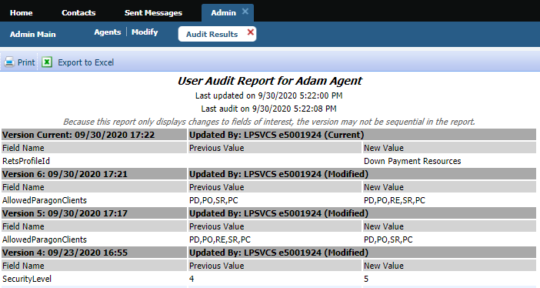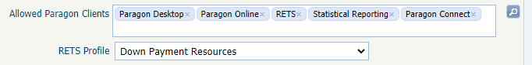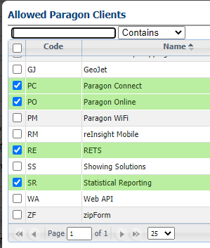

## Admin – Change New Login Page Picture and Logo

### Action Item: If you choose to change the Logo or Background image contact your SSM

As part of our continued effort to enhance the usability of Paragon, we have refreshed the Paragon login page. The MLS Logo and Background image can be customized by contacting your SSM.

**Note:** If these fields are blank, the default Paragon logo and default background photo (shown below) will be displayed.



Your MLS may choose to replace the background image and Paragon logo with their own image and logo. This is a great opportunity to select a background photo that represents your local region, like a popular landmark.

**Note:** The updates to the Paragon Login Page only affects MLSs that use the Paragon Login screen and not those who use a Third-Party login solution like Clareity.

To customize the MLS Logo and New Background image, you will contact your SSM with the new Logo and/or Photo. Please follow the recommendations below.

When uploading the MLS Logo, **it is highly recommended that the logo includes a transparent background (.png file) for optimal display and a minimum resolution of 600X250.**

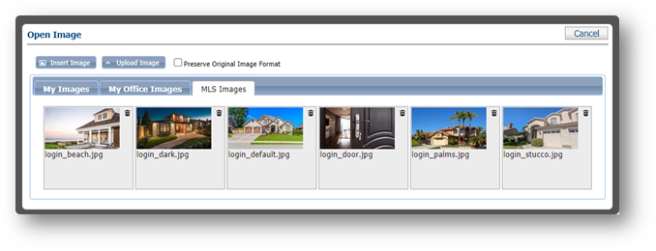

For the New Background Image, Black Knight provides six regional images, or **you can send your SSM your own background image photo with a minimum resolution of 1920X1080**.

We are excited to present to you the newly redesigned Paragon Login Page!

# Paragon Connect

**All options in this section are either configurable via MLS Administration controls or by your System Support Manager as noted.**

## Tour & Open House and Detail Report

### Action Item: N/A

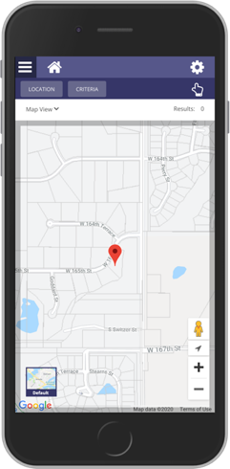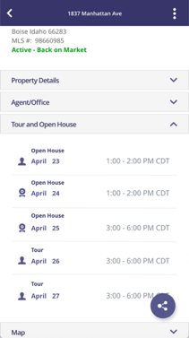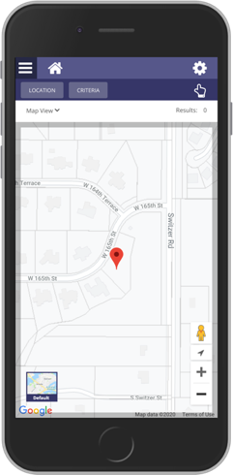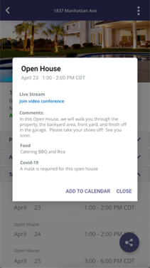

The detail report found in Paragon Connect and the ConnectView in Paragon Classic will now have a new container dedicated to tour and open house information. This is not restricted to tour and open house searches. Any listing found in the system that has upcoming tour or open house events, will now display inside the detail report.

You can click on each event to view the details or view a live stream link and you can even add it to your default native calendar for reminders.

We also recently updated each event with an icon. This will allow you to identify it as a live stream or in-person event.

## Mobile Redirect

### A screen shot of a smart phone Description automatically generatedAction Item: N/A

As part of our plan to sunset Paragon Mobile (PM), agents who attempt to access PM via a bookmark or app shortcut link after the 5.80 release will automatically be redirected to an introduction page for Paragon Connect (PC). This page will include information about the upgrade from PM, features and benefits of PC, a button to “Learn More” and an “OK, let’s go!” button to the PC login page.

## Detail Cleanup

### Action Item: N/A

The Paragon Connect detail report and the ConnectView in Paragon Classic has been updated to match the UI/UX of the mobile detail report. Now the report will look and function the same regardless of the device that you are on. Users will now be able to access third party integrations, and other system related options.

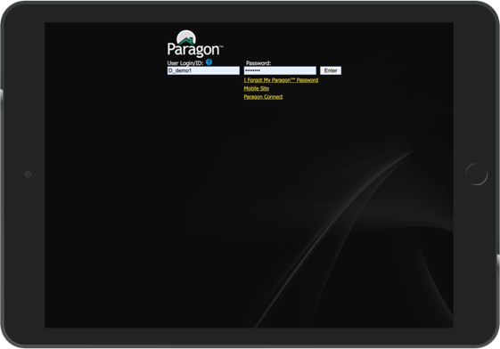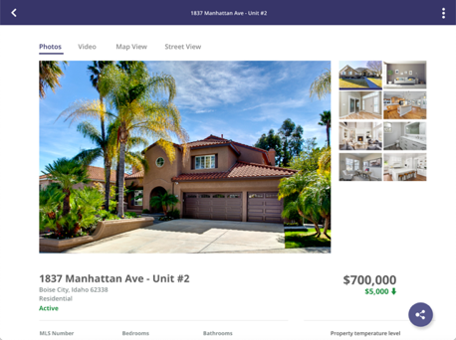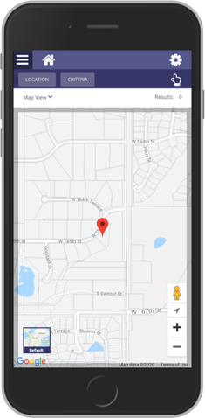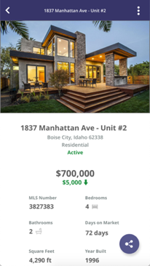

## Photo Check

### Action Item: N/A

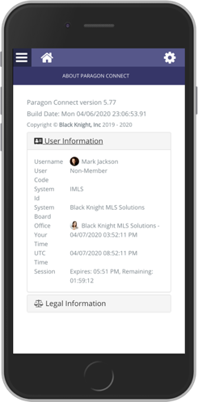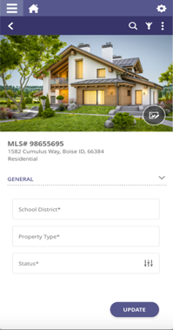

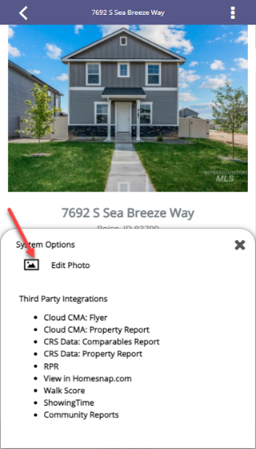As we continue our work on rolling out full listing edit, you will be pleased to know that we have just added a listing photo check to our detail report. This means that if you have edit permissions on a listing you will be able to go directly to the listing form from any property search to quickly add or modify any listing photo! This is available throughout the application, whether you are running a power search, property search, hotsheet search, etc.

## Collaboration Center Cleanup

### Action Item: N/A

Although it is no longer Spring, the Collaboration Center application went through a special round of spring cleaning. The Black Knight team has implemented several enhancements, design issues and addressed over 65 issue corrections. To save the trees and not waste so much paper, we will just highlight a small sampling of the issues that were fixed.

**CUSTOM CC2 FIELD**

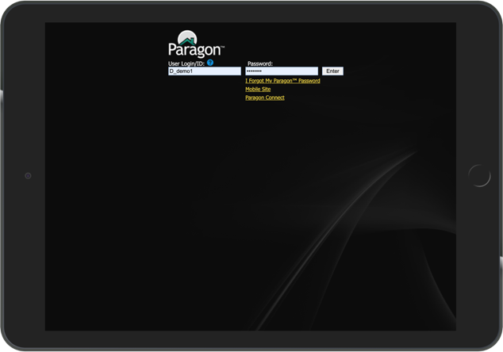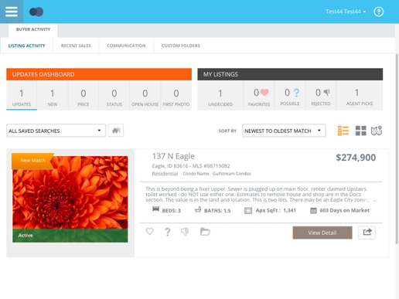

New to the Collaboration Center is the ability to add one custom field to the thumbnail and tile summary views. This allows MLS organizations to show a field that is not there today.

Example: Condo Name

A new field was added to the class table. This requires SSM or admin staff to choose a field for each class.

**COMPARE LABEL**

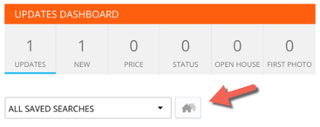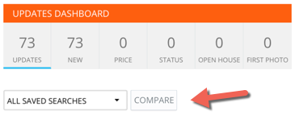

The compare icon was updated to a label rather than an icon. Several users commented that they did not know what that icon was used for.

**SEARCH ICON**

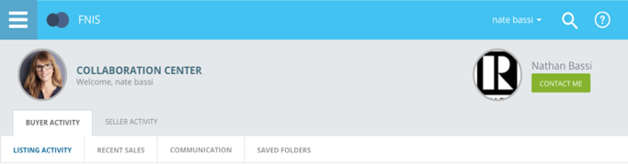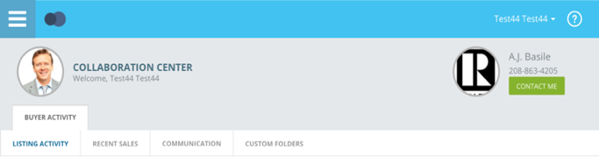

We received feedback that many users do not realize a property search can be run in the Collaboration Center, when enabled. To help with this, we added a search icon to the header that will open the property search module. It will also be available while using a smart phone.

**TOOL TIP**

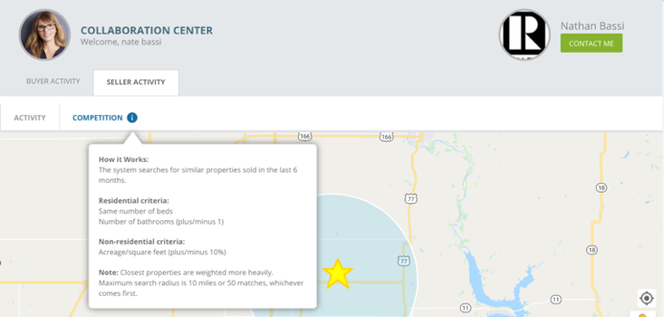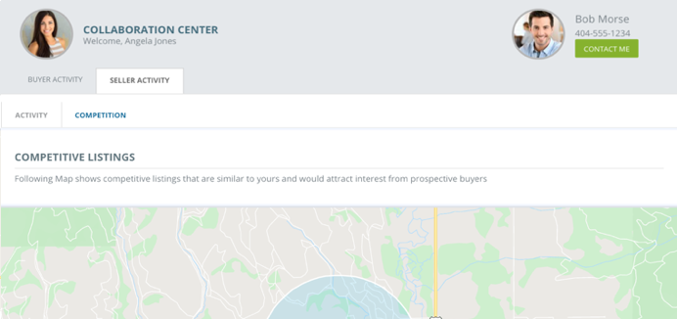

We have added a tool tip to the seller side Competition tab; several customers raised questions on how we calculated or found competitive listings within the map. The new tool tip will show how these listings are matched.

**NON-DISCLOSURE $0**

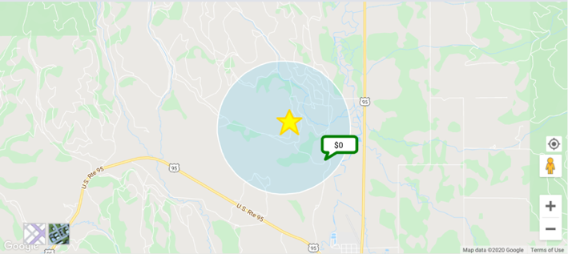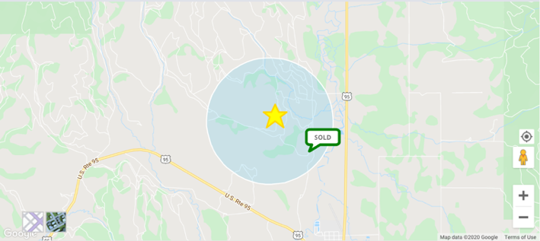

If your MLS is using the configurations for non-disclosures, the system is supposed to hide the sold price. When this is enabled the price was hidden and was replaced with $0.

This looked rather confusing. Now it will display “Sold.”

**GRAY BOX**

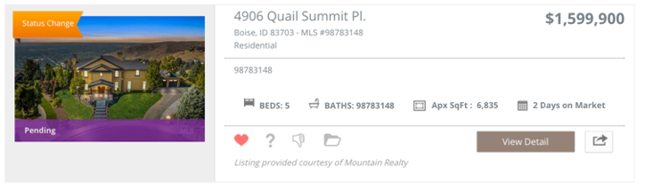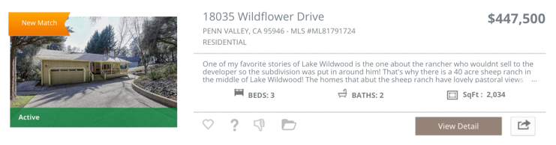

The border or box around the photo has been removed. Photos come in at various resolutions making the gray box appear to be much larger and unbalanced. This has been removed.

**FIRST LOADING APPLICATION**

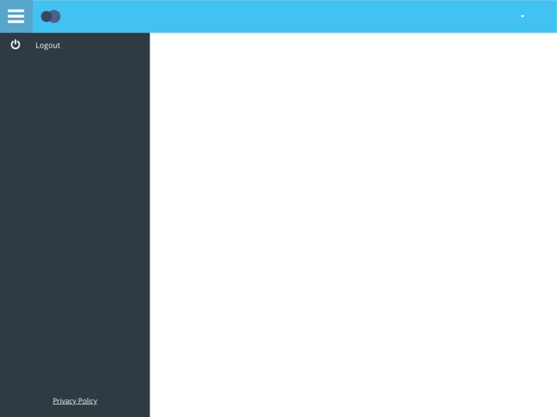

Each time you enter or reload the Collaboration Center site, the menu box would open first before displaying the contents on the screen. In 5.80, it will no longer load this menu control.

**SELL SIDE EMAILS**

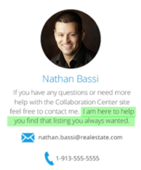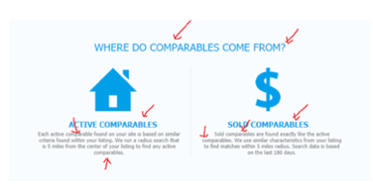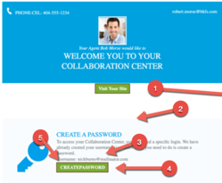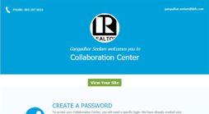

The sell side emails needed some cleanup. Layout updates, spelling and grammar updates, spacing, padding, etc. You named it we fixed it!

# Paragon Affiliate Connect

**All options in this section are either configurable via MLS Administration controls or by your System Support Manager as noted.**

# Corrected Paragon Affiliate Connect Issues

|  |  |  |
| --- | --- | --- |
| **Ticket #** | **Module** | **Summary** |
| DEV-2055 | Affiliates | City drop down not reflecting cities of the Affiliate Office you belong to. |
| DEV-2071 | Affiliates | Unless you check the box next to an affiliate you cannot see the actions you can take with that affiliate. |
| DEV-2056 | Affiliates | The drop down for Type would not display all Affiliate types. There should not be a limit on the number of affiliate types. |

## Paragon Affiliate Connect – Disclaimer for Collaboration Center

### Action Item: N/A

The MLS can add a disclaimer to appear in the footer of the Collaboration Center. The specific disclaimer will appear in the footer of the email sent from the Collaboration Center and appear in the footer of the Collaboration Center site.

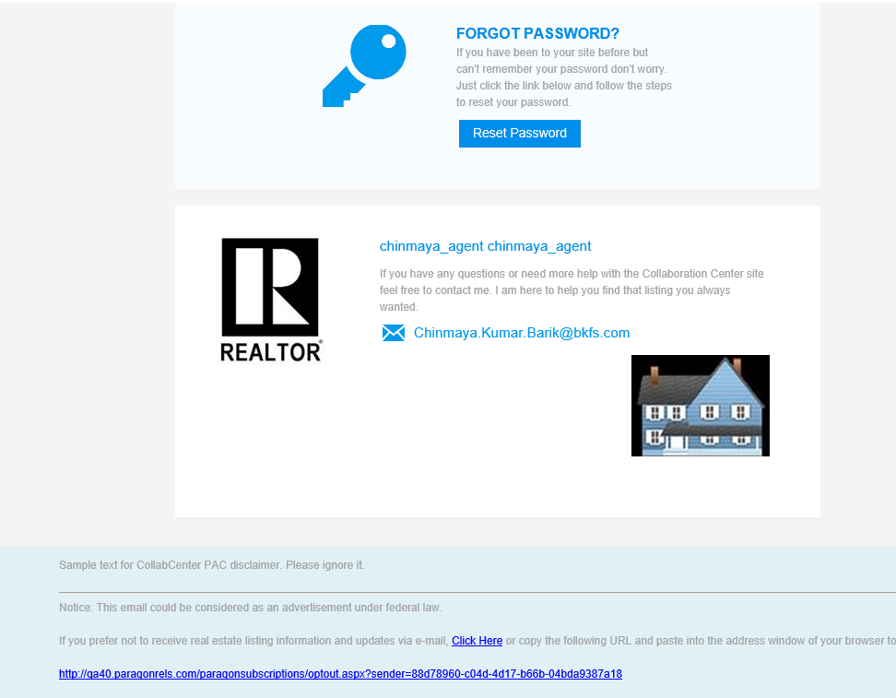

## Paragon for Brokers (P4B) Dashboard change

### Action Item: N/A

The My Affiliates link has been added to the Paragon for Brokers (P4B) dashboard. This link has the same functionality of Preferences/My Affiliates. It has been added to the P4B dashboard to highlight the broker added affiliates.

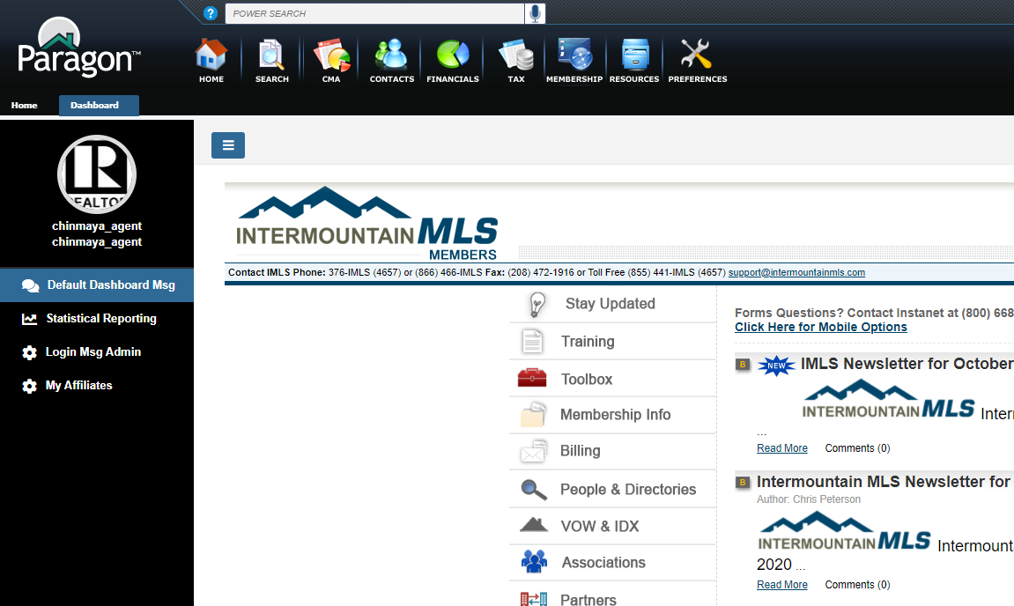

## Preferences - Ability to Suppress a Connected Affiliate’s Branding Block

### Action Item: N/A

Agents will have the ability to suppress a connected affiliate’s branding block from appearing in Collaboration Center. Now, when an agent suppresses an affiliate from appearing in Collab Center, the affiliate will also NOT display in the Collab Center emails that are sent.

## Preferences – Notification Options

### Action Item: N/A

Under Preference/Affiliate Connect, the label for “Seller Activity” has been changed to “Listing Activity” to better reflect the notifications that are sent. Affiliate Connect sends notifications to the affiliate based on listing activity, not sellers.

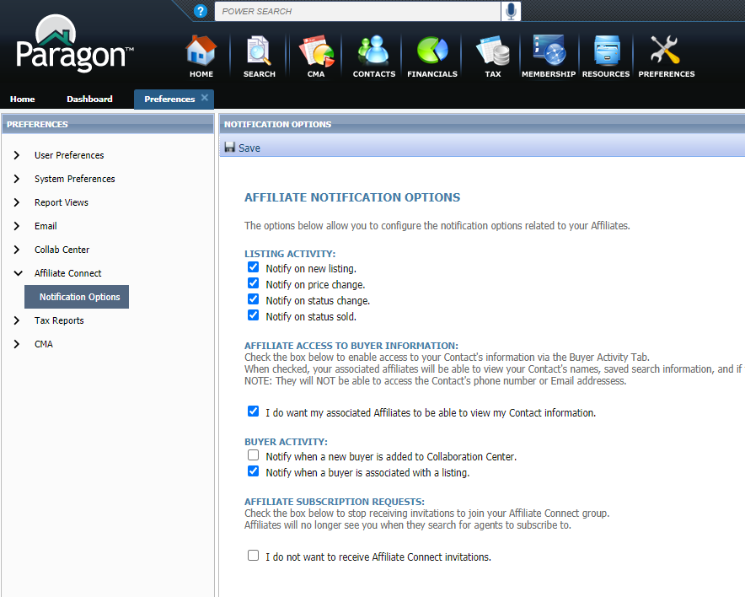

## Search Screen – Office City/State

### Action Item: N/A

To accommodate MLSs that may have affiliate offices in multiple states, the state abbreviation has been added to the city name under the Office City filter in Affiliate Search.

