Paragon Customer Toolkit - Release 5.81

## **Communications Plan Overview**

Welcome to the Paragon release communication Toolkit. The intention of this kit is to help you with communicating the release information to your membership.

In this kit you will find the following:

* Link to Release Notes for Paragon 5.81: the notes include any configurations and administration items that you will need to know about.
* Administration Configuration Options: What changes you may need to decide on
* Agent level Communication Plan: a link to an editable Customer Communication, and homepage notifications.
* Social Media: a post that you can use for Facebook, Instagram or other sites with a video of the release features.
* Example Home Page Announcements: You can cut and paste into your Homepage.

The goal is to make everyone aware of all the great Paragon enhancements to boost the way Members do Business!

## **Release Notes for Paragon 5.81**

Listed below is a link to the full release notes for the MLS. These release notes are for the Association/MLS. The Agent Level changes in this document are included in the e-mail template that you will want to send out to your members.

**Link:** [Release Notes](http://paragonconnect.paragonrels.com/images/documents/release_notes/581/Paragon%205.81%20Release%20Notes.docx)

## **Administration Configuration Options**

**Disable Off Market Status checkbox on Active Statuses**

**Action Item:** N/A

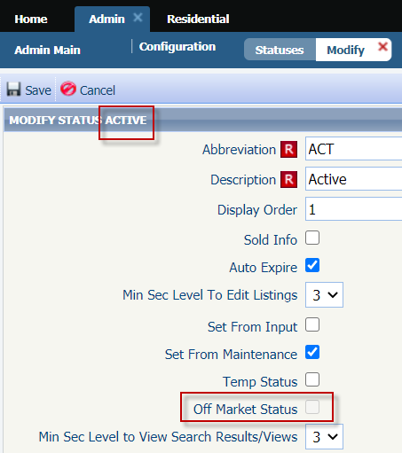To help prevent inaccurate Status setup, the Off-Market Status option has been disabled for all statuses, new and existing, in Status Category 1, Active. The Off-Market Status option is never valid for Active statuses, so disabling it will prevent it from being accidentally enabled. It is still a valid option for all other status categories.

**Update to Label in Status Setup**

**Action Item:** N/A

Have you had to ask around your office or call your SSM to ask what the “Maintain Field” or “Detail Security” levels do from the Modify Status admin? We’re happy to announce that you’ll never have to ask around or make that call again. We’ve renamed the labels to have a much clearer description.

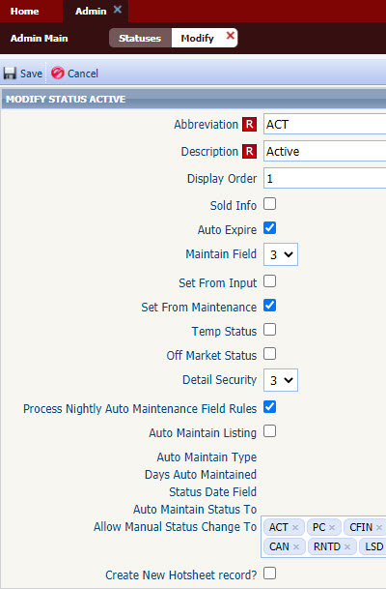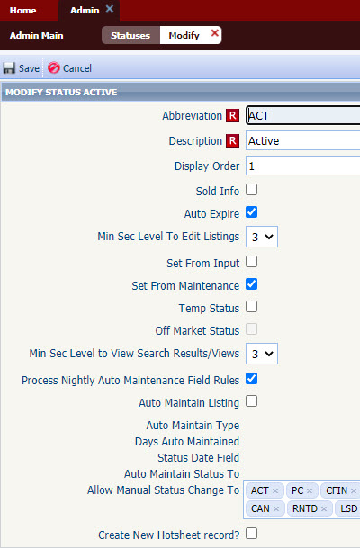

**Broker Syndication**

**Action Item:** If desired MLS/Board can set syndication to allow

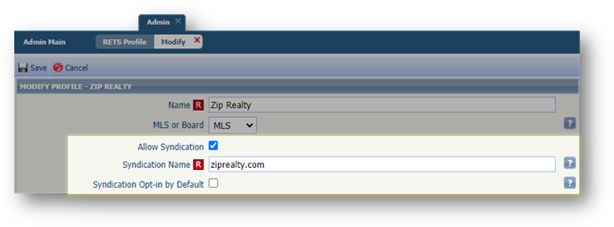Paragon now offers a streamlined way for brokers to manage their participation for syndication-based RETS exports. New syndication options are now available when setting up a RETS Profile. The new optional settings in the MLS/Board RETS profile setup allow for management of listing syndication (at the Broker, then the Agent level). When Syndication is set to allow, a syndication site name must be specified. This Syndication Name value will be displayed to Brokers and Agents when setting their individual participation preference. By default, no offices are automatically included in the syndication profile allowing individual brokers the ability to sign-up to have their listings syndicated. If desired, “Opt-in by Default” can be selected and will automatically include all offices as “opted-in” to participating in syndication for this website, but brokers retain the ability to then opt-out if they choose.

When Allow Syndication is selected for any profile, brokers and managers (5+) will be presented with a message at login informing them of the available Syndication website option and a link to edit their participation preferences. Brokers then have the ability to allow individual agents to override the office participation setting.

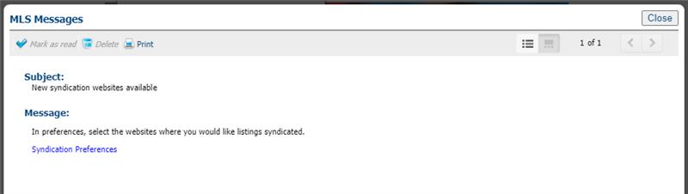

Broker/Manager-level users (5+) can modify syndication options in their user preferences for all offices in their firm and grant their Agents the ability to choose the syndication settings for their listings as well.

The Broker/Manager will set up their office syndication settings per office. In the broker’s system preferences they will choose to turn on/off syndication per office. They can also deny or allow the agent the ability to choose their own participation setting.

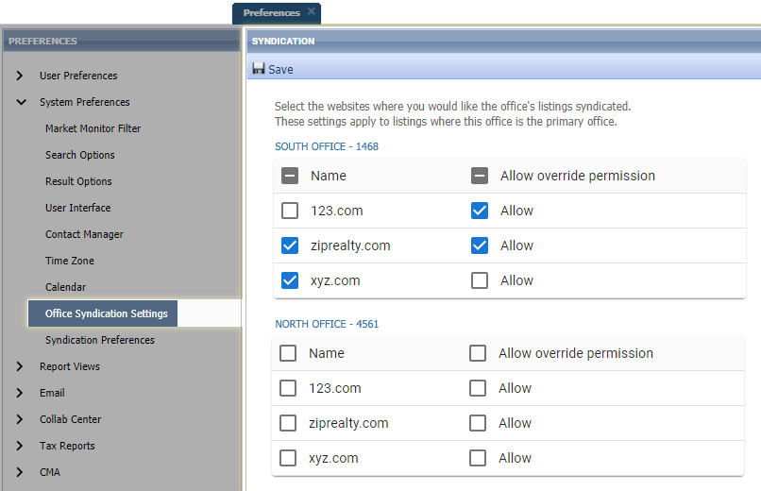 In the example below this Broker of South Office -1468 has declined the syndication of all their office listings to 123.com, but allowed agents in their office the ability to send their individual listings. They opted in for syndication to ziprealty.com and also allowed the Agent to be able to opt out. On xyz.com they opted in for syndication but did not allow the Agent to opt out. For their branch office North Office – 4561 they didn’t opt in to syndicating listings for any of the websites.

Agent-level users (4-) can modify syndication options in their System Preferences. If the Broker has allowed Syndication override, the Agent will see the following in their Syndication Preferences.

The Agent, if allowed by the Broker can opt in or out of syndication by checking or unchecking the box. If the name is greyed out, you are not allowed to change that syndication.

In the example below the agent who belongs to the South Office – 1468 will have the ability to syndicate their own listings to 123.com even though all office listings will not be sent, turn off syndication to ziprealty.com for their own listings even though all office listing would normally be sent, but not allowed to alter xyz.com participation (all office listings will be sent).

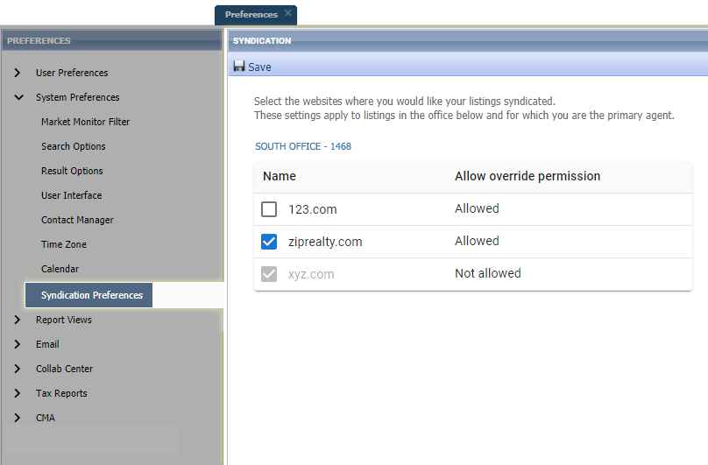

Note: Individual listings included in syndication honor the participation settings of the Primary List Agent (LA1)    
Addresses are redacted when "Internet Address Display" (existing Paragon field) is set to "No" in Listing Maintenance

## **Agent Level Changes Communication Plan**

The following link is to the e-mail template that you can copy and paste from to send out to your members keeping them informed on the release. [Paragon Release 5.81 Member Email](http://paragonconnect.paragonrels.com/images/documents/release_notes/581/Email%20to%20agents%205.81.docx)

This is a word document that you can edit so if you **do not** have certain functionality, for example In this release we have Broker Syndication, you can remove those sections first before sending. Also, in the first sentence you will want to add **your MLS name** (it is in red), so that it is being sent from **your** organization to **your** members.

To ensure that your members are always informed about the latest and greatest enhancement to their MLS System, please announce the enhancements to your membership, post to Social Media sites, include them in your newsletters and post notices to your homepage and login messages.

## **Social Media Post**

Copy and paste the following into your social media and the picture below will display with the video.

Please encourage your membership to like our Facebook page @ParagonMLS.

Check out the exciting new features of the Paragon 5.81 release!

**[](https://player.vimeo.com/video/504537421?app_id=122963)**

## **Example Home Page Announcements**

The release has a lot of nice enhancements, you may want to highlight a different one every few days on your homepage and via Social Media. You can just cut and paste these into your homepage editor. If you want to add pictures you can do that too but make sure to upload them to your server.

**Enhanced Access to Integrations and Paragon Tools**

Does your Action Icons take up most of the space on your spreadsheet? Wouldn’t it be nice if you could view more data and fewer icons but still have access to the integrations and tools? Well, you are in luck! In 5.81, we have enhanced the way users access integrations and other Paragon System Actions from the spreadsheet search report as well as the default views. The Action Icons column of the spreadsheet has been modified to display a single icon  to provide access and more viewing space for data.



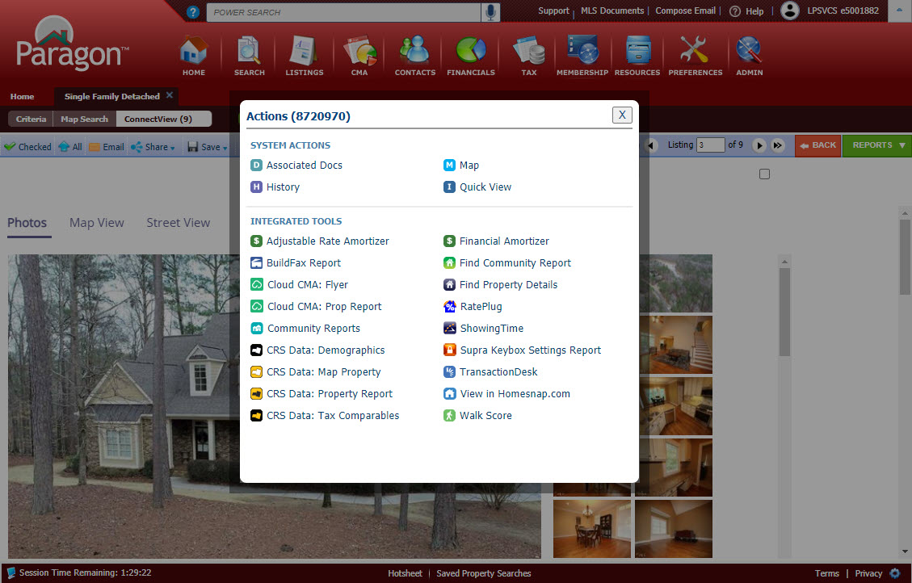

**Listing Report Menu Enhancements**

The Listing Report Menu now indicates our preferred default reports for Search Reports and Detail Reports. If you do not like your default you can change this in your preference from the preferences menu, go to system preferences and result options.

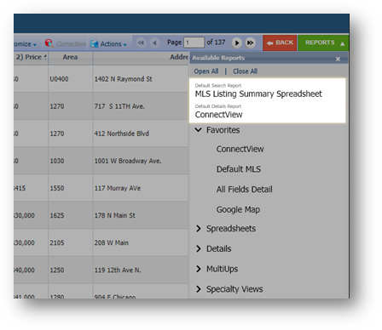

**Paragon Connect – Change your Photo Image Just got easier**

Does your agent photo need updating? Now you can snap a picture or upload a new agent profile image. Your image is synced with Paragon Classic so there is no need to reload or add twice. It also uses a crop tool to make sure your photo fits the circle profile layout perfectly.

You will notice a pencil icon on the profile photo. This just lets you know that you can change this photo.

Make sure to visit the full instructions in the email we sent on the 5.81 enhancements.