Paragon 5.81 Release Enhancements (February 2021)

Corrected Paragon Issues 2

MLS Customizations and Administration 4

Admin – Disable Off Market Status checkbox on Active statuses 4

Admin – Update to Label in Status Setup 5

Admin - Broker Syndication 6

Admin – Embedded Videos 7

Agent Level Changes 8

Enhanced Access to Integrations and Paragon Tools 8

Prospecting – Updates to Expiring Notifications 11

Prospecting –Reminder to Approve Listings for Agent Preview 12

Search – Add Date Modified to Saved Property Searches 12

Search – Clarify access to Download Documents functionality 13

Power Search – Remove voice icon from incompatible browsers 14

CMA – Standardize references to the CMA Preference Wizard 14

Property Watch –Suspend Notifications Based on Security Level 14

Photos –Easier to Read Instructions for Uploading Your Photos 15

Reports –Listing Report Menu Enhancements 16

Preferences –Results Preference UI Update 17

Preferences – Broker Syndication 18

Partial Listing – Removal of the Logoff Toolbar Button 21

Listings – New “Add” button in Listing Toolbar 21

Listings – New Listing Navigation Simplification 22

Paragon Connect 23

Settings – Snap or Upload Agent Image 23

Save from Results 24

Embedded Videos 25

Photo Label & Description 26

Collaboration Center Texting 26

Paragon Affiliate Connect 27

Corrected Paragon Affiliate Connect Issues 27

Association Autonomy – Apply Board/Association Participation/Membership Participation logic 27

# Corrected Paragon Issues

|  |  |  |  |  |
| --- | --- | --- | --- | --- |
| **Ticket#** | **Product** | **Module** | **Organization** | **Summary** |
| DEV-3248 | Paragon | Email | BCRES - REB2 Residential, GJARA - Grand Junction Area REALTORS Assoc, IRMLS - Indiana Regional MLS, PARMLS - Pensacola AOR | Notification recurrence settings are not being properly applied/adhered to during prospecting processes |
| DEV-2799 | Paragon | Admin | RMLSA - Regional MLS Alliance (Peoria) | Missing Board Option When Copying a Class with a Custom Report |
| DEV-2797 | Paragon | Configuration | HUDSON - Hudson County MLS | Download option always available even when MLS doesn't allow Public Associated Docs |
| DEV-2512 | Paragon | Contacts | BCRES - REB2 Residential | Edit Widget Issue with Contact Activity on Paragon Homepage |
| DEV-2468 | Paragon | Contacts | SCKMLS - South Central Kansas MLS (Wichita) | Sale / Rent set to Not Equals does not prospect correctly |
| DEV-2440 | Paragon | CMA | BCRES - REB2 Residential, MAXEBRDI - MAXEBRDI MLS, RAE - REALTOR Assoc of Edmonton | CMA Final Comments display default unless generated from Step 5: Final Comments |
| DEV-2385 | Paragon | CMA | BCRES - REB2 Residential | Adding Comparables to CMA from Listing Cart Sort issue with Date Created |
| DEV-2265 | Paragon | Search | BCCLS - REB2 Commercial, BCRES - REB2 Residential | Save to Listing Cart wrong MLS# displaying |
| DEV-2182 | Paragon | Email | RAE - REALTOR Assoc of Edmonton | Compose Email To Line Inconsistent Search Results |
| DEV-3127 | Paragon | WebAPI | NEREN - New England Real Estate Network | Automatic Mapping of Values with Web API Uses Description Instead of Value |
| DEV-3082 | Paragon | Email | CR - California Regional MLS, SDMLS - San Diego MLS | Photo showing smaller in hyperlink slideshow |
| DEV-3185 | Collab Link | View/Reports | SCWMLS - South Central Wisconsin (Madison) | CollabLink Thumbnail View Does Not Follow Buy Side Collab Center Configurations |
| DEV-3250 | Collab Center | View/Reports | SCWMLS - South Central Wisconsin (Madison) | Aerial Satellite View is Not Displaying on the Listing Detail Map |
| **Ticket#** | **Product** | **Module** | **Organization** | **Summary** |
| DEV-3175 | Collab Center | Search | OBARMLS - Outer Banks AOR | Getting "Object reference" error when using Location search |
| DEV-3188 | Collab Center | Listing Photos | CARMLS - CARMLS, Inc. (Arkansas) | Portrait photos stretched to landscape on mobile collab center |
| DEV-2987 | Collab Center | Dashboard | NSAR - NS and PEI Real Estate Associations | P90-NSAR: Numbers on collab center dashboard don't match results on contact |
| DEV-2985 | Collab Center | Configuration | RASE - REALTOR Assoc of the Sioux Empire | Collab Center Thumbnail shows the Days On market value regardless of Configurations |
| DEV-2978 | Collab Center | View/Reports | TRIANGLE - Triangle MLS | Collab center map view is not showing city names as map views do in Paragon |
| DEV-2947 | Collab Center | Search | SCWMLS - South Central Wisconsin (Madison) | Revise Compare Listings instruction text for clarity |
| DEV-2945 | Collab Center | View/Reports | WVMLS - Willamette Valley MLS | The cell phone number on the mobile view is in the wrong place and is too big |
| DEV-2944 | Collab Center | Email | BCRES - REB2 Residential | CC2 - Seller Side - Prospective Buyers Saved in Search verbiage needs clarification in update email |
| DEV-2942 | Collab Center | Search | SCWMLS - South Central Wisconsin (Madison) | When sorting listings in detail view, green growler message can obscure Close button |
| DEV-2867 | Collab Center | View/Reports | NEREN - New England Real Estate Network | Valuations Tab Displays Regardless of Whether AVMs Are On or Off for Collab Center |
| DEV-2141 | Collab Center | View/Reports | BCRES - REB2 Residential, CR - California Regional MLS | Collab Center says current version of IOS Edge version is unsupported and will not allow display of content |
| DEV-3079 | Paragon Connect | Search | IRMLS - Indiana Regional MLS | Pre Direction criteria not being queried properly in Paragon Connect |
| DEV-3058 | Paragon Connect | Contacts | SCWMLS - South Central Wisconsin (Madison) | Contact Filter Label Summary Doesn't Change on Mobile View After Making Selection |
| DEV-2879 | Paragon Connect | Conversion: Saved Search | COLUMBIA - ConsolidatedMLS | Paragon Connect not listing searches that do not have UserSavedSearch table records |
| DEV-3136 | Affiliate Connect | Dashboard | NEREN - New England Real Estate Network | Help overlay on Affiliate Dashboard |

# MLS Customizations and Administration

**All options in this section are either configurable via MLS Administration controls or by your System Support Manager as noted.**

## Admin – Disable Off Market Status checkbox on Active statuses

### Action Item: N/A

To ensure the integrity of Active Statuses, the “Off Market Status” checkbox will now display as disabled for all statuses in Status Category 1, Active.

The “Off Market Status” option is never valid for Active statuses, so disabling it will prevent it from being accidentally enabled. It is still a valid option for all other status categories.

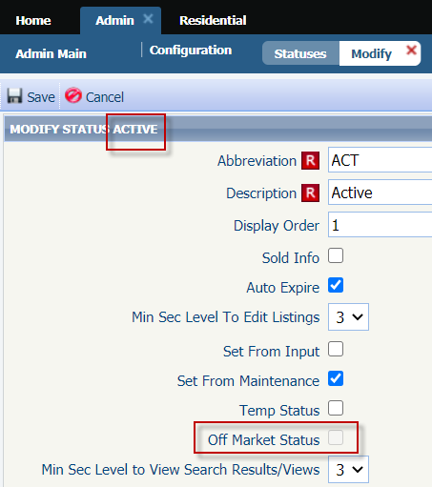

## Admin – Update to Label in Status Setup

### Action Item: N/A

Have you had to ask around your office or call your SSM to ask what the “Maintain Field” or “Detail Security” levels do from the Modify Status admin? We’re happy to announce that you’ll never have to ask around or make that call again. We’ve renamed the labels to have a much clearer description.

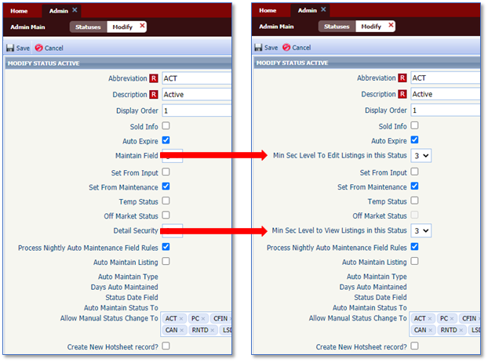

## Admin - Broker Syndication

### Action Item: If desired MLS can set Syndication to allow

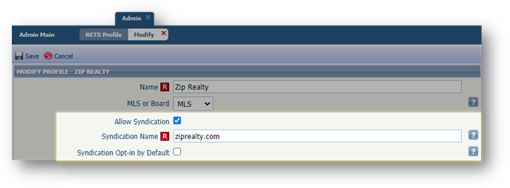Paragon now offers a streamlined way for brokers to manage their participation for syndication-based RETS exports. New syndication options are now available when setting up a RETS Profile. The new optional settings in the MLS/Board RETS profile setup allow for management of listing syndication (at the Broker, then the Agent level). When Syndication is set to allow, a syndication site name must be specified. This Syndication Name value will be displayed to Brokers and Agents when setting their individual participation preference. By default, no offices are automatically included in the syndication profile allowing individual brokers the ability to sign-up to have their listings syndicated. If desired, “Opt-in by Default” can be selected and will automatically include all offices as “opted-in” to participating in syndication for this website, but brokers retain the ability to then opt-out if they choose.

When Allow Syndication is selected for any profile, brokers and managers (5+) will be presented with a message at login informing them of the available Syndication website option and a link to edit their participation preferences. Brokers then have the ability to allow individual agents to override the office participation setting.

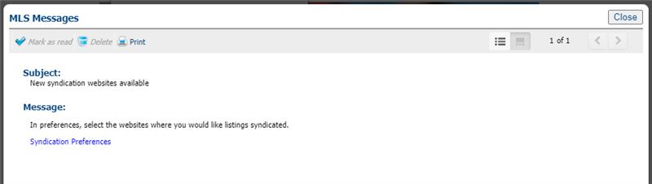

## Admin – Embedded Videos

## 

### Action Item: MLS Admin will need to edit to allow Embedded Videos

In 5.81, we have added three new fields in the listings table. When enabled these three fields, it will allow all users with listing edit rights to embed a YouTube or Vimeo video URL within the listing.

These videos would show up in the ConnectView report within Paragon Classic, and will also be available in Paragon Connect, Collaboration Center, and Collab Link.

By ­­default, these three fields are set to a level 9 security level. They must be enabled, and their security reduced for this to be used. This can be edited by MLS Admin. (**these will not be available via RETS at this time**)

The three fields are:

1. Graphical user interface, application

   Description automatically generatedVideo
2. Last Video Update Date
3. Video Count

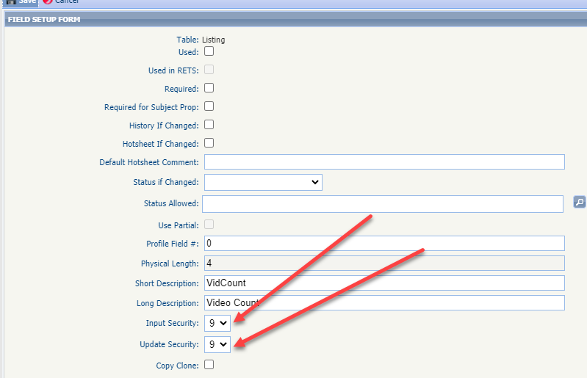

# Agent Level Changes

**The following section contains changes that are active system wide and available to users based on their assigned security levels.**

## Enhanced Access to Integrations and Paragon Tools

### Action Item: N/A

Does your Action Icons column look like the following? Wouldn’t it be nice if you could view more data and fewer icons but still have access to the integrations and tools? Well, you’re in luck.

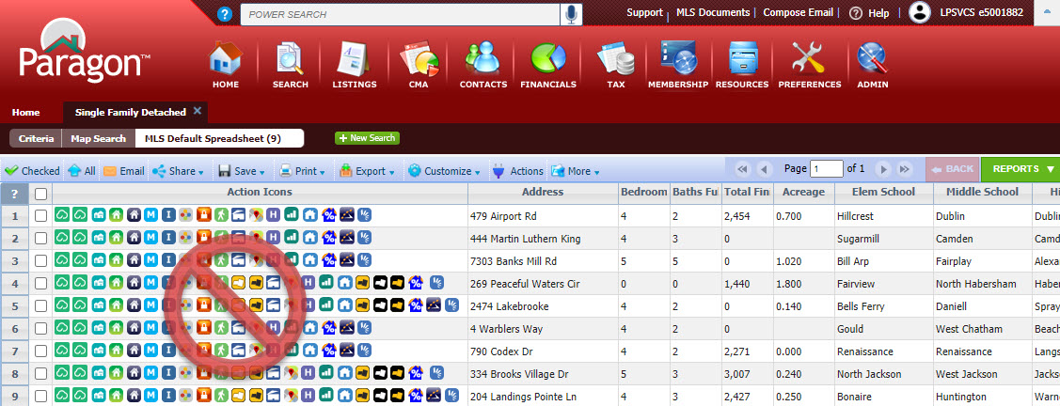

In 5.81, we enhanced the way users access Integrations and other Paragon System Actions from the spreadsheet search report as well as the detail views. The Action Icons column of the spreadsheet has been modified to display a single icon  to provide access and more viewing space for data.

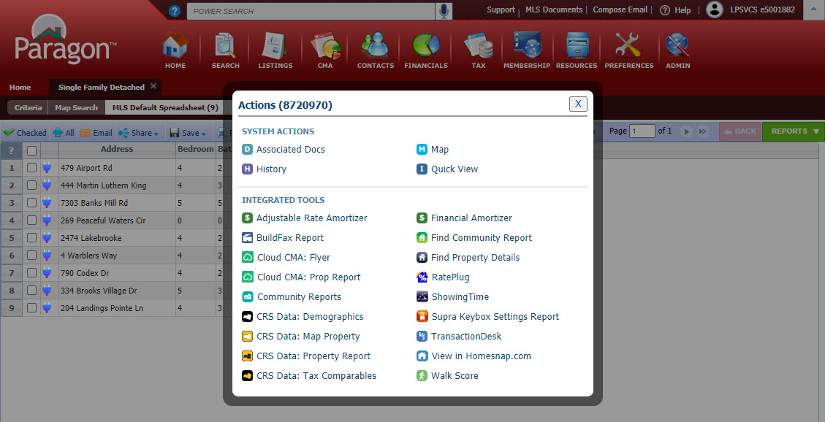

In addition to the column in the spreadsheet, a new Actions button has been added to the menu bar.



This does a couple of things. One, from the spreadsheet report view it provides access to actions that users can take when multiple records are selected. The Actions dialog box includes logic to display the available options based on whether one or some records are selected.

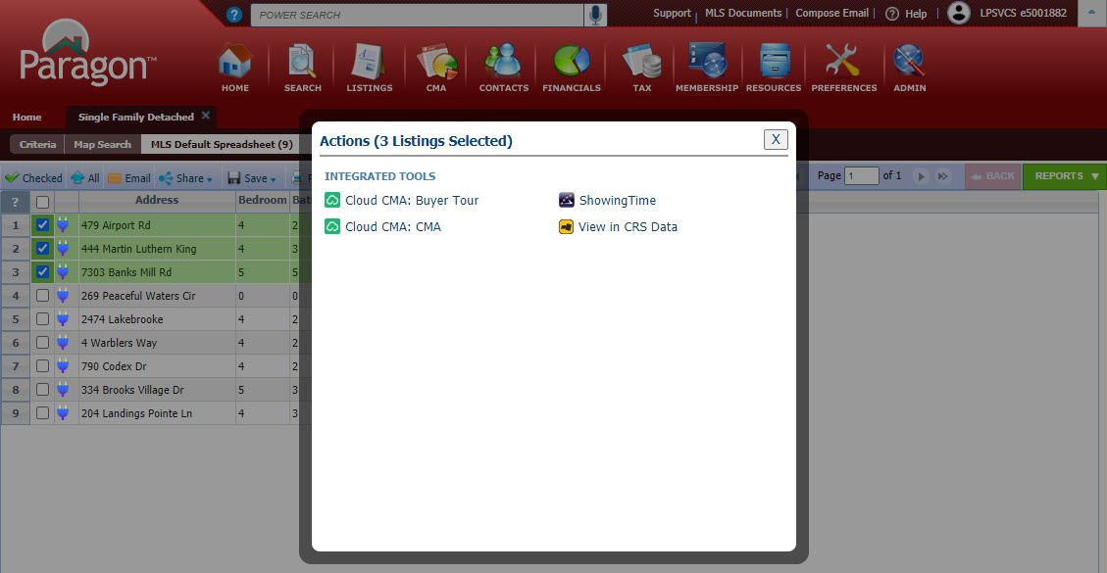

Two, it makes Integrations and Paragon Tools available from ConnectView (and any other detail view). Clicking on the button will display all the available options for the record in view.

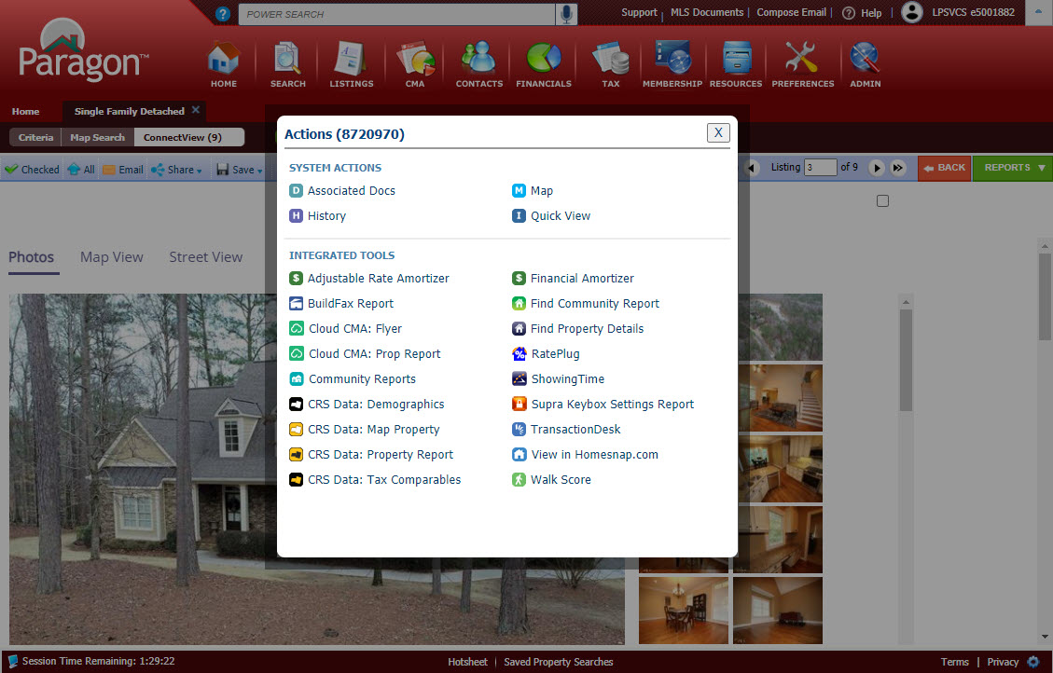

This effectively removes the need to have the icons embedded into custom reports. Before this release, if the icon was not present in the current report being viewed, users would have to return to the spreadsheet search report or pull up the All Fields Detail or another report containing icons in order to access the action.

**Other Menu Changes**

In addition to adding the new Actions button, the previous Actions menu was succinctly renamed “More” since it includes the overflow of menu options that do not fit in the toolbar.

Before 5.81



After 5.81

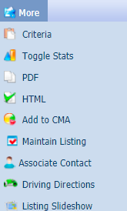

You will also notice in the overflow menu to the right that the multi-select integrations such as Cloud CMA, ShowingTime and View in CRS are no longer present (if your MLS subscribed, that is). They now reside under the new Actions menu as previously shown when more than one record is selected in the spreadsheet.

In summary, following are the benefits of this great new feature:

* Access to integrations from ConnectView or any other detail view
* All integrations accessible from central location
* More space for listing data on spreadsheet due to narrower column in spreadsheets
* Actions button in toolbar is context sensitive  
  (i.e. displays single-option integrations when only one listing is selected or multi-option integrations when multiple are selected)
* Access to integrations from any detail view even if Action icons are not in report
* No need to hover over an icon to “discover” what it is – the label is displayed with the icon
* Action icons no longer needed in custom reports

## Prospecting – Updates to Expiring Notifications

### Action Item: N/A

To Simplify and improve user experience, the expiring notifications dialog window has been enhanced to include the Contact Name, the Last Accessed and Last Notified Dates. Also included is the ability to enable/disable or extend the notifications for another year with a single click!

Additionally, when a search is extended, Paragon will run the search against current prospecting restrictions and return the usual error message if any criteria in the search is now prohibited.

Old View: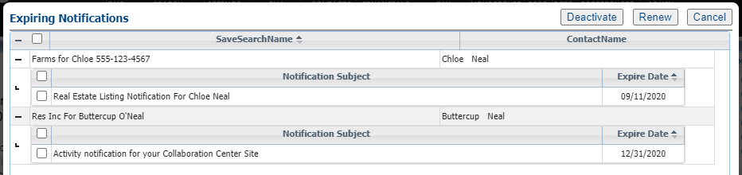

## Prospecting –Reminder to Approve Listings for Agent Preview

### Action Item: N/A

When using Agent Preview and Collaboration Center, listings do not appear in Collaboration Center until they are approved by the agent. To remind agents that they must approve their listings, so they appear in Collaboration Center, a new warning message displays when the Collaboration Center Welcome Email is sent initially or resent via Resend Invitation. The warning remains on screen until the user closes it.

## Search – Add Date Modified to Saved Property Searches

### Action Item: N/A

To assist users with managing saved searches, a Modified date column has been added to the grid in Search > Saved Property Searches. The grid can be sorted by the Modified date by clicking on the column header. Table

## Search – Clarify access to Download Documents functionality

### Action Item: N/A

The option to allow bulk download of Associated Documents was displaying even when no valid documents were available. To avoid confusion, the Download Documents option will be hidden when public documents are not enabled on the site. When public documents are enabled, the Download Documents option is available but disabled unless the user is on the Associated Documents report.

Public Documents enabled = Download Documents enabled: 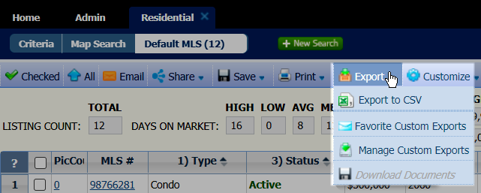

Download Documents enabled from the Associated Docs report:

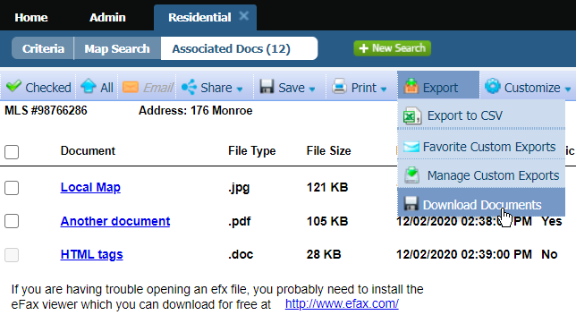

## Power Search – Remove voice icon from incompatible browsers

### Action Item: N/A

The voice option on Power Search is currently only valid for the Chrome browser. To avoid confusion, the voice search icon has been removed from all other browsers.

## CMA – Standardize references to the CMA Preference Wizard

### Action Item: N/A

References to the CMA Preferences Wizard have been standardized across the CMA module, to clarify for the user that all instances are referencing the same Wizard.

## Property Watch –Suspend Notifications Based on Security Level

### Action Item: N/A

This enhancement fixes an issue where Property Watch notifications were being sent out even if the user fell below the specified security level for Property Watch. If a user falls below the MLS-specified security level, no email notifications will be sent to the agent for new alerts, but the alerts will be retained in Paragon. If the user’s security level changes in future to a valid setting for Property Watch notifications, notifications will resume.

## Photos –Easier to Read Instructions for Uploading Your Photos

### Action Item: N/A

When uploading your images in Listing Input, Agent Photos, Office Logos, etc., we have simplified the instructions while retaining all functionality.

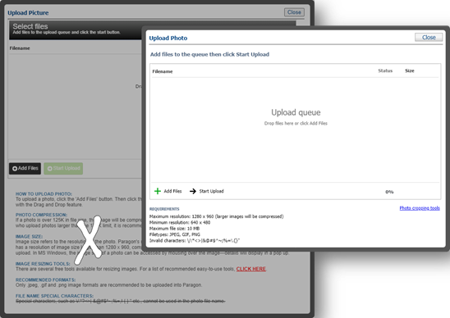

## Reports –Listing Report Menu Enhancements

### Action Item: N/A

The Listing Reports Menu now indicates the user’s preferred default reports for Search Reports and Detail Reports.

The user can change their preference from this screen.    
Note: Selected preferences will be reflected in User Preferences | System Preferences | Results Options

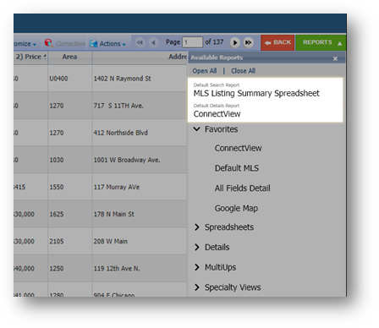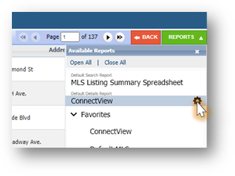

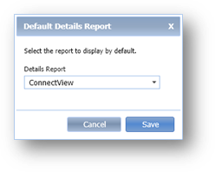

## Preferences –Results Preference UI Update

### Action Item: N/A

Result Options page in User Preferences and in the Preference Wizard, has been reorganized so that related options are grouped together, and unnecessary text has been removed to create a more user-friendly layout.

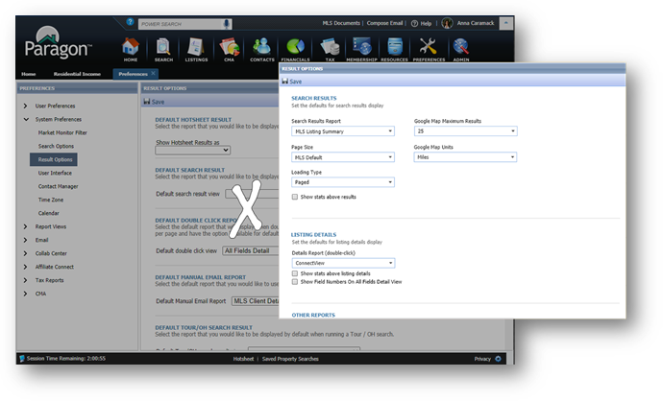

## Preferences – Broker Syndication

### Action Item: N/A

We are excited to introduce a new (optional) feature for Broker Syndication in Paragon!

If your MLS has chosen to participate in Broker Syndication, the Broker/Manager will receive a message in MLS Messaging when they log into Paragon.



Broker/Manager-level users (5+) can modify syndication options in their user preferences for all offices in their firm and grant their Agents the ability to choose the syndication settings for their listings as well.

The Broker/Manager will set up their office syndication settings per office. In the broker’s system preferences they will choose to turn on/off syndication per office. They can also deny or allow the agent the ability to choose their own participation setting.

In the example below this Broker of South Office -1468 has declined the syndication of all their office listings to 123.com, but allowed agents in their office the ability to send their individual listings. They opted in for syndication to ziprealty.com and also allowed the Agent to be able to opt out. On xyz.com they opted in for syndication but did not allow the Agent to opt out. For their branch office North Office – 4561 they didn’t opt in to syndicating listings for any of the websites.

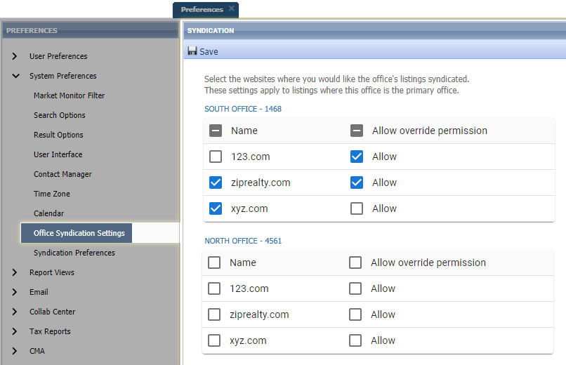

Agent-level users (4-) can modify syndication options in their System Preferences. If the Broker has allowed Syndication override, the Agent will see the following in their Syndication Preferences.

The Agent, if allowed by the Broker can opt in or out of syndication by checking or unchecking the box. If the name is greyed out, you are not allowed to change that syndication.

In the example below the agent who belongs to the South Office – 1468 will have the ability to syndicate their own listings to 123.com even though all office listings will not be sent, turn off syndication to ziprealty.com for their own listings even though all office listing would normally be sent, but not allowed to alter xyz.com participation (all office listings will be sent).

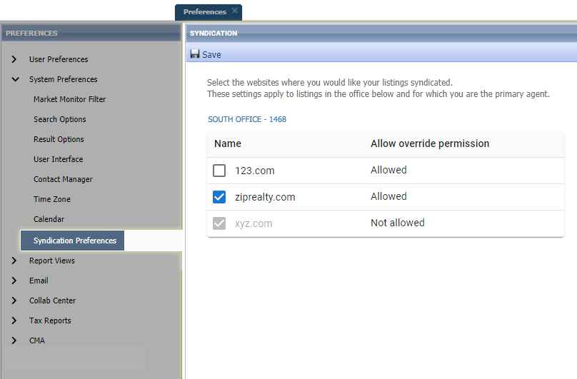

Note: Individual listings included in syndication honor the participation settings of the Primary List Agent (LA1)    
Addresses are redacted when "Internet Address Display" (existing Paragon field) is set to "No" in Listing Maintenance

## Partial Listing – Removal of the Logoff Toolbar Button

### Action Item: N/A

The Log Off button has been removed from the Listings Maintenance toolbar. This addresses a defect that was introduced in 5.80 with the login screen update. Users can easily assume identity from the user menu.

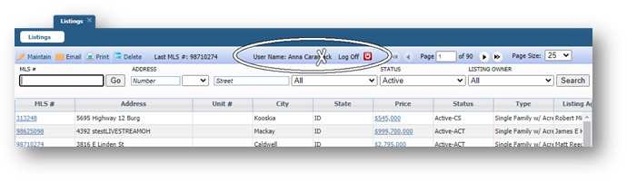

## Listings – New “Add” button in Listing Toolbar

### Action Item: N/A

When maintaining a listing we have added a new “Add” button so that you can easily have access to add a new listing of any class. (this is for both Partial and Full) This will simplify the steps needed when adding and modify listings.

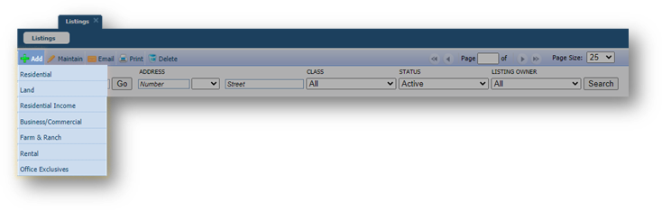

## Listings – New Listing Navigation Simplification

When maintaining a listing in the past you had to save your listing in order to see the additional options available such as adding or maintain photos, adding an open house etc. Now for both Partial and Full when adding a listing you will have all of the additional navigation options available to you without having to save first.

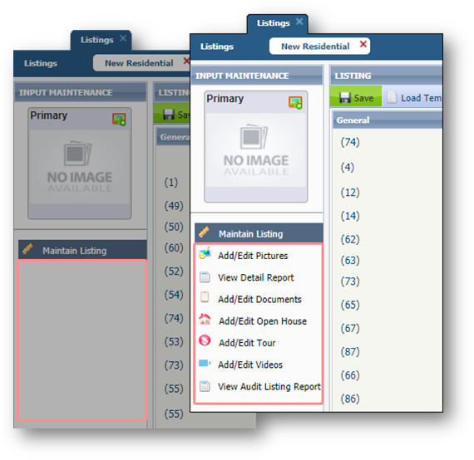

# Paragon Connect

**All options in this section are either configurable via MLS Administration controls or by your System Support Manager as noted.**

## Settings – Snap or Upload Agent Image

### Graphical user interface, application Description automatically generatedAction Item: N/A

Does your agent photo need updating? Now you can snap a picture or upload a new agent profile image. Your image is synced with Paragon Classic so there is no need to reload or add twice. It also uses a crop tool to make sure your photo fits the circle profile layout perfectly.

You will notice a pencil icon on the profile photo. This just lets you know that you can change this photo.

**HOW IT WORKS!**

After you tap on the pencil icon, you will be presented with three options:

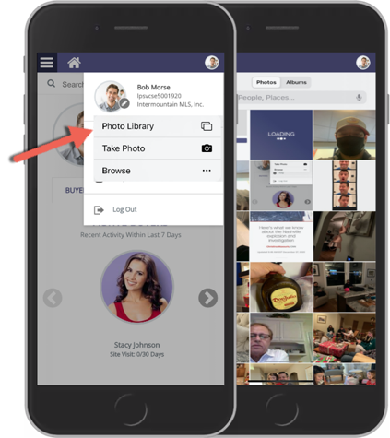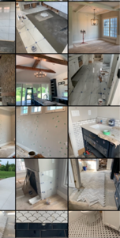

* **Photo Library:** This will allow you to choose a photo from your phone’s photo library.
* **Take Photo:** Use your camera on your phone to snap a selfie of yourself.
* **Browse:** If you have storage options or storage apps on your phone you can locate your profile image with these applications.

**UPLOAD AND CROP**

If you do plan to snap your own photo, just note the application will come built in with a crop tool to make sure your image fits perfectly with in the circle frame.

Just snap your photo and you will be taken to a crop screen. From here you can move the crop area and you can also increase or decrease the crop square. When done just click save and your profile image will be replaced. Again, this also updates your profile image within Paragon Classic.

## Save from Results

Now from the search result screen, agents can save a search and setup a Collaboration Center site. Prior to this enhancement, agents were required to go back to the search screen and then save the search. This new workflow will provide agents with an alternate workflow to quickly save a search.

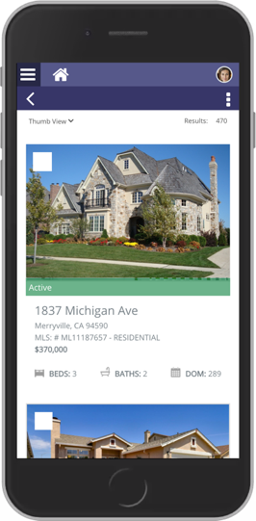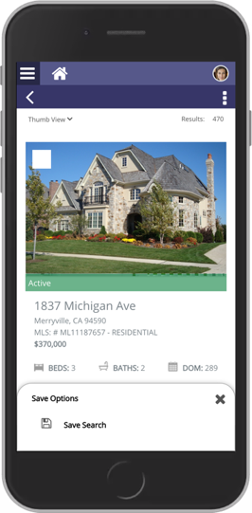

## Embedded Videos

### Action Item: N/A

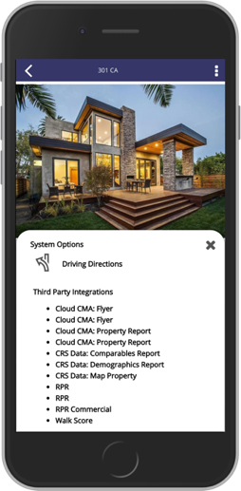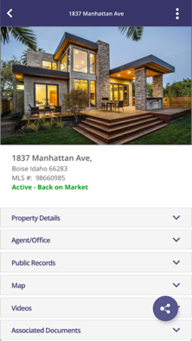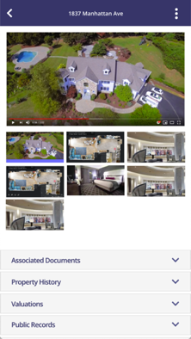

*New Video Container*



*Embedded Video*

In a previous release, Black Knight added Live Stream links inside of our applications to help agents show homes during this pandemic. Our research has found that several agents were trying to link to just videos and not live stream events. To help agents even further during this time and beyond, the Paragon Classic and Paragon Connect teams worked on a joint project to allow agents to embed a link to a YouTube or Vimeo videos. Paragon will allow you to add 10 videos links per listing.

## Photo Label & Description

### Action Item: N/A

The photo label and description will now show within both the Paragon Connect detail report and the ConnectView (Classic). This will be available both on a small and large form factor.

## Collaboration Center Texting

### Action Item: N/A

The Collaboration Center is excited to announce that text messaging from a mobile device is now available. When on a detail report you can now go to the options icon and see a new option called “Text Message.”

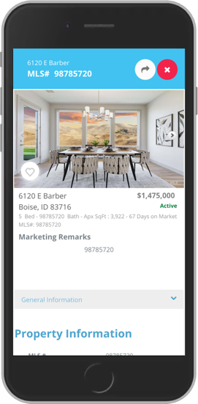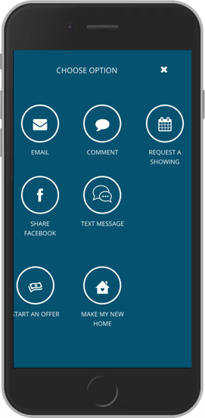

This will open your default native texting app on your mobile device. It will then generate a link to the public version of this report and paste it in a new message. From there, the end user can choose who to send the text message to.

# Paragon Affiliate Connect

**All options in this section are either configurable via MLS Administration controls or by your System Support Manager as noted.**

# Corrected Paragon Affiliate Connect Issues

|  |  |  |
| --- | --- | --- |
| **Ticket #** | **Module** | **Summary** |
| DEV-3136 | Affiliate Dashboard | The help overlay in the affiliate dashboard is now transparent, so it overlays on the dashboard correctly |
|  |  |  |
|  |  |  |

## Association Autonomy – Apply Board/Association Participation/Membership Participation logic

### Action Item: N/A

Paragon Affiliate Connect now follows the same membership Participation sharing rules within associations. Both agents and affiliates will be searchable and able to connect based on the Board/Association participation rules applied.

The checkbox for Affiliate Connect participation indicates if a board or association participates in Paragon Affiliate Connect. If they participate the membership participation settings apply. If the association does not participate, none of their members will have access to Paragon Affiliate Connect, or will they be searchable by an affiliate in another association.

