Paragon Customer Toolkit - Release 5.83

## **Communications Plan Overview**

Welcome to the Paragon release communication Toolkit. The intention of this kit is to help you with communicating the release information to your membership.

In this kit you will find the following:

* Link to Release Notes for Paragon 5.83: the notes include any configurations and administration items that you will need to know about.
* Administration Configuration Options: What changes you may need to decide on
* Agent level Communication Plan: a link to an editable Customer Communication, and homepage notifications.
* Social Media: a post that you can use for Facebook, Instagram or other sites with a video of the release features.
* Example Home Page Announcements: You can cut and paste into your Homepage.

The goal is to make everyone aware of all the great Paragon enhancements to boost the way Members do Business!

## **Release Notes for Paragon 5.83**

Listed below is a link to the full release notes for the MLS. These release notes are for the Association/MLS. The Agent Level changes in this document are included in the e-mail template that you will want to send out to your members.

**Link:** [Release Notes](http://paragonconnect.paragonrels.com/images/documents/release_notes/583/Paragon%205.83%20Release%20Notes.docx)

## **Administration Configuration Options**

**Collaboration Center – Consumer Mortgage Center**

Black Knight is excited to announce the new enhanced Mortgage Center within the Collaboration Center! We have updated the mortgage calculator, and with Black Knight’s recent acquisition of Optimal Blue, we have a new tool that can provide highly accurate real-time and historical rate trends for your clients! Optimal Blue provides the technology used by major lenders to manage rate locks for the mortgage applications. This rate lock data is aggregated and anonymized to generate unique analytics that provide an accurate picture of exactly what rates are being quoted by major lenders.

The Consumer Mortgage Center will include:

* A new interactive mortgage calculator that allows consumers to enter a down payment, interest rate and terms.
* Consumers can request a customized quote directly from the Mortgage Center.
* A rate indices widget that allows consumers to see current rates and trends over time.

The new Mortgage Center gives the consumer all the tools they need, to know what to expect when shopping for a new loan.

The display is powered by a mortgage lender named Nexa Mortgage dba Axen Mortgage (“Axen”) and is an advertisement. If you would like to opt-out of enabling Axen’s mortgage calculator in the Paragon Collaboration Center, please notify your SSM before May 26, 2021.

**Updates to Changed Users and Changed Office Reports**

To bring added benefit to the Changed Users and Changed Offices reports, you can now search by Board ID, in addition to Date Range.

We’ve also added the office Board ID (Member of Board field) and the Last Change Date to both reports. Click the Last Change Date to view the audit report for even more details!

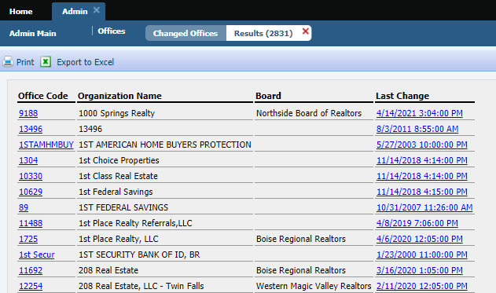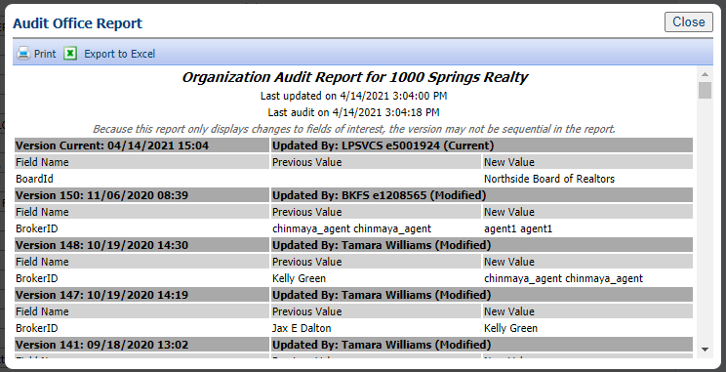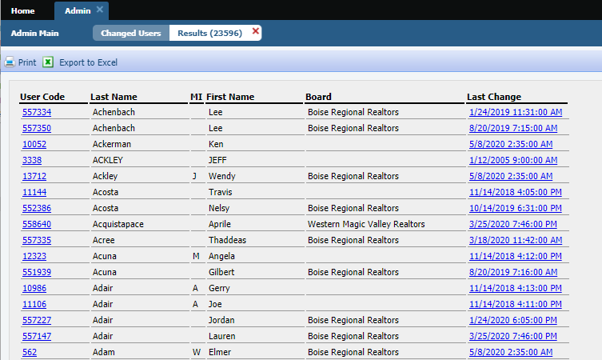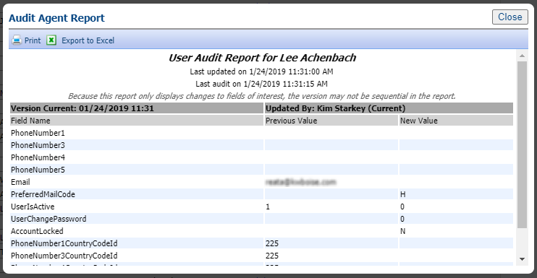

## **Agent Level Changes Communication Plan**

The following link is to the e-mail template that you can copy and paste from to send out to your members keeping them informed on the release. [Paragon Release 5.83 Member Email](http://paragonconnect.paragonrels.com/images/documents/release_notes/583/Email%20to%20agents%205.83.docx)

This is a word document that you can edit so if you **do not** have certain functionality, for example In this release we have Broker Syndication, you can remove those sections first before sending. Also, in the first sentence you will want to add **your MLS name** (it is in red), so that it is being sent from **your** organization to **your** members.

To ensure that your members are always informed about the latest and greatest enhancement to their MLS System, please announce the enhancements to your membership, post to Social Media sites, include them in your newsletters and post notices to your homepage and login messages.

## **Social Media Post**

[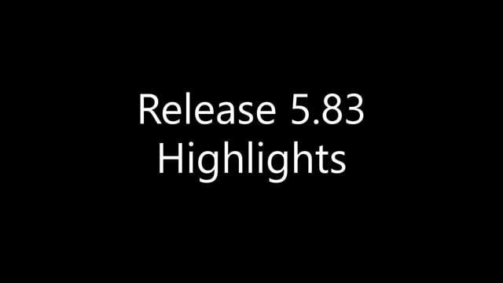](https://player.vimeo.com/video/544734925?app_id=122963)Copy and paste the following into your social media and the picture below will display with the video. Encourage your membership to like our Facebook page @ParagonMLS. Check out the exciting new features of the Paragon 5.83 release!

## **Example Home Page Announcements**

The release has a lot of nice enhancements, you may want to highlight a different one every few days on your homepage and via Social Media. You can just cut and paste these into your homepage editor. If you want to add pictures you can do that too but make sure to upload them to your server.

**Renamed “Default T/OH” label in Tour and Open House Reports Tree**

To clarify the workflow in the Preferences Wizard, the Required ‘R’ icon has been added to the Name field, and the Default checkbox is selected on both the Message Body and Email Signature pages. This ensures that any changes made to these pages will be saved. The default can be changed through Preferences when additional Message Bodies or Email Signatures are created.

To help clarify the labels for Tour and Open House defaults in the reports tree we have renamed them to be more consistent.

**Current Label:** **Updated Label:**

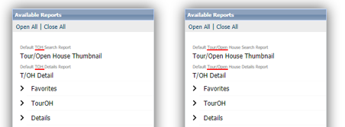

**Accessing you last five (5) searches**

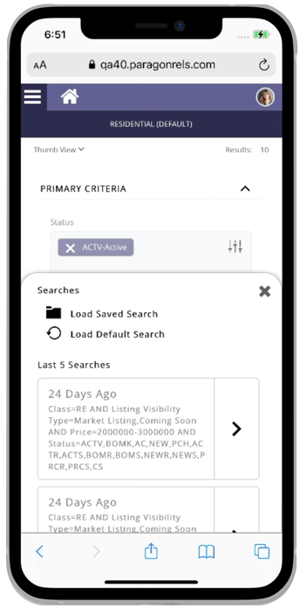

Paragon Connect can now access your last five searches. This is synced with Paragon Classic so the five searches you see are from either system.

The folder icon now opens a drawer instead of going directly to the load search dialog. The “Load Default Search” option has been moved to this location as well.

Another nice feature is you can either click on the criteria to load the search criteria in the search form, or you can click/tap on the arrow to go directly to the results.

Note: Accessing a class-based search from the hamburger menu will always load your default search.

**Texting Detail Report Phone Number**

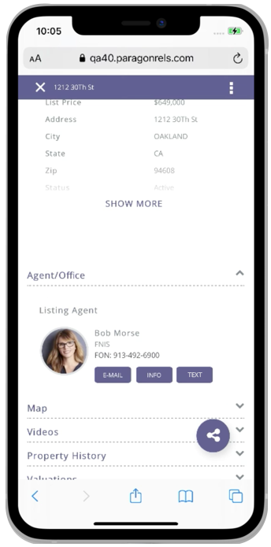

Paragon Connect today supports texting on a mobile device. The detail report today includes a feature to text the listing or selling agent directly from the detail report. However, the texting button uses the number that is displayed. In some cases, this is an office phone number or a phone number that doesn’t support texting.

To address texting phone number accuracy, Paragon Connect will now look at the mobile preferences in Paragon Classic. If a number is supplied, Paragon Connect will display the texting button on the report. The texting feature will use the phone number supplied in the mobile preference setting.

* **Pencil Icon added to Paragon Connect**

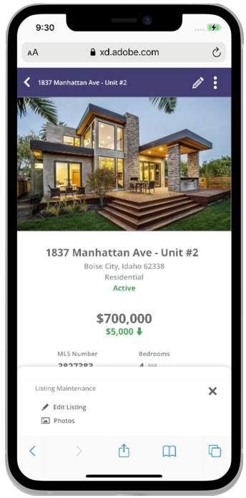

Full listing edit is just around the corner. In Paragon Connect, if you have the proper permissions, you can edit a listing or photo from any search result. Currently, this option is stored in our (three-dot) overflow menu. However, the time it takes to load these options is excessive due to the number of permission checks and configurations.

Our solution is to move the edit options to the detail report and provide a new icon to access these options. This new icon is a pencil and it will host any future listing edit options.

* **Edit Photos**

Prior to the 5.83 release, the ability to edit a photo was tied to a security configuration to enable full listing edit. We have separated the edit photo feature so it will no longer be tied to this configuration. You will now be able to edit photos from Paragon Connect provided you have the proper photo permissions. Note: you can access the edit photo feature from a detail report.

