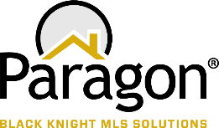

**PARAGON - INNOVATING THE WAY AGENTS DO BUSINESS**

**Paragon Release 5.83**

We (enter your MLS Name here) wanted you to be the first to know about the latest enhancements to your Paragon MLS System. All enhancements are designed to help you navigate through the system and enhance your experience with Paragon.  Below is a list of the enhancements and links to view videos or PDFs of the new features. We encourage you to continue reading and let us know what you think on the [Paragon MLS Facebook site](https://www.facebook.com/ParagonMLS/). Also make sure you click “Like” on the Facebook site to view what’s new with Paragon more frequently.

**WHAT’S NEW!**

**PARAGON**

* **Update notification end date on Agent Recommendation**

Your Contacts’ Agent Recommended carts automatically have notifications turned on for Collaboration Center…and those notifications have the same one-year default expiration date as any other Collaboration Center notifications. With this enhancement, any time you add a new listing to the Agent recommended cart, the system willcheck the notification end date and automatically extend the notification end date for another year if the end date has passed.

* **Update Toggle Switch Style**

Reversed the toggle switch to align with the industry standard (thumb is to the right when on) and added refined color and mouse-over effects to provide action affordability.

|  |  |  |
| --- | --- | --- |
| Off | On | |
|  |  | |
|  | |  |

* **Disabled Notifications for an Inactive Client**

The notifications in Collaboration Center are now disabled whenever a contact goes from active to inactive. This will prevent notifications from auto sending when a contact is no longer active with the agent.

|  |  |
| --- | --- |
| * **Verbiage update for listing syndication user preferences**   We have clarified the instruction text and the permission column header in user preferences for listing syndication to help explain the process.  **Existing verbiage**  **5.83 verbiage update** |  |
|  |  |

* **Renamed “Default T/OH” label in Tour and Open House reports tree**

To clarify the workflow in the Preferences Wizard, the Required ‘R’ icon has been added to the Name field, and the Default checkbox is selected on both the Message Body and Email Signature pages. This ensures that any changes made to these pages will be saved. The default can be changed through Preferences when additional Message Bodies or Email Signatures are created.

To help clarify the labels for Tour and Open House defaults in the reports tree we have renamed them to be more consistent.

**Current Label:** **Updated Label:**

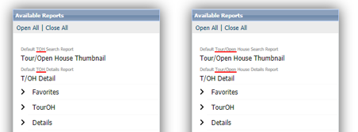

* **Multi-Select Integrations available in Paragon Connect**

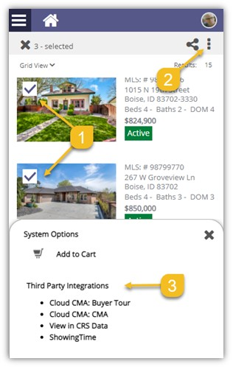We’re happy to announce that users can select and take third-party actions on multiple records from Paragon Connect search results. By clicking the overflow menu, you can now see both System options and third-party integrations! Prior to this change, the only option available was Add to Cart.

* **Accessing you last five (5) searches**

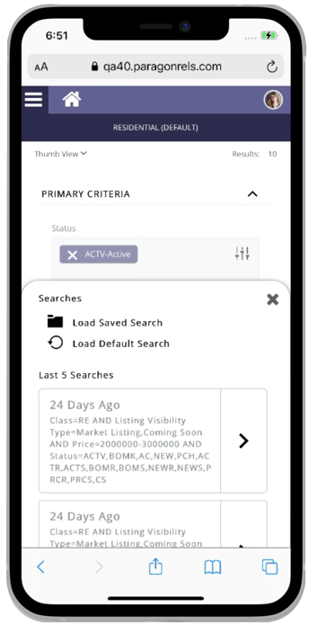

Paragon Connect can now access your last five searches. This is synced with Paragon Classic so the five searches you see are from either system.

The folder icon now opens a drawer instead of going directly to the load search dialog. The “Load Default Search” option has been moved to this location as well.

Another nice feature is you can either click on the criteria to load the search criteria in the search form, or you can click/tap on the arrow to go directly to the results.

Note: Accessing a class-based search from the hamburger menu will   
always load your default search.

* **Preferred Phone number on Paragon Connect Detail Report**

On the Paragon Connect detail report, the agent’s phone number displays the office or agent’s phone number based on a configuration. However, there is a user preference in Paragon Classic that allows users to choose which phone number to use for reports, which was being ignored by Paragon Connect.

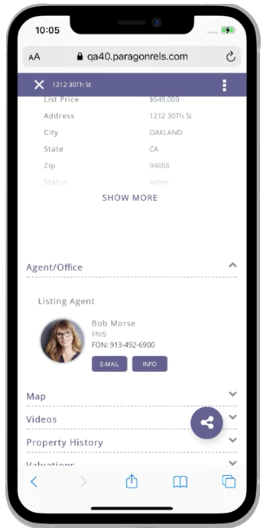

Paragon Connect has been updated to honor that preference. If a user chooses a phone number and check “Display this phone number...” it will display the selected phone number on the Paragon Connect detail report.

* **Texting Detail Report Phone Number**

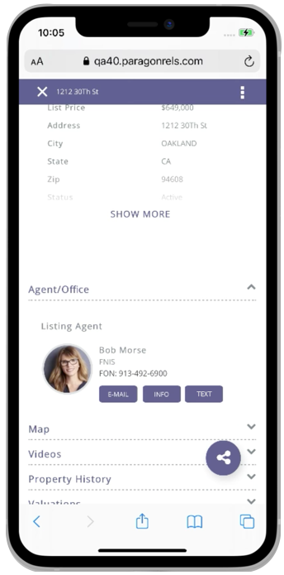

Paragon Connect today supports texting on a mobile device. The detail report today includes a feature to text the listing or selling agent directly from the detail report. However, the texting button uses the number that is displayed. In some cases, this is an office phone number or a phone number that doesn’t support texting.

To address texting phone number accuracy, Paragon Connect will now look at the mobile preferences in Paragon Classic. If a number is supplied, Paragon Connect will display the texting button on the report. The texting feature will use the phone number supplied in the mobile preference setting.

* **Pencil Icon added to Paragon Connect**

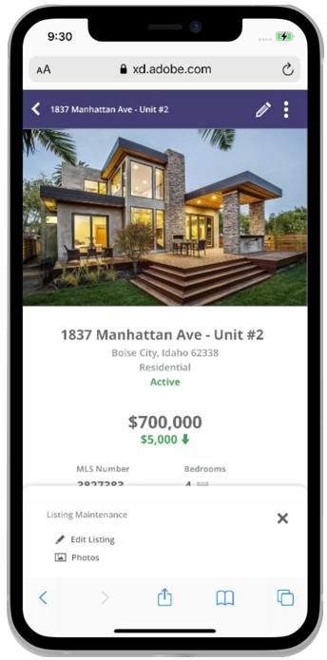

Full listing edit is just around the corner. In Paragon Connect, if you have the proper permissions, you can edit a listing or photo from any search result. Prior to this release, this option was stored in the (three-dot) overflow menu. However, the time it took to load these options is excessive due to the number of permission checks and configurations that existed.

The solution is to move the edit options to the detail report and provide a new icon to access these options. This new icon is a pencil and it will host any future listing edit options.

* **Edit Photos**



Prior to the 5.83 release, the ability to edit a photo was tied to a security configuration to enable full listing edit. We have separated the edit photo feature so it will no longer be tied to this configuration. You will now be able to edit photos from Paragon Connect provided you have the proper photo permissions.

**Note:** You can access the edit photo feature from a detail report.

* **Collaboration Center – Change Search radius to an Input Field and Change Default to 1 mile/km**

For Contacts who can create their own searches in Collaboration Center, they will now find the Address Search’s Radius field easier to use. We’ve removed the slider and switched it to an input field and changed the default amount from 5 miles to 1 mile. Users can input distances up to 50 miles/80 km.

* **Collaboration Center – Consumer Mortgage Center**

Black Knight is excited to announce the new enhanced Mortgage Center within the Collaboration Center! We have updated the mortgage calculator, and with Black Knight’s recent acquisition of Optimal Blue, we have a new tool that can provide highly accurate real-time and historical rate trends for your clients! Optimal Blue provides the technology used by major lenders to manage rate locks for the mortgage applications. This rate lock data is aggregated and anonymized to generate unique analytics that provide an accurate picture of exactly what rates are being quoted by major lenders.

The Consumer Mortgage Center will include:

* A new interactive mortgage calculator that allows consumers to enter a down payment, interest rate and terms.
* Consumers can request a customized quote directly from the Mortgage Center.
* A picture containing graphical user interface

  Description automatically generatedGraphical user interface, website

  Description automatically generatedA rate indices widget that allows consumers to see current rates and trends over time.

The new Mortgage Center gives the consumer all the tools they need, to know what to expect when shopping for a new loan. The display is powered by a mortgage lender named Nexa Mortgage dba Axen Mortgage (“Axen”) and is an advertisement