Paragon 5.83 Release Enhancements (June 2021)

(Edited on 5/12/2021)

Corrected Paragon Issues 2

MLS Customizations and Administration 4

Admin - Collaboration Center- Consumer Mortgage Center 4

Admin – Updates to Changed Users and Changed Office Reports 5

Agent Level Changes 7

Update notification end date on Agent recommendation 7

Verbiage update for listing syndication user preference 7

Rename “Default T/OH” label in the Tour and Open House Reports Tree 8

Update Toggle Switch Style 8

Collaboration Center 9

Change Search radius to an Input Field and Change Default to 1 mile/km 9

Disabled Notifications for an Inactive Client 9

Updates to Collab Center Mobile Property Search 10

Collaboration Center- Consumer Mortgage Center 11

Paragon Connect 12

Multi-Select Integrations available in Paragon Connect 12

Accessing your last five (5) searches 13

Preferred Phone number on Paragon Connect Detail Report 13

Texting Detail Report Phone number 14

Pencil Icon added to Paragon Connect 15

Edit Photos 15

# Corrected Paragon Issues

|  |  |  |  |  |
| --- | --- | --- | --- | --- |
| **Ticket#** | **Product** | **Module** | **Organization** | **Summary** |
| DEV-4092 | Paragon | Statistics | GFBR - Greater Fairbanks MLS, Grand Junction, Sanibel Islands, South Jersey Short | Market Statistics Report does not generate |
| DEV-4067 | Paragon | Calculators | RMLSA - Regional MLS Alliance (Peoria) | E-mailed Links to Calculators Result in Page Cannot Be Displayed Error |
| DEV-4018 | Paragon | Contacts | NCWV - North Central West Virginia, RANW | Quick Actions bottom banner is cutting off bottom contact when page is full |
| DEV-3946 | Paragon Connect | Contacts | RAE - REALTOR Assoc of Edmonton | PC: No warning for closing Create Contact form without saving |
| DEV-3923 | Paragon | PowerSearch | BCRES - REB2 Residential | Unable to load saved searches from Power Search |
| DEV-3819 | Paragon | View/Reports | NEREN - New England Real Estate Network | Available Reports from Comparable Search Results in the CMA Module Covers Green Reports Button, Can't Close Available Reports |
| DEV-3805 | Paragon | Search | TRIANGLE - Triangle MLS | Clicking on the Google Maps report from search criteria page does not generate report |
| DEV-3766 | Paragon | Admin | NEREN - New England Real Estate Network, RMLS Alliance (Peoria) | "Error Loading Grid" when attempting to customize the Listing Audit Report |
| DEV-3673 | Collab Center | Contacts | BCRES - REB2 Residential, NEREN, Edmonton | Contact's Last Accessed Date showing as blank |
| DEV-3607 | Collab Center | Email | RANWMLS - REALTOR Assoc of NE WI | Forwarded CC notification emails will not display the preview listing primary photo |
| DEV-3426 | Paragon | Search | RMLSA - Regional MLS Alliance (Peoria) | Cannot Set Board Default for Quick Searches |
| DEV-3346 | Paragon | View/Reports | RMLSA - Regional MLS Alliance (Peoria) | Vertical Photos in E-mailable Listing Slideshow Get Cropped |
| DEV-3275 | Paragon | View/Reports | NEREN - New England Real Estate Network | Correct Listing Agent Shown on Property History Report |
| DEV-2966 | Collab Center | Search | BCRES - REB2 Residential | Duplicate Collab Center searches when saving searches |
| DEV-2961 | Collab Link | Other | MIDKANSAS - Mid-Kansas MLS | Collab Link Mobile Contact Us Page Displays Erroneous Characters |
| DEV-2956 | Collab Center | Configuration | NRV - New River Valley AOR | (Furnished) is a field in Collab Center Location search for all classes |
| DEV-2910 | Paragon | LIM | RMLSA - Regional MLS Alliance (Peoria) | Not Available/Required Field rules not recognizing Lookup Data with spaces and potentially other characters |
| DEV-2497 | Paragon | Admin | BCRES - REB2 Residential | When agent website contains Https, Paragon is prepending http |
| DEV-2489 | Paragon | Search | BCRES - REB2 Residential, SCWMLS | MLS numbers copied from Collab Center emails don't work in Quick Search |
| DEV-2434 | Paragon | Search | CREN - Colorado Real Estate Network, Inc, Great Plains Regional, Edmonton, SCWMLS, San Diego | Advanced Search "Contains All" filtering as 'Or' Statement |
| DEV-2409 | Paragon | CMA | NEREN - New England Real Estate Network, Tallahassee | Space needed between Address 1 and 2 on the CMA Cover Page |
| DEV-4092 | Paragon | Statistics | GFBR - Greater Fairbanks MLS, Grand Junction, Sanibel Islands, South Jersey Short | Market Statistics Report does not generate |

# MLS Customizations and Administration

**All options in this section are either configurable via MLS Administration controls or by your System Support Manager as noted.**

## Admin - Collaboration Center- Consumer Mortgage Center

### Action Item: Contact SSM by May 26th if Opt Out

Black Knight is excited to announce the new enhanced Mortgage Center within the Collaboration Center! We have updated the mortgage calculator, and with Black Knight’s recent acquisition of Optimal Blue, we have a new tool that can provide highly accurate real-time and historical rate trends for your clients! Optimal Blue provides the technology used by major lenders to manage rate locks for the mortgage applications. This rate lock data is aggregated and anonymized to generate unique analytics that provide an accurate picture of exactly what rates are being quoted by major lenders.

The Consumer Mortgage Center will include:

* A new interactive mortgage calculator that allows consumers to enter a down payment, interest rate and terms.
* Consumers can request a customized quote directly from the Mortgage Center.
* A rate indices widget that allows consumers to see current rates and trends over time.

The new Mortgage Center gives the consumer all the tools they need, to know what to expect when shopping for a new loan.

The display is powered by a mortgage lender named Nexa Mortgage dba Axen Mortgage (“Axen”) and is an advertisement. If you would like to opt-out of enabling Axen’s mortgage calculator in the Paragon Collaboration Center, please notify your SSM before May 26, 2021.

## Admin – Updates to Changed Users and Changed Office Reports

### Action Item: N/A

To bring added benefit to the Changed Users and Changed Offices reports, users can now search by Board ID, in addition to Date Range.

We’ve also added the office Board ID (Member of Board field) and the Last Change Date to both reports. Click the Last Change Date to view the audit report for even more details!

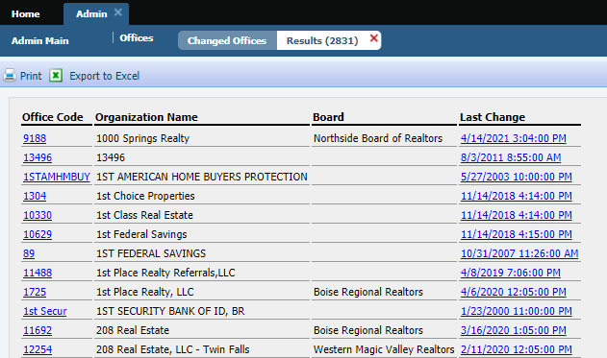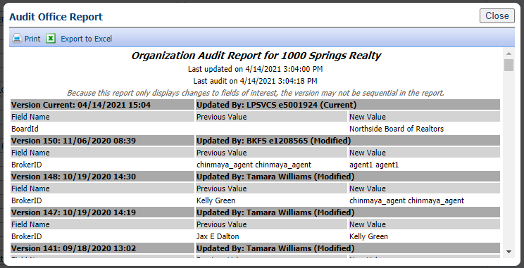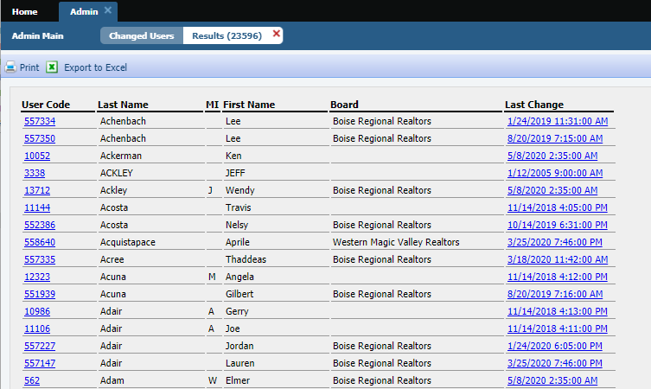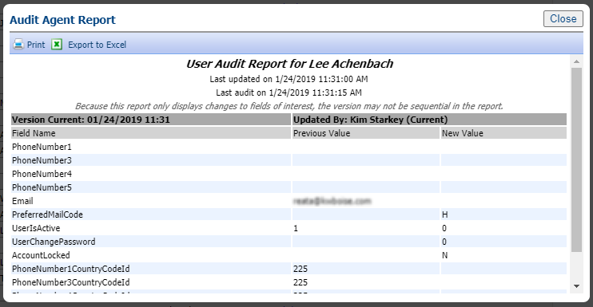

# Agent Level Changes

**The following section contains changes that are active system wide and available to users based on their assigned security levels.**

## Update notification end date on Agent recommendation

### Action Item: N/A

Your Contacts’ Agent Recommended carts automatically have notifications turned on for Collaboration Center…and those notifications have the same one-year default expiration date as any other Collaboration Center notifications. With this enhancement, any time you add a new listing to the Agent recommended cart, the system will check the notification end date and automatically extend the notification end date for another year if the end date has passed.

## Verbiage update for listing syndication user preference

### Action Item: N/A

We have clarified the instruction text and the permission column header in user preferences for listing syndication to help explain the process.

Existing verbiage

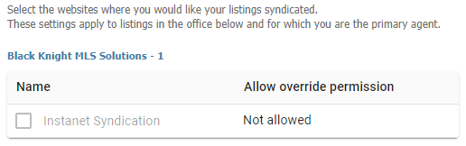

5.83 verbiage update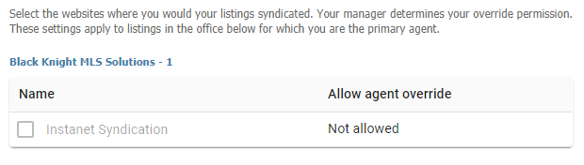

## Rename “Default T/OH” label in the Tour and Open House Reports Tree

### Action Item: N/A

To help clarify the labels for Tour and Open House defaults in the reports tree we have renamed them to be more consistent.

Current Label: Updated Label:

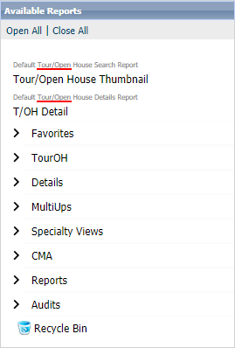

## Update Toggle Switch Style

### Action Item: N/A

We reversed the toggle switch to align with the industry standard (thumb is to the right when on) and added refined color and mouse-over effects to provide action affordability.

|  |  |
| --- | --- |
| Off | On |
|  |  |

# Collaboration Center

**All options in this section are either configurable via MLS Administration controls or by your System Support Manager as noted.**

## Change Search radius to an Input Field and Change Default to 1 mile/km

### Action Item: N/A

For Contacts who can create their own searches in Collaboration Center, they will now find the Address Search’s Radius field easier to use. We’ve removed the slider and switched it to an input field and changed the default amount from 5 miles to 1 mile. Users can input distances up to 50 miles/80 km.

## Disabled Notifications for an Inactive Client

### Action Item: N/A

The notifications in Collaboration Center are now disabled whenever a contact goes from active to inactive. This will prevent notifications from auto sending when a contact is no longer active with the agent.

## Updates to Collab Center Mobile Property Search

### Action Item: N/A

The Map search in Collaboration Center was missing a Save option when on a mobile device. Although the user could create a search on a mobile device, they couldn’t save it. We’ve added the Save button, updated the icons for drawing a shape and changing views, and all these tools were moved off the map and into the top app bar.

## Collaboration Center- Consumer Mortgage Center

### Action Item:

Black Knight is excited to announce the new enhanced Mortgage Center within the Collaboration Center! We have updated the mortgage calculator, and with Black Knight’s recent acquisition of Optimal Blue, we have a new tool that can provide highly accurate real-time and historical rate trends for your clients! Optimal Blue provides the technology used by major lenders to manage rate locks for the mortgage applications. This rate lock data is aggregated and anonymized to generate unique analytics that provide an accurate picture of exactly what rates are being quoted by major lenders.

The Consumer Mortgage Center will include:

* A new interactive mortgage calculator that allows consumers to enter a down payment, interest rate and terms.
* Consumers can request a customized quote directly from the Mortgage Center.
* A rate indices widget that allows consumers to see current rates and trends over time.

The new Mortgage Center gives the consumer all the tools they need, to know what to expect when shopping for a new loan.

The display is powered by a mortgage lender named Nexa Mortgage dba Axen Mortgage (“Axen”) and is an advertisement.

# Paragon Connect

**All options in this section are either configurable via MLS Administration controls or by your System Support Manager as noted.**

## Multi-Select Integrations available in Paragon Connect

### Action Item: N/A

We’re happy to announce that users can select and take third-party actions on multiple records from Paragon Connect search results. By clicking the overflow menu, you can now see both System options and third-party integrations! Prior to this change, the only option available was Add to Cart.

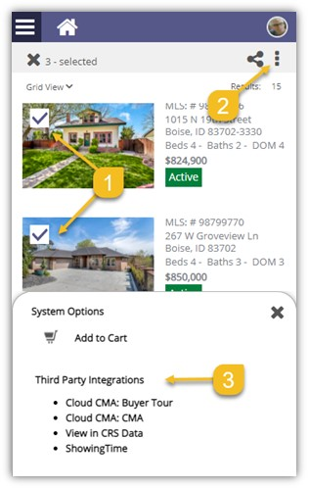

## Accessing your last five (5) searches

### Action Item: N/A

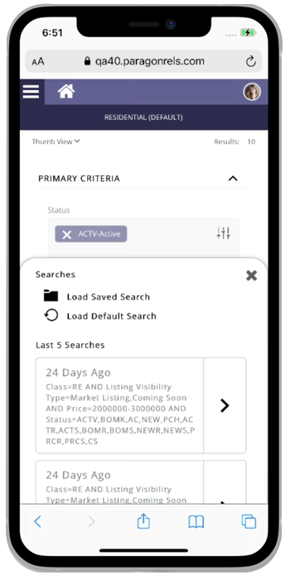

Paragon Connect can now access your last five searches. This is synced with Paragon Classic so the five searches you see are from either system.

The folder icon now opens a drawer instead of going directly to the load search dialog. The “Load Default Search” option has been moved to this location as well.

Another nice feature is you can either click on the criteria to load the search criteria in the search form, or you can click/tap on the arrow to go directly to the results.

Note: Accessing a class-based search from the hamburger menu will   
always load your default search.

## Preferred Phone number on Paragon Connect Detail Report

### Action Item: N/A

On the Paragon Connect detail report, the agent’s phone number displays the office or agent’s phone number based on a configuration. However, there is a user preference in Paragon Classic that allows users to choose which phone number to use for reports, which was being ignored by Paragon Connect.

**Paragon Connect has been updated to honor that preference. If a user chooses a phone number and check “Display this phone number...” it will display the selected phone number on the Paragon Connect detail report.

## Texting Detail Report Phone number

### Action Item: N/A

Paragon Connect today supports texting on a mobile device. The detail report today includes a feature to text the listing or selling agent directly from the detail report. However, the texting button uses the number that is displayed. In some cases, this is an office phone number or a phone number that doesn’t support texting.

To address texting phone number accuracy, Paragon Connect will now look at the mobile preferences in Paragon Classic. If a number is supplied, Paragon Connect will display the texting button on the report. The texting feature will use the phone number supplied in the mobile preference setting.

## Pencil Icon added to Paragon Connect

### Action Item: N/A

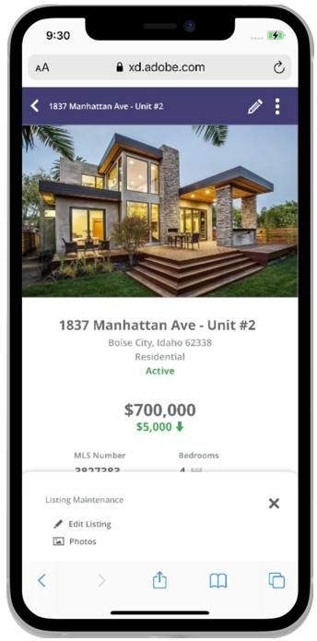

Full listing edit is just around the corner. In Paragon Connect, if you have the proper permissions, you can edit a listing or photo from any search result. Prior to this release, this option was stored in the (three-dot) overflow menu. However, the time it took to load these options is excessive due to the number of permission checks and configurations that existed.

The solution is to move the edit options to the detail report and provide a new icon to access these options. This new icon is a pencil and it will host any future listing edit options.

## Edit Photos

### Action Item: N/A



Prior to the 5.83 release, the ability to edit a photo was tied to a security configuration to enable full listing edit. We have separated the edit photo feature so it will no longer be tied to this configuration. You will now be able to edit photos from Paragon Connect provided you have the proper photo permissions.

**Note:** You can access the edit photo feature from a detail report.