Paragon Customer Toolkit - Release 5.84

## **Communications Plan Overview**

Welcome to the Paragon release communication Toolkit. The intention of this kit is to help you with communicating the release information to your membership.

In this kit you will find the following:

* Link to Release Notes for Paragon 5.84: the notes include any configurations and administration items that you will need to know about.
* Administration Configuration Options: What changes you may need to decide on
* Agent level Communication Plan: a link to an editable Customer Communication, and homepage notifications.
* Social Media: a post that you can use for Facebook, Instagram or other sites with a video of the release features.
* Example Home Page Announcements: You can cut and paste into your Homepage.

The goal is to make everyone aware of all the great Paragon enhancements to boost the way Members do Business!

## **Release Notes for Paragon 5.84**

Listed below is a link to the full release notes for the MLS. These release notes are for the Association/MLS. The Agent Level changes in this document are included in the e-mail template that you will want to send out to your members.

**Link:** [Release Notes](http://paragonconnect.paragonrels.com/images/documents/release_notes/584/Paragon%205.84%20Release%20Notes.docx)

**Administration Configuration Options**

**Paragon Connect Share to Twitter and Facebook**

Black Knight is excited to announce that we have added the ability to share listings to Facebook and Twitter from Paragon Connect! If you do not currently have this feature enabled in Paragon Professional, and would like this new functionality, please contact your SSM to enable them. With the addition of the two new share features you can now email, text, create a link, and share out to Twitter or Facebook!

**Enhanced ShowingTime Icon Webservice Call Enhanced to Send All Records**

Paragon calls a ShowingTime webservice, which determines whether the ShowingTime icon should display or be hidden in the Actions menu or on reports. Previously, Paragon was only checking records in the Active or Pending status category. This was not an issue until some customers stared using off-market statuses for “Coming Soon” listings. Now Paragon will be checking all statuses and the icon will appear or be hidden as expected for all records

**Board Configuration Enhancement for Intelligent Analytics**

We have enhanced the board configuration for Intelligent Analytics to support multi-board customers where one board might utilize CRS Data and the other may utilize Paragon Tax. What are Intelligent Analytics? Great question. Intelligent Analytics are data and services made available to CRS Data and Paragon Tax customers as well as any customer who chooses to subscribe for a monthly fee. Subscribers receive the following features: Enhanced Data on the Parcel-Click Property Panel, Integrated Public Record Search from the Map View, Public Record section for the ConnectView and Paragon Connect Detail View, Public Record Property Watch and Alerts. For more information about Intelligent Analytics, contact your Black Knight sales representative.

## **Agent Level Changes Communication Plan**

The following link is to the e-mail template that you can copy and paste from to send out to your members keeping them informed on the release. [Paragon Release 5.84 Member Email](http://paragonconnect.paragonrels.com/images/documents/release_notes/584/Email%20to%20agents%205.84.docx)

This is a word document that you can edit so if you **do not** have certain functionality, for example if you do not use Twitter and Facebook, you can remove that section first before sending. Also, in the first sentence you will want to add **your MLS name** (it is in red), so that it is being sent from **your** organization to **your** members.

To ensure that your members are always informed about the latest and greatest enhancement to their MLS System, please announce the enhancements to your membership, post to Social Media sites, include them in your newsletters and post notices to your homepage and login messages.

## **Social Media Post**

Copy and paste the following into your social media and the picture below will display with the video. Encourage your membership to like our Facebook page @ParagonMLS. Check out the exciting new features of the Paragon 5.84 release!

[](https://player.vimeo.com/video/568910521?app_id=122963)

## **Example Home Page Announcements**

The release has a lot of nice enhancements, you may want to highlight a different one every few days on your homepage and via Social Media. You can just cut and paste these into your homepage editor. If you want to add pictures you can do that too but make sure to upload them to your server.

**Paragon Connect adds Map Layers**

You are now able to access your favorite default mapping layers from any device! The default layers that are available in Paragon Professional are now available in Paragon Connect! Switch to the silver map type and be able to better visualize the map layers like flood plain, traffic areas, and more.

**Paragon Connect allows you to perform Multi-Class searches**

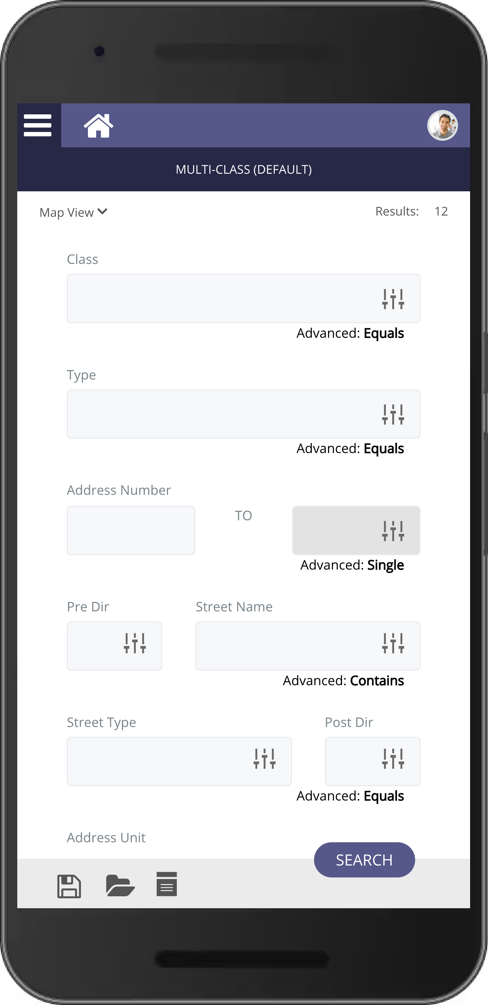Using Paragon Connect you can now search across classes with the Multi-Class Search! This search syncs with Paragon Professional and will open the door to using more multi-class type searches throughout the application.

**Share to Twitter and Facebook using Paragon Connect** 

Paragon Connect today supports texting on a mobile device. The detail report today includes a feature to text the listing or selling agent directly from the detail report. However, the texting button uses the number that is displayed. In some cases, this is an office phone number or a phone number that doesn’t support texting.