

**PARAGON - INNOVATING THE WAY AGENTS DO BUSINESS**

**Paragon Release 5.84**

We (enter your MLS Name here) wanted you to be the first to know about the latest enhancements to your Paragon MLS System. All enhancements are designed to help you navigate through the system and enhance your experience with Paragon.  Below is a list of the enhancements and links to view videos or PDFs of the new features. We encourage you to continue reading and let us know what you think on the [Paragon MLS Facebook site](https://www.facebook.com/ParagonMLS/). Also make sure you click “Like” on the Facebook site to view what’s new with Paragon more frequently.

**WHAT’S NEW!**

**PARAGON**

* **Clean up of unnecessary white space in ConnectView**

To utilize all the screen space, we removed some of the unnecessary white space that was at the top of ConnectView.

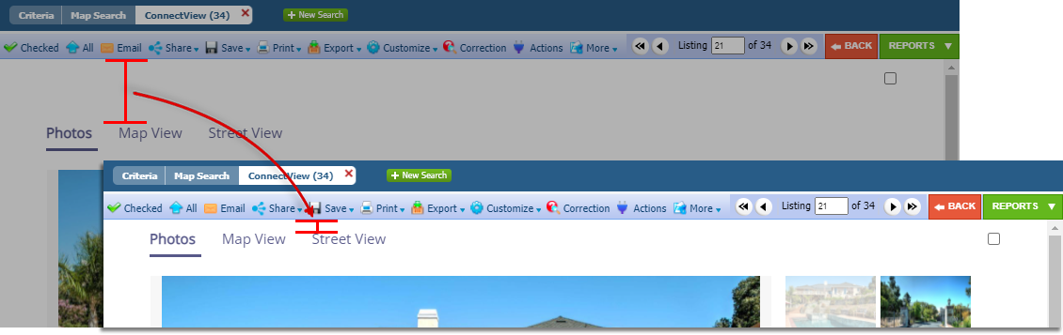

* **Update to your Client’s Collaboration Center – Shortcut App Icon**

|  |  |
| --- | --- |
| Your Clients can save an icon to their home screen on their mobile devices. We have updated the default icon to resemble more of an app-like appearance.  **Colabor..** |  |

* Map

  Description automatically generated**Map Layers available in Paragon Connect**

You are now able to access your favorite default mapping layers from any device! The default layers that are available in Paragon Professional are now available in Paragon Connect! Switch to the silver map type and be able to better visualize the map layers like flood plain, traffic areas, and more.

* 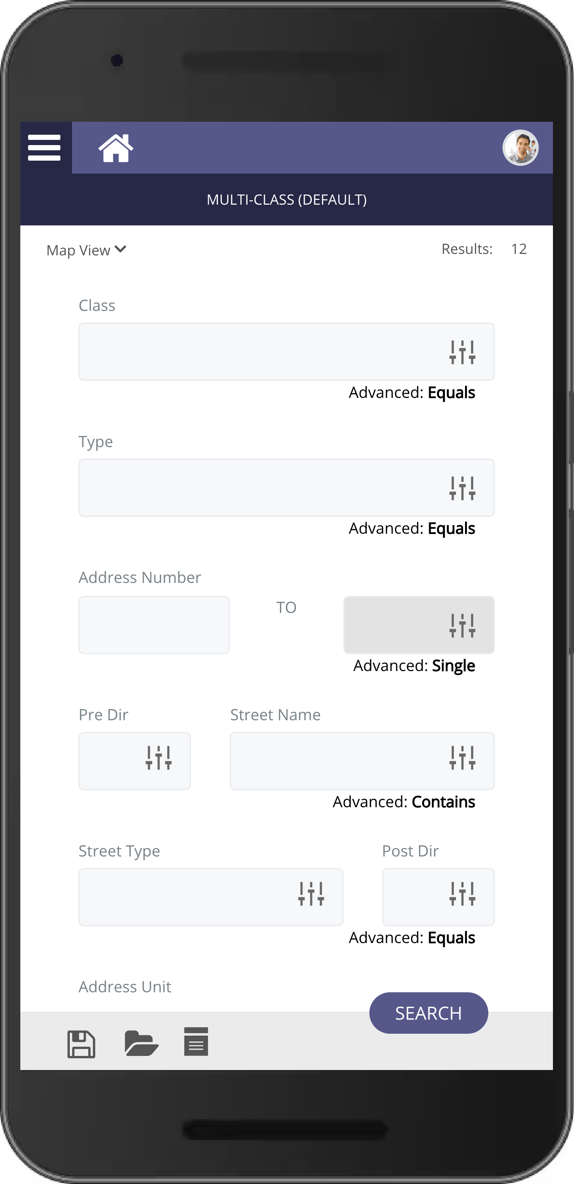**Multi-class Searching in Paragon Connect**

In this version of Paragon Connect you will have the ability to search across classes with the Multi-Class search! This search syncs with Paragon Professional and will open the door to using more multi-class type searches throughout the application.

* A screenshot of a cell phone

  Description automatically generated with medium confidence**Share to Twitter and Facebook**

We are happy to announce that we’ve added the ability to share listings to Facebook and Twitter from Paragon Connect. If your MLS currently has this feature enabled in Paragon, the share features will automatically appear in Paragon Connect. If your MLS doesn’t have them enabled but would like to do so, please contact your board/association. With the addition of these two new sharing features you can now email, text, create a link, and share out to Twitter or Facebook!



