Paragon 5.84 Release Enhancements (July 2021)

(Edited on 7/28/2021 page 4 and 10)

Corrected Paragon Issues 2

MLS Customizations and Administration 4

Paragon Connect Share to Twitter and Facebook 4

Enhanced ShowingTime Icon Webservice Call Enhanced to Send All Records 4

Board Configuration Enhancement for Intelligent Analytics 5

Agent Level Changes 6

Enhanced ShowingTime Icon Webservice Call Enhanced to Send All Records 6

Clean up of Unnecessary White Space in ConnectView 6

Collaboration Center 7

Collaboration Center – Shortcut App Icon 7

Paragon Connect 8

Map Layers 8

Multi-Class Search 9

Share to Twitter and Facebook  10

Paragon Affiliate Connect 11

Corrected Paragon Affiliate Connect Issues 11

Affiliate Dashboard – Buyer Activity Tab Text 12

Affiliate Dashboard – Make My New Home 13

Agent My Affiliate Dashboard – Searching “All” Affiliate Types or Office City 14

Agent - Affiliate Connect Preferences 14

# Corrected Paragon Issues

|  |  |  |  |  |
| --- | --- | --- | --- | --- |
| **Ticket#** | **Product** | **Module** | **Organization** | **Summary** |
| DEV-4494 | Collab Center, Paragon | Configuration | CCAR - Coastal Carolinas AOR | Collab Center Preferences Wizard not working |
| DEV-4298 | Paragon | Listing Photos | BCRES - REB2 Residential | Error not produced when image is oversized |
| DEV-4279 | Paragon | CMA | SPTBGMLS - Spartanburg MLS | Automated Valuation models is being cut off from page in CMA |
| DEV-4263 | Paragon | CMA | BCRES - REB2 Residential | Menu button for CMA Preferences Wizard has incorrect label |
| DEV-4215 | Paragon | Preferences | All Customers | Remove the Help video icons/links from user preferences |
| DEV-4174 | Paragon | Mapping or Geo-coding | COLUMBIA – Consolidated MLS | Advance Mapping: Searching by drive time throws error |
| DEV-4166 | Collab Center, Paragon | Messaging | CCAR - Coastal Carolinas AOR | Collab Center Welcome Message error when contact email address contains a ˜ character |
| DEV-4051 | Paragon | Email | COLUMBIA – Consolidated MLS | Emailing Associated Documents back to back throws an “error occurred: growler |
| DEV-4020 | Paragon | Tax | NEREN - New England Real Estate Network | Receive "Select a Record" error on Spreadsheet View, and Record Selection visual glitch |
| DEV-3980 | Paragon | Search | All Customers | Saved Property Searches: include contact-created searches in My Searches filter |
| DEV-3942 | Paragon | Search | SCWMLS - South Central Wisconsin (Madison) | Clicking the Links in the Major and Primary Area Column When Using the Area Search Modal No Longer Selects that Area |
| DEV-3906 | Paragon | View/Reports | NEREN - New England Real Estate Network | Column Width Cannot Be Returned to the Default Width on Action Icon Field |
| DEV-3831 | Paragon | Admin | IRMLS - Indiana Regional MLS | "Page cannot be displayed" error when trying to use Copy Previous Agreement button for Login Agreement |
| DEV-3810 | Paragon | Contacts | NEREN, Regional MLS | Reverse Prospecting search issues |
| DEV-3765 | Paragon | Third Party | NEREN - New England Real Estate Network | Custom Method is not evaluated when using new combined TPI Actions button, allowing Integrations to Display When It Should Not |
| DEV-3238 | Paragon | LIM | LEWISCLARK - Lewis Clark BOR | 'R' Labeled Room Information Fields Not Requiring Values Before Saving |
| DEV-3164 | Paragon | Contacts | CR - California Regional MLS | Deleted saved searches still appearing under contact |
| DEV-3089 | Paragon | View/Reports | COLUMBIA – Consolidated MLS | Advanced Mapping - Parcel Error "Not Logged In" |
| DEV-2863 | Paragon | View/Reports | CR - California Regional MLS | External/datashare photos are blurry when viewed in reports as a PDF via Actions menu |
| DEV-2841 | Paragon | Search | BCRES - REB2 Residential | Inaccurate template_section_item_attrib values can unexpectedly adjust multi-class search criteria layout |
| DEV-2489 | Paragon | Search | BCRES - REB2 Residential, SCWMLS | MLS numbers copied from Collab Center emails don't work in Quick Search |
| DEV-2450 | Paragon | View/Reports | COLUMBIA - ConsolidatedMLS, Flint Hills, GALMLS, NEREN, Olympic, RAE, Sanibel, Yuma | CMA Summary/Multiple Extra "FALSE" Fields Ex. Sold Price Per SQFT & Apx Living Sqft |
| DEV-4434 | Collab Center | Dashboard | NSAR - NS and PEI Real Estate Associations | Collab Center dashboard not reflecting open houses |
| DEV-3892 | Collab Center | General UI | All Customers | UPDATE APP ICON: When saving to home screen please use these icons for Collaboration Center |
| DEV-2986 | Collab Center | Other | SCWMLS - South Central Wisconsin (Madison) | [P50] SCWMLS Adding a Delayed Listing to Agent Recommended |

# MLS Customizations and Administration

**All options in this section are either configurable via MLS Administration controls or by your System Support Manager as noted.**

## Paragon Connect Share to Twitter and Facebook

### Action Item: If not turned on, contact your SSM

We are happy to announce that we’ve added the ability to share listings to Facebook and Twitter from Paragon Connect. If your MLS currently has the Share feature enabled for search results in Paragon, the share features will automatically appear in Paragon Connect. If you don’t have them enabled but would like to make them available contact your board/association. With the addition of these two new shares features you can now email, text, create a link, and share out to Twitter or Facebook!

## Enhanced ShowingTime Icon Webservice Call Enhanced to Send All Records

### Action Item: N/A

Paragon calls a ShowingTime webservice, which determines whether the ShowingTime icon should display or be hidden in the Actions menu or on reports. Previously, Paragon was only checking records in the Active or Pending status category. This was not an issue until some customers started using off-market statuses for “Coming Soon” listings. Now Paragon will be checking all statuses and the icon will appear or be hidden as expected for all records

## Board Configuration Enhancement for Intelligent Analytics

### Action Item: N/A

We have enhanced the board configuration for Intelligent Analytics to support multi-board customers where one board might utilize CRS Data and the other may utilize Paragon Tax. What are Intelligent Analytics? Great question. Intelligent Analytics are data and services made available to CRS Data and Paragon Tax customers as well as any customer who chooses to subscribe for a monthly fee. Subscribers receive the following features: Enhanced Data on the Parcel-Click Property Panel, Integrated Public Record Search from the Map View, Public Record section for the ConnectView and Paragon Connect Detail View, Public Record Property Watch and Alerts. For more information about Intelligent Analytics, contact your Black Knight sales representative.

# Agent Level Changes

**The following section contains changes that are active system wide and available to users based on their assigned security levels.**

## Enhanced ShowingTime Icon Webservice Call Enhanced to Send All Records

### Action Item: N/A

Paragon calls a ShowingTime webservice, which determines whether the ShowingTime icon should display or be hidden in the Actions menu or on reports. Previously, Paragon was only checking records in the Active or Pending status category. This was not an issue until some customers stared using off-market statuses for “Coming Soon” listings. Now Paragon will be checking all statuses and the icon will appear or be hidden as expected for all records

## Clean up of Unnecessary White Space in ConnectView

### Action Item: N/A

To utilize all the screen space, we removed some of the unnecessary white space that was at the top of ConnectView.

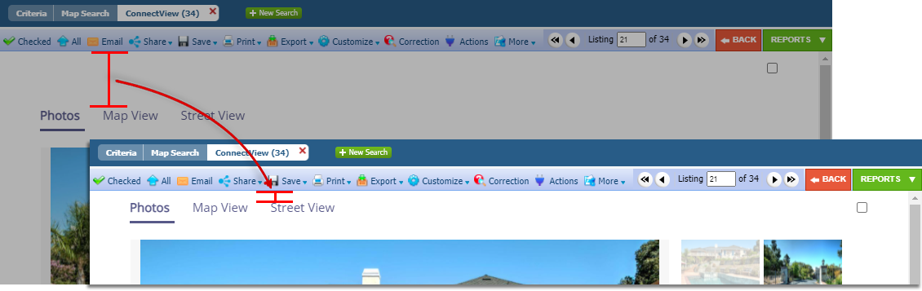

# Collaboration Center

**All options in this section are either configurable via MLS Administration controls or by your System Support Manager as noted.**

## Collaboration Center – Shortcut App Icon

### A picture containing electronics Description automatically generatedAction Item: N/A

Your Clients can save an icon to their home screen on their mobile devices. We have updated the default icon to resemble more of an app-like appearance.

# Paragon Connect

**All options in this section are either configurable via MLS Administration controls or by your System Support Manager as noted.**

## Map Layers

### Map Description automatically generatedAction Item: N/A

You are now able to access your favorite default mapping layers from any device! The default layers that are available in Paragon Professional are now available in Paragon Connect! Switch to the silver map type and be able to better visualize the map layers like flood plain, traffic areas, and more.

## Multi-Class Search

### Action Item: N/A

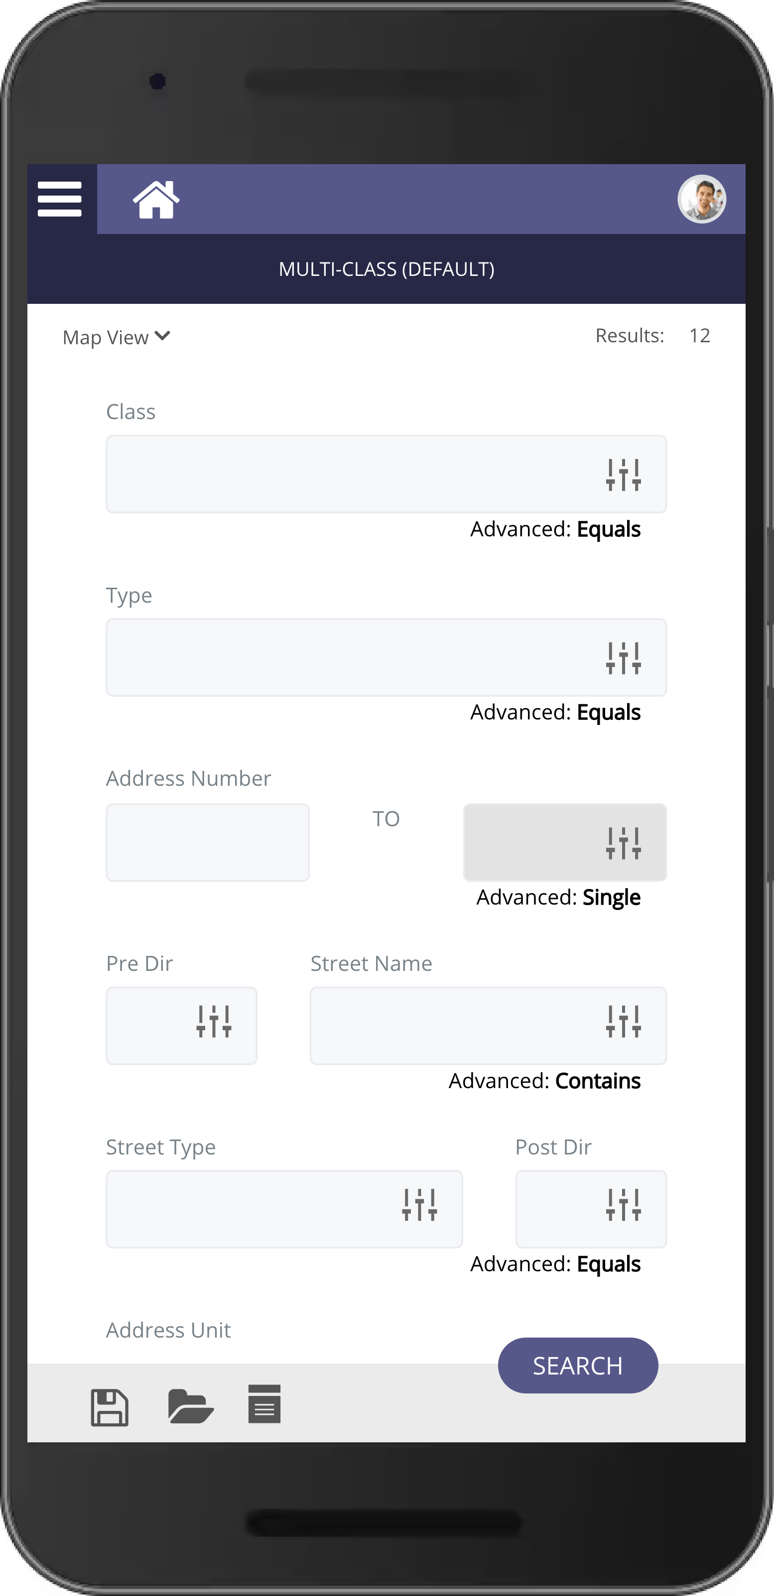In this version of Paragon Connect you will have the ability to search across classes with the Multi-Class search! This search syncs with Paragon Professional and will open the door to using more multi-class type searches throughout the application.

## Share to Twitter and Facebook

### A screenshot of a cell phone Description automatically generated with medium confidenceAction Item: N/A

We are happy to announce that we’ve added the ability to share listings to Facebook and Twitter from Paragon Connect. If your MLS currently has the Share feature enabled for search results in Paragon, the share features will automatically appear in Paragon Connect. If your MLS doesn’t have them enabled but would like to do so, please contact your board/association. With the addition of these two new sharing features you can now email, text, create a link, and share out to Twitter or Facebook!





# Paragon Affiliate Connect

**All options in this section are either configurable via MLS Administration controls or by your System Support Manager as noted.**

# Corrected Paragon Affiliate Connect Issues

|  |  |  |
| --- | --- | --- |
| **Ticket #** | **Module** | **Summary** |
| DEV-4257 | Dashboard | PAC: change View Details to Buyer Details |
| DEV-4253 | Dashboard | PAC: Hide references to My New Home when not enabled |
| DEV-4104 | Messaging | Welcome message to Affiliate has typo |
| DEV-4071 | AC - Affiliate Search | Error showing when trying to search for all types of affiliates |
| DEV-3410 | Preferences | Verbiage change- Preferences/Affiliate Connect |

## Affiliate Dashboard – Buyer Activity Tab Text

### Action Item: N/A

The Affiliate Dashboard uses the View Details button in several locations, but different data was returned depending on where the button was located. To be consistent with Paragon Connect and Collaboration Center, when a listing detail view is returned, the button will still read View Detail. To eliminate confusion, the button on the Buyer Activity tab has been renamed to Buyer Detail and will continue to open the Buyer Details page.

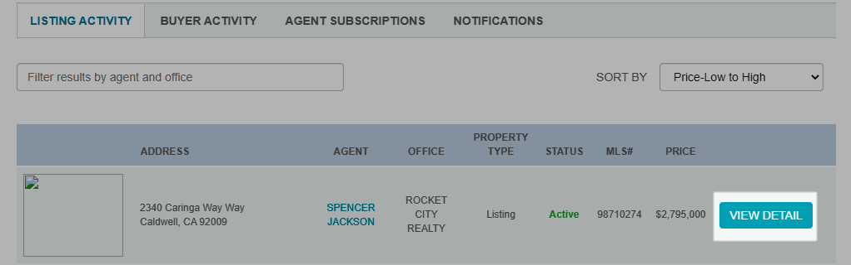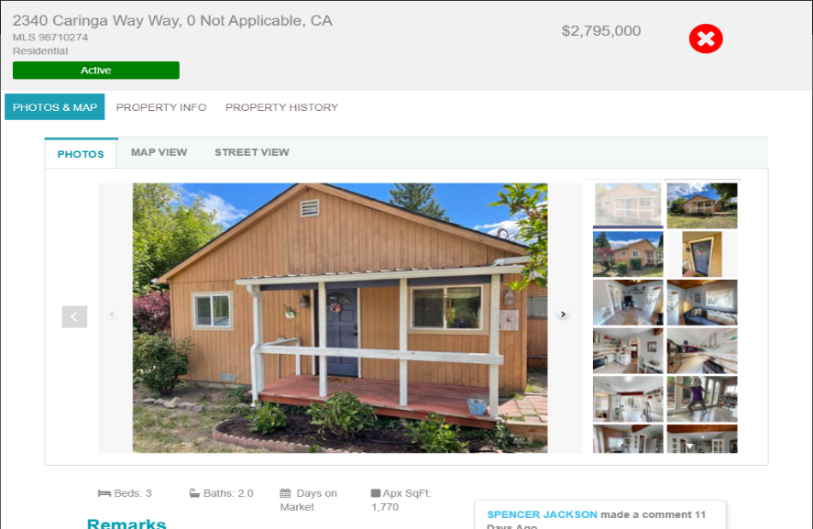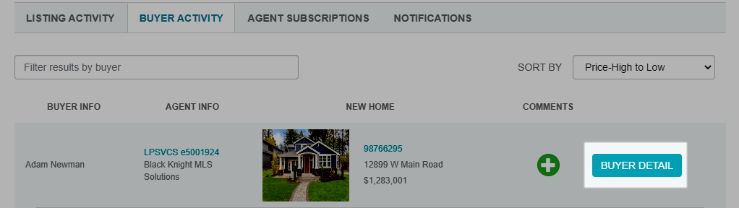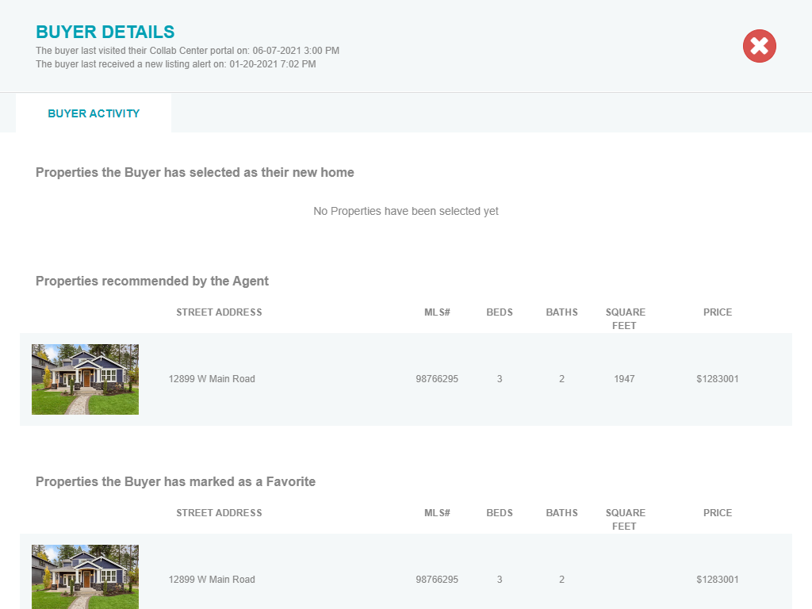

## Affiliate Dashboard – Make My New Home

### Action Item: N/A

The Collaboration Center feature, Make My New Home, is configurable by MLS, and may not be turned on for your clients. However, the related New Home feature was displaying on the Affiliate Dashboard even when not enabled on Collaboration Center. This enhancement hides all My New Home references on the Affiliate Dashboard when it is turned off in Collaboration Center.

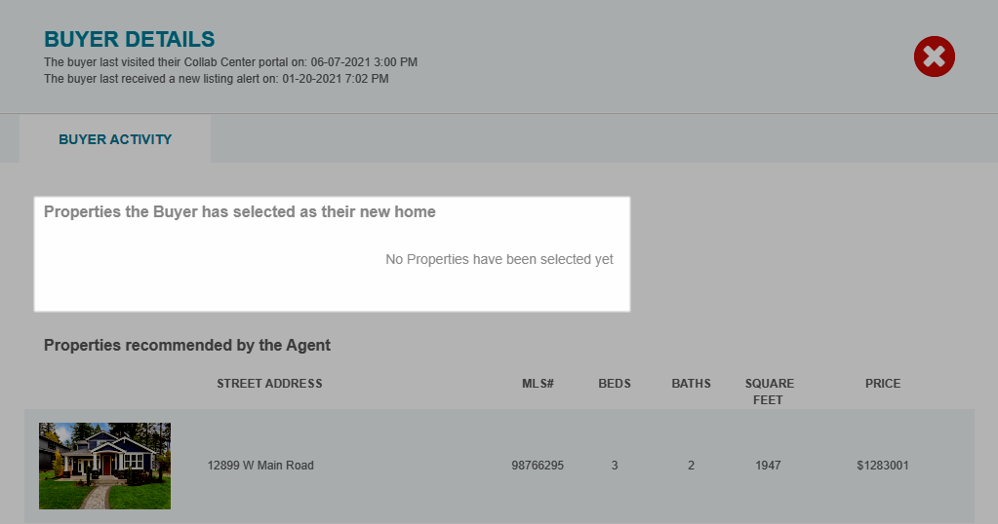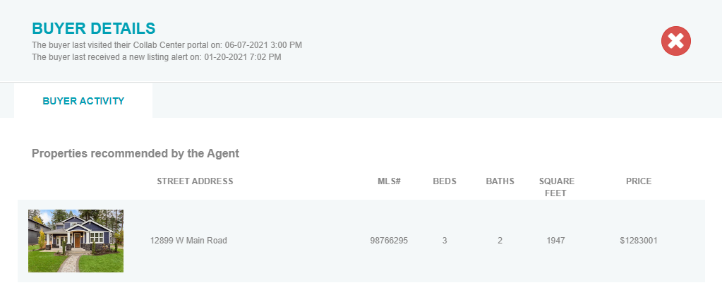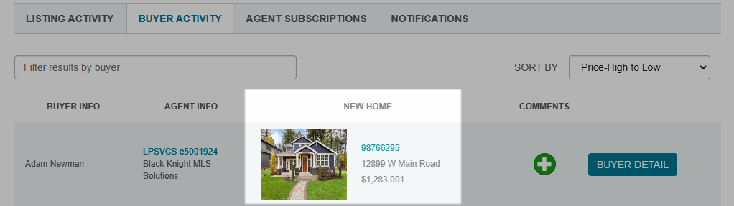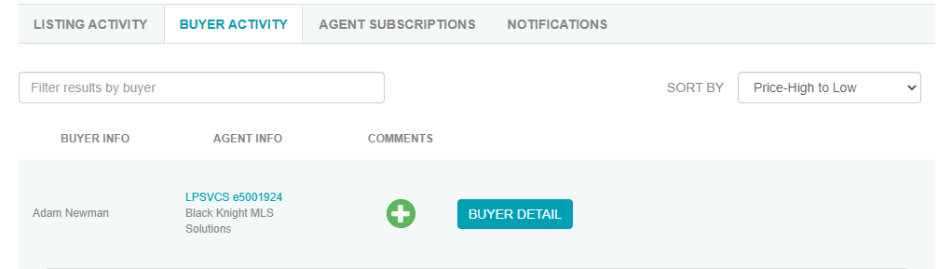

## Agent My Affiliate Dashboard – Searching “All” Affiliate Types or Office City

### Action Item: N/A

For Paragon and Paragon Connect users searching on the My Affiliates page, selecting the default ‘All’ option for Type or Office City sometimes returned the error, At least one search criteria must be entered. This has been corrected, so searching on All will return matches.

## Agent - Affiliate Connect Preferences

### Action Item: N/A

In Preferences > Affiliate Connect > Notification Options, the verbiage on the Affiliate Subscriptions Request has been clarified.

