Paragon Customer Toolkit - Release 5.85

## **Communications Plan Overview**

Welcome to the Paragon release communication Toolkit. The intention of this kit is to help you with communicating the release information to your membership.

In this kit you will find the following:

* Link to Release Notes for Paragon 5.85: the notes include any configurations and administration items that you will need to know about.
* Administration Configuration Options: What changes you may need to decide on
* Agent level Communication Plan: a link to an editable Customer Communication, and homepage notifications.
* Social Media: a post that you can use for Facebook, Instagram or other sites with a video of the release features.
* Example Home Page Announcements: You can cut and paste into your Homepage.

The goal is to make everyone aware of all the great Paragon enhancements to boost the way Members do Business!

## **Release Notes for Paragon 5.85**

Listed below is a link to the full release notes for the MLS. These release notes are for the Association/MLS. The Agent Level changes in this document are included in the e-mail template that you will want to send out to your members.

**Link:** [Release Notes](https://info.email-bkfs.com/acton/attachment/35341/f-e6abe60f-4d1b-49ff-9d44-36ce3b29b3f3/1/-/-/-/-/Paragon%205.85%20Release%20Notes.docx)

## **Administration Configuration Options**

**Admin User Interface Refresh and Search**

We are happy to introduce an updated look for the Administration module. Increasing the font size and adding some spacing between the links in the Admin panel makes the page easier to scan!

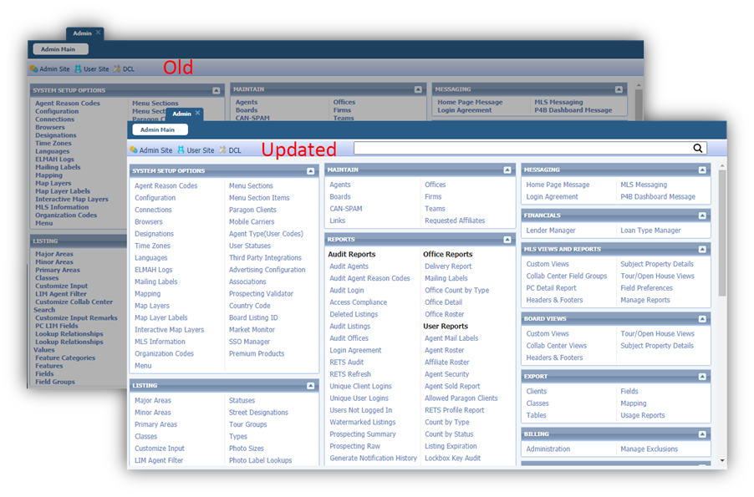

To assist you in locating an action item you are looking for, a new search feature has been added. All items that match what is being typed will be filtered down to just those and displayed in the section they currently reside in!

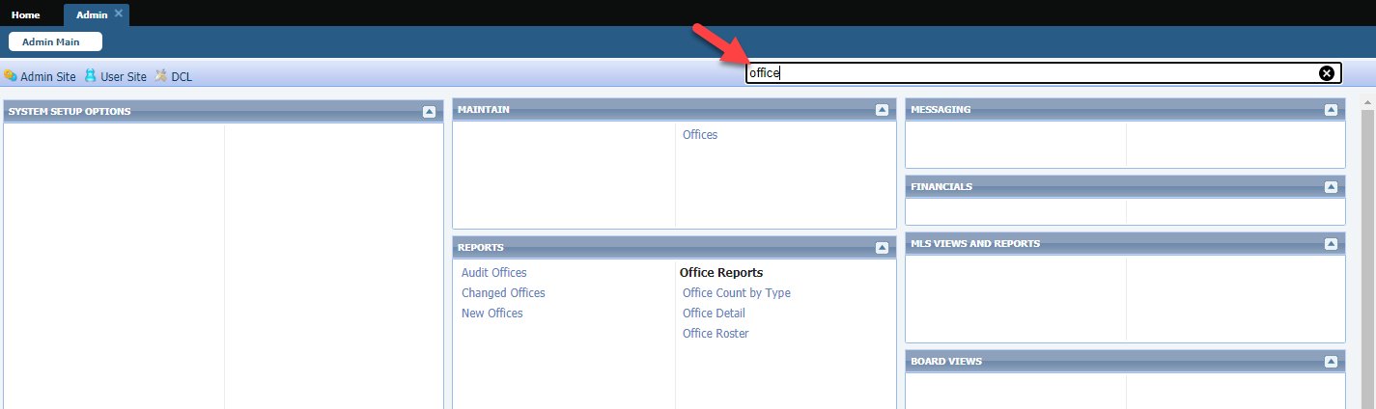

**Mortgage Center for Paragon Connect and ConnectView**

We have enhanced the Paragon Connect Detail View and the ConnectView report to support a configurable calculator. The current calculator was hard coded into the report with no option to disable or replace with a different calculator. Now the section can be disabled, or a different calculator can be used. We also renamed the section to Mortgage Center to be consistent with the Collab Center.

The following screenshot shows the current production calculator and an example where we used one of the Paragon calculators.

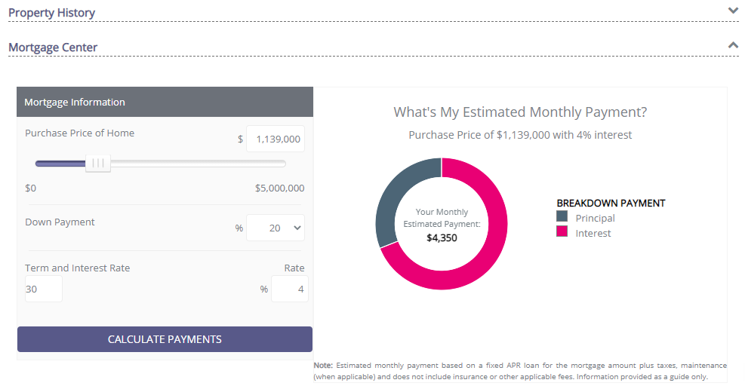

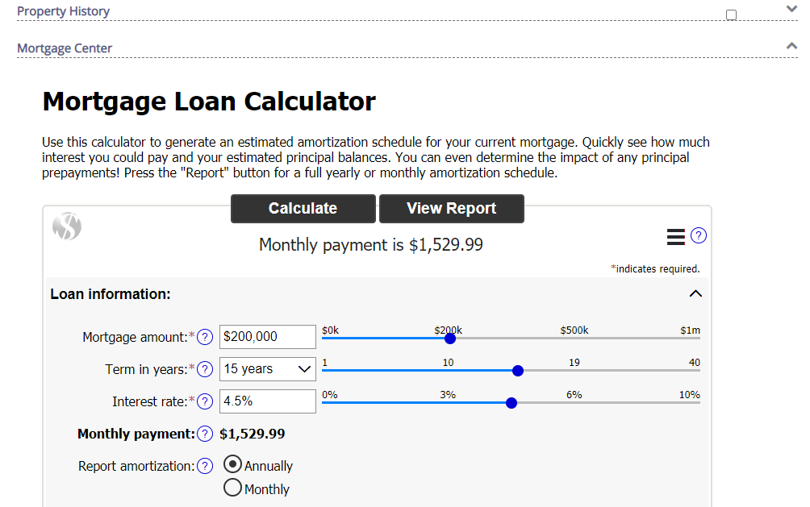

## **Agent Level Changes Communication Plan**

The following link is to the e-mail template that you can copy and paste from to send out to your members keeping them informed on the release. [Paragon Release 5.85 Member Email](https://info.email-bkfs.com/acton/attachment/35341/f-f7be6126-b9b9-4bf8-a5b2-611fe70a6e37/1/-/-/-/-/Email%20to%20agents%205.85.docx)

This is a word document that you can edit so if you **do not** have certain functionality, for example if you do not use Twitter and Facebook, you can remove that section first before sending. Also, in the first sentence you will want to add **your MLS name** (it is in red), so that it is being sent from **your** organization to **your** members.

To ensure that your members are always informed about the latest and greatest enhancement to their MLS System, please announce the enhancements to your membership, post to Social Media sites, include them in your newsletters and post notices to your homepage and login messages.

## **Social Media Post**

Copy and paste the following into your social media and the picture below will display with the video. Encourage your membership to like our Facebook page @ParagonMLS. Check out the exciting new features of the Paragon 5.85 release!

[](https://player.vimeo.com/video/591174285?app_id=122963&h=490a6aa312)

## **Example Home Page Announcements**

The release has a lot of nice enhancements, you may want to highlight a different one every few days on your homepage and via Social Media. You can just cut and paste these into your homepage editor. If you want to add pictures you can do that too but make sure to upload them to your server.

**Auto Detect Login**

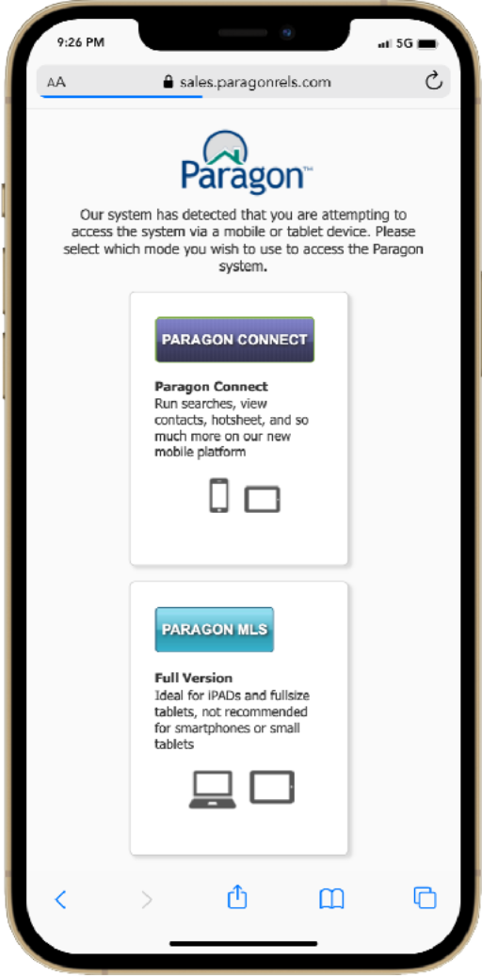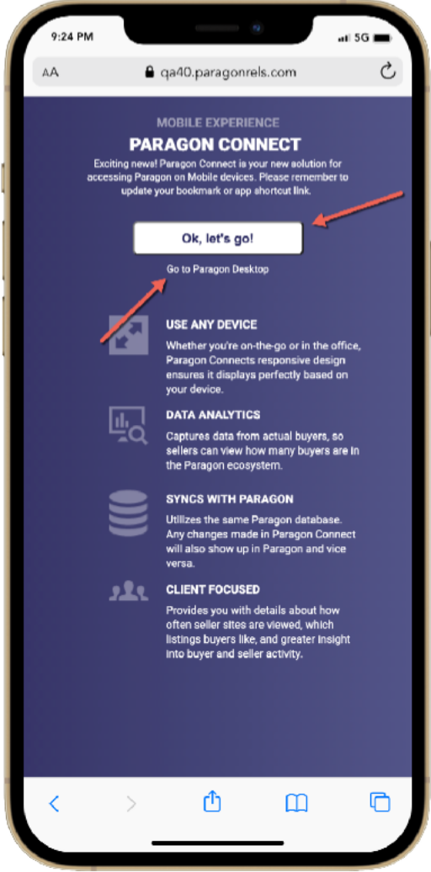Paragon and Paragon Connect both have their own login page, however, if you attempt to access Paragon from a mobile device, the auto detect page will appear. Prior to this release, the system would show you two options, do you want to access Paragon MLS or Paragon Connect? Rather than making these seem like two equal options, a new auto detect page was built to try to navigate mobile users towards Paragon Connect. You can still access your Paragon system by clicking the “Go to Paragon Desktop” link below the primary button. To provide your mobile members the best possible experience we are highlighting the Paragon Connect login.

**Paragon Connect - Photo Reorder**

Now you can do even more with your photos in Paragon Connect. The photo module will now allow you to reorder your photos. Simply click on the reorder button and drag the photos into the desired order. Once complete, click on the green ok button and your changes and ordering will be saved.

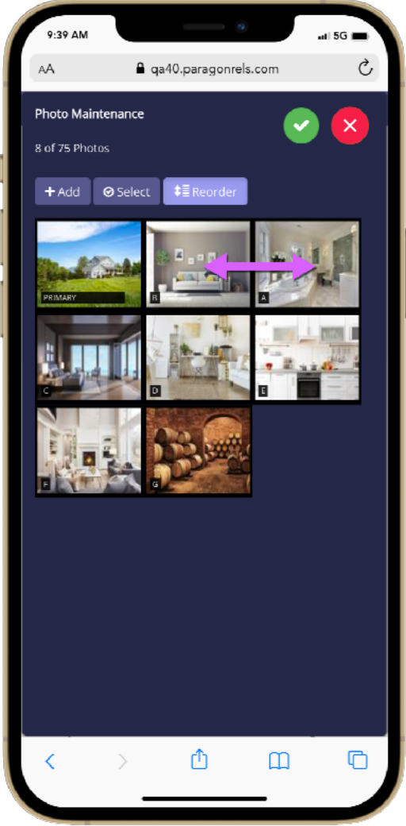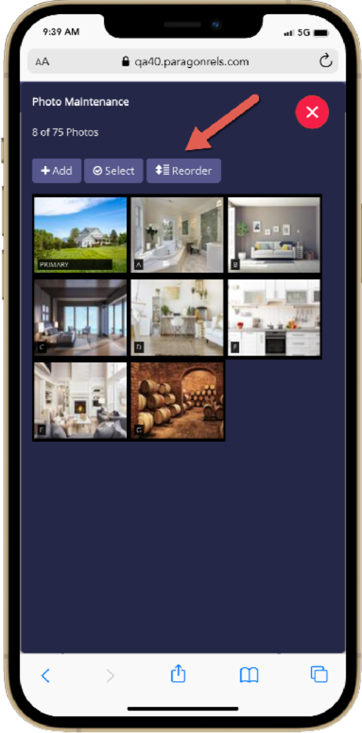

**1. Start Reorder**

Tap on the reorder

button to put system

in reorder mode

**2. Drag and Drop**

Select the photo you

want to reorder and

drag and drop it into

place.

**3. Save Changes**

Letters on photos

Will auto update after

Clicking the green

check circle.

**Additional Tips**

Note that the reorder button will NOT display if you have only one photo added to your listing. You can also change which photo is the primary photo by dragging a photo into the primary slot

**CMA Cover Page – Displays Address 2**

When Address 2, is used as part of the listing address, it will now be displayed on the CMA Cover Page!

