

**PARAGON - INNOVATING THE WAY AGENTS DO BUSINESS**

**Paragon Release 5.85**

We (enter your MLS Name here) wanted you to be the first to know about the latest enhancements to your Paragon MLS System. All enhancements are designed to help you navigate through the system and enhance your experience with Paragon.  Below is a list of the enhancements and links to view videos or PDFs of the new features. We encourage you to continue reading and let us know what you think on the [Paragon MLS Facebook site](https://www.facebook.com/ParagonMLS/). Also make sure you click “Like” on the Facebook site to view what’s new with Paragon more frequently.

**WHAT’S NEW!**

**PARAGON**

* **CMA Cover Page – Add Field Name for Address 2**

|  |  |
| --- | --- |
| When Address 2, is used as part of the listing address, there wasn’t a field name associated with the data when viewing the CMA Cover Page. This enhancement adds the long description to the Subject Property display on the Cover Page.  Graphical user interface, application  Description automatically generatedSubject Property with Address 2  Graphical user interface, website  Description automatically generated  Cover Page missing Address 2 label  Updated Cover Page with Address 2 label |  |

* **Update to Financial Calculators (US)**

The following updates were applied to the Financial Calculators

1. Updated font to match Paragon fonts
2. Disabled the email feature – this function was enabled in error during a previous update. The calculators require a Paragon session and as a result, emailing them to clients is not an option.
3. Collapsed the graphs by default – this helps reduce scrolling
4. Removed the Definitions from the bottom of the calculator. The text is located under the info tip question marks. Repeating them at the bottom was unnecessary and caused more scrolling.

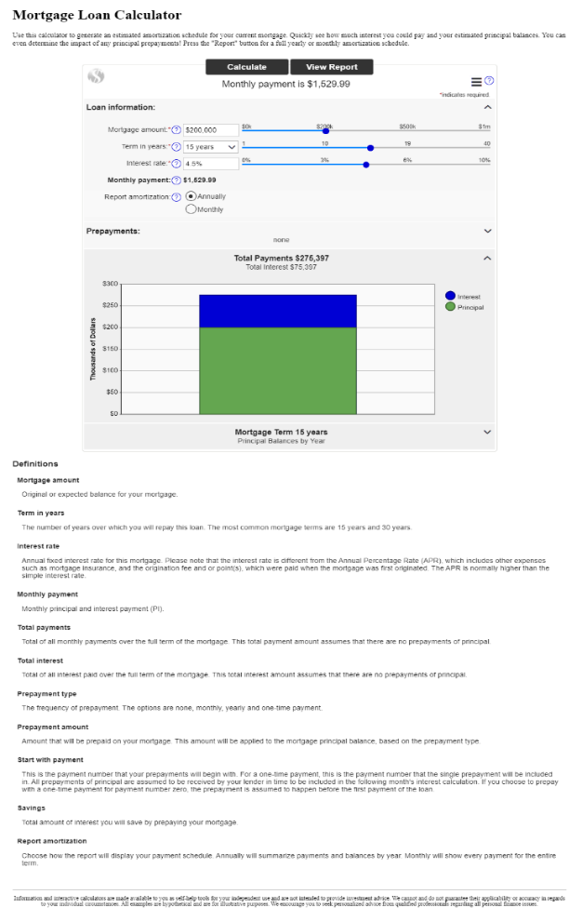

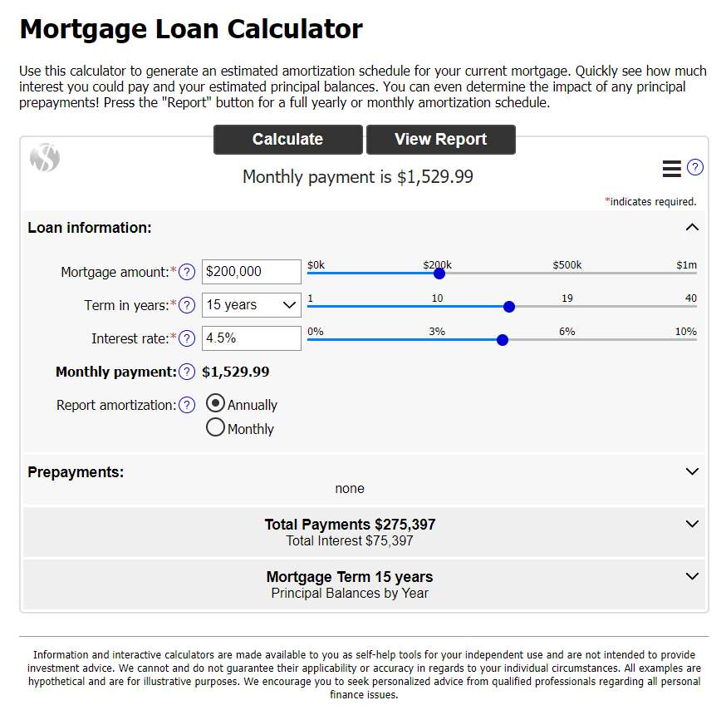

* **Auto Detect Login**

|  |  |
| --- | --- |
| Paragon and Paragon Connect both have their own login page, however, if you attempt to access Paragon from a mobile device, the auto detect page will appear. Prior to this release, the system would show you two options, do you want to access Paragon MLS or Paragon Connect? Rather than making these seem like two equal options, a new auto detect page was built to try to navigate mobile users towards Paragon Connect. You can still access your Paragon system by clicking the “Go to Paragon Desktop” link below the primary button. To provide your mobile members the best possible experience we are highlighting the Paragon Connect login.    **Before After** |  |

* **Photo Reorder in Paragon Connect**

Now you can do even more with your photos in Paragon Connect. The photo module will now allow you to reorder your photos. Simply click on the reorder button and drag the photos into the desired order. Once complete, click on the green ok button and your changes and ordering will be saved.

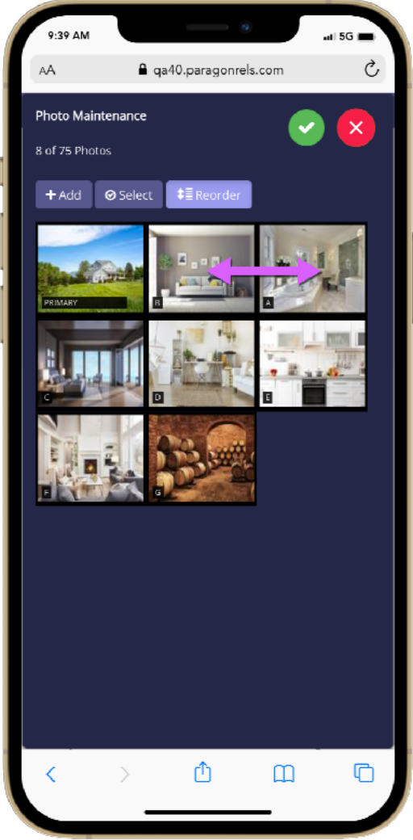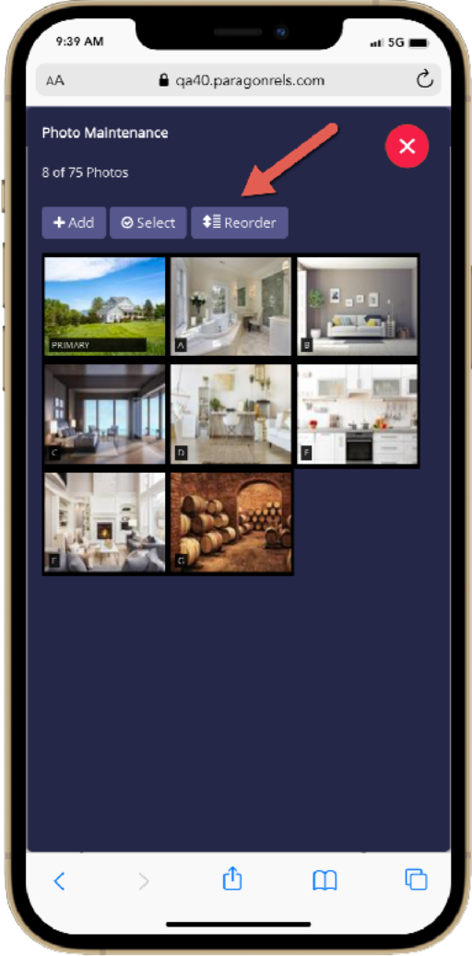

**1. Start Reorder**

Tap on the reorder

button to put system

in reorder mode

**2. Drag and Drop**

Select the photo you

want to reorder and

drag and drop it into

place.

**3. Save Changes**

Letters on photos

Will auto update after

Clicking the green

check circle.

**Additional Tips**

Note that the reorder button will NOT display if you have only one photo added to your listing. You can also change which photo is the primary photo by dragging a photo into the primary slot

|  |  |
| --- | --- |
|  |  |

* **Changes to your Clients Collaboration Center – Property Search Changes**

The Collaboration Center property search has undergone minor changes to help enhance the search process. Below are just a few of the changes that were introduced.

**Layers Control**

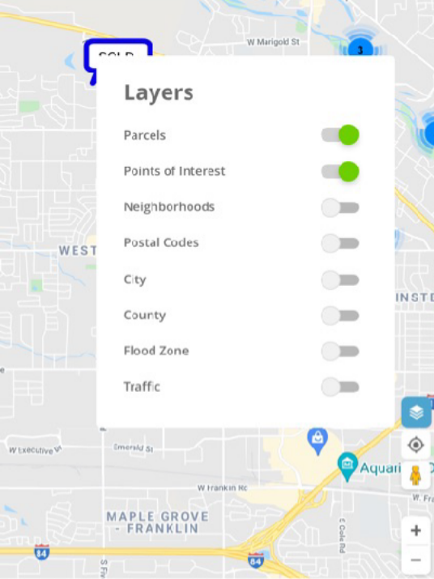A new layer icon was added to the bottom right navigation controls. This new icon replaces the “menu Options” button that was previously located on the map. This allows your clients to quickly enable any layer on the map. In addition, the parcel label is enabled by default. This will allow your clients to see parcel lines around properties when zoomed in on the map.

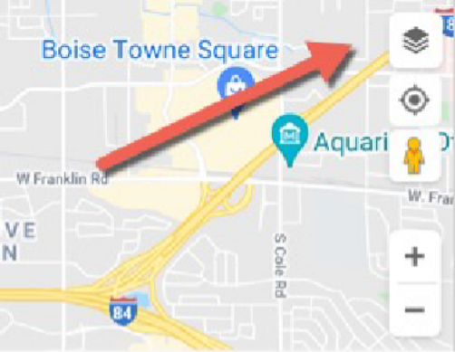

**Default and Toggle Mode**

Icon added above the “My Location” icon. It turns blue when enabled

**Reset**

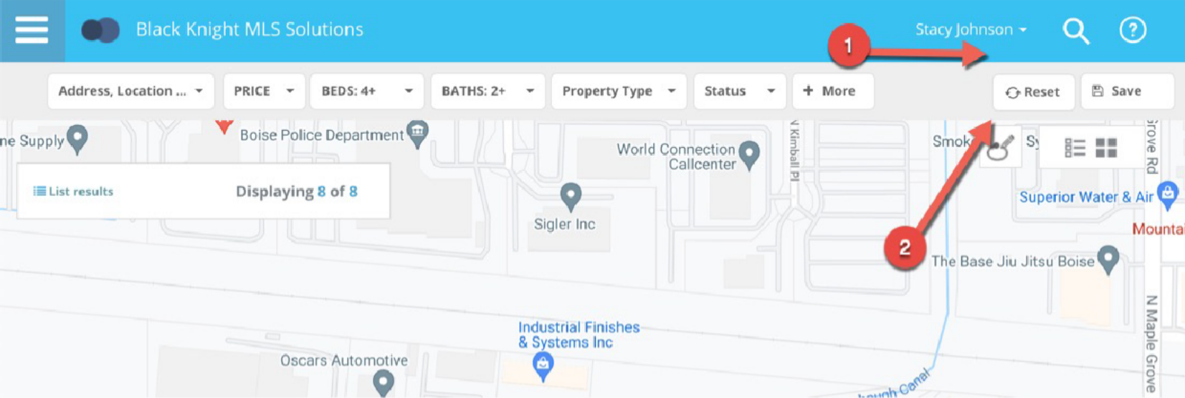A new reset button has been added to the Collaboration Center search bar. This reset option will allow a user to reset the property search back to the default criteria as when first opened. This way if you get lost or if you want to start your search over you can click the reset button.

**Price Range**

Prior to this release, the Collaboration Center search defaulted to a price range of $350K - $750K. In some housing markets, that range wouldn’t produce any results. Some markets are much higher and some they are much lower. Rather than providing a default price range, the property search will no longer default to any range. It should return all prices based on the map viewing area.

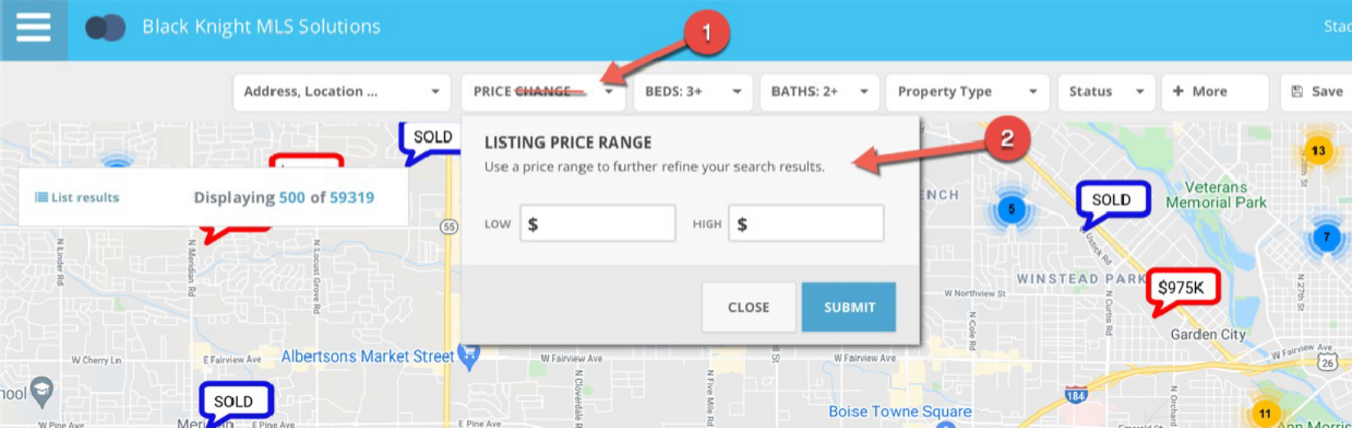Another change to the price component is the removal of the price slider. We found that the slider was difficult to move in increments that made it easy to set a min and max price, and it also maxed out at 3.4 million dollars. Now the price contains a min and max input field that the client can use to input their own price ranges. The top label has also been renamed to just say “Price”.

**Default Statuses**

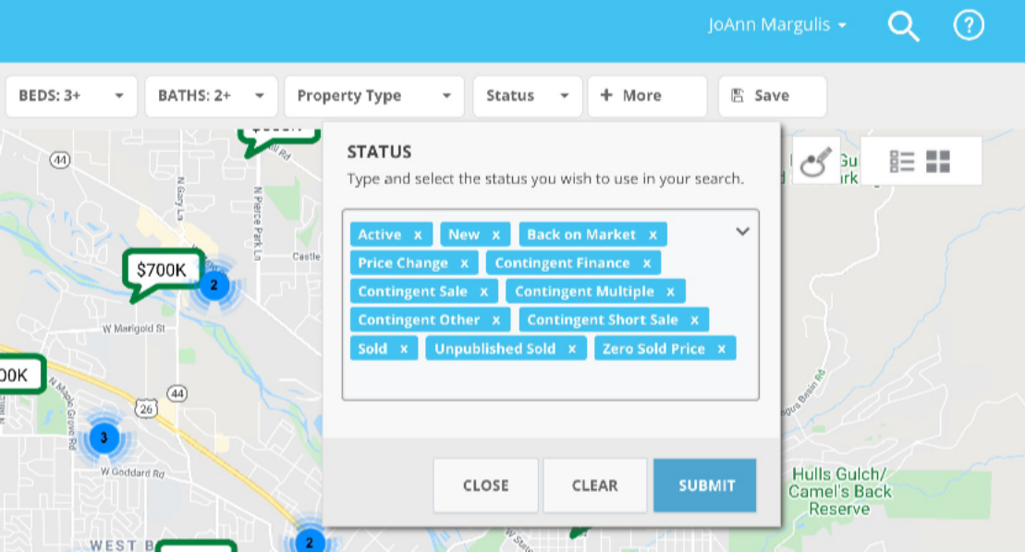The status control contains allowable search statuses a client can use to search for listings. Prior to this release, the status control would only default to the first sub-status of active, even if you had additional active sub-statuses Now the control defaults to all allowable statuses that are available.

**Example**

This is an example of a system that allows for active, contingent and sold listings to be found on the map.

**Status Control**

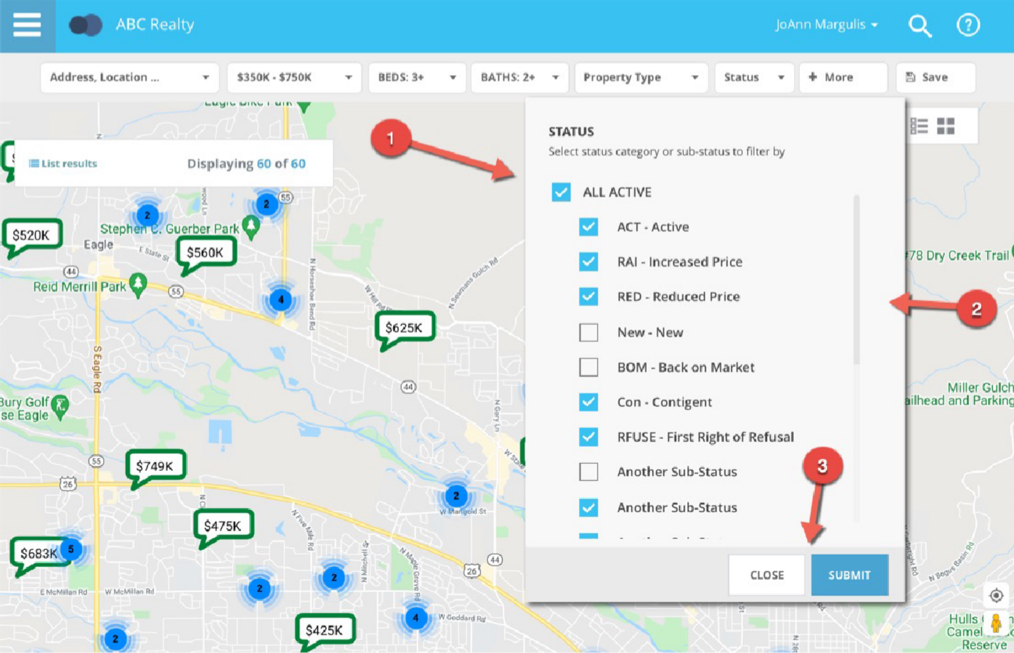Along with defaulting to all allowable statuses, the interface and selection controls were updated. The current lookup control required the client to either type a status or open a full screen modal to choose from a list of available statuses. Now the statuses are all visible on the control and you can easily check or uncheck the statuses you want.

**Hover Removed**

While Hovering over a pin, the Collaboration Center showed a hover control above the pin. This was duplicate information found in the mini preview when clicking or tapping on a pin. It has been removed.

