Paragon 5.85 Release Enhancements (updated on 9/2/2021)

Corrected Paragon Issues 2

MLS Customizations and Administration 3

Admin User Interface Refresh and Search 3

Mortgage Center for Paragon Connect and ConnectView 4

Agent Level Changes 5

Update to Financial Calculators (US) 5

CMA Cover Page – Add Field Name for Address 2 6

Collaboration Center 7

Collaboration Center - Property Search Changes 7

Paragon Connect 11

Auto Detect Login 11

Photo Reorder 12

Paragon Affiliate Connect 13

Corrected Paragon Affiliate Connect Issues 13

Agent Affiliate Dashboard Hidden on Smaller Devices 13

Notifications Tab Hidden 14

# Corrected Paragon Issues

|  |  |  |  |  |
| --- | --- | --- | --- | --- |
| **Ticket#** | **Product** | **Module** | **Organization** | **Summary** |
| DCL-10917 | Paragon | Associated Documents | FREEPORT, RAARMLS | Unable to access associated docs in .efx format |
| TK-5160 | Paragon | Admin | PARMLS - Pensacola AOR | Correct spelling for "Indoctrination" in Edit User Records |
| TK-5122 | Paragon | CMA | NEREN - New England Real Estate Network | Address Shows as White on the CMA Cover Page with Theme Set to Basic |
| TK-5110 | Paragon | Nightly Processing | PEEDEEMLS - REALTOR Assoc Greater Pee Dee | Listings in the Off Market status are not being purged when passing the Months to keep on the Status Cat |
| TK-4836 | Paragon | View/Reports | SCWMLS - South Central Wisconsin (Madison) | PubLink (Legacy E-mail Report) Does Not Show the Correct City in the Left Frame/Panel |
| TK-4869 | Paragon | Market Monitor | IRMLS, MIMLS, NEREN, NSAR, PACMLS, NKMLS, Northwest Oklahoma | Market Monitor is not showing the correct count |
| TK-4281 | Paragon | Market Monitor | DAAR - Lake Superior Area MLS | Market Monitor is disregarding State filter |
| TK-4361 | Paragon | Preferences | BCRES, NEREN, RAE | Saving Preferences: CC Search Options gives error |
| TK-4160 | Paragon | View/Reports | NSMLS | Market Conditions addendum does not load |
| TK-4131 | Paragon | Tax | SJSR - South Jersey Shore Regional MLS | Getting "connection reset" when printing PDF versions of tax records |
| TK-3882 | Paragon | LIM | IGL - Iowa Great Lakes BOR, WVMLS | MLS is receiving reports auto save is not triggering on listings. |
| TK-3529 | Paragon | Email | BCRES - REB2 Residential | Recurring notifications not going out when they are scheduled to |
| TK-3305 | Paragon | Listing Photos | CR - California Regional MLS | 54th secondary photo (slot BB) is showing 28th secondary photo (slot AB) on custom detail reports |
| DCL-50352 | Paragon | Prospecting | MLSBOX | Agent gets "page cannot be displayed" when emailing under reverse prospecting |
| DCL-44835 | Paragon | Admin | WVMLS | WVMLS- Needs the Days on Market field added to the Realty Toolkit Custom Export mapping table |

# MLS Customizations and Administration

**All options in this section are either configurable via MLS Administration controls or by your System Support Manager as noted.**

## Admin User Interface Refresh and Search

### Action Item: N/A

We are happy to introduce an updated look for the Administration module. Increasing the font size and adding some spacing between the links in the Admin panel makes the page easier to scan! 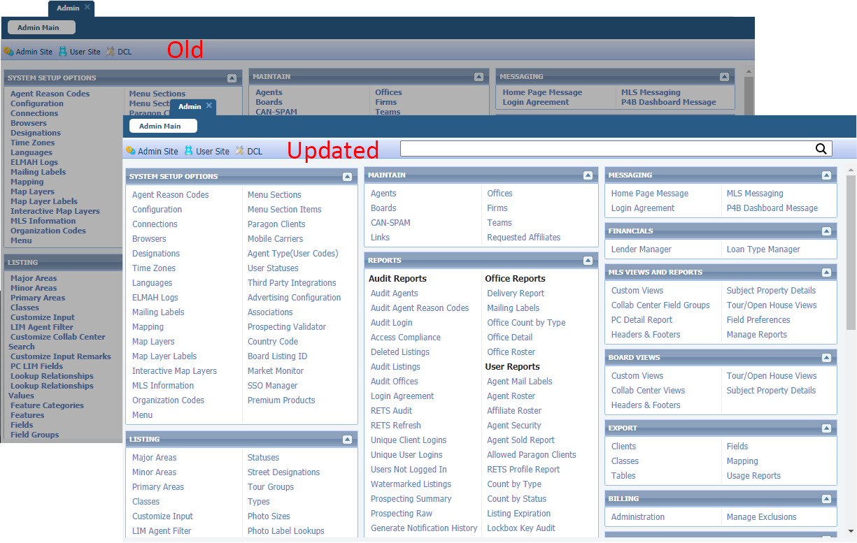

To assist you in locating an action item you are looking for, a new search feature has been added. All items that match what is being typed will be filtered down to just those and displayed in the section they currently reside in!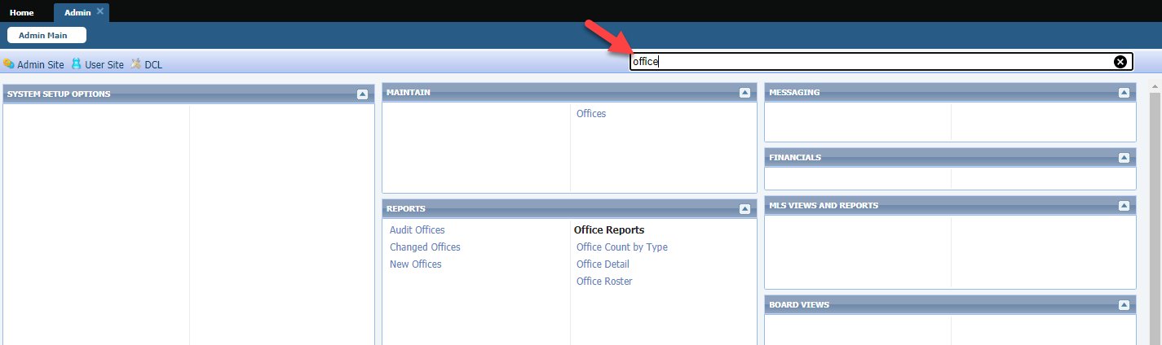

## Mortgage Center for Paragon Connect and ConnectView

### Action Item: N/A unless you want to disable or change calculator

We have enhanced the Paragon Connect Detail View and the ConnectView report to support a configurable calculator. The current calculator was hard coded into the report with no option to disable or replace with a different calculator. Now the section can be disabled, or a different calculator can be used. We also renamed the section to Mortgage Center to be consistent with the Collab Center.

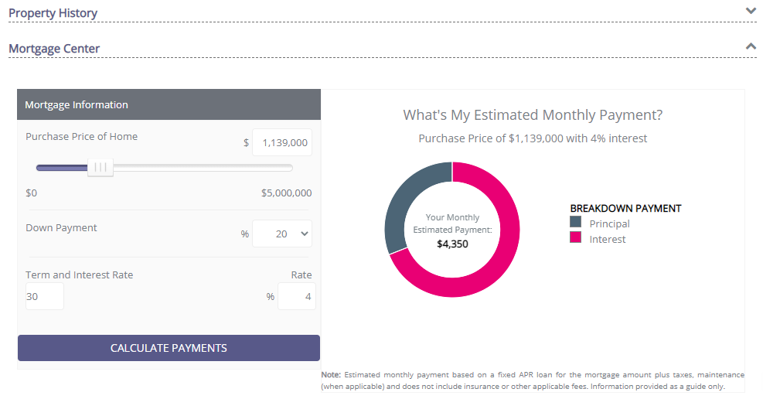The following screenshot shows the current production calculator and an example where we used one of the Paragon calculators.

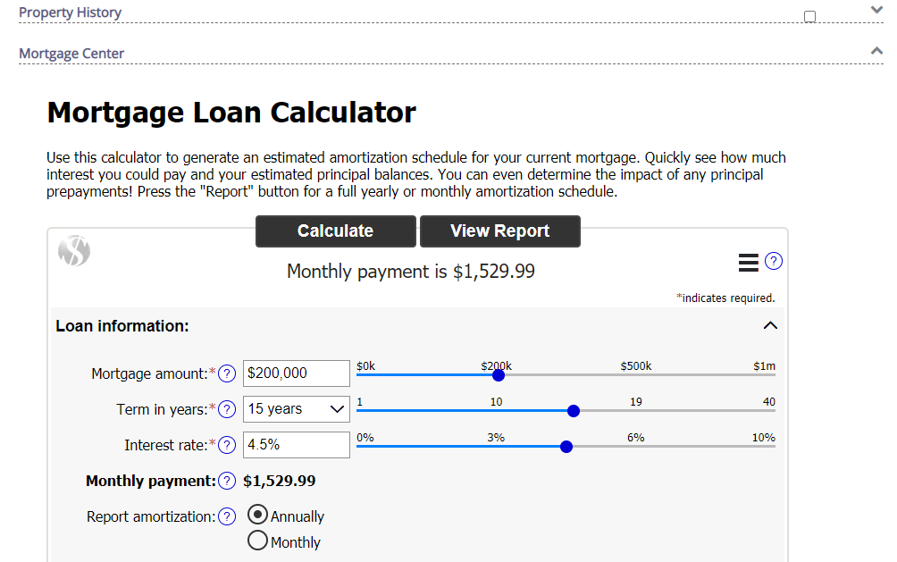

# Agent Level Changes

**The following section contains changes that are active system wide and available to users based on their assigned security levels.**

## Update to Financial Calculators (US)

### Action Item: N/A

The following updates were applied to the Financial Calculators

1. Updated font to match Paragon fonts
2. Disabled the email feature – this function was enabled in error during a previous update. The calculators require a Paragon session and as a result, emailing them to clients is not an option.
3. Collapsed the graphs by default – this helps reduce scrolling
4. 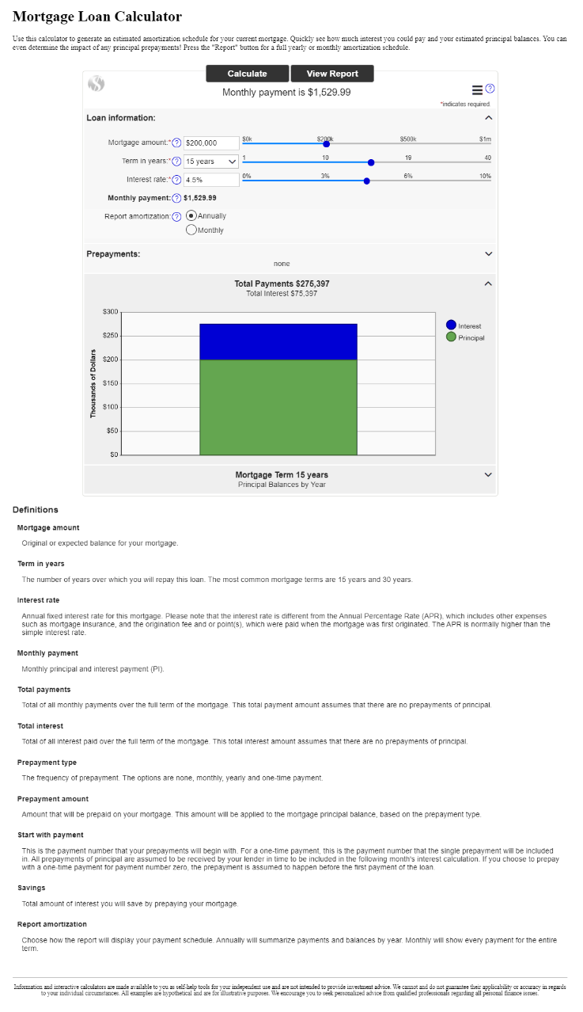Removed the Definitions from the bottom of the calculator. The text is located under the info tip question marks. Repeating them at the bottom was unnecessary and caused more scrolling.

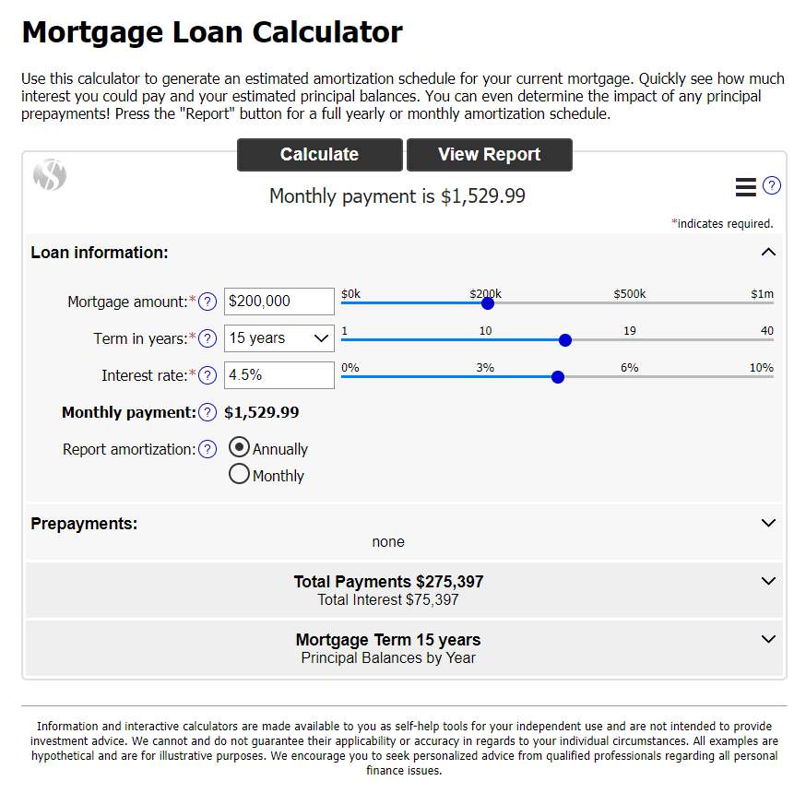

## CMA Cover Page – Add Field Name for Address 2

### Action Item: N/A

When Address 2, is used as part of the listing address, there wasn’t a field name associated with the data when viewing the CMA Cover Page. This enhancement adds the long description to the Subject Property display on the Cover Page.

Subject Property with Address 2

Cover Page missing Address 2 label

Updated Cover Page with Address 2 label

# Collaboration Center

**All options in this section are either configurable via MLS Administration controls or by your System Support Manager as noted.**

## Collaboration Center - Property Search Changes

### Action Item: N/A

The Collaboration Center property search has undergone minor changes to help enhance the search process. Below are just a few of the changes that were introduced.

**Layers Control**

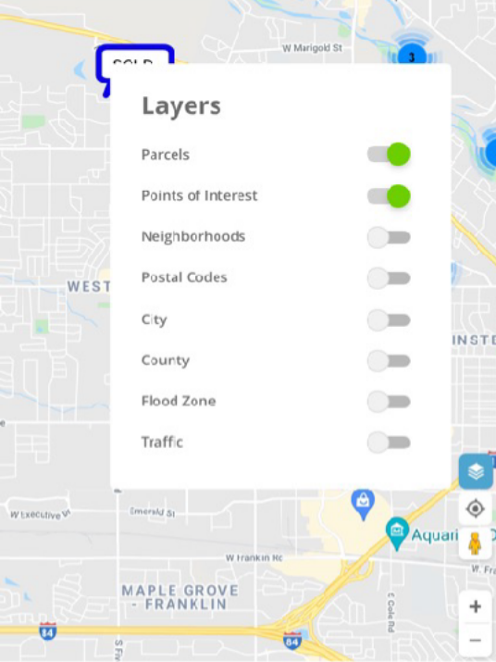A new layer icon was added to the bottom right navigation controls. This new icon replaces the “menu Options” button that was previously located on the map. This allows your clients to quickly enable any layer on the map. In addition, the parcel label is enabled by default. This will allow your clients to see parcel lines around properties when zoomed in on the map.

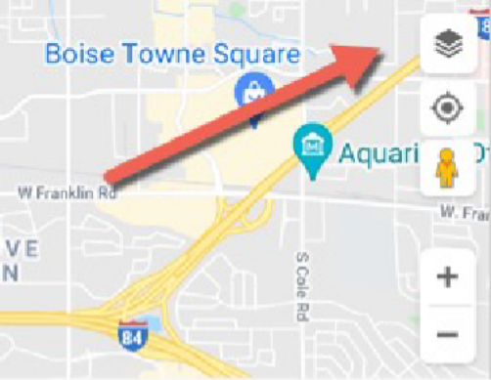

**Default and Toggle Mode**

Icon added above the “My Location” icon. It turns blue when enabled

**Reset**

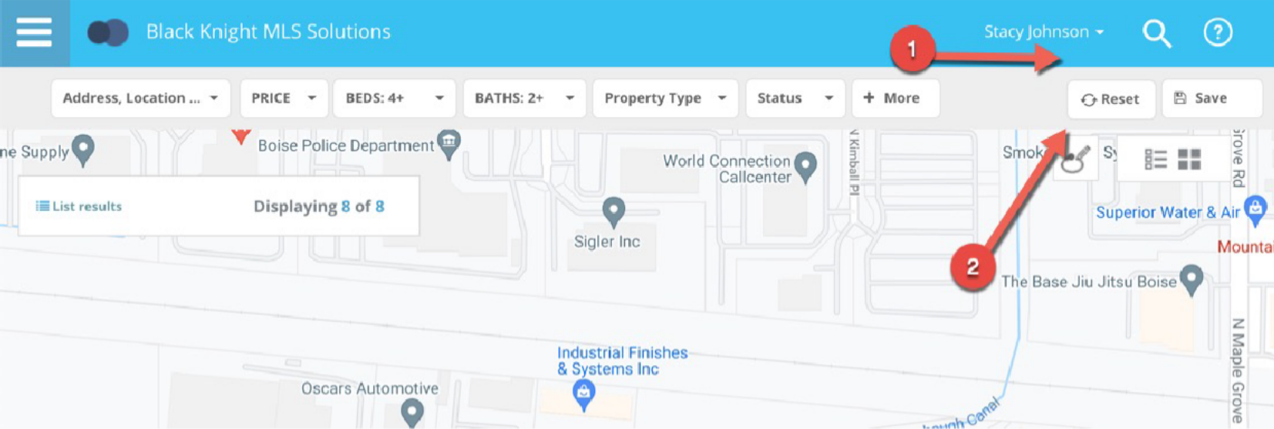A new reset button has been added to the Collaboration Center search bar. This reset option will allow a user to reset the property search back to the default criteria as when first opened. This way if you get lost or if you want to start your search over you can click the reset button.

**Price Range**

Prior to this release, the Collaboration Center search defaulted to a price range of $350K - $750K. In some housing markets, that range wouldn’t produce any results. Some markets are much higher and some they are much lower. Rather than providing a default price range, the property search will no longer default to any range. It should return all prices based on the map viewing area.

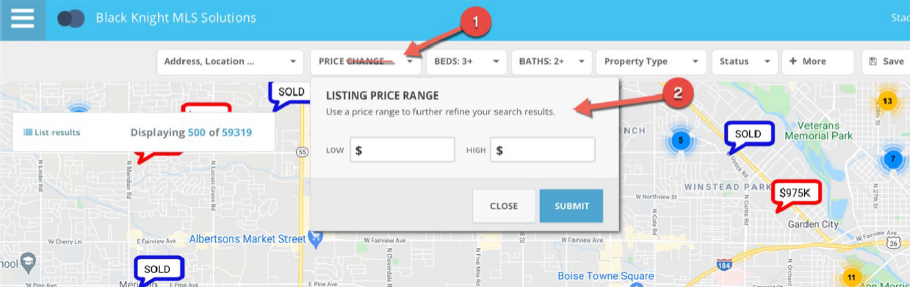Another change to the price component is the removal of the price slider. We found that the slider was difficult to move in increments that made it easy to set a min and max price, and it also maxed out at 3.4 million dollars. Now the price contains a min and max input field that the client can use to input their own price ranges. The top label has also been renamed to just say “Price”.

**Default Statuses**

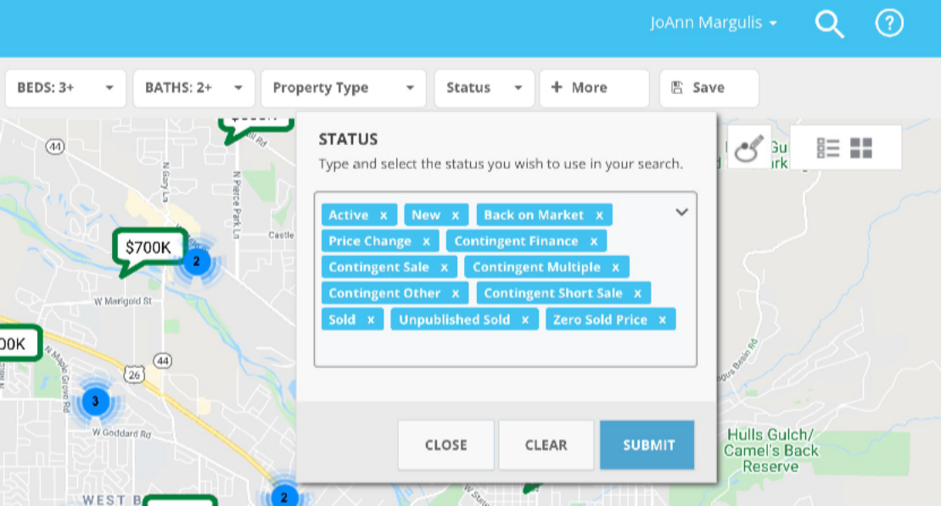The status control contains allowable search statuses a client can use to search for listings. Prior to this release, the status control would only default to the first sub-status of active, even if you had additional active sub-statuses Now the control defaults to all allowable statuses that are available.

**Example**

This is an example of a system that allows for active, contingent and sold listings to be found on the map.

**Status Control**

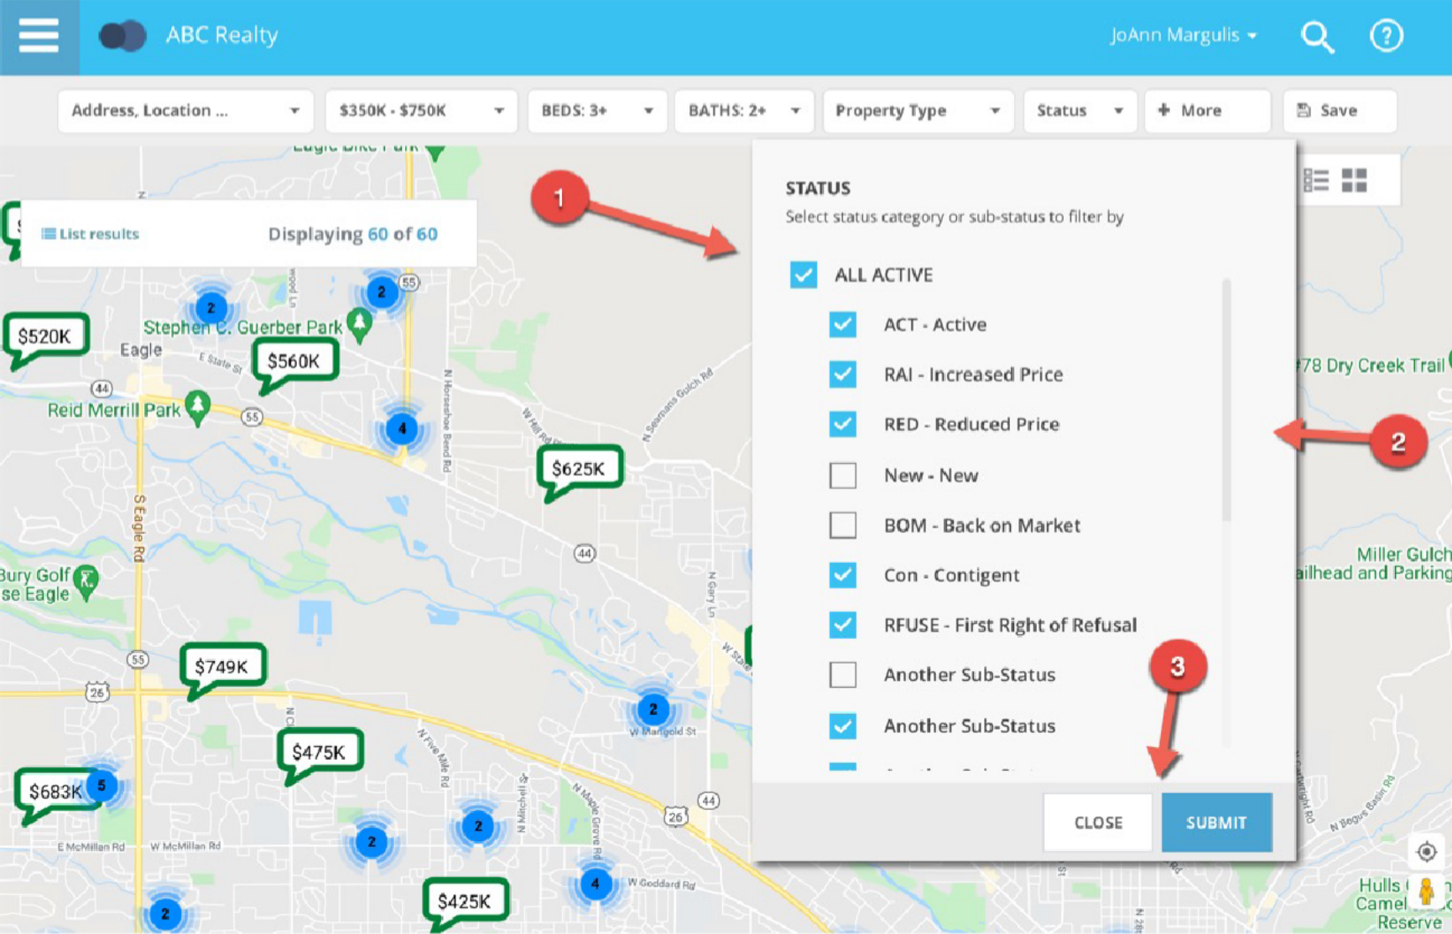Along with defaulting to all allowable statuses, the interface and selection controls were updated. The current lookup control required the client to either type a status or open a full screen modal to choose from a list of available statuses. Now the statuses are all visible on the control and you can easily check or uncheck the statuses you want.

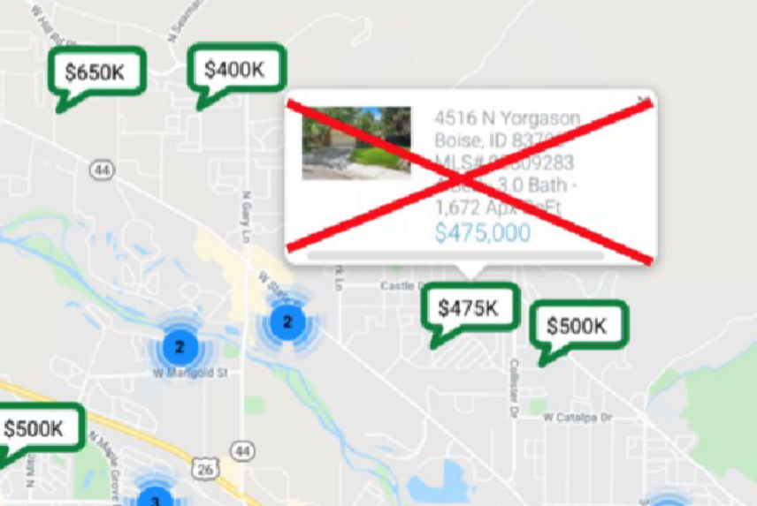**Hover Removed**

While Hovering over a pin, the Collaboration Center showed a hover control above the pin. This was duplicate information found in the mini preview when clicking or tapping on a pin. It has been removed.

# Paragon Connect

**All options in this section are either configurable via MLS Administration controls or by your System Support Manager as noted.**

## Auto Detect Login

### Action Item: N/A

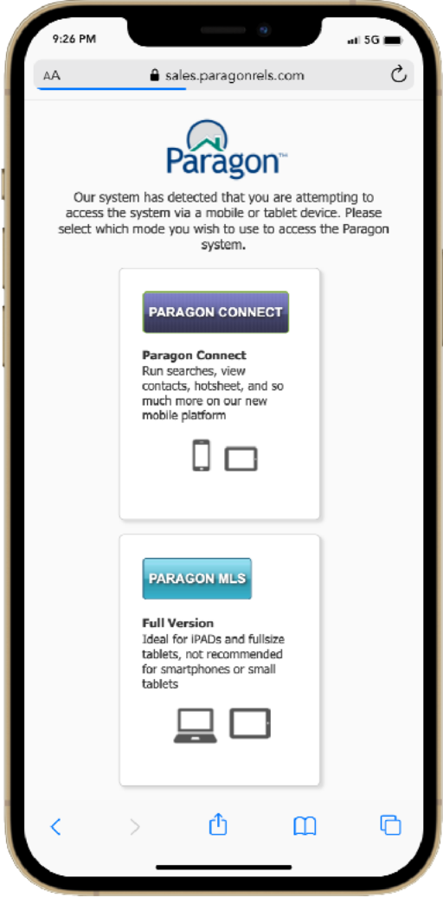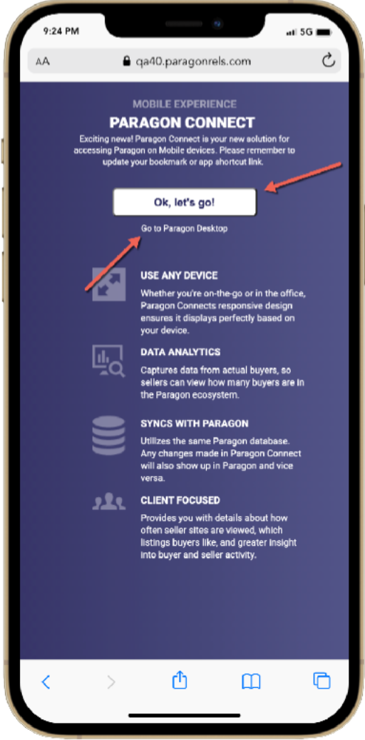Paragon and Paragon Connect both have their own login page, however, if you attempt to access Paragon from a mobile device, the auto detect page will appear. Prior to this release, the system would show you two options, do you want to access Paragon MLS or Paragon Connect? Rather than making these seem like two equal options, a new auto detect page was built to try to navigate mobile users towards Paragon Connect. You can still access your Paragon system by clicking the “Go to Paragon Desktop” link below the primary button. To provide your mobile members the best possible experience we are highlighting the Paragon Connect login.

**Before After**

## Photo Reorder (updated information 9/2/2021)

### Action Item: N/A

Now you can do even more with your photos in Paragon Connect. The photo module will now allow you to reorder your photos. Simply click on the reorder button and drag the photos into the desired order. Once complete, click on the green ok button and your changes and ordering will be saved.

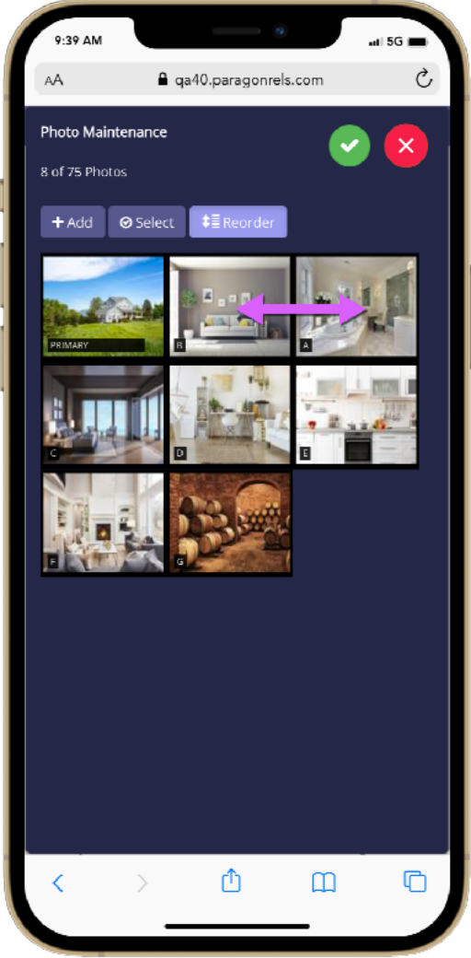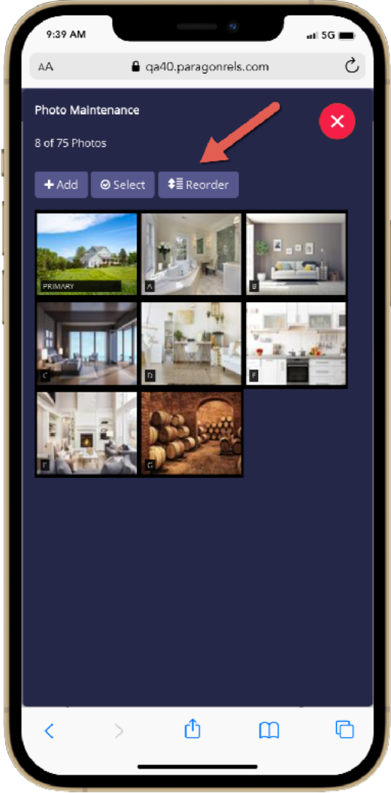

**1. Start Reorder**

Tap on the reorder

button to put system

in reorder mode

**2. Drag and Drop**

Select the photo you

want to reorder and

drag and drop it into

place.

**3. Save Changes**

Letters on photos

Will auto update after

Clicking the green

check circle.

**Additional Tips**

Note that the reorder button will NOT display if you have only one photo added to your listing. You can also change which photo is the primary photo by dragging a photo into the primary slot

# Paragon Affiliate Connect

**All options in this section are either configurable via MLS Administration controls or by your System Support Manager as noted.**

# Corrected Paragon Affiliate Connect Issues

|  |  |  |
| --- | --- | --- |
| **Ticket #** | **Module** | **Summary** |
| DEV-4675 | Dashboard | Hide the affiliate-related Notifications tab on all platforms |
| DEV-4731 | Dashboard | PAC: Hide the agent Affiliate dashboard on smaller devices |
| DEV-4749 | Email | Unable to share the listings through email |

## Agent Affiliate Dashboard Hidden on Smaller Devices

### Action Item: N/A

The agent’s Affiliate dashboard does not properly scale for mobile and small tablet devices, and parts of the page become inaccessible, resulting in a poor user experience. Because the page will need a complete rework to correct this issue, the Affiliate menu will be hidden on devices with resolution less than 992 x 800 pixels until that work can be completed.

1My Affiliates page in Paragon Connect Affiliate Connect menu removed

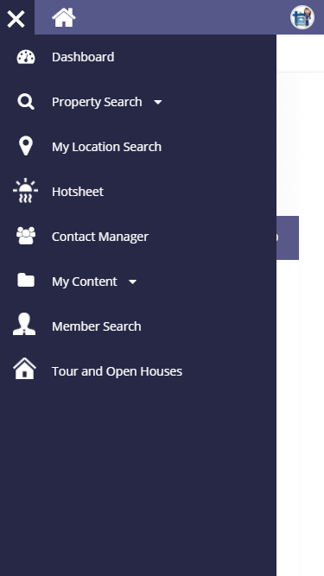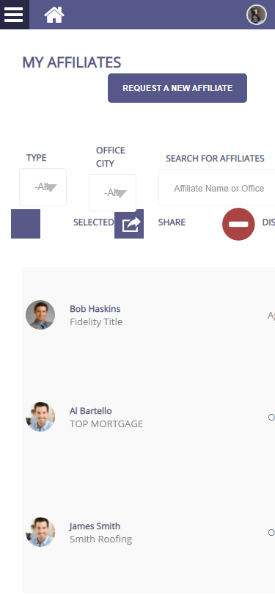

## Notifications Tab Hidden

### Action Item: N/A

The Notifications workflow is being reviewed to ensure correct information is being logged on the Notifications page. In the meantime, the page will be hidden to eliminate confusion.

Affiliate Notifications Tabs

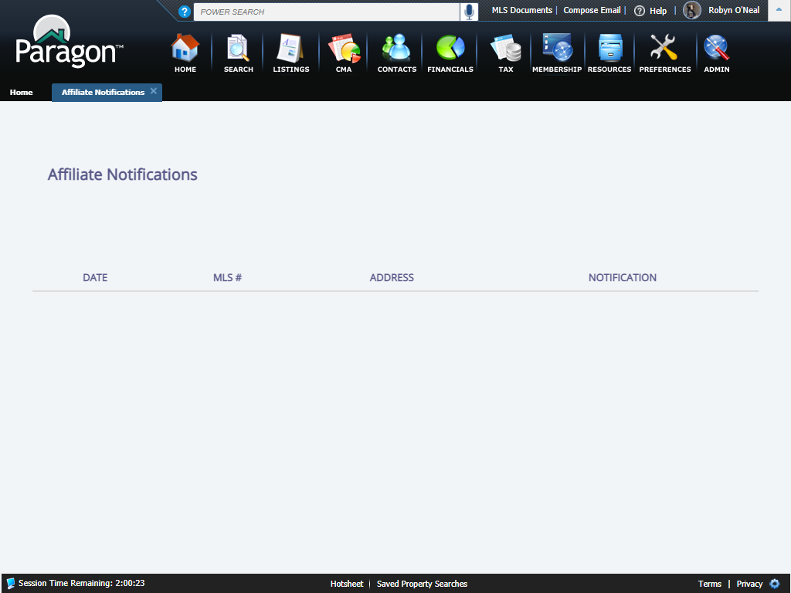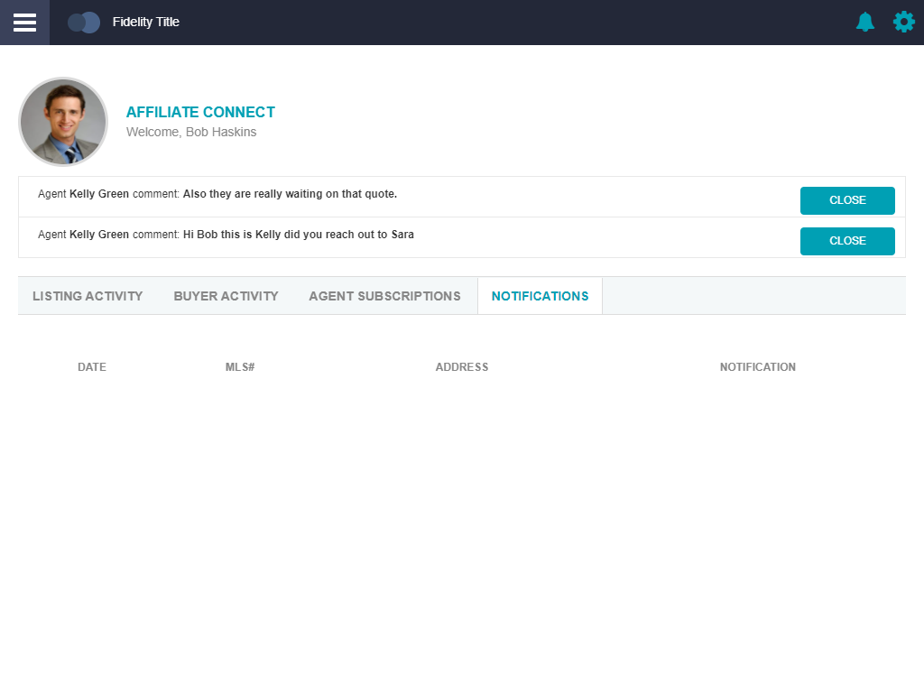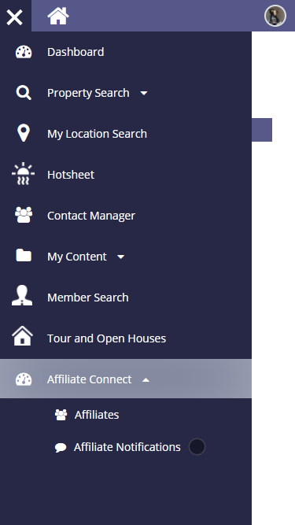

Notifications removed from menu