Paragon Customer Toolkit - Release 5.86

## **Communications Plan Overview**

Welcome to the Paragon release communication Toolkit. The intention of this kit is to help you with communicating the release information to your membership.

In this kit you will find the following:

* Link to Release Notes for Paragon 5.86: the notes include any configurations and administration items that you will need to know about.
* Administration Configuration Options: What changes you may need to decide on
* Agent level Communication Plan: a link to an editable Customer Communication, and homepage notifications.
* Social Media: a post that you can use for Facebook, Instagram or other sites with a video of the release features.
* Example Home Page Announcements: You can cut and paste into your Homepage.

The goal is to make everyone aware of all the great Paragon enhancements to boost the way Members do Business!

## **Release Notes for Paragon 5.86**

Listed below is a link to the full release notes for the MLS. These release notes are for the Association/MLS. The Agent Level changes in this document are included in the e-mail template that you will want to send out to your members.

**Link:** [Release Notes](https://info.email-bkfs.com/acton/attachment/35341/f-7134a300-1cb9-44cb-876b-7cbd005b17a5/0/-/-/-/-/Paragon%205.86%20Release%20Notes.docx)

## **Administration Configuration Options**

**Admin User Interface Tour for Paragon Release Notes**

We are excited to announce that Admin users will now have the Paragon Release Notes at your fingertips as we have added a popup UI tour. This is key as new Paragon major releases occur approximately every six to eight weeks and it’s important to communicate release changes to all your members. This popup will lead you to the secure Admin site where you will be able to access the Release Tool Kit at any time. If you do not have a login for the administration site, contact your SSM to get one. This option will only appear for level 7 or higher users.

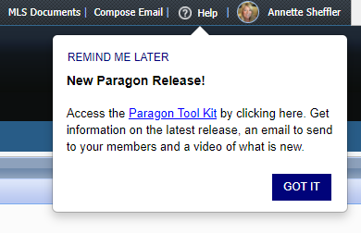

**Admin – RETS Profile field for Web API Client**

Paragon’s Web API client uses your existing RETS profiles. When assigning the Web API to a user’s Allowed Paragon Clients, it’s no longer necessary to include the RETS client to enable the RETS Profile field. The RETS Profile field will be enabled if either RETS or Web API is included in the user’s Allowed Paragon Clients.

**Admin – New fields added to Agent and Office grids**

For multi-board Paragon systems, we’ve added Member of Board to the Agent and Office grids and added a filter for that column. Visible boards will be based on the user’s security level. The Member of Board field displays the Office’s Member of Board value.

If Boards are not enabled on your system, the column and filter will be hidden.

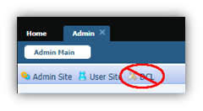**Admin – Remove DCL Button**

In Admin, the DCL button has been removed from the toolbar since DCL has been retired.

## **Agent Level Changes Communication Plan**

The following link is to the e-mail template that you can copy and paste from to send out to your members keeping them informed on the release. [Paragon Release 5.86 Member Email](https://info.email-bkfs.com/acton/attachment/35341/f-cecf57fd-400f-49fd-a552-4268b9c86b66/0/-/-/-/-/Email%20to%20agents%205.86.docx)

This is a word document that you can edit so if you **do not** have certain functionality, for example if you do not use Twitter and Facebook, you can remove that section first before sending. Also, in the first sentence you will want to add **your MLS name** (it is in red), so that it is being sent from **your** organization to **your** members.

To ensure that your members are always informed about the latest and greatest enhancement to their MLS System, please announce the enhancements to your membership, post to Social Media sites, include them in your newsletters and post notices to your homepage and login messages.

## **Social Media Post**

Copy and paste the following into your social media and the picture below will display with the video. Encourage your membership to like our Facebook page @ParagonMLS. Check out the exciting new features of the Paragon 5.86 release!

[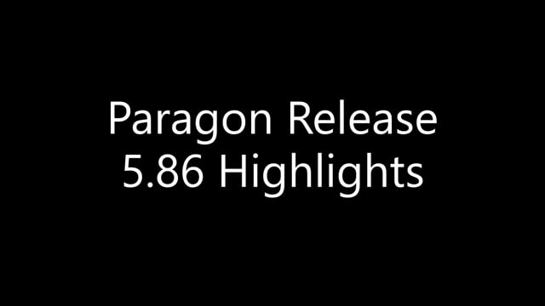](https://player.vimeo.com/video/641267687?h=db13ae4761&app_id=122963)

## **Example Home Page Announcements**

The release has a lot of nice enhancements, you may want to highlight a different one every few days on your homepage and via Social Media. You can just cut and paste these into your homepage editor. If you want to add pictures you can do that too but make sure to upload them to your server.

**Price Analysis Widget**

Black Knight is very excited to announce the release of the Price Analysis feature, which can be used by agents to determine pricing by viewing the Potential Buyers and any available AVMs if enabled. The feature can be accessed from the menu bar of the Listing Input Form for a current Full, Partial or Subject Property Listing.

Clicking the option will launch an interactive modal displaying the Potential Buyers in Paragon.

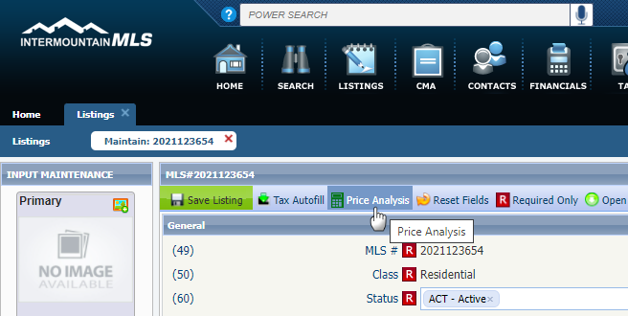The Potential Buyers are based on contacts whose saved search notifications include search criteria that match the listing in focus.

Armed with the Potential Buyers and the AVMs, agents can enter a New Price into the interactive widget and click the Recalculate Buyers to determine the effective change on potential buyers.

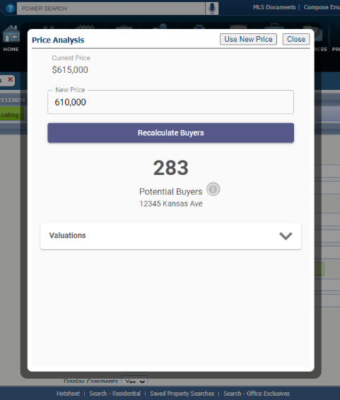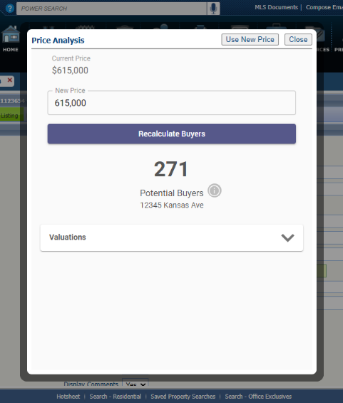

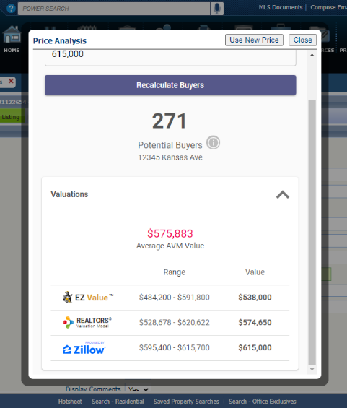

From here, the agent can click the “Use New Price” button and the widget will auto-pop the new price onto the form or they can close the widget to end. This will be an incredible tool that agents can show clients or potential clients to help determine pricing and/or to help motivate to list.

And there’s more to come! Coming in 5.87, we’ll be adding another metric to the Price Analysis widget called Location Score, which will display the relative hotness of the postal area for the listing compared to other postal areas.