

**PARAGON - INNOVATING THE WAY AGENTS DO BUSINESS**

**Paragon Release 5.86**

We (enter your MLS Name here) wanted you to be the first to know about the latest enhancements to your Paragon MLS System. All enhancements are designed to help you navigate through the system and enhance your experience with Paragon.  Below is a list of the enhancements and links to view videos or PDFs of the new features. We encourage you to continue reading and let us know what you think on the [Paragon MLS Facebook site](https://www.facebook.com/ParagonMLS/). Also make sure you click “Like” on the Facebook site to view what’s new with Paragon more frequently.

**WHAT’S NEW!**

**PARAGON**

* **Price Analysis Widget**

|  |  |
| --- | --- |
| Black Knight is very excited to announce the release of the Price Analysis feature, which can be used by agents to determine pricing by viewing the Potential Buyers and any available AVMs if enabled. The feature can be accessed from the menu bar of the Listing Input Form for a current Full, Partial or Subject Property Listing.  Clicking the option will launch an interactive modal displaying the Potential Buyers in Paragon.  The Potential Buyers are based on contacts whose saved search notifications include search criteria that match the listing in focus.  Armed with the Potential Buyers and the AVMs, agents can enter a New Price into the interactive widget and click the Recalculate Buyers to determine the effective change on potential buyers.    From here, the agent can click the “Use New Price” button and the widget will auto-pop the new price onto the form or they can close the widget to end. This will be an incredible tool that agents can show clients or potential clients to help determine pricing and/or to help motivate to list.  And there’s more to come! Coming in 5.87, we’ll be adding another metric to the Price Analysis widget called Location Score, which will display the relative hotness of the postal area for the listing compared to other postal areas. |  |

* **UI UPDATES**

In the Agent Recommended heading we changed the word “client’s” to “contact’s” 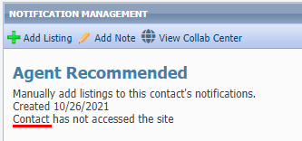

On the Contact’s Saved Search pages, we refined the user interface by removing some extra space in the Activity table and an unnecessary scrollbar in the Comments table.

Existing Saved Search page:

Updated Saved Search page:

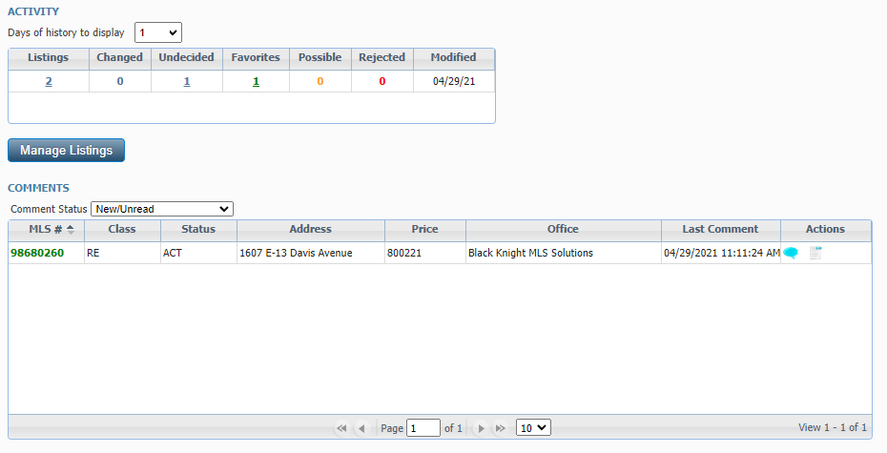

In the Comments dialog box we changed the pane title from “Messages” to “Comments” and the commit button from “Comment” to “Submit” to be more uniform and standard.

* **Paragon Connect – Top App Bar**

|  |  |
| --- | --- |
| A new top add bar has been added to the Paragon Connect application. It is like the previous top bar with a few modiﬁcations. The proﬁle menu and home button have been moved into the left navigation. This new top bar is a step in the direction for using your browser to control navigation (Back and Forward). Work is still needed for the rest of the application, but soon you will be able to use your browser's native buttons to navigate around Paragon Connect. |  |

* **Contact List in Paragon Connect**

The Contact list has been upgraded to support several new features. First, let’s look at the changes to the overall layout.

The previous version used about 25% of the top section of the application with headers, search bars, action buttons, etc. This took up too much room as you can see now, the new version places the actions in the new top app bar allowing you to physically view twice as many Contacts as before.

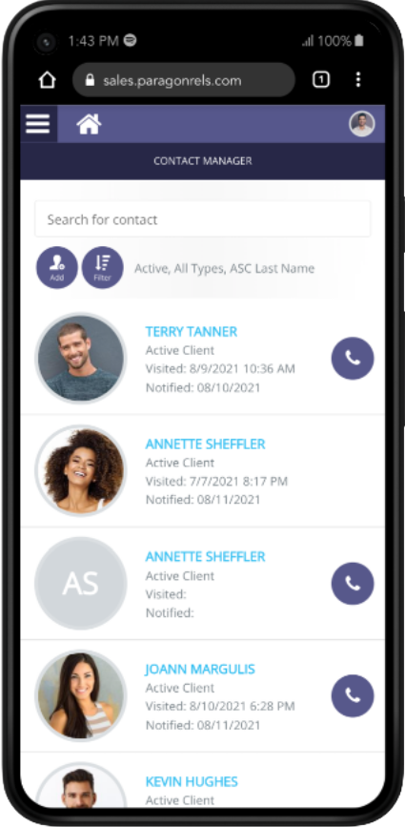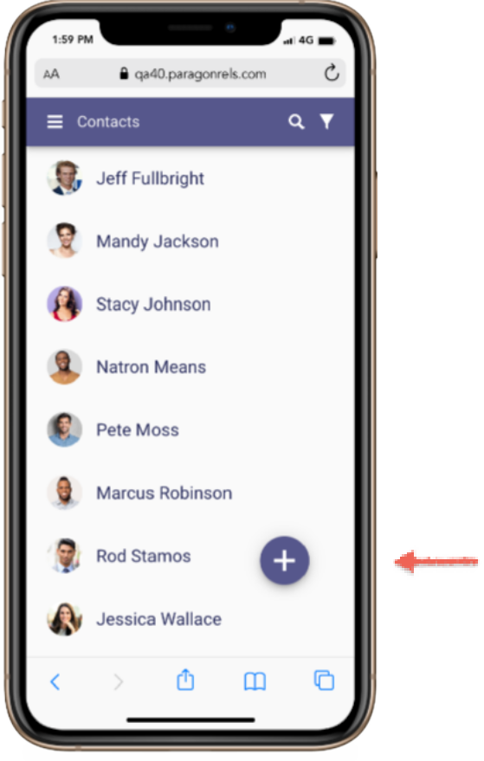

**Screen Space**

User Can only see about 75% of the screen. Too many headers.

**New App Bar**

All options now appear in a single app bar providing more space

**More Contacts**

You now have double the number of contacts visible at once (8)

**Contacts Visible**

Only four contacts can be seen at one time

Before After

**Add Contact**

Easy to add new contacts from floating add button

Before After

* **Paragon Connect – Search**

To search for a contact, simply tap on the search icon in the app bar. The top app bar is replaced with a search bar, and you can quickly start searching for any contact in your list. As you begin typing the application will automatically start searching for your contacts.

**Search**

Tapping on the search icon to open the search dialog

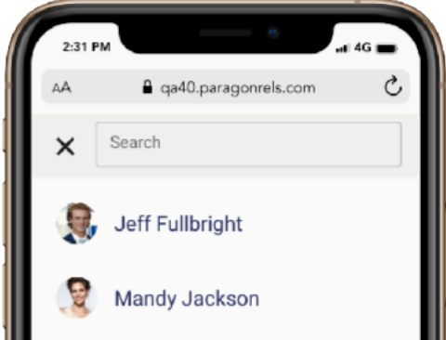

* **Paragon Connect – Filter Contacts**

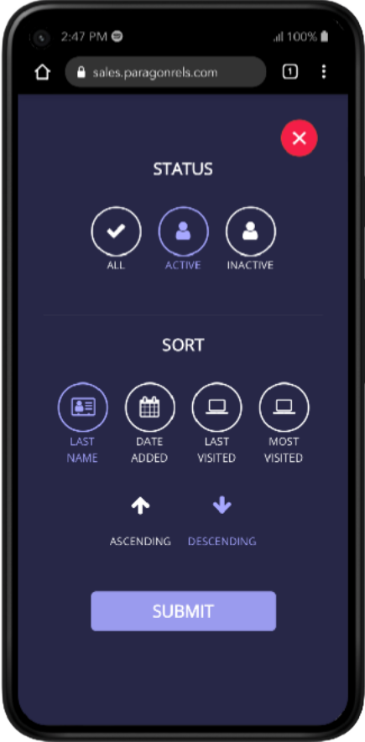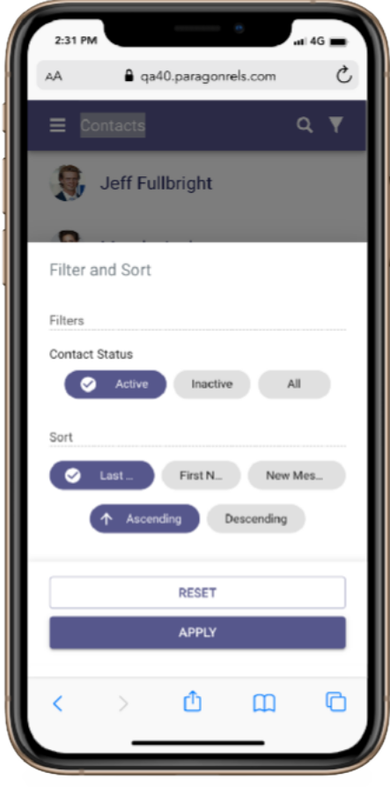The filter function has been updated to allow you to quickly find contacts. Rather than a full screen modal, we leave you on the screen and open a drawer below the contact list. Here you will find a few new filter options.



**Contact Status**

Active (Default), Inactive All



**Sort**

Last Name (Default), First Name, New Message



**Order**

Ascending (Default), Descending

* **Paragon Connect – Add Contacts**

Adding a contact in Paragon Connect has been standardized and streamlined. On the contact list, you will find a floating button with a plus sign. This will be our new standard for adding new content within Paragon Connect. Tapping on this button will launch the Add Contact form. Upcoming releases will continually add the ability to enter and edit more contact data.

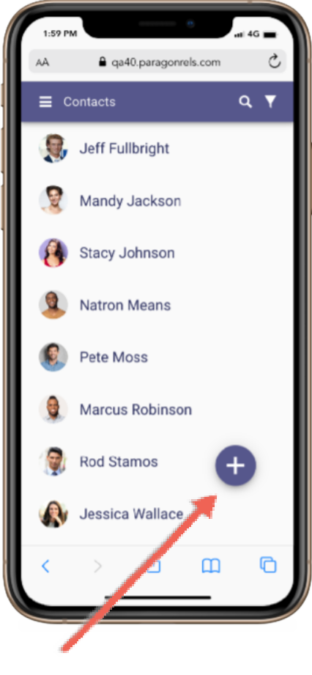

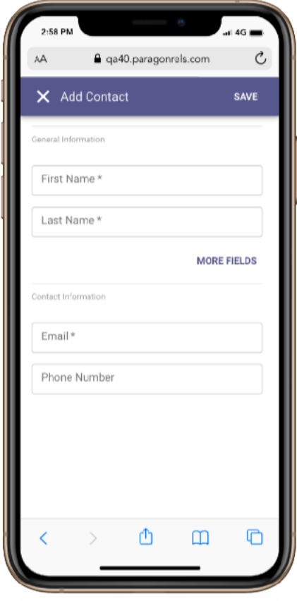

**Add New Contact**

This is the new form for adding a contact. Same fields, but utilizes our standard form components

**Add Button**

Tapping on this floating button launches the add new contact form

**Add Button**

Tapping on this floating button launches the add new contact form

* **Paragon Connect – More Fields**

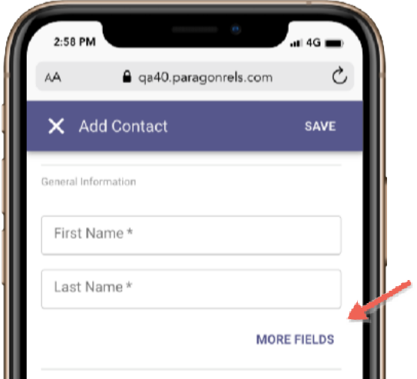By default, the add form displays first and last name. Tapping the “MORE FIELDS” link will expand the form to show “Prefix” and “Suffix”.

**More Fields**

This is the new form for adding a contact. Same fields, but utilizes our standard form components

* **Paragon Connect – Deleting Contacts**

New to Paragon Connect is the ability to delete one or more contacts. From the contact list, if you tap on the photo, it automatically checks the contact. You can select multiple contacts by tapping contact images. Once a contact is selected, you will notice the top app bar changes to show the actions that you can perform. You can tap the X to cancel your selection, or you can tap on the overflow (three dot icon) and choose “delete” to remove the contacts.

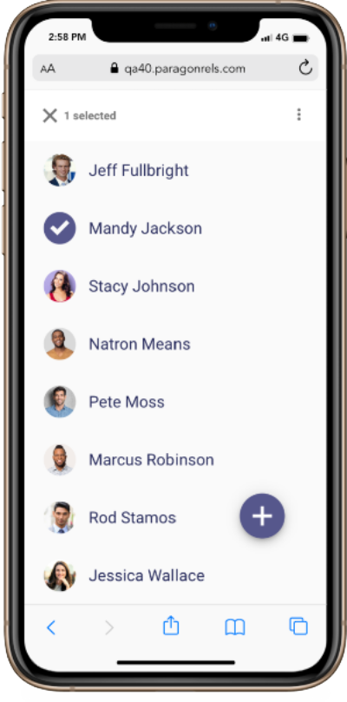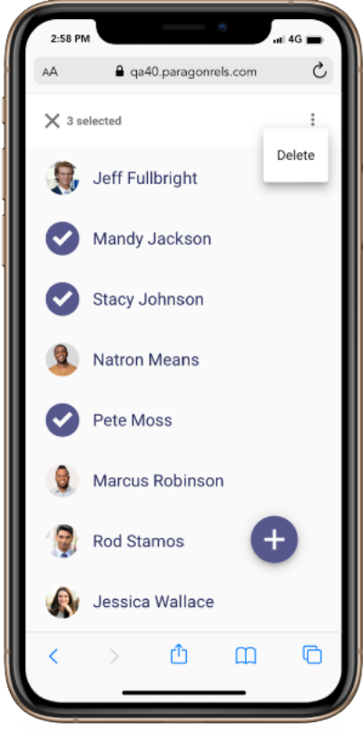

**Overflow**

Click the overflow option to delete the selected contact(s)

**Tap Photo**

Tap photo or initials and the system will select that contact

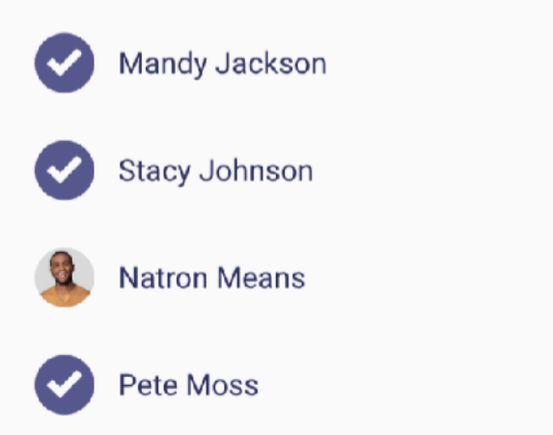

**Selecting Multiple**

Notice you can select more than one contact from the list. The only action at this time is to delete the contact however, in the future there will be additional options for multiple contacts.

* **Paragon Connect – Contact Viewer**

The contact viewer is the page that displays after tapping on a contact. This has been updated and enhanced to make room to support several future contact features. The buyer and seller content are still available; however, the location of this information has been updated.

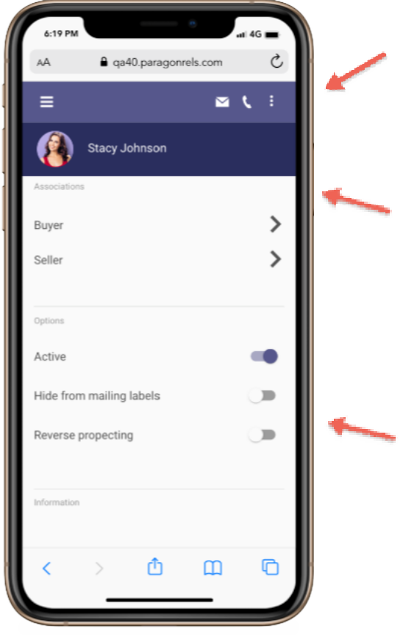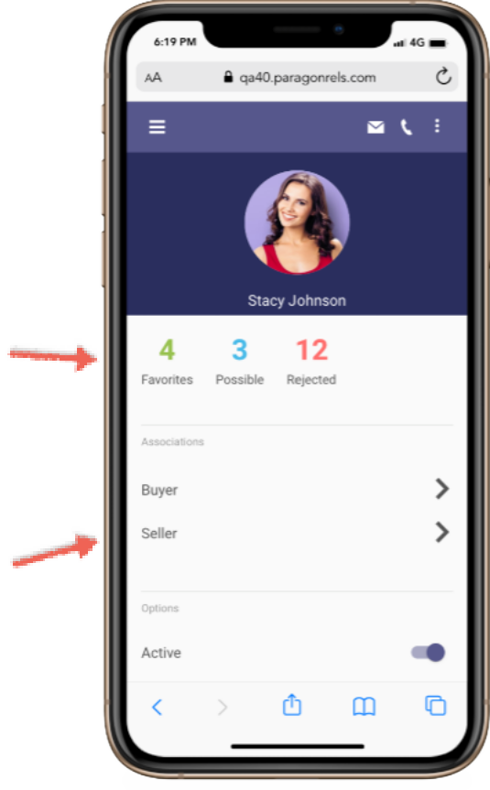

**Counts**

If the contact is setup with a Collaboration Center, counts will appear

**Buyer-Seller**

Same buyer and seller content exists below

**Action Icons**

Email, phone, collaboration center links, and more all found here

**Scroll Effect**

As you scroll the page, the large photo transitions to the small header

**New Options**

You can now use these new options while maintaining your contact

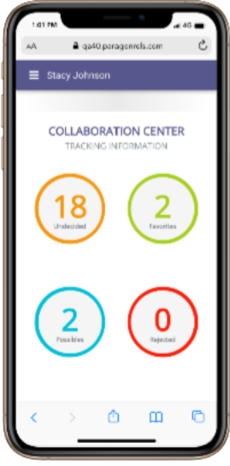**Buy Side**

The Buyer link found on the contact view will take you to the Collaboration Center categories like it does today on the mobile. Each of these is linkable to view the listings in each category. Future enhancements are planned for this screen to manage your sites, communications, searches and more.

**Sell Side**

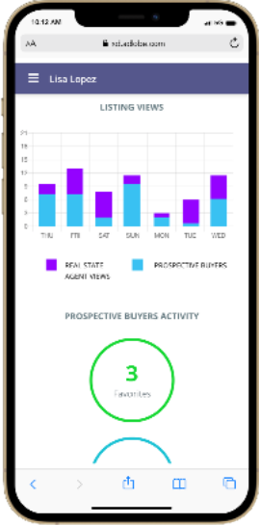The seller content is also the same as it was prior to this new contact view. You will find all the same statistical data, hits, counts, and more. Additional updates are planned for this module including managing your sell side options, competition information and more.

* **Paragon Connect – Compose Email Updates**

How you select an email and how you compose an email in Paragon Connect has been updated. Contacts can sometimes have more than one email address. The new contact viewer allows you to choose one or more email addresses at a time before you compose the message. You will also find that the email module has been updated. A new layout has been applied to make composing an email easier and more standard.

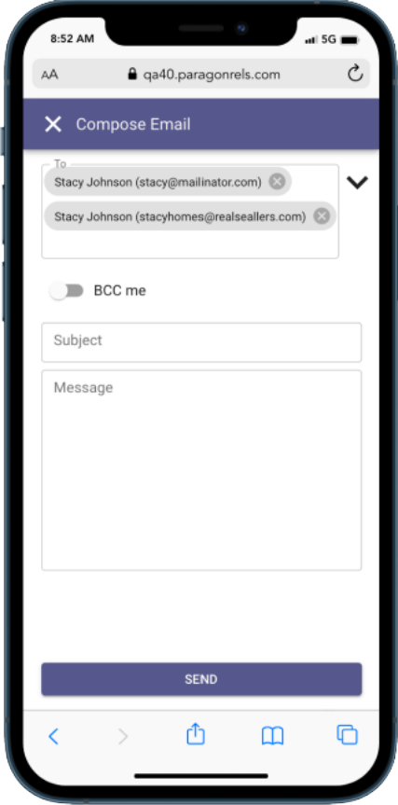

**Addresses Added**

The system responds by opening email modal and populating both email addresses in the To: section

**BCC me**

Clicking on the drop down arrow will provide you with BCC and CC options. The switch allows you to BCC yourself

**Updated Email Screen**

An improved interface with lighter colors and improved UI elements

**Email**

Email module that contains your contact’s email addresses

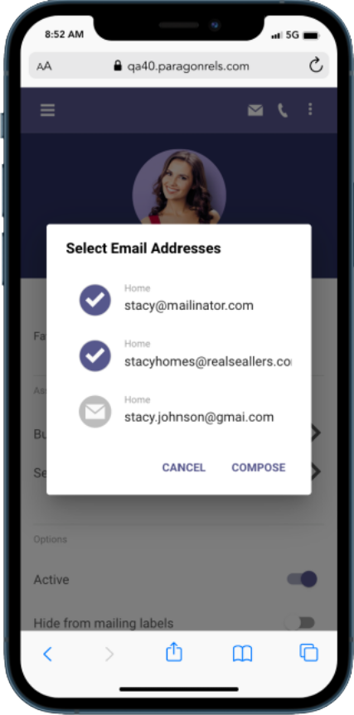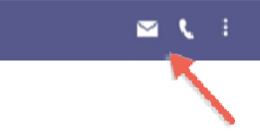

**Select Addresses**

Allows you to select more than one email to compose new email.

If only one email is available, it will take you straight to the compose email screen.

* **Paragon Connect – Complete Address Book**

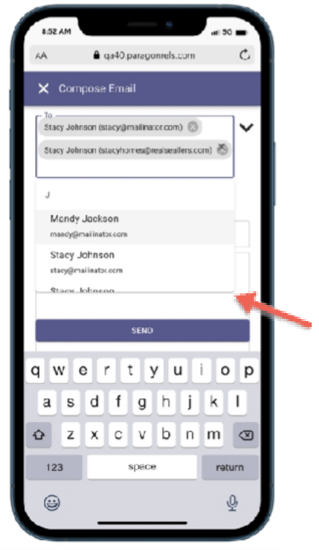New to Paragon Connect is the auto complete address book feature. As you begin to type an email address or a contact, the system will return a list of possible matches based on the email address found in your Paragon Connect address book. This will allow you to quickly find and compose an email.

This new email module is only found in the contact viewer but will be added to other areas of the system in the future.

**Auto Complete**

Start typing a contact’s name or an email address

* **Paragon Connect – Phone Updates**

Like the email interactions, the phone or call interactions have been updated as well. It’s not uncommon that a contact will have a cell phone, work phone, or maybe even a land line number. Rather than just using the primary phone number, Paragon Connect now allows you to choose which phone number to contact. If you are on a mobile phone, when choosing a phone number, it will prompt you to either to make a call or send a text.

* 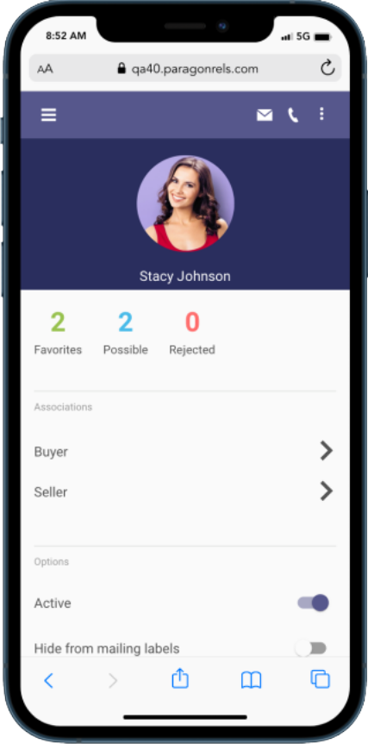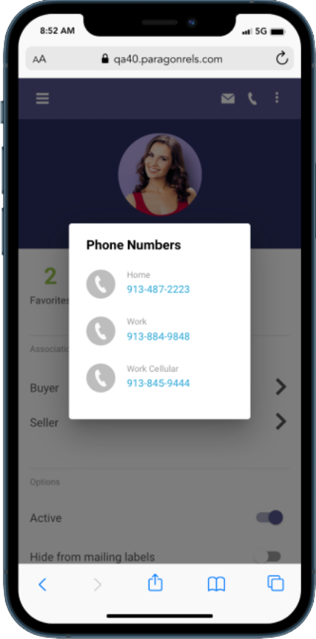

**Phone Icon**

Phone number icon allows you to call or text your contact

**Select Phone Number**

When multiple phone numbers are associated, you must tap the one you want use

* **Paragon Connect – Texting**

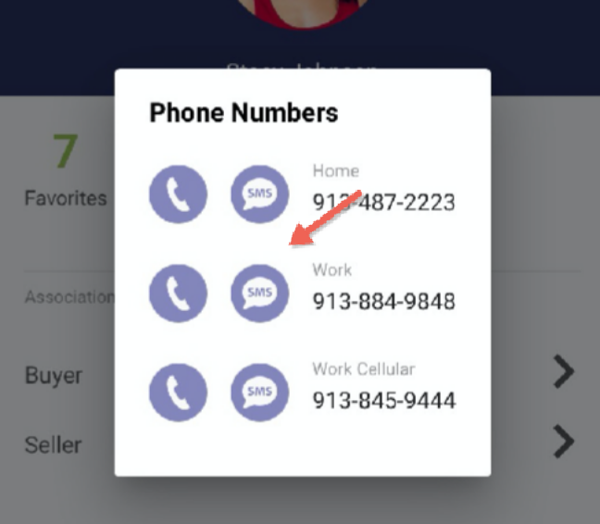While using a mobile device, clicking on the phone icon will not only display all available phone numbers, but it will also provide you with a SMS option. Clicking this icon will launch your default native texting app. This will allow you to instantly text your contact without having to switch to your texting app.

Note: We are unable to determine which phone number is a mobile phone only so all phone numbers will have this option displayed next to it.

* **Paragon Connect – Show Password**

Logging into systems that require a password may not be fun, especially when password requirements are very strict and require random capitalization, numbers, special characters, etc. To help make the login process a bit easier, Black Knight has handed a show password option. While you are in a secure location, you can tap on the eyeball icon and when you type your password you will see the actual text you are typing.

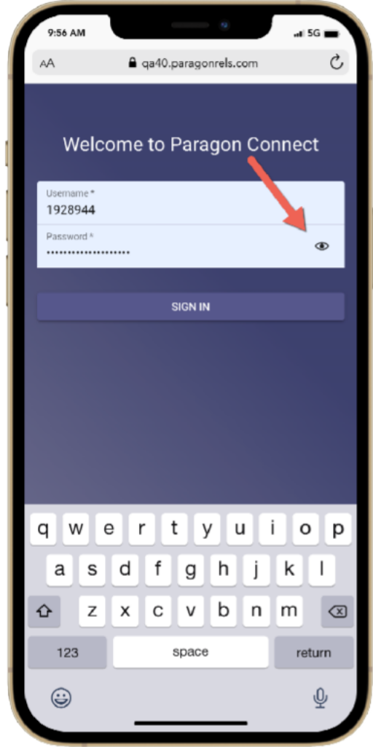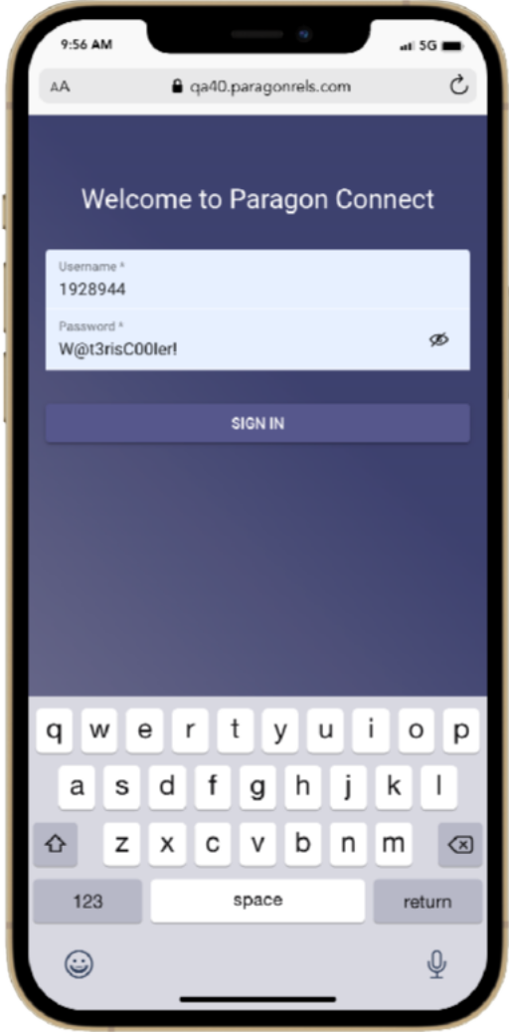

**Password**

Your password text is hidden with asterisks by default, but if in a secure location, you can tap on the eyeball and see actual text