Paragon 5.86 Release Enhancements

Updated on 11/5/2021

Corrected Paragon Issues 3

MLS Customizations and Administration 5

Admin - UI Tour for Paragon Release Notes 5

Admin – RETS Profile field for Web API client 5

Admin – New fields added to Agent and Office grids 6

Admin – Remove DCL button 7

Agent Level Changes 8

UI Updates 8

Price Analysis Widget 10

Collaboration Center 12

Collaboration Center – Property Search Moved to Main Tab 12

Paragon Connect 13

Top App Bar 13

Contact List 14

Search 15

Filter Contacts 15

Add Contacts 16

More Fields 17

Deleting Contacts 18

Contact Viewer 19

Compose Email Updates 21

Auto Complete Address Book 22

Phone Updates 23

Texting 24

Show Password 25

Removed Items 26

Theme Colors 26

Edit Profile Image 26

Paragon Affiliate Connect 27

Corrected Paragon Affiliate Connect Issues 27

Admin – New link to send Affiliate Welcome email 29

Admin – Display Affiliate Broker Options in Preferences based on security level 30

Admin – Association Autonomy options for Affiliate Connect 30

Updated text for Broker Options in Preferences 30

Add office-level Disclaimer for Office Affiliates 31

Updates to the My Affiliates page 32

Service Providers Tab in Collaboration Center 34

Reply button on dashboard notifications 35

Updates to the Buyer Activity tab 36

Additional updates to the Comments workflow 37

# Corrected Paragon Issues

|  |  |  |  |  |
| --- | --- | --- | --- | --- |
| **Ticket#** | **Product** | **Module** | **Organization** | **Summary** |
| DEV-5285 | Paragon | Third Party | CR - California Regional MLS | Customers would like new icons for Glide integration |
| TK-6724 | Collab Link | View/Reports | MAXEBRDI - MAXEBRDI MLS | Collab Link does not show social media links when Collab Center does |
| TK-6057 | Paragon | RETS Admin | SMLSA - Strategic MLS Alliance | Enable RETS Profile field in member record for Web API client |
| TK-6289 | Collab Center | Prospecting | BCRES, RAE, SCWMLS, NNRMLS, SDMLS | CC2 Agent Circle Image Displays as a Box in Outlook |
| DEV-5113 | Paragon | Admin | IRMLS - Indiana Regional MLS | Add fields to Agent (Member of Board) and Office (Broker and Board) admin grids |
| TK-5464 | Collab Center | View/Reports | SCWMLS - South Central Wisconsin (Madison) | Street View Does Not Display Correct Geo Coordinates and Doesn't Display Location Pin |
| TK-840 | Paragon | Admin | IRMLS, NCWV, WVMMLS | WVMLS requesting enhancement to set default for Upload Photos on Agent Records to All |
| TK-6148 | Collab Center | Dashboard | BCRES - REB2 Residential | Collab Center Dashboard My Listings undecided does not account for Unique listing count. |
| DEV-5036 | Paragon | Admin | All Customers | Remove DCL button from Paragon Admin Menu |
| TK-6050 | Paragon | LIM | SDMLS - San Diego MLS | Page cannot be displayed error when using copy/clone on listing with media URL based photos |
| TK-4771 TK-5928 | Collab Link | Listing Photos | BCRES, CCAR | Listing photo rotation in collablink on mobile device error |
| DEV-4841 | Collab Center | Search | All Customers | SEARCH HIDDEN: Property search is hidden from users’ perspective…Implement Property Search to be accessed from a top-level Tab. |
| TK-5830 | Paragon | View/Reports | Iowa Great Lakes BOR, MAXEBRDI | Email Attach as PDF duplicates listing tours on reports |
| DEV-4774 | Paragon | Data | MLSL - MLS Listings, NRV | DataIndexer encountering issues processing queued UpdateListing messages |
| DEV-4769 | Collab Center | Other | All Customers | Create a top-level tab for Service Partners (connected Affiliates) do be displayed in Collab Center |
| DEV-4737 | Paragon | General UI | All Customers | Implement UI Tour for release notes for Admin Users |
| TK-735 | Paragon | LIM | NEREN - New England Real Estate Network | Tour Open House Whitelist Ignored When Virtual Tour Check Box is Not Selected |
| TK-5114 | Paragon | View/Reports | LAWTONBOR - Lawton BOR | Listing Office Info not correctly placed on Agent Detail Report |
| TK-3829 | Paragon | Mapping or Geo-coding | NEREN - New England Real Estate Network | Default geocode should not land on 0,0 |
| DEV-4529 | Paragon | LIM | All Customers | Unable to remove added Room Info |
| DEV-4421 | Paragon | General UI | All Customers | DinkyTown calculators no longer defaulting Price |
| DEV-4327 | Paragon | General UI | All Customers | Retire old UI Tours |
| TK-4591 | Paragon | Mapping or Geo-coding | COLUMBIA - ConsolidatedMLS | Advanced Mapping layer labels on/off switch no longer available |
| TK-3542 | Paragon | CMA | NEREN - New England Real Estate Network | Moving Between Steps and Screens in the CMA Module Feel Sluggish |
| TK-4274 | Paragon | Email | SAR - Spokane AOR | Google + icon showing instead of Instagram on Collab Center welcome email |
| TK-3036 | Paragon | View/Reports | CR - California Regional MLS | Error when viewing a Google Map report then selecting another report |
| TK-1857 | Paragon | Search | NEREN - New England Real Estate Network | Last Search is Not Being Saved into Last Search List |
| DEV-2489 | Paragon | Search | BCRES, SCWMLS | MLS numbers copied from Collab Center emails don't work in Quick Search |
| DEV-2472 | Paragon | Configuration | All Customers | POWER_SEARCH_RESULTS_PER_CATEGORY value set is not what is displaying |

# MLS Customizations and Administration

**All options in this section are either configurable via MLS Administration controls or by your System Support Manager as noted.**

## Admin - UI Tour for Paragon Release Notes

### Action Item: N/A

We are excited to announce that Admin users will now have the Paragon Release Notes at your fingertips as we have added a popup UI tour. This is key as new Paragon major releases occur approximately every six to eight weeks and it’s important to communicate release changes to all your members. This popup will lead you to the secure Admin site where you will be able to access the Release Tool Kit at any time. If you do not have a login for the administration site, contact your SSM to get one. This option will only appear for level 7 or higher users.

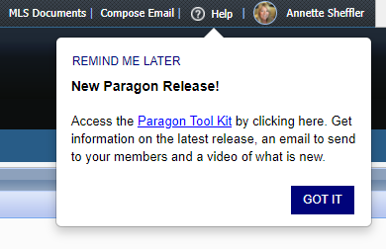

## Admin – RETS Profile field for Web API client

### Action Item: N/A

Paragon’s Web API client uses your existing RETS profiles. When assigning the Web API to a user’s Allowed Paragon Clients, it’s no longer necessary to include the RETS client to enable the RETS Profile field. The RETS Profile field will be enabled if either RETS or Web API is included in the user’s Allowed Paragon Clients.

## Admin – New fields added to Agent and Office grids

### Action Item: N/A

For multi-board Paragon systems, we’ve added Member of Board to the Agent and Office grids and added a filter for that column. Visible boards will be based on the user’s security level. The Member of Board field displays the Office’s Member of Board value.

If Boards are not enabled on your system, the column and filter will be hidden.

## Admin – Remove DCL button

### Action Item: N/A

In Admin, the DCL button has been removed from the toolbar since DCL has been retired.

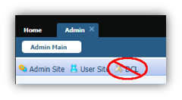

# Agent Level Changes

**The following section contains changes that are active system wide and available to users based on their assigned security levels.**

## UI Updates

### Action Item: N/A

On the Contact’s Saved Search pages, we refined the user interface by removing some extra space in the Activity table and an unnecessary scrollbar in the Comments table.

Existing Saved Search page:

Updated Saved Search page:

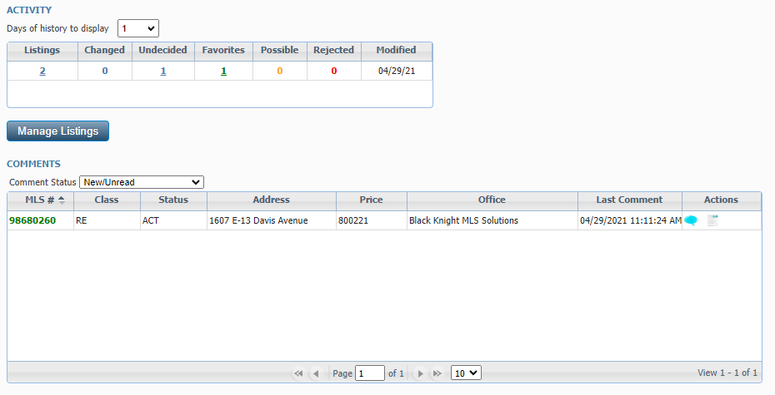

In the Comments dialog box we changed the pane title from “Messages” to “Comments” and the commit button from “Comment” to “Submit” to be more uniform and standard.

In the Agent Recommended heading we changed the word “client’s” to “contact’s.”

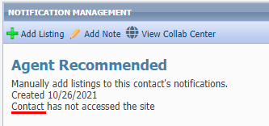

## Price Analysis Widget

### Action Item: N/A

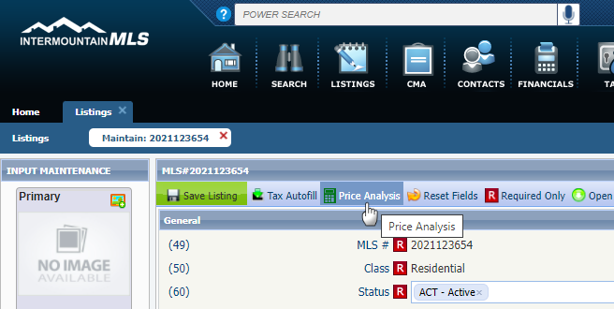Black Knight is very excited to announce the release of the Price Analysis feature, which can be used by agents to determine pricing by viewing the Potential Buyers and any available AVMs if enabled. The feature can be accessed from the menu bar of the Listing Input Form for a current Full, Partial or Subject Property Listing.

Clicking the option will launch an interactive modal displaying the Potential Buyers in Paragon.

The Potential Buyers are based on contacts whose saved search notifications include search criteria that match the listing in focus.

Armed with the Potential Buyers and the AVMs, agents can enter a New Price into the interactive widget and click the Recalculate Buyers to determine the effective change on potential buyers.

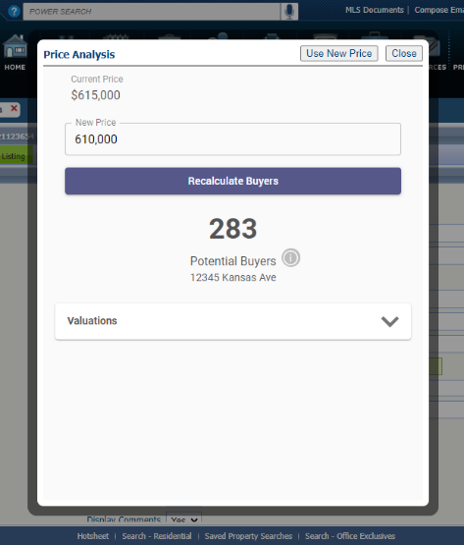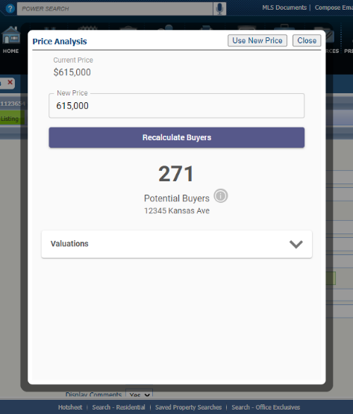

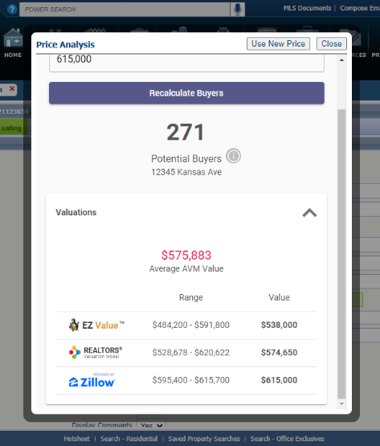

From here, the agent can click the “Use New Price” button and the widget will auto-pop the new price onto the form or they can close the widget to end. This will be an incredible tool that agents can show clients or potential clients to help determine pricing and/or to help motivate to list.

And there’s more to come! Coming in 5.87, we’ll be adding another metric to the Price Analysis widget called Location Score, which will display the relative hotness of the postal area for the listing compared to other postal areas.

# Collaboration Center

**All options in this section are either configurable via MLS Administration controls or by your System Support Manager as noted.**

## Collaboration Center – Property Search Moved to Main Tab

### Action Item: N/A

To help promote the property search feature in the Collaboration Center for your contacts, we have created a property search feature tab on the dashboard. This will allow the search feature to be more visible to your contact. It will contain the same search features as previously, and it is only found on the larger resolutions (PC’s, tablets), and has no impact to the mobile users.

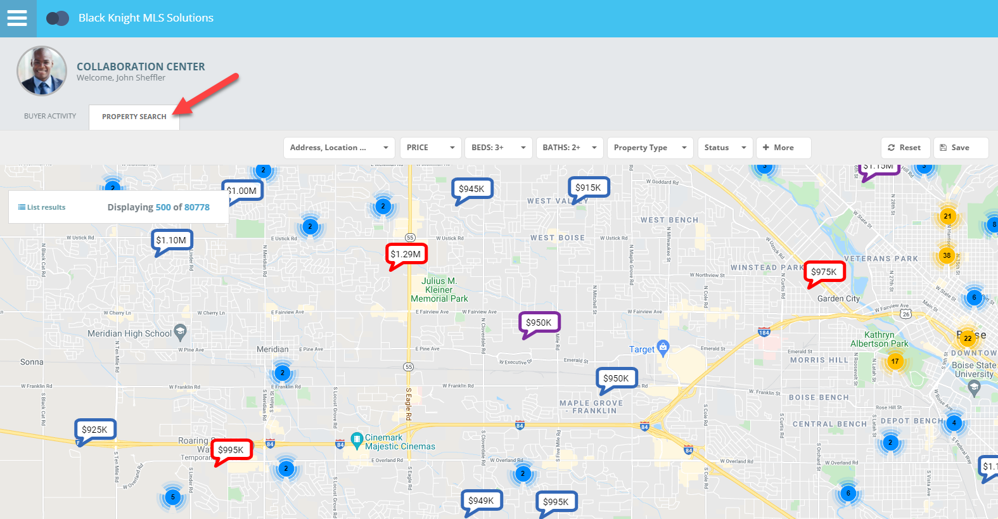

# Paragon Connect

**All options in this section are either configurable via MLS Administration controls or by your System Support Manager as noted.**

## Top App Bar

### Action Item: N/A

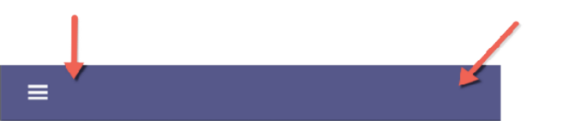

A new top add bar has been added to the Paragon Connect application. It is like the previous top bar with a few modiﬁcations. The proﬁle menu and home button have been moved into the left navigation. This new top bar is a step in the direction for using your browser to control navigation (Back and Forward). Work is still needed for the rest of the application, but soon you will be able to use your browser's native buttons to navigate around Paragon Connect.

## Contact List

### Action Item: N/A

The Contact list has been upgraded to support several new features. First, let’s look at the changes to the overall layout.

The previous version used about 25% of the top section of the application with headers, search bars, action buttons, etc. This took up too much room as you can see now, the new version places the actions in the new top app bar allowing you to physically view twice as many Contacts as before.

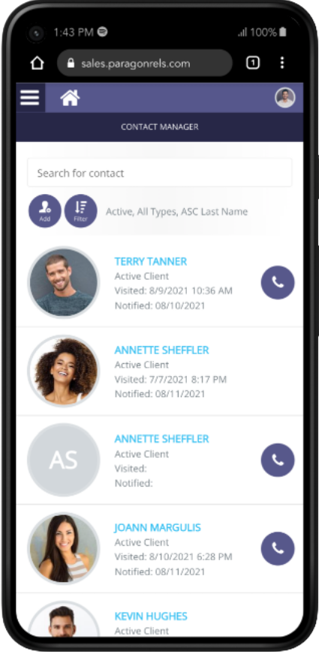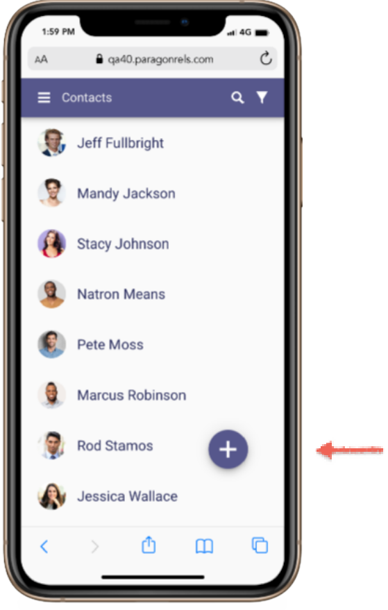

**New App Bar**

All options now appear in a single app bar providing more space

**Screen Space**

User Can only see about 75% of the screen. Too many headers.

**More Contacts**

You now have double the number of contacts visible at once (8)

**Contacts Visible**

Only four contacts can be seen at one time

**Add Contact**

Easy to add new contacts from floating add button

Before After

## Search

To search for a contact, simply tap on the search icon in the app bar. The top app bar is replaced with a search bar, and you can quickly start searching for any contact in your list. As you begin typing the application will automatically start searching for your contacts.

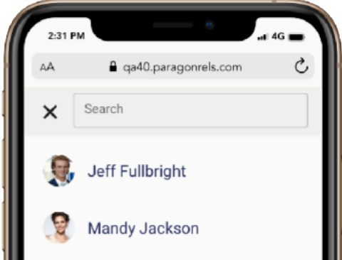

**Search**

Tapping on the search icon to open the search dialog

## Filter Contacts

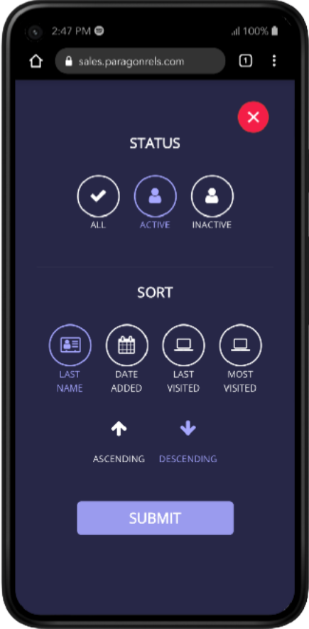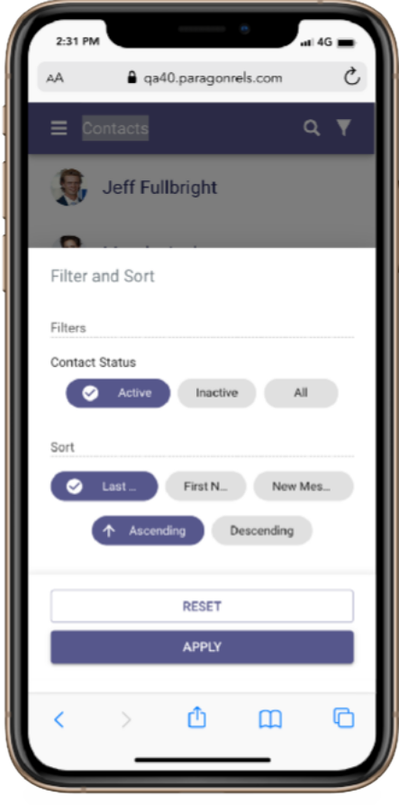The filter function has been updated to allow you to quickly find contacts. Rather than a full screen modal, we leave you on the screen and open a drawer below the contact list. Here you will find a few new filter options.

**Contact Status**

Active (Default), Inactive All





**Sort**

Last Name (Default), First Name, New Message



**Order**

Ascending (Default), Descending

## Add Contacts

Adding a contact in Paragon Connect has been standardized and streamlined. On the contact list, you will find a floating button with a plus sign. This will be our new standard for adding new content within Paragon Connect. Tapping on this button will launch the Add Contact form. Upcoming releases will continually add the ability to enter and edit more contact data.

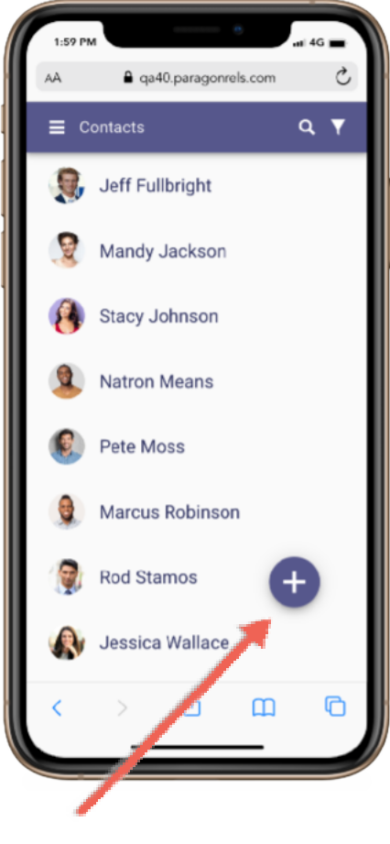

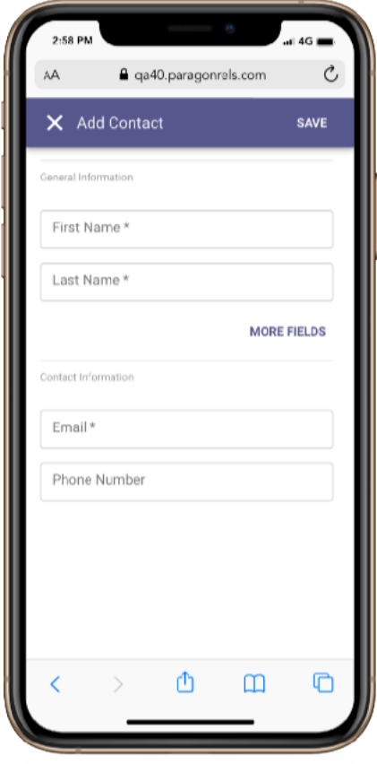

**Add Button**

Tapping on this floating button launches the add new contact form

**Add New Contact**

This is the new form for adding a contact. Same fields, but utilizes our standard form components

## More Fields

By default, the add form displays first and last name. Tapping the “MORE FIELDS” link will expand the form to show “Prefix” and “Suffix”.

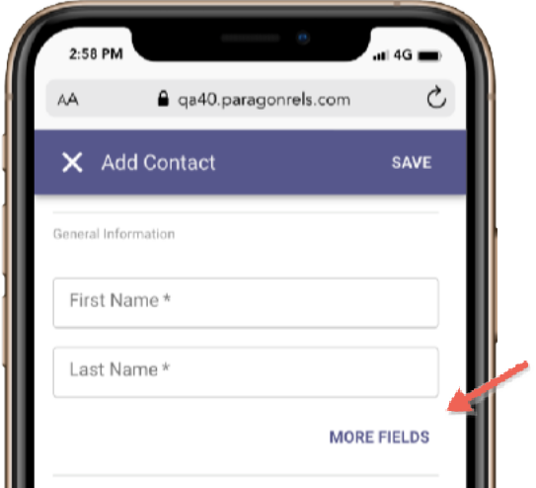

**More Fields**

This is the new form for adding a contact. Same fields, but utilizes our standard form components

## Deleting Contacts

New to Paragon Connect is the ability to delete one or more contacts. From the contact list, if you tap on the photo, it automatically checks the contact. You can select multiple contacts by tapping contact images. Once a contact is selected, you will notice the top app bar changes to show the actions that you can perform. You can tap the X to cancel your selection, or you can tap on the overflow (three dot icon) and choose “delete” to remove the contacts.

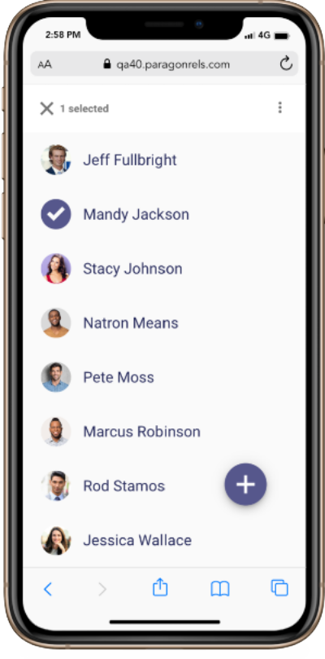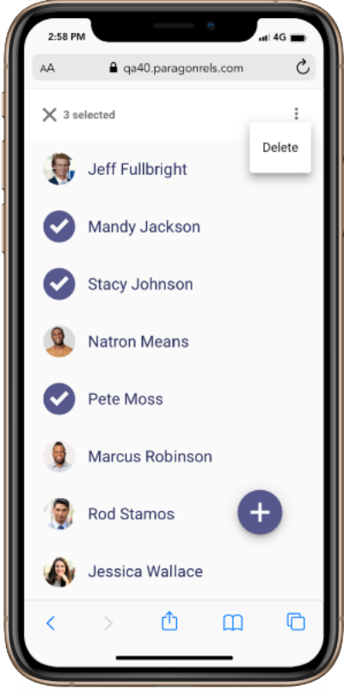

**Overflow**

Click the overflow option to delete the selected contact(s)

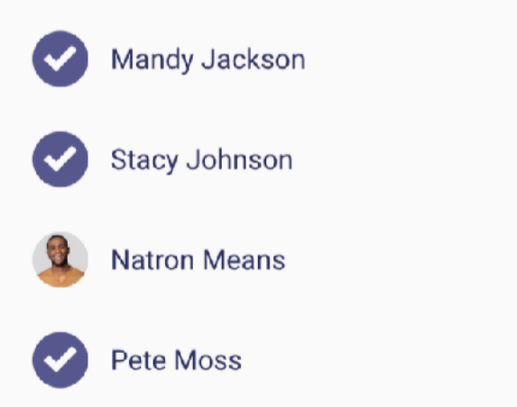

**Tap Photo**

Tap photo or initials and the system will select that contact

**Selecting Multiple**

Notice you can select more than one contact from the list. The only action at this time is to delete the contact however, in the future there will be additional options for multiple contacts.

## Contact Viewer

The contact viewer is the page that displays after tapping on a contact. This has been updated and enhanced to make room to support several future contact features. The buyer and seller content are still available; however, the location of this information has been updated.

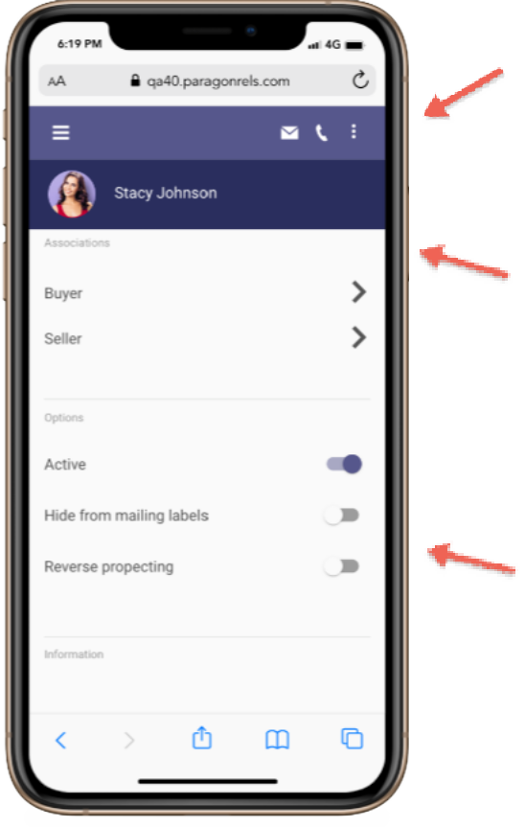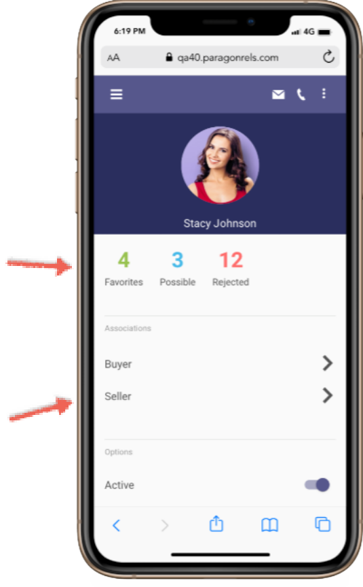

**Action Icons**

Email, phone, collaboration center links, and more all found here

**Scroll Effect**

As you scroll the page, the large photo transitions to the small header

**Counts**

If the contact is setup with a Collaboration Center, counts will appear

**New Options**

You can now use these new options while maintaining your contact

**Buyer-Seller**

Same buyer and seller content exists below

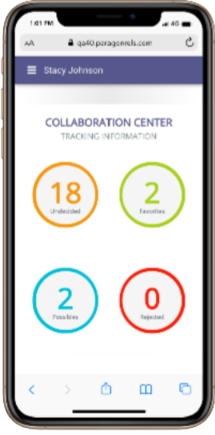**Buy Side**

The Buyer link found on the contact view will take you to the Collaboration Center categories like it does today on the mobile. Each of these is linkable to view the listings in each category. Future enhancements are planned for this screen to manage your sites, communications, searches and more.

**Sell Side**

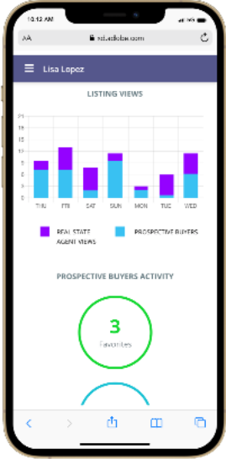The seller content is also the same as it was prior to this new contact view. You will find all the same statistical data, hits, counts, and more. Additional updates are planned for this module including managing your sell side options, competition information and more.

## Compose Email Updates

How you select an email and how you compose an email in Paragon Connect has been updated. Contacts can sometimes have more than one email address. The new contact viewer allows you to choose one or more email addresses at a time before you compose the message. You will also find that the email module has been updated. A new layout has been applied to make composing an email easier and more standard.

**Addresses Added**

The system responds by opening email modal and populating both email addresses in the To: section

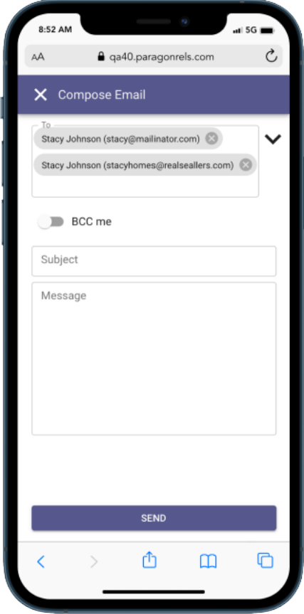

**Updated Email Screen**

An improved interface with lighter colors and improved UI elements

**BCC me**

Clicking on the drop down arrow will provide you with BCC and CC options. The switch allows you to BCC yourself

**Select Addresses**

Allows you to select more than one email to compose new email.

If only one email is available, it will take you straight to the compose email screen.

**Email**

Email module that contains your contact’s email addresses

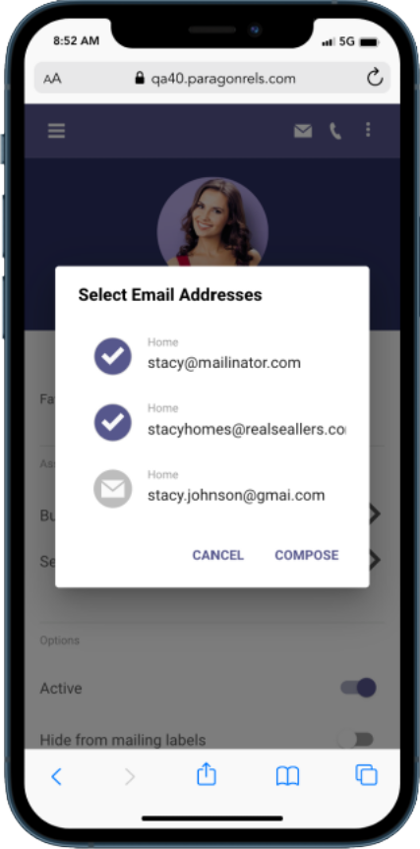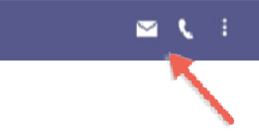

## Auto Complete Address Book

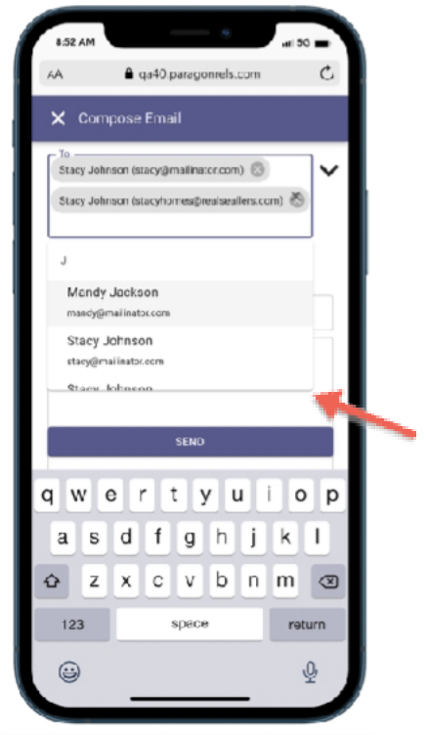New to Paragon Connect is the auto complete address book feature. As you begin to type an email address or a contact, the system will return a list of possible matches based on the email address found in your Paragon Connect address book. This will allow you to quickly find and compose an email.

This new email module is only found in the contact viewer but will be added to other areas of the system in the future.

**Auto Complete**

Start typing a contact’s name or an email address

## Phone Updates

Like the email interactions, the phone or call interactions have been updated as well. It’s not uncommon that a contact will have a cell phone, work phone, or maybe even a land line number. Rather than just using the primary phone number, Paragon Connect now allows you to choose which phone number to contact. If you are on a mobile phone, when choosing a phone number, it will prompt you to either to make a call or send a text.

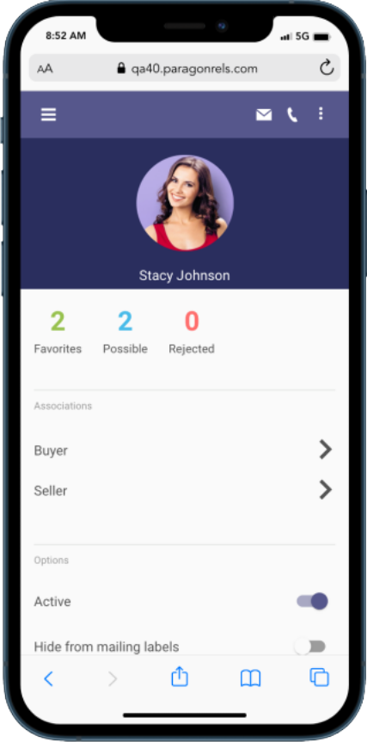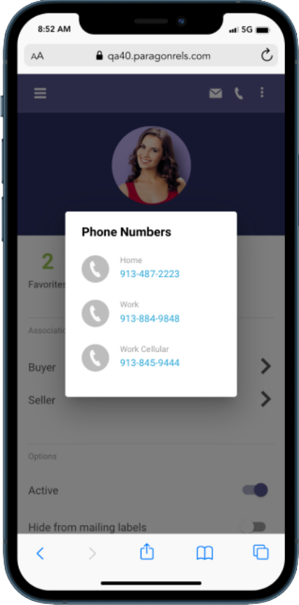

**Phone Icon**

Phone number icon allows you to call or text your contact

**Select Phone Number**

When multiple phone numbers are associated, you must tap the one you want use

## Texting

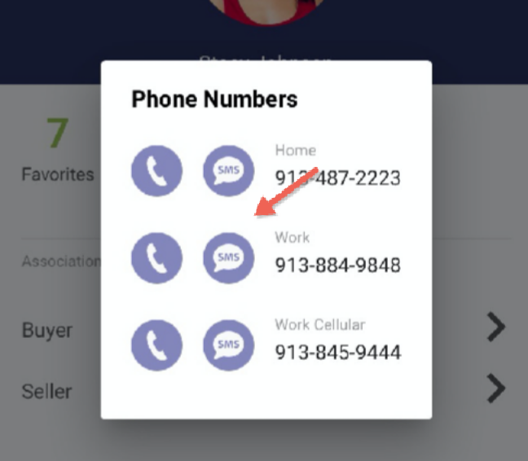While using a mobile device, clicking on the phone icon will not only display all available phone numbers, but it will also provide you with a SMS option. Clicking this icon will launch your default native texting app. This will allow you to instantly text your contact without having to switch to your texting app.

Note: We are unable to determine which phone number is a mobile phone only so all phone numbers will have this option displayed next to it.

## Show Password

Logging into systems that require a password may not be fun, especially when password requirements are very strict and require random capitalization, numbers, special characters, etc. To help make the login process a bit easier, Black Knight has handed a show password option. While you are in a secure location, you can tap on the eyeball icon and when you type your password you will see the actual text you are typing.

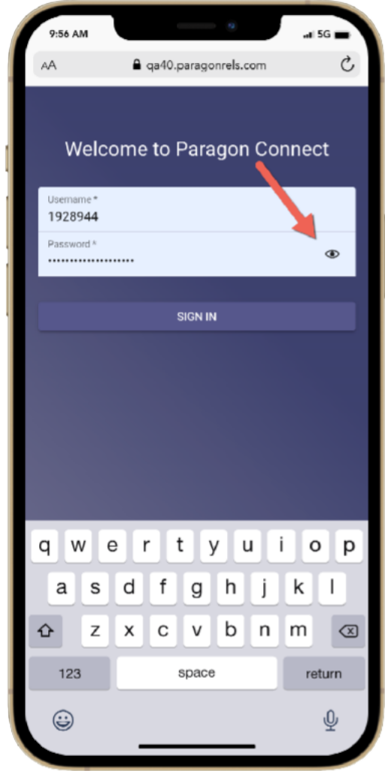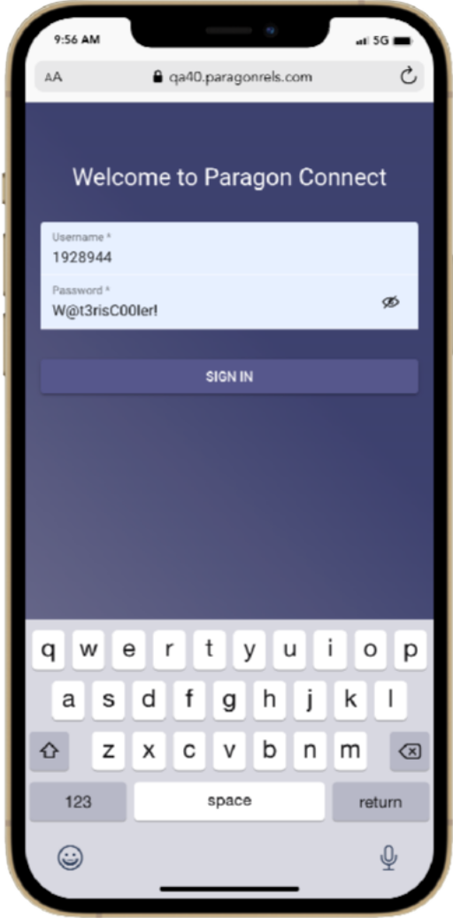

**Password**

Your password text is hidden with asterisks by default, but if in a secure location, you can tap on the eyeball and see actual text

## Removed Items

As we transition over to some of these new features there are a few items you may notice missing in this latest release. Below is a summary of the items removed from Paragon Connect.

## Theme Colors

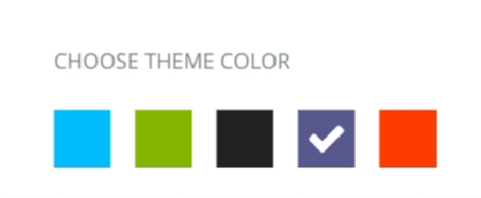Theme colors will be removed from the Paragon Connect system. The new app bar and elements are not ready for additional theme colors. In the future we will look to reimplement theme options.

## Edit Profile Image

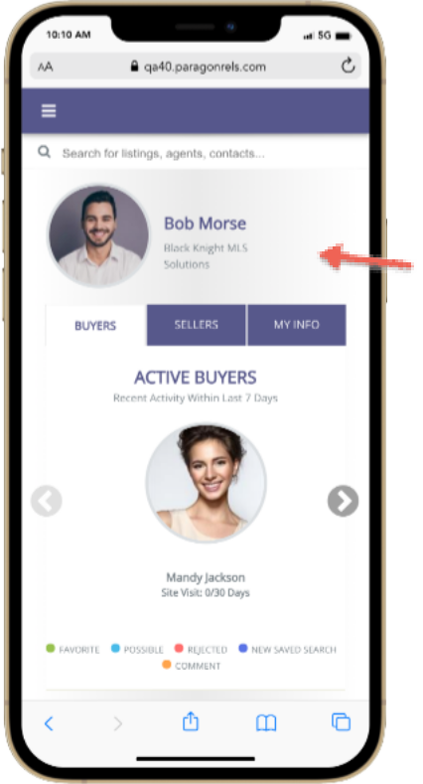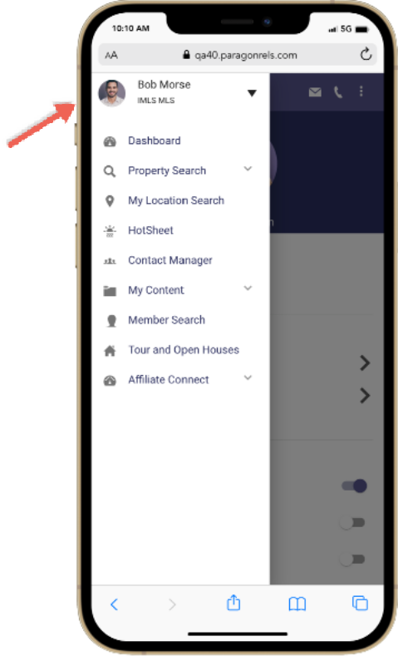The profile menu has been transitioned from the top app bar into the left navigation. The profile image in previous versions of Paragon Connect allowed you to upload or snap a new profile image. This feature will be added back in a future release. You can still perform this action by clicking on the agent profile image on the dashboard.

**Profile Image**

Currently, the agent photo is for display purposes only

**Agent Image Update**

You can still update your agent profile image by clicking on the agent photo on the dashboard

# Paragon Affiliate Connect

**All options in this section are either configurable via MLS Administration controls or by your System Support Manager as noted.**

# Corrected Paragon Affiliate Connect Issues

|  |  |  |
| --- | --- | --- |
| **Ticket #** | **Module** | **Summary** |
| DEV-5350 | Other | Communications page is showing blank |
| DEV-5328 | Other | No space between marketing text and action button in branding block |
| DEV-5323 | Other | Agent search results is showing a scrollbar when no results found |
| DEV-5256 | Other | Agent search is fetching different results each time |
| DEV-5255 | Email | Comment option should not display when the affiliate request to an agent is in pending state |
| DEV-5253 | Dashboard | Edit Branding Block page |
| DEV-5209 | AC - Agent Search | When an affiliate searches for an agent and that affiliate is an "Office" designated Affiliate, the office agents should not appear in the affiliate search |
| DEV-5162 | Email | "Send Affiliate Welcome Email" option should check the appropriate condition from agent type (User Codes) |
| DEV-5151 | Dashboard | Fix the column sort order on the My Affiliates page |
| DEV-5112 | General UI | Branding block "button text" field is restricted to fifteen characters only |
| DEV-5088 | Dashboard | Sometimes the Affiliate Dashboard loads without my agents |
| DEV-5073 | Dashboard | Remove the Comments widget from the detail views |
| DEV-5068 | Dashboard | Add State to addresses on Agent modal |
| DEV-5046 | Dashboard | When Sharing an Affiliate, the 'select all contacts' button also selects all affiliates |
| DEV-4995 | Dashboard | Updates to the Buyer Activity tab |
| DEV-4989 | Search | When an affiliate does an agent search and no results appear, there is no indication that the search is done |
| DEV-4988 | Other | Use client CC2 access on Buyer Detail page |
| DEV-4987 | Preferences | Update the text on the Broker Affiliate Connect preferences |
| DEV-4887 | Admin | Implement an option for Association Autonomy to separate Agent Membership Participation vs. Affiliate Participation |
| DEV-4861 | Dashboard | As a Broker I need the ability to have a default disclosure for all broker level affiliates |
| DEV-4769 | Other | Create a top-level tab for Service Partners (connected Affiliates) to be displayed in Collab Center |
| DEV-4715 | Dashboard | Update the "no messages yet" text on the Communications page |
| DEV-4714 | Dashboard | Add Comments column to the Agent Subscriptions page |
| DEV-4710 | Dashboard | Add confirmation message when Disconnecting from an Affiliate |
| DEV-4708 | Dashboard | Update Request Affiliate modal |
| DEV-4629 | Configuration | P4B dashboard should not be accessible by affiliate or any user with user type is affiliate |
| DEV-4590 | Dashboard | Mobile Testing: Filter by and SORT by options are missing from LISTING ACTIVITY, BUYER ACTIVITY tab |
| DEV-4589 | Dashboard | Mobile Testing: NEW HOME details are not displaying in BUYER ACTIVITY tab |
| DEV-4588 | General UI | Mobile Testing: Agent subscription tab ->observed additional fields in the page |
| DEV-4585 | General UI | Mobile Testing: CCA dashboard profile setting page alignment is not proper |
| DEV-4584 | General UI | Mobile Testing: Search option is not fully visible from agent search tab |
| DEV-4583 | General UI | Mobile Testing: Agent search result data did not display with appropriate field info |
| DEV-4202 | Email | Agent's contacts shared with added comments to affiliate, but the same comment is missing in the email |
| DEV-4126 | Admin | Add New "Send Affiliate Welcome Email" Link to Participating Affiliate User Records |
| DEV-3971 | Dashboard | Agent Subscriptions Tab does not refresh after sending or canceling a sub request |
| DEV-3536 | Email | Affiliate Notification: Subject Line Incorrect |
| DEV-3521 | Affiliate Search | Move "My Affiliates" link to Resources (out of Preferences) |
| DEV-3484 | Configuration | Broker Options: Should Not Use Office Record > Office Broker Field as part of requirements for access |
| DEV-3420 | AC - Agent Search | Association autonomy rules not followed when affiliate board setup as partial with agent board |
| DEV-3419 | AC - Agent Search | Association autonomy rules not followed when agent board setup as partial with non-affiliate board |
| DEV-3273 | Dashboard | Affiliate Dashboard- add character count/limit to marketing section |
| DEV-2091 | Dashboard | Affiliate Connect: Agent Dashboard Redesign |

## Admin – New link to send Affiliate Welcome email

### Action Item: N/A

A link to Send Affiliate Welcome Email will display on the agent record, when Affiliate Connect is enabled, and the Agent Type is an Affiliate User. Previously, the welcome email was generated automatically when a new Affiliate user was added to Paragon, but there was no way to send the email for an existing user, or to resend a copy.

## Admin – Display Affiliate Broker Options in Preferences based on security level

### Action Item: N/A

The Affiliate > Broker Options in Preferences previously displayed only when the user was listed as the Office Broker in an office record. This has been updated to go by security level instead of the Office Broker field. Users with security level 5 and up will now see the Broker Options in Preferences.

## Admin – Association Autonomy options for Affiliate Connect

### Action Item: N/A

The Affiliate Connect checkbox for each Association has been moved to a new Affiliate Connect Participation section. The board restrictions will work the same as the existing Membership restrictions, with options for Full participation to all boards; Partial participation to specified boards; and None, participation in just the Affiliate’s board.

## Updated text for Broker Options in Preferences

### Action Item: N/A

The text in Preferences > Broker Options for Allow Agent Affiliates was restated for clarity.

## Add office-level Disclaimer for Office Affiliates

### Action Item: N/A

A new feature was added to Preferences > Affiliate Connect > Broker Options, to allow the broker to enter a disclaimer for their office-level affiliates. The disclaimer will apply to all office affiliates, and will be visible to agents in the office from the My Affiliates tab. This eliminates the need for the broker to add a disclaimer to each office affiliate separately.

## Updates to the My Affiliates page

### Action Item: N/A

Several items on the Paragon > My Affiliates page have been updated to a newer User Interface.

* The Request an Affiliate dialog box was updated.

* A confirmation message was added when the user disconnects from an affiliate.

* To improve communication between the agent and affiliate, when an agent shares an affiliate with a contact/client, the affiliate will get a notification on their dashboard, a new comment in the comments thread with that agent, and an email notification. The client’s contact information is not shared with the affiliate.

## Service Providers Tab in Collaboration Center

### Action Item: N/A

Collaboration Center users will see a new tab for Service Providers to the right of the existing tabs. When Affiliate Connect is enabled, the tab will display with all the branding blocks for the agent’s connected affiliates. This provides the client with a full list of potential providers selected by their agent.

## Reply button on dashboard notifications

### Action Item: N/A

The Close button on the dashboard notifications for agents and affiliates has been changed to Reply. The Reply button will open the comment thread between the affiliate and agent, allowing the user to view the comment thread and reply from there. Clicking the Reply button will also remove the notification from the dashboard.

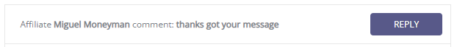

## Updates to the Buyer Activity tab

### Action Item: N/A

On the Affiliate Dashboard, the Buyer Activity tab has been streamlined to present each buyer one time, instead of multiple times.

If Make My New Home is enabled in Collaboration Center, the Buyer Activity tab will include a column to display the latest ‘my new home’ selected by the buyer.

## Additional updates to the Comments workflow

### Action Item: N/A

On the Affiliate Dashboard, several items were updated to improve the comments workflow between affiliate and agent.

* The Comments link was removed from the Buyer Activity tab and will be moved to the Buyer Detail tab in a future release.
* A Comments column was added to each agent on the Agent Subscriptions tab.

* Text on the Communications page was updated for clarity and the button text updated to Start a Conversation. Clicking the button will open the Agent Subscriptions tab, where the affiliate can begin a conversation with one of their connected agents.

