Paragon 5.87 Release Enhancements
Updated on 1/20/2021
Corrected Paragon Issues 2
MLS Customizations and Administration 3
Admin – Expose Field Rules table to Level 8 Users and Add Fields 3
Admin – Change Replace Lookup modals to sort by Description 5
Agent Level Changes 7
UI Updates - Updated Colors on Contact Activity Widget 7
Contact – Default Options for Collaboration Center Emails 8
Tax Autofill - Forced Tax Autofill by Board 8
Listing Input - Enhanced Listing Congratulations Modal 9
Mapping – Ability to delete a point in Polygon Map Drawing tool 10
Mapping – AVM Data on Parcels 11
Collaboration Center 12
Detail Report Updates 12
Expand Full Screen 13
Paragon Connect 14
Listing Edit Updates 14
Price Analysis 15
Menu Updates 16
Contact – Buyer Activity 17
Continue Buyer Activity Updates 18
Forgot Password 19
Change Password 20
Logout – SSO (Single Sign-on) Only 21
Paragon Affiliate Connect 22
Corrected Paragon Affiliate Connect Issues 22
Affiliate Branding Blocks 23
Affiliate/Agent Profile Photo 24
Connecting to Affiliates 24
New Login Page for Affiliates 25
Login Name Displayed in Welcome Email to Affiliate 25
Email Communications 25

Corrected Paragon Issues
Ticket# | Product | Module | Organization | Summary
TK-7492 | Paragon | Email | Sanibel And Captiva Islands AOR | Agent Unable to Make Changes to Saved Signature With Quotes
TK-7263 | Paragon | Admin | COLUMBIA - ConsolidatedMLS | Unable to delete Feature Category and Features
TK-7000 | Paragon | General UI | NJMLS - New Jersey MLS (Bergen) | P60 NJMLS - Page unavailable error when attempting to modify any sold status
TK-5941 | Paragon | CMA | Georgia MLS, Edmonton/RAE, RMLS (Peoria) | Suggested List Price Does Not Display Correctly
TK-5754 | Paragon | Print | CR - California Regional MLS, SDMLS | Overlapping text on agent preferred 1 report when using print + and pdf output type
TK-913 | Paragon | View/Reports | MIMLS - MiRealSource | MIMLS Adding Multiple Date Fields to Spreadsheet Required for Data to Show and Shifts Columns
TK-5128 | Paragon | Admin | NRV - New River Valley AOR | Getting 'page cannot be displayed' error when running lookup relationship values report
TK-4346 | Paragon | Prospecting | CCAR - Coastal Carolinas AOR, NSAR, RAE, SCWMLS, TAOSMLS, Tyler Texas | Paragon extension of email not working correctly
TK-4123 | Paragon | Power Search | NEREN - New England Real Estate Network | Clicking in Power Search Box After a Search is Run No Longer Displays Previous Search Results - Enter Doesn't Work to Re-run
TK-3206 | Paragon | Statistics | COLUMBIA - ConsolidatedMLS | Inventory Supply graph aggregating and calculating sold listings incorrectly
TK-2589 | Paragon | View/Reports | BLACKHILLS - Black Hills AOR, MiRealsource, NEREN, OBARMLS, SEDWAR, SJSR | Programmed Page Breaks in Membership Roster Don't Line Up When Printed
TK-5982 | Paragon | Email | CR - California Regional MLS, IRMLS, NEREN | Collab Center Automatic notifications not including Message Body

MLS Customizations and Administration
All options in this section are either configurable via MLS Administration controls or by your System Support Manager as noted.

Admin – Expose Field Rules table to Level 8 Users and Add Fields

Action Item: N/A

We’ve exposed the Field Rules table for security level 8 Admin users, to give them access to view existing field rules. In addition to the existing search filters for Rule ID and Message, we’ve also included a filter to allow searching on the target field.
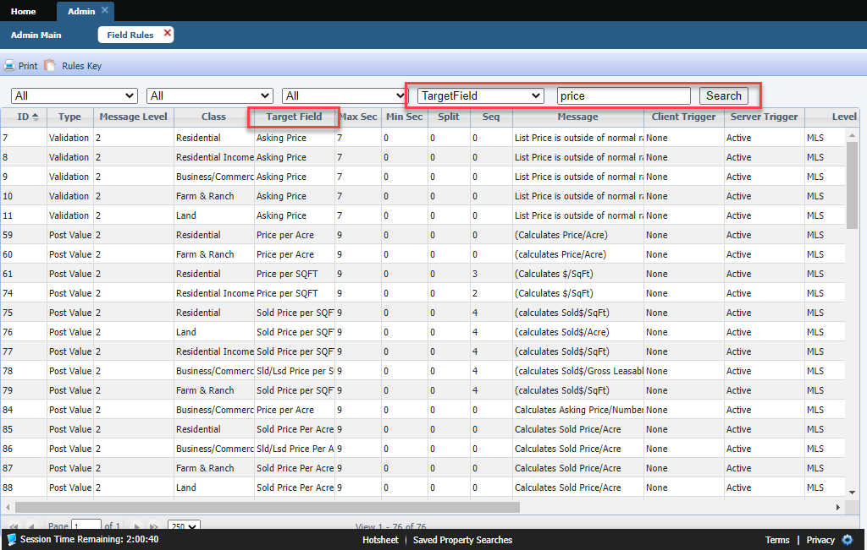

In addition to exposing the Field Rules table to level 8 users, we have added a few columns of information:

- Description – This field will be used going forward by Black Knight Implementation Specialists for entering an English description of what a field rule is doing. For example, the Message returned to a user might be “List Price is outside of normal range. Is this correct?” But this doesn’t tell the MLS admin what the rule is doing. The Description might be “This rule checks that the list price is less than $40,000 OR greater than $15,000,000 and if it is either, the message is returned to the user.”
Note: The Description field will be blank for all current field rules and will only be used for new field rules or if someone adds a description to a current rule.
- Update Date – This date will default to the 5.87 release date for all current rules and will display a new date when a rule is added or edited.
- Updated By – This field will default to “PARAGON, SYSTEM” for current rules and will display the BK Admin’s name when a rule is added or edited.

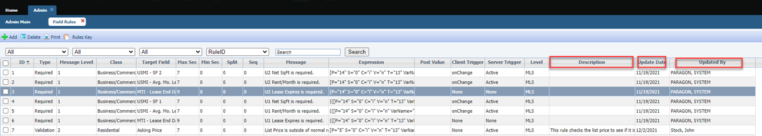

Admin – Change Replace Lookup modals to sort by Description

Action Item: N/A

When deleting a lookup, we made it easier to locate a lookup replacement by displaying the lookups in alpha order by description, rather than by the abbreviation or code. This affects Lookups, Streets, and Minor Areas. Additionally, the “Select a Lookup” dropdown on the Lookups grid now sorts alphabetically by Description, instead of by physical field number.
Minor Areas:
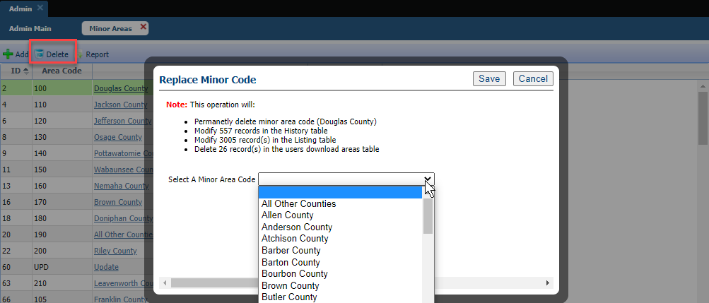
Streets:
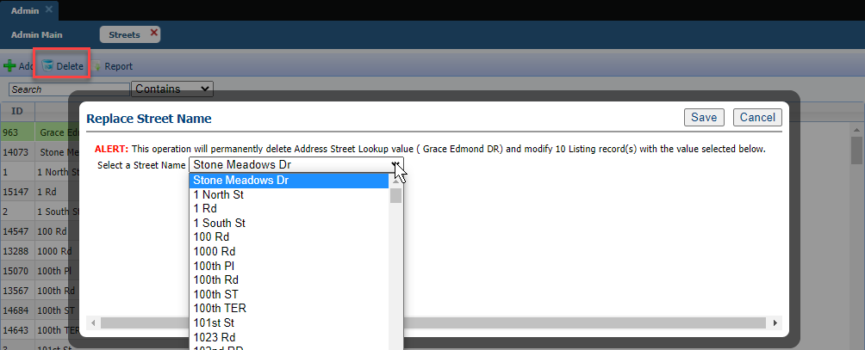
Lookups:
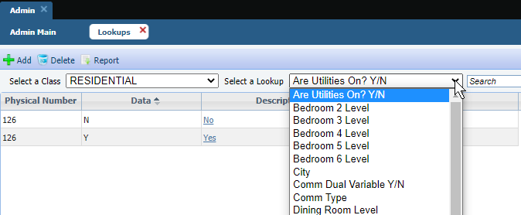
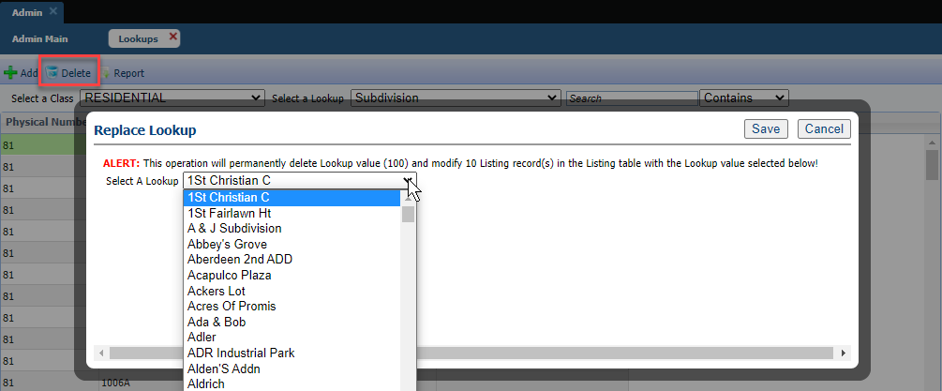

Agent Level Changes
The following section contains changes that are active system wide and available to users based on their assigned security levels.

UI Updates - Updated Colors on Contact Activity Widget

Action Item: N/A
We updated the colors for Comments and Searches at the top of the Contact Activity widget on the Paragon Pro home screen to match the colors used in Paragon Connect.
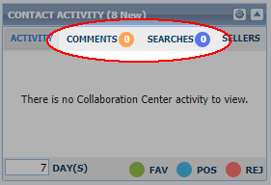

Contact – Default Options for Collaboration Center Emails

Action Item: N/A
We cleaned up the help text for attaching the email Message Body to Collaboration Center notifications and fixed an issue where the selected message body would display on the initial Welcome email, but was missing on subsequent notification emails.

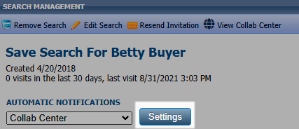

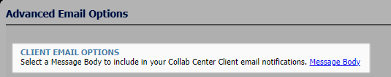

Tax Autofill - Forced Tax Autofill by Board

Action Item: N/A
Forced Tax Autofill is a feature that redirects users to the tax autofill screen when a user adds a new listing. This feature was using a global MLS setting so if it was ON it was on for everyone in the MLS. This became an issue recently for a customer with multiple boards where one board has tax autofill and the others do not. To resolve this, we have enhanced the configuration to be at the board level so that it only applies to members of a board where it is required.

Listing Input - Enhanced Listing Congratulations Modal

Action Item: N/A
The Listing Congratulations Modal has been enhanced to give your members more information about the property and the integrated services. This includes displaying the primary photo of the property, more space for the third-party vendor’s logo and up to 100 characters for the description or call-to-action text. Paragon also has the ability to add a custom sort to the integrations so if you have a vendor that you want promoted to your membership, it can be moved to the top of the list.
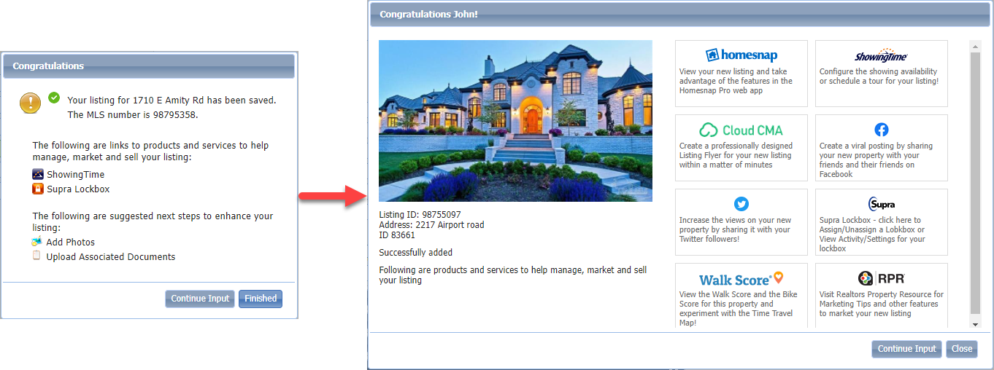

Mapping – Ability to delete a point in Polygon Map Drawing tool

Action Item: N/A
A new feature was added to the Polygon drawing tool to allow users to delete end points. Previously, if a user wanted to modify their polygon, they had to either move the respective points to reshape the drawing OR start over because moving all or some of the points was more work. With this enhancement, users can right-click on an endpoint and a “Delete” option will pop up. Selecting the option removes the point and the drawing updates based on the deleted point.
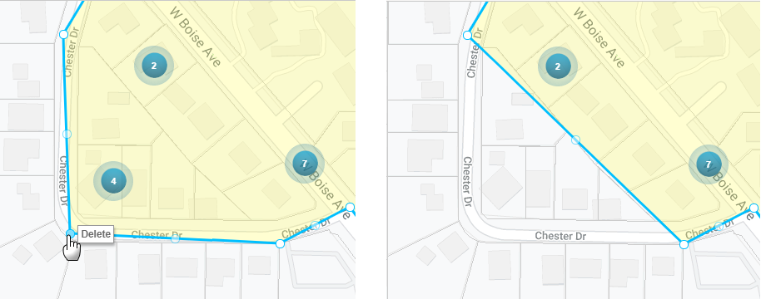

Mapping – AVM Data on Parcels

Action Item: N/A
Paragon Map Search has been enhanced to support AVM labels on parcels bringing Paragon to par with some of the top real estate platforms including our own partner, Homesnap. Agents will no longer have to click on the parcel to see the AVM.

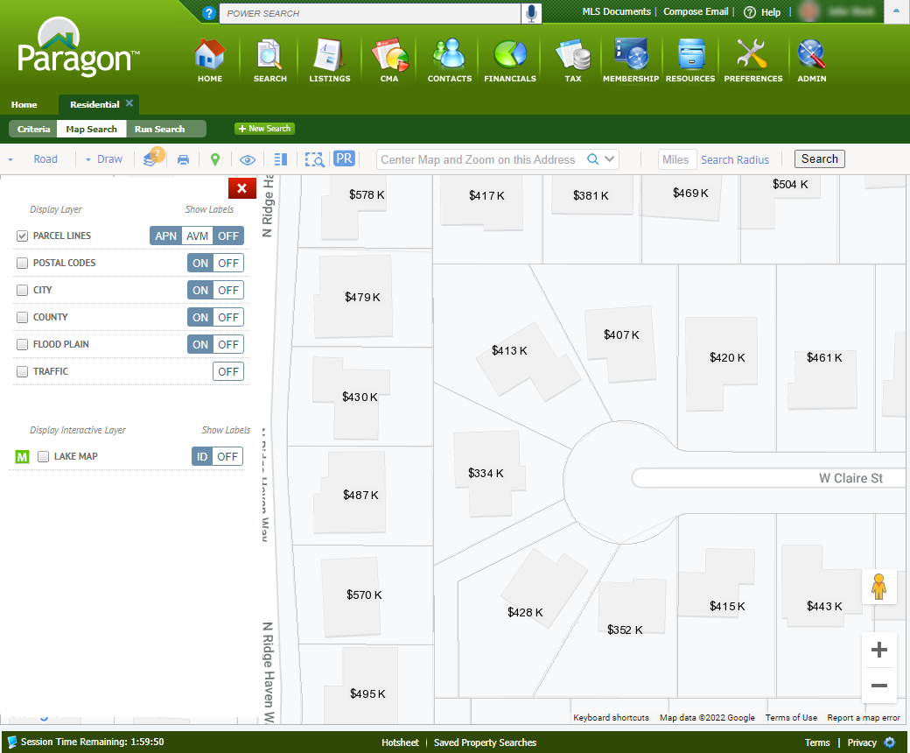
The labels will display by default for customers that have the BK EZ Value AVM enabled. Agents can toggle them ON/OFF from the layers panel or set their own default from User Preferences > Search Options > Parcel Layer.

Collaboration Center
All options in this section are either configurable via MLS Administration controls or by your System Support Manager as noted.

Detail Report Updates

Action Item: N/A

A few minor changes were made to the top header section of the Collaboration Center detail report. The header’s height was reduced, icons grouped and aligned to the right. The close button was updated, and the price was grouped with the address information.
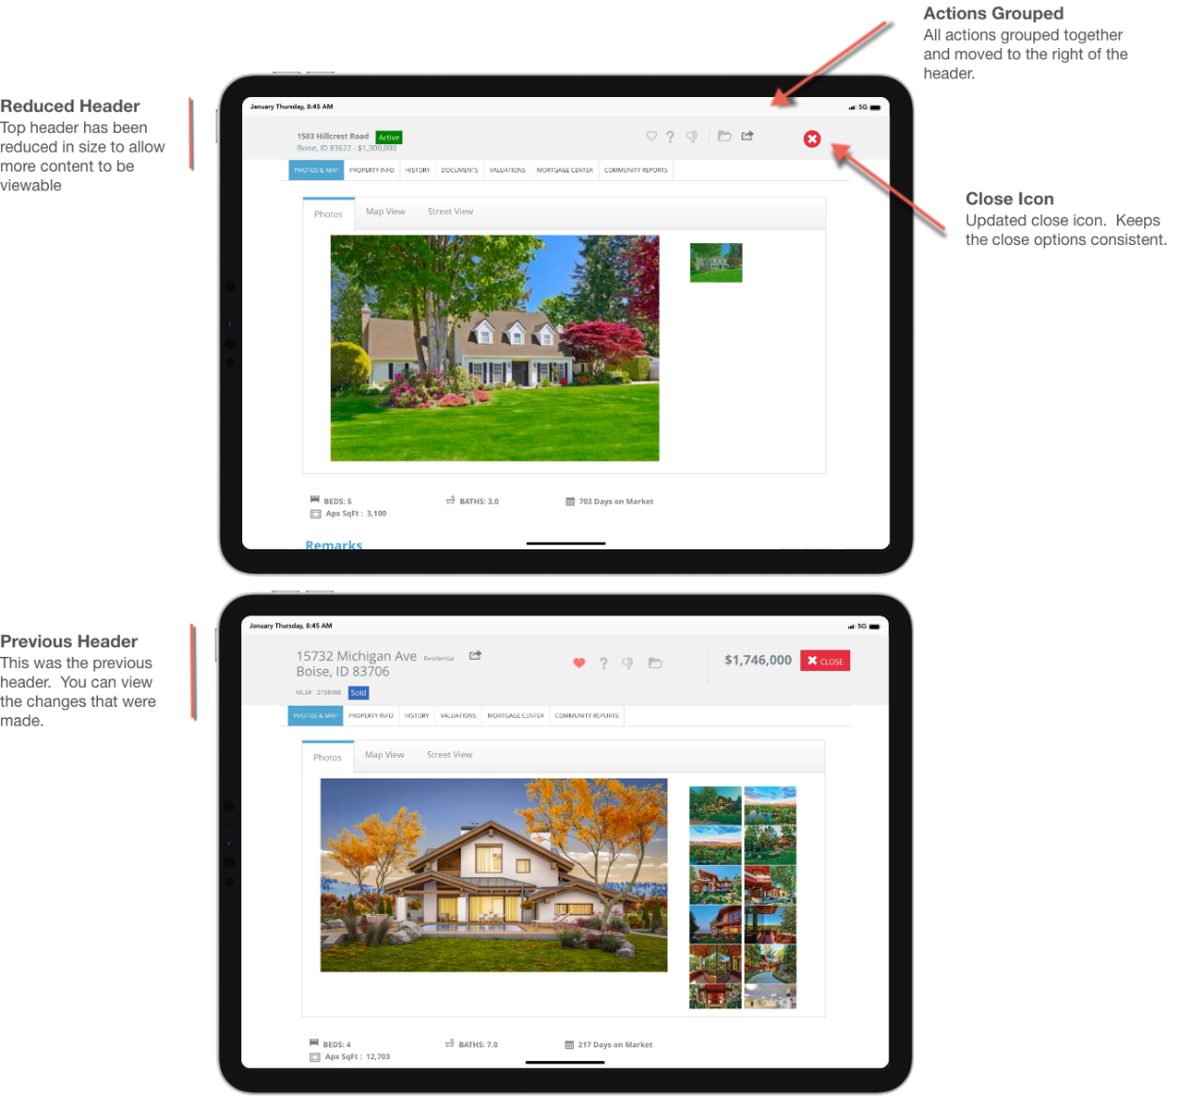

Expand Full Screen

Action Item: N/A

The search feature in Collaboration Center was recently moved into one of the primary tabs on the dashboard. A new expand option is now available for those who want to search in full screen mode. Once in full screen mode, the expand icon changes to a reduce icon that when activated takes you back to the default layout.
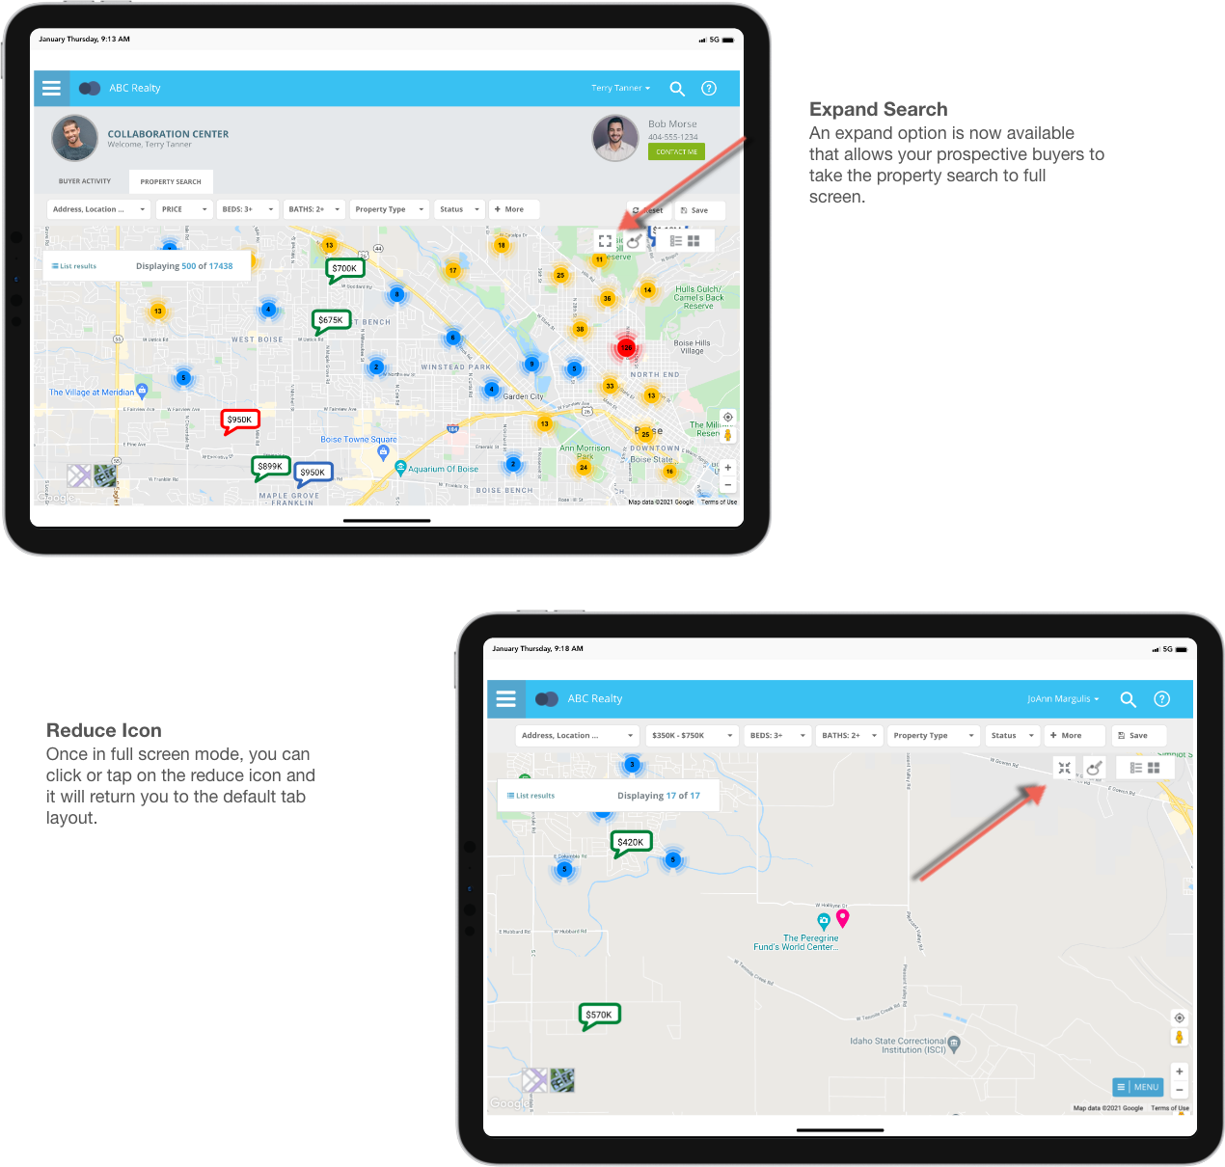

Paragon Connect
All options in this section are either configurable via MLS Administration controls or by your System Support Manager as noted.

Listing Edit Updates

Action Item: N/A
A few exciting changes are coming to full listing edit. The first, was to remove the secondary navigation bar located below the top app bar. This module now allows you to use your browser controls to move back, forward, or even refresh. The second, was to move the search feature to the top app bar. This will now utilize our standard search component. The final update made to this module is the addition of an overflow menu (three dots). This will house all our future LIM features. Examples: change geocode, embed videos, tour and open house, etc.

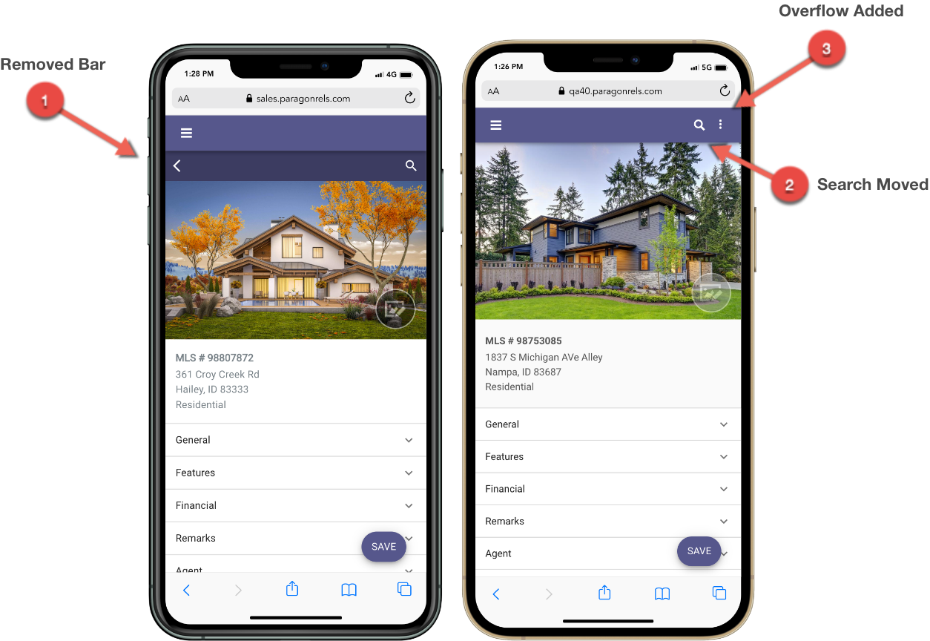

Price Analysis

Action Item: N/A
The Price Analysis feature that was introduced in 5.86 to Paragon Professional and is now available in Paragon Connect. It can be used by agents to determine pricing by viewing the Potential Buyers and any available AVMs if enabled. The feature can be accessed from the overflow icon in the top app bar of the full listing edit module.
The Potential Buyers are based on current Paragon and Paragon Connect saved searches that include the property and are assigned to clients who are prospecting, i.e., they are set up for auto-notifications.
Armed with the Potential Buyers and the AVMs, agents can enter a New Price into the interactive widget and click the Recalculate Buyers to determine the effective change on potential buyers.

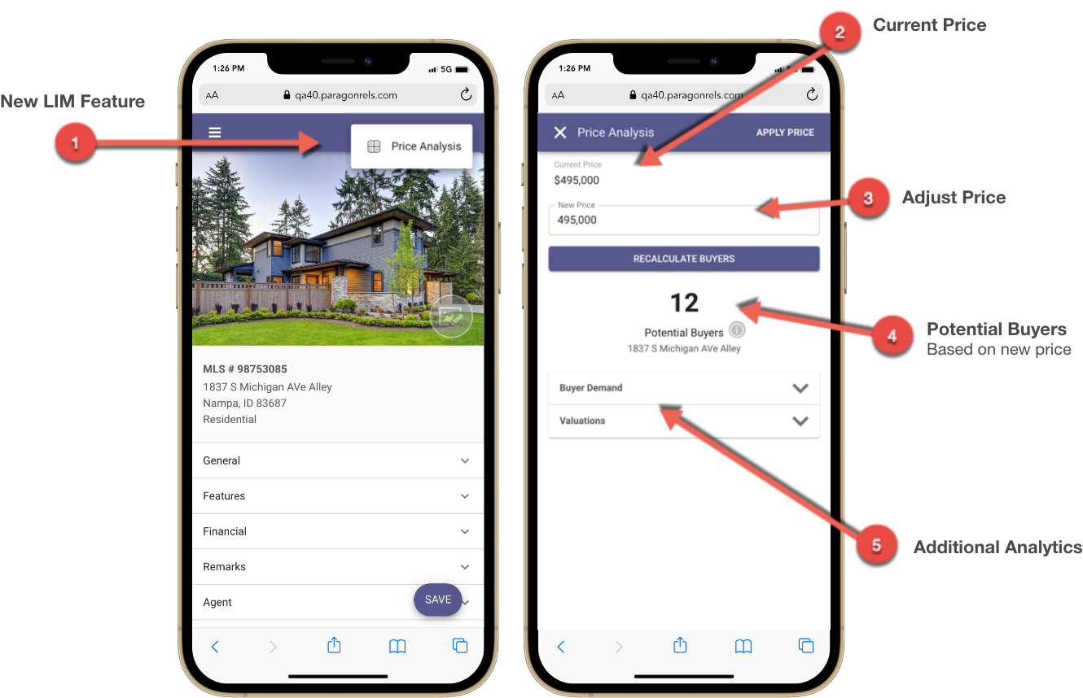

Menu Updates

Action Item: N/A
To prepare for additional features in Paragon Connect, Black Knight has made some adjustments to the overall left navigation. The tree structure found in the left navigation today is not optimized for mobile applications. To accommodate for more menu items, the tree structure was removed in favor of a new top-level page. This allows us to keep the primary navigation simple but allows for room to expand the additional content on the top-level page.
Black Knight also consolidated all the different search options available in Paragon Connect into one single menu called” Properties.” This means you have a single location now for Class based searches, location search, Hotsheet, tour and open house, etc.
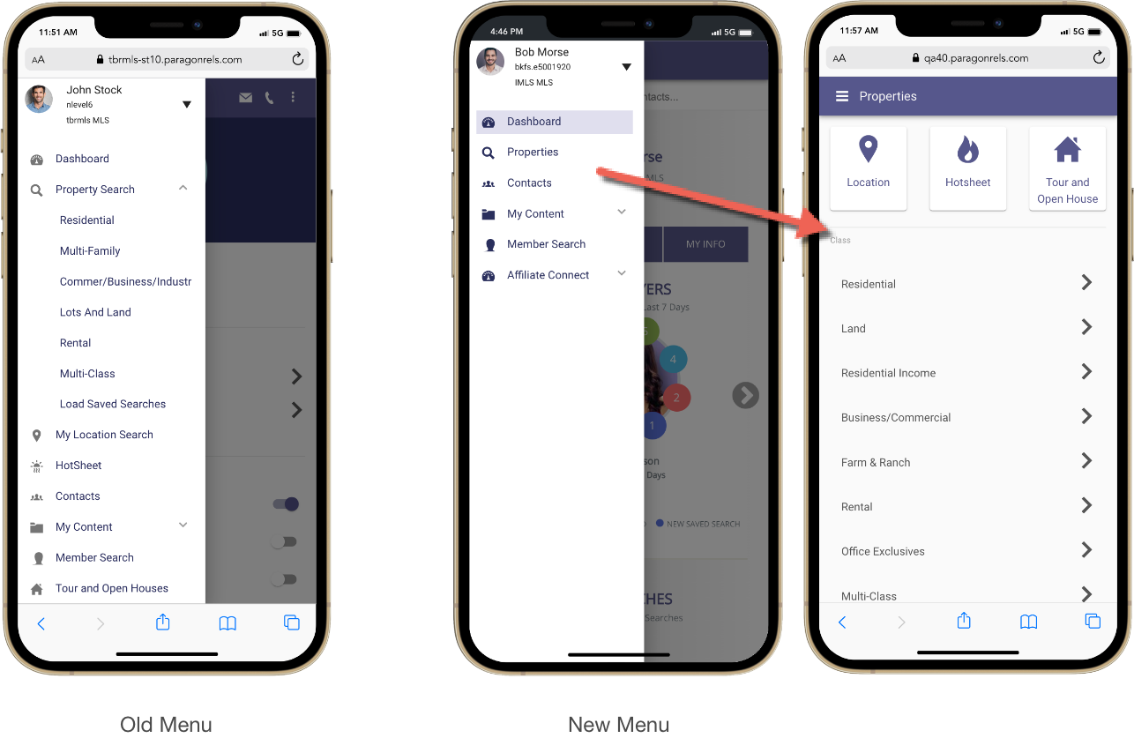

Contact – Buyer Activity

Action Item: N/A
The buyer section within the contact viewer is getting a major upgrade. Prior to this release, the buyer activity would take you to four circles where you would find the total number of undecideds, favorites, possible, and rejected listings for a specific contact. This was a sum of all searches and archived matches, and there was no option to filter these by saved searches. Now you will see each search is broken down into its own card. You can see the total number of listings, plus the different categories for each search. You can see who created the search (Agent vs Client). When the last notification was sent. You can also click on each category to see the results within each card.

This is just the beginning. Soon, you will be able to modify these searches, update the notification settings, and create a new search from this location. Below is a breakdown of a few new features.
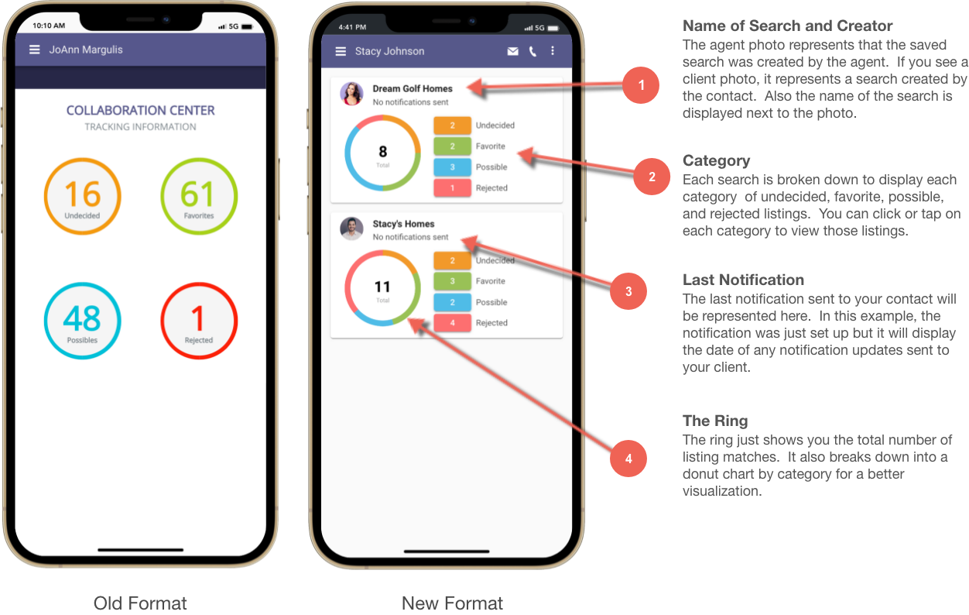

Continue Buyer Activity Updates

Action Item: N/A
There are additional features included with the buyer activity that are worth noting. Notifications that are disabled are displayed on page, but the counts and links are disabled. In a future release, end users will be able to enable/disable the from Paragon Connect.
Agent Picks or (Known as Agent Recommend in Paragon Professional) are also seen on the buyer activity. This works just like a search card except these are listings you have recommended to your clients.
Finally, the buyer activity section will display a card for any legacy email notifications setup. There are no links or actions on this card other than to inform you that the search and notification is in use.
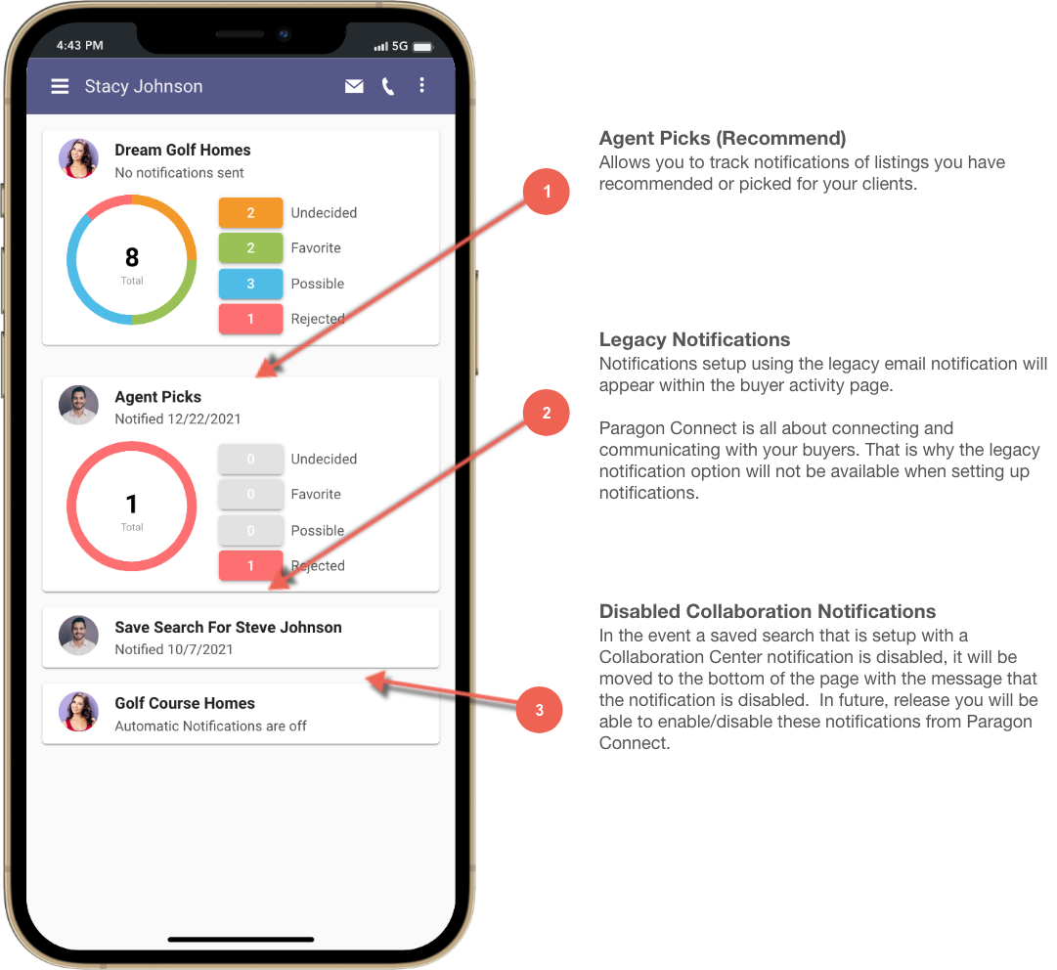

Forgot Password

Action Item: N/A
Paragon Connect has added a “Forgot Password” feature that allows you to reset your password. This may or may not be available depending on your organization’s rules and regulations. However, if you are allowed to use this functionality, you will simply enter your username and an email address, then reset instructions will be sent to the email address associated with the username entered. That email will contain a link that will take you to a page where you can reset your password.
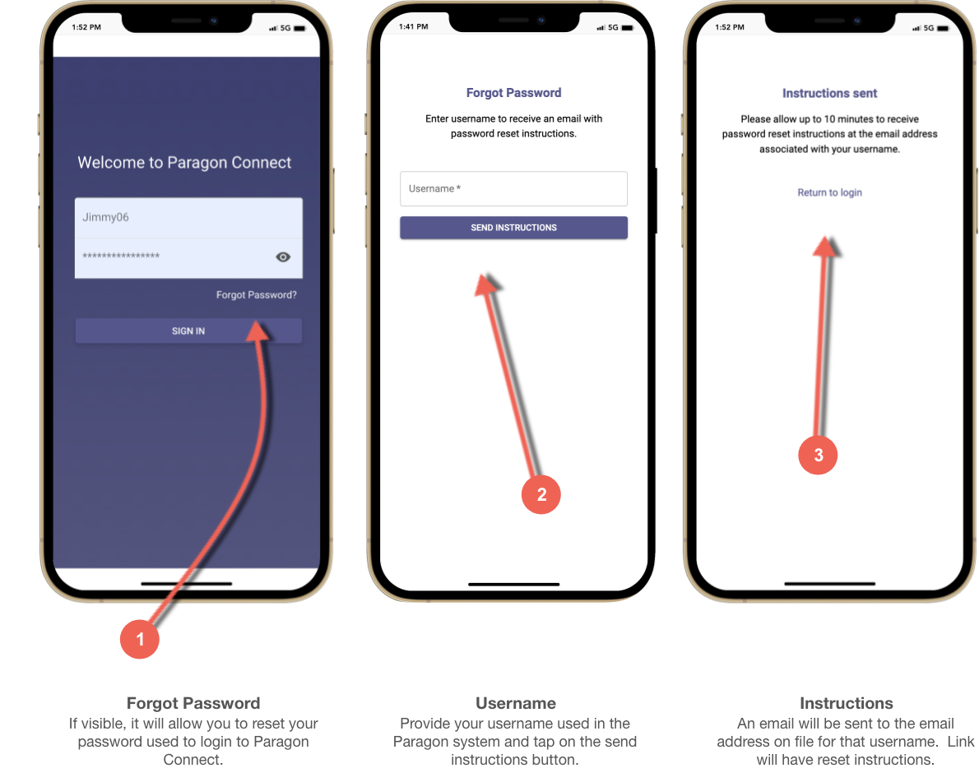

Change Password

Action Item: N/A
Whether you forgot or the application forces you to change your password, Paragon Connect has you covered. This may or may not be available depending on your organization’s rules and regulations. There are many different rules when it comes to forcing strong passwords. Paragon is configurable to allow your organization to choose from a variety of different password rules. Examples include at least one capital letter, special character, numeric character, capitalization, and more. Once you pass all the rules and requirements, you will be able to change your password.

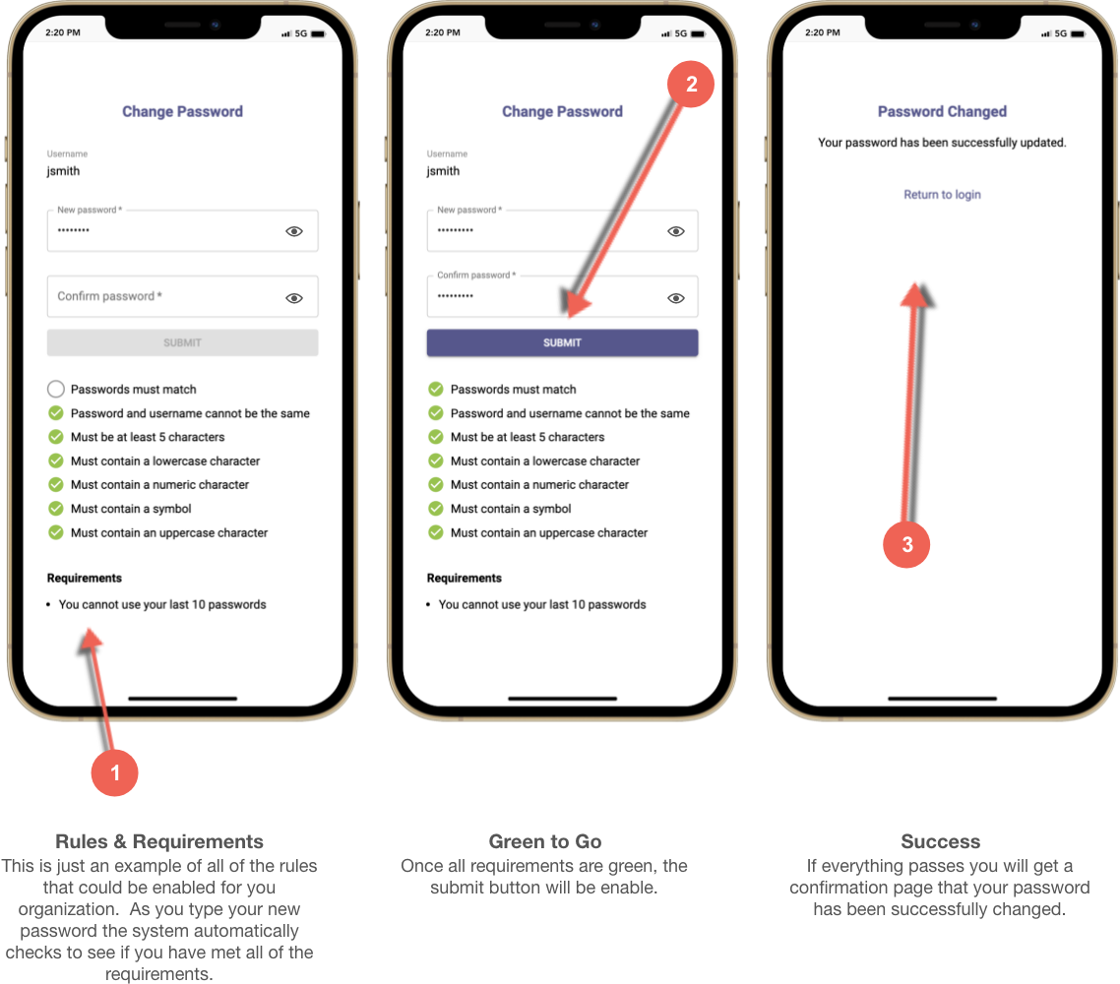

Logout – SSO (Single Sign-on) Only

Action Item: N/A
The process to login and out of Paragon Connect is quite different using a SSO solution. The user must login using a third-party application instead of logging directly into Paragon Connect. When users choose to logout of the system it takes them to the Paragon Connect login instead of the third-party application. This is confusing and depending on your setup will not allow your user to log back into the application.
It is difficult for Black Knight to route you back to your third-party application as there are several different types. However, with the 5.87 release, if you are using SSO to authenticate into Paragon Connect, the logout will now take you to a page informing you that you must navigate back to your original application to login.
Note: This new logout page should only appear IF you authenticate into PC via an external SSO.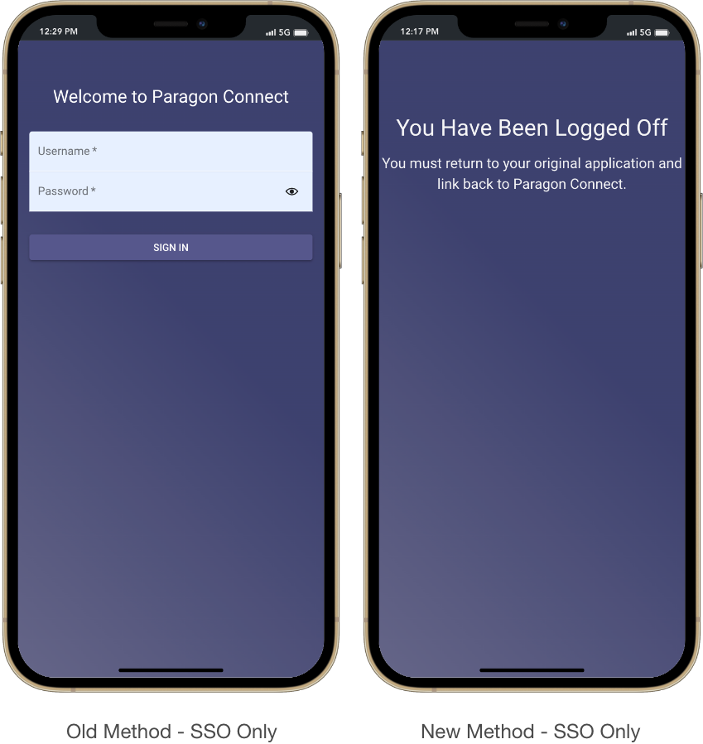

Paragon Affiliate Connect
All options in this section are either configurable via MLS Administration controls or by your System Support Manager as noted.

Corrected Paragon Affiliate Connect Issues
Ticket # | Module | Summary
DEV-5457 | AC- Affiliate Search | Agent is searchable even when agent's office board affiliate connect participation is unchecked
DEV-5465 | Configuration | Non P4B agent should not get access to my affiliate dashboard via PC
DEV-5550 | Dashboard | Service Partners option does not display under Collab Center menu option
DEV-5617 | Email | Text correction in the email body for affiliate disconnect email
DEV-5636 | Login/SSO | Getting an error when a user goes to the CCA login page
DEV-5686/ TK-7710 | Preferences | Office Name of Affiliate Member is Being Squashed Together in Certain Areas.
DEV-5690/ TK-7723 | Search | [object Object] Text Shows as the Value for Map Shapes in Saved Searches Within PAC
DEV-5418 | Collab Center | Service Partners tab in collab center the branding block should show the office logo
DEV-5370 | Admin | Affiliates logo does not size correctly
Multiple | E-mail | - Text correction in the email body for affiliate disconnect email when disconnected from office/firm  - No email sent to affiliate when affiliate is created  - Remove comment from the email body when agent shared service partner with the client  - Text correction in the email body when agent shared an affiliate with the contact  - Affiliate got notified twice instead once when agent accepted the invitation  - Text correction in the email body for affiliate disconnect email

Affiliate Branding Blocks

Action Item: N/A

If connected to an Agent, the Affiliate branding blocks will appear on the connected agents’ client’s collab center detail view. The system has been limited to display a maximum of three affiliate blocks at a time. The order of appearance and the order of affiliates that appear will be randomized.
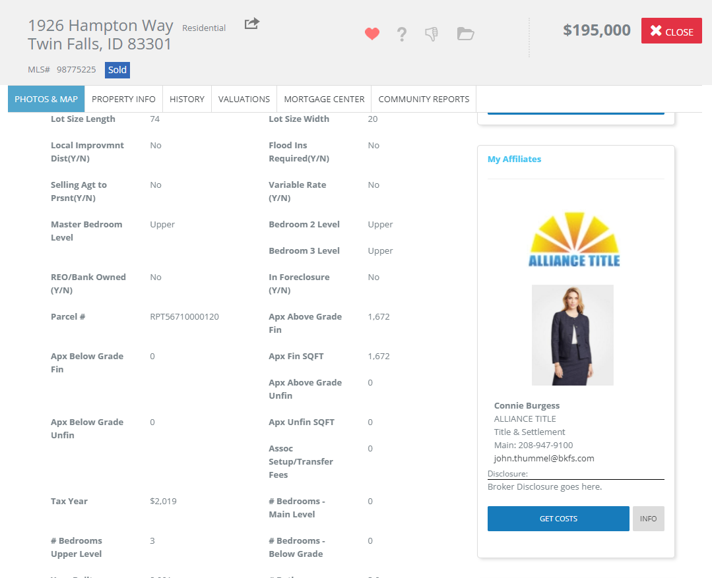

Affiliate/Agent Profile Photo

Action Item: N/A

If the Agent and/or the Affiliate does not have a photo selected to display in their profile. The image circle will use their initials instead of the “R” (for Realtor logo) that used to display.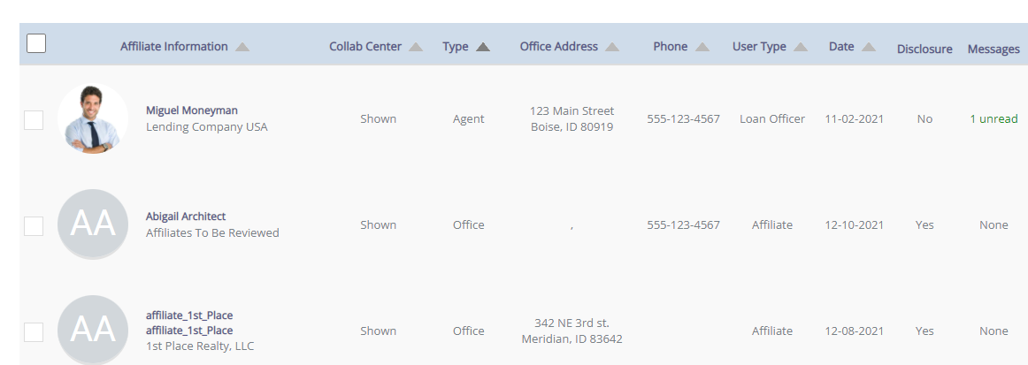

Connecting to Affiliates

Action Item: N/A

When an agent searches for an affiliate to connect with, the only available affiliates that will appear are the ones with an email address attached to their profile.

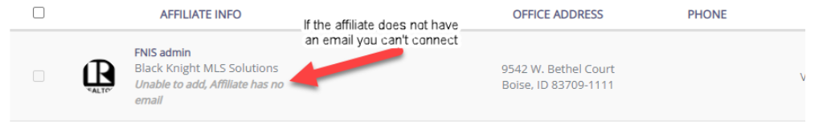

New Login Page for Affiliates

Action Item: N/A

We have updated the login page for Affiliates, to keep more in line with Paragon. Previously we would take the Affiliate to a purple page where they would log into the system. Now when going to log into the system the Affiliate will see a similar page as Paragon users, however it will be labeled as Paragon Affiliate Connect!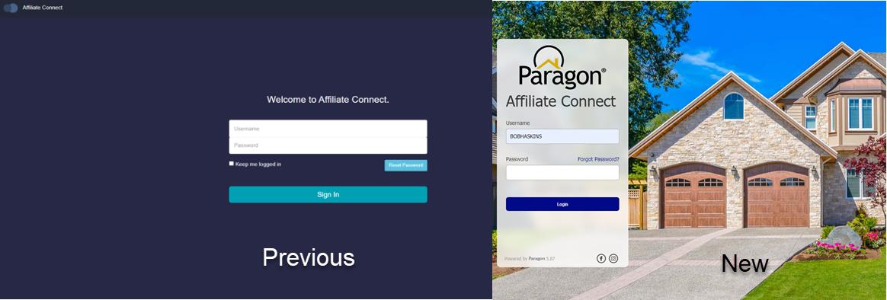

Login Name Displayed in Welcome Email to Affiliate

Action Item: N/A

When joining Paragon Affiliate Connect (PAC) the Affiliate welcome email will now show the login name and a link to set their password.

Email Communications

Action Item: N/A

All the various email communications delivered via Affiliate Connect have been updated to reflect the new standard styling and consistent information.

