Paragon Customer Toolkit - Release 5.88

## **Communications Plan Overview**

Welcome to the Paragon release communication Toolkit. The intention of this kit is to help you with communicating the release information to your membership.

In this kit you will find the following:

* Link to Release Notes for Paragon 5.88: the notes include any configurations and administration items that you will need to know about.
* Administration Configuration Options: What changes you may need to decide on
* Agent level Communication Plan: a link to an editable Customer Communication, and homepage notifications.
* Social Media: a post that you can use for Facebook, Instagram or other sites with a video of the release features.
* Example Home Page Announcements: You can cut and paste into your Homepage.

The goal is to make everyone aware of all the great Paragon enhancements to boost the way Members do Business!

## **Release Notes for Paragon 5.88**

Listed below is a link to the full release notes for the MLS. These release notes are for the Association/MLS. The Agent Level changes in this document are included in the e-mail template that you will want to send out to your members.

**Link:** [Release Notes](http://paragonconnect.paragonrels.com/images/documents/release_notes/588/Paragon%205.88%20Release%20Notes.docx)

## **Administration Configuration Options**

**Check Minimum Height of Report Elements**

To help mitigate an intermittent issue in the Report Editor, when a custom report is saved, a check will be run against the specified font size for each element. If the element is less than the font size, it will be automatically increased.

Admin > MLS Views and Reports > Custom Views > edit report.

Preferences > Custom Views > edit report.



## **Agent Level Changes Communication Plan**

The following link is to the e-mail template that you can copy and paste from to send out to your members keeping them informed on the release. [Paragon Release 5.88 Member Email](http://paragonconnect.paragonrels.com/images/documents/release_notes/588/Email%20to%20agents%205.88.docx)

This is a word document that you can edit so if you **do not** have certain functionality, for example if you do not allow changing of passwords on Paragon or do not have SSO, you can remove that section first before sending. Also, in the first sentence you will want to add **your MLS name** (it is in red), so that it is being sent from **your** organization to **your** members.

To ensure that your members are always informed about the latest and greatest enhancement to their MLS System, please announce the enhancements to your membership, post to Social Media sites, include them in your newsletters and post notices to your homepage and login messages.

## **Social Media Post**

Copy and paste the following into your social media and the picture below will display with the video. Encourage your membership to like our Facebook page @ParagonMLS. Check out the exciting new features of the Paragon 5.88 release!

[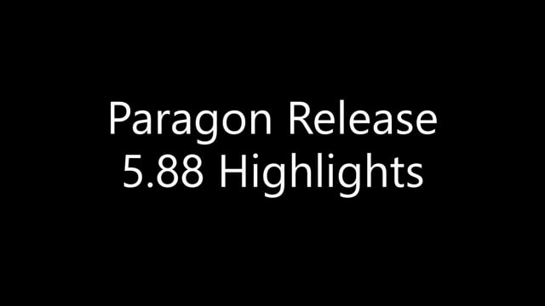](https://player.vimeo.com/video/686847114?h=8bc1cb3cce&app_id=122963)

## **Example Home Page Announcements**

The release has a lot of nice enhancements, you may want to highlight a different one every few days on your homepage and via Social Media. You can just cut and paste these into your homepage editor. If you want to add pictures you can do that too but make sure to upload them to your server.

**Saved Property Search Grid Update**

We’ve made some improvements to the Saved Property Searches grid to give you more information at a glance and improve the workflow.

* Changed the default filter to My Searches; you can still find all your MLS and Board defined searches by changing the filter.
* Sorted by Modified date, most recent at the top. No more scrolling through pages of old searches to find the latest.
* New column to show who created the search: MLS, Board, Me, your contact in Collaboration Center.

**Paragon Connect – Large Devices**

As you migrate from mobile devices to large devices like laptops, desktops, etc. the thumbnail view goes from a single column layout to a 2-column layout. Allowing you to view more listings per page.

**Paragon Connect – Contextual Bar**

When you check one or more listings a gray contextual bar will open showing you options you can take on those listings. The new thumbnail view’s contextual bar opens now at the very top allowing for more viewing area.

The same share options will be available in the new thumbnail view. (Email, text, copy link, etc.)

In addition, the ability to add listings to a cart, driving directions, and third-party integrations are also available.