

**PARAGON - INNOVATING THE WAY AGENTS DO BUSINESS**

**Paragon Release 5.88**

We (enter your MLS Name here) wanted you to be the first to know about the latest enhancements to your Paragon MLS System. All enhancements are designed to help you navigate through the system and enhance your experience with Paragon.  Below is a list of the enhancements and links to view videos or PDFs of the new features. We encourage you to continue reading and let us know what you think on the [Paragon MLS Facebook site](https://www.facebook.com/ParagonMLS/). Also make sure you click “Like” on the Facebook site to view what’s new with Paragon more frequently.

**WHAT’S NEW!**

**PARAGON**

* **Updates to the Saved Property Searches Grid**

We’ve made some improvements to the Saved Property Searches grid to give you more information at a glance and improve the workflow.

* Changed the default filter to My Searches; you can still find all your MLS and Board defined searches by changing the filter.
* Sorted by Modified date, most recent at the top. No more scrolling through pages of old searches to find the latest.
* New column to show who created the search: MLS, Board, Me, your contact in Collaboration Center.

* **Updated the Preferences for Email Options**

The Email Preferences page has been updated to present a cleaner view with more concise wording. The Display Property Address option has also been moved out of its own node and into the Email Options page.

* **Updated the Verbiage on Upload Associated Document Dialog Box**

The verbiage in the dialog box for adding documents to a listing has been updated to reflect the fact that Public documents will be available in Collaboration Center as well as available for sharing via email.

* **Contact Comments Enhancements**

The Comments table in Saved Search Management has been enhanced to be more intuitive and interactive.

* The rows in the MLS column now link to the Detail report for the property
* A new column displays the last comment
  + The last comment shows the status read vs. unread (bold and bubble icon)
  + Clicking the last comment opens the “Comments in Context” dialog box

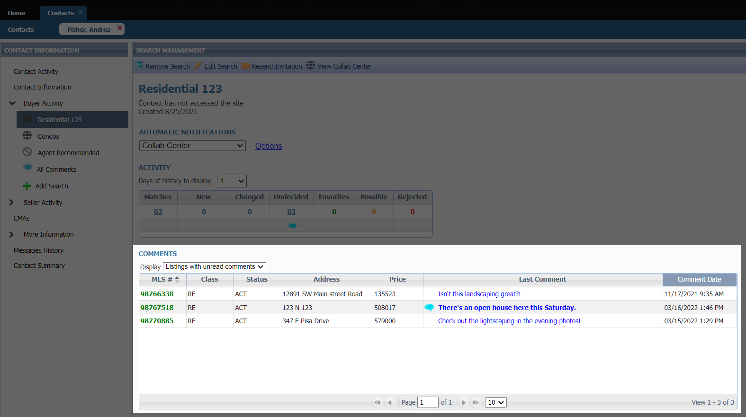

**Collaboration Center – Your client’s portal**

* **Parcel Lines**

Prior to the 5.88 release, when you were to zoom into the map you would first see the default Google parcel lines then the parcels from Black Knight would load. This would lead to multiple parcels stacked on each other.

Now the default Google parcels have been removed so that you can easily see the Black Knight parcels on the property search.

**Paragon Connect**

* **Menu Updates**

We start of the 5.88 release notes with some additional menu updates. As we continue to prepare for additional modules, we want to make sure the navigation menu is presented in a fashion that allows you to easily find your content. Below are two screenshots of how the menu looks in 5.87 and the updates we made in 5.88. You will see the changes listed.

|  |  |
| --- | --- |
|  |  |

* Graphical user interface, text, application

  Description automatically generated**Archive Listings**

The buyer activity within the contact manager was recently updated to include a card containing counts from "Archived Listings.”

An “Archived Listing” is a listing your buyer marked as a favorite or possible that is not tied to a saved search. This typically is the result from changes to the search criteria or the listing data is updated to the point it no longer matches your saved search.

Since these are still important to your buyers, we have moved them into an “Archived Listing” section. You will now find a card in the buyer activity that shows you total count of archived listings. You will also see a breakdown of the favorite and possible listings.

Note: Undecided and rejected listings are not kept if criteria of the search or listing is updated.

* **Large Devices**

As you migrate from mobile devices to large devices like laptops, desktops, etc. the thumbnail view goes from a single column layout to a 2-column layout. Allowing you to view more listings per page.

* **Thumbnail View**

The thumbnail view in Paragon Connect is getting an upgrade. This new thumbnail view not only is faster and more responsive than its previous version, but it also has a few other characteristics that set it apart. The fonts are lager and darker in color making it easier to read. The status bar in the previous version has been removed from the photo allowing for the photo to be more visible. We have also carried over the same customizable field allowed to be viewed in the Collaboration Center. This allows you to add one custom field per class in this new thumbnail view. This is especially useful for selling condos where address and photos are identical.

It is important to note that the new thumbnail view can only be found within the “Contact Module” at this time. Additional view updates are being analyzed and developed and we did not want to interrupt your daily business until all these updates are complete.

* **Contextual Bar**

When you check one or more listings a gray contextual bar will open showing you options you can take on those listings. The new thumbnail view’s contextual bar opens now at the very top allowing for more viewing area.

The same share options will be available in the new thumbnail view. (Email, text, copy link, etc.)

In addition, the ability to add listings to a cart, driving directions, and third-party integrations are also available.

