Paragon 5.88 Release Enhancements – (*Updated on 3/17/2022)*

Corrected Paragon Issues 2

MLS Customizations and Administration 4

Admin – Check Minimum Height of Report Elements 4

Agent Level Changes 5

Saved Property Search - Updates to the Saved Property Searches Grid 5

Preferences - Update the Email Options page 6

UI – Conditionally hide Syndication Preferences 7

Update verbiage on upload Associated Document dialog box 7

Contacts Comments Enhancements 8

Collaboration Center 9

Parcel Lines 9

Paragon Connect 10

Menu Updates 10

Archive Listings 11

Thumbnail View 12

Large Devices 13

Contextual Bar 13

Paragon Affiliate Connect 14

Corrected Paragon Affiliate Connect Issues 14

# Corrected Paragon Issues

|  |  |  |  |
| --- | --- | --- | --- |
| **Ticket#** | **Module** | **Organization** | **Summary** |
| TK-8683 | Data | MAXEBRDI - MAXEBRDI MLS, Santa Fe | Price Date field is not updating with Price changes |
| TK-8591 | LIM | MIMLS - MiRealSource | Selling Agent Fields Do Not Populate Values in Listing Input and Maintenance |
| TK-8590 | IDX | IOWAREALTORS - Heart of Iowa BOR (Northstar MLS), Valley MLS | Users IDX Links are failing |
| TK-8640 | Admin | RMLSA - Regional MLS Alliance (Peoria), Valley MLS | RETS Admin Field Feature Produces Error |
| TK-8597 | Preferences | CR - California Regional MLS, Hot Springs, NEREN, MAXEBRD | Preferences >> Collab center>>Office Information, Automated values > Getting page load error |
| TK-8472 | Configuration | IMLS - Intermountain MLS, San Diego, Valley MLS | System isn't setting dom_freeze_date value on listings input directly into LVTs that don't calculate DOM |
| TK-8449 | Admin | CREN - Colorado Real Estate Network, Inc | P100 User gets page cannot be displayed error attempting to create lookup relationships values |
| TK-8375 | IDX | VALLEYMLS – Valley MLS / NALMLS (Huntsville) | Page cannot be displayed error when accessing smartframing |
| TK-8330 | Search | CARMLS - CARMLS, Inc. (Arkansas), IMLS, Valley MLS | P100 User gets page cannot be displayed error running hotsheet search |
| DEV-5976 | LIM | BCRES - REB2 Residential | Field rule misfires when looking at Input Agent |
| DEV-5953 | CMA | BCRES - REB2 Residential, Edmonton | Subject Property - Blank screen when trying to Add New or Maintain |
| DEV-5945 | LIM | SDMLS - San Diego MLS | Value Range Pricing prevents LIM form from loading |
| TK-8179 | Admin | Charlottesville/Augusta/Harrisonburg-Rockingham, Hot Springs, Northern Ontario | Staff Kicked Back to Login Page when Adding a New User |
| TK-7529 | CC2 - Preferences | NEREN - New England Real Estate Network | Setting Collab Center Search Preferences to Disabled Hides Property Types for Existing CC2 Sites Where Property Search is Allowed |
| TK-7719 | CMA | BCAR - Baldwin County AOR, BCRES, Edmonton, Pocatello, IRMLS, Regional MLS Alliance (Peoria), NEREN | Intermittent Initial Save Issue with CMA's |
| TK-7584 | Tour/Open House | NEREN - New England Real Estate Network | Unable to Modify Open House or Tours on Partials |
| TK-7492 | Email | SANCAPMLS - Sanibel and Captiva Islands AOR | Agent Unable to Make Changes to Saved Signature with Quotes |
| TK-7263 | Admin | COLUMBIA - ConsolidatedMLS | Unable to delete Feature Category and Features |
| TK-7000 | General UI | NJMLS - New Jersey MLS (Bergen) | Page unavailable error when attempting to modify any sold status |
| TK-6751 | CC2 - Dashboard | BCRES - REB2 Residential | Collab Center loads slowly |
| TK-5754 | Print | CR - California Regional MLS, SDMLS | Overlapping text on agent preferred 1 report when using print + and pdf output type |
| TK-913 | View/Reports | MIMLS - MiRealSource | Adding Multiple Date Fields to Spreadsheet Required for Data to Show and Shifts Columns |
| TK-5128 | Admin | NRV - New River Valley AOR | Getting 'page cannot be displayed' error when running lookup relationship values report |
| TK-4346 | Prospecting | CCAR - Coastal Carolinas AOR, NSAR, RAE, SWMLS, TAOSMLS, TylerTexas | Paragon extension of email not working correctly |
| TK-3323 | Print | BCRES - REB2 Residential, CLS, IMLS, MIMLS, NEREN, NSAR, NRV, RAE, RANWMLS, RMLSA, VALLEYMLS, Cheyenne, PEI | Office and Agent Images Do Not Print When Using PDF Output with Print+ |
| TK-3206 | Statistics | COLUMBIA - ConsolidatedMLS | Inventory Supply graph aggregating and calculating sold listings incorrectly |
| TK-2589 | View/Reports | BLACKHILLS - Black Hills AOR, MIMLS, NEREN, NMMLS, OBARMLS, SJSR, SEDWAR | Programmed Page Breaks in Membership Roster Don't Line Up When Printed |

# MLS Customizations and Administration

**All options in this section are either configurable via MLS Administration controls or by your System Support Manager as noted.**

## Admin – Check Minimum Height of Report Elements

### Action Item: N/A

To help mitigate an intermittent issue in the Report Editor, when a custom report is saved, a check will be run against the specified font size for each element. If the element is less than the font size, it will be automatically increased.

Admin > MLS Views and Reports > Custom Views > edit report.

Preferences > Custom Views > edit report.



# Agent Level Changes

**The following section contains changes that are active system wide and available to users based on their assigned security levels.**

## Saved Property Search - Updates to the Saved Property Searches Grid

### Action Item: N/A

We’ve made some improvements to the Saved Property Searches grid to give you more information, at a glance and improve the workflow.

* Changed the default filter to My Searches; you can still find all your MLS and Board defined searches by changing the filter.
* Sorted by Modified date, most recent at the top. No more scrolling through pages of old searches to find the latest.
* New column to show who created the search: MLS, Board, Me, your contact in Collaboration Center.

## Preferences - Update the Email Options page

### Action Item: N/A

The Email Preferences page has been updated to present a cleaner view with more concise wording. The Display Property Address option has also been moved out of its own node and into the Email Options page.

## UI – Conditionally hide Syndication Preferences

### Action Item: N/A

Customers who do not use Paragon Syndication will no longer see the Syndication Features in the User Preferences tree.

## Update verbiage on upload Associated Document dialog box

### Action Item: N/A

The verbiage in the dialog box for adding documents to a listing has been updated to reflect the fact that public documents will be available in Collaboration Center as well as available for sharing via email.

## Contacts Comments Enhancements

### Action Item: N/A

The Comments table in Saved Search Management has been enhanced to be more intuitive and interactive.

* The rows in the MLS column now link to the Detail report for the property
* A new column displays the last comment
  + The last comment shows the status read vs. unread (bold and bubble icon)
  + Clicking the last comment opens the “Comments in Context” dialog box

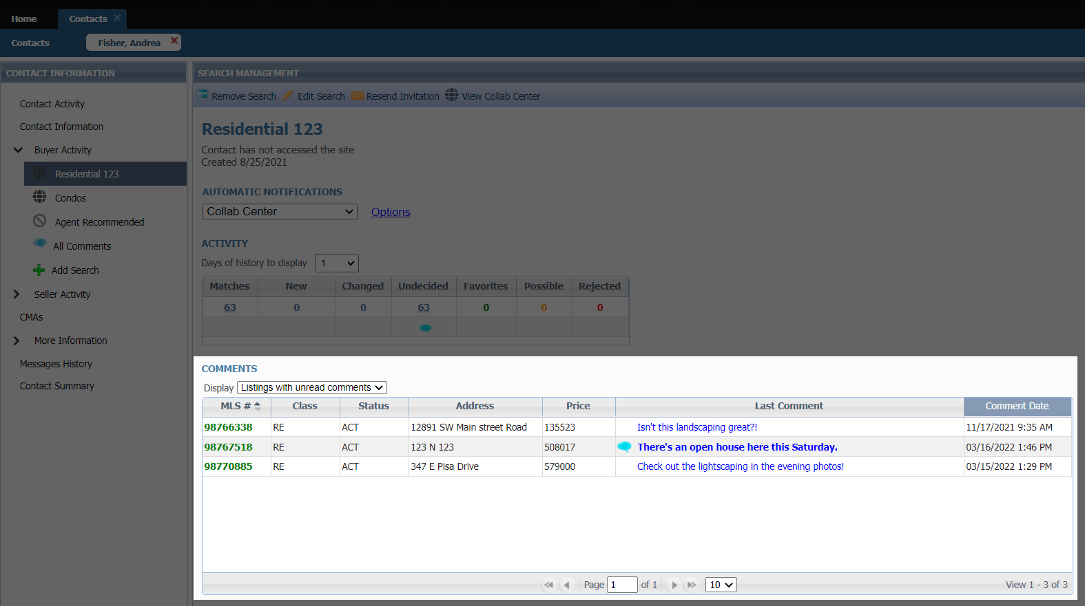

# Collaboration Center

**All options in this section are either configurable via MLS Administration controls or by your System Support Manager as noted.**

## Parcel Lines

### Action Item: N/A

Prior to the 5.88 release, when you were to zoom into the map you would first see the default Google parcel lines then the parcels from Black Knight would load. This would lead to multiple parcels stacked on each other.

Now the default Google parcels have been removed so that you can easily see the Black Knight parcels on the property search.

# Paragon Connect

**All options in this section are either configurable via MLS Administration controls or by your System Support Manager as noted.**

## Menu Updates

### Action Item: N/A

We start of the 5.88 release notes with some additional menu updates. As we continue to prepare for additional modules, we want to make sure the navigation menu is presented in a fashion that allows you to easily find your content. Below are two screenshots of how the menu looks in 5.87 and the updates we made in 5.88. You will see the changes listed.

## Archive Listings

### Action Item: N/A

The buyer activity within the contact manager was recently updated to include a card containing counts from "Archived Listings.”

An “Archived Listing” is a listing your buyer marked as a favorite or possible that is not tied to a saved search. This typically is the result from changes to the search criteria or the listing data is updated to the point it no longer matches your saved search.

Since these are still important to your buyers, we have moved them into an “Archived Listing” section. You will now find a card in the buyer activity that shows you total count of archived listings. You will also see a breakdown of the favorite and possible listings.

Note: Undecided and rejected listings are not kept if criteria of the search or listing is updated.

## Thumbnail View

### Action Item: N/A

The thumbnail view in Paragon Connect is getting an upgrade. This new thumbnail view not only is faster and more responsive than its previous version, but it also has a few other characteristics that set it apart. The fonts are larger and darker in color making it easier to read. The status bar in the previous version has been removed from the photo allowing for the photo to be more visible. We have also carried over the same customizable field allowed to be viewed in the Collaboration Center. This allows the MLS to add one custom field per class in this new thumbnail view. This is especially useful for selling condos where address and photos are identical.

It is important to note that the new thumbnail view can only be found within the “Contact Module” at this time. Additional view updates are being analyzed and developed and we did not want to interrupt your daily business until all these updates are complete.Graphical user interface, application

## Large Devices

### Graphical user interface, website Description automatically generatedAction Item: N/A

As you migrate from mobile devices to large devices like laptops, desktops, etc. the thumbnail view goes from a single column layout to a 2-column layout allowing you to view more listings per page.

## Contextual Bar

### Graphical user interface, application Description automatically generatedAction Item: N/A

When you check one or more listings a gray contextual bar will open showing you options you can take on those listings. The new thumbnail view’s contextual bar opens now at the very top allowing for more viewing area.

The same share options will be available in the new thumbnail view. (Email, text, copy link, etc.)

In addition, the ability to add listings to a cart, driving directions, and third-party integrations are also available.

# Paragon Affiliate Connect

**All options in this section are either configurable via MLS Administration controls or by your System Support Manager as noted.**

# Corrected Paragon Affiliate Connect Issues

|  |  |  |
| --- | --- | --- |
| **Ticket #** | **Module** | **Summary** |
| TK-7723 | Search | [object Object] Text Shows as the Value for Map Shapes in Saved Searches Within PAC |
| TK-7710 | Preferences | Office Name of Affiliate Member is Being Squashed Together in Certain Areas. |
| DEV-5550 | Dashboard | Service Partners option does not display under Collab Center menu option |
| DEV-5467 | Configuration | Affiliate is searchable even when affiliate's office board affiliate connect participation is unchecked |
| DEV-5457 | AC - Affiliate Search | Agent is searchable even when agent's office board affiliate connect participation is unchecked |
| DEV-5449 | Login Page | Change the Affiliate Connect login page to have the same branding as Paragon |
| DEV-5418 | Other | Service Partners tab in collab center the branding block should show the office logo |
| DEV-5321 | Admin | Affiliate connect disclosure and office level affiliates management |
| DEV-5320 | AC - Affiliate Search | Add and Search Affiliates UX Update |
| DEV-5306 | AC - Affiliate Search | As an Agent when I looked up Affiliates to connect with, I should not see unavailable affiliates |
| DEV-5236 | Dashboard | PAC: Change Default No Photo Image to Use Initials rather than REALTOR R logo |