Paragon Customer Toolkit - Release 5.89

## **Communications Plan Overview**

Welcome to the Paragon release communication Toolkit. The intention of this kit is to help you with communicating the release information to your membership.

In this kit you will find the following:

* Link to Release Notes for Paragon 5.89: the notes include any configurations and administration items that you will need to know about.
* Administration Configuration Options: What changes you may need to decide on
* Agent level Communication Plan: a link to an editable Customer Communication, and homepage notifications.
* Social Media: a post that you can use for Facebook, Instagram or other sites with a video of the release features.
* Example Home Page Announcements: You can cut and paste into your Homepage.

The goal is to make everyone aware of all the great Paragon enhancements to boost the way Members do Business!

## **Release Notes for Paragon 5.89**

Listed below is a link to the full release notes for the MLS. These release notes are for the Association/MLS. The Agent Level changes in this document are included in the e-mail template that you will want to send out to your members.

**Link:** [Release Notes](https://pahelp.paragonrels.com/ReleaseNotes/WordDocs/5_89_Release_Notes.docx)

## **Administration Configuration Options**

**New Paragon Connect option from Collaboration Center agent notification emails**

A new configuration setting was added to allow the MLS to select which login page is presented from the “Go to Paragon” button on Collaboration Center agent notification emails. All customers will default to Paragon; please contact your SSM to request a change.

Options: None (hides the button), Paragon, or Paragon Connect

**Option to search all offices or all firms in Statistical Reporting**

For customers who wish to allow users to search any office or firm in Statistical Reporting, two new configuration settings have been added.

* Allow all Offices: When enabled, this allows any user with access to an Office-level statistical report to search any office. Configuration setting options: Y, N.
* Allow all Firms: When enabled, this allows any user with access to a Firm-level statistical report to search any firm. Configuration setting options: Y, N.

When set to Y, on reports with the Listing Owner filter, the filter will default to “Listings for My Firm” or “Listings for My Office,” but will include the option “Another Firm’s Listings” or “Another Office’s Listings.”

All customers will default to N (current restrictions will continue to apply). Please contact your SSM to request a change.

*****Note: There is an existing configuration for Allow all Agents.*

**Option to modify the price value for the first recorded entry in the Property History Report**

Previously in the 5.88 release we added a new feature allowing staff to modify the price value for the First Recorded Entry in Property History Report.

This feature allows a mistyped price to be corrected (eg. – user meant to enter 120,000 and entered 1200,000 instead).

When an Admin user navigates to the Price Change feature (Listings > Maintain Listings > MLS: XXX > Click on the price or Select an Action Price Change),

and updates the original price, the change will result in the appropriate History Record in the first Recorded entry field.

**Please Note:** This change does not affect the Listing Audit in any way. Please contact your SSM to request this change.

## **Agent Level Changes Communication Plan**

The following link is to the e-mail template that you can copy and paste from to send out to your members keeping them informed on the release. [Paragon Release 5.89 Member Email](https://pahelp.paragonrels.com/ReleaseNotes/WordDocs/5_89Email_to_agents.docx)

This is a word document that you can edit so if you **do not** have certain functionality, for example if you do not allow changing of passwords on Paragon or do not have SSO, you can remove that section first before sending. Also, in the first sentence you will want to add **your MLS name** (it is in red), so that it is being sent from **your** organization to **your** members.

To ensure that your members are always informed about the latest and greatest enhancement to their MLS System, please announce the enhancements to your membership, post to Social Media sites, include them in your newsletters and post notices to your homepage and login messages.

## **Social Media Post**

Copy and paste the following into your social media and the picture below will display with the video. Encourage your membership to like our Facebook page @ParagonMLS. Check out the exciting new features of the Paragon 5.89 release! If clicking on the image does not open the video, please [click here](https://vimeo.com/709503693) to open the video.

[](https://player.vimeo.com/video/709503693?h=de4c216101&app_id=122963)

## **Example Home Page Announcements**

The release has a lot of nice enhancements, you may want to highlight a different one every few days on your homepage and via Social Media. You can just cut and paste these into your homepage editor. If you want to add pictures you can do that too but make sure to upload them to your server.

**Automatically display legend when a Layer is selected**

The map layer control in Paragon has been enhanced to automatically expand the legend when the layer is selected. Previously, after clicking on the legend, users had to click on the icon to expand it. With this new functionality, just selecting the layer expands it as shown below for the current Flood Plain layer

**Validate Address Location**

The “Validate Address Location” is the latest enhancement added to the listing edit module. This is known as “Change Geocode” in Paragon Professional. Here is how it works!

After entering your new listing (or from a current listing), click the overflow menu and select Validate Address Location and the map will display with a property pin and a NEW **Accuracy Indicator**

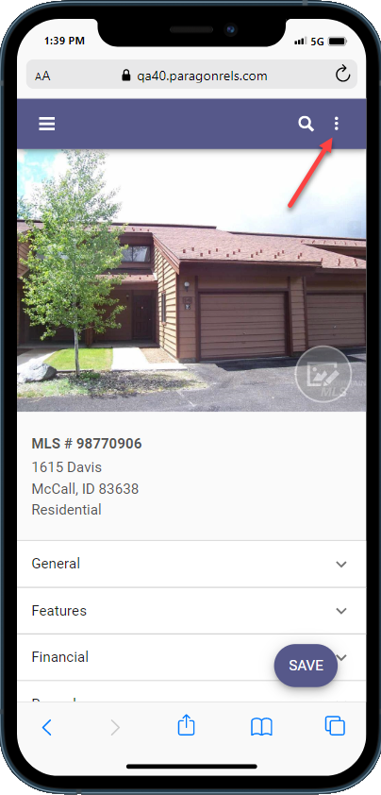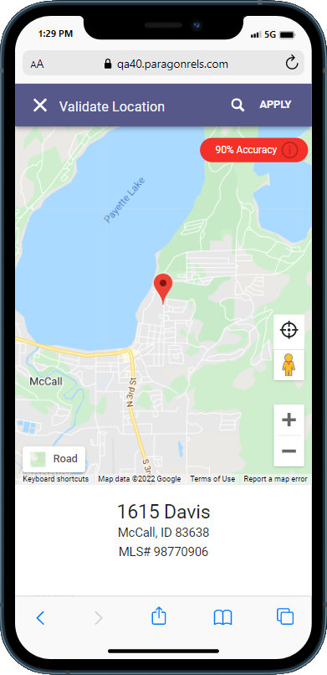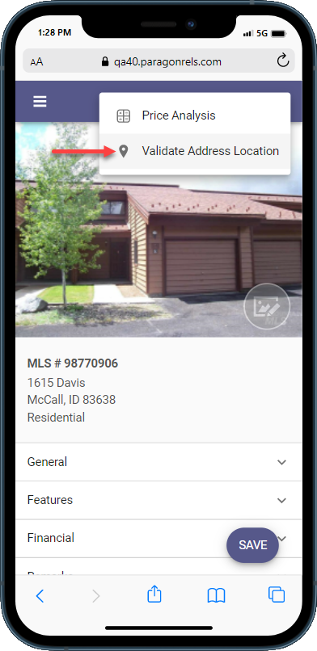

If the Accuracy Indicator is red, it means that the geocode accuracy is something less than 100%. If it is green, then it’s spot on at 100% OR it has been manually placed. The goal is to provide you with an easy-to-see visual display of the geocode quality.

The accuracy indicator includes a **tool tip** icon that when clicked will display more information about the rating.