

**PARAGON - INNOVATING THE WAY AGENTS DO BUSINESS**

**Paragon Release 5.89**

We (enter your MLS Name here) wanted you to be the first to know about the latest enhancements to your Paragon MLS System. All enhancements are designed to help you navigate through the system and enhance your experience with Paragon.  Below is a list of the enhancements and links to view videos or PDFs of the new features. We encourage you to continue reading and let us know what you think on the [Paragon MLS Facebook site](https://www.facebook.com/ParagonMLS/). Also make sure you click “Like” on the Facebook site to view what’s new with Paragon more frequently.

**WHAT’S NEW!**

**PARAGON**

* **Automatically display legend when a Layer is selected**

The map layer control in Paragon has been enhanced to automatically expand the legend when the layer is selected. Previously, after clicking on the legend, users had to click on the icon to expand it. With this new functionality, just selecting the layer expands it as shown below for the current Flood Plain layer.

**Paragon Connect**

* **Validate Address Location**

The “Validate Address Location” is the latest enhancement added to the listing edit module. This is known as “Change Geocode” in Paragon Professional. Here’s how it works!

After entering your new listing (or from a current listing), click the overflow menu and select Validate Address Location and the map will display with a property pin and a NEW **Accuracy Indicator**

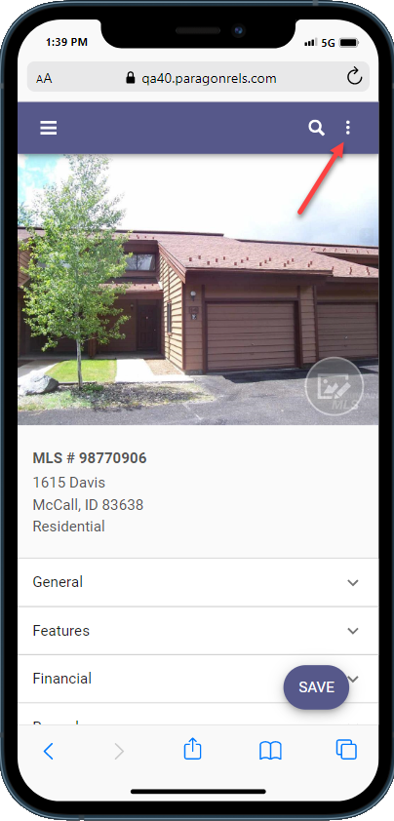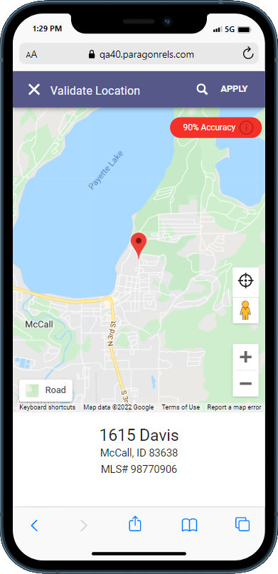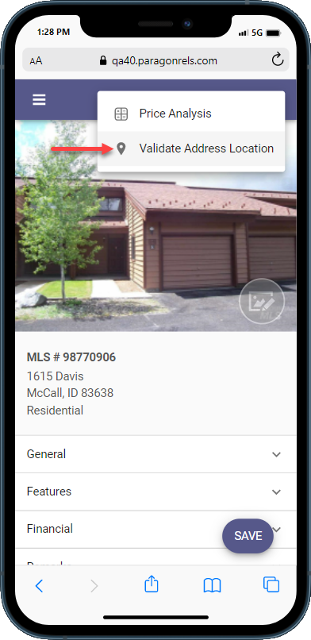

If the Accuracy Indicator is red, it means that the geocode accuracy is something less than 100%. If it is green, then it’s spot on at 100% OR it has been manually placed. The goal is to provide you with an easy-to-see visual display of the geocode quality.

The accuracy indicator includes a **tool tip** icon that when clicked will display more information about the rating.

### Geocode Using Address Search

* You can try manually entering the address to see if the pin moves by clicking the address search icon, entering the address and clicking the search icon again to get the result. By the way, this map search is the equivalent of the “Center Map and Zoom on this Address” in Paragon Pro.

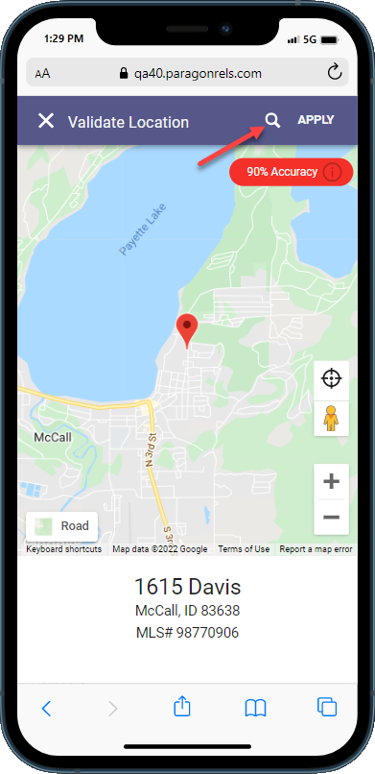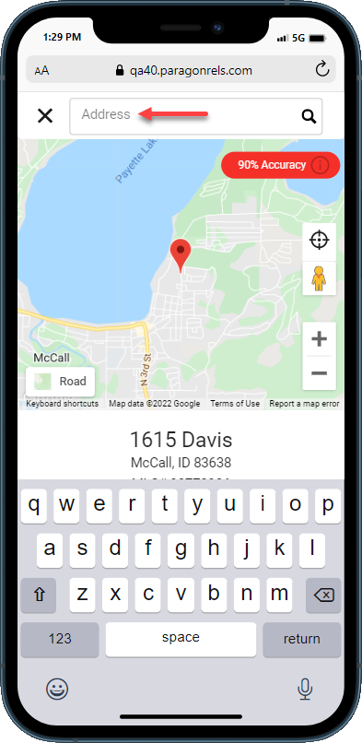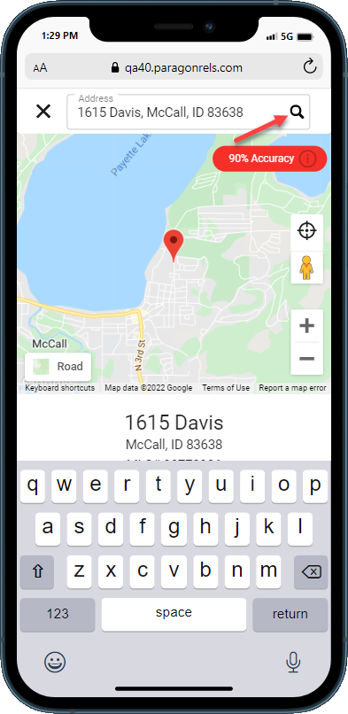

If the default Road view does not provide enough information, switch to any one of seven views using the NEW **Map Types** feature!

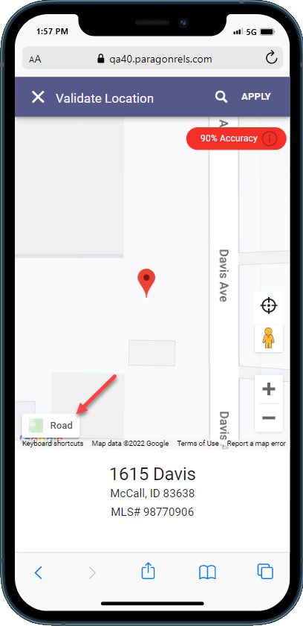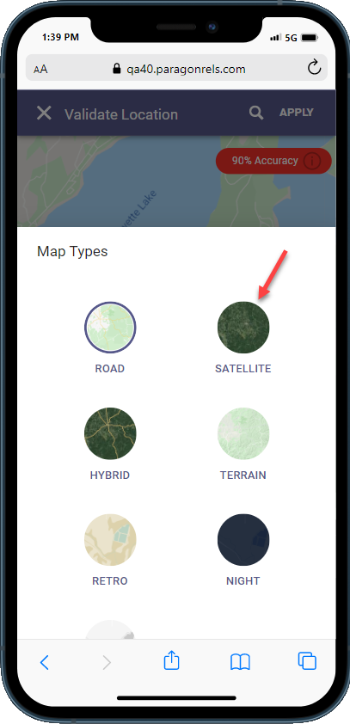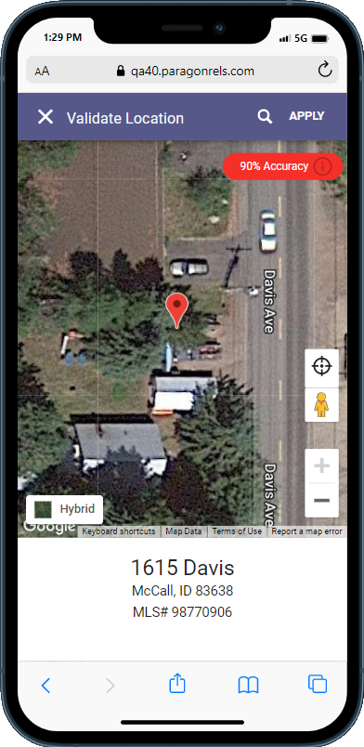

### Geocode by Moving Map Pin

You can move the pin manually by clicking on the pin with a mouse or using your finger to drag the pin to the new location. After moving the pin, the Accuracy Indicator will change to green and read “Manually Placed.” If you are happy with the location, click APPLY. You will receive a prompt that the changes were applied but that you still need to save to retain the settings.

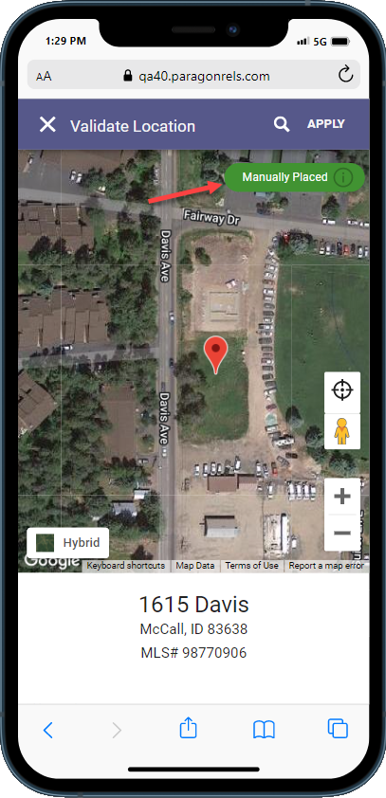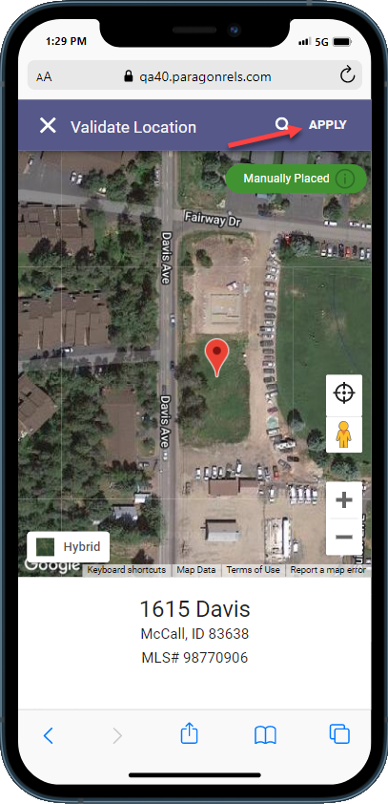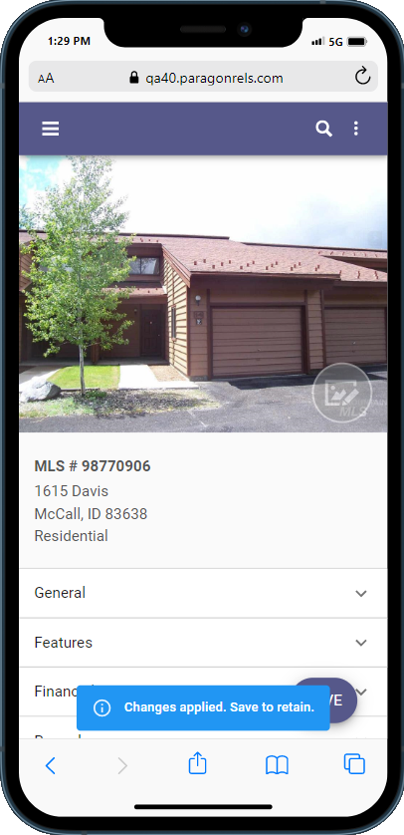

### Graphical user interface, application Description automatically generatedWarning and Error Validation

In addition to being able to manually validate your location, the listing edit module will also check for any errors or warnings related to your address upon saving a listing. These are based on your business rules set for your organization.

* **Contact Notification Options**

Prior to the 5.89 release, contact notiﬁcation settings are only adjustable in Paragon Professional. Now, Paragon Connect users can adjust a variety of notiﬁcation options. Enable/disable your notiﬁcations, change notiﬁcation triggers, update when your notiﬁcations are sent and more. Below breaks down the diﬀerent options.

### Overflow Options

While viewing a saved search card, you will notice a new three dot overflow menu icon. This icon contains a menu with all your notification options. It includes the following:

* Disable/Enable Collab Center
* Email Options
* Notification Triggers
* Notification Time Frames
* Resend Notification
* Delete Search

### Enable/Disable

You now can enable/disable saved searches from displaying in your Collaboration Center site. In the example provided, the user disables the saved search. It removes the activity chart and moves it to the bottom of the list. User can then re-enable the saved search at any time by going to the overﬂow menu and tapping “Enable Collaboration Center.”

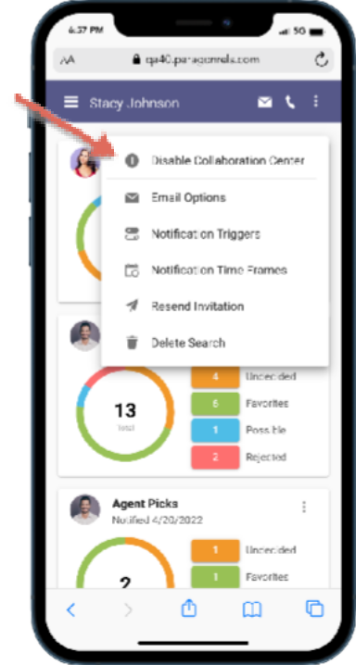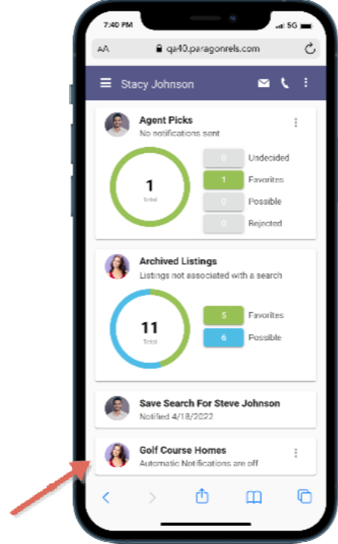

### Email Options

Email options allow the user to edit who receives any email notification updates from the Collaboration Center. It also allows you to add a custom message that is displayed each time a notification email is sent.

Options include:

* Add or modify primary recipients
* Add or modify Cc recipients
* Add or modify Bcc recipients
* Modify email subject title
* Add or modify Custom message

### Graphical user interface, application Description automatically generatedGraphical user interface, text, application Description automatically generatedNotification Triggers

Notification triggers allow you to set what type of notifications your users will receive. Do they want to be notified on just new matches? Maybe it is new matches, price changes, status changes, etc. The notification trigger option will allow you to set what type of notifications your user will receive on each saved search.

* New Matches
* Price Changes
* Status Changes
* New Comments
* Open House Tour
* Initial Photo

### Graphical user interface, application Description automatically generatedGraphical user interface, text, application Description automatically generatedTime Frames

The Notification time frame allows you to edit how long the notification is active. By default, when you setup a notification, the date range is set to a year. You cannot set the date range to be longer than a year but if your notification is about to expire you can extend it to a full 12 months.

The time frame option also contains your client and agent notification frequency options. You can choose whether the notifications are set to off, immediately, or recurring. If set to recurring, you can set the notification time and when these notifications are sent. Below are the three frequency options:

* Daily
* Weekly (choose days)
* Monthly

### Delete Search

There are times when you no longer need a saved search. When this occurs, you can now use the “Delete Search” option from the saved search card overflow. This will remove the contact from the saved search and delete the card. A confirmation will display to make sure you want to delete the search.

### Resend Invitation

There are times when a prospective buyer cannot find or did not receive the Collaboration Center welcome email. This welcome email contains the information needed to use and access the Collaboration Center.

When this occurs, you can now go to that saved search for that contact and resend the invitation. The resend invitation contains an email dialog where you can add additional email addresses and provide a custom message.

* **New Detail Report**

As we continue to optimize Paragon Connect, we are pleased to introduce our updated detail report. This report is like the previous version only there are some significant upgrades. Below are a few noticeable upgrades:

* Performance boost
* Larger, darker fonts
* Several UI Updates

*Note: New detail report is only found from results generated from within the contact manager module.*

### Performance Boost

The loading of the report has been a major focus of the new React detail report. The goal is for that report to open as quickly as possible. This allows you to view full listing data quickly!

* **Current Detail Report**

4-5 Seconds

* **New Detail Report**

1-2 Seconds

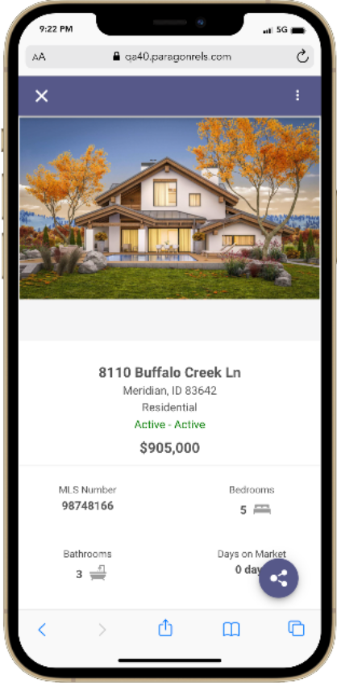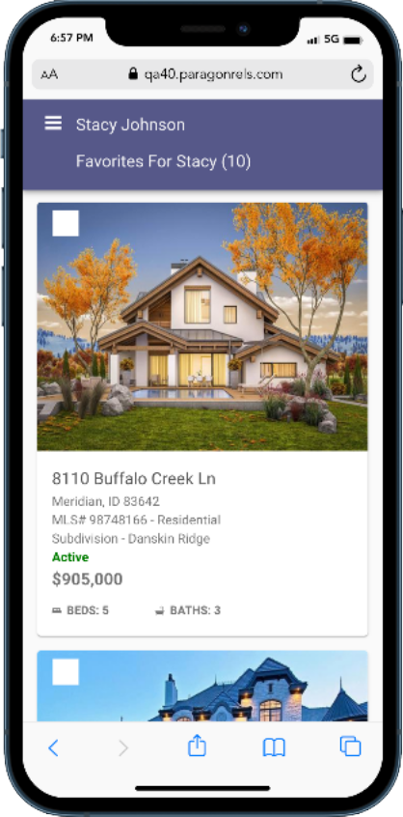

### Font Updates

There are several updates to the font type, styles, color and more. The ﬁrst update is the font family being used. All the new React based components are using Roboto instead of Open Sans. It is a thicker type of font making it easier to read. The font color was also darkened to help make it easier to read. Also, the font sizes were increased. Overall, the legibility of the detail report has been greatly improved.

Current Report New React Detail Report

### Additional Updates

There are several other updates made to this report. You will see updates to the mortgage calculator, AVMs, property history, public records, share options, and even how you access different menu options.