Paragon 5.89 Release Enhancements (Updated on 5/11/2022)

Corrected Paragon Issues 2

MLS Customizations and Administration 3

Admin –New Paragon Connect option from Collaboration Center agent notification emails 3

Admin –Options to search all offices or all firms in Statistical Reporting 4

Admin –Options to modify the price value for the first recorded entry in the Property History Report 5

Agent Level Changes 6

Automatically Display Legend When Layer is Selected 6

Collaboration Center 7

No Changes 7

Paragon Connect 8

Validate Address Location 8

Contact Notification Options 11

New Detail Report 16

Paragon Affiliate Connect 20

Corrected Paragon Affiliate Connect Issues 20

# Corrected Paragon Issues

|  |  |  |  |
| --- | --- | --- | --- |
| **Ticket#** | **Module** | **Organization** | **Summary** |
| TK-692 | View/Reports | NEREN - New England Real Estate Network | Color Picker in the Custom Editor Doesn't Display Values Correctly and Buttons Block Interface |
| DEV-6314 | Collab Center - Analytics | All | Zestimate displaying "No valuation available" for every Parcel and Listing in production |
| TK-8876 | Admin | BCAR - Baldwin County AOR, CCAR, RAARMLS, Valley MLS, NALMLS | Login Agreements causing Error |
| DEV-6158 | Analytics | All | AVMs appearing in Price Analysis Widget even when disabled at MLS level |
| TK-8477 | Collab Center - Associated Documents | GAMLS - Georgia MLS, NJMLS | Assoc Docs stored as URL have broken path when emailed |
| DEV-6075 | CMA | All | CMA Calculated Adjustments - User cannot remove field item/s once added from left grouping (available options) |
| TK-892 | View/Reports | BCRES - REB2 Residential, CCAR, CRMLS, IRMLS, MIMLS, NEREN, OABRMLS, SANCAPMLS, SCKMLS, SDMLS, SFAR, Triangle MLS, WVMLS, RMLSA | Driving Directions through Google Do Not Display Correct Address, But Correct Location |
| DEV-5991 | Statistics | All | Paragon>>Stats Reporting: Year To year Reports alignment is not displaying correct. |
| TK-8135 | Mapping or Geo-coding | NEREN - New England Real Estate Network | Typo in Tooltip to Turn Map Boundary On/Off |
| TK-8151 | Email | GALMLS - Greater Alabama MLS | Corrections email does not allow images to be uploaded |
| TK-7021 | CMA | TCAOR - Tehama County AOR | P20 Tehama County: Printing CMA Presentation in Firefox gives extra blank pages |
| DEV-2591 | Contacts | REB | BCRES Agent unable to remove suffix from Contact |

# MLS Customizations and Administration

**All options in this section are either configurable via MLS Administration controls or by your System Support Manager as noted.**

## Admin –New Paragon Connect option from Collaboration Center agent notification emails

### Action Item: Contact your SSM to request a change

A new configuration setting was added to allow the MLS to select which login page is presented from the “Go to Paragon” button on Collaboration Center agent notification emails. All customers will default to Paragon; please contact your SSM to request a change.

Options: None (hides the button), Paragon, or Paragon Connect

## Admin –Options to search all offices or all firms in Statistical Reporting

### Action Item: Contact your SSM to request a change

For customers who wish to allow users to search any office or firm in Statistical Reporting, two new configuration settings have been added.

* Allow all Offices: When enabled, this allows any user with access to an Office-level statistical report to search any office. Configuration setting options: Y, N.
* Allow all Firms: When enabled, this allows any user with access to a Firm-level statistical report to search any firm. Configuration setting options: Y, N.

When set to Y, on reports with the Listing Owner filter, the filter will default to “Listings for My Firm” or “Listings for My Office,” but will include the option “Another Firm’s Listings” or “Another Office’s Listings.”

All customers will default to N (current restrictions will continue to apply). Please contact your SSM to request a change.

*Note: There is an existing configuration for Allow all Agents.*

## Admin –Options to modify the price value for the first recorded entry in the Property History Report

### Action Item: Contact your SSM to request the configuration to be turned on

Previously in the 5.88 release we added a new feature allowing staff to modify the price value for the First Recorded Entry in Property History Report.

This feature allows a mistyped price to be corrected (eg. – user meant to enter 120,000 and entered 1200,000 instead).

When an Admin user navigates to the Price Change feature (Listings > Maintain Listings > MLS: XXX > Click on the price or Select an Action Price Change),

and updates the original price, the change will result in the appropriate History Record in the first Recorded entry field.

**Please Note:** This change does not affect the Listing Audit in any way.

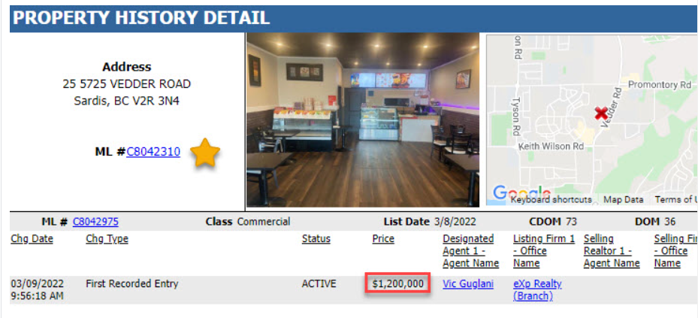 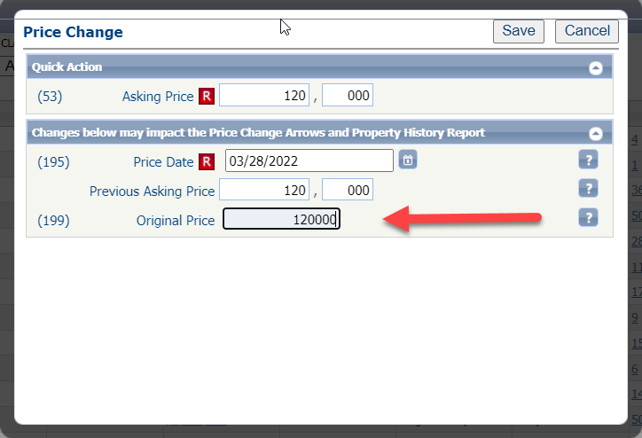

# Agent Level Changes

**The following section contains changes that are active system wide and available to users based on their assigned security levels.**

## Automatically Display Legend When Layer is Selected

### Action Item: N/A

The map layer control in Paragon has been enhanced to automatically expand the legend when the layer is selected. Previously, after clicking on the legend, users had to click on the icon to expand it. With this new functionality, just selecting the layer expands it as shown below for the current Flood Plain layer.

# Collaboration Center

**All options in this section are either configurable via MLS Administration controls or by your System Support Manager as noted.**

## No Changes

### Action Item: N/A

# Paragon Connect

**All options in this section are either configurable via MLS Administration controls or by your System Support Manager as noted.**

## Validate Address Location

### Action Item: N/A

The “Validate Address Location” is the latest enhancement added to the listing edit module. This is known as “Change Geocode” in Paragon Professional. Here’s how it works!

After entering your new listing (or from a current listing), click the overflow menu and select Validate Address Location and the map will display with a property pin and a NEW **Accuracy Indicator**

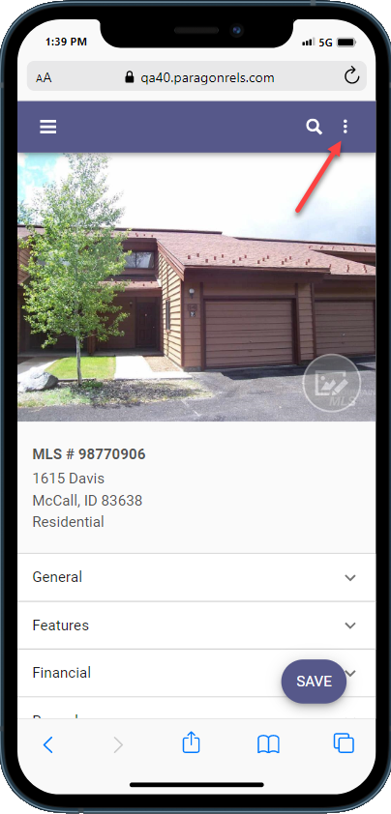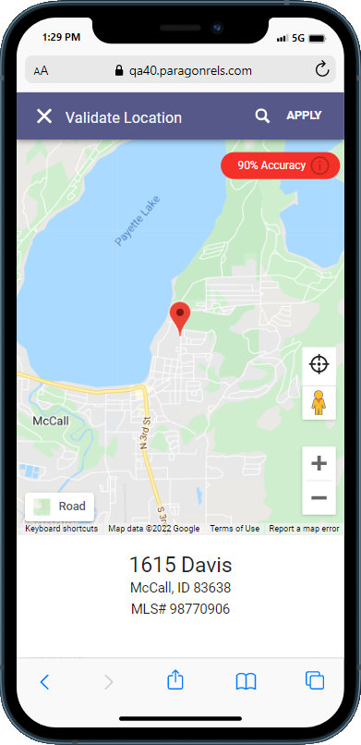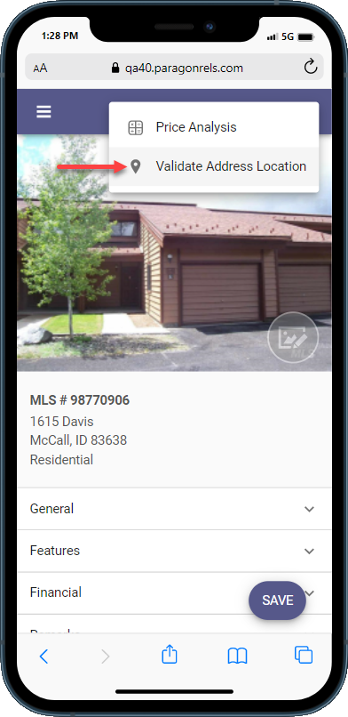

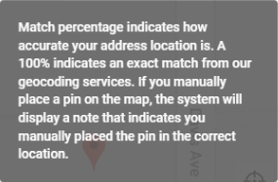If the Accuracy Indicator is red, it means that the geocode accuracy is something less than 100%. If it is green, then it’s spot on at 100% OR it has been manually placed. The goal is to provide you with an easy-to-see visual display of the geocode quality.

The accuracy indicator includes a **tool tip** icon that when clicked will display more information about the rating.

### Geocode Using Address Search

You can try manually entering the address to see if the pin moves by clicking the address search icon, entering the address and clicking the search icon again to get the result. By the way, this map search is the equivalent of the “Center Map and Zoom on this Address” in Paragon Pro.

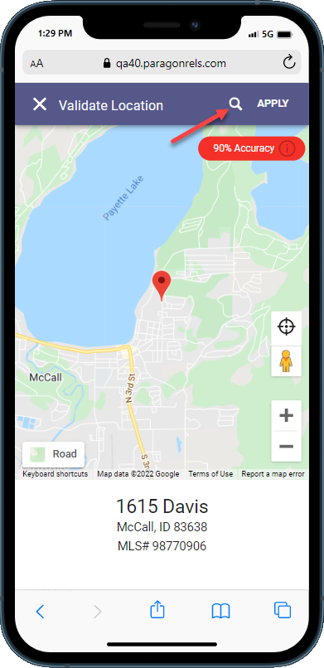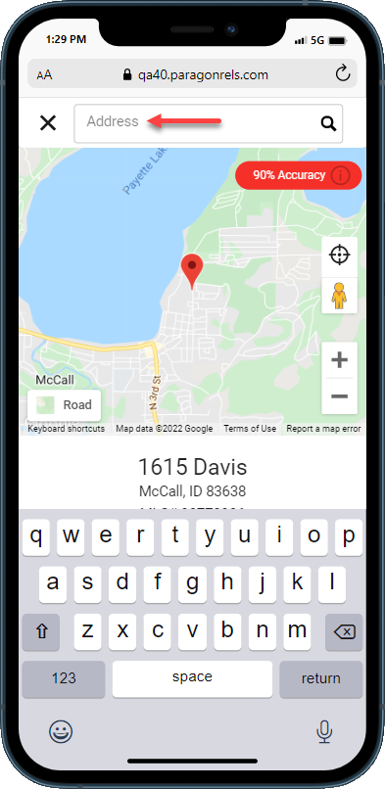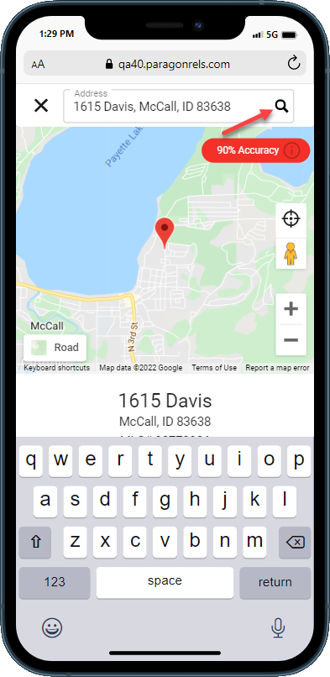

If the default Road view doesn’t provide enough information, switch to any one of seven views using the NEW **Map Types** feature!

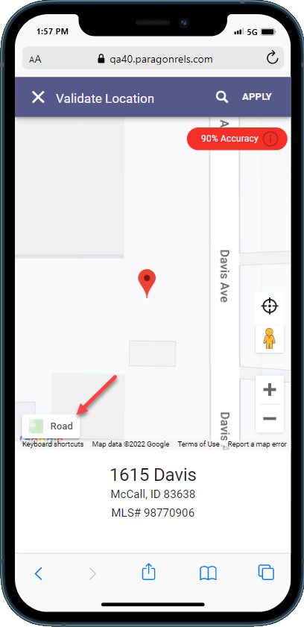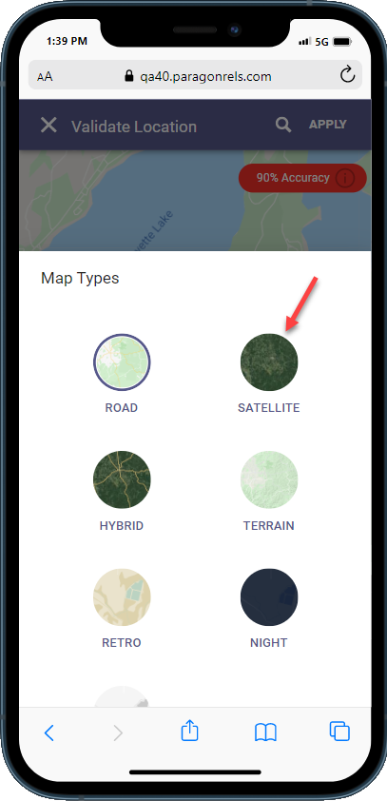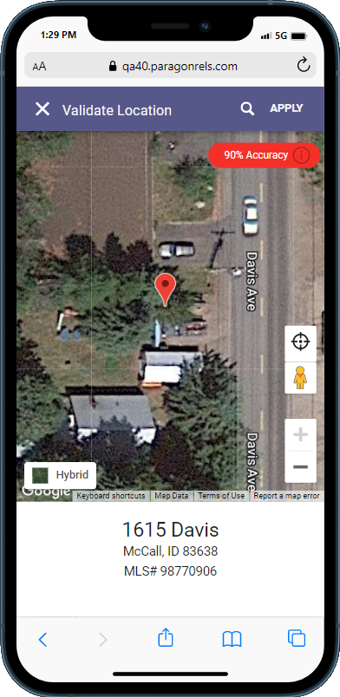

### Geocode by Moving Map Pin

You can move the pin manually by clicking on the pin with a mouse or using your finger to drag the pin to the new location. After moving the pin, the Accuracy Indicator will change to green and read “Manually Placed.” If you’re happy with the location, click APPLY. You will receive a prompt that the changes were applied but that you still need to save to retain the settings.

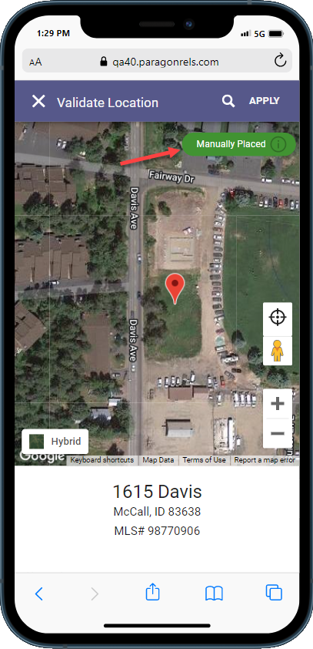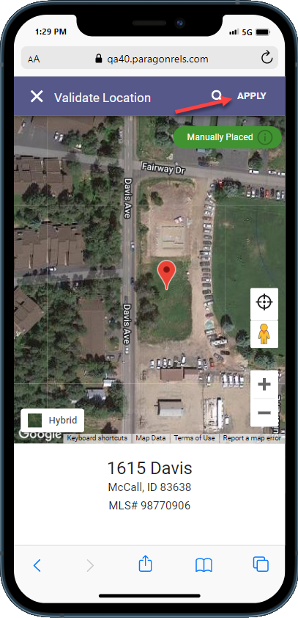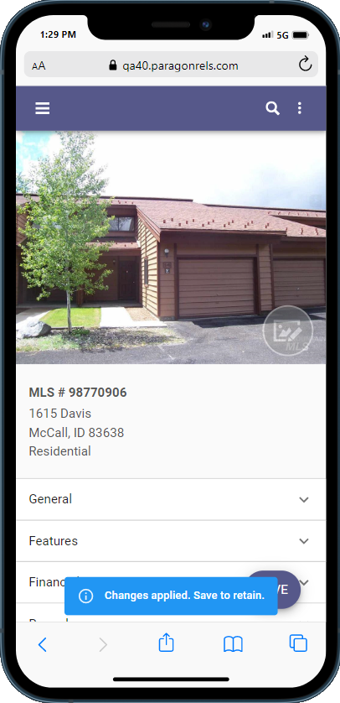

### Warning and Error Validation

In addition to being able to manually validate your location, the listing edit module will also check for any errors or warnings related to your address upon saving a listing. These are based on your business rules set for your organization.

## Contact Notification Options

### Action Item: N/A

Prior to the 5.89 release, contact notiﬁcation settings are only adjustable in Paragon Professional. Now, Paragon Connect users can adjust a variety of notiﬁcation options. Enable/disable your notiﬁcations, change notiﬁcation triggers, update when your notiﬁcations are sent and more. Below breaks down the diﬀerent options.

### Overflow Options

While viewing a saved search card, you will notice a new three dot overflow menu icon. This icon contains a menu with all your notification options. It includes the following:

* Disable/Enable Collab Center
* Email Options
* **Graphical user interface, application, chat or text message

  Description automatically generatedGraphical user interface, application

  Description automatically generated**Notification Triggers
* Notification Time Frames
* Resend Notification
* Delete Search

*Note: Overflow only available on saved searches for Collab Center*

### Enable/Disable

You now can enable/disable saved searches from displaying in your Collaboration Center site. In the example provided, the user disables the saved search. It removes the activity chart and moves it to the bottom of the list. User can then re-enable the saved search at any time by going to the overﬂow menu and tapping “Enable Collaboration Center.”

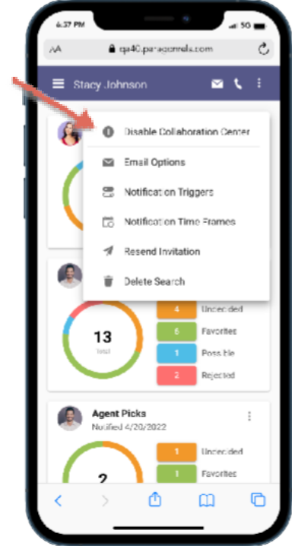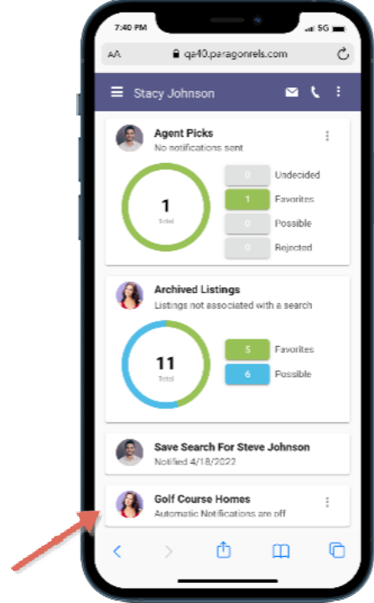

### Graphical user interface, application Description automatically generatedGraphical user interface, application Description automatically generatedEmail Options

Email options allow the user to edit who receives any email notification updates from the Collaboration Center. It also allows you to add a custom message that is displayed each time a notification email is sent.

Options include:

* Add or modify primary recipients
* Add or modify Cc recipients
* Add or modify Bcc recipients
* Modify email subject title
* Add or modify Custom message

### Notification Triggers

Notification triggers allow you to set what type of notifications your users will receive. Do they want to be notified on just new matches? Maybe it is new matches, price changes, status changes, etc. The notification trigger option will allow you to set what type of notifications your user will receive on each saved search.

* New Matches
* Price Changes
* Status Changes
* New Comments
* Open House Tour
* Initial Photo

### Time Frames

The Notification time frame allows you to edit how long the notification is active. By default, when you setup a notification, the date range is set to a year. You cannot set the date range to be longer than a year but if your notification is about to expire you can extend it to a full 12 months.

The time frame option also contains your client and agent notification frequency options. You can choose whether the notifications are set to off, immediately, or recurring. If set to recurring, you can set the notification time and when these notifications are sent. Below are the three frequency options:

* Daily
* Weekly (choose days)
* Monthly

### Delete Search

There are times when you no longer need a saved search. When this occurs, you can now use the “Delete Search” option from the saved search card overflow. This will remove the contact from the saved search and delete the card. A confirmation will display to make sure you want to delete the search.

### Resend Invitation

There are times when a prospective buyer cannot find or did not receive the Collaboration Center welcome email. This welcome email contains the information needed to use and access the Collaboration Center.

When this occurs, you can now go to that saved search for that contact and resend the invitation. The resend invitation contains an email dialog where you can add additional email addresses and provide a custom message.

## New Detail Report

### Action Item: N/A

As we continue to optimize Paragon Connect, we are pleased to introduce our updated detail report. This report is like the previous version only there are some significant upgrades. Below are a few noticeable upgrades:

* Performance boost
* Larger, darker fonts
* Several UI Updates

*Note: New detail report is only found from results generated from within the contact manager module.*

### Performance Boost

The loading of the report has been a major focus of the new React detail report. The goal is for that report to open as quickly as possible. This allows you to view full listing data quickly!

* **Current Detail Report**

4-5 Seconds

* **New Detail Report**

1-2 Seconds

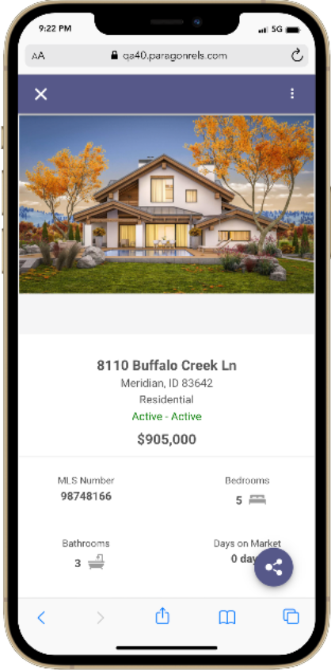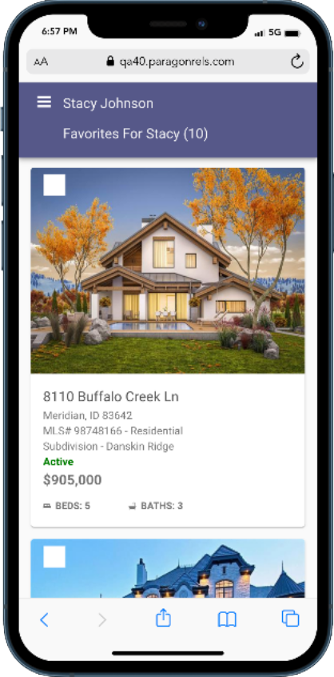

### Font Updates

There are several updates to the font type, styles, color and more. The ﬁrst update is the font family being used. All the new React based components are using Roboto instead of Open Sans. It is a thicker type of font making it easier to read. The font color was also darkened to help make it easier to read. Also, the font sizes were increased. Overall, the legibility of the detail report has been greatly improved.

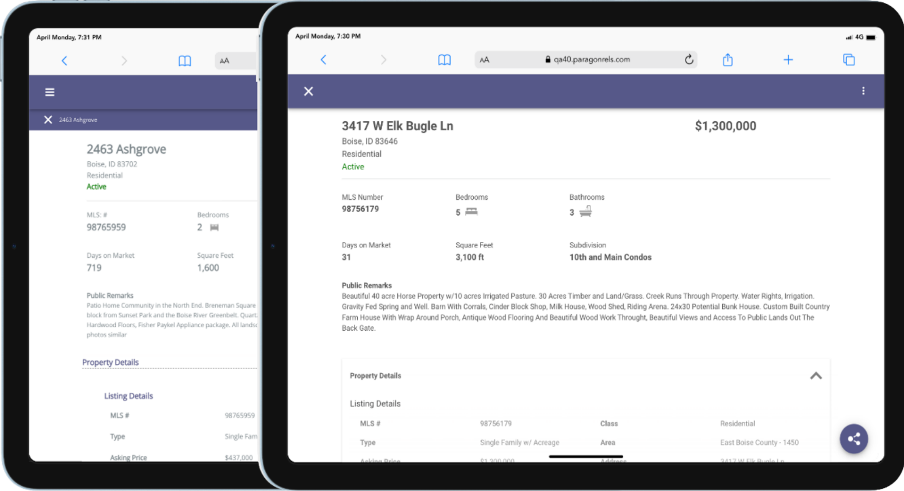

Current Report New React Detail Report

### Additional Updates

There are several other updates made to this report. You will see updates to the mortgage calculator, AVMs, property history, public records, share options, and even how you access different menu options.

# Paragon Affiliate Connect

**All options in this section are either configurable via MLS Administration controls or by your System Support Manager as noted.**

# Corrected Paragon Affiliate Connect Issues

|  |  |  |
| --- | --- | --- |
| **Ticket #** | **Module** | **Summary** |
| DEV-5970 | Admin | Ability to disable My Affiliates under Broker Options is not working |
| DEV-6234 | Affiliate Search | [Regression] No record shows when agent search for affiliate to connect |
| DEV-6009 | General UI | The info button for affiliates in the service partners tab need to be updated |
| DEV-6516 | Email | When an agent shares the affiliates with contacts, the agent message does not appear |
| DEV-6313 | Email Communications | Buyer activity emails are being sent to affiliates even though the setting is off |
| DEV-6342 | General UI | Disable "Connect to an Affiliate Option" when a Broker does not allow Agents to connect to personal affiliates |
| DEV-6367 | General UI | Affiliate List Extends Past Boundaries of Select Affiliate to Connect Modal |
| DEV-6452 | General UI | When an affiliate looks at "buyer activity tab" there are "=" symbols next to the search criteria |
| DEV-6486 | General UI | the logo and affiliate photo on branding block run together |
| DEV-6556 | Email Communications | Prospecting email notifications to affiliates needs to be turned off |
| DEV-6585 | Dashboard | Affiliate dashboard sorting default needs to be changed |