Paragon Customer Toolkit - Release 5.90

## **Communications Plan Overview**

Welcome to the Paragon release communication Toolkit. The intention of this kit is to help you with communicating the release information to your membership.

In this kit you will find the following:

* Link to Release Notes for Paragon 5.90: the notes include any configurations and administration items that you will need to know about.
* Administration Configuration Options: What changes you may need to decide on
* Agent level Communication Plan: a link to an editable Customer Communication, and homepage notifications.
* Social Media: a post that you can use for Facebook, Instagram or other sites with a video of the release features.
* Example Home Page Announcements: You can cut and paste into your Homepage.

The goal is to make everyone aware of all the great Paragon enhancements to boost the way Members do Business!

## **Release Notes for Paragon 5.90**

Listed below is a link to the full release notes for the MLS. These release notes are for the Association/MLS. The Agent Level changes in this document are included in the e-mail template that you will want to send out to your members.

**Link:** [Release Notes](https://pahelp.paragonrels.com/ReleaseNotes/WordDocs/5_90_Release_Notes.docx)

## **Administration Configuration Options**

**NAR Mandate – Broker Attribution**

**Action Item:** If you need help with the RETS change contact your SSM (this will require a RETS refresh)

In compliance with the NAR mandate for Broker Attribution, a new node has been added to the Preferences/System tree for “IDX/VOW Contact Info” in Paragon Professional. This addition will allow the broker to select a phone number **or** email address to be displayed in listings that go out in IDX and VOW data feeds via RETS.

**Figure 1: IDX/VOW Contact Info node**

A dropdown will be added to the page labeled as ‘Attribution Contact,’ thus allowing the broker to select from a list of phone numbers and emails. However, this field is optional, and the broker does not have to set a value. Only security level 5 and up will be able to populate this field and only one value can be selected. The dropdown list will include the following options:

* No value selected
* Agent preferred phone
* Agent email
* Office broker preferred phone
* Office broker email
* Office phone #1 – 3
* Office email

When any of the above options are not populated with data in Paragon, that option will not display in the dropdown list. If a broker is not assigned to the office, a message will appear indicating, “No broker is currently assigned to this office” and the two broker dropdown options will not appear in the list.

**Figure 2: No broker associated with the office**

When the broker is assigned to multiple offices, each office will appear with a separate dropdown. The broker will have the ability to set a different value for each office. Graphical user interface, text, application

**Figure 3: Multiple offices**

The “No Value Selected,” which is equivalent to not having selected an option, will be the default. As per the mandate, the Listing Participant must select the value and therefore, Black Knight is not allowed to pre-select for the Broker/MLS. Once a real value is selected by the broker, the actual phone number or email address will get appended to outbound IDX and VOW listing data feeds. The field will be labeled as, ‘AttributionContact’ in the data feed in accordance with the RESO standard. Also, a RETS Profile will need to be created for the Attribution Contact. This screenshot illustrates that setup:

**Figure 4: Sample RETS Profile**

## **Statistical Reporting – Add Zero Volume filter to Year-to-Year Report**

The Year-to-Year report now respects the Include w/ Zero Volume filter. When selected, the report includes all results. When unselected, the report will exclude sections where all columns are zeroes. The filter will be added to the report and selected by default. This will ensure the report runs as it currently does, returning all results. Users can uncheck the filter in the search criteria to exclude sections where all columns are zeroes.

## **Add # Branches and Member of Board to Firms Grid**

From Admin > Maintain > Firms, the grid now includes a column for # Branches, and the office Member of Board (when Boards are enabled). The Boards filter is also available in the Firms toolbar.

The # Branches link opens a modal with the main office and branch information

**RETS/WebAPI – Add PasswordModDate**

### **Action Item:** Please Contact your SSM if you wish to have this field added to a RETS or WebAPI feed.

To help our customers keep passwords in sync between Paragon and membership import systems, a new field, PasswordModDate, has been added to the user table. This field will be automatically populated any time an agent’s password is updated in Paragon.

## **Listing Maintenance Menu Option - Paragon Connect**

### **Action Item**: Contact your SSM if you would like to turn on this option

This release includes the beginning work for a new Listing Maintenance module within Paragon Connect. Currently agents do have the ability to edit existing listings. With this new feature it gives them the ability to start a brand-new listing and continue to edit it until it is ready to be published as a complete, live listing.

This new feature also provides the agent a place to access all the published and unpublished listings they have permission to maintain.

This new feature will be **disabled** by default for all customer systems and can be enabled upon request by your SSM. It can be enabled by security level allowing MLS Staff the ability to evaluate before turning it on for all levels of users.

## **Agent Level Changes Communication Plan**

The following link is to the e-mail template that you can copy and paste from to send out to your members keeping them informed on the release. [Paragon Release 5.90 Member Email](https://pahelp.paragonrels.com/ReleaseNotes/WordDocs/5_90Email_to_agents.docx)

This is a word document that you can edit so if you **do not** have certain functionality, for example in this release there are three optional items, Statistical Reporting – Year-to-Year Report and the Month End Report and for Paragon Connect the Listing Add, you can remove those sections first before sending. Also, in the first sentence you will want to add **your MLS name** (it is in red), so that it is being sent from **your** organization to **your** members.

To ensure that your members are always informed about the latest and greatest enhancement to their MLS System, please announce the enhancements to your membership, post to Social Media sites, include them in your newsletters and post notices to your homepage and login messages.

## **Social Media Post**

Copy and paste the following into your social media and the picture below will display with the video. Encourage your membership to like our Facebook page @ParagonMLS. Check out the exciting new features of the Paragon 5.90 release! If clicking on the image does not open the video, please [click here](https://vimeo.com/725395041) to open the video.

[](https://player.vimeo.com/video/725395041?h=f55ee03e3d&app_id=122963)

## **Example Home Page Announcements**

The release has a lot of nice enhancements, you may want to highlight a different one every few days on your homepage and via social media. You can just cut and paste these into your homepage editor. If you want to add pictures you can do that too but make sure to upload them to your server.

**New Hotsheet in Paragon Connect**

The Hotsheet search in Paragon Connect has been completely remodeled and upgraded in the 5.90 release. This search now includes additional functionality that makes it fully in sync with Paragon Professional. In addition to the new functionality, this module has been migrated into our React/Inferno code base. It even includes a few new features not found in Paragon Professional. Check out the full release for all the functionality!

**New Listing Detail Report in Paragon Connect**

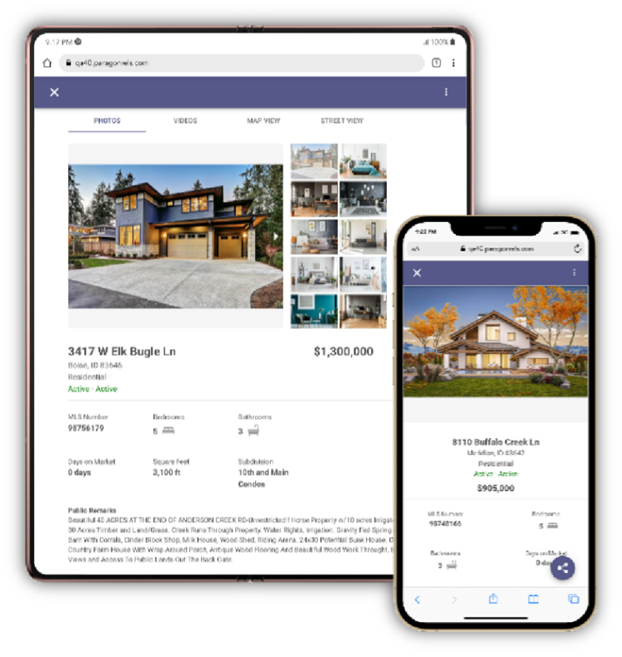The new high performing detail report has replaced the old Paragon Connect detail report throughout the following areas in Paragon Connect.

Property Class Search

* My Location Search
* Open House Search
* Hotsheet Search
* Power Search
* Single bubble count on active buyer on the dashboard
* Seller’s tab on dashboard
* Comments on dashboard
* My Info Page
* My Listing Carts

***Note:*** *The new version of the Connect View report will not be updated in Paragon Professional until the 5.91 release.*