Paragon Customer Toolkit - Release 5.91

## **Communications Plan Overview**

Welcome to the Paragon release communication Toolkit. The intention of this kit is to help you with communicating the release information to your membership.

In this kit you will find the following:

* Link to Release Notes for Paragon 5.91: the notes include any configurations and administration items that you will need to know about.
* Administration Configuration Options: What changes you may need to decide on
* Agent level Communication Plan: a link to an editable Customer Communication, and homepage notifications.
* Social Media: a post that you can use for Facebook, Instagram or other sites with a video of the release features.
* Example Home Page Announcements: You can cut and paste into your Homepage.

The goal is to make everyone aware of all the great Paragon enhancements to boost the way Members do Business!

## **Release Notes for Paragon 5.91**

Listed below is a link to the full release notes for the MLS. These release notes are for the Association/MLS. The Agent Level changes in this document are included in the e-mail template that you will want to send out to your members.

**Link:** [Release Notes](https://pahelp.paragonrels.com/ReleaseNotes/WordDocs/5_91_Release_Notes.docx)

## **Administration Configuration Options**

**Admin Grids – Miscellaneous Updates**

**Action Item:** N/A

To improve functionality, various updates have been added to several result grids in the admin module.

* **Admin > Reports > Office Reports > Office Roster**: The Office State filter was added, and the Office City filter was changed to a lookup, making it consistent with the Office City filter on other roster reports.

* **Admin > Manage > Firms:** From the Firms grid, selecting Report now opens the report filters and results in new tabs, rather than replacing the grid view.

* **Admin > Listing > State:** All the columns have been enhanced to sort the grid in ascending or descending order, as is common throughout Paragon.

## **Admin – Collaboration Center – Option to turn off Login**

**Action Item:** Contact your SSM if you wish to turn off the Collaboration Center client login requirement.

To accommodate our customers’ request, we have provided an option to turn off the client login requirement in Collaboration Center. Turning off the login requirement removes the create and reset password information from the client email notifications, hides the “Create an account” page on Collaboration Center, hides the Login page, and hides the Logout button.

**Please note that this does NOT make the Collaboration Center a public site.** Links to the Collaboration Center in the client emails contain a unique ID that will automatically log the user into their personal Collaboration Center site. Without that unique ID, they will not be able to access the site.

The client will need to access the site from the links in the client email notifications or welcome email. Attempting to access the site from a bookmark will return a “session ended” message instructing the user to use the emailed links or contact their real estate professional.

## **Agent Level Changes Communication Plan**

The following link is to the e-mail template that you can copy and paste from to send out to your members keeping them informed on the release. [Paragon Release 5.91 Member Email](https://pahelp.paragonrels.com/ReleaseNotes/WordDocs/5_91_Email_to_agents.docx)

This is a word document that you can edit so if you **do not** have certain functionality, for example in this release there are three optional items, Statistical Reporting – Year-to-Year Report and the Month End Report and for Paragon Connect the Listing Add, you can remove those sections first before sending. Also, in the first sentence you will want to add **your MLS name** (it is in red), so that it is being sent from **your** organization to **your** members.

To ensure that your members are always informed about the latest and greatest enhancement to their MLS System, please announce the enhancements to your membership, post to Social Media sites, include them in your newsletters and post notices to your homepage and login messages.

## **Social Media Post**

Copy and paste the following into your social media and the picture below will display with the video. Encourage your membership to like our Facebook page @ParagonMLS. Check out the exciting new features of the Paragon 5.91 release! If clicking on the image does not open the video, please [click here](https://vimeo.com/745861176) to open the video.

[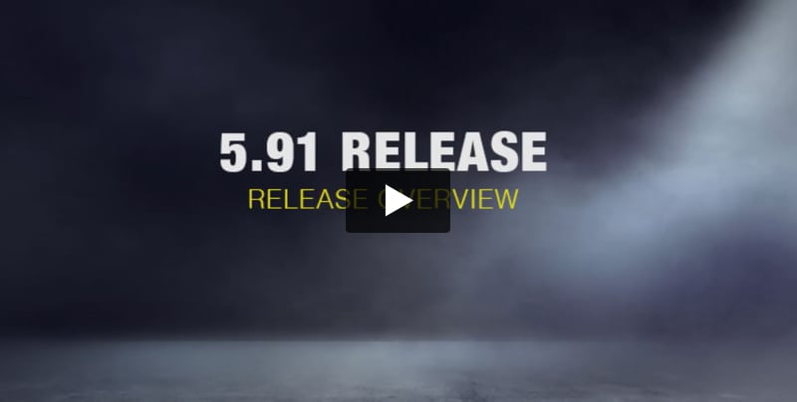](https://vimeo.com/745861176?embed_email_provider=gmail)

## **Example Home Page Announcements**

The release has a lot of nice enhancements, you may want to highlight a different one every few days on your homepage and via social media. You can just cut and paste these into your homepage editor. If you want to add pictures you can do that too but make sure to upload them to your server.

## **Contact Message History**

You now have access in Paragon Connect to view the message history for your contacts. The message history can be accessed by navigating to a contact profile page and clicking the Message History link. The key features contained in this release are the following:

* Filter messages by message type and/or date range
* Delete message(s)
* Search for messages
* Preview messages

## **Connect View in Paragon Professional**

The Connect View already exists today in your Paragon Professional system. However, in 5.91 the report has been completely upgraded. While the functionality and data will remain, the same there are key upgrades that you will come to enjoy. Below is a list of those upgraded features and functions.

**Performance**

The report’s backend and frontend have been upgraded to use our latest Next Generation coding features. The report should now display and function much faster than before.

### **Display**

All font sizes are increased form 12px to 14px, the font color is darkened, and the font type has been changed to a cleaner and easier to read font.

### **Mix Features and Fields**

The new detail report now allows you organization to mix features and ﬁelds in the same section.

Previously, features could only be displayed in a feature section.

### **Additional Updates**

There are other updates made to this report. You will see updates to the mortgage calculator, AVMs, property history, public records, and more.