Paragon Customer Toolkit - Release 5.92

## **Communications Plan Overview**

Welcome to the Paragon release communication Toolkit. The intention of this kit is to help you with communicating the release information to your membership.

In this kit you will find the following:

* Link to Release Notes for Paragon 5.92: the notes include any configurations and administration items that you will need to know about.
* Administration Configuration Options: What changes you may need to decide on
* Agent level Communication Plan: a link to an editable Customer Communication, and homepage notifications.
* Social Media: a post that you can use for Facebook, Instagram or other sites with a video of the release features.
* Example Home Page Announcements: You can cut and paste into your Homepage.

The goal is to make everyone aware of all the great Paragon enhancements to boost the way Members do Business!

## **Release Notes for Paragon 5.92**

Listed below is a link to the full release notes for the MLS. These release notes are for the Association/MLS. The Agent Level changes in this document are included in the e-mail template that you will want to send out to your members.

**Link:** [Release Notes](https://pahelp.paragonrels.com/ReleaseNotes/WordDocs/5_92_Release_Notes.docx)

## **Administration Configuration Options**

**Admin – Restrict Level 7 user access to Level 8 member records**

**Action Item:** N/A

Per customer request, security level 7 users viewing the member record for a level 8 user will be unable to change the Active checkbox, the Locked checkbox, or the Security Level dropdown. [Admin > Manage > Users]

**Admin – Member of Board defaults to All Boards for Level 8 users**

**Action Item:**  Contact your SSM to change the default from N to Y

If multiple boards are set up on your site, the Member of Board dropdown on the Agent and Office grids will default to All Boards for level 8 users, if the config setting RESTRICT_SL8_TO_OFFICE_BOARDS=N. If RESTRICT_SL8_TO_OFFICE_BOARDS=Y, the dropdown will default to the user’s Office Member of Board. Graphical user interface, application

## **Agent Level Changes Communication Plan**

The following link is to the e-mail template that you can copy and paste from to send out to your members keeping them informed on the release. [Paragon Release 5.92 Member Email](https://pahelp.paragonrels.com/ReleaseNotes/WordDocs/5_92_Email_to_agents.docx)

This is a word document that you can edit so if you **do not** have certain functionality, for example in this release there are three optional items, Statistical Reporting – Year-to-Year Report and the Month End Report and for Paragon Connect the Listing Add, you can remove those sections first before sending. Also, in the first sentence you will want to add **your MLS name** (it is in red), so that it is being sent from **your** organization to **your** members.

To ensure that your members are always informed about the latest and greatest enhancement to their MLS System, please announce the enhancements to your membership, post to Social Media sites, include them in your newsletters and post notices to your homepage and login messages.

## **Social Media Post**

Copy and paste the following into your social media and the picture below will display with the video. Encourage your membership to like our Facebook page @ParagonMLS. Check out the exciting new features of the Paragon 5.92 release! If clicking on the image does not open the video, please [click here](https://vimeo.com/765695217) to open the video.

[](https://vimeo.com/765695217?embed_email_provider=gmail)

## **Example Home Page Announcements**

The release has a lot of nice enhancements, you may want to highlight a different one every few days on your homepage and via social media. You can just cut and paste these into your homepage editor. If you want to add pictures you can do that too but make sure to upload them to your server.

## **Contact List Updates**

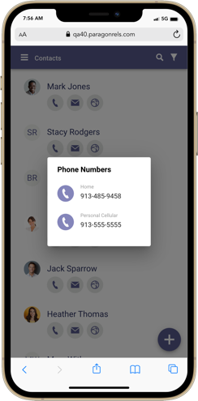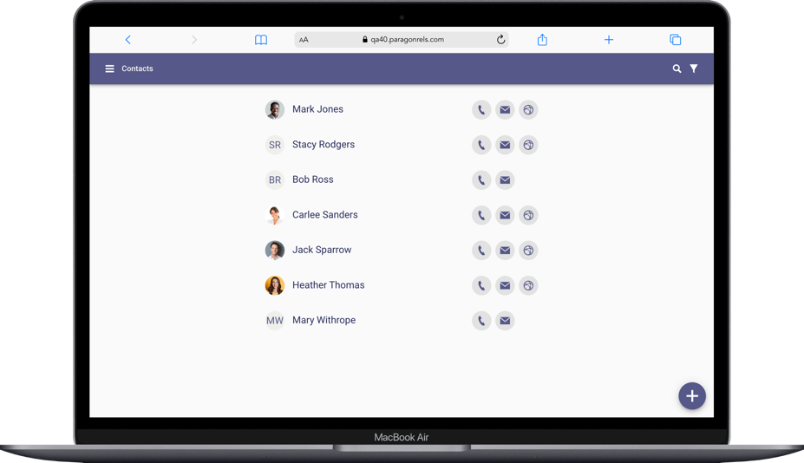The contact list was updated to include three shortcut actions that help you quickly get access your client’s information. These three actions include the ability to view all phone numbers, email addresses, and a link to the client’s Collaboration Center site.

**Phone:**

Tapping on the phone icon will open a simple dialog and list all phone numbers associated with the contact. Depending on the device you are on you can tap on the phone number to instantly call the contact or you can click on an SMS icon to text your client.

**Email:**

Clicking or tapping on the email icon will open a simple dialog with a list of all email addresses associated to the contact. You can select one or more email addresses to compose an email to your client.

**Collaboration Center:**

If your contact has a notification setup, you will find a web icon that when clicked/tapped will take you to your contact’s Collaboration Center site.

## **Hotsheet Alert Save**

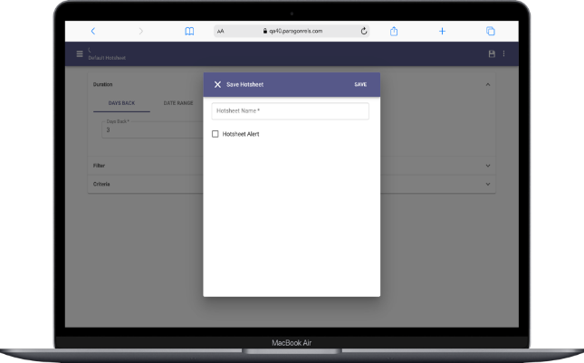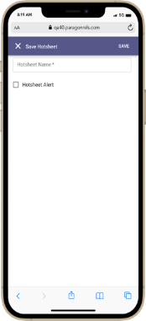

Prior to the 5.92 release, you would need to go to your saved Hotsheet searches to set a Hotsheet alert. Now you can set a Hotsheet alert while you save a new search. Note: Max number of alerts you can save is 5. Once you meet this threshold, the option to save a new alert from the save process will be disabled.

## **Rich Text Editor**

The compose email message body has been upgraded to include a rich text editor. This will allow you to now apply some formatting options to the emails that you compose. This is available on all devices small and large. Below is a list of formatting options you will find.

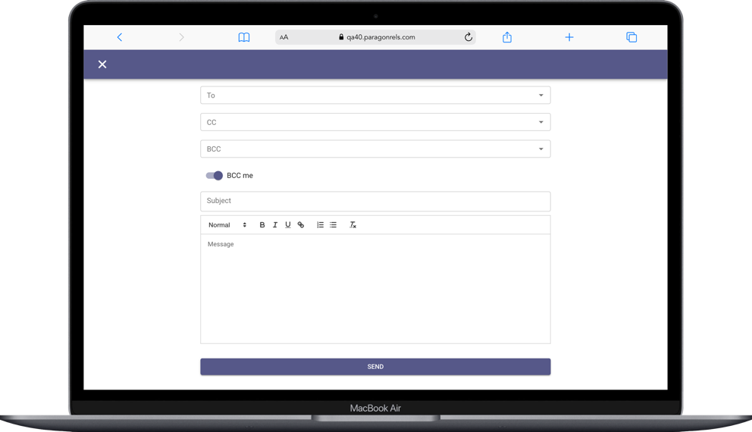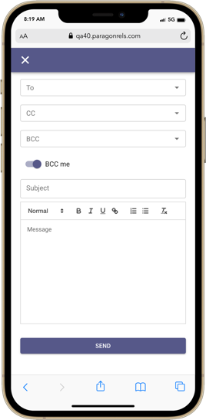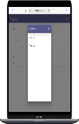

* Font type
* Bold
* Italics
* Underline
* Add a link
* Unordered bullets
* Numbered bullets
* Stroke

## **Associated Documents Listing Input Maintenance**

If enabled in Paragon Professional, you will now have access in Paragon Connect to upload or manage documents for your listings. The Associated Documents feature can be accessed by navigating to the listing edit screen in the Listing Input Maintenance module. Paragon Connect Associated Documents follow the exact same logic as Paragon Pro for document size, number of documents, document type, etc. The key features contained in this release are the following:

* Add documents
* Manage documents
  + Edit
  + Delete
* View documents

***Note:*** *The Associated Documents were released to production between the 5.91 and 5.92 releases.*