

**PARAGON - INNOVATING THE WAY AGENTS DO BUSINESS**

**Paragon Release 5.92**

We (enter your MLS Name here) wanted you to be the first to know about the latest enhancements to your Paragon MLS System. All enhancements are designed to help you navigate through the system and enhance your experience with Paragon.  Below is a list of the enhancements and links to view videos or PDFs of the new features. We encourage you to continue reading and let us know what you think on the [Paragon MLS Facebook site](https://www.facebook.com/ParagonMLS/). Also make sure you click “Like” on the Facebook site to view what’s new with Paragon more frequently.

**WHAT’S NEW!**

**PARAGON**

**Updated help text on Expiring Notifications modal**

On the Expiring Notifications modal, extending notifications follows your setting in Preferences > Email > Default Notification Recurrence > Expiration. The Expiring Notifications modal incorrectly stated that notifications would be renewed for 12 months. The text has been corrected to note that the renewal period will follow your preferences.

*Previous text:* Extend will renew the notifications for 1 year.

*Updated text:* Extend will renew the notifications for up to 1 year, based on your notification settings in Preferences.

**Password Change Screen now reflects maximum allowed characters**

Paragon has a maximum limit of 20 characters for user passwords, but this was not conveyed on the Change Password screen. The password input text boxes will no longer allow more than 20 characters to be entered, and passwords copied and pasted into the field will truncate at 20 characters.

The password requirement text for minimum length was updated to reflect the minimum and maximum number of allowed characters: Length must be between [#] and 20 characters. [*Note: minimum number of characters is configured per MLS.*]

In addition, help text was added to address imported or copy/pasted passwords: Imported passwords are limited to the first 20 characters.

**Paragon Connect**

## Contact List Updates

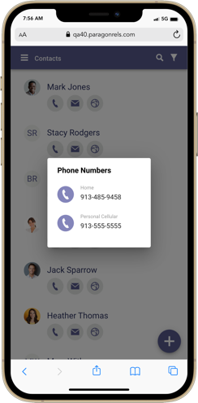The contact list was updated to include three shortcut actions that help you quickly get access your client’s information. These three actions include the ability to view all phone numbers, email addresses, and a link to the client’s Collaboration Center site.

**Phone:**

Tapping on the phone icon will open a simple dialog and list all phone numbers associated with the contact. Depending on the device you are on you can tap on the phone number to instantly call the contact or you can click on an SMS icon to text your client.

**Email:**

Clicking or tapping on the email icon will open a simple dialog with a list of all email addresses associated to the contact. You can select one or more email addresses to compose an email to your client.

**Collaboration Center:**

If your contact has a notification setup, you will find a web icon that when clicked/tapped will take you to your contact’s Collaboration Center site.

## Hotsheet Alert Save

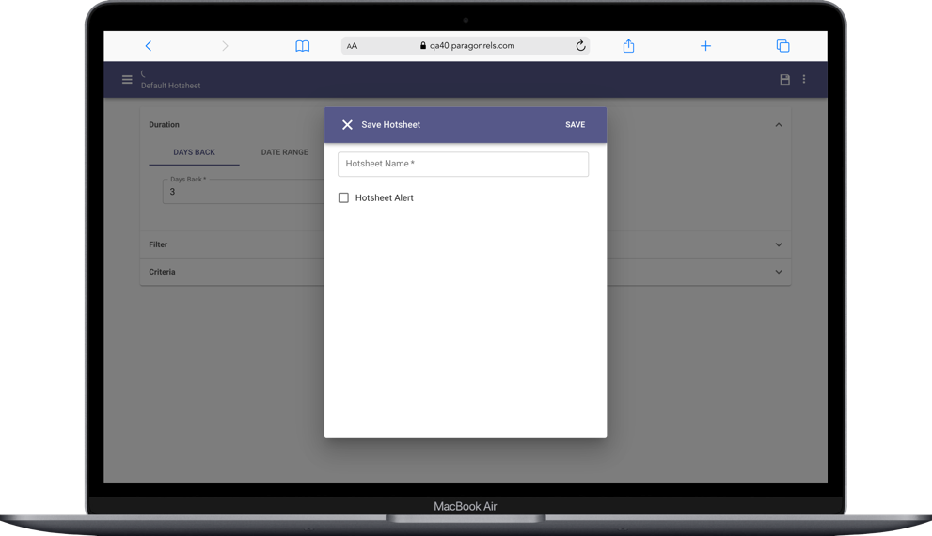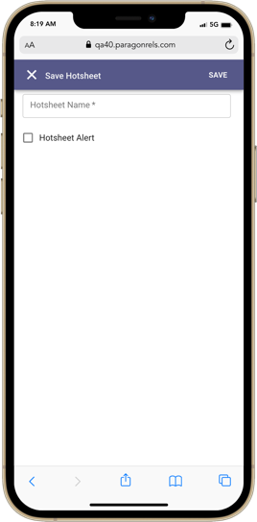

Prior to the 5.92 release, you would need to go to your saved Hotsheet searches to set a Hotsheet alert. Now you can set a Hotsheet alert while you save a new search. Note: Max number of alerts you can save is 5. Once you meet this threshold, the option to save a new alert from the save process will be disabled.

## Rich Text Editor

The compose email message body has been upgraded to include a rich text editor. This will allow you to now apply some formatting options to the emails that you compose. This is available on all devices small and large. Below is a list of formatting options you will find.

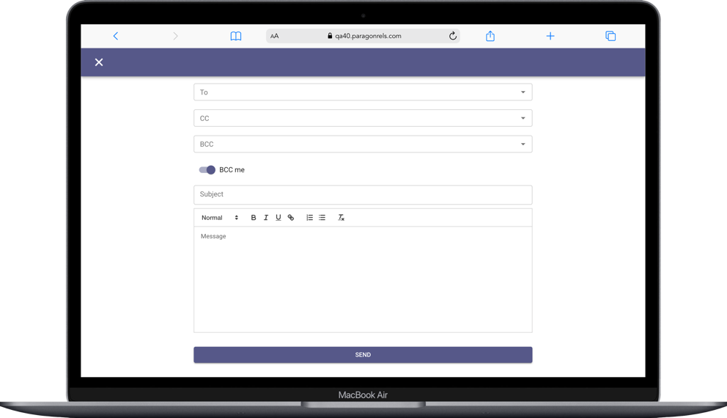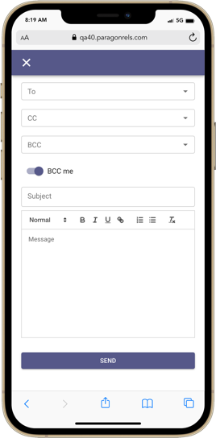

* Font type
* Bold
* Italics
* Underline
* Add a link
* Unordered bullets
* Numbered bullets
* Stroke

## A picture containing text, screenshot, monitor Description automatically generatedPurge Date

The ability to add a new listing is just around the corner. There are still a few features we are working on before we enable this feature for everyone. In the meantime, here is an update to the “Unpublished” section. The listings results have now been updated to include a “Purge Date.” This purge date will let you know when this unpublished (partial) listing will be removed from the system if not converted to a published (live) listing.

## Co-Agent

While viewing a list of your published or unpublished listings, you will now see the Co-Agent added to any listing that contains a secondary agent on the listing.

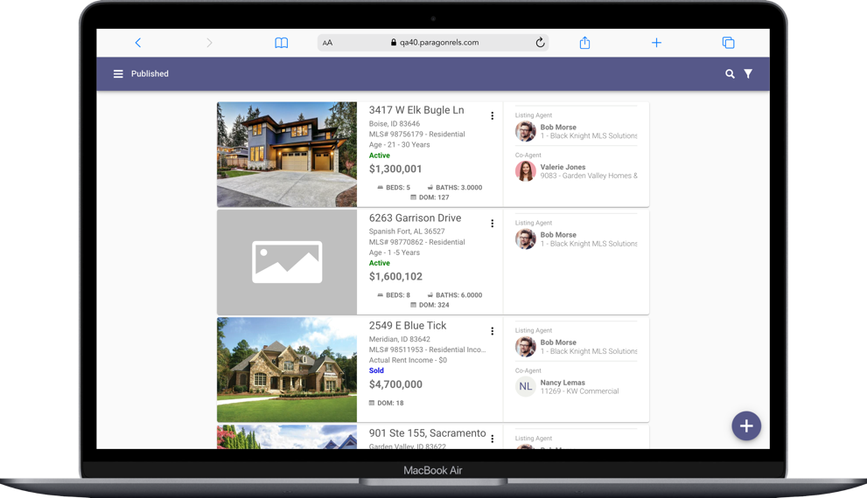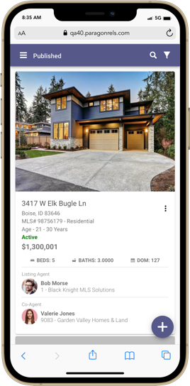

You can also click or tap on the agent or co-agent to view additional agent and office information.

## Graphical user interface, application Description automatically generatedLookup Sort

The lookup sort order has been updated to honor the configurable sort order established by the Paragon Pro system.

## Tour - LIM

The ability to add, edit, and delete tours has been added to the 5.92 release. This will sync with your Paragon Pro system and will alow you to see any tours created in either system.

***Note:*** *If your system utilizes “Tour Groups” the ability to add/edit tours has been disabled. Additional enhancements are needed to support this feature and will be added to the system in the near future.*

**Add:**

To add a new tour, you first must go to a listing that you can edit. Once you have accessed the listing edit form, the overflow icon (three dots) will contain a new option called “Tours.” This will house all of your tours for that listing. To add a new tour, you will click on the purple + icon in lower right hand corner. This will launch the add tour modal. You fill out the form as instructed, click save, and just like that a new tour has been created.

**Edit:**

You can click/tap on the card to edit the tour. You can also click/tap on the three dot overflow icon on the card to see an edit option.

**Delete/+ Calendar:**

There are two links on the card. The +Calendar link will add the event to your native calendar that you are using. The delete option will allow you to delete the tour from the listing.

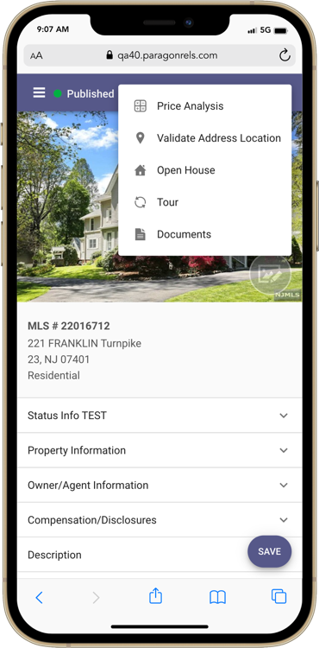

Delete Tour

Add New Tour

Tour Menu

Tour Cards

## Associated Documents Listing Input Maintenance

If enabled in Paragon Professional, you will now have access in Paragon Connect to upload or manage documents for your listings. The Associated Documents feature can be accessed by navigating to the listing edit screen in the Listing Input Maintenance module. Paragon Connect Associated Documents follow the exact same logic as Paragon Pro for document size, number of documents, document type, etc. The key features contained in this release are the following:

* Add documents
* Manage documents
  + Edit
  + Delete
* View documents

***Note:*** *The Associated Documents were released to production between the 5.91 and 5.92 releases.*

**Access Associated Documents**

The Associated Documents can be accessed by navigating to the edit listing screen in the Listing Input Maintenance module, clicking on the overflow menu, and clicking on the Documents link.

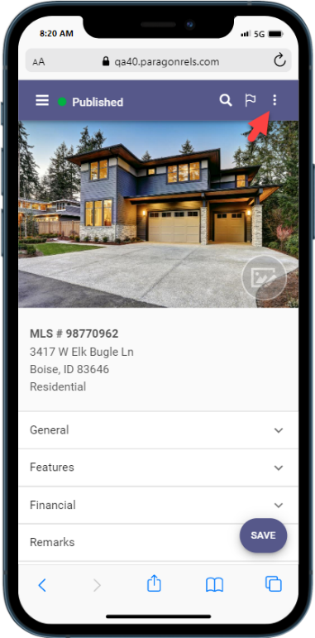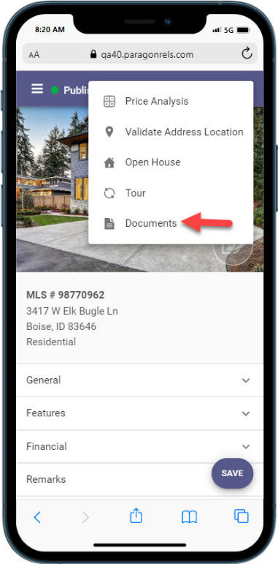

**Adding a Document**

Clicking on the + button will display the Add Document upload page. The following options will be available on the upload page:

* Choose File – Clicking CHOOSE FILE will opens the native file selection option for your device.
* Description – Enter a brief description of the document.
* Document Type – This field will only display if enabled by your administrator. It will display as a drop-down menu.
* Share with Public – Checking this option will make the document publicly display in Collaboration Center and available to be shared via email.
* Click the UPLOAD link to upload the document.

**Manage Documents**

Clicking on the document card opens the document.

Clicking on DELETE will delete the document.

Clicking on EDIT allows you to edit the description, document type, and the share option. The document type field will only display if enabled by your administrator. Clicking the SAVE link will save your changes.

## CRS Data Tax Autofill from Listing Maintenance

CRS Data Tax Autofill will be available for all CRS Data customers. It will appear as an option from the Listing Add + plus sign.

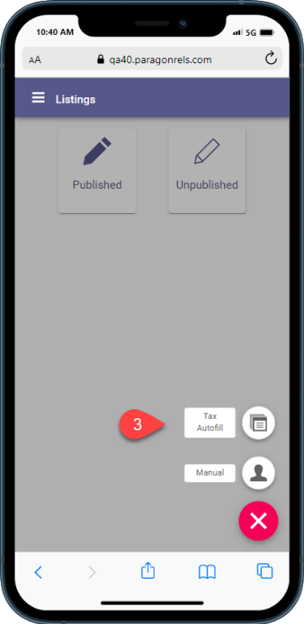

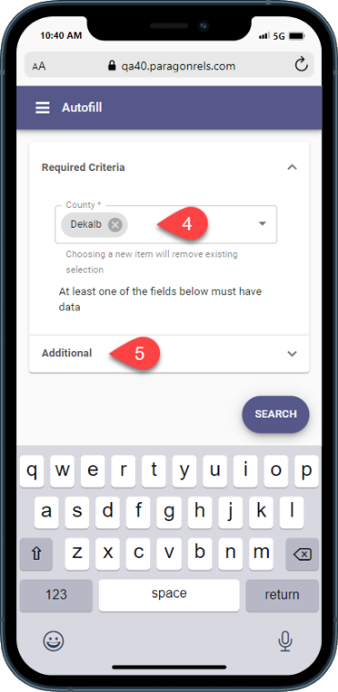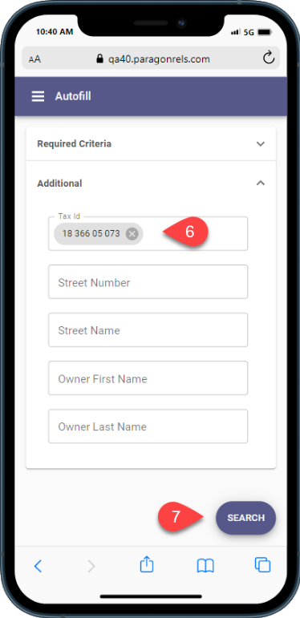

CRS Data Tax Autofill continued…

