Paragon Customer Toolkit - Release 5.93

## **Communications Plan Overview**

Welcome to the Paragon release communication Toolkit. The intention of this kit is to help you with communicating the release information to your membership.

In this kit you will find the following:

* Link to Release Notes for Paragon 5.93: the notes include any configurations and administration items that you will need to know about.
* Administration Configuration Options: What changes you may need to decide on
* Agent level Communication Plan: a link to an editable Customer Communication, and homepage notifications.
* Social Media: a post that you can use for Facebook, Instagram or other sites with a video of the release features.
* Example Home Page Announcements: You can cut and paste into your Homepage.

The goal is to make everyone aware of all the great Paragon enhancements to boost the way Members do Business!

## **Release Notes for Paragon 5.93**

Listed below is a link to the full release notes for the MLS. These release notes are for the Association/MLS. The Agent Level changes in this document are included in the e-mail template that you will want to send out to your members.

**Link:** [Release Notes](https://pahelp.paragonrels.com/ReleaseNotes/WordDocs/5_93_Release_Notes.docx)

## **Administration Configuration Options**

**Admin – Broker Attribution has been expanded to LIM**

**Action Item:** Contact your SSM to Enabled this field

To allow broker attribution selection on a listing-by-listing basis, we have added a new LIM field, “Broker Attribution Override” (phys num 543). This field is **disabled by default**, you must contact your SSM to enable it. Please note that this field cannot be set to Required.

This new field allows up to fifty freeform characters for entry of a phone number or email address. This field is not searchable in property searches but is viewable on listing reports. When populated on a listing, it will override the value the broker has set for the IDX/VOW data feeds in Paragon Preferences and the value entered on the listing will go out in the data feeds instead. To revert this back to the value set by the broker in Preferences, simply clear out the value entered on the listing.

Upon saving a value for this field on the listing, LIM will display a notification message indicating that it will override what the broker has set up in Preferences and will display the current Preference value. The notification will only display when the field goes from empty to populated with a value.

This field is also available for selection in IDX Smart framing views.

**NOTE:** The MLS determines the security level for who can input and update this field.

Figure 1: Paragon - Broker Attribution Override LIM field and grid notification

Figure 2: PC - Broker Attribution Override LIM field and notification

**Admin – Enabling the new Paragon Connect Print Solution Through TPI**

**Action Item:**  Contact your SSM to let them know if you want this enabled and what report you would like to enable to print

By default, these points will be disabled. Administrators must reach out to their SSMs to enable these points and to let your SSM know what report you would like to print.

## **Agent Level Changes Communication Plan**

The following link is to the e-mail template that you can copy and paste from to send out to your members keeping them informed on the release. [Paragon Release 5.93 Member Email](https://pahelp.paragonrels.com/ReleaseNotes/WordDocs/5_93_Email_to_agents.docx)

This is a word document that you can edit so if you **do not** have certain functionality, for example in this release there are three optional items, Statistical Reporting – Year-to-Year Report and the Month End Report and for Paragon Connect the Listing Add, you can remove those sections first before sending. Also, in the first sentence you will want to add **your MLS name** (it is in red), so that it is being sent from **your** organization to **your** members.

To ensure that your members are always informed about the latest and greatest enhancement to their MLS System, please announce the enhancements to your membership, post to Social Media sites, include them in your newsletters and post notices to your homepage and login messages.

## **Social Media Post**

[](https://player.vimeo.com/video/790588928?h=a1dbcbfd77&app_id=122963)Copy and paste the following into your social media and the picture below will display with the video. Encourage your membership to like our Facebook page @ParagonMLS. Check out the exciting new features of the Paragon 5.93 release! If clicking on the image does not open the video, please [click here](https://vimeo.com/790588928) to open the video.

## **Example Home Page Announcements**

The tour and open house search have undergone a complete makeover. Prior to this release, the search features were very limited. You only had a few fields, and you could only run a search. Now, you will find all the same search fields, save, edit, and delete features found in Paragon Professional.

**Fields:**

You will find three containers on the tour and open house search form. The first allows you to search for days in the future or a specific date range. The next container consists of tour and open house unique fields. The last container contains up to sixteen additional fields determined by your organization.

**Search Options:**

You can now save, load, rename, edit, and delete any tour and open house search. These searches are in sync with Paragon Professional so you can use either application to update your tour and open house searches. In addition, you can also update and modify your tour and open house search template.

**Results**

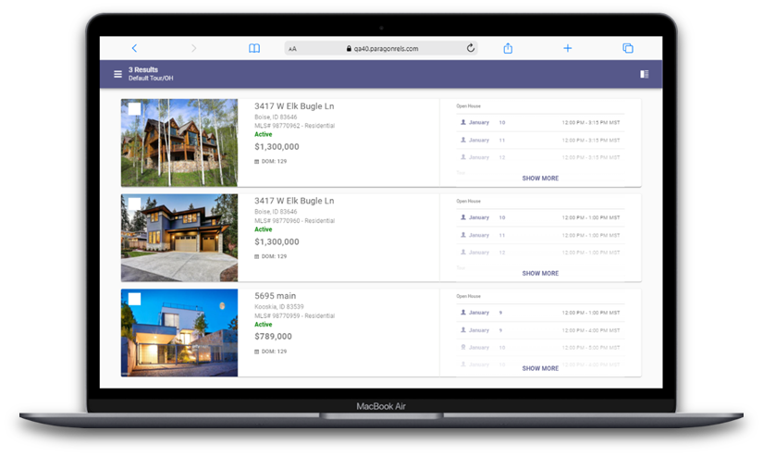When you perform a search, you will also see the thumbnail view contains a section for the date and time for each tour and open house. If too many are found on one listing, the system will allow you to click to expand to a dialog box to see all available tour and open houses. You can tap or click on any single event to see the date, time, and any other relevant data.

## **Spreadsheet**

One of the more important features of any real estate application is the ability to quickly access a grid of results. Now in Paragon Connect, you will find a new spreadsheet view. This will allow you to sort, check one or more listings, check all, and customize fields on the grid.

This spreadsheet view is 100% responsive which means not only will you be able to use this on a large desktop resolution but on just about any device. This includes your phone, tablet, phablet, etc. The key is the design. We hard coded the checkbox and photo to be the first two columns. Those two columns are frozen allowing you to scroll horizontally on any device without losing those two important elements.

**Check/Check All**

The spreadsheet view allows you to check one or more listings. The top bar opens and presents the available options based on the number of listings checked. You can also check all visible listings. By default, the first twenty listings are displayed. When you click on the check all box, it will check the visible twenty listings. If you have more than twenty results, as you scroll down, the next twenty will load and display (total forty now). Those twenty listings just loaded will not be checked. You would just need to click the check all box again for all forty to be checked.

**Sort**

The spreadsheet will by default be sorted by price. However, you can simply click or tap on any column header to sort by that field.

**Customize**

The spreadsheet customization screen can be accessed by clicking the cog icon in the spreadsheet app bar. Here you will have the ability to set a default sort, change the order of the columns, remove columns, and add new columns.

