

PARAGON - INNOVATING THE WAY AGENTS DO BUSINESS
Paragon Release 5.93

We (enter your MLS Name here) wanted you to be the first to know about the latest enhancements to your Paragon MLS System. All enhancements are designed to help you navigate through the system and enhance your experience with Paragon. Below is a list of the enhancements and links to view videos or PDFs of the new features. We encourage you to continue reading and let us know what you think on the Paragon MLS Facebook site. Also make sure you click “Like” on the Facebook site to view what’s new with Paragon more frequently.

WHAT’S NEW!

PARAGON

Stats Reports – # Expired added to Market Statistics
A column for number of expired listings was added to the bottom grid of the Market Statistics report. The display of Expired listings is now consistent with the display of Sold listings on the grid. The preview image and explanatory text on the landing page was also updated.
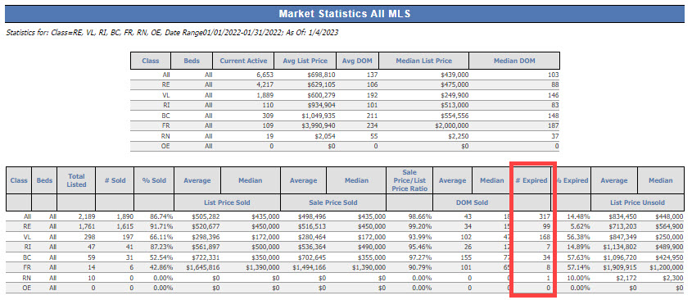

LIM – Fix column sort on Tour and Open House grids
Users can now sort the Tour or Open House records in LIM by any of the columns.
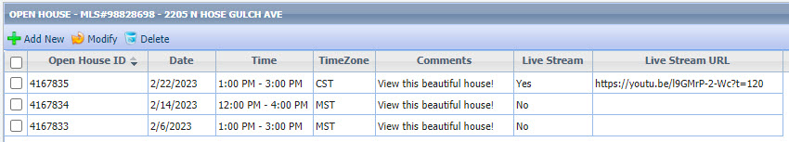

Collaboration Center

Collaboration Center – Display agent’s Office address on notification emails
Based on user feedback, the agent’s address displayed on Collaboration Center emails will default to the agent’s office address. Because the office address is required for emails to be sent from Paragon, this ensures that an address will always display.
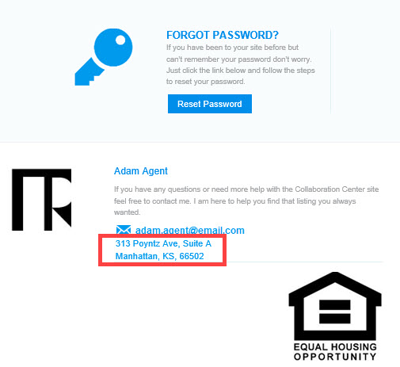

Rename Agent Pick to Recommended
The Agent Pick section label on the Collaboration Center has been updated from Agent Picks to Recommended.

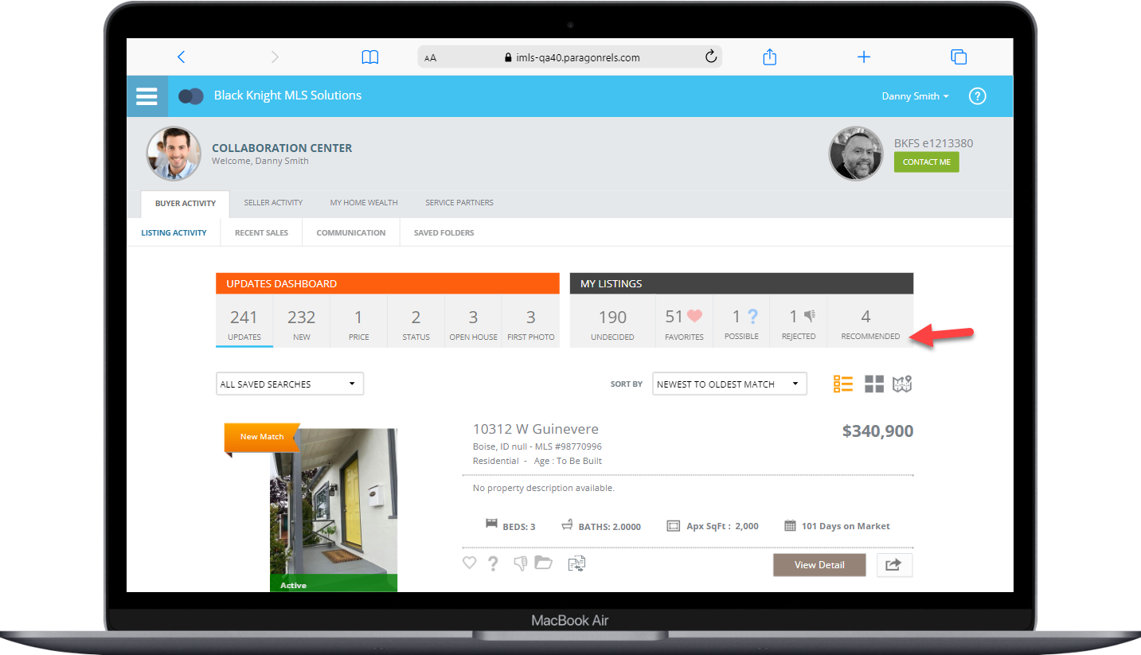

Paragon Connect

Supra Integration Added to Paragon Connect

If your MLS has Supra integration, Supra integration points have been added to Paragon Connect.
- From Search Results – the Keybox Settings Report
- From Listing Maintenance – Assign Lockbox, Settings Report, Unassign Lockbox and Activity Report
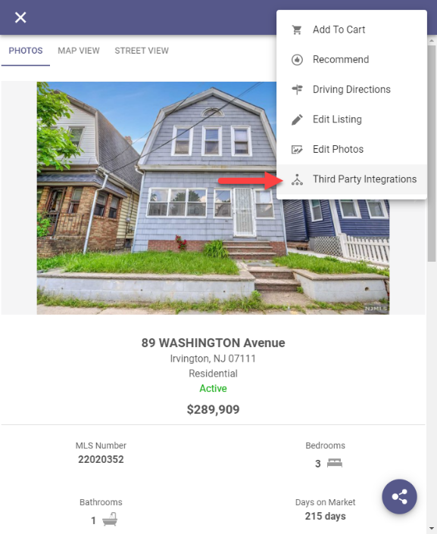
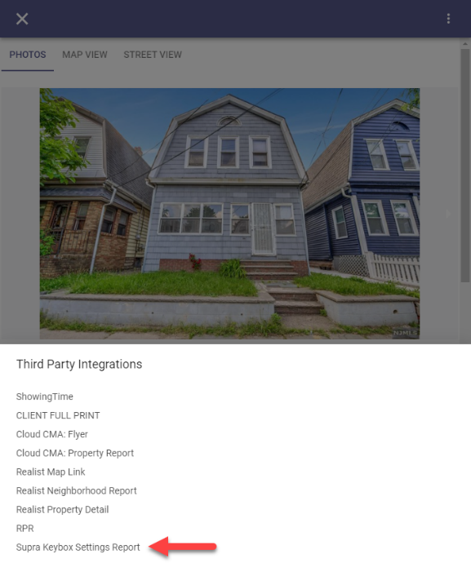
From Search Results, select a property from the grid or from a detail as shown below, click the overflow menu and select Third Party Integrations and then select Supra Keybox Settings Report from the menu and a new browser will launch displaying the Supra report.

From Listing Maintenance, select a published property and click the overflow menu from the input form and select Third Party Integrations and the four Supra options will appear in the menu. Selecting any of the options will launch a new browser displaying the Supra content.
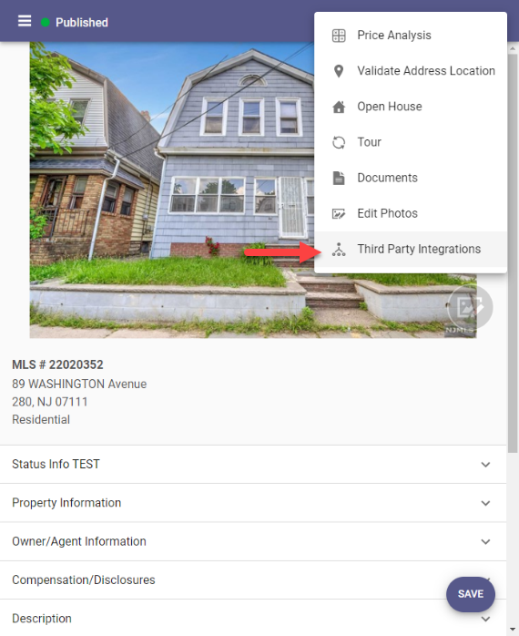
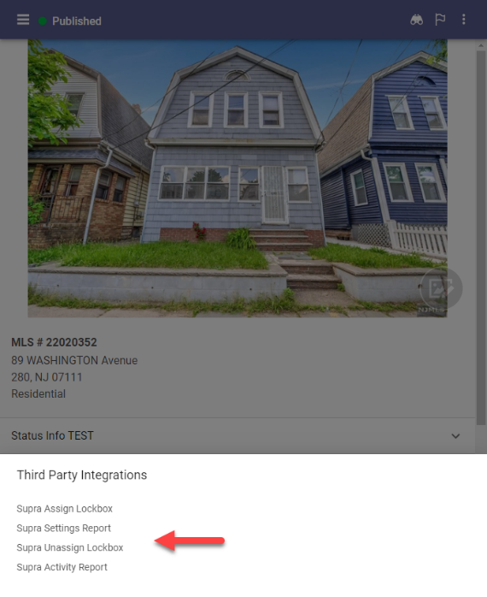

Tour and Open House Search
The tour and open house search have undergone a complete makeover. Prior to this release, the search features were very limited. You only had a few fields, and you could only run a search. Now, you will find all the same search fields, save, edit, and delete features found in Paragon Professional.
Fields:
You will find three containers on the tour and open house search form. The first allows you to search for days in the future or a specific date range. The next container consists of tour and open house unique fields. The last container contains up to sixteen additional fields determined by your organization.
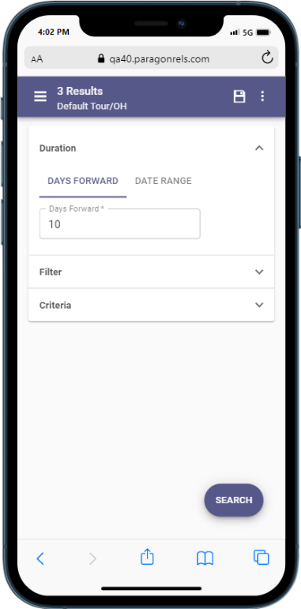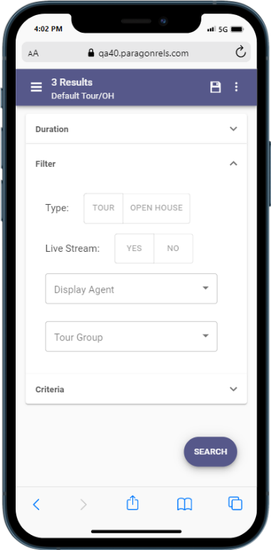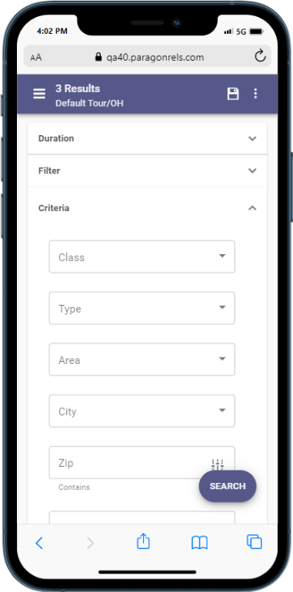 Search Options:
You can now save, load, rename, edit, and delete any tour and open house search. These searches are in sync with Paragon Professional so you can use either application to update your tour and open house searches. In addition, you can also update and modify your tour and open house search template.

Results
When you perform a search, you will also see the thumbnail view contains a section for the date and time for each tour and open house. If too many are found on one listing, the system will allow you to click to expand to a dialog box to see all available tour and open houses. You can tap or click on any single event to see the date, time, and any other relevant data.
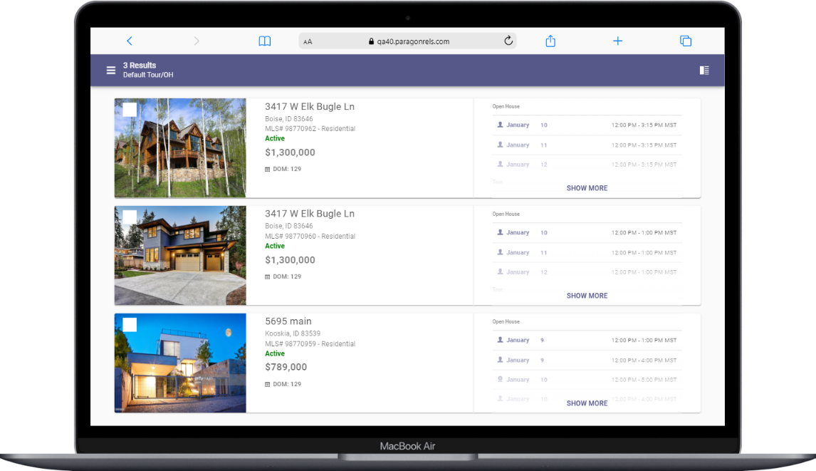
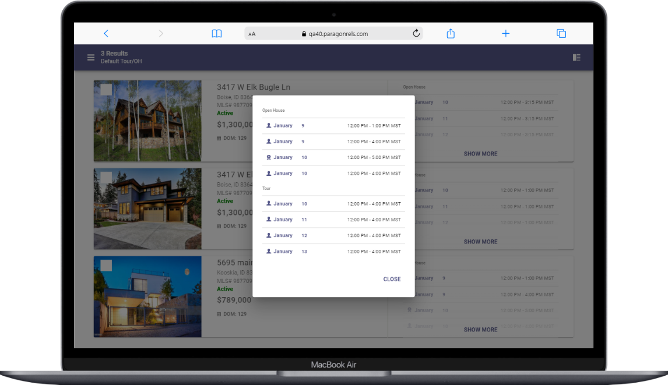

Spreadsheet
One of the more important features of any real estate application is the ability to quickly access a grid of results. Now in Paragon Connect, you will find a new spreadsheet view. This will allow you to sort, check one or more listings, check all, and customize fields on the grid.
This spreadsheet view is 100% responsive which means not only will you be able to use this on a large desktop resolution but on just about any device. This includes your phone, tablet, phablet, etc. The key is the design. We hard coded the checkbox and photo to be the first two columns. Those two columns are frozen allowing you to scroll horizontally on any device without losing those two important elements.
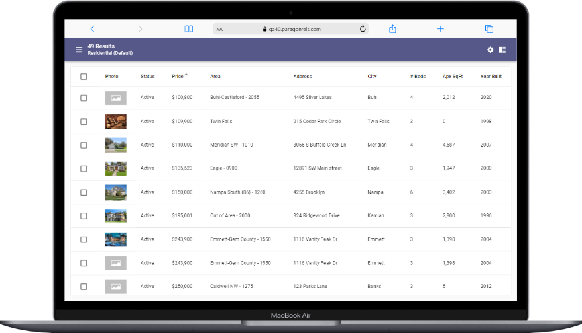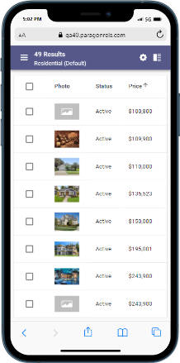
Check/Check All
The spreadsheet view allows you to check one or more listings. The top bar opens and presents the available options based on the number of listings checked. You can also check all visible listings. By default, the first twenty listings are displayed. When you click on the check all box, it will check the visible twenty listings. If you have more than twenty results, as you scroll down, the next twenty will load and display (total forty now). Those twenty listings just loaded will not be checked. You would just need to click the check all box again for all forty to be checked.
Sort
The spreadsheet will by default be sorted by price. However, you can simply click or tap on any column header to sort by that field.

Customize
The spreadsheet customization screen can be accessed by clicking the cog icon in the spreadsheet app bar. Here you will have the ability to set a default sort, change the order of the columns, remove columns, and add new columns.
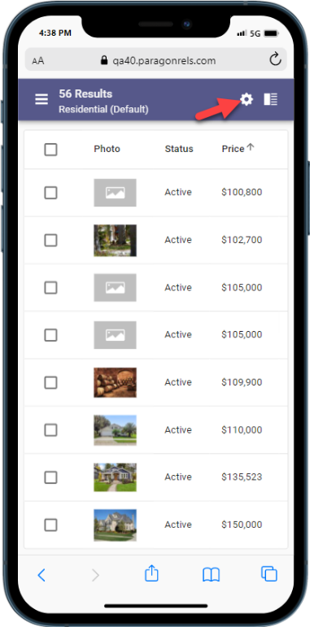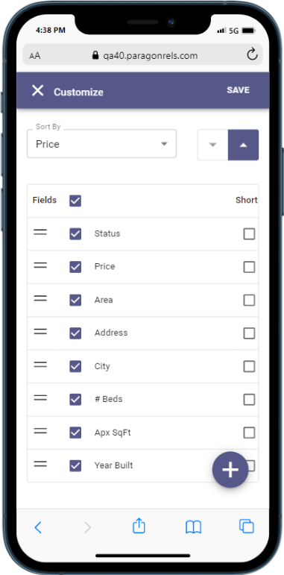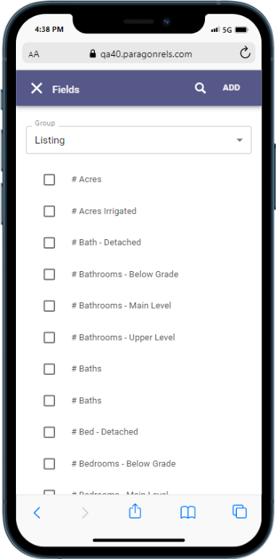

Agent Recommended
You can now recommend listing(s) in Paragon Connect for your contacts.
- Included features:
  - Recommend listing(s) for a single existing contact or multiple contacts
  - Recommend listing(s) and create a new contact all in one step
  - Access and manage recommended listings: Remove, manually add a listing using the Listing ID, Add a Note

Recommending listing to exiting contacts
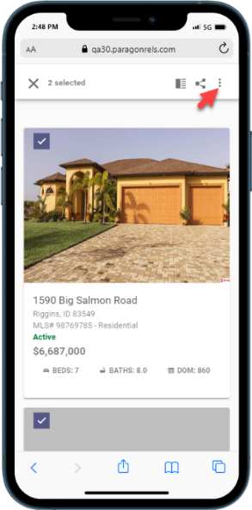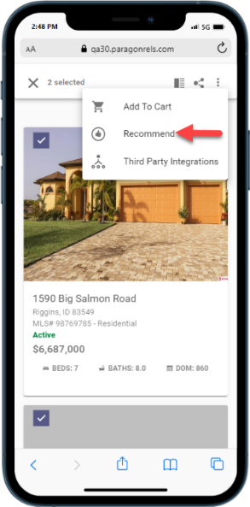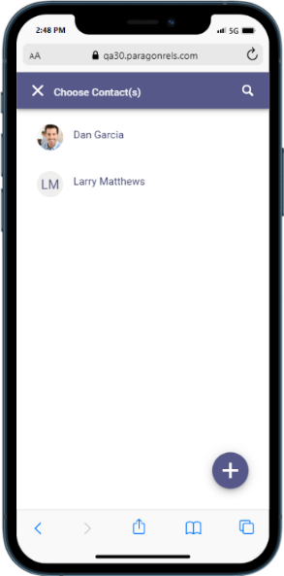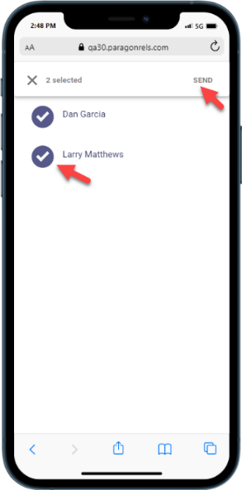
Create a new contact as you recommend listings
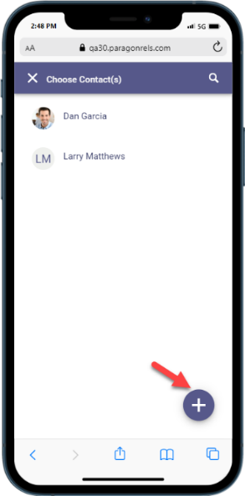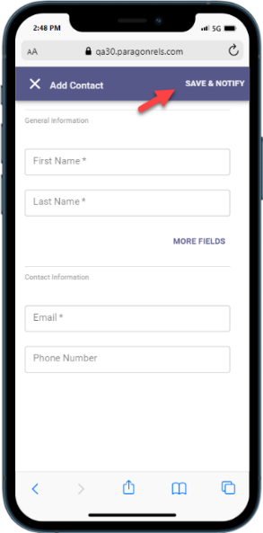

Access and Manage Recommended Listings
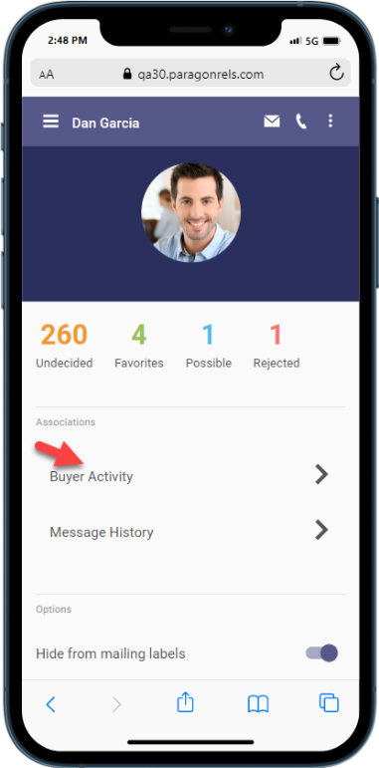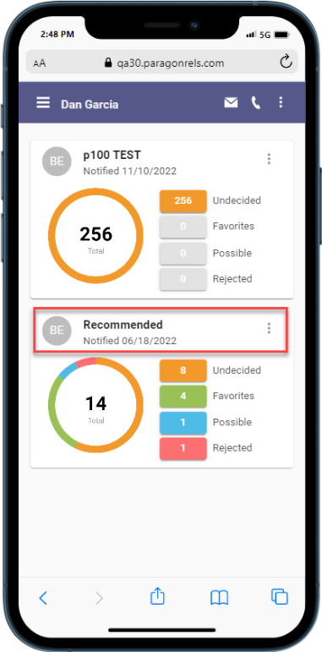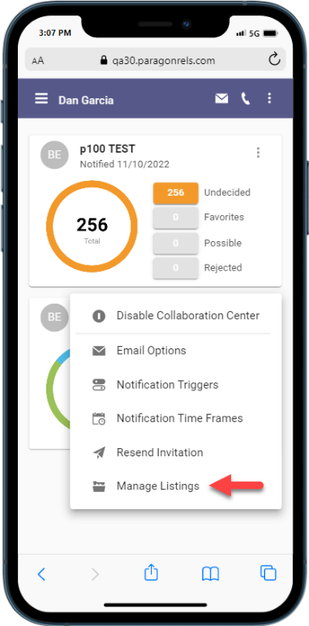
Remove Recommended Listing(s)
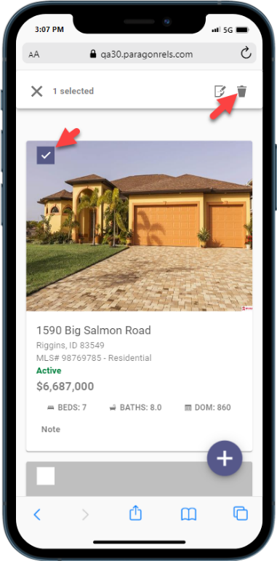

Recommend a listing using the Listing ID
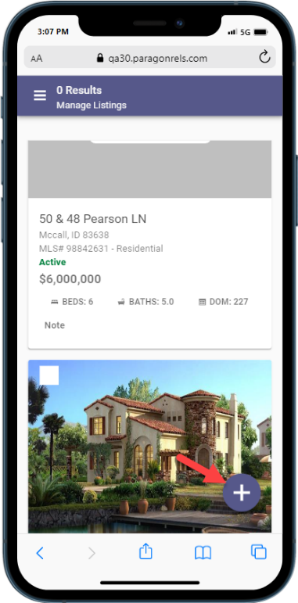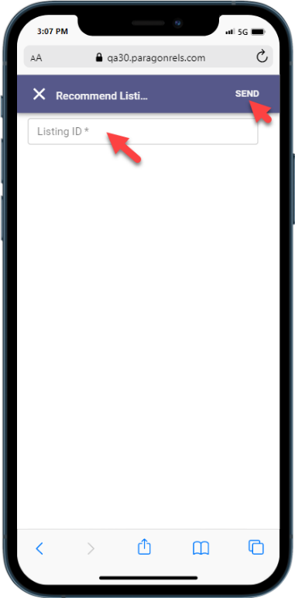
Adding notes to a recommended listing
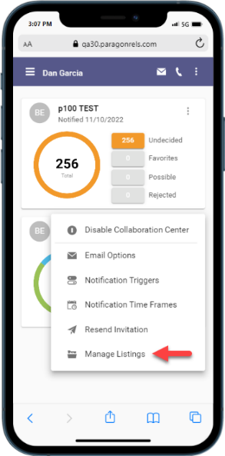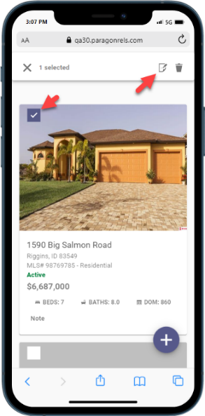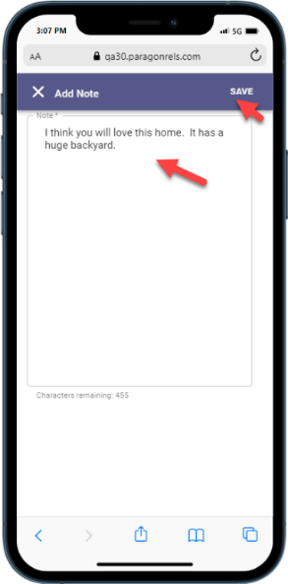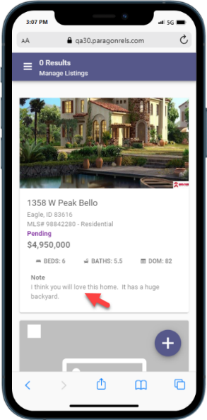

Resources Third Party Links
Access your third-party links in Paragon Connect via the new Resources link. This menu option displays all the supported options currently available within your Paragon Professional Resource menu.
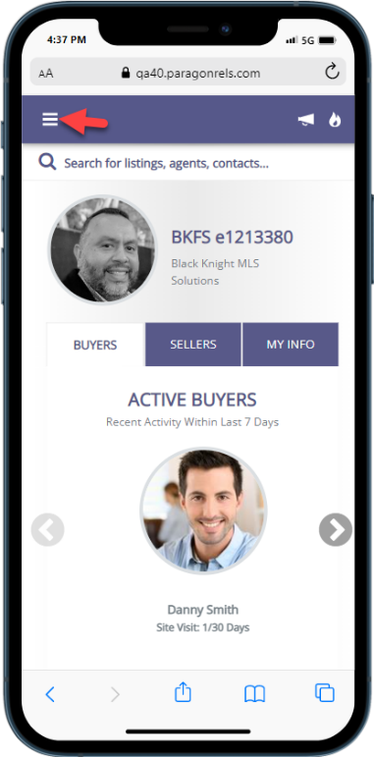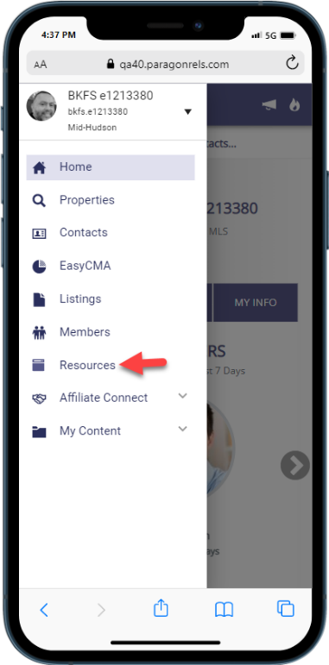

Photo Maintenance
The Photo Maintenance module has also been migrated into our design framework. You will find all the same options as before and then some. Below are some updates you will find.
- Preview uploaded listing photos
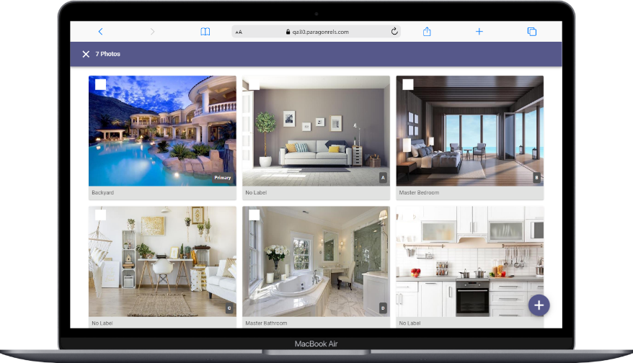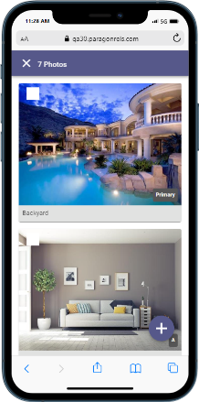

- If you have access to add photos the + button appears in the lower right corner.
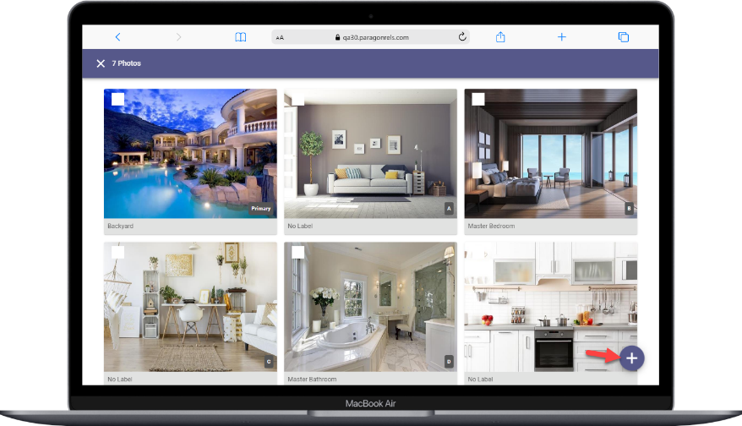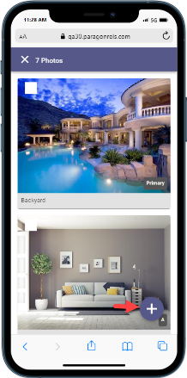
- Add photo label and description. This option will only display if enabled by your administrator.
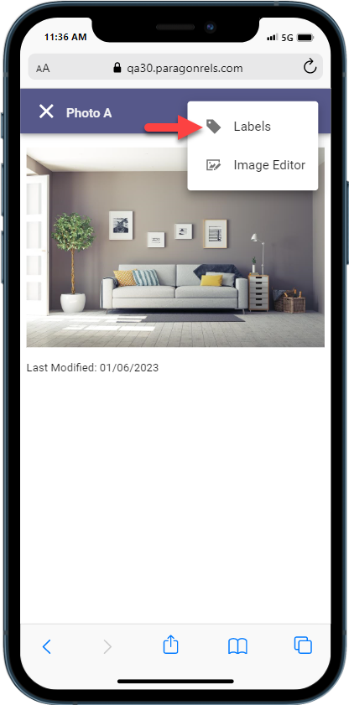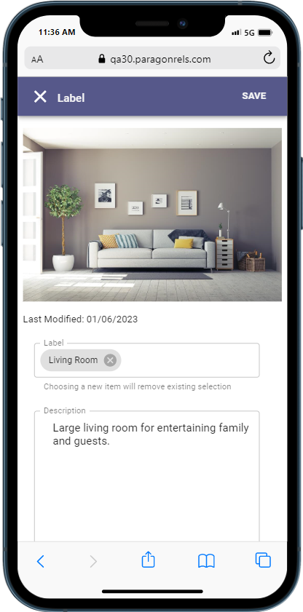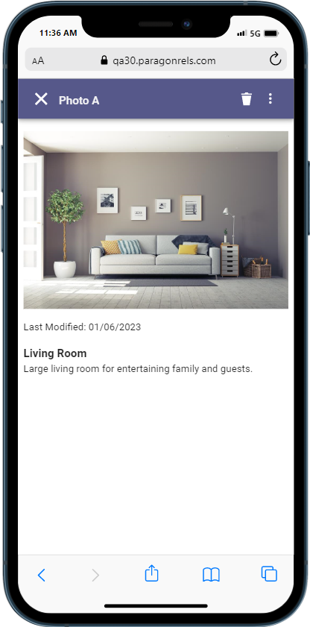

- Image Editor: Crop, Flip, Rotate, Photo Filters
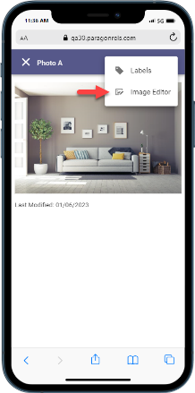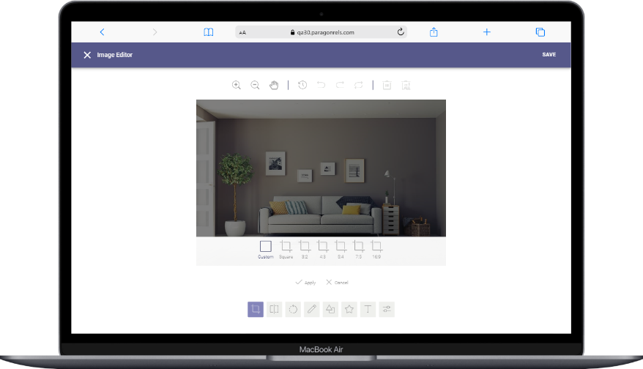
- Delete single photo or select multiple photos to delete.
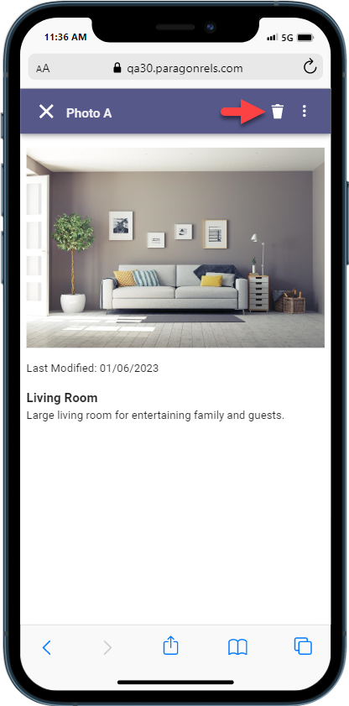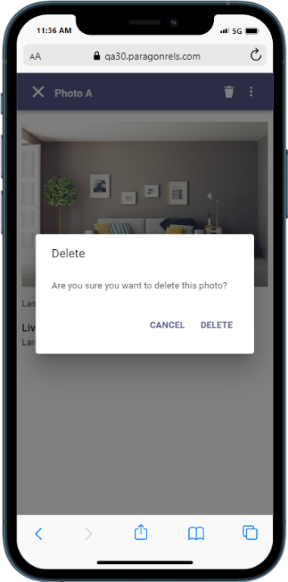

- Access the Edit Photos link directly from the LIM results overflow menu.
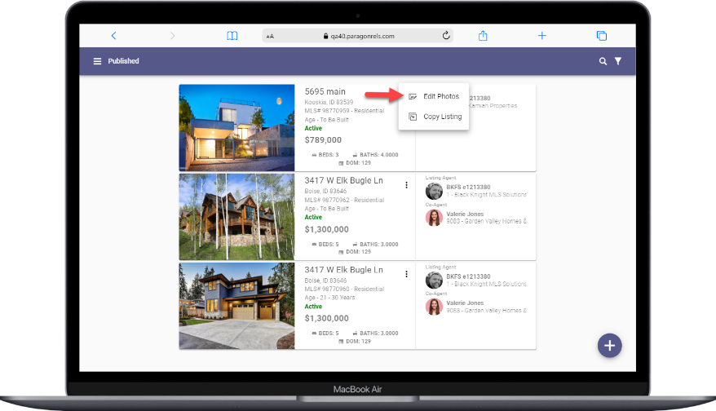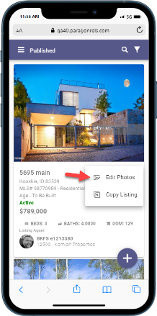

Print Single Listing
The ability to print a single listing has been added to Paragon Connect. The default Paragon Professional Agent and Detail reports will be available to print under the overflow menu.
Note: These printable reports must be enabled by your administrator.
