Paragon 5.93 Release Enhancements
Updated on: 1/17/23

Corrected Paragon Issues 2
MLS Customizations and Administration 3
Admin – Broker Attribution has been Expanded to LIM 3
Admin - Enabling the new Paragon Connect Print Solution through TPI 5
Agent Level Changes 6
Stats Reports – # Expired added to Market Statistics 6
LIM – Fix column sort on Tour and Open House grids 6
Collaboration Center 7
Collaboration Center – Display agent’s Office address on notification emails 7
Rename Agent Pick to Recommended 8
Paragon Connect 9
Supra Integration Added to Paragon Connect 9
Branding 11
Tour and Open House Search 12
Spreadsheet 14
Agent Recommended 16
Resources Third Party Links 19
Photo Maintenance 19
Print Single Listing 22
Paragon Affiliate Connect 23
Admin – Access Affiliate Dashboard from Admin 23
Display agent’s or affiliate’s Office address on notification emails 24
Corrected Paragon Affiliate Connect Issues 25

Corrected Paragon Issues
Ticket# | Module | Organization | Summary
TK-12247 | CMA | NGLRMLS, Great Plains, Selkirk, SEDWAR, Texas AOR | Error Generating CMA “error creating the CMA packet"
TK-11755 | View/Reports | NEREN - New England Real Estate Network | Not All State Abbreviations are Completely Shown in All Capital Letters in Lookup Autocomplete Fields
TK-10807 | LIM | NEREN - New England Real Estate Network | Certain Setup Allows for Users to Enter No State
TK-12099 | Property Watch/Alert | GAMLS - Georgia MLS, NNRMLS, Tahoe Sierra | Property Watch - no new alerts since early 2022
TK-12077 | Preferences | SCWMLS - South Central Wisconsin (Madison) | Unicode seen in Delete Email Signature Color Box Popup Confirmation
TK-10824 | Mapping or Geo-coding | NSAR - NS and PEI Real Estate Associations | Validate Map Zoom Level is NOT adjusting when updated via LIM
TK-9752 | Contacts | BCRES - REB2 Residential, RAE, CRMLS | Page cannot be displayed for Collab Center comments
TK-8722 | Search | RAE - REALTOR Assoc of Edmonton | Restricted feature category values still selectable via autocomplete
TK-7676 | View/Reports | CAPEMAY - Cape May County BOR | Market Share Detail Report and High Result Count
TK-7062 | Search | BCRES - REB2 Residential, Edmonton | Remove listing carts from Power Search results
TK-11670 | Collab Link | RAE - REALTOR Assoc of Edmonton | Wrong address is showing on Seller's Collab Notifications

MLS Customizations and Administration
All options in this section are either configurable via MLS Administration controls or by your System Support Manager as noted.

Admin – Broker Attribution has been Expanded to LIM

Action Item: Contact your SSM to Enabled this field

To allow broker attribution selection on a listing-by-listing basis, we have added a new LIM field, “Broker Attribution Override” (phys num 543). This field is disabled by default, you must contact your SSM to enable it. Please note that this field cannot be set to Required.

This new field allows up to fifty freeform characters for entry of a phone number or email address. This field is not searchable in property searches but is viewable on listing reports. When populated on a listing, it will override the value the broker has set for the IDX/VOW data feeds in Paragon Preferences and the value entered on the listing will go out in the data feeds instead. To revert this back to the value set by the broker in Preferences, simply clear out the value entered on the listing.

Upon saving a value for this field on the listing, LIM will display a notification message indicating that it will override what the broker has set up in Preferences and will display the current Preference value. The notification will only display when the field goes from empty to populated with a value.

This field is also available for selection in IDX Smart framing views.

NOTE: The MLS determines the security level for who can input and update this field.
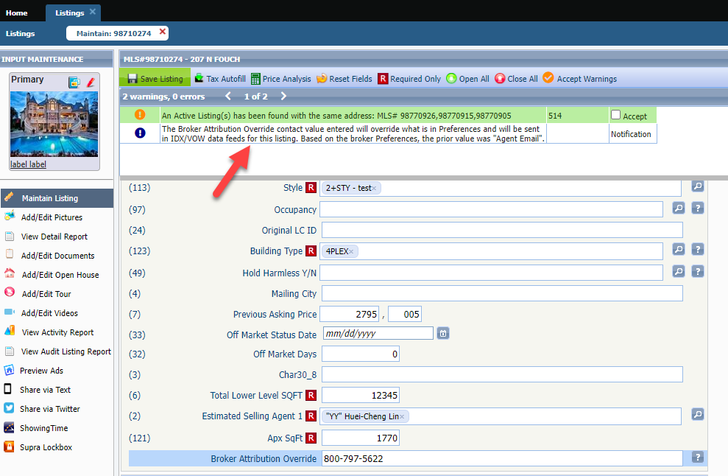
Figure 1: Paragon - Broker Attribution Override LIM field and grid notification

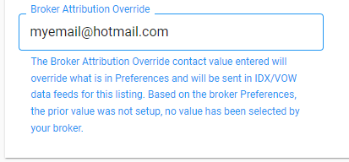
Figure 2: PC - Broker Attribution Override LIM field and notification

Admin - Enabling the new Paragon Connect Print Solution through TPI

Action Item: Contact your SSM to let them know if you want this enabled and what report you would like to enable to print

By default, these points will be disabled. Administrators must reach out to their SSMs to enable these points and to let your SSM know what report you would like to print.

Agent Level Changes
The following section contains changes that are active system wide and available to users based on their assigned security levels.

Stats Reports – # Expired added to Market Statistics
A column for number of expired listings was added to the bottom grid of the Market Statistics report. The display of Expired listings is now consistent with the display of Sold listings on the grid. The preview image and explanatory text on the landing page was also updated.
Action item: N/A
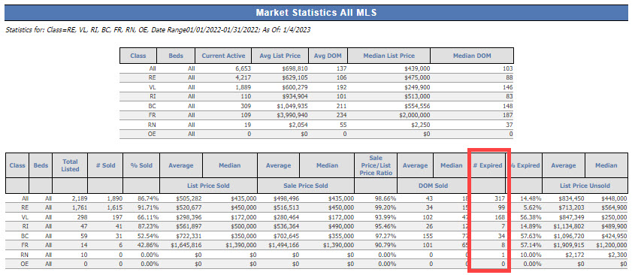

LIM – Fix column sort on Tour and Open House grids
Users can now sort the Tour or Open House records in LIM by any of the columns.
Action item: N/A
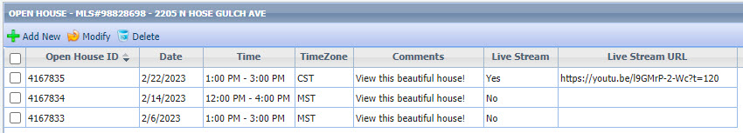

Collaboration Center
All options in this section are either configurable via MLS Administration controls or by your System Support Manager as noted.

Collaboration Center – Display agent’s Office address on notification emails
Based on user feedback, the agent’s address displayed on Collaboration Center emails will default to the agent’s office address. Because the office address is required for emails to be sent from Paragon, this ensures that an address will always display.
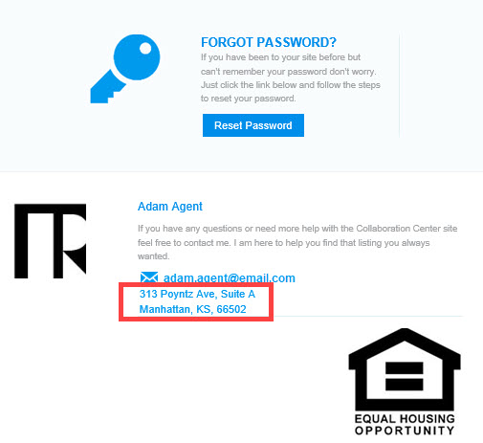

Rename Agent Pick to Recommended
The Agent Pick section label on the Collaboration Center has been updated from Agent Picks to Recommended.

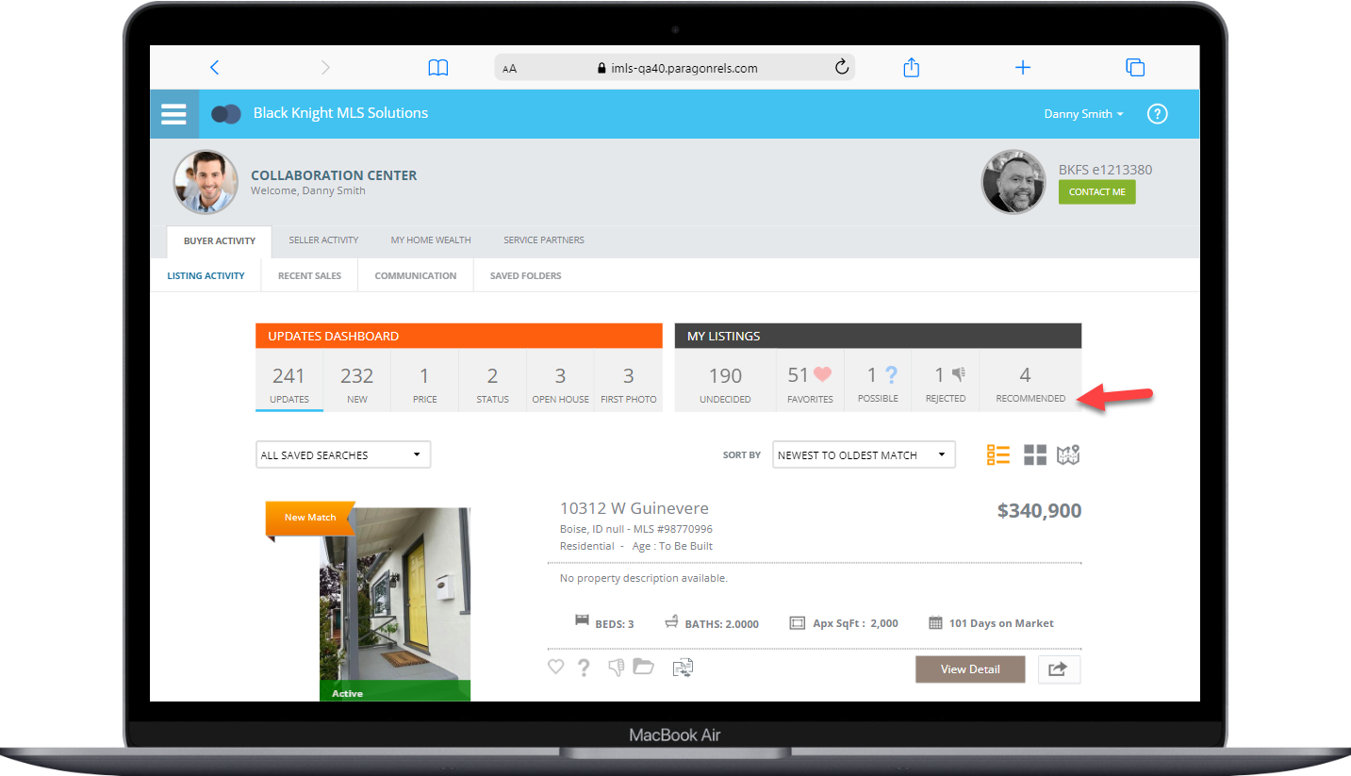

Paragon Connect
All options in this section are either configurable via MLS Administration controls or by your System Support Manager as noted.

Supra Integration Added to Paragon Connect
The following Supra integration points have been added to Paragon Connect.
- From Search Results – the Keybox Settings Report
- From Listing Maintenance – Assign Lockbox, Settings Report, Unassign Lockbox and Activity Report
Action item: – a script will be created and run to enable these integration points for all current Supra customers
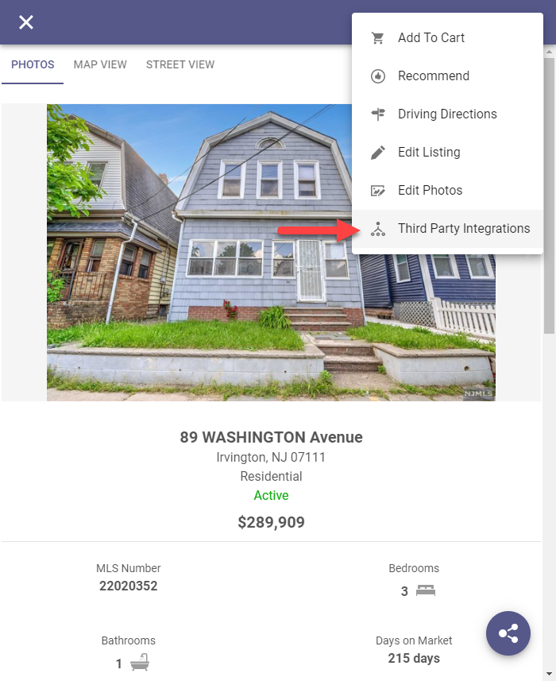
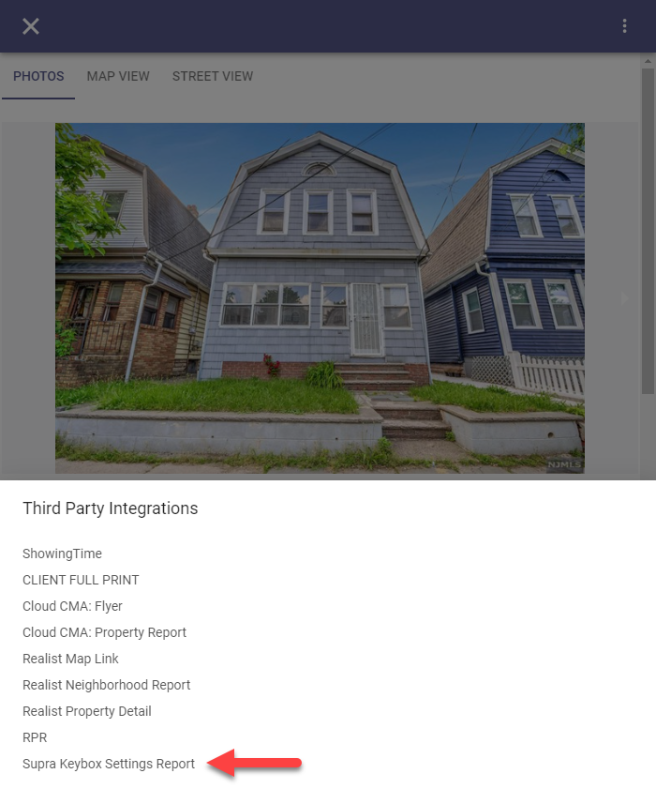
From Search Results, select a property from the grid or from a detail as shown below, click the overflow menu and select Third Party Integrations and then select Supra Keybox Settings Report from the menu and a new browser will launch displaying the Supra report.

From Listing Maintenance, select a published property and click the overflow menu from the input form and select Third Party Integrations and the four Supra options will appear in the menu. Selecting any of the options will launch a new browser displaying the Supra content.
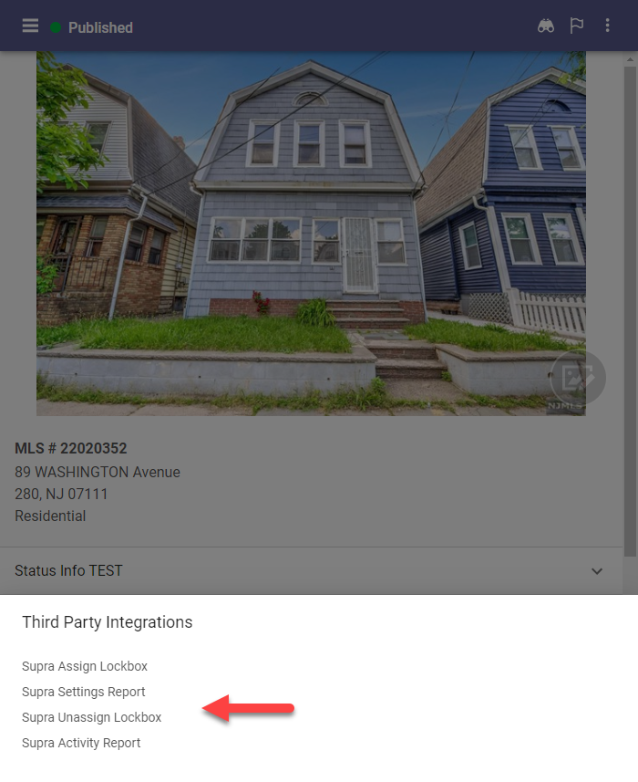
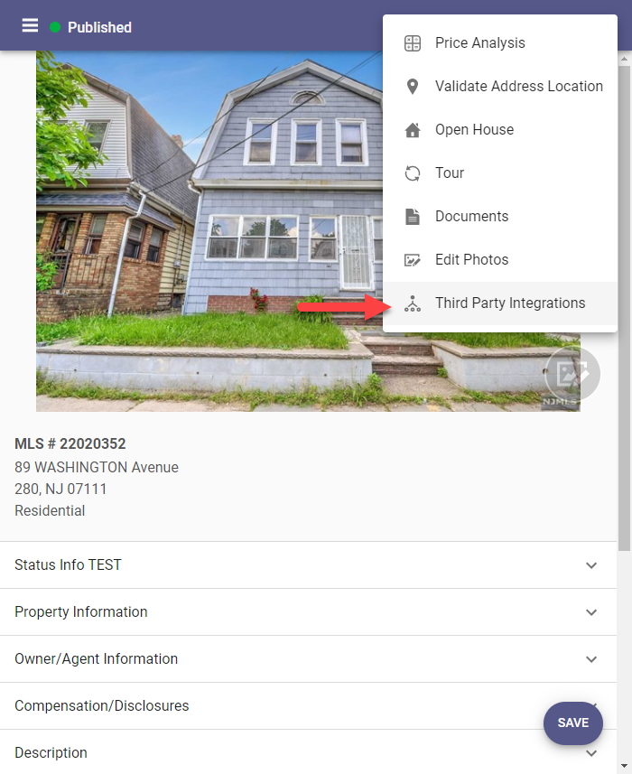

Branding
The login page has been modified to incorporate branding opportunities for your MLS. When you go to the Paragon Connect login screen, you will find your organization’s logo. In addition, if you are on a larger device, you will notice we have included the same custom image used on the Paragon Professional login screen.
Note: If you are currently using an SSO dashboard you will not experience these updates
Branding has also been added to the hamburger menu in Paragon Connect.
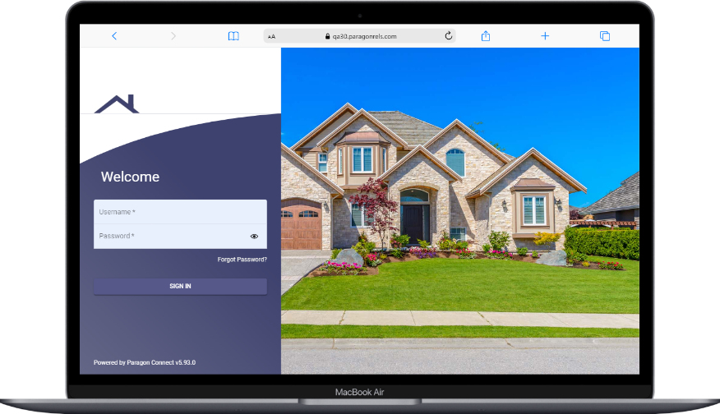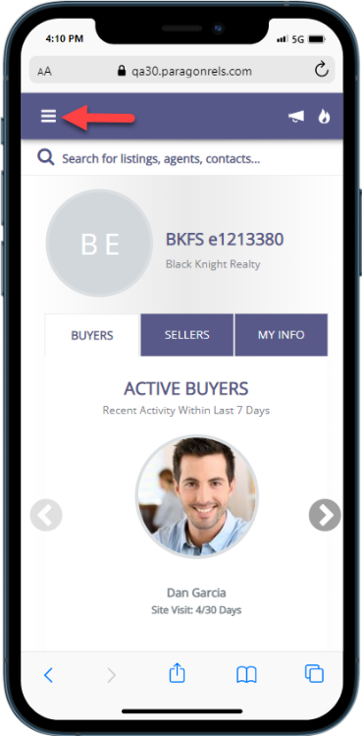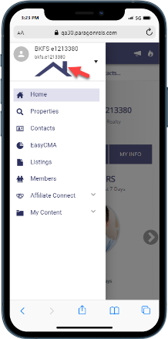

Tour and Open House Search
The tour and open house search have undergone a complete makeover. Prior to this release, the search features were very limited. You only had a few fields, and you could only run a search. Now, you will find all the same search fields, save, edit, and delete features found in Paragon Professional.
Fields:
You will find three containers on the tour and open house search form. The first allows you to search for days in the future or a specific date range. The next container consists of tour and open house unique fields. The last container contains up to sixteen additional fields determined by your organization.
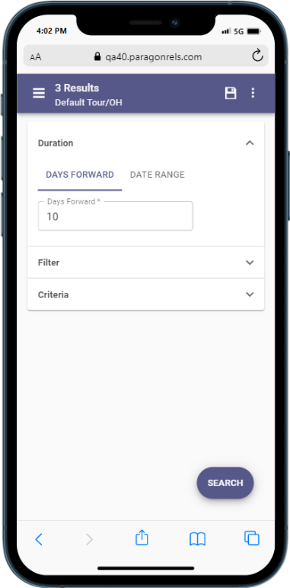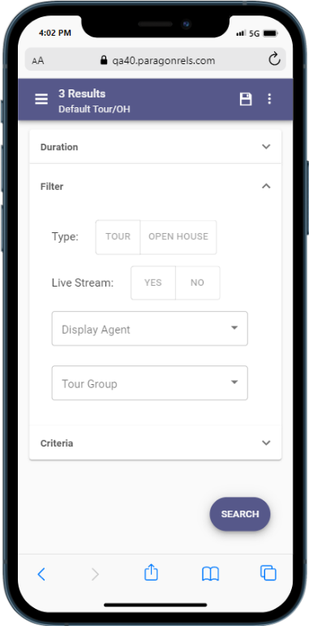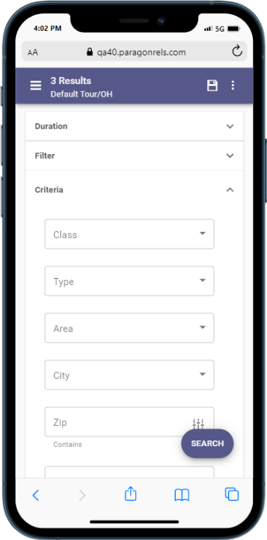 Search Options:
You can now save, load, rename, edit, and delete any tour and open house search. These searches are in sync with Paragon Professional so you can use either application to update your tour and open house searches. In addition, you can also update and modify your tour and open house search template.

Results
When you perform a search, you will also see the thumbnail view contains a section for the date and time for each tour and open house. If too many are found on one listing, the system will allow you to click to expand to a dialog box to see all available tour and open houses. You can tap or click on any single event to see the date, time, and any other relevant data.
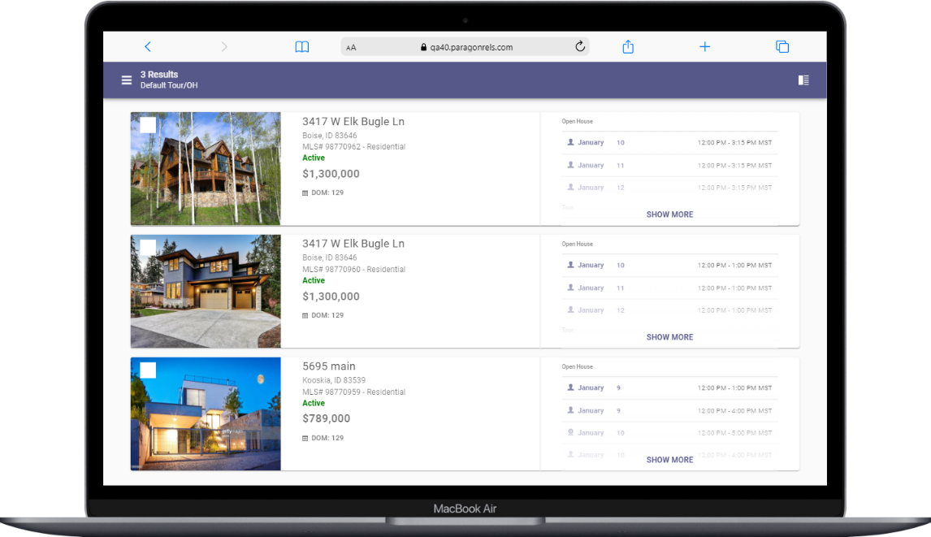
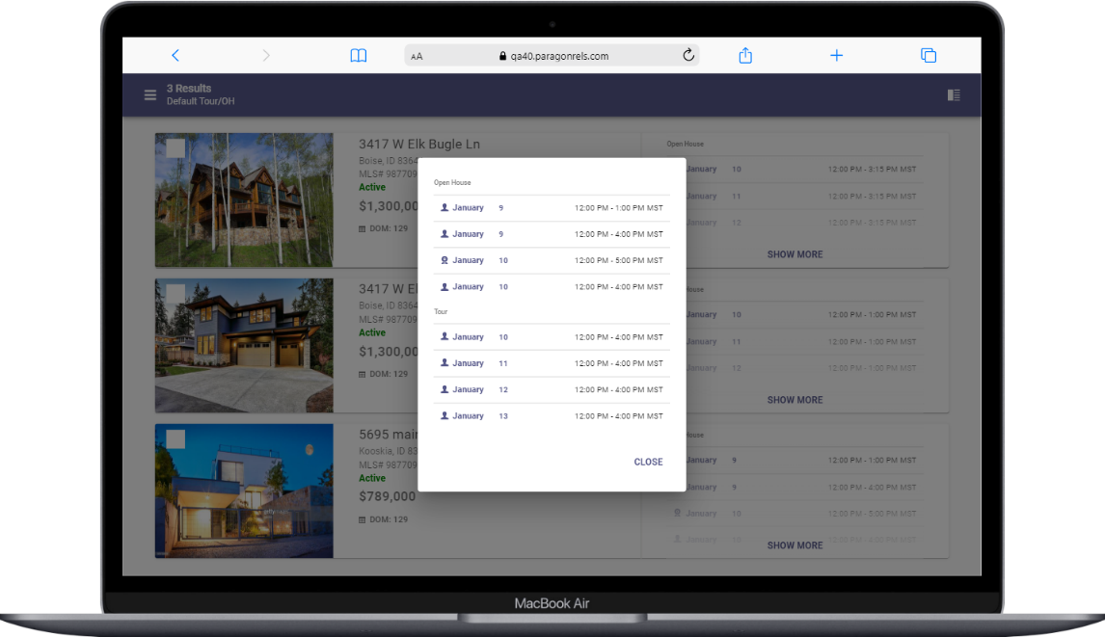

Spreadsheet
One of the more important features of any real estate application is the ability to quickly access a grid of results. Now in Paragon Connect, you will find a new spreadsheet view. This will allow you to sort, check one or more listings, check all, and customize fields on the grid.
This spreadsheet view is 100% responsive which means not only will you be able to use this on a large desktop resolution but on just about any device. This includes your phone, tablet, phablet, etc. The key is the design. We hard coded the checkbox and photo to be the first two columns. Those two columns are frozen allowing you to scroll horizontally on any device without losing those two important elements. Note: The spreadsheet is only available when viewing listing results in Hotsheet, Tour/Open House Search, and Contacts.
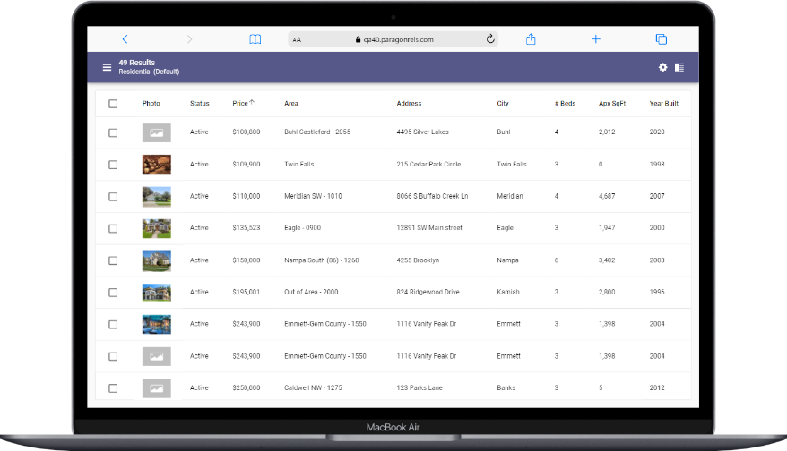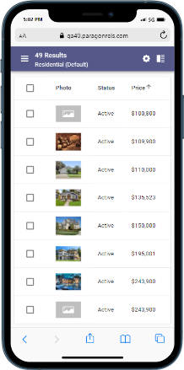
Check/Check All
The spreadsheet view allows you to check one or more listings. The top bar opens and presents the available options based on the number of listings checked. You can also check all visible listings. By default, the first twenty listings are displayed. When you click on the check all box, it will check the visible twenty listings. If you have more than twenty results, as you scroll down, the next twenty will load and display (total forty now). Those twenty listings just loaded will not be checked. You would just need to click the check all box again for all forty to be checked.
Sort
The spreadsheet will by default be sorted by price. However, you can simply click or tap on any column header to sort by that field.

Customize
The spreadsheet customization screen can be accessed by clicking the cog icon in the spreadsheet app bar. Here you will have the ability to set a default sort, change the order of the columns, remove columns, and add new columns.
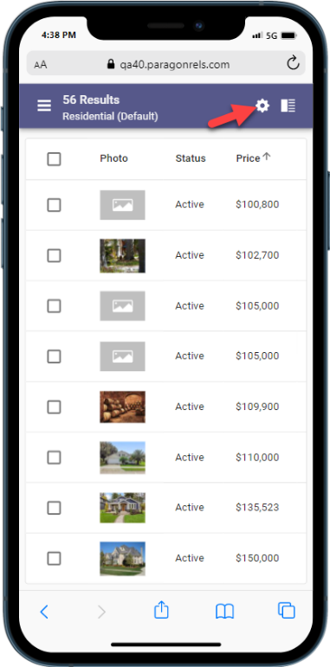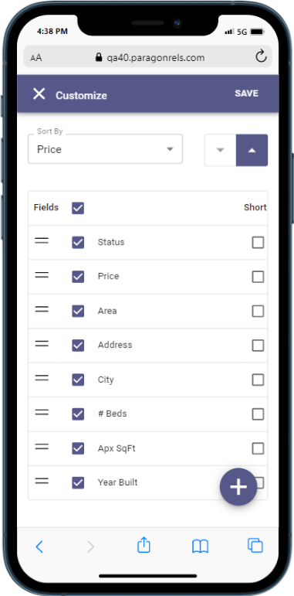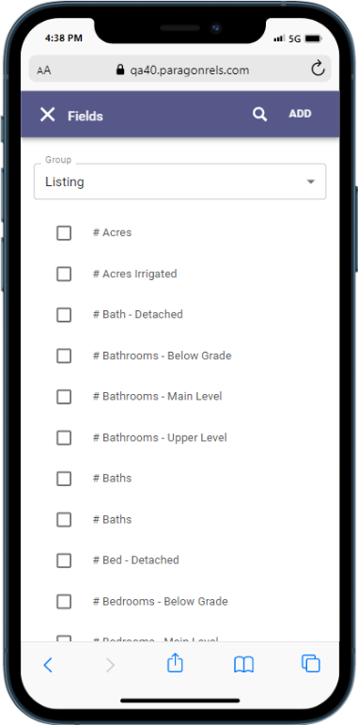

Agent Recommended
You can now recommend listing(s) in Paragon Connect for your contacts.
- Included features:
  - Recommend listing(s) for a single existing contact or multiple contacts
  - Recommend listing(s) and create a new contact all in one step
  - Access and manage recommended listings: Remove, manually add a listing using the Listing ID, Add a Note
- Note: The Recommended functionality is only available when viewing listing results in Hotsheet, Tour/Open House Search, and Contacts.
Recommending listing to exiting contacts
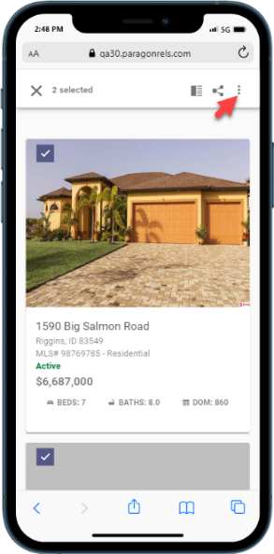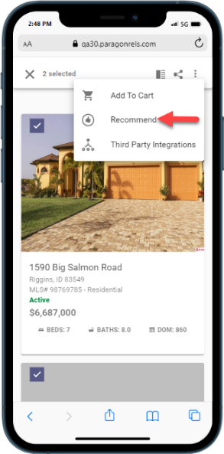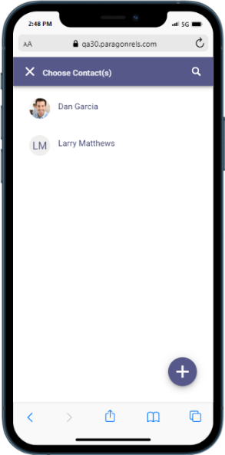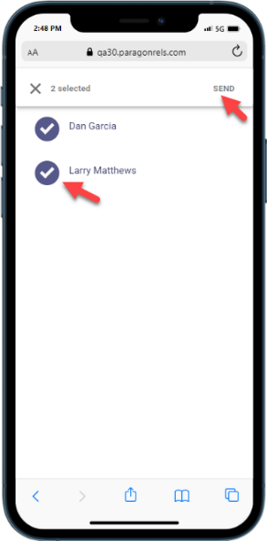
Create a new contact as you recommend listings
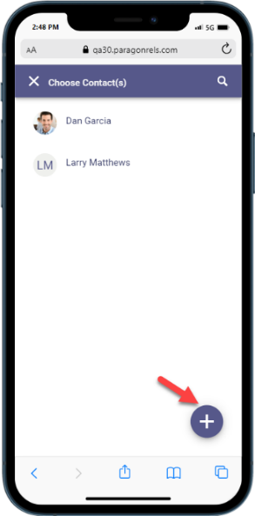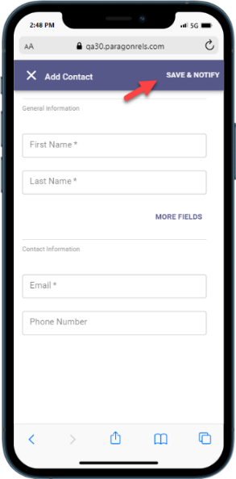
Access and Manage Recommended Listings
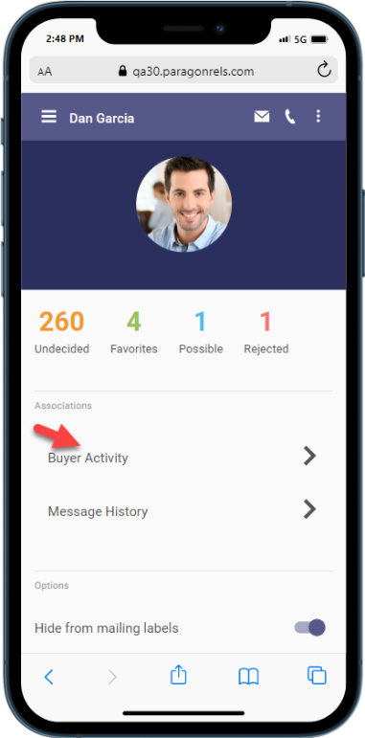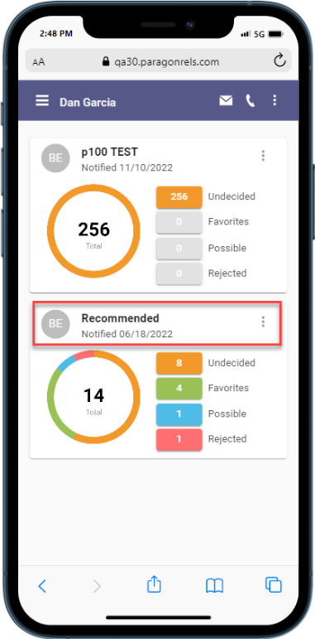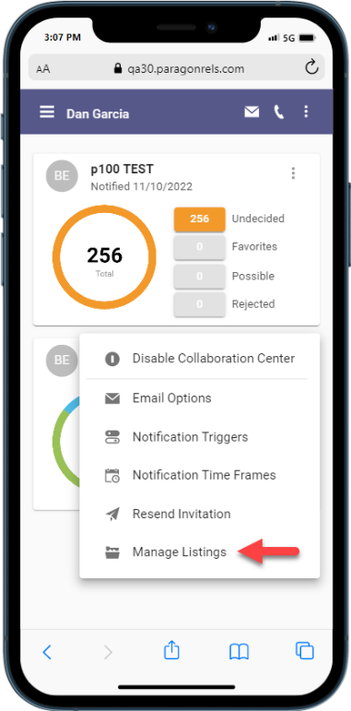
Remove Recommended Listing(s)
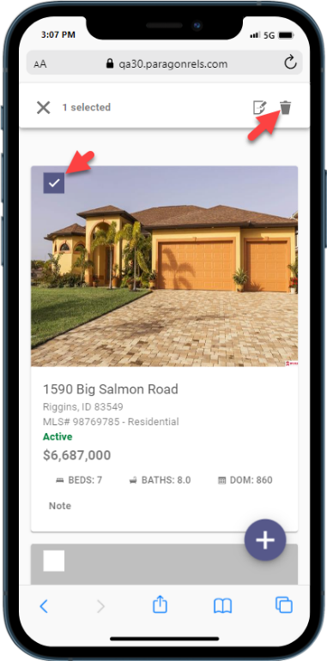

Recommend a listing using the Listing ID
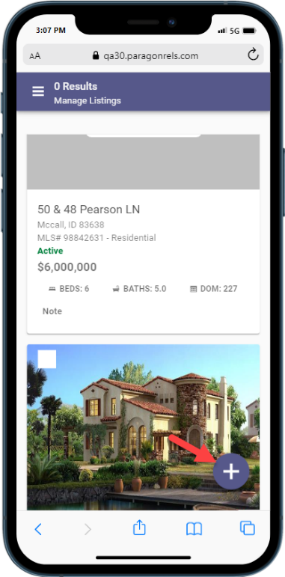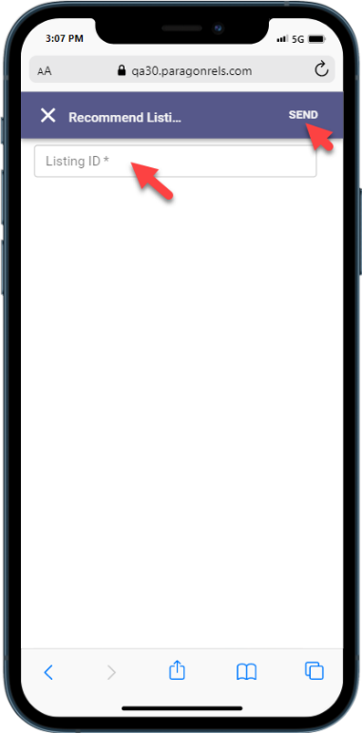
Adding notes to a recommended listing
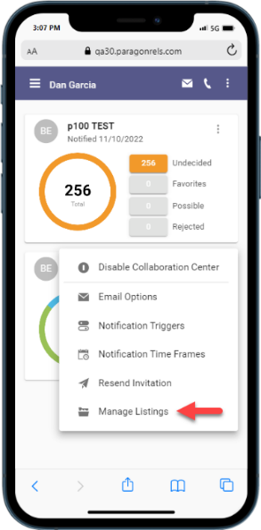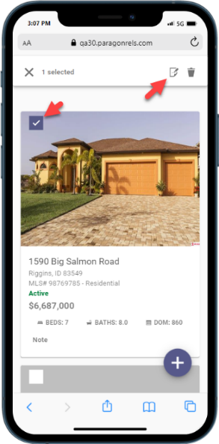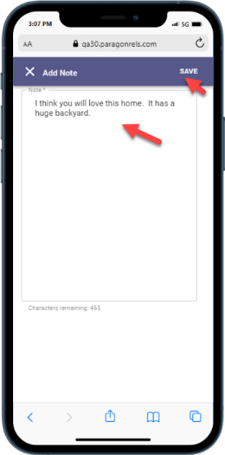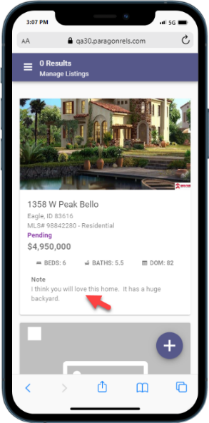

Resources Third Party Links
Access your third-party links in Paragon Connect via the new Resources link. This menu option displays all the supported options currently available within your Paragon Professional Resource menu.
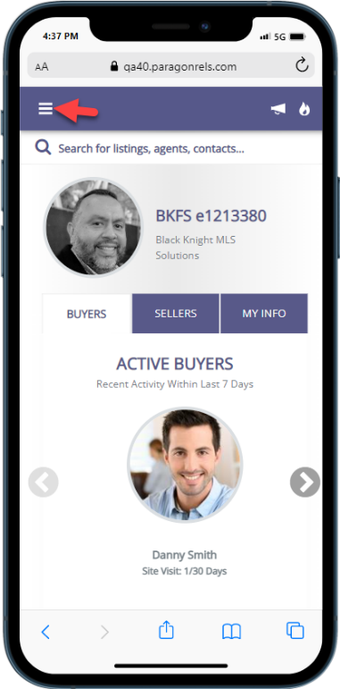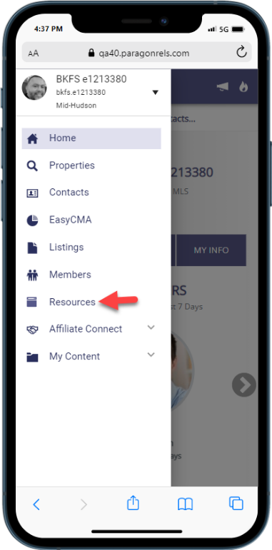

Photo Maintenance
The Photo Maintenance module has also been migrated into our design framework. You will find all the same options as before and then some. Below are some updates you will find.
- Preview uploaded listing photos
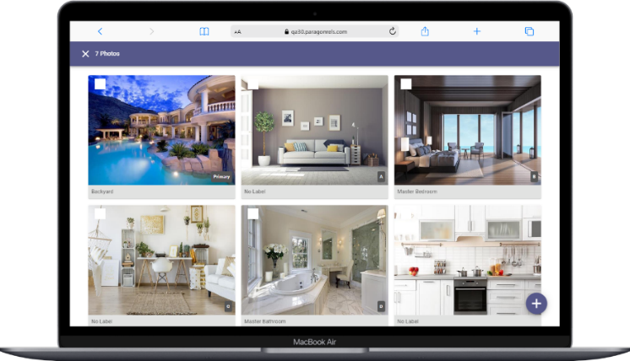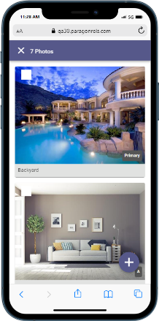
- If you have access to add photos the + button appears in the lower right corner.
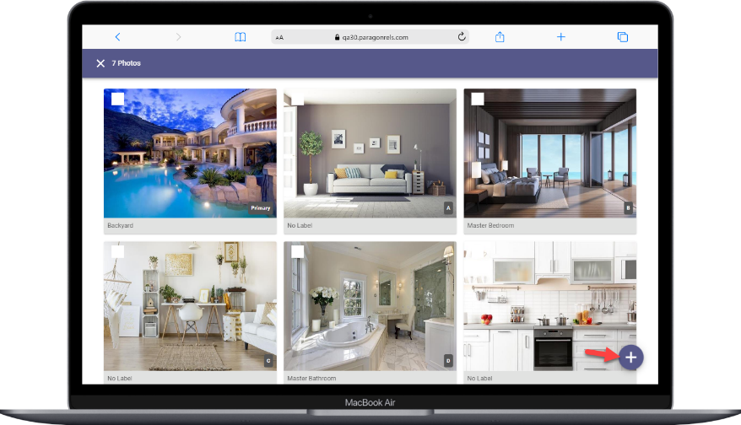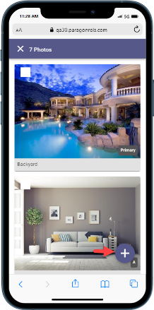
- Add photo label and description. This option will only display if enabled by your administrator.
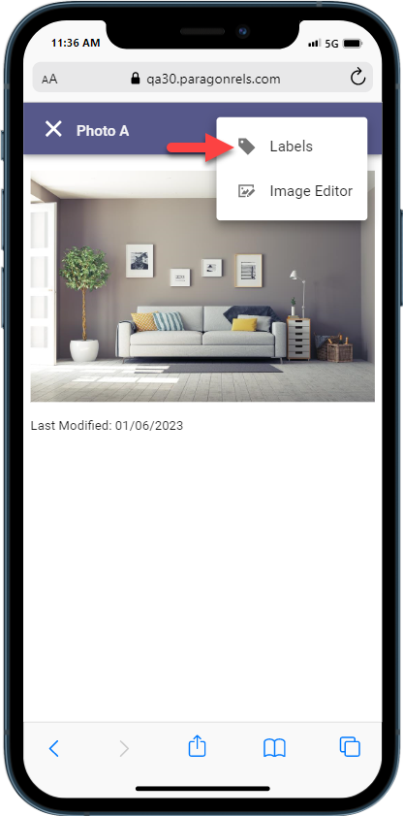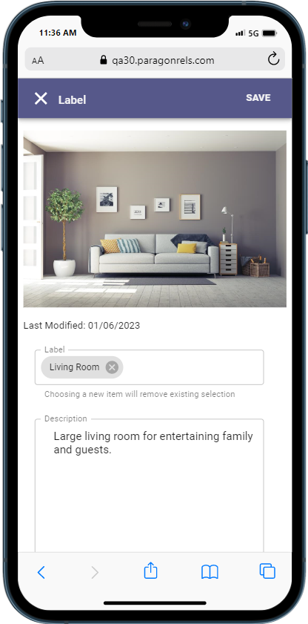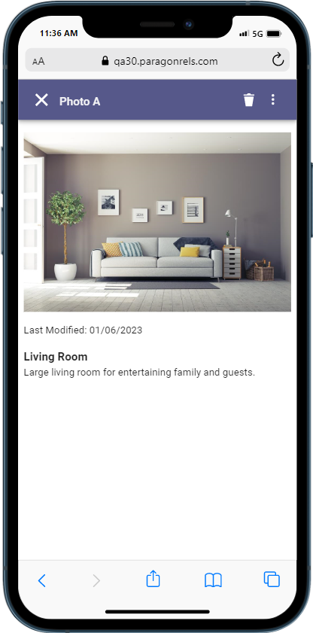

- Image Editor: Crop, Flip, Rotate, Photo Filters
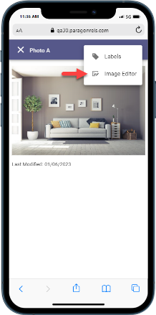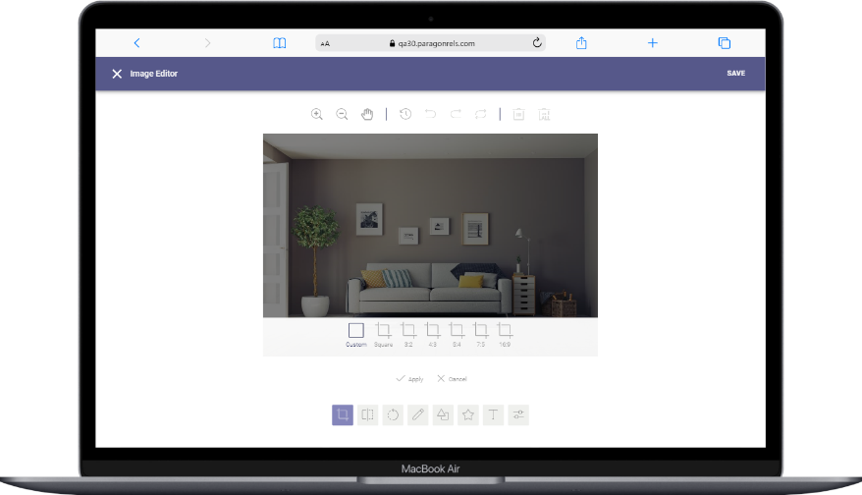
- Delete single photo or select multiple photos to delete.
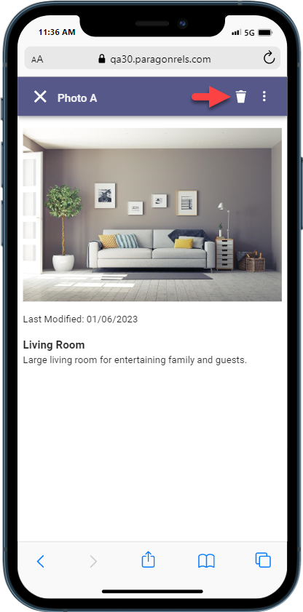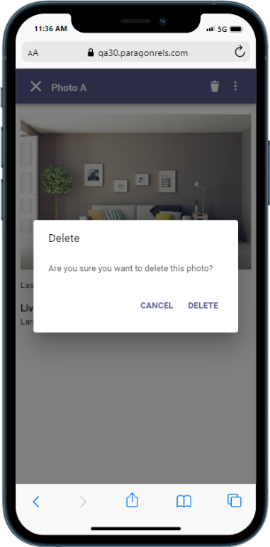

- Access the Edit Photos link directly from the LIM results overflow menu.
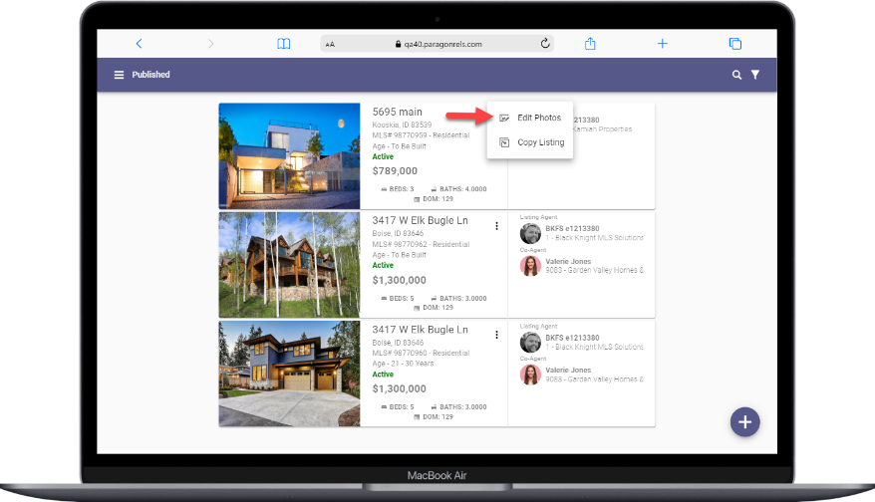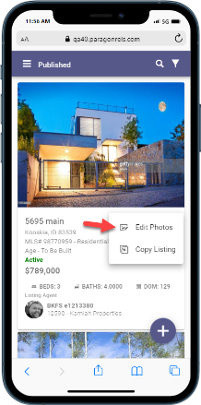

Print Single Listing
The ability to print a single listing has been added to Paragon Connect. The default Paragon Professional Agent and Detail reports will be available to print under the overflow menu.
Note: These printable reports must be enabled by your administrator.
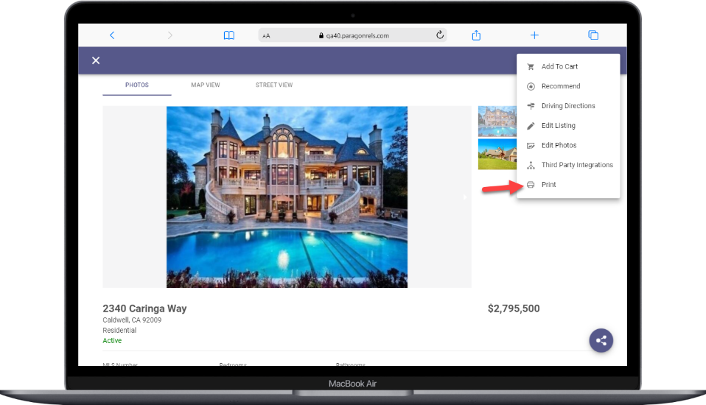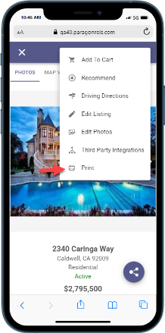

Paragon Affiliate Connect
All options in this section are either configurable via MLS Administration controls or by your System Support Manager as noted.

Admin – Access Affiliate Dashboard from Admin
Action item: N/A
Previously, admins with security level 7 or above could assume the identity of an affiliate and view the Affiliate dashboard inside of Paragon Professional. To allow the admin to see exactly what the affiliate is seeing, we have added a link in the Affiliate member record to access the stand-alone Affiliate dashboard. (See Figure 1 and 2)
After the admin accesses the affiliate record and logs out, the login will be recorded in the Audit Login report in Paragon. (See Figure 3)
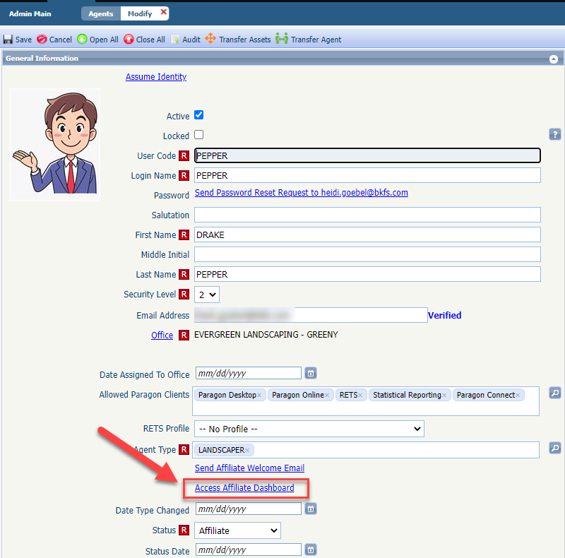
Figure 1: Paragon – Admin>Agent
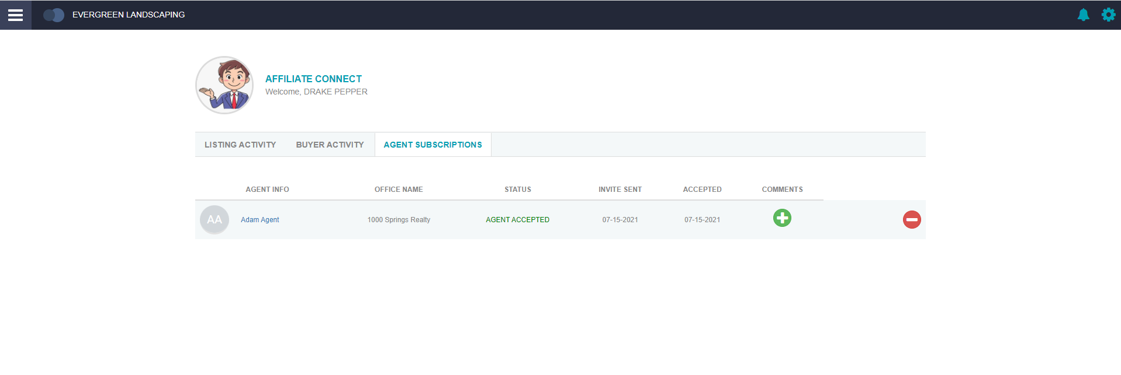
Figure 2: Affiliate Dashboard accessed through Admin

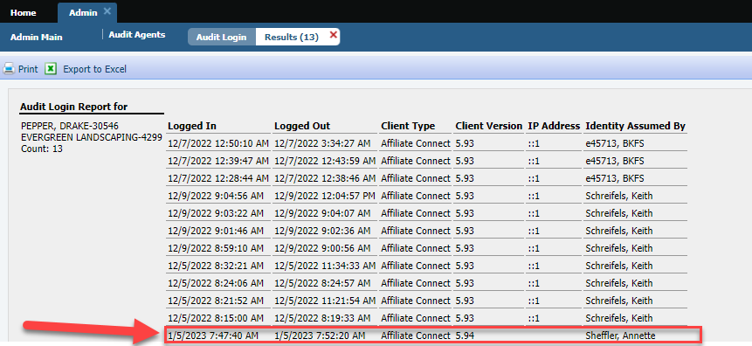
Figure 3: Audit Login

Display agent’s or affiliate’s Office address on notification emails
To comply with CAN-SPAM regulations, the Office address for the sending agent or affiliate will display with their other contact information on all notification emails sent from the Affiliate Connect module. Because the office address is required for emails to be sent from Paragon, this ensure that an address will always display.
Action item: N/A

Corrected Paragon Affiliate Connect Issues
Ticket # | Module | Summary
DEV-8016 | Affiliate Search | Affiliate Connect Performance: Affiliate Login Performance Issues
DEV-2105 | Affiliate Connect | Access Affiliate Dashboard from Admin

