Paragon 5.94 Release Enhancements
Updated on: 3/30/2023.
(Added TK-13439 to corrected issues)

Corrected Paragon Issues 2
MLS Customizations and Administration 3
Admin – Allow Agents to Control the Display of AVMs in Collaboration Center and CollabLink 3
Agent Level Changes 6
Property Search Agent and Office Field Auto-Complete Enhancements 6
Statistical Reports – Market Activity by Location 8
Paragon Connect 9
Value Range Pricing – Listing Maintenance 9
View Detail – Listing Maintenance 9
Paragon Affiliate Connect 10
Corrected Paragon Affiliate Connect Issues 10

Corrected Paragon Issues
Ticket# | Module | Organization | Summary
TK-12808 | Preferences | CARMLS, REALCOMP | Special character Typos shown on Agent Image preference page
TK-12729 | Contacts | BCRES - REB2 Residential | Collab Center Comments Displaying Today and Yesterday for Messages made on same day
TK-12709 | General UI | Iowa Great Lakes BOR, ValleyMLS/NALMLS | Resources > My Links throws Invalid Security error for specific agents
TK-12635 | Admin | Northwest Oklahoma AOR | Unable to run Major Area report (Admin> Major Area) "The page you are attempting to access." error
TK-11721 | CMA | Bayou BOR, REALCOMP, SCWMLS | Need to remove CMA link for "Having CMA output issues?"
TK-12540 | Search | Northern Nevada Regional MLS | NNRMLS Quicksearch Bedroom # not altering the count returned.
TK-11179 | Statistics | Greater Alabama MLS | Stat reporting Graphs function not displaying
TK-12468 | Admin | Regional MLS Alliance (Peoria) | Offices not sorting correctly for Office ID or Office code
TK-11754 | Configuration | Baldwin County AOR, IRMLS | Open houses are not being deleted based on TOUR_OH_LISTING_STATUSES config
TK-9072 | Hotsheet | BCRES - REB2 Residential | When doing search with Hotsheet option, navigating to next listing does not work
TK-10329 | WebAPI | New England Real Estate Network | Web API: Display Correct Calling Code for CountryCodeID Fields
TK-12291  /TK-12343 | Hotsheet | New England Real Estate Network | Hotsheet Saved Searches Not Loading Criteria Page when apostrophe is utilized in the name
TK-10897 | Search | Regional MLS Alliance (Peoria) | Map Search No Longer Opens to the Map, but Starts with Criteria - Jumps to Map After One Field is Entered
TK-9834 | Statistics | Colorado Real Estate Network, Inc | Year to Year Stats Report Displays Incorrect Median Sale Information
TK-11992 | Admin | BCRES - REB2 Residential | LVT causing Match Address field rules to be ignored
TK-11533 | Collab Center/Email | NEREN, SCWMLS, SDMLS, TOPEKA | Adjust HTML to Address Blue Bars on Client Collab Center E-mail Notifications
TK-11081 | PowerSearch | San Diego MLS | CLAW Datashare Listings not available via Power Search
TK-8758 | WebAPI | South Central Wisconsin (Madison) | Web API: Paragon Enumerations Fail to Display with Some Formulas
TK-13439 | Market Monitor | CARMLS, CREN, IMLS, ValleyMLS, Huntsville | Will not sort by DOM in spreadsheets

MLS Customizations and Administration
All options in this section are either configurable via MLS Administration controls or by your System Support Manager as noted.

Admin – Allow Agents to Control the Display of AVMs in Collaboration Center and CollabLink

Action Item: Contact your SSM to enable the new Admin field.

An Admin field has been added to allow MLSs to establish whether they want to permit agents to determine if AVMs display on their listings in Collaboration Center and CollabLink based on the existing VOW AVM listing field value. The new Admin feature, “Display AVM per Listing VOW Setting” can be found in Admin > Collab Center under the Detail Report section.

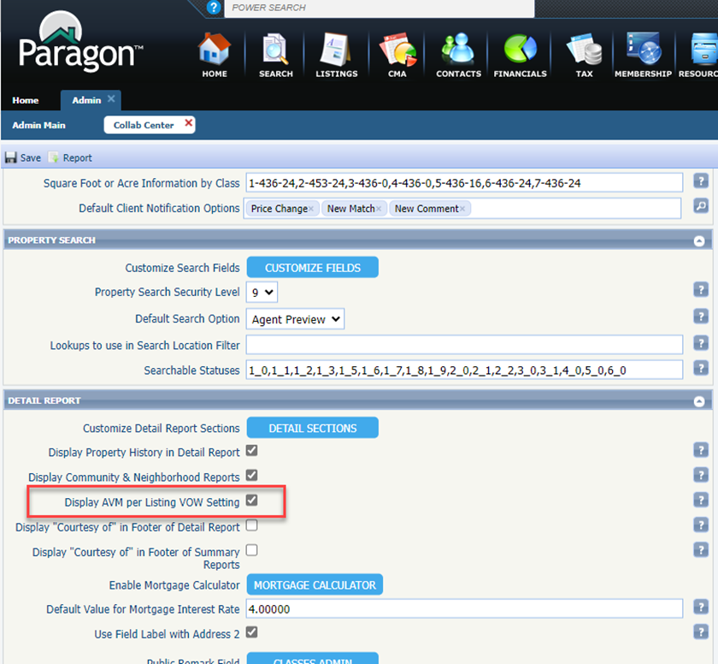
Figure 1: Admin > Collab Center Feature
Admin Feature is OFF
If Display AVM per Listing VOW Setting = OFF (unchecked), AVMs in Collaboration Center/CollabLink will function as they do today.
Admin Feature is ON
Display AVM per Listing VOW Setting works with the VOW AVM listing field (phys # 638) and the settings in Preferences > Collab Center > Automated Valuations.
This feature only controls whether the AVMs display in Collaboration Center and CollabLink for a particular listing, NOT whether the listing itself displays.
- If Display AVM per Listing VOW Setting = On (checked), and VOW AVM = Yes, the AVMs specified in Preferences > Collab Center > Automated Valuations will display in Collaboration Center and CollabLink for that listing. If no AVMs are selected in Preferences, no AVMs will display for that listing.
- If Display AVM per Listing VOW Setting = On (checked), and VOW AVM = No, no AVMs will display for that listing, even if AVMs are selected in Preferences.
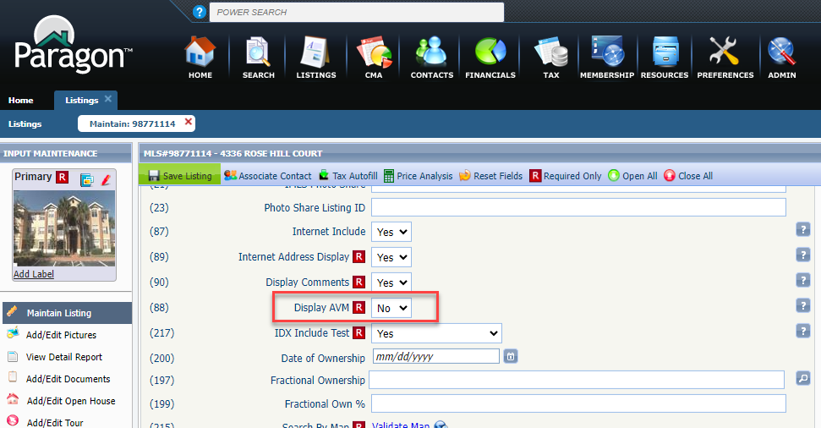
Figure 2: VOW AVM Listing Field
Note: The VOW AVM field display name is determined by the MLS and may not actually display as “VOW
AVM’ for your MLS, but its physical number will be 638 in Admin > Fields.
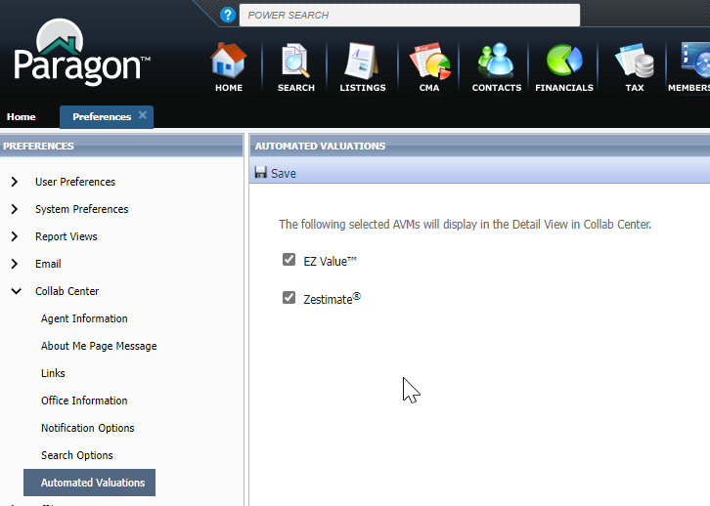
Figure 3: Preferences > Collab Center > Automated Valuations

Agent Level Changes
The following section contains changes that are active system wide and available to users based on their assigned security levels.

Property Search Agent and Office Field Auto-Complete Enhancements

We have made changes to all property search Agent dropdown fields so that they now display the agent’s user code and whether the agent is inactive. The list will sort by first and last name, then status with the active agents appearing first.
We have also made a change to all property search Office dropdown fields to identify the inactive offices. The list will sort by name then status with the active offices appearing first.
Note: The office user code was already displaying in the list prior to this release.
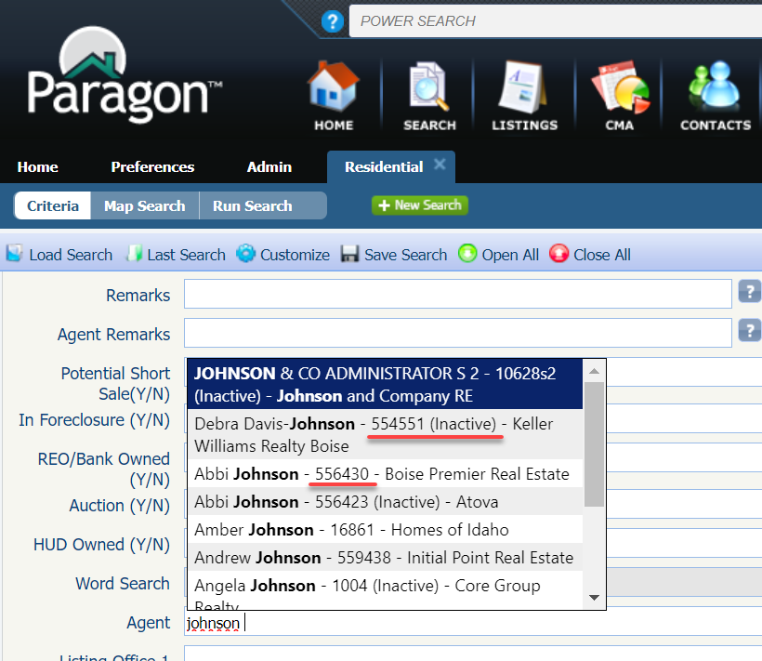
Figure 1: Agent Property Search Field (Note - Abbi Johnson’s active record displays first)
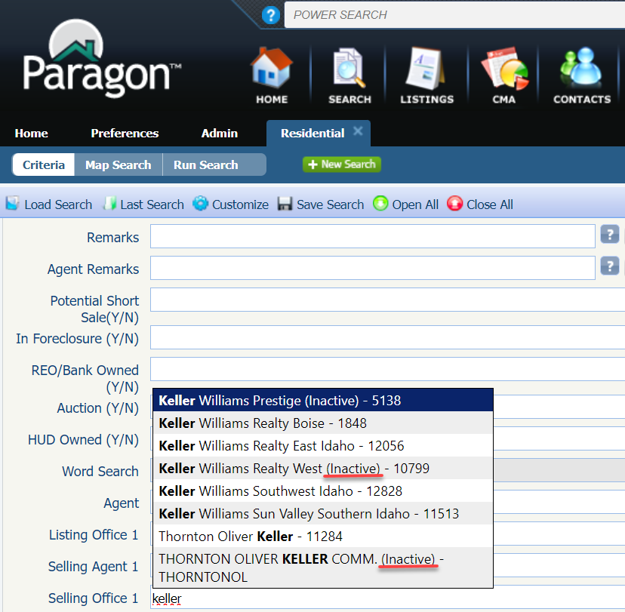
Figure 2: Office Property Search Field

Statistical Reports – Market Activity by Location

Per customer request, the Market Activity by Zip and Month report has been upgraded to allow users to group the report results by other location fields besides zip/postal code. A new option on the criteria page allows the user to specify how the results are displayed: by State/Province, City, Area, or Zip/Postal Code.
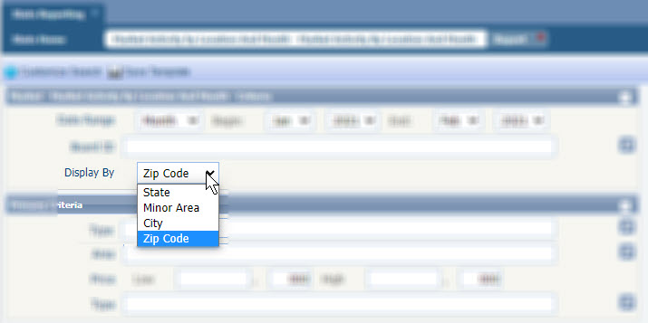
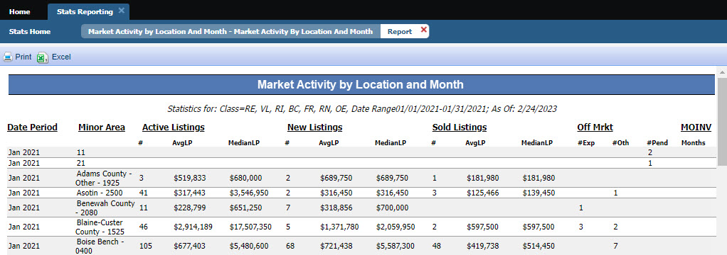

Paragon Connect
The following section contains changes that are active system wide and available to users based on their assigned security levels.

Value Range Pricing – Listing Maintenance
This feature Value Range Pricing is now supported within Paragon Connects listing edit module. This is existing configurable functionality used in Paragon Professional today. For those organizations that allow Value Price Range pricing, the feature allows listings to be populated with an exact list price or a price range.

View Detail – Listing Maintenance
While viewing your published listings with the listing maintenance module, you can now use the overflow menu on each listing to pull up the full listing detail report. This allows you to quickly examine the listing information.
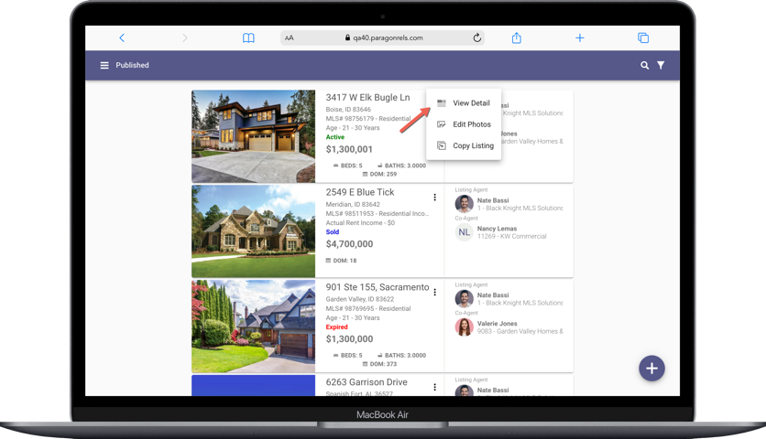

Paragon Affiliate Connect
All options in this section are either configurable via MLS Administration controls or by your System Support Manager as noted.

Corrected Paragon Affiliate Connect Issues
Ticket # | Module | Summary
Dev-8281 | Email | Affiliate Connect - New Connection email typo

