Paragon 6.0 Release Enhancements
Updated on: January 29, 2024

Corrected Paragon Issues
Ticket# | Module | Organization | Summary
TK-17081 | Contacts | BCRES - REB2 Residential, COLUMBIA - ConsolidatedMLS, MAXEBRDI - MAXEBRDI MLS, PRIMEMLS - Prime MLS (NEREN), SJSR - South Jersey Shore Regional MLS, WVMLS - Willamette Valley MLS | Error when trying to view sent messages
DEV-11949 | LIM |  | Specific User is getting an error page when trying to share Via CollabLink Share
TK-11193 | LIM | MIMLS - MiRealSource | Co-List and Selling Agent Fields Do Not Allow Users to See More Than Just Their Office
TK-16638 | Contacts | IMLS - Intermountain MLS, SCWMLS - South Central Wisconsin (Madison) | Agent's Contacts Having Notifications Automatically Disabled

MLS Customizations and Administration
All options in this section are either configurable via MLS Administration controls or by your System Support Manager as noted.

Admin – No Admin Changes

Agent Level Changes Paragon Professional
The following section contains some changes that are active system wide, and some may only be available to users based on their assigned security levels.

Agent Level - No New features

Corrections and Improvements

- Correction for the agent options that appear in the LIM lookups when Association Autonomy filters are applied
- Improvements to the performance for Prospecting notifications

Collaboration Center
All options in this section are either configurable via MLS Administration controls or by your System Support Manager as noted.

Collaboration Center - No New features

Corrections and Improvements

- None

Paragon Connect
The following section contains changes that are active system wide and available to users based on their assigned security levels.

New - System Documents

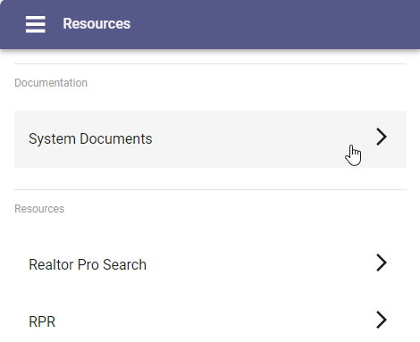
The files available within Paragon Professional under “MLS Documents” are now available within Paragon Connect. These System Documents can be found from the main menu under “Resources”.

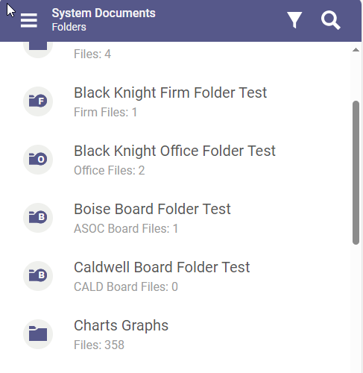
Any documents already uploaded to Paragon Professional will appear here within Paragon Connect. Users can see documents available to the entire System, for their Board, for their Firm, and for their Office, if they are configured and they exist. The folder icon will indicate the corresponding level.

Users with permission to add new documents will be able to add and modify files to the appropriate folders.

Corrections and Improvements

- Correction to the Suggested Price on EasyCMA when public record comps are included
- Correction to the message displayed when new listings are recommended if the notification settings were originally disabled

OpenMLS RESO API
To use the following functionality, you’ll need the Green Data enabled in Paragon and RETS. Mapping from regular Listing fields is not supported.

No OpenMLS RESO API

