
08

08
Fall

Fall

Paragon 6.3 and 6.4 Release Enhancements
14 March 2024

1. Corrected Issues 3
2. MLS Customizations and Administration 5
2.1. Restb.ai Photo Tagging in Paragon Pro & Paragon Connect 5
2.2. Restb.ai Compliance Violations in Paragon Pro & Paragon Connect 6
3. Paragon Connect 7
3.1. Paragon Connect Corrections and Improvements 7
3.2. EasyCMA Dashboard Updates 8
3.3. New Listing Maintenance Filter Options 9
3.4. New Tax Mode Option on Map View 10
3.5. New Results Analytics View 11

Paragon 6.3 and 6.4 Release Enhancements

Corrected Issues
Ticket# | Module | Organization | Summary
TK-17266 | Listing Photos | RAE - REALTOR Assoc of Edmonton | Unable to scroll down while re-arrange photos on Paragon Connect
TK-17358 | View/Reports | NTREIS - North Texas REIS | P160 - NTREIS - Scrolling in spreadsheet view shows text between check box and thumbnail
TK-17147 | Field Rules | NSAR - NS and PEI Real Estate Associations | PC Not Available Field rules not hiding fields
TK-16286 | Search | REALCOMP - Realcomp II Ltd | Realcomp - Field appears in Criteria Summary even if NULL
TK-17641 | LIM | MAXEBRDI - MAXEBRDI MLS | Field rules causing error when saving listing on Paragon Connect.
TK-17165 | Texting |  | Unable to share listings via text on Iphone
TK-17138 | Texting | GPRMLS - Great Plains Regional MLS | PC APP Clicking SMS/Text link does nothing in Members
TK-17418 | CMA | GPRMLS - Great Plains Regional MLS, PRIMEMLS - Prime MLS (NEREN) | EasyCMA Broken Image icons displayed on Subject Property Google Map View
TK-17266 | Listing Photos | RAE - REALTOR Assoc of Edmonton | Unable to scroll down while re-arrange photos on Paragon Connect
TK-17334 | CMA | OBARMLS - Outer Banks AOR, SMLSA- Strategic MLS Alliance | EasyCMA: No comparables found
TK-17320 | Email | BCRES - REB2 Residential | CC BCC Recipient Fields are not displaying data when looking in Contacts Sent Messages
TK-17147 | Field Rules | NSAR - NS and PEI Real Estate Associations | PC Not Available Field rules not hiding fields
TK-16286 | Search | REALCOMP - Realcomp II Ltd | Realcomp - Field appears in Criteria Summary even if NULL
TK-13248, | Assoc Doc |  | CKAR Listing CK8908573 - Associated Documents did not automatically remove after system settings of one month
TK-15751 | CMA |  | Remove drawing tool from map view

MLS Customizations and Administration

Restb.ai Photo Tagging in Paragon Pro & Paragon Connect
Action Item: Contract Addendum Required
We now offer an optional integration with Restb.ai to automatically apply RESO labels to all uploaded photos. This feature is available when any new photo is uploaded to a listing through Paragon Pro or Paragon Connect.
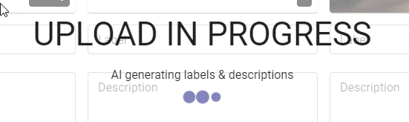
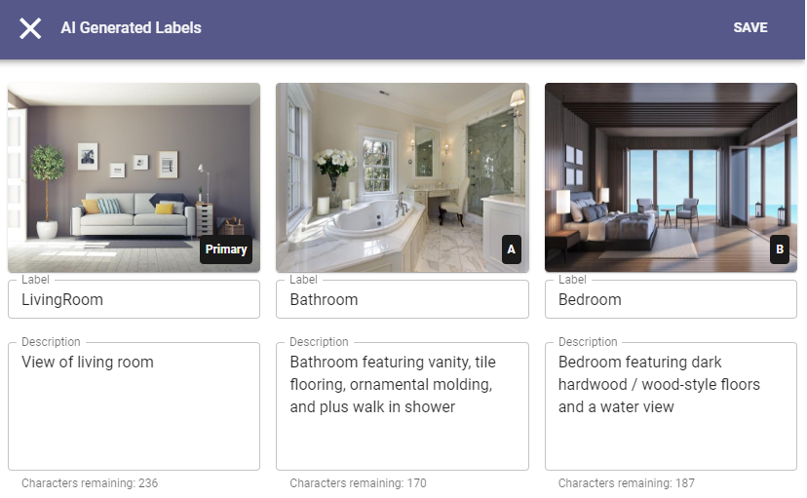
While the photos are uploaded, they are processed through the Restb.ai engine to automatically apply Photos Labels and Descriptions to each image. Users can review and modify the labels and descriptions and make any needed changes.

Restb.ai Compliance Violations in Paragon Pro & Paragon Connect
Action Item: Contract Addendum Required
We now offer an optional integration with Restb.ai to automatically scan all newly uploaded listing photos to identify any possible compliance violations. Restb.ai offers 21 standard checks looking for potentially inappropriate content like yard signs, faces, or phone numbers. When any violation is encountered it is recorded behind the scenes. System Administrators can use a new Restb.ai Compliance Report to search for any violations by date range or violation type. The report details each listing, affected Photo, Uploading User, Listing Office, Date, and Violation. The listing ID opens to the default Detail View so administrators can conveniently access the listing photos and property information.

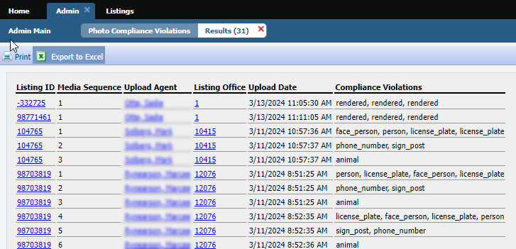

Paragon Connect

Paragon Connect Corrections and Improvements
- Improvement to add support for SentriLock LIM integrations
- Improvement to allow Lookup Options that are configured with URLs to display the links on the Detail View
- Improvement to display a new Watch Alerts section on the Public Records Detail View showing any Alerts received for properties using Property Watch
- Corrections to the User Interface to account for changes within the last version of the Chrome Browser

EasyCMA Dashboard Updates
To address some layout issues and spacing challenges, the CMA Cards on the EasyCMA Dashboard have a new look and feel.
The updated cards allow more room to display property addresses and any assigned Contact data.
With this change users now have the ability to easily assign or remove a contact from the CMA. These cards continue to show the status of the CMA along with the date last generated or updated.
The new card format also allows for future expansion of user options.
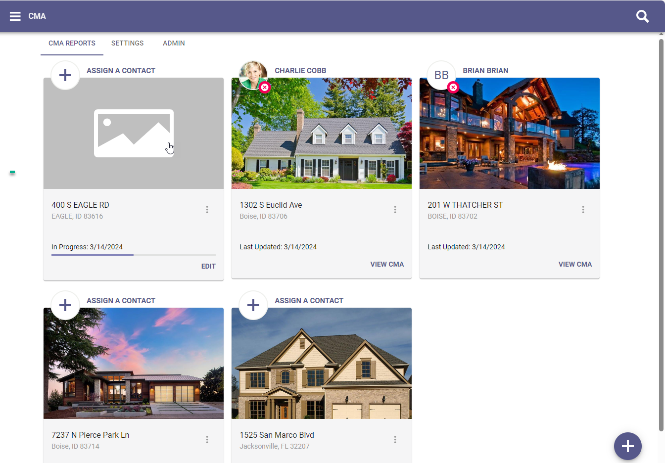

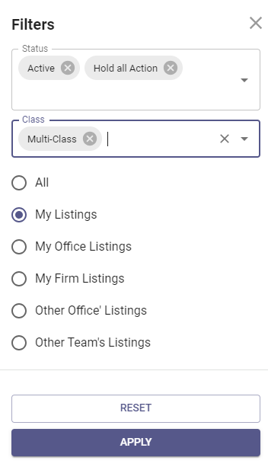
New Listing Maintenance Filter Options
The Filter Options under Listings have been expanded to allow for greater user flexibility.

The Status filter now displays individual Statuses instead of the previous Status Category options. This allows users to see and select specific statuses they may be interested in maintaining.

New options may also appear for users on Teams or those with expanded permissions, like Office Managers, Brokers, and System Administrators. These options allow you to search for and filter listings by Other Agents or Other Offices.

To account for the new options, the filter has been moved to appear on the right-side allowing more space to see and use the expanded filter options.

New Tax Mode Option on Map View
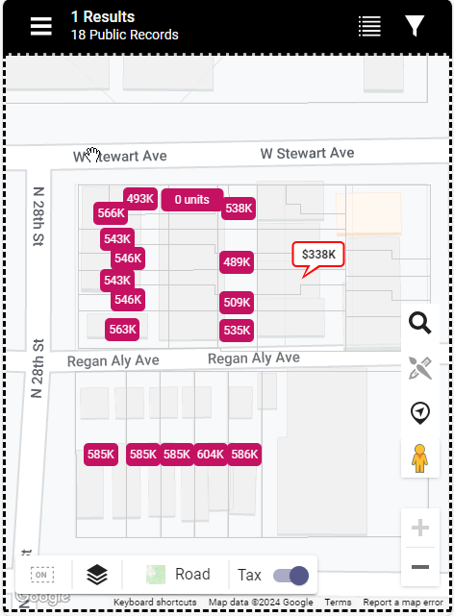
For any systems that utilize the Integrated Search Option in Paragon Professional, an updated version of this feature is now available within Paragon Connect. A new option labeled “Tax” will appear in the bottom menu on the Map View.

Once enabled and zoomed in, the map view will update to include results for Public Records alongside any listing data matching your current search.

To utilize this feature start with a property search to set and find the types of properties you are looking to find and view the results on the Map View. Use the toggle to switch to Tax Mode and the menu will update to black to indicate the mode is activated. From here you can use the Filter icon to apply search criteria to public records.

The Map View will show listing pins alongside public record markers. Users can view the listing or public record detail views for additional information. You can also choose to view the matching, visible results in a Spreadsheet View and export the results for any additional analysis.

New Results Analytics View
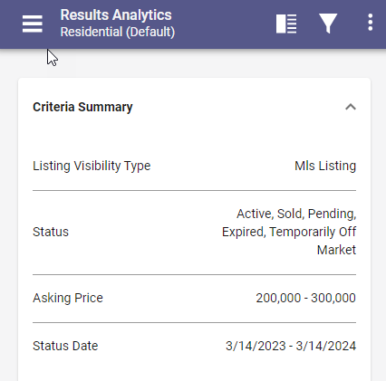
A new view called Results Analytics is now available from the View Switcher for any standard property search results. This new view provides informative analytics for the listings results, summarizing and breaking down key data points like DOM, Price, and Status.

This Results Analytics View starts with a quick summary of the criteria used to return the matching listings. Within the top menu users have access to the Filter icon which allows you to easily adjust your criteria and update the analytics view instantly.

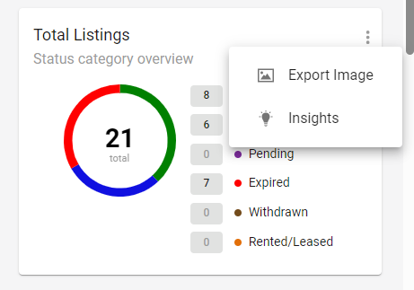
The view is comprised of 7 widgets, each highlighting a different summary or breakdown of the results. Each widget overflow menu includes an option to Export the chart so it can be included or shared any place the user chooses, like in a separate email, text, or webpage.
Each overflow also includes Insights to provide details about the purpose of the chart.

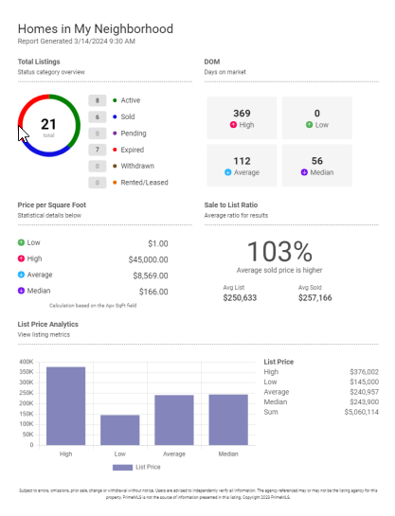
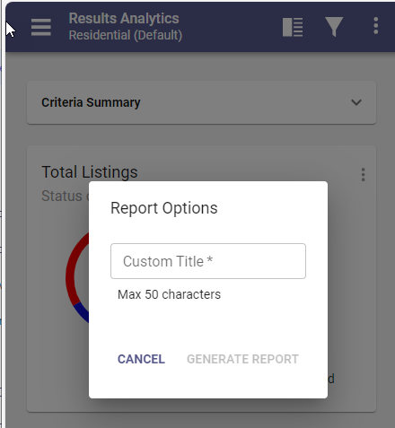
Users also have the ability to generate a PDF of the Results View. A custom Title is assigned for the PDF which can be downloaded or printed using your browser options.

