
08

08
Fall

Fall

Paragon 7.1 Release Enhancements
11 April 2024
1. Corrected Paragon Issues 2
TK-17187 2
TK-17813 2
TK-17898 3
2. MLS Customizations and Administration 4
2.1. No MLS Customizations and Administration 4
3. Paragon Connect 4
3.1 Paragon Connect Corrections and Improvements 4
3.2 New Option to Grant Assume Identity Permission 4
3.3 Connect users New Custom Sort Options for Hotsheet 5

Paragon 7.1 Release Enhancements

Corrected Paragon Issues
Ticket # | Module | Organization | Summary
TK-16436 | Contacts | REALCOMP - Realcom II Ltd | Entering Email notification via PC adds page break HTML element to message body
TK-17187 | Statistics | BCAR - Baldwin County AOR;SMLSA - Strategic MLS Alliance | Agent Ranking within Firm throwing The page you are attempting to access is unavailable..
TK-15609;TK-17602 | View/Reports | CR - California Regional MLS;MAXEBRDI - MAXEBRDI MLS;TOPEKAMLS - Topeka BOR (Sunflower) | When externally hosted photos are used and Spinner option selected, photos do not display
TK-17800 | Tax | SJSR - South Jersey Shore Regional MLS | Realist Tax Autofill fails from CMA Create Presentation workflow
TK-17813 | View/Reports | WVMLS - Willamette Valley MLS | WVMLS - Unable to view sent emails listing reports
TK-17877 | MLS Docs | RMLSA - Regional MLS Alliance (Peoria) | System Docs - Limiting to first 25 files in a folder
TK-17888 | Hotsheet | GPRMLS - Great Plains Regional MLS | GPRMLS - Error when saving/loading Hotsheet search
TK-17898 | LIM | NJMLS - New Jersey MLS (Bergen) | Required Bit Type Fields Not Showing Asterisk in Listing Input and Maintenance
TK-17924;TK-17879 | Other | BLACKHILLS - Black Hills AOR;CARMLS - CARMLS, Inc. (Arkansas) | Android: Paragon Connect on Android devices unable to copy link

MLS Customizations and Administration

No MLS Customizations and Administration
Action Item: none

Paragon Connect

3.1 Paragon Connect Corrections and Improvements
- Correction on the Input form to show the required * next to Yes/No type fields, fields with only a toggle option for values

3.2 New Option to Grant Assume Identity Permission
Now within Paragon Connect users can see and edit permissions for others to assume their identity. Access to this feature is defined by rules within your local system and each user’s level of access. This feature is not available to System Administrators.

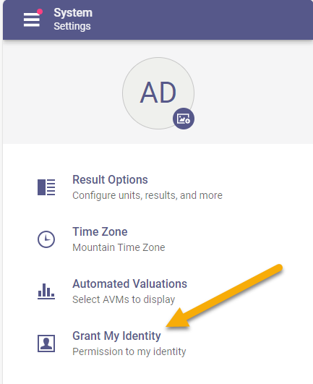

If authorized, users may see a new option called “Grant My Identity” under Settings > System. From this new page you can easily see any users who are currently authorized to assume your identity.

If permitted, you can also add users to this list. You will see a + icon which opens a list of users. You may pick from any of these users to grant them permission to assume your identity. Once granted, those users will be able to use the Assume Identity feature to perform work on your behalf.

For any Office Manager or Broker level users, there is a second new Setting option called “Office Grant Identity”.
From this page office administrators can see any permissions granted for users within their office or firm. If authorized, you can grant permission to assume identity rights between users within your office(s).
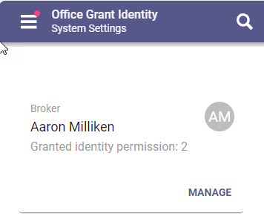

3.3 Connect users New Custom Sort Options for Hotsheet
Connect users now have the option to choose their preferred order for Hotsheet results. On the Hotsheet search form the Filter container shows all the available Hotsheet Filter types. In the top menu there is a new icon that allows you to change the order for your hotsheet results sorting by the new Filter order.
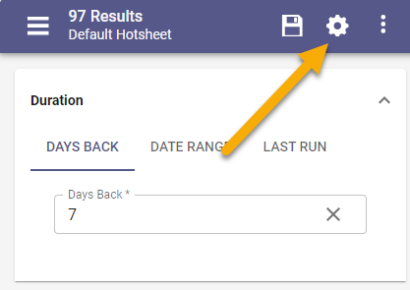
Click the new gear icon in the top app bar to see a list of the current Hotsheet Filters. Simply drag and drop the filter options into your preferred order and click Update.
Once you update the order you will instantly see the filter options on the Hotsheet search form appear in the new order. You only must do this one time, your preference will be saved and used for all Connect hotsheet searches.
The Connect Hotsheet results always appear in the same order as the Filter options. 