
08

08
Fall

Fall

Paragon 7.4 Release Enhancements

23 May 2024

1. Corrected Paragon Issues 2
2. MLS Customizations and Administration 3
2.1. No MLS Customizations and Administration 3
3. Paragon Connect 3
3.1. Paragon Connect Corrections and Improvements 3
3.2. New Detail Layout for EasyCMA Comparables 4
3.3. New option to Assign Your Listing to a Contact from Listings 5

Corrected Paragon Issues
Ticket# | Module | Organization | Summary
DEV-13239 | Email | PRIMEMLS - Prime MLS (NEREN) | CC Seller Welcome Email > Displaying 2 headers and two agent sections
DEV-13219 | Market Monitor | NNRMLS - Northern Nevada Regional MLS;VALLEYMLS - ValleyMLS / NALMLS (Huntsville) | Market Monitor showing incorrect count compared to spreadsheet returned.
DEV-13178 | View/Reports | NJMLS - New Jersey MLS (Bergen);RAE - REALTOR Assoc of Edmonton | PConnect: Detail View Not Scrollable on Phone or Keyboard Arrows When Reached Through Map then Spreadsheet
DEV-13152 | Search | GPRMLS - Great Plains Regional MLS | PC Search - LVT options are mistakenly restricted for non-staff
DEV-13104 | Third Party | RAE - REALTOR Assoc of Edmonton | HTTP Referrer is null for GeoJet integration
DEV-13062 | LIM | NTREIS - North Texas REIS | Paragon Connect RUG field Lookups display ID Value and Short Value but not Description
DEV-11652 | Admin | DAAR - Lake Superior Area MLS | Unable to merge office
DEV-13218 | Listing Photos | BCRES - REB2 Residential;CCAR - Coastal Carolinas AOR;COLUMBIA - ConsolidatedMLS;CREN - Colorado Real Estate Network, Inc;GAMLS - Georgia MLS;GREENVILLE - Greater Greenville AOR;IGL - Iowa Great Lakes BOR;IMLS - Intermountain MLS;NSAR - NS and PEI Real Estate Associations;RAE - REALTOR Assoc of Edmonton;RMLSA - Regional MLS Alliance (Peoria);SCWMLS - South Central Wisconsin (Madison) | PC: EXIF Orientation data causing Photos to Photos Appearing Upside Down on Listing in Safari and Apple Devices

MLS Customizations and Administration

No MLS Customizations and Administration
Action Item: none

Paragon Connect

Paragon Connect Corrections and Improvements
- Improvement to enable the Map Seach icon on the Property Search form to allow quick access to the map for searching
- Improvement to show the Search button on Property Search form in a “disabled” state, instead of hiding it, until the results count is within the maximum results range
- Improvement to update the Third Party icon throughout the site to better distinguish it from the Share icon:

New Detail Layout for EasyCMA Comparables
When EasyCMA reports are generated the detail view for comparables will use a brand new report layout. Previously, the comparables would display using the CollabLink layout.
This new format looks similar to the professional ConnectView, but is designed for public display. It includes the fields and display permissions defined for your setup of the public CollabCenter view. This view provides all the same, important property data for the selected comparable properties that displays beautifully on any device.
This new format will automatically apply to any existing EasyCMAs or to any newly created EasyCMAs.
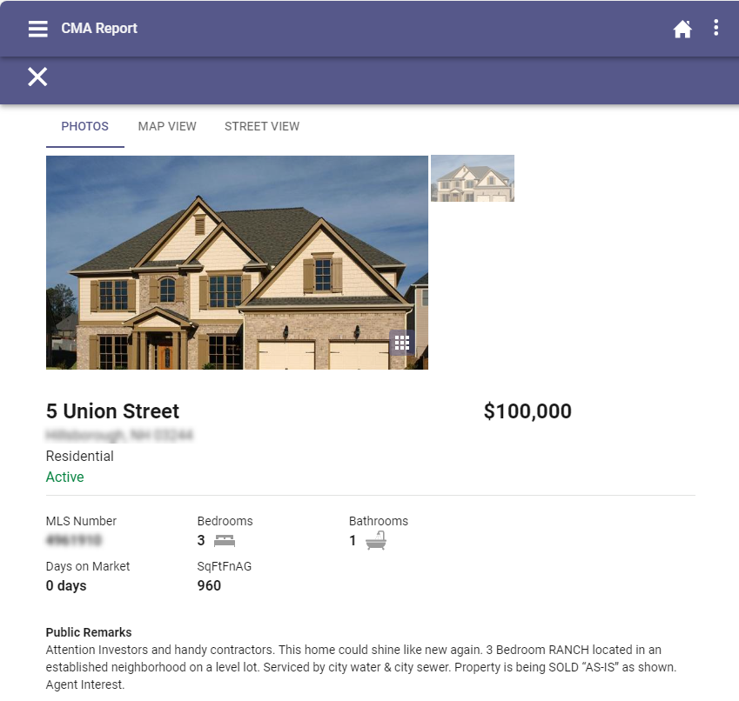

New option to Assign Your Listing to a Contact from Listings
In the last release we updated the Contact Summary page to include a way to assign listings to Contacts to enable the Seller Dashboard feature. This release we included this option from the Listings module.
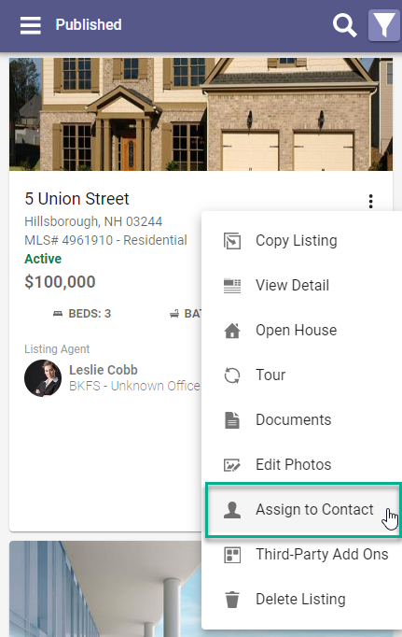
Simply go to your Published listings, from the Overflow menu you see a new option labeled “Assign to Contact”.
This option is available if you are any of the Listing Agents for the listing.

After selecting this new option, you follow the same steps available from the Seller Dashboard or Contact Summary to pick or create your Contact and set up any options for the Seller Notifications.

If a Contact is already assigned, this option under Published Listings will update to show “Unassign Contact”.

